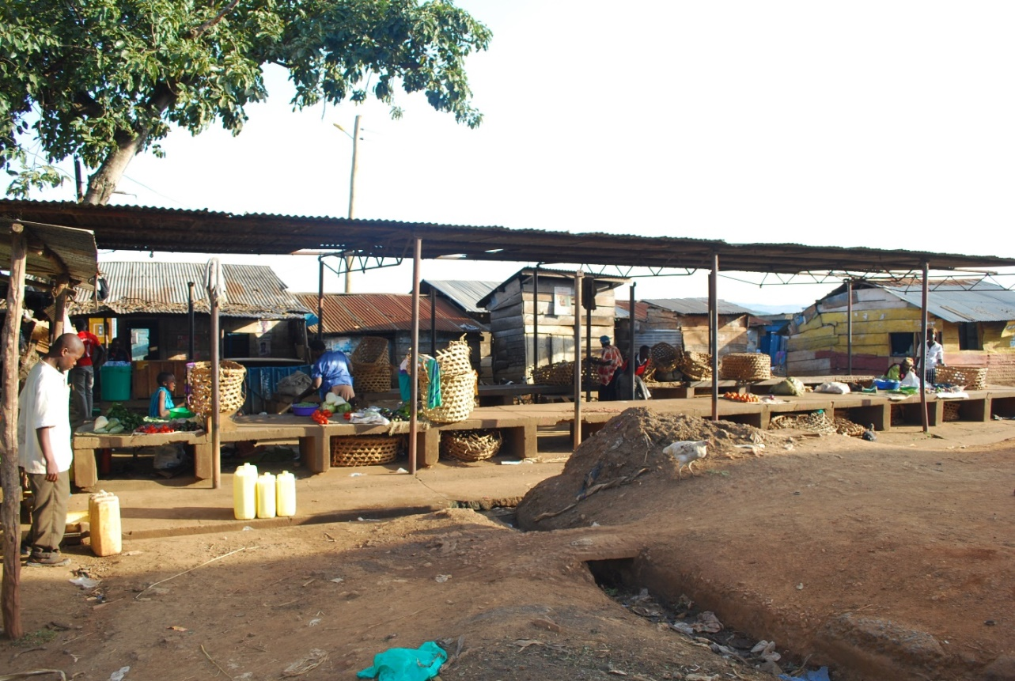
Fish market at Masese landing site on Lake Victoria. Decline of native fishery has left traders idle in fish markets. (Photo credit: EPIC 2017)

