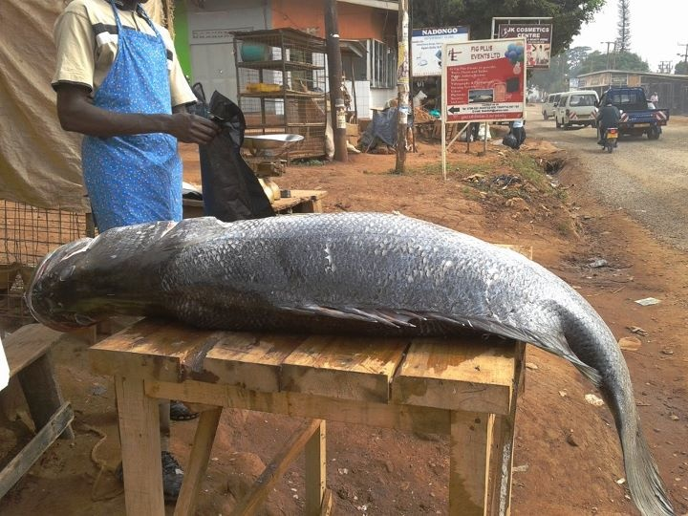
The Predator Nile perch, they are found too far out in the open water for small fishing boats, and are too big to be caught with unsophisticated gear.

