UNITED  NATIONS |  |  | 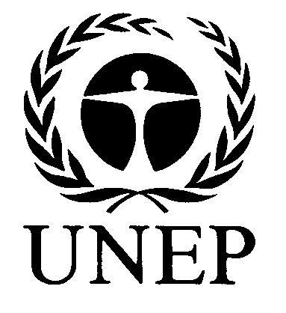 |  | 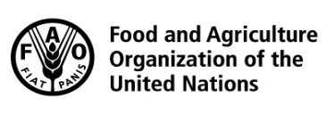 |  |  | BES
 |  |  |  |  |  |  | IPBES/6/INF/29
 |  | Intergovernmental Science-Policy Platform on Biodiversity and Ecosystem Services |  |  |  |  | Distr.: General  7 February 2018  English only
Plenary of the Intergovernmental Science-Policy
Platform on Biodiversity and Ecosystem Services
Sixth session
Medellin, Colombia, 18–24 March 2018
Item 2 (c) of the provisional agenda*
Organizational matters: election of members of the Multidisciplinary Expert Panel

Compilation of curricula vitae of proposed members of the Multidisciplinary Expert Panel: proposals from Latin American and Caribbean States
Note by the secretariat
The annex to the present note, which is presented without formal editing, sets out a compilation of the curricula vitae of the candidates proposed for membership of the Multidisciplinary Expert Panel, as submitted by Latin American and Caribbean States. The curricula vitae have been made available, as received, from https://www.ipbes.net/nominations/mep-2017.

Annex
Compilation of curricula vitae of proposed members of the Multidisciplinary Expert Panel:
proposals from Latin American and Caribbean States
Nominated by | Name | Affiliation | Expertise | Gender | Link to curriculum vitae
Argentina | Bibiana Vila | Consejo Nacional de Investigaciones Científicas y Técnicas (CONICET) - Universidad Nacional de Luján (UNLU) | Wildlife conservation | Female | https://www.ipbes.net/sites/default/files/argentina_-_candidatura_mep_-_vila_-_cv_2018.pdf
Chile | Mary T.K. Arroyo | Instituto de Ecología y Biodiversidad (IEB)  Universidad de Chile | Botany, plant ecology, conservation | Female | https://www.ipbes.net/sites/default/files/cv_mary_t_k_arroyo_short.doc
Colombia | Germán Ignacio Andrade Pérez | University of Andes | Resource management, sustainability | Male | https://www.ipbes.net/sites/default/files/cv_giandrade_january_2018_1.pdf
Costa Rica | Carmen Roldan | Directora de Comericializacion del Fondo Nacional de Financiamiento Forestal | Tropical biology, education | Female | https://www.ipbes.net/sites/default/files/cv_carmen_roldan_chacon_2017.pdf
Cuba | Cristóbal Félix Díaz Morejón | Ministry of Science, Technology and the Environment | Soils, water resources | Male | https://www.ipbes.net/sites/default/files/cristobal_diaz_cuba_curriculum_vitae_english_complete.doc
Dominican Republic | Álvarez De Vanderhorst Juana Venecia | Ministry of Foreign Affairs | Marine biology | Female | https://www.ipbes.net/sites/default/files/cv-venecia1.doc
Dominican Republic | Reynoso Omar Shamir | National Maritime Affairs Authority. Global Democracy and Development Foundation | Biology | Male | https://www.ipbes.net/sites/default/files/cv_omar_shamir_reynoso_0.docx
Grenada | James Finlay | Consultant | Fisheries | Male | https://www.ipbes.net/sites/default/files/ars_ipbes_nomination_form_for_mep.pdf
Mexico | Porfirio Alvarez-Torres | Mexican Consortium of Marine Research Institutions for the Gulf of Mexico (CiiMar-GoM) | Marine research | Male | https://www.ipbes.net/sites/default/files/cv_porfirio_alvarez_january_2018_english_0.pdf
Mexico | Antonio Díaz-De-León | Innovative Cutting Edge Solutions Consulting (ICES) | Various biodiversity-related topics | Male | https://www.ipbes.net/sites/default/files/curriculum_vitae_a._diaz_de_leon_mep.docx
Saint Lucia | Marie-Louise Felix | Sir Arthur Lewis Community College | Marine, freshwater | Female | https://www.ipbes.net/sites/default/files/cmlf2b.pdf
Saint Lucia | Francillia N. Solomon | Government of Saint Lucia | Resource management | Female | https://www.ipbes.net/sites/default/files/fnsolomon_ipbes_mep_resume.doc
Trinidad and Tobago | Reia Guppy | The University of Trinidad and Tobago | Marine ecology, small island conservation | Female | https://www.ipbes.net/sites/default/files/r_guppy_cv_nov_2017.pdf
Trinidad and Tobago | Rahanna Juman | Institute of Marine Affairs | Marine Affairs | Female | https://www.ipbes.net/sites/default/files/rahanna_jumans_cv_2017.pdf
Trinidad and Tobago | Vidiah Ramkhelawan | Ministry of Tourism | Management of tropical ecosystems | Female | https://www.ipbes.net/sites/default/files/cv_vidiah_2018.pdf

* IPBES/6/1.

