IPBES Catalogue of policy support tools and methodologies

Step by step guide to upload content

Step 1: Log in
1.1 Open the IPBES website https://www.ipbes.net/ In order to upload content you need to be signed in with your IPBES account.

1.2 If you are already registered, please log in and then go straight to step 1.3
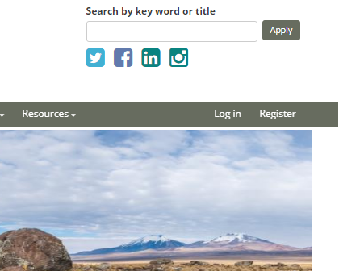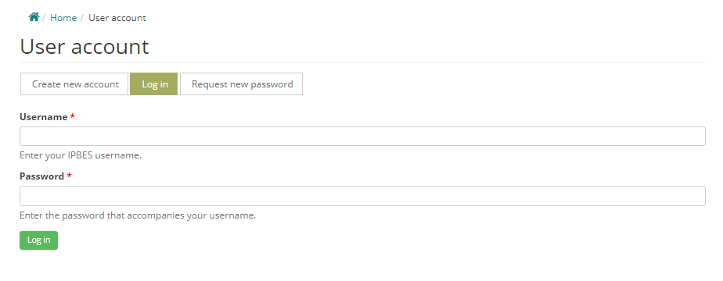

If you are not registered, please follow the Register link in IPBES home page https://www.ipbes.net/user/register
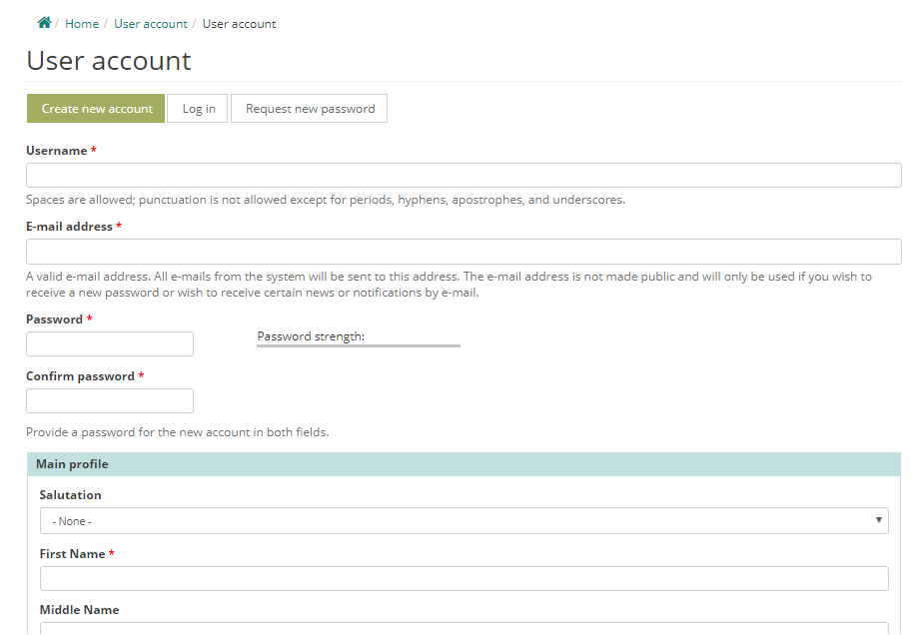

After following the link, please fill in the register form, and confirm your registration by clicking on the link in the email you will have received from secretariat@ipbes.net. If you cannot find the email, please check your spam folder.
1.3 Once you are signed in with your IPBES account, please follow this link to access the policy support portal

Step 2: What kind of resources to upload, and where?
First you should decide whether your resource is relevant to IPBES’ work and if so, under which section of the Catalogue it falls.

2.1 Is the resource relevant to IPBES?
Your resource should have the potential to support policy formulation and implementation in relation to biodiversity and ecosystems.

2.2 What kind of resource are you trying to upload?
The categories of resources that can be uploaded include:
- policy instruments
- policy support tools
- case studies – only if they are linked to a tool or instrument
- capacity-building opportunities and resources – only if they are linked to a tool or instrument
- assessments

Policy Instruments: A policy instrument is a set of means or mechanisms to achieve a policy goal. In the context of IPBES, there are four categories of policy instruments:
- Legal and Regulatory Instruments: Laws and regulations developed by governments at different levels with the ultimate aim of enhancing the protection of the environment, the development of sustainable production systems, and enhancing human wellbeing.
- Rights-Based Instruments and Customary Norms: International and national human rights instruments whether binding or non-binding can be created to fit socio-ecological systems. Strengthening of collective rights, customary norms and institutions of indigenous peoples and local communities, can promote adaptive governance and fair management of natural resources.
- Economic and Financial Instruments: Economic and financial instruments can be used to change people’s behaviour towards desired policy objectives. E.g. subsidies, taxes, charges, fiscal transfers, environmental stewardship schemes.
- Social and Cultural Instruments: While linked to them, social instruments go beyond economic and financial instruments. E.g. awareness based voluntary interventions include information-related instruments (environmental education, eco-labelling, pollutant release and transfer registers, biodiversity registers, awareness raising); corporate social responsibility; and enhancement of collective action (e.g. indigenous peoples, local communities, and local resource users).

Policy Support Tools:
Policy support tools are approaches and techniques based on science and other knowledge systems that can inform, assist and enhance relevant decisions, policy making and implementation at local, national, regional and global levels to protect nature, thereby promoting nature’s contributions to people and a good quality of life. In the context of IPBES, there are seven families of policy support tools:
- Assembling data and knowledge (including monitoring): Address knowledge gaps by providing data: E.g. databases, indicators, mapping of ecosystem services etc.
- Assessment and evaluation: Synthesize and assess existing knowledge relative to status, function, and drivers of nature, nature’s contributions to people, human well-being, and the connections between these. E.g. management effectiveness evaluations, scenarios, cost-benefit analysis etc.
- Public discussion, involvement and participatory process: Support discussion and deliberation, contribute to identifying problems and opportunities, setting joint goals and priorities, and meeting agreed objectives. E.g. stakeholder consultation, field observation, focused group discussion, mass media communication, and cultural mapping.
- Selection and design of policy instruments: Used for identification and evaluation of new and existing policies and institutional settings. They focus primarily on the choice and design of new and existing policies and their instruments. E.g. policy analysis, instrument impact evaluation, ex-ante evaluation of options and scenarios, policy mix analysis.
- Implementation, outreach and enforcement: Support the implementation of policy instruments such as laws, regulations, economic instruments and incentives. E.g. environmental and social safeguards, audits, process standards (e.g. ISO), monitoring, reporting and verification.
- Training and capacity building: Identify and/or address capacity gaps and shortfalls by enhancing the skills and capacity of relevant actors and organizations. E.g. handbooks, manuals, guides, e-learning resources, education, workshops, knowledge sharing.
- Social learning, innovation and adaptive governance: Aim to improve responsiveness, risk management and overall performance of the policy process while identifying opportunities to promote social learning and strengthening links and feedback mechanisms across elements and activities. E.g. collaborative networks, methodologies relating to adaptive governance.

Case studies:
Case studies are past or ongoing projects that illustrate the use of relevant tools and/or instruments.
They can only be uploaded if they are linked to a tool or instrument already included in the catalogue. Therefore, please ensure the relevant tool or instrument is already there or otherwise upload those first, and then add your case study.
Since case studies provide examples relating to the practical application of policy support tools or instruments, it is strongly encouraged that we have a variety of case studies for each of those. To the extent possible, please do bear this in mind when selecting the material to upload.

Capacity-building opportunities and resources:
Capacity-building opportunities and resources are means to help build the knowledge and skills necessary for the application of relevant tools and instruments. E.g. in-person and online training, massive open online courses (MOOCs), webinars.
Capacity-building opportunities and resources can only be uploaded if they are linked to a tool or instrument already included in the catalogue. Therefore, please ensure the relevant tool or instrument is already there or otherwise upload those first, and then add your capacity-building opportunity or resource.

Assessments:
An assessment is usually defined as a social process of undertaking a critical, objective evaluation and analysis of data and information, designed to meet its users’ needs. They can be used to communicate complex information to decision makers, therefore providing scientifically credible answers to policy-relevant questions. In IPBES context, they are published outputs of scientific, technical and socioeconomic issues that take into account different approaches, visions and knowledge systems. They should be composed of two or more sections including a summary for policymakers, an optional technical summary and individual chapters and their executive summaries.

Step 3: Uploading your resource
3.1 Once you identify the section of the Catalogue your resource belongs to, please follow the link to the type of resource (tool, instrument, case study, learning opportunity) you wish to upload. All types of resources can be uploaded following this link and selecting the relevant product type to upload. See the ‘about’ section of the website for information on which type of product you are uploading.

3.2 After following that link, please fill in the upload form to the best of your ability. Your resource will be significantly more helpful to users if you can complete as many of the aspects of this form as you can, not just the compulsory elements – in particular the relevant tags (‘Related Aichi Biodiversity Targets and Sustainable Development Goals’, ‘Related Nature’s Contribution to People and ‘Related Terrestrial and aquatic units of analysis’) and interlinkages with other related resources. Please do take the time to upload your resource properly.

Kindly note that each of the forms includes guidance for their completion. Compulsory elements are marked with “*”.
If you would like to see in detail the information included in each one of the forms, please see the relevant annex, as follows:
- Annex 1: Uploading “policy support tools” and “policy instruments”
- Annex 2: Uploading “case studies”
- Annex 3: Uploading “capacity-building opportunities and resources”
- Annex 4: Uploading “assessments”

3.3 Before saving your upload, we suggest that you preview it in order to verify that the information is displayed correctly.
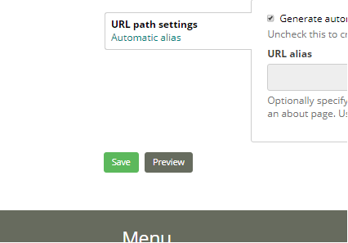

2.4 Once that is done, you can save your upload. Content that has been submitted will be reviewed by Technical Support Unit and published.

If you have further questions, please feel free to contact us

Annex 1: Template for uploading “policy support tools” and “policy instruments” click arrow to expand
Only elements marked with * are compulsory but please do give as much information as possible regarding the other elements.

Title*
Include a title to your tool/instrument. Please avoid the use of abbreviations and acronyms unless these are extensively used and widely known.

Access section*
Select “Creator”.
Policy Instrument or Policy Support Tool? *
Policy instruments are interventions by which policy and decision-making institutions attempt to achieve a desired policy objective for addressing a challenge or opportunity. They are the actions taken to protect nature and promote its sustainable use at local, national, regional and global levels.
Policy support tools are approaches based on science and other knowledge systems, which can inform, assist, and enhance the development and implementation of policy instruments. These policy tools are designed to guide the instrument actions taken.

Category of policy instruments or family of policy support tools *
When uploading a policy instrument, please select all the relevant category/ies that apply:
Category of policy instruments
- Legal and Regulatory Instruments
- Rights-Based Instruments and Customary Norms
- Economic and Financial Instruments
- Social and Cultural Instruments

When uploading a policy support tool, please select all the relevant family/ies that apply:
Family of policy support tools
- Assembling data and knowledge (including monitoring)
- Public discussion, involvement and participatory process
- Selection and design of policy instruments
- Implementation, outreach and enforcement
- Assessment and evaluation
- Training and capacity building
- Social learning, innovation and adaptive governance

Description of resource
Summary of the resource* Please write a short summary describing the policy support tool or instrument you are uploading. Please mention the type of material you are uploading, and explain briefly how it works/what is contains. Max 800 characters.

Aim of the resource Please briefly state the objective of the specific resource. What was the resource developed for? Maximum 800 characters.

Scale of application: Please select all that apply.
- Global
- Regional
- Sub-regional
- National
- Subnational
- Local
- N/A

Contact details
Contact Name (Person or group/organization)*: Please fill in the details for any main organization/person that has known expertise in the tool/instrument. A maximum of 3 allowed.
Email*
Website: Specify the website of the relevant institution for this product.
Phone number: Telephone number of the contact person including country code and without spaces e.g. +4915157526422. Max length: 15 characters.
Photo or Logo: Allowed file extensions: png, gif, jpg, jpeg. Maximum 1 image. Max file size 2MB.

The following three sections are relevant tags which will help users to refine their searches¹. These options can all be selected under the search bar.

Related Nature’s Contributions to People: ‘Nature’s contributions to people’ refer to all the contributions, both positive and negative, of nature to good quality of life for individuals, communities, societies, nations or humanity as a whole — in rural and urban settings. An explanation of each category can be found here. Please select all that apply to the specific resource you are uploading.
- Energy
- Food and feed
- Formation, protection and decontamination of soils and sediments
- Habitat creation and maintenance
- Learning and inspiration
- Maintenance of options
- Materials and assistance
- Medicinal, biochemical and genetic resources
- Physical and psychological experiences
- Pollination and dispersal of seeds and other propagules
- Regulation of air quality
- Regulation of climate
- Regulation of freshwater and coastal water quality
- Regulation of freshwater quantity, location and timing
- Regulation of hazards and extreme events
- Regulation of ocean acidification
- Regulation of organisms detrimental to humans
- Supporting identities

Related Aichi Biodiversity Targets and Sustainable Development Goals*: Please select all that apply.
- ABT 1. Awareness of biodiversity values
- ABT 2. Integration of biodiversity values
- ABT 3. Incentives
- ABT 4. Sustainable production and consumption
- ABT 5. Habitat loss, fragmentation and degradation
- ABT 6. Sustainable exploitation of aquatic resources
- ABT 7. Sustainable agriculture, forestry and aquaculture
- ABT 8. Pollution reduction
- ABT 9. Invasive alien speciesrelated
- ABT 10. Coral reefs and other vulnerable ecosystems
- ABT 11. Protected areas
- ABT 12. Threatened species
- ABT 13. Genetic diversity of crops, animals and wild relatives
- ABT 14. Ecosystem services
- ABT 15. Climate change and resilience
- ABT 16. Access and benefit sharing
- ABT 17. National biodiversity strategies and action plans
- ABT 18. Traditional knowledge and customary use
- ABT 19. Knowledge, science and technologies
- ABT 20. Mobilization of financial resources
- SDG1. No poverty
- SDG2. Zero hunger
- SDG3. Good health and well-being
- SDG4. Quality education
- SDG5. Gender equality
- SDG6. Clean water and sanitation
- SDG7. Affordable and clean energy
- SDG8. Decent work and economic growth
- SDG9. Industry, innovation and infrastructure
- SDG10. Reduced inequalities
- SDG11. Sustainable cities and communities
- SDG12. Responsible consumption and production
- SDG13. Climate action
- SDG14. Life below water
- SDG15. Life on land
- SDG16. Peace, justice and strong institutions
- SDG17. Partnerships for the goals

Related realm: Please select all that apply.
- Coastal and marine
- Freshwater
- Terrestrial
THEN, BASED ON THE COMPLETED INFO, PEOPLE WOULD STILL HAVE THE POSSIBILITY OF SELECTING UNITS OF ANALYSIS:
Related terrestrial and aquatic units of analysis: Please select all that apply.
- Coastal Habitats/Coastal and Near shore Marine/inshore ecosystems
- Cultivated areas (incl. cropping, aquaculture, intensive livestock farming, etc.)
- Drylands and Desert
- Heathlands, scrubs and tundra (e.g. Mediterranean scrublands, tundra)
- Inland Surface Waters and Water Bodies/Freshwater - rivers, lakes and estuaries
- Marine/Deepwater/Offshore systems
- Savannas and Grasslands (e.g. xeric grasslands, alpine meadows)
- Temperate and boreal forests and woodlands
- Tropical and subtropical dry and humid forests
- Urban/Semi-urban
- Wetlands – peatland, mires, bogs

Sub/region where used: Please select all that apply.
- Antarctica
- Caribbean
- Central Africa
- Central Asia
- Central and Western Europe
- East Africa and adjacent islands
- Eastern Europe
- Mesoamerica
- North Africa
- North America
- North-East Asia
- Oceania
- South America
- South Asia
- South-East Asia
- Southern Africa
- West Africa
- Western Asia
- N/A

Related content Please note, you can only select resources that have already been entered into the catalogue. If a resource is missing, please consider adding it.
Policy instruments or policy support tools: Please select any related policy instruments and/or policy support tools from our database.
Related experts: Please select anyone the policy instrument or policy support tool is related to from our database of experts. Please note, you can only select experts who have user accounts on this website.

Images
Please upload a maximum of 1 image that are relevant to your resource and will serve to identify it.
Files must be less than 100 MB. Allowed file types: png gif jpg jpeg.

UN languages in which the resource is available: Please select the official languages of the United Nations in which the product is available. For other languages, please specify them in the box “other language”.

Other languages in which the resource is available: Please select all that apply

----Do you want to add more details?

Requirements for using the resource: Please inform users of any prerequisite needed to use the resource (specific dataset, skill, training course etc.). If you have resources that would help answer those requirements, please upload them in the “resources” section down below.

Potential benefits and limitations from using the resource: Please list up to 5 potential benefits and 5 limitations. Please use separate line for each. Max length is 255 characters per line.

Assessment of effectiveness of the tool or instrument: Please summarise here the outcome of any assessment of effectiveness the resource has been subject to. If you have resources that assessed effectiveness, please note them here and upload them in the “resources” section below.

Date of publication/creation of the resource: If your resource is only applicable within a certain time frame, please give this information here.

Is the resource freely available?
- Yes
- No

Related resources (supporting resources)
Please upload all resources relevant to your resource (including suggested literature).
Title: Please add the title for the related resource be identified with.
Author: Please reference the author of the attached resource.
DOI reference: DOI stands for Digital Object Identifier. A DOI is a unique persistent identifier for a published digital object, such as an article or a study.
Upload or select existing file – Add new file: Allowed file extensions: doc, docx, pdf. Maximum file size: 50 MB. Maximum of 3 documents is allowed.
Video embed: File uploads of videos is not allowed. Please upload the video to YouTube or Vimeo and paste the URL from YouTube or Vimeo here.
Links: Please add any relevant links such as the project website, relevant data sets, dedicated forums, etc. A maximum of 3 links is allowed. Use "Title" feed to identify the resource.

Revision information
Revision log message: If you are updating this resource, please provide an explanation of the changes you are making. This will help other authors understand your motivations.

Moderation state: Set the moderation state for this content. If you are happy with the information you have uploaded and think that your resource is ready to be published, please change the moderation state from “Draft” to “Needs Review”.

Annex 2: Template for uploading “case studies” click arrow to expand
Only elements marked with * are compulsory but please do give as much information as possible regarding the other elements.

Title*

Include a title for your case study. Please avoid the use of abbreviations and acronyms unless these are extensively used and widely known.

Access section*
Select “Creator”.

Summary*
Please write a short summary of the case study. Max 800 characters.

Countries*
Please select the country/countries in which the case study was conducted.

Note
Please do not fill in this box.

Image
Upload illustrative teaser image of the case study here. Maximum of 1 image allowed. Files must be less than 100 MB. Allowed file types: png gif jpg jpeg.

Contact details
Contact Name (Person or group/organization)*: Please fill in the details for any main organization/person that has known expertise in the case study. A maximum of 3 allowed.
Email*
Website: Specify the website of the relevant institution for this case study.
Logo: Allowed file extensions: png, gif, jpg, jpeg. Maximum 1 image. Max file size 2MB.

UN languages in which the resource is available: Please select the official languages of the United Nations in which the product is available. For other languages, please specify them in the box “other language”.

Other languages: Please select all that apply

Related Nature’s Contributions to People: ‘Nature’s contributions to people’ refer to all the contributions, both positive and negative, of nature to good quality of life for individuals, communities, societies, nations or humanity as a whole — in rural and urban settings. An explanation of each category can be found here. Please select all that apply.
- Energy
- Food and feed
- Formation, protection and decontamination of soils and sediments
- Habitat creation and maintenance
- Learning and inspiration
- Maintenance of options
- Materials and assistance
- Medicinal, biochemical and genetic resources
- Physical and psychological experiences
- Pollination and dispersal of seeds and other propagules
- Regulation of air quality
- Regulation of climate
- Regulation of freshwater and coastal water quality
- Regulation of freshwater quantity, location and timing
- Regulation of hazards and extreme events
- Regulation of ocean acidification
- Regulation of organisms detrimental to humans
- Supporting identities

Related Aichi Biodiversity Targets and Sustainable Development Goals*. Please select all that apply.
- ABT 1. Awareness of biodiversity values
- ABT 2. Integration of biodiversity values
- ABT 3. Incentives
- ABT 4. Sustainable production and consumption
- ABT 5. Habitat loss, fragmentation and degradation
- ABT 6. Sustainable exploitation of aquatic resources
- ABT 7. Sustainable agriculture, forestry and aquaculture
- ABT 8. Pollution reduction
- ABT 9. Invasive alien species
- ABT 10. Coral reefs and other vulnerable ecosystems
- ABT 11. Protected areas
- ABT 12. Threatened species
- ABT 13. Genetic diversity of crops, animals and wild relatives
- ABT 14. Ecosystem services
- ABT 15. Climate change and resilience
- ABT 16. Access and benefit sharing
- ABT 17. National biodiversity strategies and action plans
- ABT 18. Traditional knowledge and customary use
- ABT 19. Knowledge, science and technologies
- ABT 20. Mobilization of financial resources
- SDG1. No poverty
- SDG2. Zero hunger
- SDG3. Good health and well-being
- SDG4. Quality education
- SDG5. Gender equality
- SDG6. Clean water and sanitation
- SDG7. Affordable and clean energy
- SDG8. Decent work and economic growth
- SDG9. Industry, innovation and infrastructure
- SDG10. Reduced inequalities
- SDG11. Sustainable cities and communities
- SDG12. Responsible consumption and production
- SDG13. Climate action
- SDG14. Life below water
- SDG15. Life on land
- SDG16. Peace, justice and strong institutions
- SDG17. Partnerships for the goals

Related realm: Please select all that apply.
- Coastal and marine
- Freshwater
- Terrestrial
----THEN, BASED ON THE COMPLETED INFO, PEOPLE WOULD STILL HAVE THE POSSIBILITY OF SELECTING UNITS OF ANALYSIS:
Related Terrestrial and aquatic units of analysis: Please select all that apply.
- Coastal Habitats/Coastal and Near shore Marine/inshore ecosystems
- Cultivated areas (incl. cropping, aquaculture, intensive livestock farming, etc.)
- Drylands and Desert
- Heathlands, scrubs and tundra (e.g. Mediterranean scrublands, tundra)
- Inland Surface Waters and Water Bodies/Freshwater - rivers, lakes and estuaries
- Marine/Deepwater/Offshore systems
- Savannas and Grasslands (e.g. xeric grasslands, alpine meadows)
- Temperate and boreal forests and woodlands
- Tropical and subtropical dry and humid forests
- Urban/Semi-urban
- Wetlands – peatland, mires, bogs

Related content Please note, you can only select resources that have already been entered into the catalogue. If a resource is missing, please consider adding it.
Tools and instruments*: Please select policy instruments and/or policy support tools that are used in the case study.
Assessments: Please select the assessments in which this case study has been discussed.
Experts: Please select the experts who have been involved in this case study. Please note, you can only select experts who have user accounts on this website.

Lesson learned*
Please give a short summary of the lessons learned from the case study regarding application of policy support tools and methodologies of relevance to support policy formulation and implementation.

Was the case study replicated somewhere else?
If so, please provide a short summary how and where.

Date in which the case study was carried out
Please give the date range during which the case study was conducted.

Date in which the case study was published
Please give the date range when the case study was published.

Related resources (supporting documents)
Please upload the document relevant to your case study.
Title:
Attach media: Allowed file extensions: doc, docx, pdf. Maximum file size: 50 MB

Scope: Sub/regions covered
NB. Please do not fill this in as the selection will be automatically done based on the countries you have selected above.

Revision information
Revision log message: If you are updating this resource, please provide an explanation of the changes you are making. This will help other authors understand your motivations.

Moderation state: Set the moderation state for this content. If you are happy with the information you have uploaded and think that your resource is ready to be published, please change the moderation state from “Draft” to “Needs Review”.

Annex 3: Template for uploading “capacity-building opportunities and resources” click arrow to expand
Only elements marked with * are compulsory but please do give as much information as possible regarding the other elements.

Title*

Include a title for the capacity-building opportunity. Please avoid the use of abbreviations and acronyms unless these are extensively used and widely known.

Access section*
Select “Creator”.

Summary of the capacity-building opportunity or resource*
Please write a short summary (max 800 characters) describing the capacity-building opportunity you are uploading. Please mention the type of material you are uploading, and explain briefly the aim of the resource. Please avoid the use of acronyms.

Capacity-building opportunity or resource type*. Select the relevant option(s) from those below.
- Document (e.g. guidance)
- Online (e.g. webinars, e-learning tools and other online approaches)
- In-person (e.g. advice, mentoring, trainer)
- Training courses
- Communities of practice

Curriculum, agenda

Please write down or upload a summary of content of the capacity-building opportunity.

Contact details
Contact Name (Person or group/organization)*: Please fill in the details for any main organization/person that has known expertise in the capacity building resource or opportunity. A maximum of 3 allowed.
Email*
Website: Specify the website of the relevant institution for this product.
Phone number: Telephone number of the contact person including country code and without spaces e.g. +4915157526422. Max length: 15 characters
Logo: Allowed file extensions: png, gif, jpg, jpeg. Maximum 1 image. Max file size 2MB.

Related Nature’s Contributions to People
‘Nature’s contributions to people’ refer to all the contributions, both positive and negative, of nature to good quality of life for individuals, communities, societies, nations or humanity as a whole — in rural and urban settings. An explanation of each category can be found here. Please select all that apply.
- Energy
- Food and feed
- Formation, protection and decontamination of soils and sediments
- Habitat creation and maintenance
- Learning and inspiration
- Maintenance of options
- Materials and assistance
- Medicinal, biochemical and genetic resources
- Physical and psychological experiences
- Pollination and dispersal of seeds and other propagules
- Regulation of air quality
- Regulation of climate
- Regulation of freshwater and coastal water quality
- Regulation of freshwater quantity, location and timing
- Regulation of hazards and extreme events
- Regulation of ocean acidification
- Regulation of organisms detrimental to humans
- Supporting identities

Related Aichi Biodiversity Targets and Sustainable Development Goals*. Please select all that apply.
- ABT 1. Awareness of biodiversity values
- ABT 2. Integration of biodiversity values
- ABT 3. Incentives
- ABT 4. Sustainable production and consumption
- ABT 5. Habitat loss, fragmentation and degradation
- ABT 6. Sustainable exploitation of aquatic resources
- ABT 7. Sustainable agriculture, forestry and aquaculture
- ABT 8. Pollution reduction
- ABT 9. Invasive alien species
- ABT 10. Coral reefs and other vulnerable ecosystems
- ABT 11. Protected areas
- ABT 12. Threatened species
- ABT 13. Genetic diversity of crops, animals and wild relatives
- ABT 14. Ecosystem services
- ABT 15. Climate change and resilience
- ABT 16. Access and benefit sharing
- ABT 17. National biodiversity strategies and action plans
- ABT 18. Traditional knowledge and customary use
- ABT 19. Knowledge, science and technologies
- ABT 20. Mobilization of financial resources
- SDG1. No poverty
- SDG2. Zero hunger
- SDG3. Good health and well-being
- SDG4. Quality education
- SDG5. Gender equality
- SDG6. Clean water and sanitation
- SDG7. Affordable and clean energy
- SDG8. Decent work and economic growth
- SDG9. Industry, innovation and infrastructure
- SDG10. Reduced inequalities
- SDG11. Sustainable cities and communities
- SDG12. Responsible consumption and production
- SDG13. Climate action
- SDG14. Life below water
- SDG15. Life on land
- SDG16. Peace, justice and strong institutions
- SDG17. Partnerships for the goals

Countries
Please select the country/countries from which the capacity-building resource or opportunity originates.

Scope: Sub/regions covered
NB. Please do not fill this in as the selection will be automatically done based on the countries you have selected above.

Related content Please note, you can only select resources that have already been entered into the catalogue. If a resource is missing, please consider adding it.
Policy instruments and policy support tools*: Please select any other policy instruments and/or policy support tools that are related to this capacity-building opportunity or resource from our database.
Case studies: Please select any case studies related to the capacity-building opportunity or resource from our database.
Assessments: Please select any assessments related to the capacity-building opportunity or resource from our database.

Image
Please upload a maximum of 1 image relevant to your capacity-building opportunity or resource.

Practical information
Is the capacity-building opportunity or resource freely available?
- Yes
- No

Requirements to use the capacity-building opportunity or resource: Please inform users of any prerequisite needed to use the capacity-building opportunity or resource (specific dataset, skill, previous training course etc.). Max 400 characters. If you have resources that would help answer those requirements, please note them here and upload them in the “resources” section down below.

UN languages in which this resource is available: Please select the official languages of the United Nations in which the learning opportunity is available.

Other languages in which this resource is available

Date (if applicable)
Please give the start date of the capacity-building opportunity, and the end date if it has already taken place.

Related resources (supporting documents)
Title: Add title of the related resource. This will be the title for the resource to be identified with.
Upload – Add new file: Please upload all resources relevant to your capacity-building opportunity or resource. Allowed file extensions: doc, docx, pdf, jpeg, png, jpg. Files must be less than 100 MB.
Video embed: File uploads of videos is not allowed. Please upload the video to YouTube or Vimeo and paste the URL from YouTube or Vimeo. Only one video is allowed.

Revision information
Revision log message: If you are updating this resource, please provide an explanation of the changes you are making. This will help other authors/reviewers understand your motivations.

Moderation state: Set the moderation state for this content. If you are happy with the information you have uploaded and think that your resource is ready to be published, please change the moderation state from “Draft” to “Needs Review”.

Annex 4: Template for uploading “assessments” click arrow to expand
Only elements marked with * are compulsory but please do give as much information as possible regarding the other elements.

Title*

Include a title for your assessment. Please avoid the use of abbreviations and acronyms unless these are extensively used and widely known.

Access section*
Select “Creator”.

Summary*
Please give a summary of the assessment.

Scope: sub/region covered*: Please select all that apply.
- Antarctica
- Caribbean
- Central Africa
- Central Asia
- Central and Western Europe
- East Africa and adjacent islands
- Eastern Europe
- Mesoamerica
- North Africa
- North America
- North-East Asia
- Oceania
- South America
- South Asia
- South-East Asia
- Southern Africa
- West Africa
- Western Asia

Deliverables
Please select the relevant deliverable(s) for this assessment. This only applies to IPBES products.
Related Nature’s Contributions to People: ‘Nature’s contributions to people’ refer to all the contributions, both positive and negative, of nature to good quality of life for individuals, communities, societies, nations or humanity as a whole — in rural and urban settings. An explanation of each category can be found here. Please select all that apply.
- Energy
- Food and feed
- Formation, protection and decontamination of soils and sediments
- Habitat creation and maintenance
- Learning and inspiration
- Maintenance of options
- Materials and assistance
- Medicinal, biochemical and genetic resources
- Physical and psychological experiences
- Pollination and dispersal of seeds and other propagules
- Regulation of air quality
- Regulation of climate
- Regulation of freshwater and coastal water quality
- Regulation of freshwater quantity, location and timing
- Regulation of hazards and extreme events
- Regulation of ocean acidification
- Regulation of organisms detrimental to humans
- Supporting identities

Related Aichi Biodiversity Targets and Sustainable Development Goals*. Please select all that apply.
- ABT 1. Awareness of biodiversity values
- ABT 2. Integration of biodiversity values
- ABT 3. Incentives
- ABT 4. Sustainable production and consumption
- ABT 5. Habitat loss, fragmentation and degradation
- ABT 6. Sustainable exploitation of aquatic resources
- ABT 7. Sustainable agriculture, forestry and aquaculture
- ABT 8. Pollution reduction
- ABT 9. Invasive alien species
- ABT 10. Coral reefs and other vulnerable ecosystems
- ABT 11. Protected areas
- ABT 12. Threatened species
- ABT 13. Genetic diversity of crops, animals and wild relatives
- ABT 14. Ecosystem services
- ABT 15. Climate change and resilience
- ABT 16. Access and benefit sharing
- ABT 17. National biodiversity strategies and action plans
- ABT 18. Traditional knowledge and customary use
- ABT 19. Knowledge, science and technologies
- ABT 20. Mobilization of financial resources
- SDG1. No poverty
- SDG2. Zero hunger
- SDG3. Good health and well-being
- SDG4. Quality education
- SDG5. Gender equality
- SDG6. Clean water and sanitation
- SDG7. Affordable and clean energy
- SDG8. Decent work and economic growth
- SDG9. Industry, innovation and infrastructure
- SDG10. Reduced inequalities
- SDG11. Sustainable cities and communities
- SDG12. Responsible consumption and production
- SDG13. Climate action
- SDG14. Life below water
- SDG15. Life on land
- SDG16. Peace, justice and strong institutions
- SDG17. Partnerships for the goals

Related realm: Please select all that apply.
- Coastal and marine
- Freshwater
- Terrestrial
THEN, BASED ON THE COMPLETED INFO, PEOPLE WOULD STILL HAVE THE POSSIBILITY OF SELECTING UNITS OF ANALYSIS:
Related Terrestrial and aquatic units of analysis: Please select all that apply.
- Coastal Habitats/Coastal and Near shore Marine/inshore ecosystems
- Cultivated areas (incl. cropping, aquaculture, intensive livestock farming, etc.)
- Drylands and Desert
- Heathlands, scrubs and tundra (e.g. Mediterranean scrublands, tundra)
- Inland Surface Waters and Water Bodies/Freshwater - rivers, lakes and estuaries
- Marine/Deepwater/Offshore systems
- Savannas and Grasslands (e.g. xeric grasslands, alpine meadows)
- Temperate and boreal forests and woodlands
- Tropical and subtropical dry and humid forests
- Urban/Semi-urban
- Wetlands – peatland, mires, bogs

Contact details
Contact Name (Person or group/organization)*: Please fill in the details for any main organization/person that has known expertise in the assessment. A maximum of 3 allowed.
Email*
Website: Specify the website of the relevant institution for this assessment.
Logo: Allowed file extensions: png, gif, jpg, jpeg. Maximum 1 image. Max file size 2MB.

Images
Upload illustrative teaser image of the assessment here. Maximum of 1 image allowed. Files must be less than 100 MB. Allowed file types: png gif jpg jpeg.

Related content Please note, you can only select resources that have already been entered into the catalogue. If a resource is missing, please consider adding it.
Policy instruments and policy support tools: Please select any policy instruments and policy support tools discussed in this assessment from our database
Case studies: Please select case studies that are discussed in this assessment from our database.

Frequency
Please select the frequency at which this assessment is carried out.

Lesson learned
Please give a short summary of the lessons learned from the assessment regarding methods and process of relevance to support policy formulation and implementation.

Mandate
Please give a short description of the mandate for carrying out this assessment.

Peer Review
Please briefly explain if the assessment went through a peer review process.

Temporal coverage of the assessment
Please give the date range during which the assessment was conducted/will be completed.

Related resources (supporting documents)
Please upload the document relevant to your assessment.
Title: Please add the title for the related resource be identified with.
Attach media: Allowed file extensions: doc, docx, pdf. Maximum file size: 50 MB

UN languages in which the assessment is available: Please select the official languages of the United Nations in which the product is available. For other languages, please specify them in the box “other language”. Please select all that apply

Other languages in which the assessment is available: Please select all that apply

Revision information
Revision log message: If you are updating this resource, please provide an explanation of the changes you are making. This will help other authors understand your motivations.

Moderation state: Set the moderation state for this content. If you are happy with the information you have uploaded and think that your resource is ready to be published, please change the moderation state from “Draft” to “Needs Review”.

The category ‘Sub/region covered’ below under ‘scope’ is also one of these tags.
The category ‘Sub/region covered’ below under ‘scope’ is also one of these tags.
The category ‘Sub/region covered’ below is also one of these tags.
The category ‘Sub/region covered’ below under ‘scope’ is also one of these tags.
The category ‘Sub/region covered’ below is also one of these tags.

