IPBES Catalogue of policy support tools and methodologies

Step by step guide to upload content

Step 1: Log in
1.1 Open the IPBES website https://www.ipbes.net/ In order to upload content you need to be signed in with your IPBES account.

1.2 If you are already registered, please log in and then go straight to step 1.3
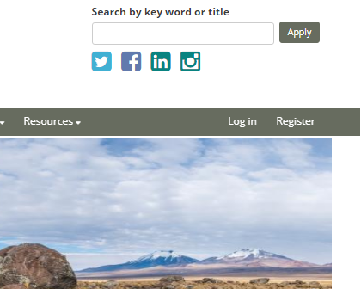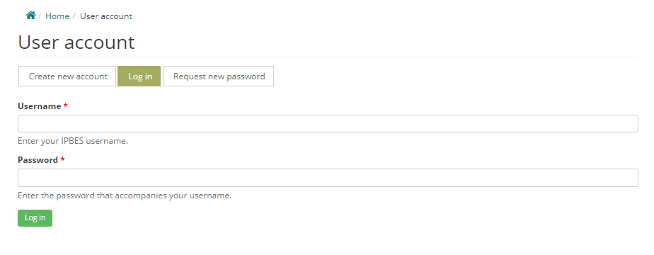

If you are not registered, please follow the Register link in IPBES home page https://www.ipbes.net/user/register
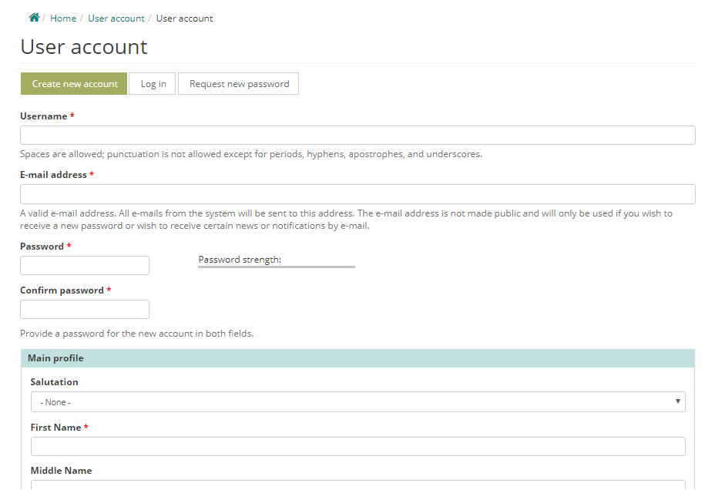

After following the link, please fill in the register form, and confirm your registration by clicking on the link in the email you will have received from secretariat@ipbes.net. If you cannot find the email, please check your spam folder.
1.3 Once you are signed in with your IPBES account, please follow this link to access the policy support portal

Step 2: What kind of resources to upload, and where?
First you should decide whether your resource is relevant to IPBES’ work and if so, under which section of the Catalogue it falls.

2.1 Is the resource relevant to IPBES?
Your resource should have the potential to support policy formulation and implementation in relation to biodiversity and ecosystems.

2.2 What kind of resource are you trying to upload?
The categories of resources that can be uploaded include:
- policy instruments
- policy support tools
- case studies – only if they are linked to a tool or instrument
- learning opportunities – only if they are linked to a tool or instrument

Policy Instruments: Policy instruments are means or techniques by which government/public authorities in local, national or international levels aim to achieve public policy objectives. In the context of IPBES, there are four categories of policy instruments:
- Legal and Regulatory Instruments: Laws and regulations developed by governments at different levels with the ultimate aim of enhancing the protection of the environment, the development of sustainable production systems, and enhancing human wellbeing.
- Rights-Based Instruments and Customary Norms: International and national human rights instruments whether binding or non-binding can be created to fit socio-ecological systems. Strengthening of collective rights, customary norms and institutions of indigenous peoples and local communities, can promote adaptive governance and fair management of natural resources.
- Economic and Financial Instruments: Economic and financial instruments can be used to change people’s behaviour towards desired policy objectives. E.g. subsidies, taxes, charges, fiscal transfers, environmental stewardship schemes.
- Social and Cultural Instruments: While linked to them, social instruments go beyond economic and financial instruments. E.g. awareness based voluntary interventions include information-related instruments (environmental education, eco-labelling, pollutant release and transfer registers, biodiversity registers, awareness raising); corporate social responsibility; and enhancement of collective action (e.g. indigenous peoples, local communities, and local resource users).

Policy Support Tools:
Policy support tools are means to help develop those schemes which aim to achieve desired policy objectives. In the context of IPBES, there are seven families of policy support tools.
- Assembling data and knowledge (including monitoring): Address knowledge gaps by providing data: E.g. databases, indicators, mapping of ecosystem services etc.
- Assessment and evaluation: Synthesize and assess existing knowledge relative to status, function, and drivers of nature, nature’s contributions to people, human well-being, and the connections between these. E.g. management effectiveness evaluations, scenarios, cost-benefit analysis etc.
- Public discussion, involvement and participatory process: Support discussion and deliberation, contribute to identifying problems and opportunities, setting joint goals and priorities, and meeting agreed objectives. E.g. stakeholder consultation, field observation, focused group discussion, mass media communication, and cultural mapping.
- Selection and design of policy instruments: Used for identification and evaluation of new and existing policies and institutional settings. They focus primarily on the choice and design of new and existing policies and their instruments. E.g. policy analysis, instrument impact evaluation, ex-ante evaluation of options and scenarios, policy mix analysis.
- Implementation, outreach and enforcement: Support the implementation of policy instruments such as laws, regulations, economic instruments and incentives. E.g. environmental and social safeguards, audits, process standards (e.g. ISO), monitoring, reporting and verification.
- Training and capacity building: Identify and/or address capacity gaps and shortfalls by enhancing the skills and capacity of relevant actors and organizations. E.g. handbooks, manuals, guides, e-learning resources, education, workshops, knowledge sharing.
- Social learning, innovation and adaptive governance: Aim to improve responsiveness, risk management and overall performance of the policy process while identifying opportunities to promote social learning and strengthening links and feedback mechanisms across elements and activities. E.g. collaborative networks, methodologies relating to adaptive governance.

Case studies:
Case studies are past or ongoing projects that illustrate the use of relevant tools and/or instruments.
They can only be uploaded if they are linked to a tool or instrument already included in the catalogue. Therefore, please ensure the relevant tool or instrument is already there or otherwise upload those first, and then add your case study.
Since case studies provide examples relating to the practical application of policy support tools or instruments, it is strongly encouraged that we have a variety of case studies for each of those. To the extent possible, please do bear this in mind when selecting the material to upload.

Learning opportunities:
Learning opportunities are means to help build the knowledge and skills necessary for the application of relevant tools and instruments. E.g. in-person and online training, massive open online courses (MOOCs), webinars.
Learning opportunities can only be uploaded if they are linked to a tool or instrument already included in the catalogue. Therefore, please ensure the relevant tool or instrument is already there or otherwise upload those first, and then add your learning opportunity.

Step 3: Uploading your resource
3.1 Once you identify the section of the Catalogue your resource belongs to, please follow the link to the type of resource (tool, instrument, case study, learning opportunity) you wish to upload. All types of resources can be uploaded following this link and selecting the relevant product type to upload. See the ‘about’ section of the website for information on which type of product you are uploading.

3.2 After following that link, please fill in the upload form to the best of your ability. Your resource will be significantly more helpful to users if you can complete as many of the aspects of this form as you can, not just the compulsory elements – in particular the relevant tags (‘Issues covered by global targets and IPBES deliverables’, ‘Related Nature’s Contribution to People and ‘Related Terrestrial and aquatic units of analysis’) and interlinkages with other related resources. Please do take the time to upload your resource properly.

Kindly note that each of the forms includes guidance for their completion. Compulsory elements are marked with “*”.
If you would like to see in detail the information included in each one of the forms, please see the relevant annex, as follows:
- Annex 1: Uploading Tools/Instruments
- Annex 2: Uploading Case studies
- Annex 3: Uploading Learning opportunities

3.3 Before saving your upload, we suggest that you preview it in order to verify that the information is displayed correctly.
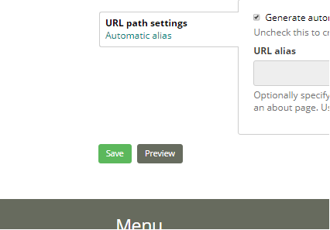

2.4 Once that is done, you can save your upload. Content that has been submitted will be reviewed by Technical Support Unit and published.

If you have further questions, please feel free to contact us

Annex 1: Template for Uploading Tools or Instruments
Only elements marked with * are compulsory but please do give as much information as possible regarding the other elements.

Title*
Include a title to your tool/instrument. Please avoid the use of abbreviations and acronyms unless these are extensively used and widely known.

Access section*
Select “Creator”.
Policy Tool or Policy instruments? *
Policy support tools refer to approaches based on science and other knowledge systems, which can inform, assist and enhance relevant development and implementation of policy instruments to better protect nature and promote its the sustainable use at local, national, regional and global levels.
Policy instruments are interventions by which policy and decision-making institutions attempt to realize or achieve a desired policy objective for addressing an identified challenge or opportunity

Family of support tools or category of policy instruments*
Information about which family of tool or instrument to select can be found in step 1 above, or here.

When uploading a policy instrument, please select all the relevant category/ies that apply:
Category of instruments
- Legal and Regulatory Instruments
- Rights-Based Instruments and Customary Norms
- Economic and Financial Instruments
- Social and Cultural Instruments

When uploading a policy support tool, please select all the relevant family/ies that apply:
Family of tools
- Assembling data and knowledge (including monitoring)
- Assessment and evaluation
- Public discussion, involvement and participatory process
- Selection and design of policy instruments
- Implementation, outreach and enforcement
- Training and capacity building
- Social learning, innovation and adaptive governance

Description of resource
Summary of the resource* Please write a short summary describing the tool or instrument you are uploading. Please mention the type of material you are uploading, and explain briefly how it works/what is contains. Max 800 characters.

Aim of the resource Please briefly state the objective of the specific resource. What was the resource developed for? Maximum 800 characters.
The following three sections are relevant tags which will help users to refine their searches¹. These options can all be selected under the search bar.

Issues covered by global targets and IPBES deliverables: Please select all that apply.
- Disaster risk reduction
- Education and public awareness
- Green infrastructure
- Habitat management (including restoration and resilience)
- Health and well-being
- Invasive alien species
- Management of genetic resources (including access and benefit-sharing)
- Mitigation of and adaptation to climate change
- Mobilization of financial, technological and human resources
- Poverty reduction
- Protected areas
- Reduced inequalities (including public access to environmental information and justice)
- Research, monitoring and indicators
- Species management
- Stakeholder engagement
- Sustainable agriculture, aquaculture and forestry
- Sustainable management of marine living resources
- Sustainable production and consumption
- Sustainable water management
- Traditional knowledge, innovations and practices

Related Nature’s Contributions to People: ‘Nature’s contributions to people’ refer to all the contributions, both positive and negative, of nature to good quality of life for individuals, communities, societies, nations or humanity as a whole — in rural and urban settings. Please select all that apply to the specific resource you are uploading.

- Energy
- Food and feed
- Formation, protection and decontamination of soils and sediments
- Habitat creation and maintenance
- Learning and inspiration
- Maintenance of options
- Materials and assistance
- Medicinal, biochemical and genetic resources
- Physical and psychological experiences
- Pollination and dispersal of seeds and other propagules
- Regulation of air quality
- Regulation of climate
- Regulation of freshwater and coastal water quality
- Regulation of freshwater quantity, location and timing
- Regulation of hazards and extreme events
- Regulation of ocean acidification
- Regulation of organisms detrimental to humans
- Supporting identities

Related Terrestrial and aquatic units of analysis: Please select all that apply.
- Coastal Habitats/Coastal and Near shore Marine/inshore ecosystems
- Cultivated areas (incl. cropping, aquaculture, intensive livestock farming, etc.)
- Drylands and Desert
- Heathlands, scrubs and tundra (e.g. Mediterranean scrublands, tundra)
- Inland Surface Waters and Water Bodies/Freshwater - rivers, lakes and estuaries
- Marine/Deepwater/Offshore systems
- Savannas and Grasslands (e.g. xeric grasslands, alpine meadows)
- Temperate and boreal forests and woodlands
- Tropical and subtropical dry and humid forests
- Urban/Semi-urban
- Wetlands – peatland, mires, bogs

Related content
Tools and instruments: Please check if the resource is related and can be linked to any other tools and/or instruments from our database.

Related experts: Please check if the resource is related and can be linked to anyone from our database of experts.

Images
Please upload a maximum of 3 images that are relevant to your resource and will serve to identify it.
Files must be less than 100 MB. Allowed file types: png gif jpg jpeg.

Using the resource
Requirements: Please inform users of any prerequisite needed to use the resource (specific dataset, skill, training course etc.). If you have resources that would help answer those requirements, please upload them in the “resources” section down below.

Advantages and Constraints: Please list up to 5 advantages and 5 constraints. Please use separate line for each. Max length is 255 characters per line.

Assessment of effectiveness of the tool/instrument: Please summarise here the outcome of any assessment of effectiveness the resource has been subject to.

Implementation time: Please select the time frame it would take for your resource to be implemented
- Less than one day
- Up to one week
- One week to one month
- Several months
- More than one year
- Not applicable

Scope
Sub/region covered: Please select all that apply.
- Antarctica
- Caribbean
- Central Africa
- Central Asia
- Central Europe
- East Africa and adjacent islands
- Eastern Europe
- Mesoamerica
- North Africa
- North America
- North-East Asia
- Oceania
- South America
- South Asia
- South-East Asia
- Southern Africa
- West Africa
- Western Asia
- Western Europe

Temporal coverage: If your resource is only applicable within a certain time frame, please give this information here.

Scale of application: Please select all that apply.
- Global
- Regional
- Sub-regional
- National
- Subnational
- Local
- N/A

Practical information
UN languages: Please select the official languages of the United Nations in which the product is available. For other languages, please specify them in the box “other language”.

Other languages: Please select all that apply

Development stage: Please inform users of the development stage of the resource.
- Full working product
- Early access
- Concept only

Price (if applicable)

License: Please inform users of the license this resource falls under.
- Creative Commons Attribution
- Creative Commons Attribution Share-Alike
- Creative Commons CCZero
- Creative Commons Non-Commercial (Any)
- GNU Free Documentation License
- License Not Specified
- Open Data Commons Attribution License
- Open Data Commons Open Database License (ODbL)
- Open Data Commons Public Domain Dedication and License (PDDL)
- Other (Attribution)
- Other (Non-Commercial)
- Other (Not Open)
- Other (Open)
- Other (Public Domain)
- UK Open Government License (OGL)
- Other

Contact details
Contact Name (Person or group/organization)*: Please fill in the details for any main organization/person that has known expertise in the tool/instrument. A maximum of 3 allowed.
Email*
Website: Specify the website of the relevant institution for this product.
Phone number: Telephone number of the contact person including country code and without spaces e.g. +4915157526422. Max length: 15 characters.
Photo or Logo: Allowed file extensions: png, gif, jpg, jpeg. Maximum 1 image. Max file size 2MB.

Resources
Please upload all resources relevant to your resource (including suggested literature).
Author: Please reference the author of the attached resource.
DOI reference: DOI stands for Digital Object Identifier. A DOI is a unique persistent identifier for a published digital object, such as an article or a study.
Upload or select existing file – Add new file: Allowed file extensions: doc, docx, pdf. Maximum file size: 50 MB. Maximum of 3 documents is allowed.
Video embed: File uploads of videos is not allowed. Please upload the video to YouTube or Vimeo and paste the URL from YouTube or Vimeo here.
Links: Please add any relevant links such as the project website, relevant data sets, dedicated forums, etc. A maximum of 3 links is allowed. Use "Title" feed to identify the resource.

Revision information
Revision log message: If you are updating this resource, please provide an explanation of the changes you are making. This will help other authors understand your motivations.

Moderation state: Set the moderation state for this content. If you are happy with the information you have uploaded and think that your resource is ready to be published, please change the moderation state from “Draft” to “Needs Review”.

Annex 2: Template for Uploading Case studies
Only elements marked with * are compulsory but please do give as much information as possible regarding the other elements.

Title*

Include a title for your case study. Please avoid the use of abbreviations and acronyms unless these are extensively used and widely known.

Access section*
Select “Creator”.

Summary
Please give a summary of the case study

Countries*
Please select the country/countries in which the case study was conducted.

Note
Please do not fill in this box.

Images
Upload illustrative teaser image of the case study here. Maximum of 3 images allowed. Files must be less than 100 MB. Allowed file types: png gif jpg jpeg.
The following three sections are relevant tags which will help users to refine their searches². These options can all be selected under the search bar.

Related Nature’s Contributions to People
‘Nature’s contributions to people’ refer to all the contributions, both positive and negative, of nature to good quality of life for individuals, communities, societies, nations or humanity as a whole — in rural and urban settings. Please select all that apply.
- Energy
- Food and feed
- Formation, protection and decontamination of soils and sediments
- Habitat creation and maintenance
- Learning and inspiration
- Maintenance of options
- Materials and assistance
- Medicinal, biochemical and genetic resources
- Physical and psychological experiences
- Pollination and dispersal of seeds and other propagules
- Regulation of air quality
- Regulation of climate
- Regulation of freshwater and coastal water quality
- Regulation of freshwater quantity, location and timing
- Regulation of hazards and extreme events
- Regulation of ocean acidification
- Regulation of organisms detrimental to humans
- Supporting identities

Related Terrestrial and aquatic units of analysis
Please select all that apply.
- Coastal Habitats/Coastal and Near shore Marine/inshore ecosystems
- Cultivated areas (incl. cropping, aquaculture, intensive livestock farming, etc.)
- Drylands and Desert
- Heathlands, scrubs and tundra (e.g. Mediterranean scrublands, tundra)
- Inland Surface Waters and Water Bodies/Freshwater - rivers, lakes and estuaries
- Marine/Deepwater/Offshore systems
- Savannas and Grasslands (e.g. xeric grasslands, alpine meadows)
- Temperate and boreal forests and woodlands
- Tropical and subtropical dry and humid forests
- Urban/Semi-urban
- Wetlands – peatland, mires, bogs

Issues covered by global targets and IPBES deliverables:
Please select all that apply.
- Disaster risk reduction
- Education and public awareness
- Green infrastructure
- Habitat management (including restoration and resilience)
- Health and well-being
- Invasive alien species
- Management of genetic resources (including access and benefit-sharing)
- Mitigation of and adaptation to climate change
- Mobilization of financial, technological and human resources
- Poverty reduction
- Protected areas
- Reduced inequalities (including public access to environmental information and justice)
- Research, monitoring and indicators
- Species management
- Stakeholder engagement
- Sustainable agriculture, aquaculture and forestry
- Sustainable management of marine living resources
- Sustainable production and consumption
- Sustainable water management
- Traditional knowledge, innovations and practices

Related content
Tools and instruments*: Please check if the resource is related and can be linked to any other tools and/or instruments from our database.
Experts: Select the experts who have been involved in this case study. You can only select experts who have user accounts on this website.

Lesson learned
Please give a short summary of the lesson learned from the case study regarding methods and strategy.

Potential impact
Please give a short summary of the potential impact the case study could have in supporting policy making.

Transferability
Please give a short summary of the transferability of the outputs from the case study.

Date
Please give the date range during which the case study was conducted.

Contact details
Contact Name (Person or group/organization)*: Please fill in the details for any main organization/person that has known expertise in the case study. A maximum of 3 allowed.
Email*
Website: Specify the website of the relevant institution for this case study.
Logo: Allowed file extensions: png, gif, jpg, jpeg. Maximum 1 image. Max file size 2MB.

Resources
Please upload the document relevant to your case study.
Attach media: Allowed file extensions: doc, docx, pdf. Maximum file size: 50 MB

Sub/region covered:
NB. Please do not fill this in as the selection will be automatically done based on the countries you have selected above.
Language: Please select the official languages of the United Nations in which the product is available. For other languages, please specify them in the box “other language”.
Other languages: Please select all that apply

Revision information
Revision log message: If you are updating this resource, please provide an explanation of the changes you are making. This will help other authors understand your motivations.

Moderation state: Set the moderation state for this content. If you are happy with the information you have uploaded and think that your resource is ready to be published, please change the moderation state from “Draft” to “Needs Review”.

Annex 3: Template for Uploading Learning opportunities
Only elements marked with * are compulsory but please do give as much information as possible regarding the other elements.

Title*

Include a title for the learning opportunity. Please avoid the use of abbreviations and acronyms unless these are extensively used and widely known.

Access section*
Select “Creator”.

Summary of resource*
Please write a short summary (max 800 characters) describing the learning opportunity you are uploading. Please mention the type of material you are uploading, and explain briefly the aim of the resource.

Curriculum, agenda
Please write down or upload a summary of content of the learning opportunity.
The following section is a relevant tag which will help users to refine their searches. These options can all be selected under the search bar.

Issues covered by global targets and IPBES deliverables
Please select all that apply.
- Disaster risk reduction
- Education and public awareness
- Green infrastructure
- Habitat management (including restoration and resilience)
- Health and well-being
- Invasive alien species
- Management of genetic resources (including access and benefit-sharing)
- Mitigation of and adaptation to climate change
- Mobilization of financial, technological and human resources
- Poverty reduction
- Protected areas
- Reduced inequalities (including public access to environmental information and justice)
- Research, monitoring and indicators
- Species management
- Stakeholder engagement
- Sustainable agriculture, aquaculture and forestry
- Sustainable management of marine living resources
- Sustainable production and consumption
- Sustainable water management
- Traditional knowledge, innovations and practices

Related content
Tools and instruments*: Please check if the resource is related and can be linked to any tools/instrument from our database.
Case studies: Please check if the resource is related and can be linked to any case studies from our database.

Learning opportunity type*
Select the relevant option from those below.
- Document
- Online
- In-person
- Webinar

Images
Please upload a maximum of 3 images relevant to your learning opportunity.

Practical information
Price (if applicable)
Requirements: Please inform users of any prerequisite needed to use the learning opportunity (specific dataset, skill, previous training course etc.). Max 400 characters. If you have resources that would help answer those requirements, please upload them in the “resources” section down below.
Languages: Please select the official languages of the United Nations in which the learning opportunity is available.
Other languages

Date (if applicable)
Please give the start date of the learning opportunity, and the end date if it has already taken place.

Contact details
Contact Name (Person or group/organization)*: Please fill in the details for any main organization/person that has known expertise in the learning opportunity. A maximum of 3 allowed.
Email*
Website: Specify the website of the relevant institution for this product.
Phone number: Telephone number of the contact person including country code and without spaces e.g. +4915157526422. Max length: 15 characters
Logo: Allowed file extensions: png, gif, jpg, jpeg. Maximum 1 image. Max file size 2MB.

Resources
Upload – Add new file: Please upload all resources relevant to the learning opportunity. Allowed file extensions: doc, docx, pdf, jpeg, png, jpg. Files must be less than 100 MB.
Video embed: File uploads of videos is not allowed. Please upload the video to YouTube or Vimeo and paste the URL from YouTube or Vimeo. Only one video is allowed.

Revision information
Revision log message: If you are updating this resource, please provide an explanation of the changes you are making. This will help other authors/reviewers understand your motivations.

Moderation state: Set the moderation state for this content. If you are happy with the information you have uploaded and think that your resource is ready to be published, please change the moderation state from “Draft” to “Needs Review”.

The category ‘Sub/region covered’ below under ‘scope’ is also one of these tags.
The category ‘Sub/region covered’ below is also one of these tags.

