UNITED  NATIONS |  |  | 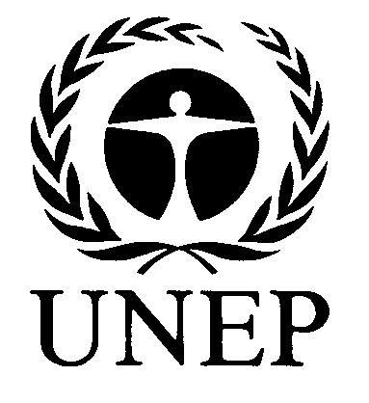 | 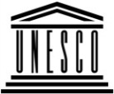 | 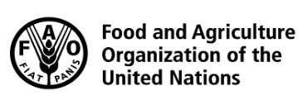 | 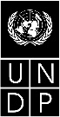 |  | BES
 |  |  |  |  |  |  | IPBES/5/INF/26
 |  | Intergovernmental Science-Policy Platform on Biodiversity and Ecosystem Services |  |  |  |  | Distr.: General  15 February 2017  English only
Plenary of the Intergovernmental Science-Policy
Platform on Biodiversity and Ecosystem Services
Fifth session
Bonn, Germany, 7–10 March 2017
Item 6 (a) of the provisional agenda*
Work programme of the Platform: capacity-building
Update on the implementation of the Biodiversity and Ecosystem Services Network and links with the work programme of the Intergovernmental Science-Policy Platform on Biodiversity and Ecosystem Services
Note by the secretariat
The annex to the present note sets out a report by the United Nations Development Programme on progress regarding the Biodiversity and Ecosystem Services Network and links with the work programme of the Intergovernmental Science-Policy Platform on Biodiversity and Ecosystem Services. The report is reproduced as received, without formal editing.

Annex
Update on the implementation of the Biodiversity and Ecosystem Services Network managed by the United Nations Development Programme and links with the work programme of the Intergovernmental Science-Policy Platform on Biodiversity and Ecosystem Services
Background on BES-Net
- The Biodiversity and Ecosystem Services Network (BES-Net) is a capacity sharing “network of networks” that promotes dialogue among science, policy and practice for more effective management of biodiversity and ecosystems, contributing to long-term human well being and sustainable development.
- The Network is supported by face-to-face capacity building activities (the BES-Net Trialogues), matchmaking activities, and a cutting-edge web portal - with all components mutually reinforcing. BES-Net facilitates and promotes dialogue on themes echoing the IPBES global assessments, and in key areas of UNDP’s work on biodiversity and ecosystems management.
- BES-Net is hosted by the United Nations Development Programme (UNDP) and is currently implemented through partnerships with the German Ministry for the Environment, Nature Conservation, Building and Nuclear Safety (BMUB) and SwedBio at the Stockholm Resilience Centre.
- Through BES-Net, UNDP contributes to the capacity building work of the Intergovernmental Platform for Biodiversity and Ecosystem Services (IPBES), in line with the call made in Busan1 for UNDP to support the capacity building work of IPBES, decision IPBES/2/5 (UN Collaborative Partnership Agreement for IPBES), decisions taken at IPBES-3, and decision IPBES-4/1- I on capacity building.
- BES-Net channels UNDP’s contributions to IPBES, harnesses UNDP’s capacity building expertise at the country level and capitalizes on the accumulated knowledge of best practices and challenges in the field. BES-Net also brings practitioners into the science-policy arena. UNDP’s commitment to supporting IPBES is set out in its biodiversity strategy, UNDP’s Biodiversity and Ecosystems Global Framework 2012-2020, which was approved by the UNDP Executive Group in September 2012.
- In implementing its mandate, BES-Net follows an inclusive approach, collaborating with relevant Multilateral Environmental Agreements, and drawing on the support of 85 partner organizations playing a key role in biodiversity and ecosystem services for sustainable development.
- The initial BES-Net strategy (IPBES/3/INF/19) was developed with inputs from multiple stakeholders in response to requests from Member States, in particular developing countries, and approved by the BES-Net Advisory Committee. The BES-Net Advisory Committee is composed of the BES-Net donors, the IPBES Secretariat, various IPBES groups and bodies (technical support unit for the capacity building task force), and other resource organisations, such as the secretariats of the CBD, and SGA Network. The co-chairs of the capacity building task force are kept informed of the Committee’s process and the other UN Agencies supporting the IPBES process have been invited as observers.
- In addition to managing BES-Net, UNDP provides technical backstopping on capacity building, contributing ideas and knowledge to the formulation of the IPBES work programme and its implementation in regions, and contributing to the task force on capacity building as a resource organisation.
BES-Net activities and links with the IPBES work programme
- BES-Net strives to support the needs of IPBES, in particular in terms of capacity building (deliverable 1(a)) and stakeholder engagement and communications (deliverable 4(d)).
- Discussions between UNDP and IPBES on how to refine the scope of their collaboration are on-going. In 2016, UNDP actively pursued this exchange with IPBES through face-to-face meetings, email exchanges and formal requests for feedback from the IPBES Bureau including on documents submitted to the two Bureau meetings held in 2016.
- In 2015, the following activities took place in coordination with the IPBES Secretariat, the IPBES task force on capacity building and its technical support unit and the expert group on policy support tools and methodologies on:
  - The prototype IPBES capacity building matchmaking facility (deliverable 1(a));
  - The prototype IPBES catalogue of policy support tools and methodologies (deliverable 4(c)); and
  - The development of dedicated webpages and online collaboration tools to support the coordination work of the IPBES Stakeholder Network.
- In 2016, implementation arrangements for IPBES evolved, the IPBES website has further developed and a new IPBES Capacity Building Rolling Plan was drafted. The scope of the UNDP/BES-Net and IPBES collaboration has therefore evolved to reflect the new IPBES needs.
- The BES-Net 2016 work plan has been adapted to reflect these changes and the following specific requests from IPBES to:
  - Remove mentioning of the IPBES Matchmaking facility on the BES-Net web-portal until it is re-conceptualized;
  - Remove the IPBES Stakeholder Network pages from the BES-Net web-portal;
  - Discontinue UNDP’s in-kind support to the further development of the IPBES Catalogue of Policy Support Tools and Methodologies, given that a new partner organization has been identified; and
  - Adapt the wording and content of the IPBES-related elements of the BES-Net
web-portal and of the BES-Net communication material accordingly, before its official launch during the CBD COP 12, held on 9 December 2016.
- IPBES has reiterated its interest in a strong collaboration on capacity building and in particular on the BES-Net Trialogues and on support to communities of practice, in the context of the newly developed IPBES Capacity Building Rolling Plan. IPBES has also expressed appreciation for the support that BES-Net provides in amplifying the work of IPBES and facilitating the uptake of its products.
- UNDP remains committed to support IPBES through BES-Net, which channels UNDP’s contributions to the Platform. BES-Net will, in particular promote the uptake of the IPBES thematic assessments through regional Trialogues, continue promoting the IPBES products and opportunities amongst its network of 85 Partners, and stands ready to continue its in-kind support to the implementation of the IPBES Capacity Building Rolling Plan. BES-Net hence proposes to:
  - Channel UNDP’s networks and expertise, including the NBSAP Forum and the Equator Initiative, which are already working closely with BES-Net;
  - Highlight the IPBES opportunities to contribute to the work of the platform on its matchmaking component, together with the opportunities of other partners, such as the CBD
Bio-Bridge Initiative;
  - Support the development of communities of practice, and promote and facilitate national and regional platforms and networks around IPBES, through the BES-Net Trialogues and their online support;
  - Support the uptake of IPBES products; and
  - Amplify IPBES’s work in terms of communication and stakeholder engagement among its partners.
BES-Net in-kind contributions to IPBES
- The BES-Net budget for 2014 was US$ 390,000.
- The total BES-Net budget for 2015 was US$ 516,000, covering UNDP staff time, consultants’ fees, travel and contractors, including the web design company, which developed the BES-Net
web-portal and the IPBES-related components and prototypes.
- In 2016, in-kind contributions from UNDP/BES-Net to IPBES amounted to USD 100,000 including provision of technical support to IPBES (in the areas of capacity development, communication, knowledge management and stakeholder engagement) and participation in
IPBES-related meetings. Further in-kind contributions to the IPBES process are provided by UNDP/BES-Net through BMUB funding, with a total value of USD 4,950,113 over the period
2016-2020, supporting deliverable 1(a) of the IPBES work programme. SwedBio at the Stockholm resilience supports IPBES through BES-Net with a total value of USD 180,000 for the period
2016-2018.
BES-Net 2016 highlights
Face-to-face Capacity Building Activities: the BES-Net Trialogues
- IPBES has highlighted that developing countries face issues in addressing pressing sustainable development questions due to a weak interface between science/traditional knowledge, policy and practice, and lack of trained national-level experts to conduct national level assessments and to integrate their findings into national policy and decision-making. Further, many countries still need support to contribute to the IPBES assessments and other deliverables and to make the most use of IPBES’s future products. This project responds to calls from developing countries for UNDP to play a role in capacity building for IPBES.
- Over the period 2016-2020, the German BMUB supports a project for « Supporting developing country capacity to address science-policy questions through IPBES via the UNDP managed Biodiversity and Ecosystem Services Network (BES-Net) and the UNEP-WCMC hosted Sub-Global Assessment Network (SGA Network).
- The project aims at supporting developing countries to address science-policy questions highlighted through IPBES, through:
  - Enhancing capacity at the national and regional levels to apply the findings of IPBES assessments. This is achieved through the UNDP-managed BES-Net capacity network hosting “Trialogue” events bringing together scientists, policy-makers and practitioners to address pressing development questions.
  - Providing technical and capacity building support to specific countries to conduct national assessments of scientific evidence on policy issues, complementing IPBES regional and thematic assessments – achieved through customized support to countries via centres of excellence and the SGA Network.
- The tools and methods used in this project will be captured and made available for replication across other countries and regions. They will be organised in two packages of capacity building support, one at the national level and one at the regional level. Multiplying effects will be enabled by the fact that participants to this project will belong to a global capacity building network allowing for knowledge and experience sharing, participate in national and regional multi-stakeholder dialogues, and provide input and feedback on their experience to the IPBES community.
- The project pilots a model at the national and regional levels to strengthen
science-policy-practice platforms to contribute to and benefit from IPBES. This includes linking national assessments and Trialogue events to IPBES global and thematic assessments, and communicating the outcome of the national and regional activities into the IPBES arena.
- UNDP will work in close partnerships with all the relevant IPBES bodies, in particular its capacity building task force, with IPBES national focal points and technical support units supporting the IPBES assessments to ensure the best capacity building support in the context of IPBES.
- In 2016, the methodology for the BES-Net Trialogues has been refined, together with a monitoring and evaluation framework, and a global BES-Net Trialogue facilitator is being recruited. Preparations are also well underway for the first Trialogue on Pollinators, Pollination and Food Production, supporting the uptake of the corresponding IPBES assessment and corresponding Summary for Policy Makers, released in 2016, in the Eastern European region.
Communication and Stakeholder Engagement
- The BES-Net communication and stakeholder engagement strategy has been developed and is being implemented, targeting the three BES-Net communities of policy, practice and knowledge holders/scientists. Key achievements include the dissemination of three newsletters, the setting up of social media accounts (4,400 page likes on Facebook in a month).
- The BES-Net web-portal (www.besnet.world) was successfully launched during the CBD COP 13, held on 9 December 2016, in Cancun, Mexico. The launch was received with overwhelming interest, with the video coverage of the launch by the IISD reporting Services being viewed by more than 10,000 people.
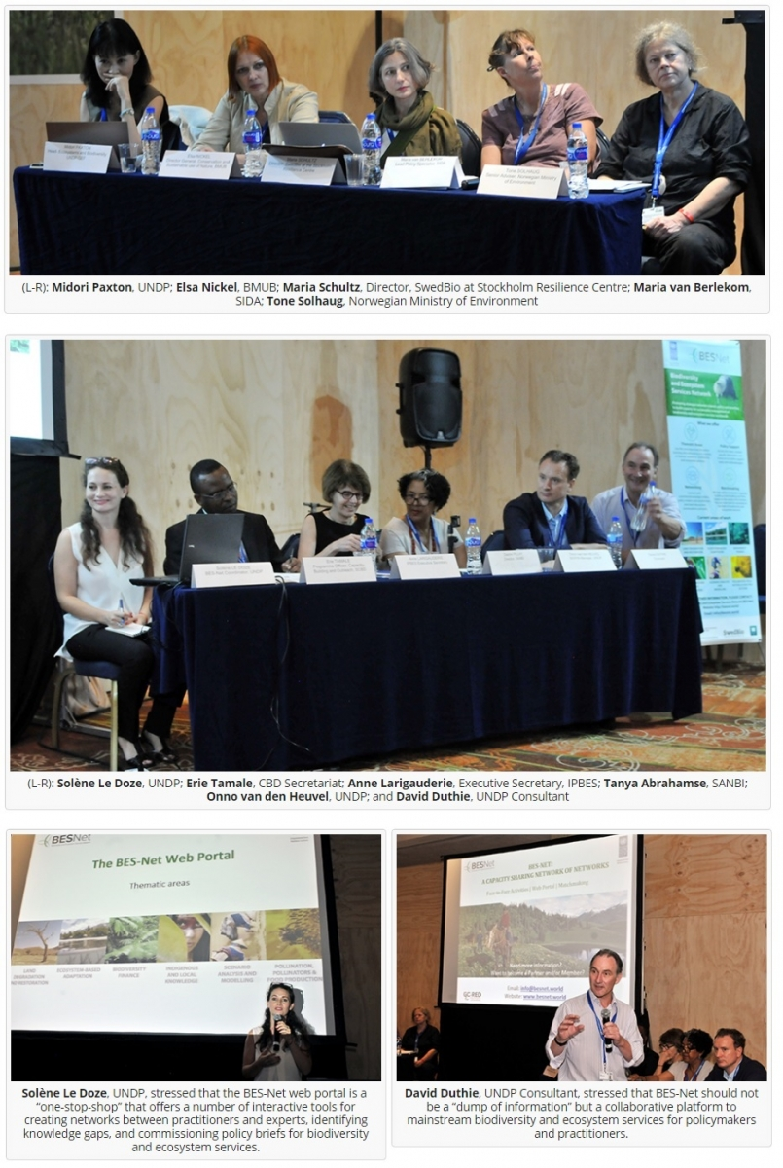
- In addition, the BES-Net team has developed and implements robust knowledge management and moderation protocols for its web-portal and had enhanced the features of the portal in 2016.
- The BES Network has been further developed, with 85 organizations playing a key role in the field of biodiversity and ecosystem services for sustainable development now being BES-Net Members, and 109 international experts – including experts involved in IPBES assessments- who agreed to respond to science/policy/practice questions from BES-Net web-portal users.
- Strategic discussions have been undertaken with key BES-Net Partners to refine collaboration, including with the CBD secretariat on the implementation of the Bio-Bridge Initiative and of the CBD’s short-term action plan (2017-2020) for capacity building.
- The BES-Net team also attended a number of key IPBES and other international events in 2016:
  - 15-19 February 2016, Bangkok, Thailand: Presentation of BES-Net at the ASEAN conference on Biodiversity 2016;
  - 10-11 February 2016, Washington DC, USA: Presentation and participation from
BES-Net at the Boundary Practitioners’ Meeting, organised by The Pew Charitable Trusts; Ocean Science Trust; Luc Hoffman Institute; WWF, Science and Resilience Institute @ Jamaica Bay;
  - 20 February 2016, Kuala Lumpur, Malaysia: Meeting with the IPBES Secretariat, some Members of the IPBES MEP and Bureau in the margins of IPBES-4, to discuss the interface between IPBES and BES-Net;
  - 21 February 2016, Kuala Lumpur, Malaysia: BES-Net presentation of BES-Net at the Stakeholder Days;
  - 22-27 February 2016, Kuala Lumpur, Malaysia: UNDP attends IPBES-4;
  - 24 February 2016, Kuala Lumpur, Malaysia: Inception meeting with countries identified for the capacity building support for national biodiversity and ecosystems assessments, was organised on the margins of the IPBES-4 meeting, together with donors and other countries undertaking national biodiversity and ecosystem assessments;
  - 27 February 2016, Kuala Lumpur, Malaysia: BES-Net Advisory Committee meeting;
  - 19-22 April 201, Budapest, Hungary: BES-Net attends the 4th IPBES Capacity Building Task Force meeting;
  - 5 May 2016, Bonn, Germany: bilateral meeting between the IPBES Secretariat and UNDP/BES-Net;
  - 20 June 2016, Cha-am, Thailand: BES-Net Presentation at the RCE Network of UNU;
  - 1-10 September 2016, Hawaii, USA: Participation from BES-Net to two side events during the IUCN World Conservation Congress (WCC) with IUCN/IPBES and with the CBD Secretariat on the Bio-Bridge Initiative;
  - 23 September 2016, New-York, USA: UNDP co-hosts the 2nd IPBES Capacity Building Forum,
  - 27-29 September 2016, Rabat, Morocco: BES-Net presents at the Presentation by BES-Net at the “Atelier de dialogue pour l’établissement de structures nationales pour l’IPBES dans les pays d’Afrique francophone” organized by the French Fondation pour la Recherche sur la Biodiversité in collaboration with OSS and NeFo;
  - 10 Nov 2016, Nairobi, Kenya: Presentation of BES-Net at the partners market place - a network of policy makers, academia and practitioners organised by CAP-Net;
  - 9 December 2016, Cancun, Mexico: Launch of the BES-Net web-portal during a side event at the CBD COP 13;
  - 6-9 December 2016, Cancun, Mexico: BES-Net presented and participated in three side event organised by the CBD Secretariat on the Bio-Bridge Initiative during the CBD COP 13.
Gender strategy
A BES-Net gender strategy has been developed and is being implemented through support from SwedBio at the Stockholm Resilience Centre.

* IPBES/5/1/Rev.1.

