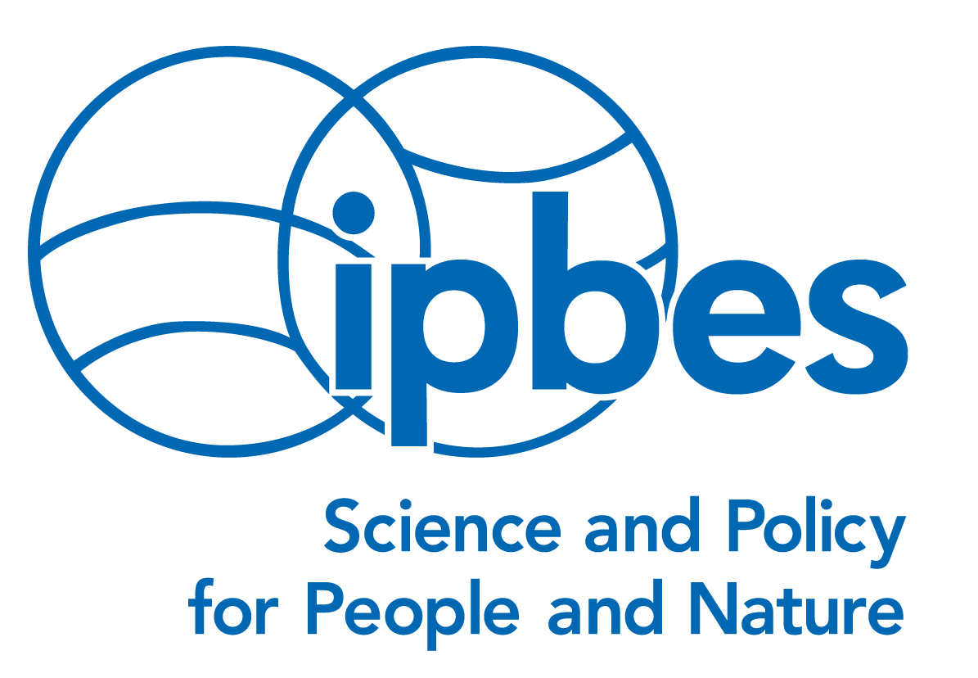 | 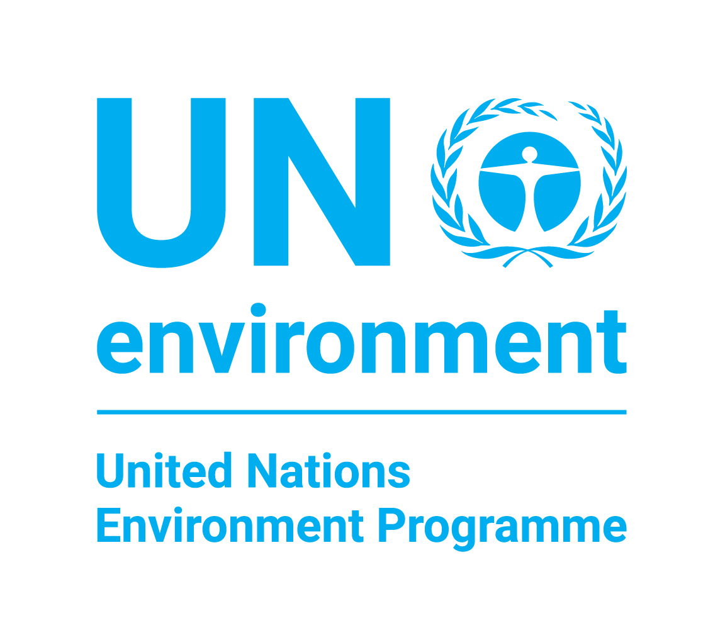 | 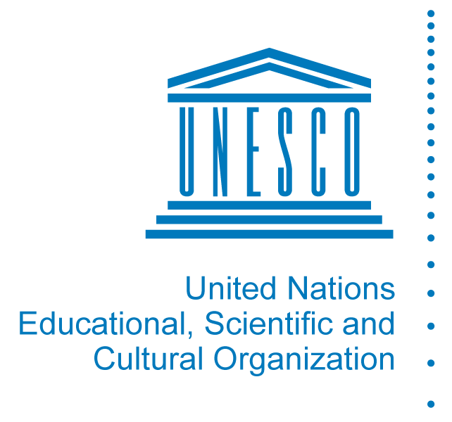 | 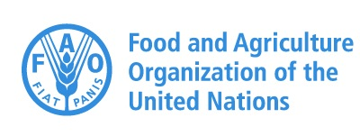 | 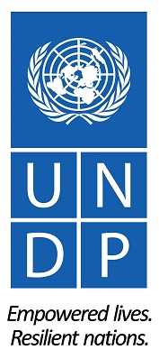
Stakeholder Day IPBES-5
27 March 2017
Venue: World Conference Center Bonn – Plenary Building,
Platz der Vereinten Nationen 2, 53113 Bonn, Germany.
http://www.worldccbonn.com/en.html

Report
Compiled by Günter Mitlacher, WWF, and Laurence Perianin, IUCN

Welcome to the Stakeholder Day
Carolyn Lundquist, National Institute of Water and Atmospheric Research of New Zealand (NIWA), and Günter Mitlacher, WWF, on behalf of the Open-ended Network of IPBES Stakeholders, opened the IPBES-5 Stakeholder Day and welcomed the 170 to 200 participants throughout the day. For the first time, the event was also broadcast live on the internet to enable the widest possible range of participants. This allowed nearly 900 additional participants from 27 countries to follow the presentations and discussions happening in the main meeting (discussions in breakout groups were not broadcast or recorded). A recording of the live stream is available at http://www.ipbes.net/ipbes-5-stakeholder-day .
The facilitators thanked the IPBES secretariat for inviting the Open-ended Network of IPBES Stakeholders to lead preparations for and to facilitate this event. It was noted that over the last months, excellent cooperation took place within the IPBES-5 Stakeholder Day organizing team, composed of the Network, IPBES secretariat and IUCN acting as IPBES secretariat support, which was set up to prepare this event (IPBES5stakeholderday@iucn.org).
The in-kind contributions from IUCN, NeFo, GIZ, and WWF for catering during breaks and lunch were acknowledged, along with the contribution of the IPBES secretariat for the meeting facilities, internet live streaming and the IISD coverage of the proceedings (IISD IPBES-5).
Then, participants were kindly invited to raise their hands to answer several questions to learn more about the audience:
- Regional presence: 7 came from Africa; 13 from the Americas (north-central-south); 12 from Asia and the Pacific; 3 from Australia / New Zealand; 28 from Europe (west-central-eastern).
- Attendance of IPBES Plenaries: 25 indicated it’s their first Plenary session; 20 were at IPBES-4 in Kuala Lumpur; 6 attended all Plenary sessions.
- Gender balance: 40 women and 30 men indicated their attendance.
- Affiliation: 22 indicated that they were from to scientific organizations and research institutes; 16 from universities; 12 from civil society organizations; 3 from indigenous people's groups; and 4 from business.
(Some participants arrived only after this discussion or did not participate when asked to raise their hands).

Morning session:
Update on the IPBES work programme, Stakeholder Engagement Strategy and Communication, and stakeholders’ activities in support of IPBES
Overview of progress on elements of the IPBES Work Programme and key topics for IPBES-5
IPBES Executive Secretary Anne Larigauderie underscored stakeholders’ role in disseminating and using IPBES publications and tools. She gave an overview of progress in implementing the IPBES work programme, key topics on the IPBES-5 agenda, and updates on the status of the various assessments.
Remarks from IPBES’ Chair
IPBES Chair Sir Robert Watson emphasized that the challenge for IPBES is to raise awareness that the importance of biodiversity and ecosystem services is on par with climate change regarding the future of the planet. He highlighted IPBES’ relevance in assessing progress towards achieving the Sustainable Development Goals (SDGs), the Convention on Biological Diversity (CBD) Aichi Biodiversity Targets and the goals of the Paris Climate Agreement. In response to questions from the floor, he agreed with the need to simplify the summaries for decision makers to be used by local stakeholders and governments, the private sector and civil society organisations.
Communication, outreach and stakeholder engagement
Robert Spaull, IPBES Secretariat, provided an update on the IPBES communication and outreach strategy and activities. He highlighted the role of stakeholders to help spread knowledge on IPBES’ work and the webcasting of the sessions to reach out and allow for the involvement of a broader audience of stakeholders.
Stakeholders’ activities in support of IPBES: examples within the Open-ended Network of IPBES Stakeholders
Co-facilitator Günter Mitlacher introduced the initiatives that different stakeholders have undertaken to disseminate IPBES’ work and to support stakeholder engagement.
Katja Heubach of GIZ (Deutsche Gesellschaft für Internationale Zusammenarbeit) reported on a ‘Guide to IPBES’ providing information on the platform’s four functions; the work programme 2014-2018; organisational structure, administration and financing; IPBES and the CBD; and opportunities to participate in the IPBES process. The guide was developed within the ValuES project, which is implemented by GIZ on behalf of the German Federal Ministry for the Environment, Nature Conservation, Building and Nuclear Safety (BMUB) with funds of the International Climate Initiative (ICI). The booklet was published in collaboration with the Network-Forum for Biodiversity Research Germany (NeFo, http://biodiversity.de) and is available in four languages: English, Spanish, French, and German (accessible at http://www.aboutvalues.net/ipbes/ ).
Malte Timpte of the Institute for Biodiversity Network, presented a ‘Guide to IPBES plenary meetings for new observers’, which was published by the Open-ended Network of IPBES Stakeholders (maltetimpte@googlemail.com ) with financial support of WWF.
Kristina Raab, Network-Forum on Biodiversity Research Germany (NeFo, http://biodiversity.de ) and Helmholtz-Centre for Environmental Research (UFZ), provided an overview of the Biodiversity Science-Policy Interfaces Network for Early Career Scientists (BSPIN), explaining that BSPIN aims to encourage the involvement of early career and young scientists in IPBES and other interfaces (http://www.biodiversity.de/en/bspin-earlycareer). BSPIN also held a workshop prior to IPBES-5 to this end. In addition, she informed about the fourth Pan-European IPBES Stakeholder Consultation (PESC-4), co-organised with France and Hungary to be held in Vácrátót, Hungary, from 12-14 June 2017 that will facilitate the involvement of stakeholders in IPBES’ work and activities in the region (http://www.fondationbiodiversite.fr/fr/fondation/evenements/divers.html).
Stakeholders’ activities in support of IPBES: examples from the room
The co-facilitators collected about 20 templates with initiatives from stakeholders and presented a few examples of such activities to the audience. All examples collected from the audience and through live streaming, which was facilitated by Laurence Perianin (IPBES liaison officer in IUCN acting as IPBES secretariat support), have been forwarded to the secretariat for the record and for further consideration.
Communication planning in preparation for the launch of the four Regional Assessments and the Assessment of Land Degradation and Restoration due to be finalized by IPBES-6 in 2018
Robert Spaull of IPBES secretariat outlined the various communication phases for the launch of the four Regional Assessments and the Assessment of Land Degradation and Restoration. As most important goals, he emphasized reaching a wider audience and ensuring and documenting the use and impacts of the reports.
Afternoon session:
Contributions of stakeholders to key IPBES-5 topics
In plenary meeting, Members of Technical Support Units (TSU), IPBES secretariat and stakeholders introduced four topics to be discussed in-depth in breakout groups, during two rounds of 45 min. Reports from the four breakout groups are presented below:
Topic 1: Deliverable 3c – Methodological assessment on scenarios and models of biodiversity and ecosystem services (IPBES/5/INF/2)
Stakeholders’ involvement in Phase II of deliverable 3c was presented by Carolyn Lundquist, NIWA, and Henrique Pereira, iDiv. The Survey of policy options for IPBES scenarios was introduced by Sylvia Karlsson-Vinkhuyzen, Wageningen University and Research, Jennifer Hauck, UFZ and CoKnow. Presenters explained that the assessment provides expert guidance on the use of scenarios and models to inform policy-making and decision-making in a variety of contexts, Phase II will further develop this aspect, and they suggested to focus discussions on, among other issues, the current use of scenarios and models for decision-making and the potential for future use.
Breakout group rapporteur Carolyn Lundquist, NIWA and facilitators Sylvia Karlsson-Vinkhuyzen, Wageningen University and Research, Jennifer Hauck, UFZ and CoKnow; Kristina Raab, NeFo and UFZ; Eefje den Belder & Tanya Lazarova, PBL Netherlands Environmental Assessment Agency reported the outcomes of the discussion as follows:
The IPBES Scenarios and Models Expert Group organised the session with the objective of receiving input for improving the usefulness and relevance of future scenarios and models for decision-makers across levels. Four groups with a total of about 40 participants discussed five topics and most (but not all) of the points raised are highlighted as follows:
1. Introduction of participants and their experience with scenarios
Participants included researchers but also government officials from national ministries, from state agencies (in federal countries), NGOs working with local governments, biodiversity NGOs and International Organisations. Many of the participants did not have experience with using scenarios but some examples included using climate models for disaster risk reduction and visioning exercises with local governments for biodiversity planning, as well as using scenarios in research. Those who had worked with scenario processes had experienced challenges in e.g. the diversity of values of stakeholders; the inability of models to link ecology with human well-being.
2. What policy and management options for scenarios and models should be tested or compared by the IPBES work on scenarios and models?
- How voluntary initiatives among stakeholders such as certification in production sectors impact on achieving the Aichi targets.
- Assess the combinations of policy options too, and see how the different combinations have an impact
- Trade-offs between policy options
- Education, awareness raising, and capacity building in formal and informal ways – working with educators
- Cross-scale approaches are needed, only policy-makers at the national level relate to the international targets
- Cross-sectoral policy-making/integrated policy-making across sectors (including scientists as a sector and boundary organizations) – use what is happening at the global level as inspiration for local level and vice versa
- Impact of different educational strategies on how people value biodiversity
3. Output options for scenarios
- Cultural values – how people value biodiversity at different levels
- Urbanization and its characteristics
- Energy-related measures - relevant for deforestation
- Ecotourism
- Public opinion – for politicians this really matters.
4. How could one expect the scenarios to be used in the future by decision-makers?
- To put the environment on the map
- Identify which policies would generate highest production values out of landscapes?
- Give message about possible futures for policy makers
- Scenarios that show policy-makers how to balance development with sustainability
- Help to meet government mandates and engage with other people.
- As a way to inform the public about actions that may result in various types of futures: scenarios can do this much better than presenting numbers or indicators.
5. What kinds of challenges and questions arise when working with scenarios and models?
- How to do scaling – up- and down-scaling?
- How to show the added value of scenarios and models for decision making?
Topic 2: Deliverable 3d - Scoping report on a methodological assessment on the diverse conceptualization of values (IPBES/5/6, IPBES/5/INF/12, IPBES/5/INF/13)
Members of the technical support unit (TSU) of deliverable 3d, David Gonzalez Jimenez, Patricia Balvanera Levy and Unai Pascual (MEP member), outlined the assessment’s purpose to support capturing different perspectives, preferences and world views on nature’s values. They explained that the assessment should not only identify diverse conceptualizations of values, but also develop ways for bridging between them, and stressed the need to learn how values are integrated into decision-making and to develop socio-economic indicators.
Breakout group rapporteur Katja Heubach, GIZ, and facilitators Rainer Schliep and Jonas Geschke, NeFo, summarized the discussions of the breakout group, which was attended by about 20 stakeholders, as follows:
1. Challenges discussed
- How to translate the different conceptualizations of values into practice?
- How to integrate weighting schemes into the values assessment?
- How to manage the integration of different values across levels (global to regional) and taking into account the heterogeneity of data underlying these values?
- Which dimensions of values are needed at which level and what does this mean with regard to data?
- The term ‘ecosystem service’ is already a kind of valuation – anthropocentric concept, originated in economics --> the IPBES multiple values concept and the Platform’s conceptual framework try to overcome the dominance of this concept
- ‘Benefits’ is also very often understood only in an economic sense; IPBES now calls ‘benefits’ ‘contributions’ – the word ‘contributions’ allows to measure and incorporate different values, perspectives and preferences; Contributions can be both positive and negative (e.g. Malaria would be a negative contribution of nature to people)
- Some countries do not understand the IPBES approach to values as it is included in the conceptual framework; there are countries with different cultures: they all have different ways of conceptualizing values
- Conceptualization of values is an evolution in itself
- Different types of values need to be translated into benefits more implicitly
- How to move from assessment/guide to practice? => meaning of values need to be translated and brought to society
- An institutional assessment could be helpful, as all assessments are about institutions and governance processes
- IPBES assessments are highly valued, as they provide a chance to compare previously made environmental impact assessments
2. Advantages and disadvantages in postponing the values assessment
- Participants felt that there could also be advantages in postponing the values assessment:
  - There are already a number of initiatives and discussions ongoing that could provide a rich base for the future work of the values assessment
  - A later start of the values assessment could allow for a better exchange of concepts and ideas between the different ongoing assessments
  - Review of TSU activities & challenges regarding the integration of values into assessments should be addressed beforehand
- Disadvantages might include
  - Losing momentum of the political interest in the topic by postponing the assessment
  - Work of the TSU is running well now, incl. its funding, which might not be the case in two years
  - There is already a pool of authors/experts that could take on the assessment challenge
3. Lessons learnt from IPCC
- Implicit value attachments in climate-related research (implicit normative judgments) – IPBES paper on multiple values published in COSUST addresses this issue: valuation is not a technical process alone but needs to account for implicit normative judgements
- IPCC uses the approach of “assessing alternative pathways” – be more explicit about the value dimension – explore implications of these different pathways
- How to bring the multiple values approach into practice and decision-making? Liaise with IPCC and other processes dealing with value approaches and methodologies
4. Task for the future values assessment:
- First identify data needs for the different conceptualizations of values and then identify the existing data gaps
- Include the monitoring aspect in the values assessment
- Establish collaboration between IPBES and IPCC on the issue
- Produce a guide on the translation of one conceptualization of values into another value system.
Topic 3: Deliverable 4e - Procedure for the review of the effectiveness of the administrative and scientific functions of the Platform
Thomas Koetz, IPBES secretariat, introduced the topic and explained that the 2019 review of the implementation of the first IPBES work programme should comprise both internal and external elements, the latter involving a review panel composed of 10 members. He underscored that stakeholders can contribute to the discussion of the terms of reference for such a review, including on criteria to be used for the evaluation, organisation of the review process, and the draft questionnaire to gather information.
Rapporteur Carsten Nesshöver, UFZ and facilitators Stefan Hotes, University of Marburg, and Marianne Darbi, UFZ, presented the results of the discussion:
About 25 stakeholders met to discuss agenda item 8 and document IPBES/5/11. The stakeholders present generally welcome the plan for the review of the platform. Following the invitation by Bureau, MEP and secretariat to comment on options of processes to implement the review, the stakeholders provide in the following some general comments on the document IPBES/5/11, specifically on the criteria for evaluating the Platform’s effectiveness, on the suggested option concerning the governance and structure of the review and its methods, and the draft questionnaire presented in the appendix of document IPBRS/5/11.

1. General comments:
- The main aim of the review is to inform the development of the second work programme. Therefore the currently proposed timing of the final external review (to be presented at IPBES-7 in 2019 – the plenary which, according to document IPBES/5/12, would also decide on the new work programme) makes this key aim impossible and strongly undermines the credibility of IPBES. The external review of the platform should be available at least one plenary before the second work programme is finally discussed and adopted. As the external review will need two years to be properly carried out, this might mean delaying the setup of the second work programme to IPBES-8.
- As the proposed review process is a mixture of an internal and external activity, it should be ensured that the external part is as independent as possible from all governance bodies of IPBES and the work and recommendations of the internal review.
- The review process and especially the external review panel should be enabled to make substantial use of the set of foreseen methods, including those that include personal interactions (interviews, focus groups). This might need more substantial financial support for these elements than currently foreseen.
2. Objectives of the review (document IPBES/5/11, Annex, paragraph 3)
- In general, the stakeholders would like to highlight that the term “effectiveness” is not explicitly defined in the context of the review and thus gives room for interpretation. The stakeholders would like to highlight that evaluating the effectiveness needs to consider various functions under all four objectives of the platform in the review.
- The criteria as currently set out are missing an element that explicitly reflects the policy relevance and impact of the platform. This should be reflected by an additional point (g), since it is also reflected in the draft questionnaire
- As for point (a), it should be made clear that the review includes a reflection on the relative budget allocations across the four functions
- As for point (e), this should explicitly include the interactions between the different task forces and expert groups
- Also, it should be ensured that the implementation of the Stakeholder Engagement Strategy is part of the review
3. Institutional structure (document IPBES/5/11, Annex, III.B. External element)
- Paragraph 7 & 8: Conflict of interest: It should be explicitly noted that the experts chosen for the review panel and the persons working for this panel are subject to the IPBES Conflict of Interest policy – just like any expert involved in IPBES activities will be
- Paragraph 7: the review panel should be selected by a self-standing selecting committee to ensure its independence from existing IPBES bodies (option b) when making selections
- Paragraph 8: The stakeholders distinctly prefers that an external professional organization selected by the selection committee administer the review process to ensure maximal independence (option 1)
4. Methods of the review (document IPBES/5/11, Annex, IV.B. External element)
- In the first paragraph (11(a)) on the methods of the external review, it should be made clear that the relevant documents to be reviewed include the increasing number of academic papers on IPBES, and also the documents from stakeholders and other actors that have been provided as INF-docs to the plenaries so far
- The questionnaire for the internal review should not only be circulated to leading actors in IPBES but should be addressed to all actors active in task forces and expert groups, including members, lead authors, and contributing authors
5. Proposed draft questionnaire (document IPBES/5/11, Appendix to Annex)
- The stakeholders acknowledge a questionnaire as important element of the review. Nonetheless, the stakeholders would like to generally propose that the questionnaire undergo detailed further development in order to make it relevant for the review and accessible for IPBES actors and stakeholders (in the external review part) alike.
- The questionnaire should be further developed with a clear scope and strategy for its analysis. For this, a piloting with some experts is recommended, in accordance with scientific standards of such activities.
- In general, the questions need to be further revised to use mainly (semi-)quantitative questions (e.g. with scales from 1 to 5 or choosing between different options to avoid “yes/no” answers), with opportunities to give qualitative answers/background, where these are the most relevant for the review’s objectives
- While the questionnaire should generally be anonymous, it would need an introductory section asking experts/stakeholders to identify those elements of the questionnaire they can in fact answer
- The questionnaire should be less technical in terms of structure and language so as to allow experts with not such in-depth knowledge on IPBES to answer at least certain parts of it.
- The questionnaire should be available in different languages
- Question 9 is the key question to gain information on the relevance of IPBES so far. Yet, the stakeholders stress the question the review should not focus only on IPBES products, but should also include the perspective that IPBES processes can act as catalysts of mutual learning and understanding, and therefore can indirectly facilitate action
- Question 12 refers to partnerships, but probably only refers to official strategic ones. In order to acknowledge the key role of stakeholders and their organisation in open networks, this role should be recognized by a stand-alone question
- Question 17(b): this sub-question is the only one explicitly referring to interactions between task forces and expert groups. This element should be strengthened in the questionnaire by a dedicated question (or set thereof).
Topic 4: Deliverable 1 c - Work on indigenous and local knowledge systems (IPBES/5/4; IPBES/5/INF/4)
Thomas Koetz, IPBES Secretariat, provided an overview of the proposed approach to working with ILK in IPBES. On this general framework, he noted the approach is multifaceted, cross-cutting, based on clear definitions and principles, and requires involvement at various scales to be supported by strategic partners. He described four distinct but overlapping phases: defining questions in the scoping of the assessment; bringing in a wide range of evidence and data in various formats and from multiple sources of ILK for the assessment itself; appropriately engaging indigenous peoples and local communities (IPLCs) in the review of draft assessments; and “giving back” knowledge and insights to IPLCs once the assessment is concluded, as well as capacity-building activities.
Joji Cariño, Forest Peoples’ Programme (FPP), agreed with the need for early inclusion of ILK holders, including at the conceptual level, both as authors and as key reviewers. She presented the existing local institutions on ILK and emphasized the need to increase their capacity. On the participatory mechanism, she underscored the need to conduct targeted calls to avoid receiving only “random” submissions. She referred to the Local Biodiversity Outlook as an example of meaningful knowledge contribution from IPLCs.
Rapporteur Joji Cariño, Forest Peoples’ Programme (FPP) and facilitator Tamar Pataridze, MEP member and co-chair of Task Force on ILK compiled the following results of the discussion:
The group of more than 30 participants reflected the Work on Indigenous and Local Knowledge Systems (IPBES5/5/4; IPBES5/INF/4). The objective of the breakout group was to reflect on the work on Indigenous and Local Knowledge Systems with a focus on deliverable 1 c contained in documents IPBES5/5/4 and IPBES5/INF/4. The breakout group benefitted from the presence of Eduardo Brondizio, Co-chair of the Global Assessment, and Thomas Koetz from IPBES secretariat, who shared valuable information and answered questions from the participants.
Participants came from some Governments, and a broad range of stakeholders, showing the strength of interest and effort on this work. Participants included, among many others, members from:
  - World Anthropological Union
  - UNU Centers of Excellence (Education for Sustainable Development)
  - Centers of Distinction on Indigenous and Local Knowledge
  - Academia, including Network of Universities working on Biological and Cultural Diversity
  - Citizen Science practitioners (on caves; on pollinators)
  - IUCN networks
  - Centre for Environment and Development
  - ICLEI (local governments).
Potentially, these groups and networks could become active through the IPBES participatory mechanisms and by working with IPBES secretariat to enhance outreach to their broad constituencies, to strengthen communication, to translate IPBES products into many languages and to carry out dialogue workshops. Their roles throughout the different phases of the assessment, including “giving back” IPBES products to ILK constituencies, were underlined.
Some networks could become IPBES “strategic partners”, recognizing that different constituencies would require customized approaches, taking into account the different institutional set-ups, and needs for capacity-building and support.
The wide interest in the break-out group underlines (demonstrates?) that ILK “is everywhere” and that having a broad definition of ILK should ensure that this work is inclusive, and attentive to diverse contexts in different regions and countries, with respect to recognizing indigenous peoples and local communities and their knowledge systems.
Elaborating on the “Approaches Paper” for the Global Assessment, it was underlined that the “questions-based approach” would bring greater focus and coherence to the treatment of ILK throughout all the phases of the assessment: conceptualization, evidence generation, peer reviews and “giving back” to the contributors of ILK. These questions would focus on:
- What are the contributions of ILK to biodiversity and ecosystem services?
- What are the pressures and drivers undermining ILK?
- What are the governance issues and response measures to the drivers of loss of biodiversity and ecosystem services?
The global assessment would also address the time-depth and global dimensions which would not always be captured by ILK and local case studies:
- What transformations have taken place in the past 50 years?
- What are current policies and programmes and their impacts (20-30 years)?
- What are possible future scenarios?
Some critical issues raised for discussion included: urbanization, cultural ecosystem services, co-production between nature and peoples, rotational agriculture or shifting cultivation.
Some methodological issues to address are: synergies between science and ILK; epistemologies and approaches towards incorporating ILK in curricula; transmission to ILK; peer-to-peer exchanges; data-sharing protocols to make sure that this is done with FPIC and sensitive data is not made public.
The approaches paper also contains fundamental principles for successfully engaging with indigenous and local knowledge, which constitute an important part of the paper.
Some available tools and resources:
- Guidelines adopted by COP13 of the CBD on Access and Use of traditional knowledge (TK): Prior Informed Consent, Free Prior Informed Consent, Participation and Approval
- Mapping of existing networks working on ILK
- Geographic Mapping and Cultural Mapping of Land Use/Biodiversity
- Submissions to UNFCCC’s Local Communities and Indigenous Peoples Platform (under UNFCCC SBSTTA) and report of its meeting in May 2017.
Closing of the Stakeholder Day
The facilitators of the Stakeholder Day explained that stakeholders will have meetings every morning during IPBES-5 to discuss whether and how to engage with deliberations on various agenda items. They thanked IPBES secretariat staff, presenters, facilitators, rapporteurs, and participants for their valuable contributions and closed the meeting at 4:20 pm with a group photo.

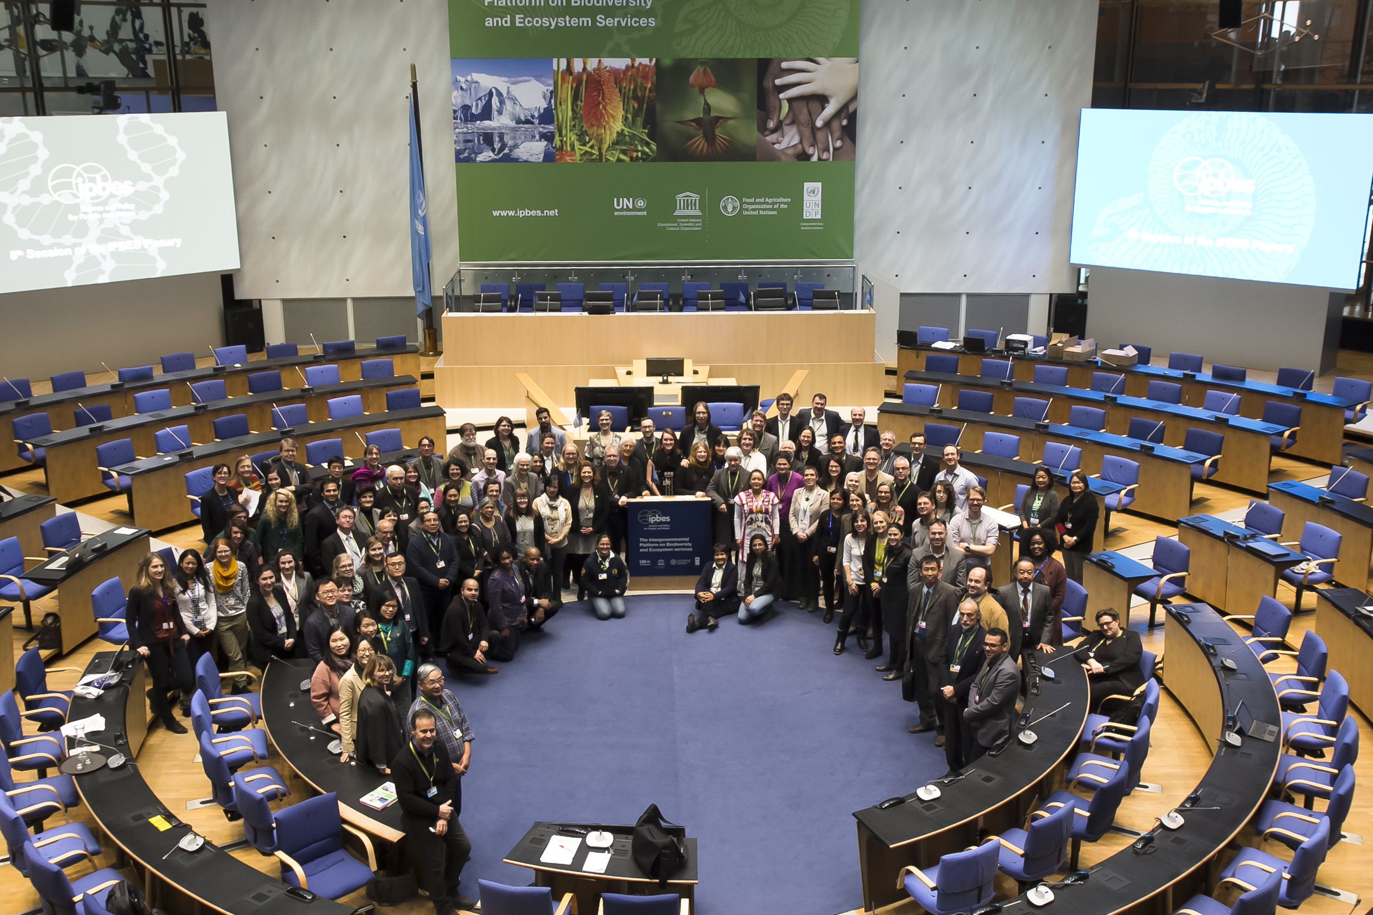
Participants of the IPBES-5 Stakeholder Day

