UNITED  NATIONS |  |  |  |  | 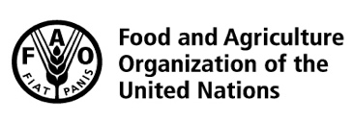 |  |  | BES
 |  |  |  |  |  |  | IPBES/5/INF/27
 |  | Intergovernmental Science-Policy Platform on Biodiversity and Ecosystem Services |  |  |  |  | Distr.: General  22 February 2017  English only
Plenary of the Intergovernmental Science-Policy
Platform on Biodiversity and Ecosystem Services
Fifth session
Bonn, Germany, 7–10 March 2017
Item 2 (b) of the provisional agenda
Organizational matters: status of the membership of the Platform
Communication from the Slovak Republic, on behalf of the member States of the European Union that are members of the Intergovernmental Science-Policy Platform on Biodiversity and Ecosystem Services, relating to the participation of the European Union in the Platform
Note by the secretariat
The annex to the present note sets out a communication received on 21 February 2017 from the Slovak Republic, on behalf of the member States of the European Union that are members of the Intergovernmental Science-Policy Platform for Biodiversity and Ecosystem Services (IPBES), relating to the participation of the European Union in IPBES. The annex is reproduced as received, without formal editing.

Annex
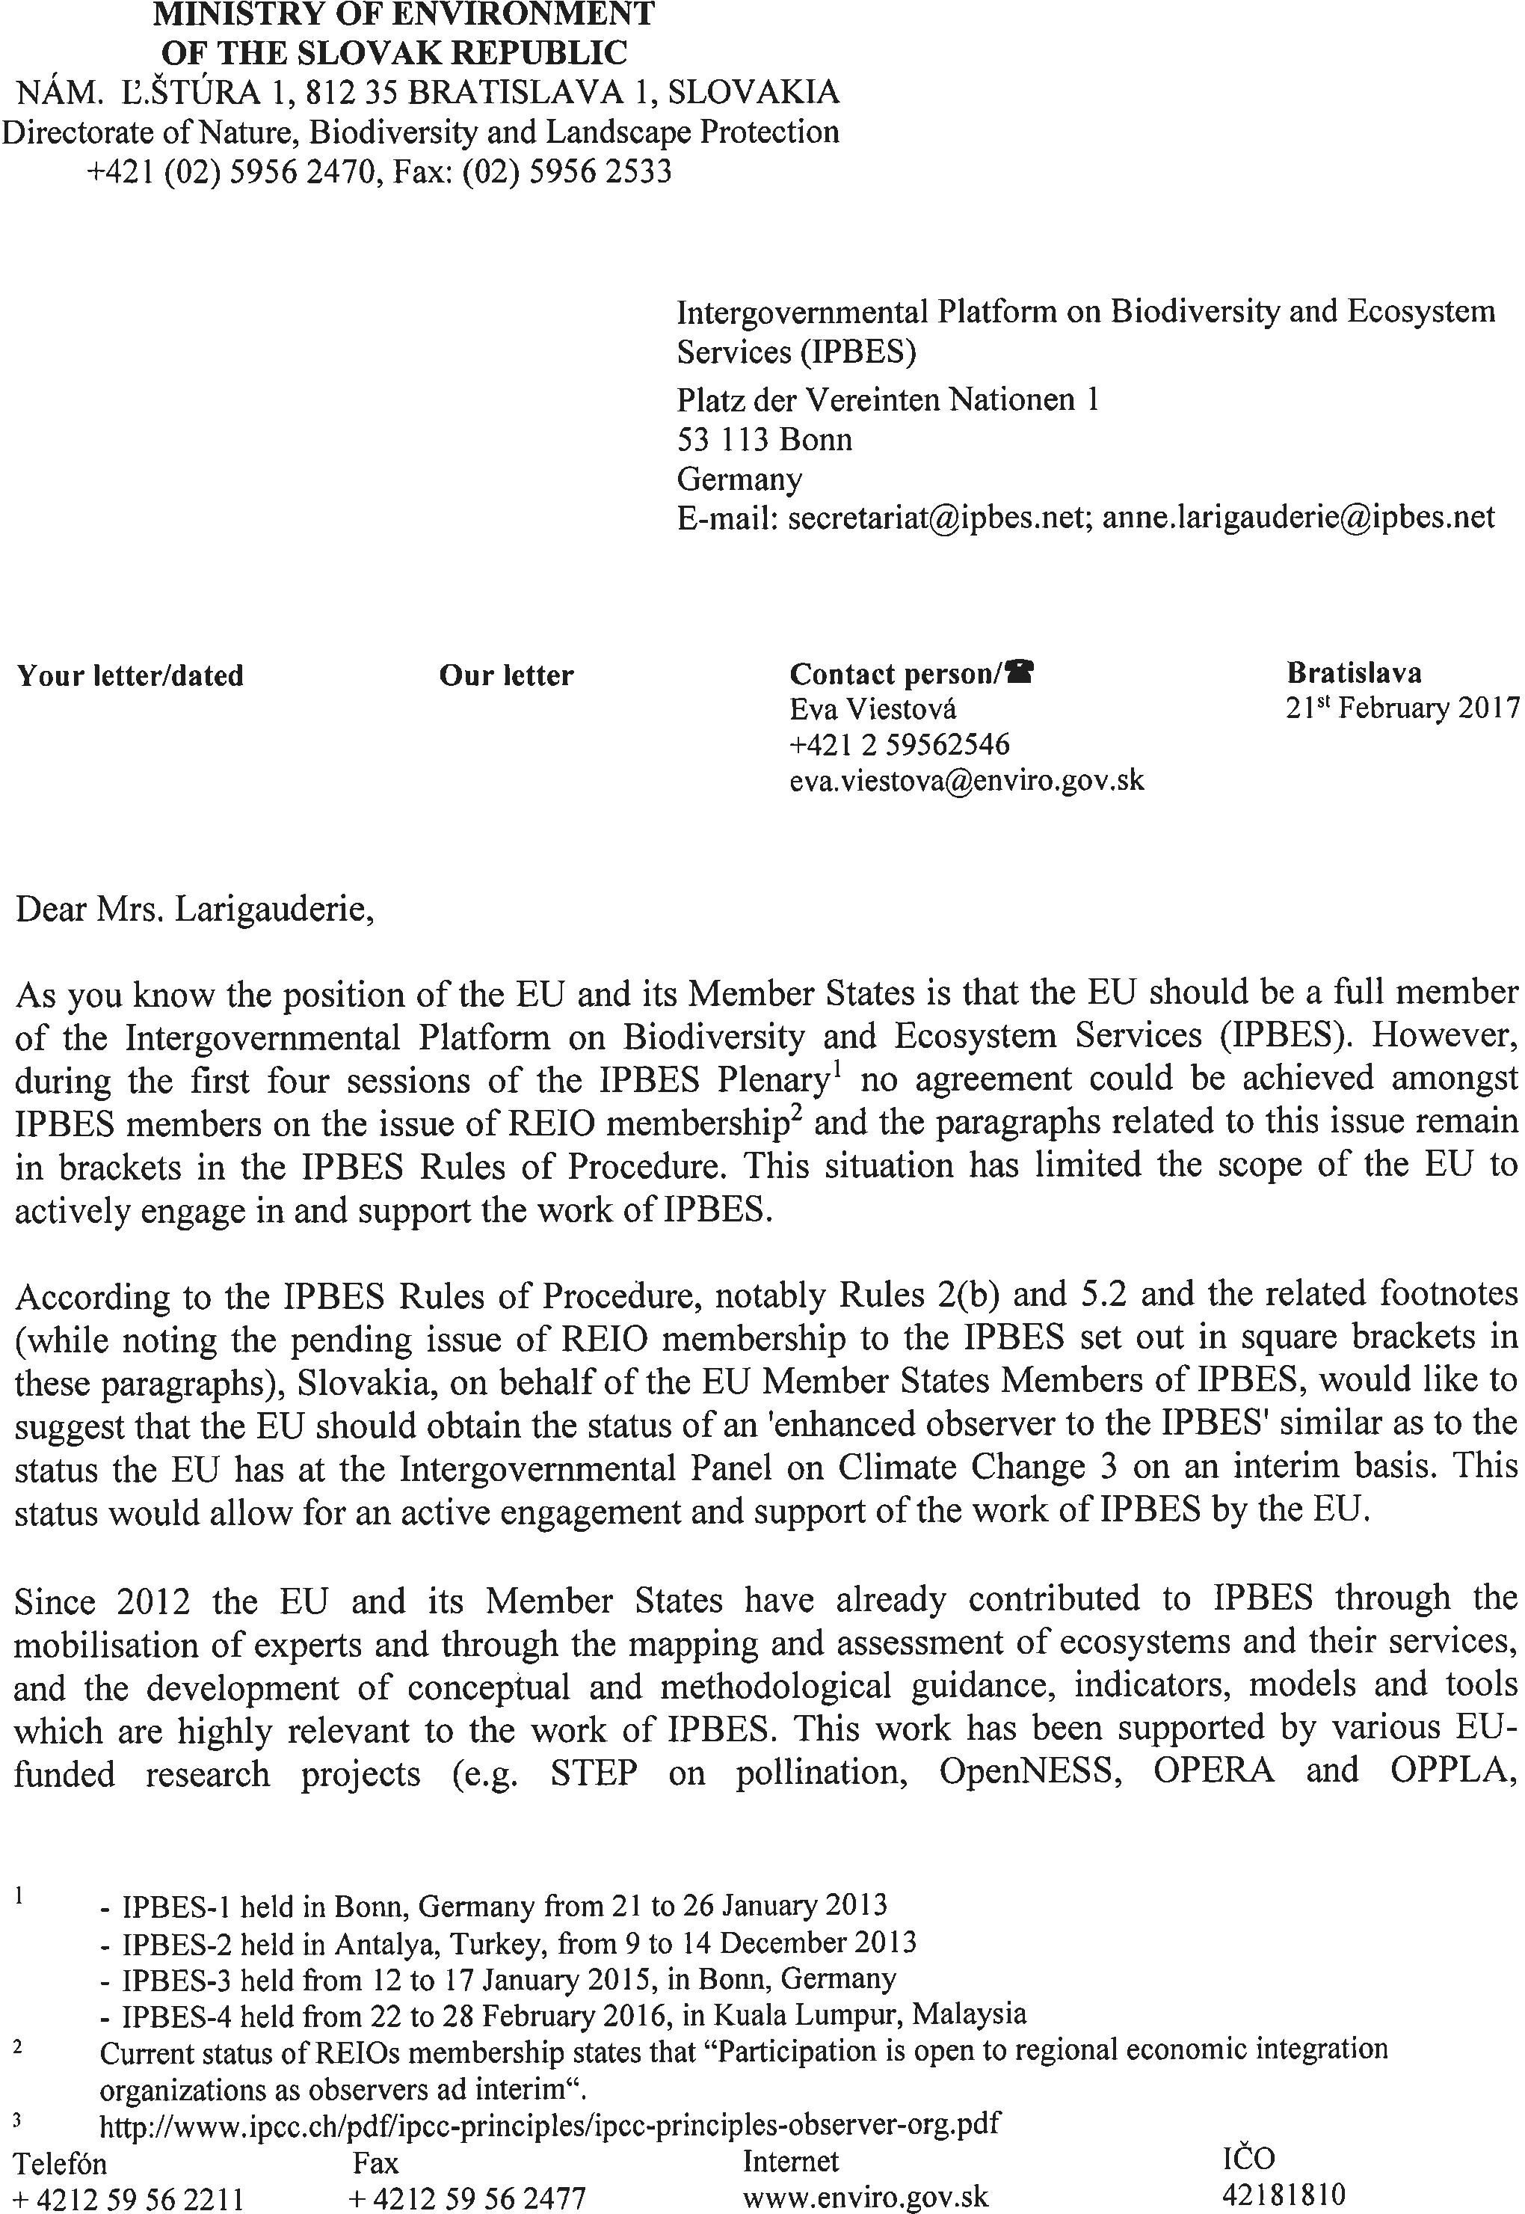

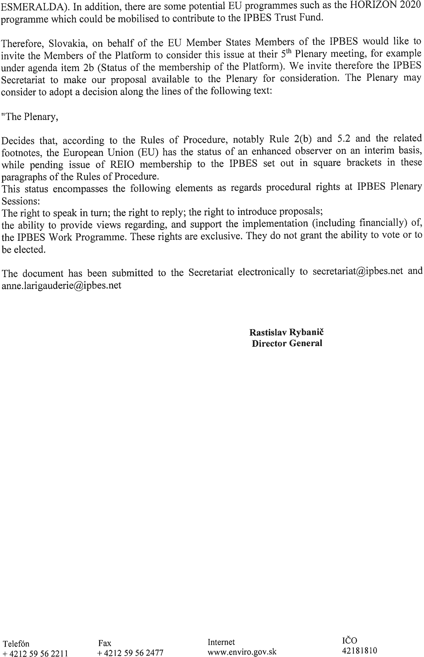

IPBES/5/1/Rev.1.

