UNITED  NATIONS |  |  | 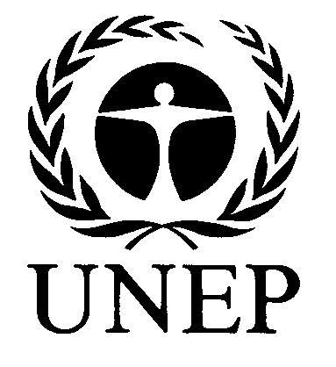 | 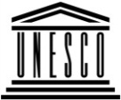 | 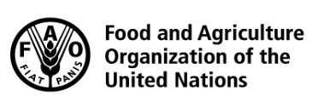 | 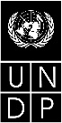 |  | BES
 |  |  |  |  |  |  | IPBES/5/INF/16
 |  | Intergovernmental Science-Policy Platform on Biodiversity and Ecosystem Services |  |  |  |  | Distr.: General  27 January 2017  English only
Plenary of the Intergovernmental Science-Policy
Platform on Biodiversity and Ecosystem Services
Fifth session
Bonn, Germany, 7–10 March 2017
Item 6 (h) of the provisional agenda*
Work programme of the Platform: communication,
stakeholder engagement and strategic partnerships
Implementation of the stakeholder engagement strategy
Note by the secretariat
- In section II of decision IPBES-4/4, the Plenary of the Intergovernmental Science-Policy Platform on Biodiversity and Ecosystem Services (IPBES) requested the Executive Secretary to undertake the activities set out in the initial implementation plan of the stakeholder engagement strategy (decision IPBES-3/4, annex II, appendix).
- Accordingly, the secretariat, with in-kind administrative support from the International Union for Conservation of Nature, has conducted a detailed stakeholder analysis survey to help inform communication and outreach decisions with regard to underrepresented stakeholder groups and to improve levels of stakeholder engagement in the work of IPBES. The annex to the present note sets out selected results of the survey and offers a number of analytical observations to inform communication and outreach decisions as mentioned above. It is presented without formal editing.

Annex
Results of the stakeholder analysis survey
I. General information
- A questionnaire concerning stakeholder was sent by email to all stakeholders included in the IPBES registry of stakeholders (6397 records) (see Figure 1 for a graphical representation of per country registered stakeholders). Responses received between Friday, 23 September and Sunday, 23 October 2016 were included in the present analysis.
- The overall response rate was 13%. Given the sample size of 834 responses, and a confidence level of 99%, the margin of error is 5%. A key learning from this first survey has been the importance of more strategic selection of response categories in the design phase – specifically to adopt a less granular level of categorisation to reduce double counting and to enable a more rigorous mapping of key gaps in the IPBES stakeholder registry.

Geographic representivity: country level
- Based on the country of primary nationality of all respondents, 112 States were represented in the responses received.
- 93 responses were from IPBES member States (representing 74,4% of the then-125 IPBES member States). 19 responses were from States which were not yet members of IPBES.
- The five countries with the greatest number of responses were India (63), Germany (47), United States of America (43), Brazil (42) and Colombia (35) (see Figure 2 for a graphical representation of the number of responses received per country).
- No responses were received from 32 then-member States of IPBES (representing a
null-response from 26% of then-IPBES member States).
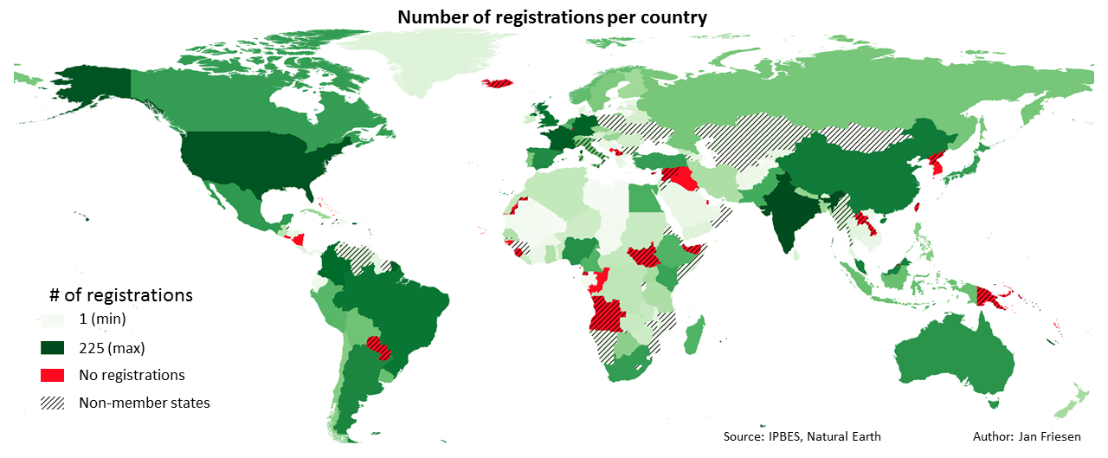
Figure 1
Number of stakeholder registrations per country as at 23 October 2016

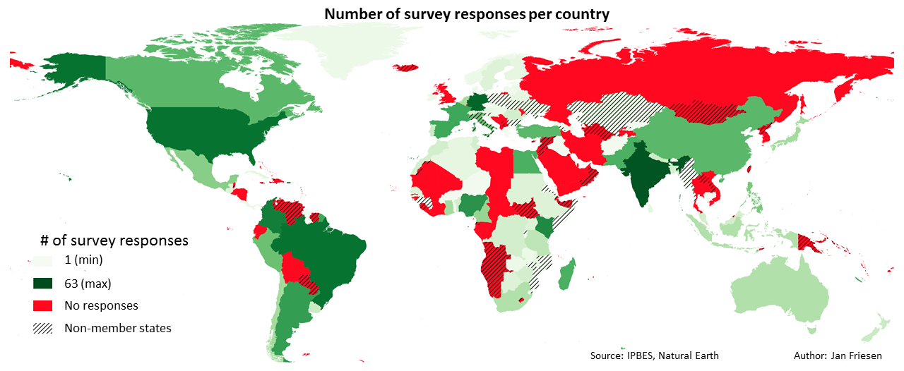
Figure 2
Number of survey responses received per country
B. Geographic representivity: regional level
- Responses were received from all five United Nations regions: Africa (AF), Asia-Pacific (AP), Eastern Europe (EE), Latin America and the Caribbean (LAC) and Western Europe and Other Groups (WEOG).
- Based on the country of primary nationality of respondents, responses were received from 21 countries out of the 26 in EE, which was the highest regional representivity (81%) (see Table 1). EE also had, however. the lowest absolute number of responses (54), representing only 7% of total responses received.
- AP had the lowest regional representivity, with responses received from fewer than 50% of countries in the region, but representing 20% of total responses received.
- WEOG had the highest number of responses (240), representing 29% of total responses received, and accounting for 65% representivity of WEOG States.
- AF accounted for 23% of total responses, with regional representivity of 61%.
- LAC accounted for 19% of total responses, with regional representivity of 49%.
- Observations:
  - In EE, the emphasis of IPBES outreach activities could be on raising awareness activities at the national and sub-national levels to increase the absolute number of stakeholders engaging with IPBES from the region.
  - In AP and LAC, where regional representivity was lower than 50%, outreach activities could be focused at the regional level to extend regional geographic stakeholder representivity.
  - In WEOG and AF, outreach activities could be designed to engage specific under-represented groups, knowledge systems or disciplines.
Figure 3
Percentage of responses per region

Table 1
Summary of responses received per United Nation region.
Region | Total # Countries | # Countries who responded | % Regional Geographic Coverage | # of Responses | % of Total Responses
AF | 54 | 33 | 61 | 192 | 23
AP | 53 | 22 | 41 | 169 | 20
EE | 26 | 21 | 81 | 54 | 6
LAC | 33 | 16 | 48 | 159 | 19
WEOG | 31 | 20 | 64 | 240 | 29
Total | 197 | 112 | n.a. | 814 | 100

C. Responses within regions
Figure 4
Number of responses per country in Africa (AF)

Figure 5
Responses per AF subregion (percentage)

Figure 6
Number of responses per country in Asia-Pacific (AP)

Figure 7
Responses per AP subregion (percentage)

- Observation: there were very few responses from the Pacific and Oceania subregion (specifically from Melanesia, Micronesia and Polynesia), with the exception of Australia and New Zealand, which are accounted for in WEOG.
Figure 8
Number of responses per country in Eastern Europe (EE)

Figure 9
Responses per EE subregion (percentage)

- Observation: the total number of responses received from EE was significantly lower than other regions, indicative of the need for focussed outreach and communication. Responses were received from three non-IPBES member States, Romania, Poland and Ukraine, possibly indicative of valuable outreach opportunities.
Figure 10
Number of responses per country in Latin America and the Caribbean (LAC)

Figure 11
Responses per LAC subregion (percentage)

Figure 12
Number of responses per country in Western Europe and Other Groups (WEOG)

Figure 13
Responses per WEOG subregion (percentage)

- Observation: the significant number of responses from Italy, a non-IPBES member State, may indicate a valuable outreach opportunity.
D. Organizations/institutions or individuals?
- Stakeholders answered mostly in their individual capacities (61% of responses) (see Figure 14), and there was no significant cross-regional difference in the percentage of stakeholders engaging in their individual capacity versus as representatives from Organizations/Institutions.
Figure 14
Percentage of respondents representing organizations/institutions vs. individuals.

II. Stakeholder mapping: organizations/institutions
A. Composition at global level
- Academic institutions (24%) and research centres (15%) accounted for 39% of responses, Governments (21%) and non-governmental organizations (12%) accounted for 33% of responses. Two categories, media and student network, were not represented in responses received.
- Observations:
  - Since 72% of responses fall within the four categories outlined above, specific outreach activities may be needed to further engage with the 15 stakeholder categories represented by the remaining 28% of responses.
  - There may be a need for specific outreach activities toward stakeholders in the media and student network categories. Such outreach activities may be best implemented initially at the global level.
Figure 15
Number of responses to the question “To which category does your Organization/Institution most closely correspond?”

B. Composition at regional level
- Not all categories were represented in all regions, with media and student network missing from all regions (see Figure 16.) The regional composition of organizational/institutional categories was also very different from one region to another, illustrated by the per region graphs that follow.
Figure 16
Organizational/institutional categories per region as a percentage of total responses per category

Figure 17
Organizational/institutional categories in Africa (AF)

- Six categories were not represented in the responses received from AF (see Figure 17):
  - Commission
  - Intergovernmental scientific organization
  - Media
  - Private sector organization
  - Specialist boundary organization
  - Student networks.

Figure 18
Organizational/institutional categories in Asia-Pacific (AP)

- Seven categories were not represented in the responses received from AP (see Figure 18):
  - Commission
  - Indigenous community platform
  - Media
  - Platform for practitioners
  - Research initiatives
  - Student network
  - Subsidiary body or mechanism established under a Multilateral Environmental Agreement
Figure 19
Organizational/institutional categories in Eastern Europe (EE)

- Only five out of 21 categories were represented in responses received from EE (see Figure 19):
  - Academic institution
  - Government
  - Non-governmental organization
  - Research centre
  - Scientific network.
Figure 20
Organizational/institutional categories in Latin America and the Caribbean (LAC)

- The following categories were not represented in responses received from LAC (see Figure 20):
  - Indigenous community platform
  - Intergovernmental organization
  - Intergovernmental scientific organization
  - Media
  - Scientific advisory group
  - Scientific network
  - Specialist “boundary” organisation
  - Student network
  - Subsidiary body
Figure 21
Organizational/institutional categories in Western Europe and Other Groups (WEOG)

- Only four categories were not represented in responses received from WEOG (see Figure 21):
  - Indigenous community platform
  - Media
  - Student network
  - Subsidiary body
- Overall Observation: The analysis presented above provides useful information about underrepresented categories in each of the four regions. It confirms that there is, for example, a general need to increase the engagement of private sector stakeholders with IPBES across all regions, and civil society engagement is another apparent gap across most regions. Such patterns will be used in future activities involving stakeholders to decide on which categories to engage as priorities depending on the specific activity and the region.
C. Organizational/institutional profile
- The social sciences (21%) as well as indigenous and local knowledge (17%) were
well-represented in survey responses received on behalf of organizations/institutions; however, natural science was predominant (indicated by 43% of organizational/institutional respondents).
- Observation: The balance in the profile of engaged organizations/institutions could be improved by attracting engagement of other disciplines, knowledge systems and the business sector.
- It is noteworthy that 43% of organizations/institutions that indicated indigenous and local knowledge as their profile were from AF and 1% were from EE (se Figure 23).
Figure 22
Organizational/institutional profile (percentage of total responses)

Figure 23
Organizational/institutional profile per region as a percentage of total responses received per category.

III. Stakeholder mapping: individual capacity
A. Composition at global level
Figure 24
Gender and age distribution of stakeholders engaging in their individual capacity (number of responses)

- The distribution of responses was a bell curve, with men more represented than women. Men accounted for 56% of respondents aged “35 to 44”, while women accounted for 43%. In the age category “45 to 54”, respondents were 67% men and 32% women.
B. Composition at regional level
Figure 25
Gender and age distribution of stakeholders engaging in their individual capacity in Africa (AF) (number of responses)

- In AF, male representation was predominant, with 80% males in the “35 to 44” category, and 66% in the “45 to 54” category.
Figure 26
Gender and age distribution of stakeholders engaging in their individual capacity in Asia–Pacific (AP) (number of responses)
- In AP, men were more represented than women, with 70% men in the “35 to 44” category, and 85% in the “45 to 54” category.
Figure 27
Gender and age distribution of stakeholders engaging in their individual capacity in Eastern Europe (EE) (number of responses)

- In EE, it was challenging to draw any significant conclusions because of the low number of responses received. There were twice as many responses received from women as there were from men in the age category “35 to 44”, but again, based on a very small sample size of 9 responses.
Figure 28
Gender and age distribution of stakeholders engaging in their individual capacity in Latin America and the Caribbean (LAC) (number of responses)

- In LAC, the distribution between men and women was balanced across the age categories represented.
Figure 29
Gender and age distribution of stakeholders engaging in their individual capacity in Western Europe and Other Groups (WEOG) (number of responses)

- In WEOG, responses from men and women were nearly balanced. Responses from women in the age category “35 to 44” were greater (56%) than the number of responses from men (44%).
C. Profile of stakeholders engaging in their individual capacity
- The profile of stakeholders engaged in their individual capacity was broadly similar to responses received from representatives of organizations/institutions with a predominance of natural sciences (51%) over social science (17%), Indigenous and Local Knowledge (14%) and business (3%).
- The percentage of individuals and organizations with a natural science background was similarly spread across the regions.
- Compared to responses received from representatives of organizations/institutions, the percentage of individuals with a business profile was greater in four regions (+11% in EE, +9% in AF and LAC, +2% in WEOG) but dropped significantly in AP (-29%).
- The percentage of stakeholders engaged in their individual capacity with an indigenous and local knowledge profile was greater than that for representatives of organizations/institutions in AP (+11%) and EE (+4%) but lower in AF (-9%) and WEOG (-7%) and comparable in LAC.
- The percentage of stakeholders engaged in their individual capacity with a social science profile was greater in EE and WEOG (+5%), lower in AF (-10%) and LAC (-3%) and comparable in AP.
Figure 30
Profile of stakeholders engaged in their individual capacity (percentage of total responses)
Figure 31
Individual profiles per region as a percentage of total responses received per category

IV. Analysis of responses to selected questions
A. Interest or expertise in IPBES areas of work
- Respondents were invited to indicate which area/s of the work programme they were most interested in, and/or which area of IPBES work most closely aligned with their own expertise. In all regions, the interests/expertise of respondents were well spread across the main areas of the IPBES work programme.
- Interest/expertise in the four regional assessments was also well spread across the regions.
Respondents engaging on behalf of organisations/institutions
- Valuation of biodiversity and nature's benefits to people, with 222 responses (11%); land degradation and restoration, with 184 responses (10%); as well as sustainable use of wild species, with 166 responses (9%) were the areas of IPBES work of most interest to respondents engaging on behalf of organisations/institutions.
Figure 32
Interest/expertise of organizations/institutions per region as a percentage of total responses received for each area of IPBES work

Respondents engaging in their individual capacity
Valuation of biodiversity and nature's benefits to people, with 311 responses (12%); land degradation and restoration, with 235 responses (9%); as well as regional and subregional assessments, with 213 responses (9%) were the areas of IPBES work of most interest to respondents engaging with IPBES in their individual capacity.
Figure 33
Interest/expertise of individuals per region as a percentage of total responses received for each area of IPBES work

B. Intended future contribution to IPBES
- Respondents were asked to indicate what contribution/s they intend to make to IPBES in the future that they were not already contributing. Given some apparently contradictory data within individual responses it is important to note that a number of respondents may have misunderstood or misread these questions, with some indicating both an intention to make future financial and/or in-kind contributions to IPBES, and simultaneously indicating as major obstacles to their engagement with IPBES a lack of financial/other resources.
- Observation: To increase and improve stakeholder engagement, this information could be used to:
  - Further develop IPBES guidelines/procedures with respect to future contributions.
  - Focus communication and outreach activities and materials.
Respondents engaging on behalf of organisations/institutions
- In AF, indigenous and local knowledge (41%), in-kind support (34%) and organizing information meetings to promote IPBES and its work were the three most-indicated future contributions from respondents engaging on behalf of organisations/institutions.
- In AP, organizing information meetings was the most-indicated future contribution (29%). In-kind support and regional knowledge were the next most-indicated (27% and 25% respectively).
- In EE, financial support was the most-indicated future contribution (10%) along with provision of expertise to IPBES, making data or indicators available to IPBES and providing regional knowledge (8% each).
- In LAC, financial support (33%), providing regional knowledge (24%) and making data available (24%) were the most-indicated future contributions.
- In WEOG, the most-indicated future contributions were provision of expertise to IPBES (28%), access to networks (24%) and nominating experts (23%).
Figure 36
Number of responses from respondents engaging on behalf of organisations/institutions to the question “What specific contributions do you/your Organization/Institution wish to make to the work of IPBES which you are not already making? (Choose all that apply)”

Figure 37
Intended future organizational/institutional contributions to IPBES (percentage of total)

Figure 38
Intended future organizational/institutional contributions per region as a percentage of total responses received per type of contribution

Respondents engaging in their individual capacity
- In AF, financial support (41%), in-kind support (32%), information meetings (31%) and indigenous and local knowledge (29%) were the most-indicated future contributions.
- In AP, indigenous and local knowledge was the most-indicated future contribution (43%). Information meetings and regional knowledge were next (25% each).
- In EE, financial support was the most-indicated future contribution (23%), followed by making data available (10%) and providing regional knowledge (9%).
- In LAC, nominating experts (24%), financial support (23%), providing regional knowledge (21%) and making data available (21%) were the most-indicated future contributions.
- In WEOG, the most-indicated future contributions were specialized expertize (33%), in-kind support (29%), making data available (27%) and access to networks (27%).
Figure 39
Number of responses from individuals to the question “What specific contributions do you/your Organization/Institution wish to make to the work of IPBES which you are not already making? (Choose all that apply)”

Figure 40
Intended future individual contributions to IPBES (percentage of total)

Figure 41
Intended future individual contributions per region as a percentage of total responses per type of contribution

C. Incentives/disincentives to engagement with IPBES
- Respondents were asked to indicate which types of incentives and disincentives were most applicable to drive or discourage their engagement with IPBES.
Incentives
- In AF, the incentives most-indicated were linked to support (Figure 42), with better organizational support (52%), better financial support (33%) and better local support (31%) indicated most often. Least mentioned was recognition (9%).
- In AP, recognition was the incentive most indicated (46%), followed by financial (29%) and international (28%) support, as well as increased knowledge (27%). Better local support was the least-indicated category (12%).
- In EE, better local support was the incentive most-indicated (12%), followed by increased knowledge (10%) and access to expertise (10%). Better visibility was least-indicated (3%).
- In LAC, better local support was the incentive most-indicated (27%), followed by helping to ensure sustainable development (26%) and access to expertise (24%). The incentive least-mentioned was better organizational support (7%).
- In WEOG, better visibility (44%) was the incentive most-indicated, along with overlapping research interests (42%), policy and decision making support (39%) and building networks (39%). The incentive least-mentioned was organizational support (3%).
- Observation: Incentives were very different between regions, which could be taken into consideration when designing communication and outreach activities/materials to encourage wider and deeper stakeholder engagement with IPBES. It should also be noted that some of the categories represented perceived incentives rather than actual benefits accruing from engagement with IPBES.
Figure 42
Incentives for engagement per region as a percentage of responses per specific incentive

Disincentives
- Lack of money (35%) and lack of time (24%) were the two most-indicated disincentives to engagement with IPBES (Figure 43), followed by lack of clarity on how IPBES works (17%). The language barrier was also indicated as a disincentive (6%).
- In AF, an insufficient research overlap was the most-indicated disincentive (46%). Language barriers (33%), insufficient recognition (30%) and risks of distortion (29%) were the next most commonly indicated categories. High work commitment was the least-indicated disincentive (14%).
- In AP, the three disincentives most-indicated were insufficient recognition (25%), risk of distortion (24%) and not enough money (22%). Language barriers were the least-indicated disincentive.
- In EE, an insufficient research overlap (11%), language barriers (9%), risk of distortion (8%) and lack of clarity about how IPBES works (8%) were most-indicated. Least-indicated was high work commitments (5%).
- In LAC, the two most-indicated disincentives were language barriers (36%) and risk of distortion (20%). High work commitment was least-indicated (16%).
- In WEOG, high work commitment was the disincentive most indicated (44%), followed by lack of clarity on how IPBES works (30%) and lack of funding (23%). Insufficient research overlap was least-indicated (8%).
- Observations:
  - IPBES provides financial support to all experts from developing countries, however, disincentives due to a “lack of money” and a “lack of time” were predominant at the global level.
  - “Unclear how IPBES works” was the third most-indicated disincentive at the global level. A communication campaign could be specifically designed to promote IPBES through the website, social media channels and marketing materials to address this issue.
  - “Language barrier” was a significant disincentive in AF, EE and LAC. Translation of more IPBES documents into the official United Nations languages could address some of these challenges.
Figure 43
Disincentives as a percentage of total responses

Figure 44
Disincentives to engagement per region as a percentage of total responses received per disincentive

* IPBES/5/1/Rev.1.
All numbers throughout the present note have been rounded to the nearest integer.
For the purposes of this survey, “boundary organizations” were taken to be organizations whose central purpose is to create and sustain meaningful and mutually beneficial links between knowledge producers and users.
The engagement with IPBES by early-career experts may be a more relevant category of stakeholders for future mapping than student networks – which may also partially explain the lack of responses received in this regard.

