UNITED  NATIONS |  |  |  |  |  |  |  | BES
 |  |  |  |  |  |  | IPBES/5/INF/15
 |  | Intergovernmental Science-Policy Platform on Biodiversity and Ecosystem Services |  |  |  |  | Distr.: General  18 January 2017  English only
Plenary of the Intergovernmental Science-Policy
Platform on Biodiversity and Ecosystem Services
Fifth session
Bonn, Germany, 7–10 March 2017
Item 6 (h) of the provisional agenda*
Work programme of the Platform: communication, stakeholder engagement and strategic partnerships
Implementation of the communications and outreach strategy
Note by the secretariat
The annex to the present note sets out the Intergovernmental Science-Policy Platform on Biodiversity and Ecosystem Services (IPBES) visual style guide approved by the Bureau as part of the ongoing implementation of the communicaton and outreach strategy (decision IPBES-3/4, annex I), which takes into account the note by the secretariat on communication and stakeholder engagement strategies (IPBES/4/INF/15). The annex is presented without formal editing.

Annex
IPBES visual style guide
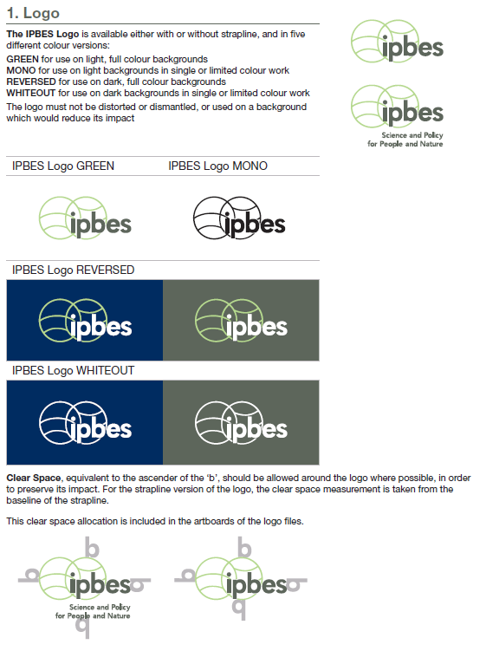

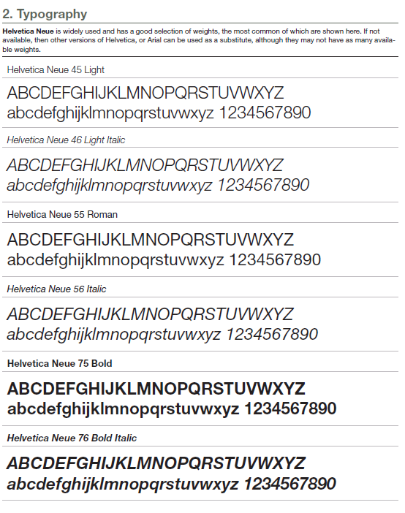

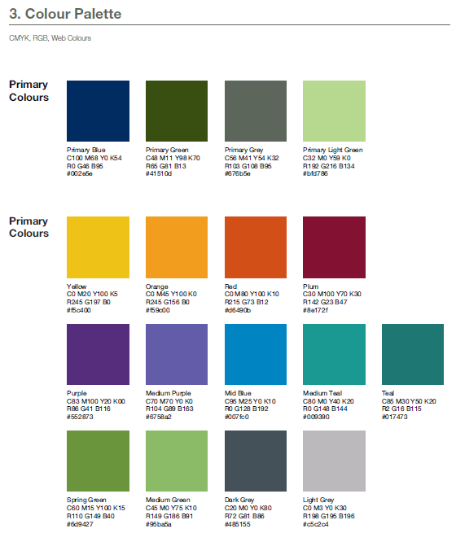

* IPBES/5/1/Rev.1.

