UNITED  NATIONS |  |  |  |  |  |  |  | BES
 |  |  |  |  |  |  | IPBES/7/INF/10
 |  | Intergovernmental Science-Policy Platform on Biodiversity and Ecosystem Services |  |  |  |  | Distr.: General  5 March 2019  English only
Plenary of the Intergovernmental Science-Policy
Platform on Biodiversity and Ecosystem Services
Seventh session
Paris, 29 April–4 May 2019
Item 5 of the provisional agenda*
Report of the Executive Secretary on the
implementation of the first work programme
for the period 2014–2018
Information on work related to the guide on the production of assessments
Note by the secretariat
- In section III of its decision IPBES-2/5, the Plenary of the Intergovernmental Science-Policy Platform on Biodiversity and Ecosystem Services (IPBES) requested the Multidisciplinary Expert Panel, in consultation with the Bureau, and supported by a time-bound and task-specific expert group, to develop a guide on the production and integration of assessments from and across all levels. The guide was intended to address the practical, procedural, conceptual and thematic aspects of undertaking assessments, drawing on the work of the task forces and other expert groups.
- In section III of its decision IPBES-3/1, the Plenary took note, on the basis of document IPBES/3/INF/4, of the development of a draft guide on the production of assessments, and requested that the guide be completed as provided for in decision IPBES-2/5, with a view to becoming a living document that would be regularly reviewed and updated as necessary, building on lessons learned and best practices gleaned from the implementation of the work programme of IPBES.
- In section III of its decision IPBES-4/1, the Plenary welcomed the review and updating of the guide, as set out in the note by the secretariat on the matter (IPBES/4/INF/9), and the plan to make the guide available as an e-book on the IPBES website and update it regularly.
- The core version of the guide on the production of assessments was presented for the information of the Plenary at its fifth session (IPBES/5/INF/6, appendix II) and sixth session (IPBES/6/INF/17, appendix).
- The annex to the present note, which is presented without formal editing, sets out an update on the guide for assessments, including on the IPBES core glossary.
Annex
I. Update on the guide for assessments
A. Core version of the guide for assessments
- The core version of the guide for assessments was prepared by a subset of the Bureau and the Multidisciplinary Expert Panel, supported by the secretariat, and by the United Nations Environment Programme – World Conservation and Monitoring Centre. It was presented for the information of the Plenary at its sixth session in document IPBES/6/INF/17.
- Since the sixth session of the Plenary, a dedicated page on the IPBES website has been developed and is available at https://www.ipbes.net/guide-production-assessments. The following resources are available on the website:
  - The laid-out core version of the guide for assessments (see figure 1);
  - The laid-out summary of the core version of the guide for assessments;
  - The high-resolution infographic on the IPBES assessment process;
  - High-resolution versions of the graphics used in the core version of the guide for assessments for the different stages of the assessment process;
  - A webinar on the IPBES assessment process.
- The laid-out summary of the core version of the guide for assessments has been printed and hard copies are available upon request.
- The secretariat has promoted the guide and associated resources through social media and targeted emails.
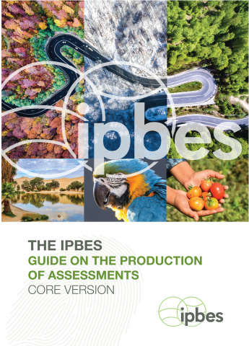
Figure 1
Cover of the laid-out core version of the guide for assessments
B. Modules of the guide for assessments
- In addition to its core, the guide will contain several modules including, for example, one module on “addressing conceptual issues”, which would, among others, introduce the concept of nature’s contributions to people, or one module on the “IPBES core glossary”. These modules are still under development or require review and updating to reflect progress in advancements within IPBES. Finalised modules will be made available at the IPBES website.
- Concerning the IPBES core glossary, the Multidisciplinary Expert Panel, at its eighth meeting (October 2016), approved the establishment of a glossary committee. The committee is currently composed of Mariteuw Chimere Diaw, Judy Fisher, Leng Guan Saw, and Bibiana Vila.
- The IPBES core glossary is available at www.ipbes.net/glossary, as a module of the guide. The core glossary provides a standard definition for important terms of broad applicability to IPBES outputs and forms the basis of assessment-specific glossaries. It is considered a living resource that is continuously updated.
II. Next steps
- The guide and the glossary are living documents and it is expected that they will be updated at regular intervals under the guidance of the Multidisciplinary Expert Panel. Feedback from experts involved in the IPBES assessments will be sought to ensure that the guide and the glossary remain relevant.

* IPBES/7/1/Rev.1.
Directly accessible at: https://www.ipbes.net/system/tdf/180719_ipbes_assessment_guide_report_hi-res.pdf?file=1&type=node&id=28500.
Directly accessible at: https://www.ipbes.net/system/tdf/180719_ipbes_assessment_guide_summary_hi-res.pdf?file=1&type=node&id=28499.
Directly accessible at: https://www.ipbes.net/module-2-ipbes-assessment-process.

