UNITED  NATIONS |  |  | 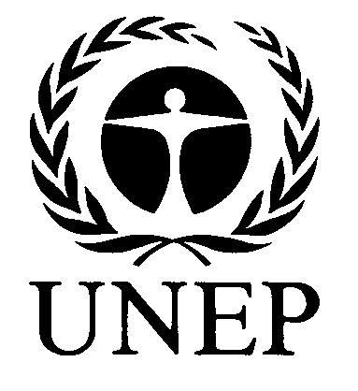 | 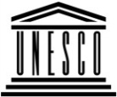 | 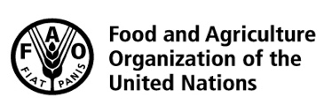 |  |  | BES
 |  |  |  |  |  |  | IPBES/6/INF/15*
 |  | Intergovernmental Science-Policy Platform on Biodiversity and Ecosystem Services |  |  |  |  | Distr.: General  12 February 2018  English only
Plenary of the Intergovernmental Science-Policy
Platform on Biodiversity and Ecosystem Services
Sixth session
Medellin, Colombia, 18–24 March 2018
Item 5 of the provisional agenda**
Report of the Executive Secretary on the implementation of the first work programme for the period 2014–2018
Information on further work related to scenarios and models of biodiversity and ecosystem services (deliverable 3 (c))
Note by the secretariat
- In section V of decision IPBES-4/1, the Plenary of the Intergovernmental Science-Policy Platform on Biodiversity and Ecosystem Services (IPBES) approved the summary for policymakers of the report of the methodological assessment of scenarios and models of biodiversity and ecosystem services set out in annex IV to that decision and accepted the chapters of the report and their executive summaries (IPBES/4/INF/3/Rev.1).
- In the same decision, the Plenary requested the Multidisciplinary Expert Panel to oversee further work related to scenarios and models focusing on two activities described in the terms of reference set out in annex V to the decision, and to appoint an expert group to perform that work. The Plenary also requested the Executive Secretary to make the necessary institutional arrangements as outlined in the terms of reference. The two activities set out in the terms of reference consisted of providing expert advice to relevant expert groups of the Platform, in particular those undertaking assessments, on the use of existing scenarios and models to address the current needs of the Platform (activity 1); and catalysing the development of scenarios and associated models by the broader scientific community for the future work of the Platform (activity 2).
- At its seventh meeting, in June 2016, the Multidisciplinary Expert Panel endorsed a detailed workplan for the second phase of the work on scenarios and models, to implement the two
above-mentioned activities, and approved the composition of the expert group to perform that work.
- The annex to the present note, which is presented without formal editing, sets out information on the work of the expert group.

Annex
Information on further work related to scenarios and models of biodiversity and ecosystem services
I. The expert group on scenarios and models
- The expert group, approved by the Panel at its seventh meeting (June 2016), is co-chaired by Carolyn Lundquist and Henrique Pereira. Paul Leadley and Marie Stenseke, from the Multidisciplinary Expert Panel (MEP), and Asghar Mohammadi Fazel and Robert Watson, from the Bureau, are overseeing progress on behalf of the MEP and Bureau, respectively.
- The technical support unit (TSU) for the IPBES work on scenarios and models, based at
PBL – the Netherlands Environmental Assessment Agency, is continuing its support during this second phase of work, and will do so until the end of the first work programme. Its members include Rob Alkemade, Eefje den Belder and, since 6 November 2017, Machteld Schoolenberg and Anja Meerbeek.
II. Activity 1
Supporting the use of scenarios and models in IPBES assessments: Progress and next steps
A. Specific support to assessments expert groups
- On behalf of the expert group on scenarios and models, the TSU is providing technical support to chapters 4 and 5 of the global assessment. The TSU organized and hosted a meeting for chapter 5 of the global assessment on 7-10 February 2017 in Den Haag, the Netherlands. The main aim of the meeting was to work on the development of the first order draft of the chapter. In total 24 authors, a MEP member, two co-chairs and TSU staff attended the meeting. A member of the TSU also attended the meeting of chapter 4 of the Global Assessment on 27 February-3 March 2017 in Aix-en-Provence, France. Members of the TSU attended the second author meeting of the global assessment on
18-22 September 2017 in Cape Town, South Africa and provided support to chapters 4 and 5, as well as administrative support.
- The expert group supported by the TSU scenarios and models, has been providing advice to the authors of the chapters 5 of the regional assessments and chapter 7 of the land degradation and restoration, aiming for consistency across all assessments. Members of the TSU on scenarios and models attended the third author meetings of the regional assessments of Asia and the Pacific and Europe and Central Asia (24-28 July 2017) to provide support to the chapters 5 of the assessments and insights into the similarities and differences between the scenarios and models chapters of the different regions.
B. Additional work in support of IPBES assessments
- The TSU on scenarios and models has been working on mobilising research groups to apply a range of the Shared Socioeconomic Pathways (SSP) scenarios of the Intergovernmental Panel on Climate Change (IPCC) to a variety of biodiversity and ecosystem services models in a consistent and harmonized fashion. In total, 14 research groups are participating in this task. A workshop on ‘Biodiversity and Ecosystem Services Scenarios for IPBES using the SSPs’ was held on 4-6 October 2017 in iDiv, Leipzig, Germany. At the workshop, the experts agreed on a timeline to provide outputs of the models to chapters 4 and 5 of the IPBES global assessment by December 2017 to be included in their second order drafts.
- In line with the aforementioned activity, the TSU and expert group on scenarios and models have also been working on mobilising IPBES stakeholders to identify policy options to enrich the SSP scenarios by developing an online questionnaire which was made available on the IPBES website. The questionnaire was filled in by 174 stakeholders and the results were analysed by the expert group. These outputs will serve as an input to chapters 4 and 5 of the global assessment as well as input to activity 2 of this group on catalysing the further development of scenarios and models.
- A scenarios and models session was organized by the expert group and TSU at the stakeholder day at the fifth IPBES Plenary (6 March 2017, Bonn, Germany). The aim of the session was to inform IPBES stakeholders on results of the methodological assessment on scenarios and models for biodiversity and ecosystem services and the way forward for IPBES scenario development. The expert group also organized breakout sessions to consult stakeholders on identifying policy options in line with the activity mentioned in paragraph 9.
- The expert group on scenarios and models, with support from the TSU, is currently working on developing an evolving guide for the IPBES community on the use of scenarios and models. The guide aims to provide advice to all IPBES expert teams, in particular to those working on the thematic, regional and global assessments, as well as to the broader scientific community. The evolving guide will be an online toolbox developed in close collaboration with the experts developing the catalogue of policy support tools and methodologies (deliverable 4 (c)). To initiate this collaboration, the TSU for scenarios and models met with experts from deliverable 4(c) on 17 January 2017 in Brussels, Belgium. In addition, the expert group on scenarios and models developed a survey aiming to obtain feedback from authors from the regional, land degradation and restoration and global assessments on their experiences in their respective assessments and their needs in regards to scenarios and models. Based on the results of the survey, the expert team is currently working on an online structure and on the content of the evolving guide.
C. Next steps in the provision of technical support to ongoing assessments
- The TSU for scenarios and models will continue to provide technical support for chapters 4 and 5 of the global assessment.
- The results from the activity on ‘Biodiversity and ecosystem services scenarios for IPBES using the SSPs’ will be published in a special issue of a journal. The results of the activity on policy options will also be pusblished in a scientific journal.
- The expert group on scenarios and models, with support from the TSU, will continue the work on the evolving guide.
III. Activity 2
Catalysing the development of scenarios and models by the broader scientific community: Progress and next steps
A. Second workshop on the way forward for IPBES scenario development
- The IPBES methodological assessment of scenarios and models of biodiversity and ecosystem services highlighted the lack of existing scenarios that fully meet the needs of IPBES. The expert group on scenarios and models, supported by the TSU, has been facilitating the process to identify, together with relevant stakeholders, gaps in existing scenarios and models. These gaps include issues not addressed in existing scenarios that are relevant for biodiversity and ecosystem services, and specific elements of biodiversity and ecosystem services.
- To initiate this process, the TSU together with the German Centre for Integrative Biodiversity Research (iDiv) organised a first scenario workshop in Leipzig from 3 to 7 October 2016. The workshop was co-funded by IPBES and iDiv. The workshop resulted in the writing of the scientific paper ‘Multi-scale scenarios for nature and nature’s contributions to people’ which presents a way forward for IPBES scenario development. The paper has now been published in the Journal ‘Nature Ecology & Evolution’. The workshop paved the way forward for scenario development for IPBES through identifying short-, medium- and long-term activities regarding the use of scenarios in IPBES.
- To initiate the process of development of IPBES scenarios, the expert group on scenarios and models, supported by the TSU, organized a workshop on “New visions for nature and nature’s contributions to people for the 21st century” on 4-8 Sept. 2017 in Auckland, New Zealand. The workshop was hosted at the University of Auckland, and was kindly co-funded by the New Zealand Ministry for Business, Innovation and Employment’s Catalyst: Seeding fund, the National Institute of Water & Atmospheric Research (NIWA), and others. The workshop engaged 73 participants with a diversity of views on nature and its contributions to people from international organizations, governments, the private sector, indigenous and local communities, non-governmental organizations and the wider scientific community from the local to global scale. The three following key questions were addressed: 1) What visions (may be multiple) exist on nature (biodiversity) and nature’s contributions to people (ecosystem services)? 2) What future ‘positive’ scenarios can be built based on these multiple visions? 3) What is required to inform decision makers to address potential changes in biodiversity and ecosystem services?
- The participants in the workshop were selected to represent a diversity of views on nature and nature’s contributions to people, and to obtain a broad set of visions, to ensure legitimacy for the process and to avoid biases. Selection criteria included representation from different sectors (governments and international organizations, private sector, interest groups and NGOs, indigenous and local communities, and the wider scientific community), regions, professional backgrounds (social, technological, ecological, economic), ages and genders. The list of participants can be found in the full report (in preparation), summarized in Appendix II.
- This visioning workshop initiated the development of the next generation of scenarios by exploring alternative visions to reach intertwined global targets, including synergies and trade-offs between nature conservation and other development goals such as the United Nations Sustainable Development Goals, and interaction across nature, nature’s contributions to people, and human
well-being. Using participatory approaches, seven visions emerged, as follows: Nature-Based Inclusive Prosperity; Sustainable Food Systems; Rewilding and refooding urban rural flows; Healthy Socio-Ecological Freshwater Systems; A Tasty World with Values; Dancing with Nature; and Healthy Oceans, Happy Communities. The detailed report from the workshop, which is in preparation, will serve as a basis for the further development of the scenarios. A summary can be found in Appendix II.
- This workshop was the first step in a process to develop multiscale scenarios for nature futures. This co-creation process will involve iterative cycles of visioning, stakeholder consultation, and modelling, across the IPBES regions and languages, different sectors, disciplines and indigenous and local communities. The next step is to identify and fill gaps in these visions, and iterate these with the current set of seven visions into a concise suite of future visions; this process will occur through global and regional on- and offline consultations in the course of 2018. Based on that, in 2019, modelling groups and expert teams will develop scenarios for each of the visions. This concludes one of several cycles, with the scenarios leading to a new round of storyline development and visioning.
B. Next steps in catalysing the further development of scenarios and models for IPBES
- Based on the outcomes of the workshop on “New visions for nature and nature’s contributions to people for the 21st century” and the workshop on ‘Way forward for IPBES scenario development’, the expert group on scenarios and models will continue in 2018 and 2019, supported by the TSU, catalysing the further development of scenarios and models for IPBES (annex V to decision
IPBES-4/1). The expert group’s programme consists of six actions, each of which will be assigned to a subset of the expert group, supported by a member of the TSU (for more details, please see terms of reference in annex V to decision IPBES-4/1). The actions include:
  - Write a scientific paper which presents the results from the workshop on “New visions for nature and nature’s contributions to people for the 21st century” on 4-8 Sept. 2017 in Auckland, New Zealand, results from further stakeholder consultations and a way forward for IPBES scenario development. The paper will aim to mobilise the broader community to address the needs of IPBES regarding scenario development, thereby catalysing new research and participation by all sectors (governments, private sector, interest groups, indigenous and local communities and the broader scientific community);
  - Develop a long-term research agenda for IPBES scenario development, following the workshop on visioning futures described above. This action aims at mobilising the scientific community to align their activities in support of the IPBES scenarios and models development agenda;
  - Mobilize stakeholders across the IPBES regions and languages, sectors, and disciplines to identify gaps in and enrich the current set of seven visions on nature and nature‘s contribution to people by means of online and offline consultation;
  - Consult stakeholders including indigenous and local communities and younger generations to consolidate and further enrich the current set of visions on nature and nature’s contributions to people through global and regional on- and offline consultations. First rounds of consultations will be held in the first two quarters of 2018 and these results will aim to strengthen the foundations for the development of a robust set of visions, specifically tailored to the objectives of IPBES;
  - Organise a second stakeholder workshop on visioning futures for biodiversity and ecosystem services, which will be a follow up to the workshop on the ‘New visions for nature and nature’s contributions to people for the 21st century’ (Auckland, New Zealand on 4-8 September 2017). The workshop will take place in the third quarter of 2018, and will be organised together with a partner organisation. The workshop is intended to bring together a subset of stakeholders from the first workshop and from the consultation rounds at multiple scales, including representatives of the scientific community, international institutions, governments, the private sector, indigenous and local communities and non-governmental organisations, ensuring a balanced representation of the diversity of stakeholder groups. In order to be meaningful for IPBES the development of pathways to these visions will be facilitated ensuring cross-scale and cross-sectoral scenarios;
  - Follow-up activities on both existing and new scenarios will include capacity-building aimed at improving the uptake and use of scenarios and models by a broad range of policymakers and stakeholders. This should involve working with the capacity-building task force (deliverable 1 (a)) and policy support tools and methodologies (deliverable 4 (c)) and in-kind support for encouraging the development of a curriculum and network of training courses and for scenarios and models (see IPBES/4/INF/22 for an example of work that has already been catalysed by the Platform) and workshops where scientists, policymakers and stakeholders lay out strategies for mobilizing scenarios and models for decision-making. These activities will be carried out in close collaboration with the task force on knowledge and data (deliverable 1 (d)) in the context of the dialogues to be convened by this task force to catalyse the generation of new knowledge and fill knowledge gaps.
C. Schedule of work
- The schedule for this work is set out in the table below. Elements in bold indicate activities that will require funding from the trust fund or in-kind support above and beyond the in-kind contribution of the Government of the Netherlands.
Actions and institutional arrangements
2018 | Continuation of activity 1 (a): facilitate access to relevant literature on scenarios and models  Continuation of activity 1 (b): facilitate access to scenarios and models outputs  Continuation of activity 1 (c): coordinate the use of scenarios and models within the Platform Support of the global and thematic assessments  Continuation of activity 1 (d): further develop the evolving guide on the use of scenarios and models  Continuation of activity 2 (a): catalyse the filling of gaps in knowledge on scenarios and models Support fellows  Continuation of activity 2 (b): catalyse the development of new scenarios  Workshop of the expert group, other scientists and stakeholders to identify and address gaps and filling and catalysing the development of new scenarios  Initiate activity 2 (c): Capacity-building to improve the uptake of participatory scenarios development (support 3 experts within the regions)
2019 | All activities continue throughout the year  Progress report on activities 1 and 2, including on support of the global assessment
Workshop of the expert group, other scientists and stakeholders on developing new scenarios for the Platform
Presentation of the work of the expert group at the seventh session of the Plenary
Final report of the expert group on all activities
E. Cost
- Following a decision from the Bureau at its tenth meeting (October 2017), advised by the MEP, an amount of $100,000 per year has been included in the provisional budgets for 2018 and 2019 (IPBES/6/9), which the Plenary will consider at its sixth session, in order to implement the work approved by the Plenary on scenarios and models.
- The PBL Netherlands Environmental Assessment Agency will continue hosting the technical support unit for the further development of scenarios and models, and providing in-kind support. In addition, partner organizations will be providing funding to complement funding from the IPBES trust fund to support, in particular, the travel of participants.

Appendix I
Draft budget for 2018-19

Year | Cost item | Assumptions | Estimated costs
 |  |  | (United States dollars)
2018 | Activity 1 (d): further develop the evolving guide | e-conference, in co-operation with deliverable  4 (c) (2 experts 3-day visit to TSU/The Hague, 2 x $3,750) | in kind
 | Activities 2 (a): consultations on gaps (online cross-scale, regional, indigenous and local knowledge); and 2(b): workshop to fill gaps and catalyse the development of new scenarios | In kind contribution by partner organizations for venue 4 days, 35 participants | in kind
 |  | Travel and DSA to support 15 participants (15 x $3,750) | 56,250
 |  | Travel and DSA to support 2 fellows (2 x $3,750) | 7,500
 | Technical support | 0.3 full-time equivalent professional position  (50 per cent in kind) | 18,750
 | Activity 1 (c): coordinate to use scenarios in the regional and thematic assessments | 2 experts attend the third author meeting of the global assessment (2 x $3,750) | 7,500
2019 | Activity 1 (c): coordinate to use scenarios in other assessments | 2 experts attend Chapter CBD STTA (2 x $3,750) | 7,500
 | Activities 2 (b): second workshop on gap filling and catalysing development of new scenarios after consultation rounds, with expert group plus 2 additional experts | Cost of the venue (4 days, 35 participants) (25 per cent in kind) | 8,750
 |  | Travel and DSA to support 40 per cent of participants (15 x $3,750) | 56,250
 |  | Travel and DSA to support 2 fellows (2 x $3,750) | 7,500
 | Activity 2 ( c) to improve uptake of participatory scenario development within regions | Travel and DSA to support 3 experts (3 x $3,750) | 11,250
 | Technical support | 0.3 full-time equivalent professional position  (50 per cent in kind) | 18,750
 | Total |  | 200,000

Appendix II
New visions for nature and nature’s contributions to people for the 21st century (workshop report)
Visions for nature and nature’s contributions to people for the 21st century
Executive summary of the report from an IPBES visioning workshop held on 4-8 Sept. 2017 in Auckland, New Zealand
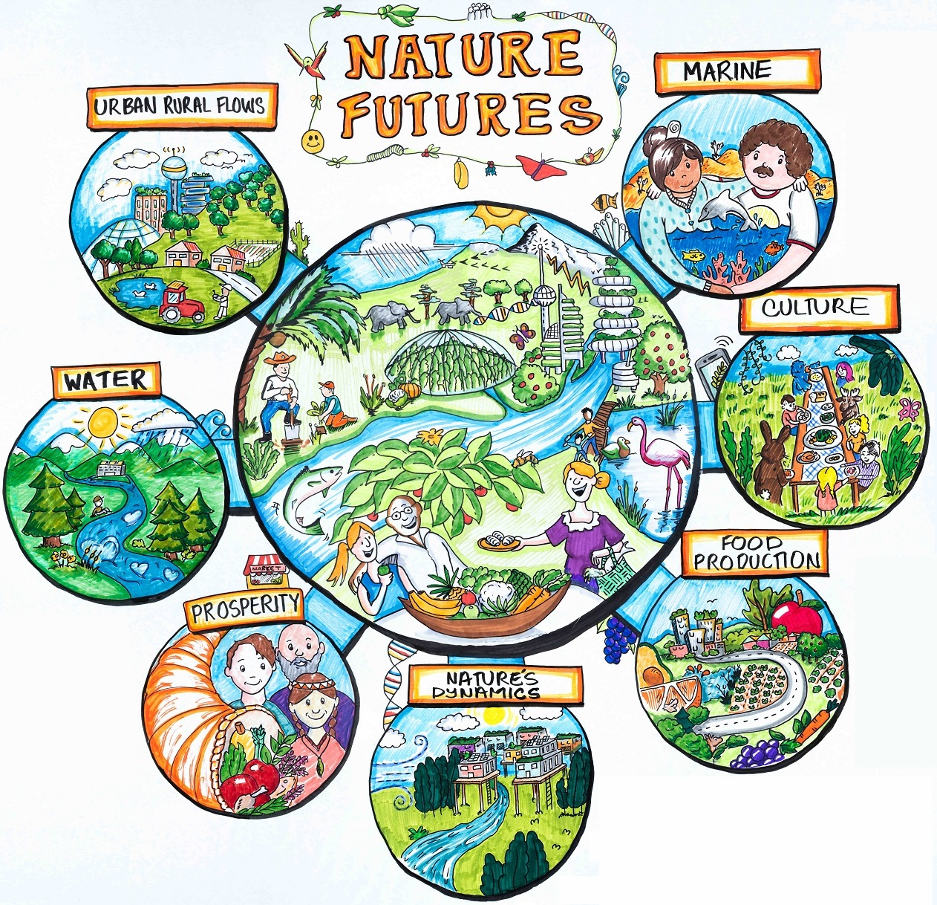

Visions for nature and nature’s contributions to people for the 21st century
Full report can be downloaded at: http://www.niwa.co.nz/naturefutures
Authors:
C. J. Lundquist; H. M. Pereira; R. Alkemade; E. den Belder; S. Carvalho Ribeiro; K. Davies; A. Greenaway; J. Hauck; S. Karlsson-Vinkhuyzen; H. Kim; N. King; T. Lazarova; L. Pereira; G. Peterson; F. Ravera; T. van den Brink; A. Argumedo; C. Arida; D. Armenteras; A.G. Ausseil; B. Baptiste; J. Belanger; K. Bingham; A.Bowden-Kerby; M. Cao; J. Carino; P.A. Van Damme; R. Devivo; F. Dickson; J.P. Dushimumuremyi; S. Ferrier; A. Flores-Díaz; M. Foley; J. Garcia Marquez; P. Giraldo-Perez; S. Greenhaigh; D.J. Hamilton; P. Hardison; G. Hicks; K. Hughey; R. Kahui-McConnell; G. Karuri-Sebina; M. De Kock; P. Leadley; F. Lemaitre; E. Maltseva; C.A. de Mattos Scaramuzza; M. Metwally; W. Nelson; H. Ngo; C. Neumann; C. Norrie; J. Perry; R. Quintana; V.E. Rodriguez Osuna; C. Roehrl; J. Seager; H. Sharpe; T. Shortland; P. Shulbaeva; U.R. Sumaila; Y. Takahashi; N. Titeux; S. Tiwari; C. Trisos; A. Ursache; A. Wheatley; D. Wilson; S. Wood; E. van Wyk; T.X. Yue; D. Zulfikar.
Artwork
Dave Leigh, Emphasise Ltd.; Mary Brake, Reflection Graphics; Pepper Lindgren-Streicher, Pepper Curry Design
Reproduction
This publication may be reproduced in whole or in part and in any form for educational or nonprofit services without special permission from the copyright holder, provided acknowledgement of the source is made.
Technical Support
IPBES Technical Support Unit on scenarios and models held at PBL Netherlands Environmental Assessment Agency
For further information, please contact:
IPBES Technical Support Unit for scenarios and models: tsu-ipbes.scenarios@pbl.nl
Acknowledgements
The IPBES Scenarios and Models Expert Group thanks the numerous individuals and institutions that supported travel and participation in the IPBES Nature Futures workshop. In particular, funding to support the workshop was provided by the New Zealand Ministry for Business, Innovation and Employment (MBIE) Catalyst: Seeding fund administered by the Royal Society of New Zealand (contract #CSG-NIW1701), the IPBES Trust Fund, the Dutch Ministry of Economic Affairs, the Dutch Ministry of Foreign Affairs, the New Zealand National Institute of Water & Atmospheric Research (NIWA), the University of Auckland School of Science, the Centre for Biodiversity and Biosecurity (Manaaki Whenua – Landcare Research/University of Auckland), Fullers and 360 Discovery Cruises. Sincere thanks also to
Director-General Lou Sanson, Department of Conservation and Dr John Quinn, Programme Leader, Freshwater and Estuaries, NIWA, Dean John Hosking, School of Science, the University of Auckland, Mr Michael Steedman, and the Auckland University Pacific Island Students Association for welcoming our participants to New Zealand.
Suggested citation
Lundquist, C. J., Pereira, H. M., Alkemade, R., den Belder, E., Carvalho Ribeiro, S., Davies, K., Greenaway, A., Hauck, J., Karlsson-Vinkhuyzen, S., Kim, H., King, N., Lazarova, T., Pereira, L., Peterson, G., Ravera, F., van den Brink, T., Argumedo, A., Arida, C., Armenteras, D., Ausseil, A.G., Baptiste, B., Belanger, J., Bingham, K., Bowden-Kerby, A., Cao, M., Carino, J., van Damme, P.A., Devivo, R., Dickson, F., Dushimumuremyi, J.P., Ferrier, S., Flores-Díaz, A., Foley, M., Garcia Marquez, J., Giraldo-Perez, P., Greenhaigh, S., Hamilton, D.J., Hardison, P., Hicks, G., Hughey, K., Kahui-McConnell, R., Karuri-Sebina, G., De Kock, M., Leadley, P., Lemaitre, F., Maltseva, E., de Mattos Scaramuzza, C.A., Metwally, M., Nelson, W., Ngo, H., Neumann, C., Norrie, C., Perry, J., Quintana, R., Rodriguez Osuna, V.E., Roehrl, C., Seager, J., Sharpe, H., Shortland, T., Shulbaeva, P., Sumaila, U.R., Takahashi, Y., Titeux, N., Tiwari, S., Trisos, C., Ursache, A., Wheatley, A., Wilson, D., Wood, S., van Wyk, E., Yue, T.X., Zulfikar, D., Brake, M., Leigh, D., Lindgren-Streicher, P. (2018) Visions for nature and nature’s contributions to people for the 21st century, NIWA, New Zealand.
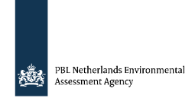
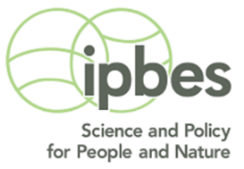

Executive Summary
- Existing scenarios of biodiversity and ecosystem services (BES) have important limitations and gaps that constrain their usefulness for the Intergovernmental Platform on Biodiversity and Ecosystem Services (IPBES). Specifically, they fail to incorporate policy objectives related to nature conservation and
social-ecological feedbacks, they do not address the linkages between biodiversity and ecosystem services, and they are typically relevant at only a particular spatial scale. In addition, nature and its benefits are treated as the consequence of human decisions, but are not at the center of the analysis. To address these issues, the IPBES Scenarios and Models Expert Group initiated the development of a set of Multiscale Scenarios for Nature Futures based on positive visions for human relationships with nature.
- The first step of this process was a visioning workshop with stakeholders and experts on 4-8 September 2017 in Auckland, New Zealand. A total of 73 participants from inter-governmental organizations, national government organizations, non-governmental organizations, academia and the private sector, from 31 countries, and with a range of sectoral expertise on biodiversity topics, from urban development to agriculture to fisheries, worked together in a visioning exercise. This report documents the results from this visioning workshop to inform further stakeholder consultation and the development of the associated multiscale scenarios by modelers and experts.
- This creative visioning exercise was carried out in four steps based on a suite of participatory methods that were used to develop visions of alternative futures (Figure 1). First the participants identified important themes to develop the visions. Next, thematic groups identified the main trends for BES in each theme and a set of “Seeds” of emerging initiatives leading to positive futures for our relationship with nature. Implications of what would happen across a range of sectors were identified for each seed. Then a pathway analysis of how the current regime in each theme may be transformed into the future desirable regime was carried out. Narratives were then built for the visions emerging from each group. Finally, commonalities of visions across the groups were identified, and the regional relevance of each vision for different parts of the world was assessed.
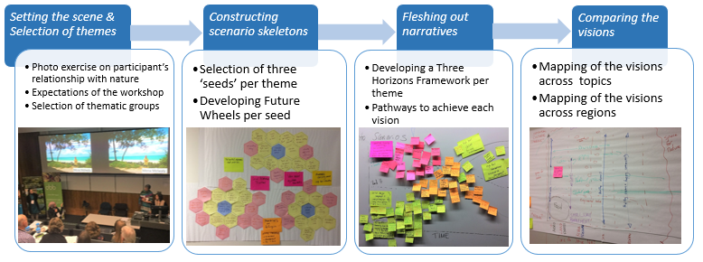
Figure 1. Steps in the development of the stakeholder visions
- Seven thematic groups emerged, with most groups developing a single vision. The visions were the following (Figure 2):
  - Nature-based Inclusive Prosperity: A healthy world, where wealth and wellbeing is accessed fairly and natural resources sustain richly diverse cultures, societies and nature into the future. This would be achieved through a recharacterization of GDP “growth” to ensure it is connected to well-being and nature; international resource use taxation schemes which incentivise sustainable resource use;
in-country development plans with ecological objectives and institutional mechanisms which support community-based economies and natural resource management.
  - Sustainable Food Systems: a world without hunger based on a combination of sustainable supply chains between producers, traders, transporters and retailers, grounded on biodiversity-based food production at land-and seascape level, and supported by reciprocal agreements for sharing benefits, i.e., water and genetic materials.
  - ReFooding and ReWilding the Urban Rural Flows: a world where urban and rural dwellers reconnect with nature, reconcile their interests and assist each other in improving quality of life in the cities and valuing the countryside. Enhanced urban rural flows is achieved by improving governance systems and a locally-contingent mix of ReFooding, i.e. localized ecosystem service flows in cultural landscapes, and ReWilding, i.e. high-tech and global solutions to free up space for nature in the countryside and the cities.
  - Healthy Social-Ecological Freshwater Systems: a world where rivers are awarded legal rights as living systems, water use and extraction is done efficiently at the micro-scale in a circular economy paradigm with no waste-water, and a shift occurs from hydroelectric to other renewable energy systems, also at the micro-scale and decentralised.
  - A Tasty World with Values: a world where human-nature relations are based on reciprocity, harmony and relationality supported by educational systems infused by these values; food is predominantly produced in bio-culturally diverse and autonomous local food systems, strong cultural institutions ensure respectful sharing among diverse knowledge systems and governance systems share universal recognition of local small producers and indigenous peoples’ sovereignty over territories, resources and knowledge.
  - Dancing with Nature: a world in which nature is given space to thrive. Nature is connected and changing at multiple scales. Dancing with Nature requires dynamic people, infrastructure, and civilizations. In this world, human societies build, live and work to accommodate and benefit from natural fluctuations, while using technology to enable people and nature to adapt to the challenges of the Anthropocene.
  - Healthy Oceans, Happy Communities: a world where the oceans and coasts are full of life, ecosystem services are sustained through the adoption of long-term sustainability strategies by governments and businesses (+500-year strategies) and the high-seas are closed to fishing. Local communities are involved in the sustainable management of coastal zones, and new technologies are developed to feed populations who also change their diets to decrease impacts on oceans.

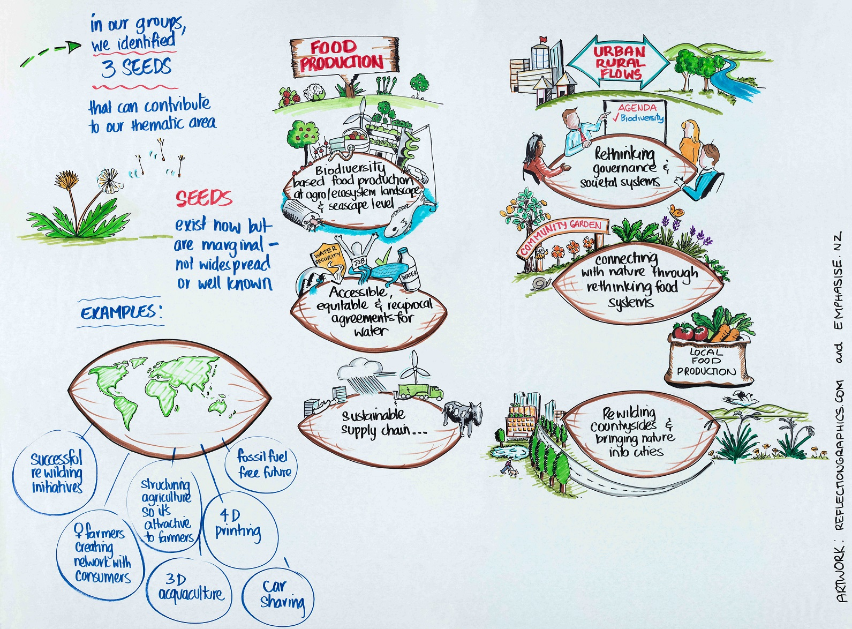
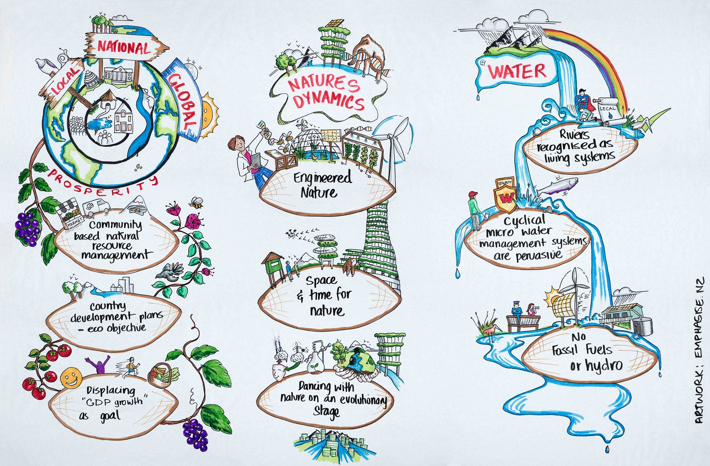
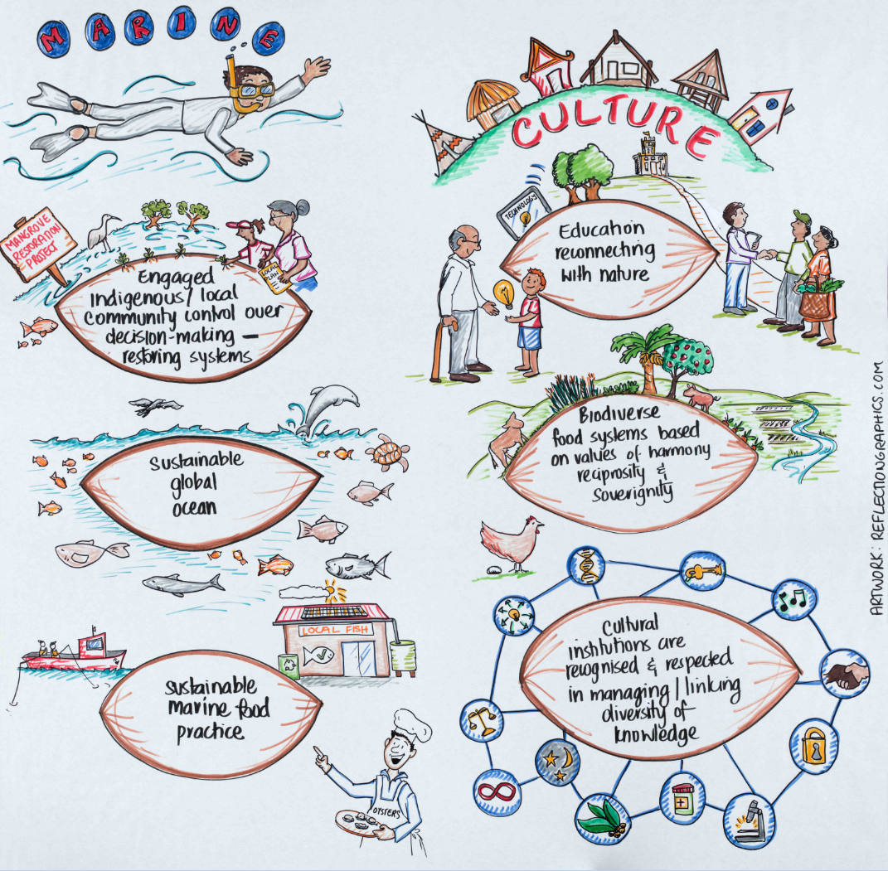
Figure 2. The three seeds for each thematic group (Source: Dave Leigh, Emphasise Ltd.; Mary Brake, Reflection Graphics; Pepper Lindgren-Streicher, Pepper Curry Design). Groups correspond to the following visions: Food Production = Sustainable Food Systems, Urban Rural Flows = ReWilding and ReFooding the Urban Rural Flows, Prosperity = Nature based Inclusive Prosperity, Nature Dynamics = Dancing with Nature, Water = Healthy
Social-Ecological Freshwater Systems, Marine = Healthy Oceans, Happy Communities, Culture = A Tasty World with Values.
- Common themes on preferences for the future of our relationship with nature emerged across the visions. Some visions emphasize the indirect and intangible benefits of biodiversity, such as in ReWilding the Urban Rural Flows, Dancing with Nature, and A Tasty World with Values, while others emphasize the direct uses of nature, such as in the ReFooding and Sustainable Food Systems. Localization of ecosystem service flows and the development of multifunctional landscapes is an important component of ReFooding the Urban Rural Flows, Healthy Social-Ecological Freshwater Ecosystems, A Tasty World with Values, and Nature-based Inclusive Prosperity, while others emphasize the management of global ecosystem service flows or the segregation of spatial uses of ecosystems, such as ReWilding the Urban Rural Flows, Dancing with Nature, and Healthy Oceans, Happy Communities. Other themes emerging from a cross-cutting analysis include the appreciation of specific elements of biodiversity or a more holistic appreciation of biodiversity, varying degrees of the use of technology to improve nature benefits, and varying intensities of nature management. Shared themes across multiple visions include green infrastructure, a circular economy, context-dependent learning to inform environmental governance, and the equalization and reduction of humanity’s global footprint. Several visions, e.g., A Tasty World with Values, require a societal paradigm shift and significant changes in values.
- These visions differ conceptually from traditional scenarios that are used in environmental management, with the emphasis on nature and nature’s benefits to people, and in visioning solely positive futures. These visions also allow for the inclusion of dynamic processes and feedbacks between humans and nature that are missing in current scenarios, e.g., changes in socio-cultural values and changes in practices and concrete strategies for how such changes would come about, inclusion of qualitative values e.g., sense of place, distribution of stakeholders’ preferences, teleconnections, and the complexity of biodiversity change (including aspects such as invasive and endemic species, and spatial scale).
- The visions identified in the workshop do not represent all possible positive future visions; rather, this workshop was just the first step in a 4-year process of developing Multiscale Scenarios for Nature Futures. This process involves iterative cycles of visioning, stakeholder consultation, and modelling (Figure 3). The current set of visions needs now to be consolidated, eventually into a smaller set of visions, through global, regional and local consultations during 2018. We envision using fora such as meetings related to the Convention on Biological Diversity, the Future Earth Network, the Natural Capital Coalition, the
High-level Political Forum on Sustainable Development among others to refine the visions and develop the scenarios. Modelling groups and expert teams will then develop scenarios for each of the visions, that will lead to a new round of storyline development and visioning. It is likely that gaps in visions (i.e., alternative futures that were not identified at the Auckland workshop) will be identified and additional visions will be incorporated into further iterations of the Multiscale Scenarios for Nature Futures. The IPBES expert group on scenarios and models will guide this process up to the end of 2019, when its mandate ends, Scenario development will then continue under the leadership of a consortium of institutes, that will be duly initiated.
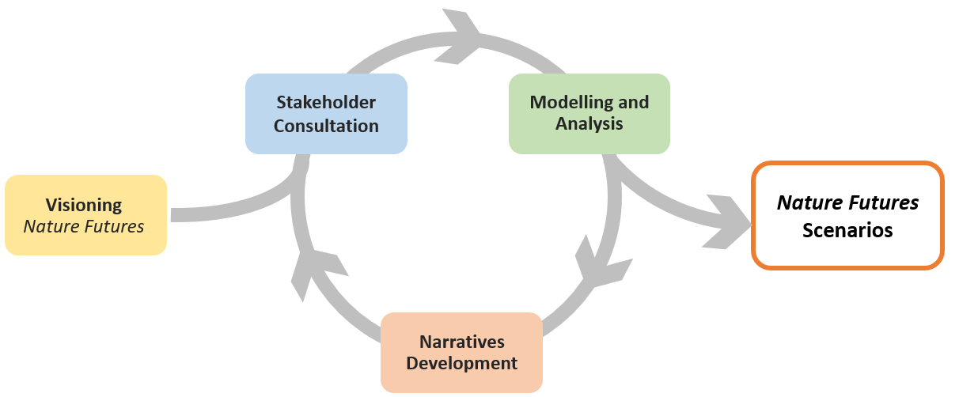
Figure 3. Iterative process for Nature Futures Scenarios development
- The process of iterating multiscale scenarios for nature futures requires substantial ongoing efforts and funding, and capacity building both within and aligned with the IPBES Work Programme. The development of the multiscale scenarios for nature futures needs to link both to ongoing work on both global scenarios connected to IPCC and UNEP GEO processes and to business and government scenarios, as well as inform the increasing number of local, national and regional social-ecological scenarios. Further efforts will be made to engage and coordinate with diverse platforms already involved in local/regional participatory scenarios development. One funding call of direct relevance to this work, the BiodiveERsA/Belmont Forum call, has been put forward and will provide substantial support toward developing Nature Futures scenarios. However, the geographic limitations of this call suggest that other funding opportunities are required to fulfil the regional geographic representation called for by the Multiscale Scenarios for Nature Futures, and to better coordinate the rapid growth in national and regional scenario approaches.

* Reissued for technical reasons on 12 Feburary 2018.
** IPBES/6/1.
Isabel M. D. Rosa, Henrique M. Pereira, Simon Ferrier, Rob Alkemade, Lilibeth A. Acosta, H. Resit Akcakaya, Eefje den Belder, Asghar M. Fazel, Shinichiro Fujimori, Mike Harfoot, Khaled A. Harhash, Paula A. Harrison, Jennifer Hauck, Rob J. J. Hendriks, Gladys Hernández, Walter Jetz, Sylvia I. Karlsson-Vinkhuyzen, HyeJin Kim, Nicholas King, Marcel T. J. Kok, Grygoriy O. Kolomytsev, Tanya Lazarova, Paul Leadley, Carolyn J. Lundquist, Jaime García Márquez, Carsten Meyer, Laetitia M. Navarro, Carsten Nesshöver, Hien T. Ngo, Karachepone N. Ninan, Maria G. Palomo, Laura M. Pereira, Garry D. Peterson, Ramon Pichs, Alexander Popp, Andy Purvis, Federica Ravera, Carlo Rondinini, Jyothis Sathyapalan, Aafke M. Schipper, Ralf Seppelt, Josef Settele, Nadia Sitas and Detlef van Vuuren. 2017. Multiscale scenarios for nature futures. Nature Ecology and Evolution 1, 1416-19.

