UNITED  NATIONS |  |  |  |  | 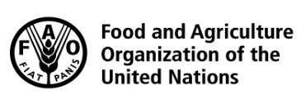 |  |  | BES
 |  |  |  |  |  |  | IPBES/6/INF/32
 |  | Intergovernmental Science-Policy Platform on Biodiversity and Ecosystem Services |  |  |  |  | Distr.: General  20 December 2017  English only
Plenary of the Intergovernmental Science-Policy Platform on Biodiversity and Ecosystem Services
Sixth session
Medellin, Colombia, 18–24 March 2018
Item 10 of the provisional agenda*
Review of the Platform
Review of the Platform: report of the internal review team
Note by the secretariat
- In decision IPBES-5/2, the Plenary of the Intergovernmental Science-Policy Platform on Biodiversity and Ecosystem Services (IPBES) approved the terms of reference for the review of the Platform, set out in the annex to the decision, and the execution of an internal review by the Multidisciplinary Expert Panel and the Bureau and the transmission of its conclusions to the external reviewers. Paragraph 5 of the terms of reference refers to the establishment of an internal review team, while paragraph 11 stipulates that the internal review team is to prepare a report from an internal perspective to be presented for the information of the Plenary at its sixth session.
- Accordingly, the report prepared by the internal review team is set out in the annex to the present note. The report, which is presented without formal editing, has been endorsed by the Multidisciplinary Expert Panel and the Bureau. It contains an executive summary, which is based on a quantitative analysis of the ratings received in response to the finalized version of the questionnaire that was set out in the appendix to the annex to decision IPBES-5/2, the qualitative comments received as part of the same questionnaire, and aspects that the members of the internal review committee chose to highlight based on their experience. The report also contains a detailed section-by-section analysis of responses to the questionnaire. Appendix I to the report provides information on the mandate, process and methodology of the report. Appendix II provides, for each of the 99 questions of the questionnaire that allowed for a rating of 1 to 5, a column chart showing the percentage of each rating for each question, and the mean rating with standard deviation. For the 7 questions for which the responses were limited to “yes” or “no”, appendix II provides the percentages of yes or no responses received, the number of responses received and a pie chart illustrating the responses. Appendix III provides information on the aspects of the work of IPBES that received the highest and lowest ratings, respectively. Appendix IV contains a summary overview of qualitative comments received as part of the questionnaire. Appendix V contains the final version of the questionnaire used as the basis for the report.

Annex
Review of the effectiveness of the administrative and scientific functions of the Platform: report of the internal review team
Introduction
- This report contains:
  - An executive summary, which presents the key outcomes of the internal review as prepared by the internal review committee and endorsed by the Bureau and the Multidisciplinary Expert Panel. Statements in bold result directly from the quantitative analysis of the questionnaire, while text not in bold originates from additional comments received via the questionnaire and includes aspects that the internal review committee chose to highlight based on the experience of its members;
  - A detailed, section-by-section analysis of the questionnaire, including considerations for the future, highlighted by the Multidisciplinary Expert Panel and Bureau based on the quantitative results and some of the qualitative comments, which are summarized in appendix IV.
  - Appendices with additional information:
    - Appendix I provides information on the mandate and process for and methods of the report;
    - Appendix II provides, for each of the 99 questions of the questionnaire that allowed for a ranking, the percentage of responses received for each of the ratings 1-5, a column chart illustrating the number of responses received for each of the ratings 1-5, and the mean with standard deviation. For the seven questions for which the responses were limited to “yes” or “no”, appendix II provides the percentages of responses (“yes” or “no”) received, the number of responses received and a pie chart illustrating the responses;
    - Appendix III provides information on the aspects of the work of IPBES that received the highest and lowest ratings, respectively;
    - Appendix IV contains a summary overview of qualitative comments received as part of the questionnaire;
    - Appendix V contains the final version of the questionnaire used as the basis for the report.
Executive summary: key outcomes of the internal review
I. General overall conclusion
- The internal review analysed IPBES according to the terms of reference of the review with regard to its effectiveness and efficiency, measured against its current objectives, operating principles, four functions and administrative and scientific processes for implementing the work programme, the efficiency of the delivery of the work programme and established support structures, the procedures for the preparation of IPBES deliverables and other relevant decisions by the IPBES Plenary.
- The internal review found that IPBES is, overall, functioning well with an overall average rating of 3.5 out of 5 (see figure 1), while there is potential for improvement in a number of areas.
Figure 1
Average percentage of responses received across all questions for each of the ratings, from 1 to 5

- Only minor differences may be observed in the overall ratings between the five categories of respondents: members of the subsidiary bodies of IPBES (49 responses) and of the secretariat and IPBES national focal points or experts that are part of the IPBES task forces and expert groups (38 responses; see figure 2).

Figure 2
Average response across all questions given by each category of respondents: members of the Bureau, Multidisciplinary Expert Panel, IPBES national focal points, secretariat, including technical support units, and selected experts (co-chairs of task forces and expert groups and coordinating lead authors of assessments)

II. Implementation of the work programme 2014-18
- The scoping processes for assessments are considered to have worked well, with the exception of the assessment of the sustainable use of wild species, where scoping such a complex issue via remote means was learnt to be inappropriate. More policy experts should be involved in the scoping processes to ensure the relevance of assessments to policymakers. The summaries for policymakers of the pollination and scenarios and models assessments were well received; and future summaries for policymakers should be similar in length or shorter. In general, the management committees of assessments undertaken thus far are considered to have fulfilled their role.
- In order to enable IPBES to improve in such areas as its interdisciplinary and multidisciplinary approach, gender equity and balanced regional representation and participation in its structure and work, the nominations of experts by Governments and organizations should include a higher number of experts with a background in social sciences and humanities, policy making, female experts, experts on indigenous and local knowledge, and experts from Eastern Europe and Africa.
- The scientific independence, credibility, relevance and legitimacy of IPBES assessments would benefit from increased input and comments in the peer-review process, in particular from Governments. The regional dialogue meetings with IPBES national focal points, which were organized under the rolling plan for capacity-building in the context of the third author meetings for the land degradation and restoration assessment and the regional assessments, were well received and could also be considered for future assessment processes as a way of assisting Governments in providing input and comments.
- Unlike the assessment function, which was implemented on the basis of a set of agreed procedures, implementation of the capacity-building, knowledge generation and policy support tools and methodologies functions, including the establishment of links with other initiatives and organizations, required the establishment of a procedural and institutional foundation. As a result, the implementation of these functions has generally been slower, but has been improving recently with relevant procedures being established.
- The usefulness of the catalogue of policy support tools, which includes the catalogues for assessments, was rated, on average, as fair. The catalogue is at an early stage of development, however, and a conclusive assessment of its usefulness is therefore not possible at this point in time. Furthermore, progress was limited by the funds allocated to support this deliverable. Implementation of this function of IPBES is not only achieved through the development of the catalogue for policy support tools, but also through the assessment function, in particular the methodological assessment of scenarios and models and the development of the preliminary guide on values and related work.
- At its fifth session, the Plenary welcomed the capacity-building rolling plan that has since been guiding capacity-building activities. The fellowship programme has been well received. The performance of the capacity-building forum was rated overall as “fair” and its structure may need to evolve. The regional dialogue meetings were well received; their performance may be further improved by holding them earlier in the peer review process.
- Aspects of the work on knowledge and data are considered as overall “fair”, and work contributing to this function should be enhanced in the future. Regarding catalyzing the generation of new knowledge, only limited activities have taken place to date as the identification of knowledge gaps builds on the assessments.
- Aspects of the work related to recognizing, respecting and adequately addressing indigenous and local knowledge were considered overall as “good” or between “fair” and “good”. This work is considered to have been advanced in a major way through the adoption, by the Plenary at its fifth session, of the approach to recognizing and working with indigenous and local knowledge. Its implementation, including through the participatory mechanism, is expected to further advance this work in the future. The involvement of indigenous and local knowledge holders in IPBES activities should be increased.
- Synergies between the four functions of IPBES are considered to be an area in need of improvement. The allocation of the budget among the various deliverables of IPBES was considered “fair”. Synergies and balance between the four functions are an important consideration for the development of the second work programme.
III. Functioning of the Plenary, Bureau, Multidisciplinary Expert Panel and secretariat, including technical support units
- Sessions of the Plenary are considered to be well organized and conducted in an effective manner, with appropriate information and documentation, and decisions of the Plenary are considered to be effectively implemented by the secretariat, Bureau and Multidisciplinary Expert Panel. Advice to the Plenary on coordination between IPBES and other relevant institutions could be improved.
- The Bureau has effectively discharged its mandate in implementing the administrative functions of IPBES, although it could improve its role in identifying donors and developing partnership arrangements for the implementation of activities of IPBES. Bureau members have effectively conducted their roles related to chairing and contributing to task forces, expert groups and assessment management committees. Members of IPBES and regional groups have been supported by their respective Bureau members to differing degrees.
- The Multidisciplinary Expert Panel has effectively discharged its mandate in implementing the scientific functions of IPBES, although it could improve its role in engaging the scientific community and other knowledge holders with the work programme. Members of the Multidisciplinary Expert Panel have effectively fulfilled their roles related to chairing and contributing to task forces and expert groups. The close interactions between the Bureau and the Multidisciplinary Expert Panel benefitted the work of both bodies and should continue in the future.
- The secretariat has been very effective, in particular given that it was significantly understaffed for a long while. It has ensured good documentation and that sessions of the Plenary and subsidiary bodies have been well organized, it has been responsive to Plenary requests and to national focal points inter-sessionally, and it has provided good support for delivery of the work programme. The effectiveness of the technical support units has been variable, with some very good, while others improved over the course of the first work programme. The appropriateness of the size, composition and set-up of the secretariat, including its technical support units, is considered “fair”; for the second work programme it is important to match the size of the work programme with adequate resources at the secretariat.
IV. Functioning of the task forces and expert groups
- Interactions between the task forces, expert groups and assessments are considered in need of improvement. The capacity-building task group and the expert groups on scenarios and models and values have worked well. The work of other expert groups was considered “fair”. While the generation of the sets of indicators has been important, the time to develop them made them less useful for the regional assessments and the land degradation and restoration assessment.
V. Partnerships, stakeholder engagement and communication
- Collaboration with partners within the United Nations system and with other relevant organizations, initiatives and networks has progressed but overall collaboration is considered to be an area in need of improvement. Stakeholder engagement, outreach and communication are considered to need strengthening, while it is acknowledged that a recent recruitment has significantly strengthened the communications and outreach activities. The visibility of IPBES needs to extend beyond ministries of environment.
VI. Effectiveness of budgetary management and financial rules
- Given the tight budgetary situation, it was recognized that there is a need to step up fundraising activities. The financial rules are considered to have been observed well, and the budget documents presented to the Plenary are adequate. Significant amounts of in-kind contributions have been obtained, reducing pressures on the IPBES trust fund.

Detailed results of the questionnaire used as basis for the internal review and considerations for the future
- The following sections present the quantitative results from the questionnaire undertaken as a basis for the internal review, followed by sub-sections on “considerations for the future” which are suggested by the Bureau and the Multidisciplinary Expert Panel based on the quantitative results and some of the qualitative comments, which are summarized in Appendix IV.
I. Functions of IPBES
A. Assessing knowledge on biodiversity and ecosystem services to support the science-policy interface
- The review of the assessment function was focused on the processes for the nomination and selection of experts, the functioning of the management teams, the processes for preparing assessment scoping reports, and the usefulness of completed assessments to policy-makers and other users. The substance of the assessments was not the subject of the review.
- The most highly rated aspect of work related to assessments was that the completed summary for policymakers of the assessment of pollination and pollinators had been written in a style that is easily understood by a wide range of audiences (mean rating of 4.1; 85% out of 66 respondents chose “well” or “very well”). The summary for policymakers of the scenarios and models assessment received a slightly lower rating (mean rating of 3.5; 55% of 62 respondents chose “well” or “very well”). The general question of whether the lengths of the completed summaries for policymakers has been appropriate was rated with “well” or “very well” by 69% out of 70 respondents.
- The scoping processes were considered to have worked well overall (mean rating for the four regional assessments 3.7; regional assessments of biodiversity and ecosystem services for Africa (3.7), the Americas (3.9), Asia-Pacific (3.8), and Europe and Central Asia (3.7); global assessment (3.9); land degradation and restoration assessment (3.7); values assessment (3.6); assessment of invasive alien species (3.4) and sustainable use of wild species (2.9)). The management committees overseeing the assessments were rated to have worked “well”, with the exception of the management committees of the land degradation assessment, and of the regional assessments for Africa that were rated “fair” (3.3 and 3.4, respectively).
- 28% of 68 respondents disagreed or disagreed strongly with the proposition that experts and Governments have provided adequate input and comments. 50% out of 68 respondents agreed or strongly agreed that the peer-review process has been efficient. The questionnaire also addressed the processes for the nomination and selection of authors, and mixed reviews were received. 54% out of 74 respondents and 55% out of 75 respondents, respectively, agreed or agreed strongly that these processes have worked well.
Considerations for the future
- The summaries for policy makers should be of a similar or shorter length to that of the assessment of pollinators, pollination and food production. The text should be written in a non-technical style that is accessible to policymakers. Governments should be invited to translate the summaries for policymakers into languages other than the official languages of the United Nations to facilitate uptake at the national level.
- The involvement of policy experts and users of IPBES assessments in the scoping processes could enhance the policy relevance of the assessments. This could be accomplished through the nomination and selection of such experts as part of the scoping expert team. An in-person meeting of scoping experts is considered indispensable for the scoping of complex themes.
- Clearer guidance on the roles, responsibilities and operational aspects of the management committees should be established.
- Access to drafts of assessment reports should be simplified. Experts and Governments are encouraged to provide more detailed comments on the draft assessment reports. Governments could be assisted through regional dialogue meetings earlier in the process, preferably at the beginning of the second order draft review processes. Communication and collaboration between assessment co-chairs and the Multidisciplinary Expert Panel and the Bureau could be strengthened.
- Governments and other stakeholder groups are encouraged to nominate a more balanced set of nominees consistent with the scope of the assessments. In particular, there is a need for increased nominations of women, social scientists, scholars from the humanities, experts and holders of indigenous and local knowledge. A greater number of nominations is needed from Eastern Europe and Africa. Governments could be assisted by the Multidisciplinary Expert Panel in identifying relevant experts in each region. The results of the selection process by the Multidisciplinary Expert Panel should be communicated more clearly and transparently.
B. Policy-relevant tools and methodologies
- The review of IPBES’ function related to policy-relevant tools and methodologies focused on the usefulness of the catalogue for policy support tools. 38% out of 56 respondents rated the usefulness of the catalogue “good” or “very good”, 18% rated it “poor” or “very poor”. The mean rating was 3.2.
Considerations for the future
- More emphasis, with a clearer mandate and adequate funding, could be placed on this activity in the future, to strengthen the development of the catalogue which includes information contained in the assessments and submitted by Governments and other stakeholders, (e.g., on the effectiveness of policy tools and methodologies), and consider other activities beyond the catalogue.
C. Capacity-building
- The review of IPBES’ function related to capacity-building focused on a range of aspects, including the pilot fellowship programme, building capacity for the implementation of the work programme, the catalysis of financial and in-kind support, the inclusion of indigenous and local knowledge holders, links with other international initiatives and the capacity-building forum.
- The pilot fellowship programme was considered the most successful aspect of IPBES’ work on capacity-building, with 70% of 63 respondents evaluating the programme as working well or very well. 38% of 56 respondents rated the matching of IPBES funding for the priority capacity-building needs identified by the Plenary, with other resources by catalysing financial and in-kind support as good or very good.
- The degree of success of the capacity-building forum was rated “fair” (mean rating 3.1). The degree to which IPBES has established appropriate links with other international initiatives and their effectiveness was rated by 48% of as “fair” and by 20% as “poor or very poor”. The degree to which capacity building activities involved indigenous and local knowledge holders received an average rating of “fair” (2.8).
Considerations for the future
- The Plenary-approved rolling plan should form the basis for capacity building activities in the near future.
- There is a need to increase interactions with the other IPBES activities, in particular the assessments, and with policy-makers, to expand partnerships, mobilize financial and technical resources, and to reconsider the format of the capacity-building forums and membership of the capacity-building task force.
D. Knowledge and data
- The review of IPBES’ function related to knowledge and data focused on cooperation with other international initiatives and use of data sets held by partner organizations, the management of data and information used in assessments and support provided by the task force on knowledge and data.
- The question regarding the work of the task force on knowledge and data received the lowest rating among the various aspects of the work on knowledge and data, with 51% of 51 respondents answering that they disagree or strongly disagree with the proposition that the task force provided, in time, the necessary inputs to assessments. Processes used to manage the data and information used in assessments were rated “fair” (mean rating of 3.0). The question to what degree IPBES has established appropriate links with other international initiatives and identified and used existing data sets held by partner organizations received a mean rating of 3.4, with 47% of 64 respondents rating it “good” or “very good”.
Considerations for the future
- The indicators work should become more interdisciplinary and take into consideration different worldviews and related knowledge systems, i.e., involve more social scientists and experts and holders of indigenous and local knowledge, and more policy-relevant. Synergies with existing data and indicator processes could be enhanced. Further guidance could be provided regarding the role of indicators in assessments.
- The work on knowledge generation should increase as assessments are completed, uncertainties and research needs identified, and potential funders engaged in a dialogue.
- The terms of reference, scope and membership of the data and knowledge task force should be revisited.
E. Synergies between the four functions
- The question whether the four functions of IPBES have worked well together received mixed results. 37% of 68 responses were “well” or “very well”, while 24% of responses were “poor” or “very poor”, and 40% of responses “fair”.
Considerations for the future
- Synergies among the four IPBES functions should be improved through measures such as: involving assessment experts in deliverables related to other functions, including related task forces (see also section IV below); participation of experts in more than one task force or activity; organization of task force meetings together; and greater interactions among technical support units. Better synergies and balance between the four functions is an important consideration for the development of the second work program.
II. Operating principles of IPBES
A. Indigenous and local knowledge
- One of IPBES’ operating principles is “recognize and respect the contribution of indigenous and local knowledge to the conservation and sustainable use of biodiversity and ecosystems”.
- 63% of 67 respondents answered that IPBES has recognized, respected and adequately addressed indigenous and local knowledge in its work “well” or “very well”; with another 28% answering “fair”. 46% out of 63 respondents agreed or agreed strongly and 41% felt neutral about whether the processes for working with indigenous and local knowledge in IPBES activities have been appropriate. 52% out of 63 respondents agreed or fully agreed that IPBES has developed new strategies and methodologies to adequately work with indigenous and local knowledge, with 16% of respondents disagreeing or strongly disagreeing.
Considerations for the future
- Better communication and linkages between the work of the task force on indigenous and local knowledge and the assessments should be established. The membership of the task force should be revisited to include experts involved in assessments; membership could include more diverse disciplinary backgrounds.
- Engagement of indigenous peoples and local communities in IPBES should be enhanced, in particular through the participatory mechanism. Work with strategic partners and organizations of indigenous peoples and local communities should be improved thorough the participatory mechanism.
- In the context of strengthening indigenous and local knowledge in IPBES, more focus could be given to local knowledge
- Governments are encouraged to nominate more experts on indigenous and local knowledge and indigenous and local knowledge experts.
B. Geographical, disciplinary and gender balances in IPBES’ activities
- The operating principles of IPBES refer to balanced regional representation and participation in the structure and work of IPBES, an interdisciplinary and multidisciplinary approach that incorporates all relevant disciplines, including social and natural sciences, as well as the need for gender equity.
- Gender balance, regional representation and participation, and the implementation of an interdisciplinary and multidisciplinary approach were rated “fair” (mean ratings of 3.6, 3.3 and 3.3, respectively).
- As of 25 November 2017, 1301 experts have been selected as members of IPBES task forces or expert groups (not including scoping processes), with the following distribution by regions: African States, 15 %; Asia-Pacific States, 20 %; Latin American and Caribbean States, 17 %; Eastern European States, 10 %; and Western European and other States, 36 %. 36% of selected experts are women. Geographic and disciplinary balances have been very difficult to achieve due to a lack of sufficient nominations of experts from some regions and with social science backgrounds. Similarly, nominations by governments only included 22% female candidates.
Considerations for the future
- Similar to the considerations in section I A above (paragraph 30), Governments and other stakeholder groups should be encouraged to nominate a more balanced set of nominees. In particular, there is a need for greater gender balance, increased nominations of social scientists, scholars from the humanities, and experts of indigenous and local knowledge. A greater number of nominations is needed from Eastern Europe and Africa.
- In line with decision IPBES-4/2, Governments in a position to do so should be further encouraged to fund the participation of their elected officers and selected experts in the work of IPBES.
C. Useful and policy-relevant information
- The operating principles of IPBES include the provision of policy-relevant information, but not policy-prescriptive advice, mindful of the respective mandates of the multilateral environmental agreements; and to be scientifically independent and ensure credibility, relevance and legitimacy through peer review of its work and transparency in its decision-making processes. In this context, the review focused on the process to receive requests, on the process of peer-review, and on whether existing processes support the policy-relevance of assessments.
- Regarding the process to receive requests, about half of the respondents agreed or agreed strongly that they held internal consultations before responding to the call for request (59% of 34 responses), that the call for requests to IPBES members and stakeholders and the mechanism proposed by the secretariat for responding to the call was clear, transparent and efficient (55% of 58 respondents), and that the list of the deliverables in the work programme, which was based on the requests, meets the needs of their country/organization and is policy-relevant (49% of 55 respondents). The question evaluating the level of satisfaction with the way the Multidisciplinary Expert Panel processed the requests and presented a prioritized list to the Plenary on the one hand received “good” or “very good” ratings from more than half of the respondents (58% of 36), but on the other hand received “poor” or “very poor” ratings from 19% of the respondents.
- The questionnaire also assessed that 42% and 58%, respectively, of 24 government representatives responding to the questionnaire provided comments during the review processes of the assessment of scenarios and models and the assessment of pollination, pollinators and food production (33% of 30 respondents and 53% of 34 stakeholder representatives, respectively). The question, whether, in their view, the scenarios and models assessment and the pollination assessment received comments which helped increase their policy relevance, was answered positively by 53% of 40 respondents and 74% of 50 respondents, respectively. 51% of 68 respondents agreed or strongly agreed that the scoping processes have been conducive to the preparation of policy-relevant deliverables (mean rating of 3.5). The conduciveness of the composition of expert groups to the preparation of policy-relevant deliverables was rated “fair” (mean rating 3.1). 83% of 66 respondents are of the view that IPBES should have mechanisms to follow the uptake of policy-relevant evidence of an assessment at national and international levels.
Considerations for the future
- To ensure assessments meet the needs of Governments and other users, calls for requests for future elements of the second work programme could be complemented by intersessional regional dialogue meetings, taking place very early in the process of framing the programme, as a mechanism to discuss future elements of a second work program.
- To further ensure assessments are policy relevant, expert scoping meetings should include policy experts from governments, and intersessional regional dialogue meetings could assist Governments in the preparation of peer-review comments.
- Processes to track the policy impact of assessments could be further developed.
III. Functioning of the Plenary, Bureau, Multidisciplinary Expert Panel, secretariat, including technical support units
A. Functioning of the Plenary
- The review of the functioning of the Plenary as the decision-making body of IPBES, comprising all members of IPBES, in line with Rule 2 of the rules of procedure for sessions of the Plenary of IPBES, focused on its general organization and conduct, the information and documentation provided to the Plenary, the effectiveness of its decisions as well as coordination between IPBES and other relevant institutions.
- It is considered that the information and documentation presented to the Plenary has enabled it to play its role in an effective manner (mean rating 3.9; “good”). Decisions made by the Plenary are considered to be effectively implemented by the secretariat, the Bureau and the MEP (mean rating 3.9; “good”). Similarly, sessions of the Plenary have been organized and conducted in an effective manner (mean rating 3.9; “good”). 60% of 58 respondents responded with a positive rating (“well” or “very well”) to the question to what degree the Plenary has been properly advised on coordination between IPBES and other relevant institutions.
Consideration for the future
- In terms of sessions of the Plenary, in-session documents should be made available more in advance to allow their thorough review by Plenary participants before adoption. More information should be provided to the Plenary on decisions taken by the Multidisciplinary Expert Panel and the Bureau in the intersessional period.
- The Plenary would be expected to continue to meet annually, although Plenary might consider other arrangements.
B. Functioning of the Bureau and Multidisciplinary Expert Panel
- The review assessed the performance of the Bureau and Multidisciplinary Expert Panel in fulfilling their mandates, as set out in the rules of procedure for sessions of the Plenary of IPBES and the resolution on IPBES adopted by the second session of the plenary meeting to determine the modalities and institutional arrangements for IPBES, held from 16 – 21 April 2012 in Panama City (see document UNEP/IPBES.MI/2/9), including the implementation of the specific administrative and scientific functions of IPBES.
- Overall, the Bureau and the Multidisciplinary Expert Panel were found to have fulfilled their functions. 80% of 55 respondents to the questionnaire answered that the Bureau followed up on requests addressed to it by the Plenary in its decisions “well” or “very well”. For the Multidisciplinary Expert Panel, the question was answered positively by 79% of 58 respondents. 76% of 58 respondents agreed or fully agreed that the Bureau effectively conducted its roles related to chairing and contributing to task forces, expert groups and assessment management committees; for the Multidisciplinary Expert Panel the score was 80% of 59 respondents on this same question.
- The Bureau is considered to have implemented the administrative functions of IPBES overall well (mean ratings between 3.5 and 4.0 for individual functions); the implementation of the function to identify donors and develop partnership arrangements could be improved (mean rating of 2.9). 71% of 52 respondents answered that members of IPBES and regional groups have been “well” or “very well” supported by their respective Bureau members.
- The Multidisciplinary Expert Panel is considered to have implemented the scientific functions of IPBES overall well (mean ratings between 3.5 and 3.9); engaging the scientific community and other knowledge holders with the work programme of IPBES, taking into account the need for different disciplines and types of knowledge, gender balance, and effective contribution and participation by experts from developing countries, could be improved (mean rating of 3.3).
Considerations for the future
- Engagement with the scientific community, in particular by the Multidisciplinary Expert Panel, should be enhanced. The capacity of the Multidisciplinary Expert Panel regarding social sciences, indigenous and local knowledge systems, humanities and policy matters should be increased. Gender balance in the membership of the Bureau and the Multidisciplinary Expert Panel could be improved. It could be considered to invite additional observers to meetings of the Multidisciplinary Expert Panel, when appropriate (e.g. co-chairs of ongoing assessments; members of secretariats of biodiversity-related multilateral environmental agreements).
- Intersessional communication between Bureau members and national focal points should be increased in most regions.
- The close interactions between the Bureau and the Multidisciplinary Expert Panel benefitted the work of both bodies and should continue in the future.
C. Functioning of the secretariat, including technical support units
- The review assessed the performance of the secretariat in fulfilling its mandate, as set out in the rules of procedure for sessions of the Plenary of IPBES and the resolution on IPBES adopted by the second session of the plenary meeting to determine the modalities and institutional arrangements for IPBES, held from 16 – 21 April 2012 in Panama City (see document UNEP/IPBES.MI/2/9), and the performance of the technical support units, which under the oversight of the secretariat provide support for regional, functional or thematic aspects of the work programme in line with decision IPBES-2/5, annex I, section III.
- The secretariat received the rating “good” (mean rating of 4.0) for effectively following up on requests addressed to it by the Plenary in its decisions, providing support for the delivery of the work programme according to the decisions of the Plenary, providing responses to queries by national focal points and stakeholders between sessions of the Plenary, and preparing documentation of high quality on time. For organizing sessions of the Plenary, meetings of the Multidisciplinary Expert Panel and Bureau and other technical meetings the secretariat received a mean rating of 4.1.
- The efficiency and effectiveness of technical support units received a mean rating of 3.5 (“good”). Integration among the various technical support units themselves, and with the secretariat headquarters was also rated 3.5 (“good”). 54% of 63 respondents rated the interaction between the various bodies of IPBES functioning “well” or “very well”.
- 28% of 72 respondents disagreed or disagreed strongly with the proposition that the size, composition and set-up of the secretariat, including its technical support units (TSU) are adequate; 43% “agreed” or “agreed strongly” with the proposition, with an overall mean rating of 3.2 (“fair”).
Considerations for the future
- For the second work programme, it is important to match the size of the work programme with adequate resources at the secretariat. The secretariat should undertake additional efforts to communicate with IPBES national focal points, with the support of members of the Bureau.
- A strong scientific and technical background and sufficient numbers of staff are important for the success of a technical support unit.
- An increased number of secondments and internships could assist the secretariat and technical support units.
IV. Functioning of the task forces and expert groups
- The review addressed the effective functioning of the task forces and expert groups established in line with decision IPBES-2/5, annex I, section III, and related decisions by the Plenary.
- The highest rating was given to the expert group on scenarios and models (81% of 53 respondents rated their effectiveness “good” or “very good”) and the task force on capacity-building (77% of 53 respondents), followed by the expert group on values (65% of 51 respondents), the task force on indigenous and local knowledge (44% of 55 respondents), the expert group on policy-support tools (34% of 47 respondents) and the task force on knowledge and data (33% of 54 respondents). The interaction among the task forces, expert groups and assessments was considered “good” or “very good” by 35% and “poor” or “very poor” by 19% of 62 respondents, with an overall mean rating of 3.1 (“fair”).
Considerations for the future
- The composition of task forces and expert groups should be reconsidered, with a greater involvement of experts engaged in assessments. Also, task forces and expert groups could provide even greater guidance and support to assessments.
V. Partnerships, stakeholder engagement and communication
A. Partnerships
- As the operating principles of IPBES also include collaborating with existing initiatives on biodiversity and ecosystem services, the review also addressed partnerships.
- Collaboration with existing initiatives on biodiversity and ecosystem services, including multilateral environmental agreements, United Nations bodies and networks of scientists and knowledge holders received an overall “fair” rating (mean rating 3.5; 52% of 67 respondents agreed or fully agreed). Similarly, the development and implementation of partnership arrangements at global, regional and national levels for the conduct of IPBES activities, received the rating “fair” (mean rating 3.4, 42% of 64 respondents agreed or fully agreed).
Considerations for the future
- Partnerships should be strengthened significantly. In particular, collaboration with all relevant multilateral environmental agreements, United Nations organizations, international assessment processes (e.g., Intergovernmental Panel on Climate Change and the World Oceans Assessment), and with networks of scientists and knowledge holders, could be further strengthened. For the second work programme, further approaches and processes for entering into and managing partnerships could be developed.
- Where possible, partnerships should be established with a concrete substantive focus.
B. Stakeholder engagement and communication
- The review of stakeholder engagement and communication focused on the implementation of the IPBES communication and outreach and stakeholder engagement strategies (decision IPBES-3/4) and whether they are considered sufficient to support the mission and work programme of IPBES.
- The IPBES communication and outreach strategy was rated “fair” (mean rating 3.3) regarding its support to the mission and work programme of the Platform. A similar rating (3.2) was achieved for the implementation of the communication and outreach strategy regarding its effectiveness in widening the reach and impact of IPBES’ work. 61% of 69 respondents agreed or strongly agreed that the branding policy of IPBES, including the use of its logo, has been adequate.
- The questions concerning stakeholder engagement received an overall “fair” rating (mean ratings 3.2). 34% of 61 respondents rated the IPBES Stakeholder Engagement Strategy “well” or “very well” regarding the question to which degree it provides sufficient support to the mission and work programme of the Platform. 31% of 59 respondents rated the implementation of the Stakeholder Engagement Strategy “well” or “very well” regarding the question to which degree it has been effective in widening the reach and impact of IPBES’ work.
Considerations for the future
- Regarding communication efforts, the visibility of IPBES should be raised outside of Ministries of the Environment (e.g. agriculture, finance, energy, etc.).
- Where possible, the use of communication materials in languages other than English could be increased.
- IPBES should engage with a wider and more diverse set of stakeholders, in particular the private sector and indigenous peoples’ organizations.
VI. Effectiveness of budgetary management and financial rules
- The review of the effectiveness of budgetary management and financial rules focused on the cost-effective use of financial resources, the observation of the financial rules, the quality of documentation provided as a basis for budget negotiations, the mobilization and use of in-kind support and the leveraging of activities undertaken by third parties, and the distribution of financial resources among the various deliverables.
- 74% of 47 respondents stated that the financial rules of IPBES have been observed “well” or “very well”; and 72% of 57 respondents agreed or agreed strongly that the budget documents had been adequately presented to Plenary. 67% of 58 respondents rated the management and cost-effective use of financial resources as “good” or “very good”. Overall mean ratings ranked between 3.7 and 4.0.
- The effective mobilization and use of the potential of in-kind offers, and of the leveraging potential of promoting and catalysing activities and impact through third parties, such as strategic partners, received mean ratings of 3.6 and 3.2, respectively, with 54% of 61 respondents and 37% of 57 respondents agreeing or agreeing strongly.
- The allocation of the budget among the various deliverables was considered “good” or “very good” by 41% of 51 respondents, with a mean rating of “fair” (3.4).
Considerations for the future
- Fundraising activities should be enhanced and funding sources diversified. The benefits that IPBES provides should be showcased more strongly.
- Communication, outreach, awareness-raising and capacity-building should be enhanced to increase support for IPBES by partners. Acknowledgement and recognition of support and in-kind contributions should be significantly strengthened.
- Consistent, targeted and systematic approaches to raising and following up on offers for in-kind contributions as well as to leveraging activities undertaken by third parties and funding in support of these activities should be developed.

Appendix I
Mandate, process and methods regarding the internal review
Mandate and process
- In decision IPBES-5/2, the Plenary approved the terms of reference for the review (contained in annex I to decision IPBES-5/2).
- In the same decision, it also requested the Bureau, in consultation with the Multidisciplinary Expert Panel, taking into account comments received at the fifth session of the Plenary, to revise the questionnaire set out in the appendix to the terms of reference; requested the secretariat to make the revised questionnaire available to members and stakeholders of IPBES for review for a period of two weeks after the fifth session of the Plenary; and requested the Bureau, in consultation with the Multidisciplinary Expert Panel, to finalize the questionnaire, taking into account the comments received during this period.
- Further, the Plenary approved the execution of an internal review by the Multidisciplinary Expert Panel and the Bureau and transmission of its conclusions to the external reviewers. It requested the internal review team to provide the report called for in paragraph 11 of the terms of reference to the Plenary at its sixth session.
- The Bureau and the Multidisciplinary Expert Panel agreed at their 8th meeting on the composition of an internal review team. The team comprises the IPBES Chair, a member of the Bureau (Alfred
Oteng-Yeboah), a co-chair and two members of the Multidisciplinary Expert Panel (Marie Stenseke, Carlos Joly and Vinod Mathur) and the Executive Secretary.
- In response to decision IPBES-5/2, the internal review team, on behalf of the Bureau and the Multidisciplinary Expert Panel, revised the questionnaire and made it available for comments to IPBES members and stakeholders for a period of two weeks (28 April to 12 May 2017). 16 sets of comments were received, including from 4 governments (Australia, Malaysia, Nepal, United States of America), the European Union and 11 individuals. The internal review committee finalized the questionnaire, taking these comments into account. The final version of the questionnaire is contained in appendix III.
- According to paragraph 11 of the terms of reference, the internal element of the review consists of a self-assessment based on the responses to the questionnaire by former and current members of the Multidisciplinary Expert Panel and Bureau; the secretariat, including the technical support units, members of IPBES task forces; co-chairs and coordinating lead authors of completed and ongoing IPBES assessments; and national focal points. The questionnaire was made available on 22 May 2017, with a deadline of 7 August 2017 for response. The questionnaire was completed by a total of 85 people, including 9 members of the Bureau, 23 members of the MEP, 21 national focal points, 17 IPBES experts (co-chairs of task forces and assessments; coordinating lead authors of assessments, and a small number of task force members and assessment lead authors that received the call in a different capacity) and 17 members of the secretariat (including members of technical support units). Some respondents provided their submissions in more than one capacity.
- In accordance with the terms of reference of the review, the internal review team has prepared, based on the responses to the questionnaire, the present report, which has been endorsed by the Multidisciplinary Expert Panel and the Bureau.
Methods
- Most questions of the questionnaire allowed respondents to select a ranting from 1 to 5 as follows:
5: very good/very well/agree strongly
4: good/well/agree
3: fair/feel neutral
2: poor/poorly/disagree
1: very poor/very poorly/disagree strongly
N/A: do not know/no opinion/not relevant for me.
- For 7 questions, the options for response were limited to “yes” or “no”. Appendix II provides for each of the 99 questions of the questionnaire that allowed for a rating, the percentage of responses received for each of the ratings 1-5, a column chart illustrating the number of responses received for each of the ratings 1-5, and the mean with standard deviation. For the seven questions for which the responses were limited to “yes” or “no”, appendix II provides the percentages of responses (“yes” or ”no”) received, the number of responses received and a pie chart for each question illustrating the responses.
- All sections of the questionnaire provided the opportunity for respondents to provide additional explanations or comments, referred to as “qualitative comments” in this document. Appendix IV provides a summary overview of these qualitative comments received.
- The report includes an executive summary, which presents the key outcomes of the internal review as prepared by the internal review committee and endorsed by the Bureau and the Multidisciplinary Expert Panel. Statements in bold font result directly from the quantitative analysis of the questionnaire, while text in normal font originates from additional comments received via the questionnaire and includes aspects that the internal review committee chose to highlight based on the experience of its members. The executive summary is reproduced in the annex to document IPBES/6/10.
- The report also contains a detailed, section-by-section analysis of the questionnaire, including considerations for the future highlighted by the Multidisciplinary Expert Panel and Bureau.

Appendix II
Results of the questionnaire
Percentage of responses (1 to 5) received; number of responses received; responses distribution (column charts); and mean with standard deviation, for each one of the 99 questions that were rated (1 to 5). For questions 50-56, for which a “yes/no” was required: percentage of responses (yes/no) received; number of responses received; and responses distribution (pie chart; “yes” corresponds to orange, and “no” to blue).
No | Questions | 1 | 2 | 3 | 4 | 5 | Number of responses | Responses distribution | Mean ± 1 standard deviation
1 | 1a.i. Land degradation and restoration? | 2% | 4% | 26% | 57% | 11% | 53 | 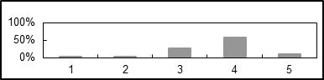
2 | 1a.ii. Overall for the 4 regional assessments? | 0% | 4% | 28% | 58% | 10% | 50 | 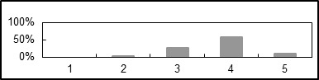
3 | 1a.iii. Regional: Africa | 0% | 0% | 37% | 56% | 7% | 27 | 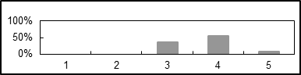
4 | 1a.iv. Regional: Americas | 0% | 0% | 23% | 60% | 17% | 30 | 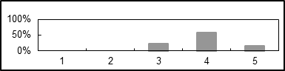
5 | 1a.v. Regional: Asia Pacific | 0% | 4% | 29% | 57% | 11% | 28 | 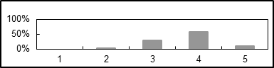
6 | 1a.vi. Regional: Europe and Central Asia | 0% | 3% | 24% | 70% | 3% | 33 | 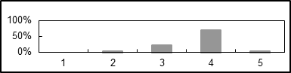
7 | 1a.vii. Global assessment? | 0% | 4% | 22% | 54% | 20% | 54 | 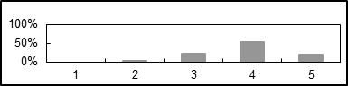
8 | 1a.viii. Invasive alien species? | 0% | 13% | 41% | 38% | 8% | 39 | 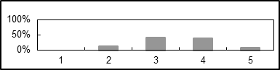
9 | 1a.ix. Sustainable use of wild species? | 16% | 20% | 29% | 33% | 2% | 45 | 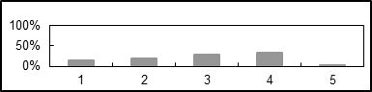 | 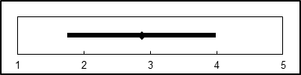
10 | 1a.x. Values and valuation? | 2% | 5% | 30% | 60% | 2% | 43 | 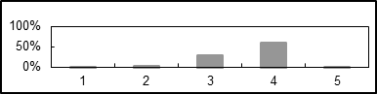
11 | 1b. Have the processes for the nomination of authors (co-chairs, coordinating lead authors, lead authors and review editors) worked well? | 3% | 8% | 35% | 47% | 7% | 74 | 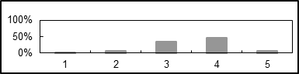
12 | 1c. Have the processes for the selection of authors (co-chairs, coordinating lead authors, lead authors and review editors) worked well? | 3% | 7% | 36% | 47% | 8% | 75 | 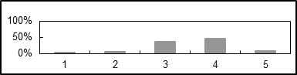
13 | 1d.i. Have experts and Governments provided adequate input and comments? | 3% | 25% | 43% | 19% | 10% | 68 | 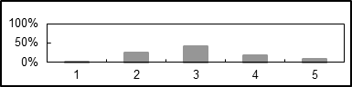
14 | 1d.ii. Has the peer-review process been efficient? | 1% | 15% | 34% | 46% | 4% | 68 | 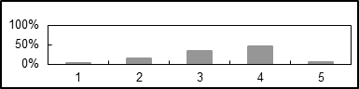
15 | 1e. To what degree have the IPBES completed assessments properly identified confidence limits (i.e. from well-established to inconclusive)? | 2% | 8% | 25% | 50% | 16% | 64 | 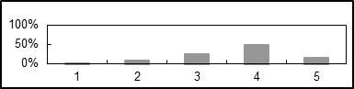
16 | 1f.i. Pollination | 0% | 2% | 14% | 62% | 23% | 66 | 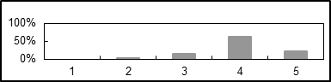
17 | 1f.ii. Scenarios and models | 2% | 8% | 35% | 44% | 11% | 62 | 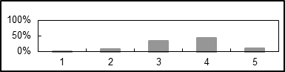
18 | 1g. To what degree have the lengths of the completed summaries for policymakers been appropriate? | 0% | 7% | 24% | 50% | 19% | 70 | 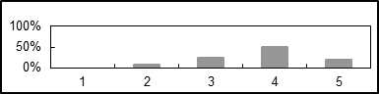
19 | 1h.i. Pollination | 0% | 4% | 28% | 48% | 20% | 25 | 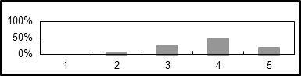
20 | 1h.ii. Scenarios and models | 0% | 0% | 29% | 63% | 8% | 24 | 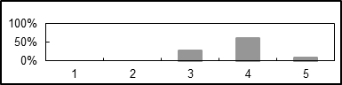
21 | 1h.iii. Regional: Africa | 0% | 13% | 42% | 38% | 8% | 24 | 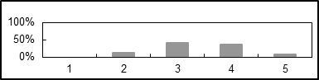
22 | 1h.iv. Regional: Americas | 0% | 9% | 41% | 45% | 5% | 22 | 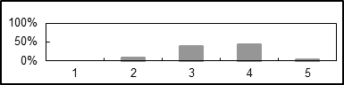
23 | 1h.v. Regional: Asia and the Pacific | 0% | 5% | 38% | 52% | 5% | 21 | 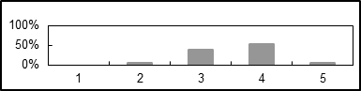
24 | 1h.vi. Regional: Europe and Central Asia | 0% | 5% | 27% | 41% | 27% | 22 | 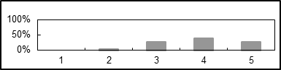
25 | 1h.vii. Land degradation | 3% | 14% | 34% | 43% | 6% | 35 | 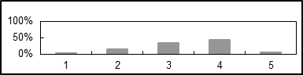
26 | 1h.viii. Global assessment | 0% | 0% | 28% | 52% | 21% | 29 | 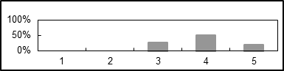
27 | 2a. Acknowledging that the catalogue of policy support tools is at an early stage of development, to what degree is it useful ? | 5% | 13% | 45% | 30% | 7% | 56 | 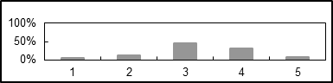
28 | 3a. To what degree has IPBES effectively matched IPBES funding for the priority capacity-building needs identified by the Plenary, with other resources by catalysing financial and in-kind support? | 2% | 14% | 46% | 34% | 4% | 56 | 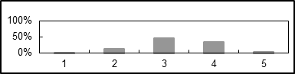
29 | 3b. To what degree has the capacity-building forum and related activities been successful and how can they be further strengthened? | 4% | 16% | 48% | 30% | 2% | 56 | 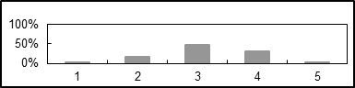
31 | 3d. To what degree has the pilot fellowship programme worked? | 5% | 5% | 21% | 46% | 24% | 63 | 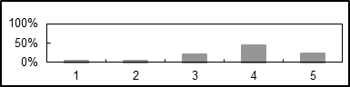
32 | 3e. To what degree have the capacity building activities involved indigenous and local knowledge holders? | 9% | 22% | 51% | 18% | 0% | 45 | 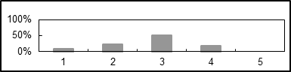
33 | 3f. To what degree has IPBES established appropriate links with other international initiatives and how effective have they been? | 7% | 16% | 41% | 30% | 5% | 56 | 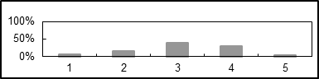
34 | 4a. To what degree has IPBES established appropriate links with other international initiatives and identified and used existing data sets held by partner organizations? | 5% | 8% | 41% | 41% | 6% | 64 | 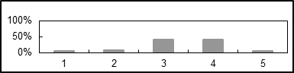
35 | 4b. Have the processes used to manage the data and information used in assessments worked well? | 7% | 24% | 40% | 24% | 5% | 58 | 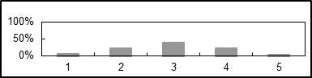
36 | 4c. Has the Knowledge, Information and Data Task Force provided, in time, the necessary inputs to assessments? | 12% | 39% | 29% | 18% | 2% | 51 | 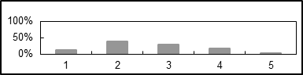 | 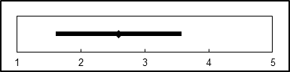
37 | 5a. Have the four functions of the work programme (capacity building, assessments, policy tools and methodologies, and stimulating new research) worked well together? | 3% | 21% | 40% | 35% | 1% | 68 | 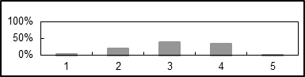
38 | 6a. To what degree has IPBES recognized, respected and adequately addressed indigenous and local knowledge in its work? | 0% | 9% | 28% | 51% | 12% | 67 | 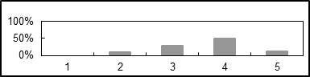
39 | 6b. Given that the work of IPBES on indigenous and local knowledge is still at a pilot stage, to what degree have the processes for working with indigenous and local knowledge in IPBES activities been appropriate? | 2% | 11% | 41% | 44% | 2% | 63 | 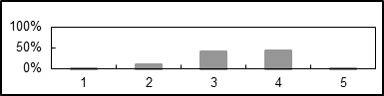
40 | 6c. To what degree has IPBES developed new strategies and methodologies to adequately work with indigenous and local knowledge? | 2% | 14% | 32% | 40% | 13% | 63 | 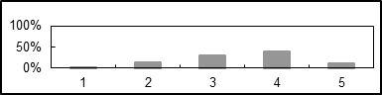
41 | 7a. To what degree has IPBES achieved appropriate regional representation and participation in its structure and work? | 4% | 20% | 24% | 48% | 4% | 75 | 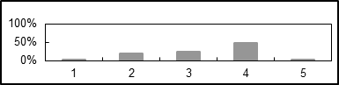
42 | 7b. To what degree has IPBES taken an appropriate interdisciplinary and multidisciplinary approach that incorporates all relevant disciplines, including social and natural sciences, in all its activities? | 0% | 18% | 35% | 43% | 4% | 77 | 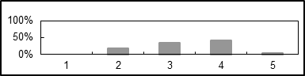
43 | 7c. To what degree has IPBES achieved appropriate gender balance in all relevant aspects of its work? | 1% | 10% | 33% | 42% | 14% | 72 | 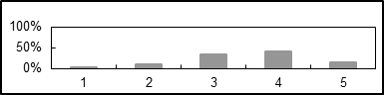
44 | 8a.a. To what degree was the call for requests to IPBES members and stakeholders and the mechanism proposed by the secretariat for responding to the call clear, transparent and efficient? | 3% | 7% | 34% | 41% | 14% | 58 | 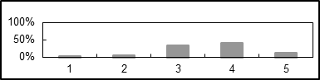
45 | 8a.b. If you represent a Government or an organisation which responded to this call: To what degree did you hold internal consultations before responding to the call for requests? | 12% | 9% | 21% | 41% | 18% | 34 | 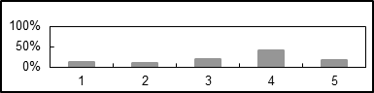
46 | 8a.c. If you represent a Government or a stakeholder organisation: to what degree were you satisfied with the way the Multidisciplinary Expert Panel processed the requests and presented a prioritized list to the Plenary? | 14% | 6% | 22% | 53% | 6% | 36 | 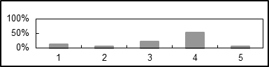
47 | 8a.d. To what degree would you say that the list of the deliverables in the work programme, which stems from the requests and the subsequent Plenary decision, meets the needs of your country/organization and is policy-relevant? | 4% | 7% | 40% | 42% | 7% | 55 | 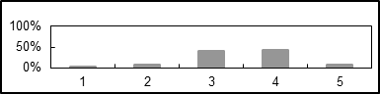
48 | 8b.h.i. To what degree have the scoping processes been conducive to the preparation of policy-relevant deliverables? | 0% | 10% | 38% | 43% | 9% | 68 | 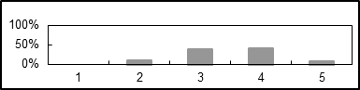
49 | 8b.h.ii. To what degree has the composition of expert groups been conducive to the preparation of policy-relevant deliverables? | 2% | 22% | 43% | 31% | 3% | 65 | 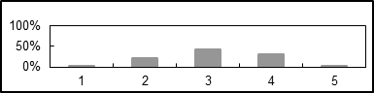
50 | 8b.a. If you are a Government representative: did you provide comments during the review process of the pollination assessment? |  | Yes: | 58% | No: | 42% | 24 | `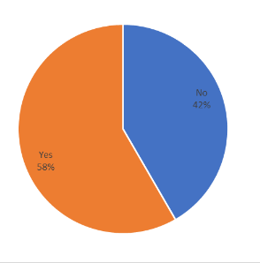
51 | 8b.b. If you are a Government representative: did you provide comments during the review process of the scenario assessment? |  | Yes: | 42% | No: | 58% | 24
52 | 8b.c. If you are a stakeholder representative or a user of IPBES information: did you provide comments during the review process of the pollination assessment? |  | Yes: | 53% | No: | 47% | 34
53 | 8b.d. If you are a stakeholder representative or a user of IPBES information: did you provide comments during the review process of the scenario assessment? |  | Yes: | 33% | No: | 67% | 30
54 | 8b.e. Did the completed pollination assessment receive comments which helped increase their policy relevance? |  | Yes: | 74% | No: | 26% | 50
55 | 8b.f. Did the completed scenarios and models assessment receive comments which helped increase their policy relevance? |  | Yes: | 53% | No: | 47% | 40
56 | 8b.g. Should IPBES have mechanisms to follow the uptake of policy relevant evidence of an assessment, at national and international levels? |  | Yes: | 83% | No: | 17% | 66
57 | 9a. To what degree have appropriate partnership arrangements at global, regional and national levels been developed for the conduct of IPBES activities, and properly implemented? | 2% | 13% | 44% | 33% | 9% | 64 | 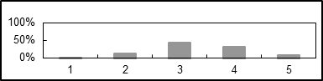
58 | 9b. To what degree has IPBES adequately collaborated with existing initiatives on biodiversity and ecosystem services, including multilateral environmental agreements, United Nations bodies and networks of scientists and knowledge holders? | 3% | 7% | 37% | 45% | 7% | 67 | 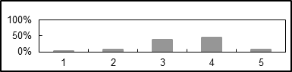
59 | 10a. To what degree has the information and documentation presented to the Plenary enabled it to play its role in an effective manner? | 0% | 6% | 13% | 63% | 19% | 64 | 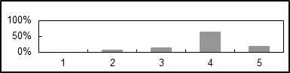
60 | 10b. To what degree have the decisions made by the Plenary been able to be effectively implemented by the secretariat, the Bureau and the Multidisciplinary Expert Panel? | 2% | 5% | 20% | 54% | 20% | 65 | 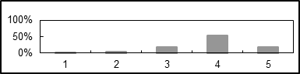
61 | 10c. To what degree have the sessions of the Plenary been organized and conducted in an effective manner? | 2% | 2% | 23% | 58% | 17% | 66 | 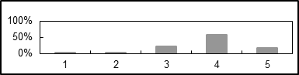
62 | 10d. To what degree has the Plenary been properly advised on coordination between IPBES and other relevant institutions? | 3% | 5% | 31% | 53% | 7% | 58 | 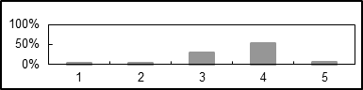
63 | 11a. To what degree have members of IPBES and regional groups been supported by their respective Bureau members? | 0% | 2% | 27% | 38% | 33% | 52 | 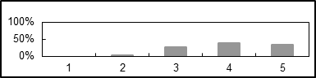 | 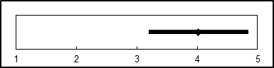
64 | 11b. To what degree has the Bureau followed up on requests addressed to it by the Plenary in its decisions? | 2% | 4% | 15% | 58% | 22% | 55 | 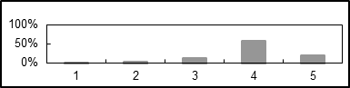
65 | 11c. To what degree has the Bureau effectively conducted its roles related to chairing and contributing to task forces, expert groups and assessment management committees? | 2% | 7% | 16% | 55% | 21% | 58 | 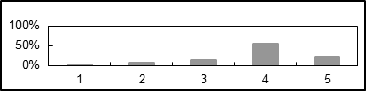
66 | 11d.i. Overseeing communications and outreach activities? | 4% | 9% | 34% | 43% | 9% | 53 | 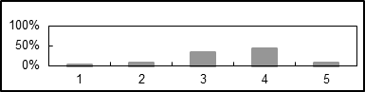
67 | 11d.ii. Reviewing progress in the implementation of Plenary decisions? | 4% | 4% | 25% | 44% | 24% | 55 | 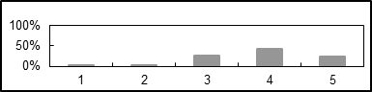
68 | 11d.iii. Monitoring the secretariat’s performance? | 2% | 2% | 30% | 51% | 15% | 47 | 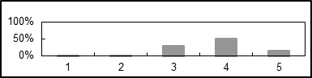
69 | 11d.iv. Organizing and conducting the sessions of the Plenary? | 2% | 2% | 16% | 54% | 26% | 57 | 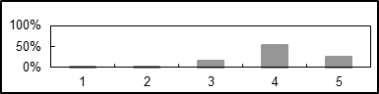
70 | 11d.v. Reviewing observance of the IPBES’ rules of procedure? | 2% | 0% | 19% | 53% | 26% | 53 | 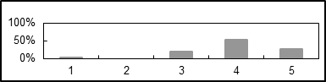 | 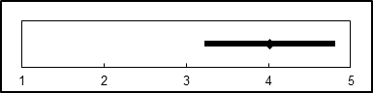
71 | 11d.vi. Reviewing the management of resources and observance of financial rules? | 4% | 2% | 23% | 44% | 27% | 52 | 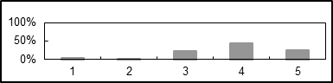
72 | 11d.vii. Advising the plenary on coordination between IPBES and other relevant institutions? | 4% | 2% | 22% | 61% | 10% | 49 | 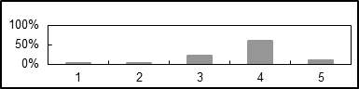
73 | 11d.viii. Identifying donors and developing partnership arrangements? | 6% | 27% | 42% | 21% | 4% | 48 | 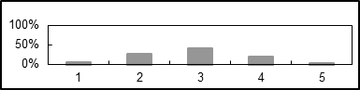
74 | 11d.ix. Maintaining synergies with the MEP? | 4% | 4% | 19% | 43% | 30% | 53 | 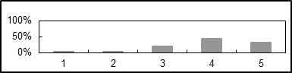
75 | 12a. To what degree has the Plenary been properly advised by MEP on scientific and technical aspects of the IPBES programme of work? | 2% | 5% | 26% | 52% | 16% | 58 | 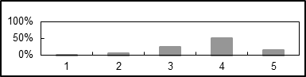
76 | 12b. To what degree has MEP effectively followed up on requests addressed to it by the Plenary in its decisions? | 0% | 7% | 14% | 59% | 21% | 58 | 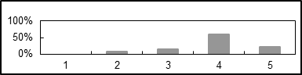
77 | 12c. To what degree has MEP effectively fulfilled its roles related to chairing and contributing to task forces and expert groups? | 0% | 7% | 14% | 54% | 25% | 59 | 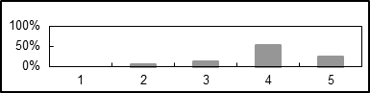
78 | 12d. To what degree has the peer-review process been properly managed and ensured the highest levels of scientific quality, independence and credibility for all products delivered by IPBES at all stages of the process? | 0% | 7% | 25% | 62% | 7% | 60 | 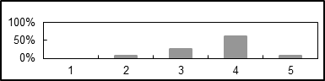
79 | 12e. To what degree have the scientific community and other knowledge holders been properly engaged with the IPBES work programme, given the need for different disciplines and types of knowledge, gender balance, and effective contribution and participation | 2% | 19% | 34% | 42% | 3% | 64 | 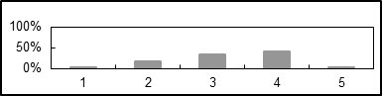
80 | 12f. To what degree has there been scientific and technical coordination among structures set up under IPBES? | 2% | 10% | 36% | 44% | 8% | 59 | 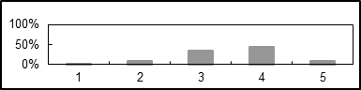 | 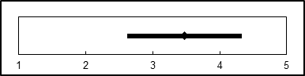
81 | 13a. To what degree has the documentation been of high quality and delivered on time? | 0% | 1% | 24% | 50% | 25% | 72 | 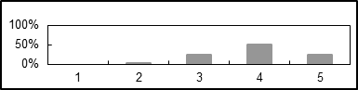
82 | 13b. To what degree have sessions of the Plenary, meetings of the Multidisciplinary Expert Panel and Bureau and other technical meetings been well organized? | 0% | 1% | 20% | 49% | 30% | 71 | 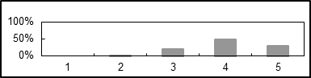
83 | 13c. To what degree has the secretariat effectively followed up on requests addressed to it by the Plenary in its decisions? | 0% | 3% | 14% | 59% | 23% | 64 | 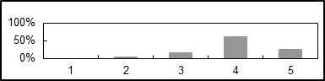
84 | 13d. To what degree has the secretariat provided responses to queries by national focal points and stakeholders between sessions of the Plenary? | 0% | 4% | 15% | 60% | 21% | 48 | 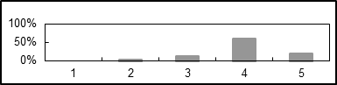
85 | 13e. To what degree has the secretariat provided support for the delivery of the work programme according to the decisions of the Plenary? | 1% | 1% | 16% | 54% | 27% | 67 | 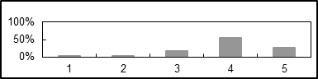
86 | 13f. To what degree has the size, composition and set-up of the secretariat, including its technical support units (TSU), been appropriate? | 4% | 24% | 29% | 35% | 8% | 72 | 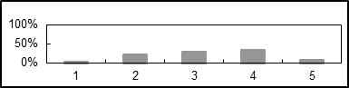
87 | 13g. To what degree has integration among TSU themselves, and with the Secretariat headquarters been effective? | 5% | 10% | 22% | 55% | 8% | 60 | 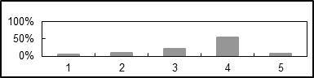
88 | 13h. To what degree has the interaction between the various bodies of IPBES functioned? | 3% | 6% | 37% | 46% | 8% | 63
89 | 13i. To what degree have the TSUs worked efficiently and effectively? | 6% | 6% | 32% | 38% | 17% | 65 | 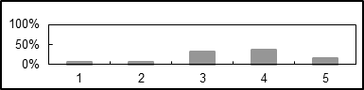
90 | 14a.i. Indigenous and local knowledge? | 2% | 15% | 40% | 33% | 11% | 55 | 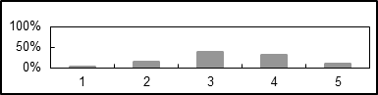
91 | 14a.ii. Capacity-building? | 0% | 4% | 19% | 64% | 13% | 53 | 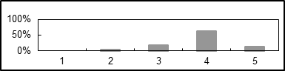
92 | 14a.iii. Data and knowledge? | 2% | 20% | 44% | 28% | 6% | 54 | 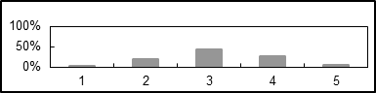
93 | 14a.iv. Values? | 2% | 12% | 22% | 51% | 14% | 51 | 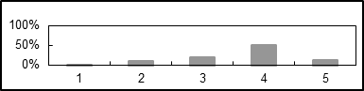
94 | 14a.v. Scenarios and models of biodiversity and ecosystem services? | 2% | 4% | 13% | 55% | 26% | 53 | 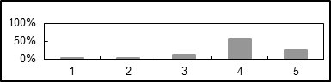
95 | 14a.vi. Policy-support tools? | 2% | 15% | 49% | 28% | 6% | 47 | 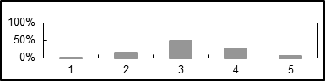
96 | 14b. To what degree has there been effective interaction between the task forces, expert groups and assessments? | 8% | 11% | 45% | 31% | 5% | 62 | 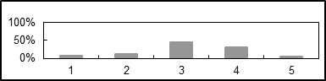
97 | 15a. To what degree have the financial resources been properly managed, i.e., used cost-effectively? | 0% | 9% | 24% | 52% | 16% | 58 | 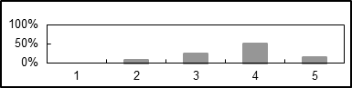
98 | 15b. To what degree have the financial rules been observed? | 0% | 4% | 21% | 45% | 30% | 47 | 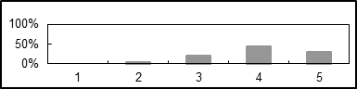
99 | 15c. To what degree have the budget documents been adequately presented to Plenary? | 2% | 5% | 21% | 54% | 18% | 57 | 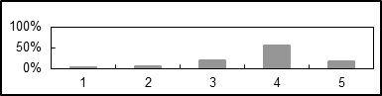
100 | 15d.i. To what degree has IPBES effectively mobilized and used the potential of in-kind offers? | 0% | 11% | 34% | 41% | 13% | 61 | 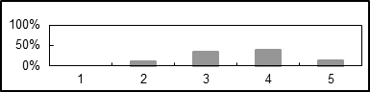
101 | 15e.i. To what degree has IPBES effectively mobilized and used the leveraging potential of promoting and catalysing activities and impact through third parties, such as strategic partners? | 2% | 12% | 49% | 37% | 0% | 57 | 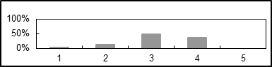
102 | 15f. To what degree has the allocation of the budget between the various deliverables been optimal? | 2% | 8% | 49% | 33% | 8% | 51 | 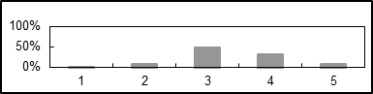
103 | 16a. To what degree has the IPBES Communication and Outreach Strategy been sufficient to support the mission and work programme of the Platform? | 1% | 15% | 42% | 36% | 5% | 73 | 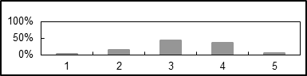
104 | 16b. To what degree has the implementation of the Communication and Outreach Strategy been effective in widening the reach and impact of IPBES’ work? | 1% | 15% | 44% | 37% | 3% | 71 | 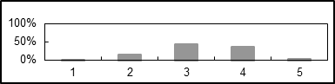
105 | 16c. To what degree has the branding policy of IPBES, including the use of its logo, been adequate? | 1% | 9% | 29% | 51% | 10% | 69 | 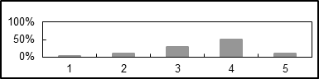
106 | 17a. To what degree has the IPBES Stakeholder Engagement Strategy been sufficient to support the mission and work programme of the Platform? | 3% | 16% | 46% | 28% | 7% | 61 | 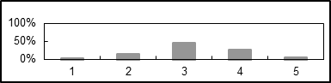
107 | 17b. To what degree has the implementation of the Stakeholder Engagement Strategy been effective in widening the reach and impact of IPBES’ work? | 3% | 14% | 53% | 24% | 7% | 59 | 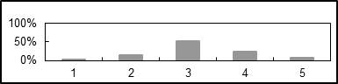

Appendix III
Highest and lowest overall ratings
Nine questions of the questionnaire received a very high rating with 80% to 100% of respondents rating them “good” or “very good” (issues highlighted in bold in table 1 below). 39 questions received this rating from 60% to 79% of respondents; and another 32 questions received it from 40% to 59% of respondents. One question received “poor” or “very poor” as a response from 40% to 60% of respondents. 16 questions received this low rating from 20% to 39% of respondents, and 82 questions received it from below 20% of respondents.
Table 1 below lists (without ranking) the questions that received the highest satisfaction, i.e. the aspects of IPBES’ work that were rated “good” or “very good” by more than 70 % of respondents to these questions.
Table 1
Work programme
- Scoping processes for the regional assessments for the Americas, Europe and Central Asia, and for the global assessment
- Style of the SPM of the pollination assessment easily understood by a range of audiences
- Functioning of the management committees overseeing the scenarios and models assessment and the global assessment
- Success of the pilot fellowship programme
Functioning of the Plenary
- Information and documentation presented to the Plenary has enabled it to play its role in an effective manner
- Decisions made by the Plenary were effectively implemented by the secretariat, the Bureau and the MEP
- Sessions of the Plenary have been organized and conducted in an effective manner
Functioning of the Bureau
- The Bureau properly discharged its administrative functions regarding:
- Organizing and conducting the sessions of the Plenary
- Following up on requests addressed to it by the Plenary in its decisions
- Chairing and contributing to task forces, expert groups and assessment management committees
- Reviewing observance of the platform’s rules of procedure
- Reviewing the management of resources and observance of financial rules
- Maintaining synergies with the MEP
- Advising the plenary on coordination between IPBES and other relevant institutions
- Providing support to members of IPBES and regional groups
Functioning of MEP
- The MEP effectively followed up on requests addressed to it by the Plenary in its decisions
- The MEP effectively fulfilled its roles related to chairing and contributing to task forces and expert groups
Functioning of the secretariat
- Documentation has been of high quality and delivered on time
- Sessions of the Plenary, meetings of the MEP and Bureau and other technical meetings have been well organized
- The secretariat has effectively followed up on requests addressed to it by the Plenary in its decisions
- The secretariat provided responses to queries by national focal points and stakeholders between sessions of the Plenary
- The secretariat provided support for the delivery of the work programme according to the decisions of the Plenary
The task forces and expert groups have been effective in the following areas:
- Capacity-building and Scenarios and models
Resource management, financial rules and reporting
- Financial rules have been observed
- Budget documents have been adequately presented to the Plenary
- Table 2 below lists (without ranking) the questions that received the lowest satisfaction, i.e. the aspects of IPBES’ work that were rated “poor” or “very poor” by 20 % or more of respondents to these questions.
Table 2
Assessments
- Scoping process for the sustainable use of wild species
- Provision of adequate input and comments by experts and Governments
Capacity building
- Degree of involvement of indigenous and local knowledge holders in capacity-building activities
- Degree of success of the capacity-building forum and related activities
- Degree of establishment of appropriate links with other international initiatives and their effectiveness
Knowledge and data
- Functioning of the processes used to manage the data and information used in assessments
Provision of inputs to assessments, in time, by the knowledge, information and data task force
Synergies between the four functions
- Degree to which the four functions of the work programme (capacity building, assessments, policy tools and methodologies, and stimulating new research) worked well together
Geographical, disciplinary and gender balances in IPBES’s activities
- Appropriate regional representation and participation in the structure and work of IPBES
Useful and policy relevant information
- Conduciveness of the composition of expert groups to the preparation of policy-relevant deliverables
- Degree to which internal consultations were held before responding to the call for requests
Functioning of Bureau
- Identification of donors and development of partnership arrangements
Functioning of MEP
- Engagement of the scientific community and other knowledge holders in the IPBES work programme, given the need for different disciplines and types of knowledge, gender balance, and effective contribution and participation by experts from developing countries
Functioning of the secretariat
- Appropriateness of the size, composition and set-up of the secretariat, including its technical support units (TSUs)
Functioning of task forces and expert groups
- Effectiveness of the task forces and expert groups in the following area: Data and knowledge
Stakeholder engagement
- Support of the IPBES Stakeholder Engagement Strategy to the mission and work programme of the Platform

Appendix IV
Summary overview of qualitative comments received as part of the questionnaire
The following contains a summary overview of individual qualitative comments submitted by respondents as part of the questionnaire in addition to their quantitative scores.

Functions of IPBES
A. Assessing knowledge on biodiversity and ecosystem services to support the science-policy interface
- Involvement of policy experts / users into the scoping processes could enhance the policy-relevance of assessments;
- Scoping reports could be shorter and less detailed;
- Nominations of experts by Governments and organizations could include a higher number of experts with a background in social sciences and humanities, female experts, experts on indigenous and local knowledge, and experts from Eastern Europe and Africa;
- Call for nominations could be communicated more widely and national focal points supported in the identification of potential nominees;
- Results of the selection process could be communicated more clearly and transparently;
- Existing selection criteria could be reviewed;
- Access to draft reports could be simplified;
- Guide for reviewers to different parts of draft reports could be provided;
- The style of summaries for policymakers could be more accessible for policymakers;
- Key messages of summaries for policymakers could be made available in more languages to facilitate their uptake by policymakers at the national level;
- The assessment reports and summaries for policymakers could be shortened to increase their relevance for policymakers;
- The organization and composition of management committees could be reviewed;
- The communication and collaboration between the Bureau and the Multidisciplinary Expert Panel, and among them with co-Chairs of assessments could be reviewed;
- The use of confidence limits in assessments was supported by some comments and questioned by others.
B. Policy-relevant tools and methodologies
- Delay in development of the catalogue could be attributed to an initial lack of Plenary guidance on procedural and institutional matters and funding; progress is expected over the coming months;
- More emphasis could be placed on this function in the future;
- Catalogue could focus on information contained in or prepared in the context of assessments; assessments could more clearly identify policy support tools, methodologies and their effectiveness;
- Contribution of information on policy support tools by Governments and stakeholders is expected to contribute further content and value;
- The catalogue could further respond to the needs of users;
- More awareness raising and promotion activities for the catalogue could be undertaken;
- The online portal could be further improved.
- Methodological assessments, such as the assessment of scenarios and models, further work following this assessment, as well as work related to the guide on values contribute to the implementation of this function of IPBES and provide content to the catalogue;
- Additional, different activities to support this function could be considered in the future.
C. Capacity-building
- Delay in the implementation of the capacity-building function could be attributed to an initial lack of Plenary guidance on procedural and institutional matters;
- At its fifth session, the Plenary welcomed the capacity-building rolling plan that since has been guiding capacity-building activities;
- Recent organization of work by the task force may contribute to significant advancement of the function in the future;
- Mobilising additional financial and technical resources (matchmaking) may require more time and support;
- Partnerships could be significantly improved and may take time and capacities to develop;
- The format of IPBES forums could be reconsidered and they could include meetings of partner organisations and networks involved in IPBES activities, or have a more scientific profile;
- The fellowship programme could be further improved;
- The membership of the task force could be revisited; members could be recruited from assessment expert groups; or with a focus on practical experience in capacity-building;
- Future activities under the capacity-building rolling plan could focus on interaction with policy-makers; national platforms and assessments; indigenous peoples and local communities; and on support for the development of science-policy interfaces at all levels.
D. Knowledge and data
- The provision of support to IPBES assessments with regard to data and indicators by the task force was delayed due to a number of reasons;
- Assessments performed by entities other than IPBES (e.g. IPCC) may not provide support to assessments in the way IPBES attempts to do so; therefore the objectives of IPBES in this area could be considered very ambitious;
- The work on indicators may benefit future assessments and therefore have a long-term dimension;
- Synergies with existing processes related to data and indicators could be enhanced;
- The work on indicators could be more interdisciplinary; steps are being taken towards a more encompassing perspective on indicators and linking them more explicitly to relevant messages for policy makers;
- Ways of making available data more accessible could be sought;
- The knowledge generation function may require more attention and development to realize the potential of IPBES to systemically and synthetically identify knowledge needs in the context of its conceptual framework and to promote and catalyse the generation of such knowledge by others;
- Processes and means to both identify knowledge needs and catalyse the needed knowledge generation could be further developed;
- The membership of the task force could be revisited; members could be recruited from assessment expert groups and include representatives of expert organizations and networks;
- The different parts of the mandate of the knowledge and data task force could be considered too diverse and too technical to be covered by the limited number of task force members and requires considerable technical support;
- The capacity of the technical support unit to support technical aspects of the work of the task force has recently increased;
E. Synergies between the four functions
- The assessment function seems to have commenced successfully;
- Delay in the implementation of the remaining three functions (capacity building, knowledge generation catalysis and policy support) may have occurred due to them building in parts on assessments, which had to be completed first, and due to an initial lack of Plenary guidance on procedural and institutional matters;
- The three remaining functions could receive more attention and resources in the future to ensure a balance among the four functions;
- Synergies among the four functions could be improved; some synergies are being achieved between the assessment and capacity-building functions;
- The disconnect between assessment and the other functions could decrease as the work on the three other functions develops;
- Communication efforts to showcase the value of all four functions of IPBES could be enhanced;
- Measures that could enhance synergies between and a balance among the four functions could include guidance to assessments, the involvement of assessment experts in deliverables related to other functions, participation of task force/expert group members in other task force/expert group meetings, organization of meetings back-to-back, further development of processes and structures to implement the assessments; follow-up to capacity-building and data needs identified in scoping reports; increasing interaction amongst technical support units in learning from and reinforcing each other.

Operating principles of IPBES
A. Indigenous and local knowledge
- Respecting and adequately addressing indigenous and local knowledge in IPBES deliverables may constitute a complex and challenging endeavour; increased efforts may be required;
- Progress has been made with the adoption of the approach to recognizing and working with indigenous and local knowledge, and its implementation, including through the participatory mechanism (decision IPBES-5/1) and could be anticipated to continue;
- The approach is piloted in the development of the global assessment of biodiversity and ecosystem services and lessons could be learned for the implementation of the approach in other deliverables;
- A stronger focus on local knowledge could be considered;
- The membership of the task force could be revisited; membership could include more diverse disciplinary backgrounds;
- Better communication and linkages between the work of the task force on indigenous and local knowledge and the assessments could improve the work under this function;
- Engagement of indigenous peoples and local communities in IPBES could be enhanced, in particular through the participatory mechanism;
- Work with strategic partners / organizations of indigenous peoples and local communities could be improved;
- The capacity of the technical support unit to support the work of the task force has increased.

B. Geographical, disciplinary and gender balances in IPBES’ activities
- An increase in nominations from all regions, particularly from the Africa and Eastern Europe regions could support IPBES in achieving regional balance;
- An increase in nominations of women could support IPBES in achieving gender balance;
- An increase in nominations of social scientists, experts with a background in humanities, experts on indigenous and local knowledge and indigenous and local knowledge experts, and experts on policy/practitioners could support IPBES in achieving disciplinary balance, recognizing and respecting the contribution of indigenous and local knowledge to the conservation and sustainable use of biodiversity and ecosystems, and in enhancing the policy-relevance of its deliverables;
- The rules and criteria for the selection of experts could be reviewed;
- The selection of indigenous and local knowledge experts and experts on policy/practitioners could be facilitated;
- The lack of support for the participation in IPBES processes for experts from the Western Europe and Others Group could be a reason for fewer nominations from some countries and experts not participating in all meetings; the issue could be reconsidered;
- The procedure to fill gaps in expertise (decision IPBES-4/3) could be considered as working well, but may have needed to be used too extensively;
- Procedures could be developed to facilitate inclusive participation and contribution by experts in meetings of IPBES subsidiary bodies, expert groups and task forces; as a balanced selection of experts may not necessarily result in balanced participation and contribution to meetings;

C. Useful and policy-relevant information
- A future call for requests may result in more requests from Governments, in particular also from developing countries, as the familiarity with IPBES has increased over the past years;
- The Multidisciplinary Expert Panel and the Bureau could guide and structure a future call for requests which may lead to less varied requests than the requests received in response to the call for requests for the first work programme;
- The process for the prioritization of requests received could be revisited;
- The second work programme might address the following suggestions: a focus on policy-support tools, nature’s contributions to people, the follow-up to the Strategic Plan for Biodiversity 2011-2020, the sustainable development goals, linkages between biodiversity and climate change, greening of infrastructure and climate proofing;
- The development of the second work programme could closely take into account available resources; the first work programme may be considered to have been too ambitious; the number of assessments could be considered to be reduced;
- The second work programme might assume a more cross-cutting approach across the four functions of IPBES;
- The interaction with and engagement of governments in IPBES, also intersessionally, could be enhanced in the second work programme;
- The second work programme could include an element of flexibility that allows adjustments over the course of the work programme;
- The secretariat is in the process of developing a database to track the impact of the pollination assessment;
- The peer-review period for assessments could be extended.

Functioning of the Plenary, Bureau, Multidisciplinary Expert Panel, secretariat, including technical support units

A. Functioning of the Plenary
- In-session documents could be made available more in advance to allow their thorough review by Plenary participants before adoption;
- Plenary guidance could have been more explicit on capacity building and policy support tools;
- More information could be provided to the Plenary on ongoing assessments, and on decisions taken by the Multidisciplinary Expert Panel and the Bureau in the intersessional period;
- If the capacity of the secretariat allows, it could be considered to organize side-events in the margins of sessions of the Plenary; the absence of side-events could also be considered to relieve pressure on Plenary participants;
- More strategic preparation for the presentation and discussion of the budget could be considered;
- The schedule of Plenary sessions could be reconsidered, in particular to allow for more time to implement decisions.

B. Functioning of the Bureau and Multidisciplinary Expert Panel
- The workload of the Bureau and Multidisciplinary Expert Panel was considered as very heavy;
- The communication between members of the Bureau and the national focal points of their respective regions could be further strengthened;
- Information of the Plenary about intersessional work by the Bureau and Multidisciplinary Expert Panel could be enhanced;
- Engagement with the scientific community, in particular by the Multidisciplinary Expert Panel, could be enhanced;
- The capacity of the Multidisciplinary Expert Panel regarding social sciences, humanities and policy matters could be increased;
- It could be considered to invite additional observers to meetings of the Multidisciplinary Expert Panel, when appropriate (e.g. co-chairs of ongoing assessments; members of secretariats of biodiversity-related multilateral environmental agreements);
- The organization of the process for the selection of experts by the Multidisciplinary Expert Panel could be reconsidered; this process is considered to consume a lot of time;
- The conduct of meetings of the Multidisciplinary Expert Panel could be enhanced to facilitate more in-depth discussions among all members;
- It might be considered to provide support for the participation of members of the Multidisciplinary Expert Panel from all regions, as some have experienced regular challenges in attending meetings.

C. Functioning of the secretariat, including technical support units
- The size and composition of the secretariat could be considered as a minimum required to effectively implement its current functions and tasks;
- It could be considered whether the size and composition of the secretariat needs to be adjusted to adequately match functions and tasks with resources to implement them;
- It could be considered to add a deputy executive secretary/office manager (P-4/P-5) to the secretariat to oversee all day-to-day human resources, operational finance and administration matters to allow the Executive Secretary to concentrate on strategic issues (resource mobilization, partnerships, outreach and strengthening policy impact);
- It could be considered to add a position to support procurement-related tasks and the establishment of legal agreements with technical support units and partners;
- It could be considered to add a position to support the establishment of partnerships, the engagement with partners and leveraging activities by partners and in-kind support;
- It could be considered to add a webmaster/social media officer;
- It could be considered to add a position to lead the implementation of the stakeholder engagement strategy;
- The secretariat could undertake additional efforts to communicate with national focal points;
- Support by technical support units contributed significantly to the work of task forces and expert groups;
- The performance of individual technical support units varied over time;
- A strong scientific and technical background and sufficient numbers of staff may be considered as prerequisite for the success of a technical support unit; selection criteria could be developed;
- Technical support units could be co-located with the secretariat in Bonn or with one of the co-chairs of an expert group or task force to foster synergies;
- Secondments and internships could be considered to support the work of the secretariat and technical support units.

Functioning of the task forces and expert groups
- Task forces and expert groups are considered to have contributed substantively to issues cutting across IPBES assessments;
- The scenarios and models expert group is considered to have worked particularly well. This could be due to the overlap in membership between the expert group and assessment expert groups; task forces and expert groups that were composed of experts not involved in an assessment could be seen as having faced more challenges;
- The membership of task forces and expert groups could be reconsidered to include more practical experience;
- It could be considered to select members of task forces and expert groups from within ongoing assessments; members from completed assessments could remain on the group to ensure coherence across past and future IPBES assessments;
- It could be considered to invite members of expert groups or task forces to assume the role of chair if the nature of the work of the group is very technical;
- It could be considered to establish groups of strategic partners to support the respective task forces/expert groups.

Partnerships, stakeholder engagement and communication

A. Partnerships
- The establishment of partnerships is being considered difficult from an administrative perspective and could be strengthened significantly;
- Collaboration with multilateral environmental agreements, in particular the United Nations Framework Convention on Climate Change and the United Nations Convention to Combat Desertification could be enhanced;
- Collaboration with the Intergovernmental Panel on Climate Change could be enhanced;
- Collaboration with networks of scientists and knowledge holders could be enhanced;
- Collaboration with the World Ocean Assessment could be enhanced;
- Collaboration at the regional and national levels could be enhanced;
- Partnerships could benefit from a concrete focus for collaboration;
- Further approaches and processes for entering into and managing partnerships could be developed.

B. Stakeholder engagement and communication
- The work undertaken and difference made by the Head of Communication is considered very positive;
- Insufficient staff and restraints posed by United Nations procurement rules could be considered as impacting the effective implementation of communication and stakeholder engagement strategies;
- The visibility of IPBES could be raised outside of Ministries of the Environment (e.g. agriculture, finance, energy, etc.);
- Work on communication could be enhanced by professional input on science communication;
- Work on communication could be regularly presented to relevant IPBES bodies for comments;
- The use of non-English communication could be increased;
- A communications strategy for strategic partners could be developed;
- Communication efforts at the regional level and in support of national focal points could be enhanced;
- Communication to policy- and decision-making bodies could be enhanced;
- The IPBES website could be improved;
- The need to recognize and collaborate with multiple stakeholder networks may have slowed the implementation of the strategy;
- IPBES could engage with a wider and more diverse set of stakeholders;
- The implementation of the IPBES policy for the use of the IPBES logo could be revisited to allow for a wider visibility of IPBES;
- Further procedures could be developed to manage the trade-off between the need to protect the reputation of IPBES and freedom/self-organization to be inclusive, cater to the needs of stakeholders and reduce work load of the secretariat.

Effectiveness of budgetary management and financial rules
- The funding situation is considered very difficult;
- Fundraising activities could be enhanced;
- Funding sources could be diversified;
- The allocation of budget among deliverables could be reconsidered;
- Communication, outreach, awareness-raising and capacity-building could be enhanced to increase support for IPBES by partners;
- The benefits that IPBES provides could be showcased more strongly;
- Acknowledgement and recognition of support and in-kind contributions could be significantly strengthened;
- Time required for the formalization of partnerships, in particular through memoranda of understanding could be considered as a barrier to the undertaking of supporting activities by third parties;
- It could be considered to organize cooperation in less formal ways to achieve more flexibility;
- Consistent, targeted and systematic approaches to raising and following up on offers for in-kind contributions as well as to leveraging activities undertaken by third parties and funding in support of these activities need could be developed;
- Partners could be engaged continuously, including at the national level, and could be invited to participate in the IPBES process;
- The financial rules could be revisited to allow for more flexibility.
- Some procurement rules of the United Nations may be considered as resulting in higher expenses for meetings.

Appendix V
This appendix reproduces the final on-line questionnaire which was used as a basis for the internal review report. This final questionnaire is based on the questionnaire appended to the terms of reference annexed to decision IPBES-5/2, which was revised by the Multidisciplinary Expert Panel and the Bureau, following input received at the fifth session of the Plenary, and further input received from Governments and stakeholders thereafter.
Questionnaire used as basis for the internal review
Introduction
Welcome to the internal review of IPBES!
Thank you for taking the time to fill the questionnaire for the internal component of the first review of IPBES. IPBES is currently implementing its first work programme (2014-2018). The review will make an important contribution to the design of the IPBES second work programme.
- The 5th session of the IPBES Plenary (March 2017) requested a review of IPBES and approved terms of reference for this review, which is made of an internal and an external element (decision IPBES-5/2).
- This questionnaire forms the basis for the internal element of the review. The questions are structured per the seven areas (sections I–VII) of the terms of reference approved by the Plenary (paragraphs 1 (a) to 1 (g) of section I of the annex to decision IPBES-5/2).
- The internal review committee, comprised of the IPBES Chair, a member of the Bureau, a co-chair and two members of the MEP and the Executive Secretary, will analyse responses to this questionnaire and prepare a draft internal review report for discussion and approval by the MEP and the Bureau at their 10th meetings (October 2017). The internal review report will be presented to IPBES-6 for information (March 2018), and transmit its conclusions to the external reviewers.
- This questionnaire is targeted at the following people:
- IPBES National focal points;
- Former and current members of the MEP and the Bureau;
- The secretariat, including the Technical Support Units;
- Members of IPBES task forces; and
- Co-chairs and Co-ordinating Lead Authors of completed and ongoing IPBES assessments.
- Deadline for response is 7 August 2017, except for current MEP and Bureau members and secretariat (including TSUs) who are requested to provide early feedback on key questions by 12 June, for the 9th MEP and Bureau meetings.
Instructions
Most questions can be answered using a semi-quantitative scale (1-5), where:
- 5 is very good/very well/agree strongly
- 4 is good/well/agree
- 3 is fair/feel neutral
- 2 is poor/poorly/disagree
- 1 is very poor/very poorly/disagree strongly
N/A is: do not know/no opinion/not relevant for me
All questions offer the possibility to further expand on the responses given.
The questionnaire includes 7 sections, numbered I to VII. Any question can be skipped. If you feel that you do not know enough to answer a question, please skip this question; response 3 on the scale (neutral) is reserved to respondents who understand the question and feel neutral about it.
If you would like to save your response and come back later you need to log in first. You will then be provided with the option to save your draft. If you need assistance please contact Benedict Omare (benedict.aboki.omare@ipbes.net)
Answers will remain confidential and the identities of reviewers will not be revealed.
Questionnaire for the internal review of IPBES
Name (Optional): _____________
Email (Optional): ______________
Please tell us who you are (you can tick multiple boxes)
- IPBES National focal point
- Bureau
- Current member
- Former member
- MEP
  - Current member
  - Former member Bureau;
- Secretariat
  - Headquarters Bonn
  - Technical support unit
- Member of an IPBES task force or of an expert group
  - Capacity building task force
  - Indigenous and local knowledge task force
  - Data and knowledge task force
  - Values expert group
  - Policy support expert group
  - Scenario-phase 2 expert group
  - Guide on assessment expert group
- Expert of a completed or an-ongoing IPBES assessment
  - Pollination
  - Scenarios and models
  - Regional
    - Africa
    - Americas
    - Asia and the Pacific
    - Europe and Central Asia
  - Land degradation
  - Global
- Role on that assessment (optional)
    - Co-chair
    - Coordinating Lead Author
Section I: Functions of IPBES
Governments agreed, in the Panama resolution, on a set of four functions for IPBES. Please see annex to this resolution, in document IPBES.MI/2/9, for a presentation of these functions. Issues 1 to 4 cover each one of these four functions.
Issue 1: Assessing knowledge on biodiversity and ecosystem services to support the science-policy interface
The objective of the questions in issue 1 is to review the processes in place to produce the assessments, but not to review the assessments themselves
- Has the assessment scoping process worked well?
- Land degradation and restoration?
- Overall for the 4 regional assessments?
- Regional: Africa?
- Regional: Americas?
- Regional: Asia Pacific?
- Regional: Europe and Central Asia?
- Global assessment?
- Invasive alien species?
- Sustainable use of wild species?
- Values and valuation?
- Have the processes for the nomination of authors (co-chairs, coordinating lead authors, lead authors and review editors) worked well?
- Have the processes for the selection of authors (co-chairs, coordinating lead authors, lead authors and review editors) worked well?
- Have the peer-review mechanisms worked to ensure scientific credibility?
    - Have experts and Governments provided adequate input and comments?
    - Has the peer-review process been efficient?
- To what degree have the IPBES completed assessments properly identified confidence limits (i.e. from well-established to inconclusive)?
- To what degree have the completed summaries for policymakers been written in a style that is easily understood by a wide range of audiences?
      - Pollination
      - Scenarios and models
- To what degree have the lengths of the completed summaries for policymakers been appropriate?
- To what degree have the management committees overseeing assessments worked well?
      - Pollination
      - Scenarios and models
      - Regional: Africa
      - Regional: Americas
      - Regional: Asia and the Pacific
      - Regional: Europe and Central Asia
      - Land degradation
      - Global assessment
- Please expand on any aspect of issue 1: ______________________
Issue 2: Policy-relevant tools and methodologies
- Acknowledging that the catalogue of policy support tools is at an early stage of development, to what degree is it useful?
- Please suggest ways to improve the catalogue of policy support tools: ________________
- Are there any other ways and means of further enhancing efforts by IPBES to deliver on this function?
Issue 3: Capacity-building
- To what degree has IPBES effectively matched IPBES funding for the priority capacity-building needs identified by the Plenary, with other resources by catalysing financial and in-kind support?
- To what degree has the capacity-building forum and related activities been successful and how can they be further strengthened?
- To what degree has IPBES effectively developed the capacities needed to implement its work programme?
- To what degree has the pilot fellowship programme worked?
- To what degree have the capacity building activities involved indigenous and local knowledge holders?
- To what degree has IPBES established appropriate links with other international initiatives and how effective have they been?
- What other avenues are needed to further catalyse and leverage funding for capacity-building? ___________
- Additional comments: ______________________
Issue 4: Knowledge and data
- To what degree has IPBES established appropriate links with other international initiatives and identified and used existing data sets held by partner organizations?
- Have the processes used to manage the data and information used in assessments worked well?
- Has the Knowledge, Information and Data Task Force provided, in time, the necessary inputs to assessments?
- Additional comments: ________________
Issue 5: Synergies between the four functions
- Have the four elements of the work programme (capacity building, assessments, policy tools and methodologies, and stimulating new research) worked well together?
- Additional comments: ________________
Section II: Operating principles of IPBES
Issue 6: Indigenous and local knowledge
- To what degree has IPBES recognized, respected and adequately addressed indigenous and local knowledge in its work?
- Given that the work of IPBES on indigenous and local knowledge is still at a pilot stage, to what degree have the processes for working with indigenous and local knowledge in IPBES activities been appropriate?
- To what degree has IPBES developed new strategies and methodologies to adequately work with indigenous and local knowledge?
- Additional comments: ________________
Issue 7: Geographical, disciplinary and gender balances in IPBES’ activities
- To what degree has IPBES achieved appropriate regional representation and participation in its structure and work?
- To what degree has IPBES taken an appropriate interdisciplinary and multidisciplinary approach that incorporates all relevant disciplines, including social and natural sciences, in all its activities?
- To what degree has IPBES achieved appropriate gender balance in all relevant aspects of its work?
- Additional comments: ________________
Issue 8: Useful and policy-relevant information
The objective of this issue 8 is not to review the policy relevance of the IPBES products, but to review the processes in place which ensure policy relevance.
Issue 8a- Regarding the process to receive and prioritize requests followed to design the first work programme:
- To what degree was the call for requests to IPBES members and stakeholders and the mechanism proposed by the secretariat for responding to the call clear, transparent and efficient?
- If you represent a Government or an organisation which responded to this call: Did you hold internal consultations before responding to the call for requests?
- If you represent a Government or a stakeholder organisation: to what degree were you satisfied with the way the Multidisciplinary Expert Panel processed the requests and presented a prioritized list to the Plenary?
- To what degree would you say that the list of the deliverables in the work programme, which stems from the requests and the subsequent Plenary decision, meets the needs of your country/organization and is policy-relevant?
- Please expand on what could be improved in the second work programme: ________________
Issue 8b- Regarding other aspects of this issue:
- If you are a Government representative: did you provide comments during the review process of the pollination assessment?
- If you are a Government representative: did you provide comments during the review process of the scenario assessment?
- If you are a stakeholder representative or a user of IPBES information: did you provide provide comments during the review process of the pollination assessment?
- If you are a stakeholder representative or a user of IPBES information: did you provide provide comments during the review process of the scenario assessment?
- Did the completed pollination assessment receive comments which helped increase their policy relevance?
- Please provide additional information: ______________________
- Did the completed scenarios and models assessment receive comments which helped increase their policy relevance?
- Please provide additional information: _______________________
- Should IPBES have mechanisms to follow the uptake of policy relevant evidence of an assessment, at national and international levels?
- To what degree have IPBES processes supported the policy-relevance of deliverables?
    - To what degree have the scoping processes been conducive to the preparation of policy-relevant deliverables?
    - To what degree has the composition of expert groups been conducive to the preparation of
policy-relevant deliverables?
- Additional comments: ___________________
Section III: Procedures for developing deliverables
Issue 9: Partnerships
- To what degree have appropriate partnership arrangements at global, regional and national levels been developed for the conduct of IPBES activities, and properly implemented?
- To what degree has IPBES adequately collaborated with existing initiatives on biodiversity and ecosystem services, including multilateral environmental agreements, United Nations bodies and networks of scientists and knowledge holders?
- Additional comments: __________________
Section IV: Functioning of the Plenary, Bureau, Multidisciplinary Expert Panel and secretariat
Issue 10: Functioning of the Plenary
- To what degree has the information and documentation presented to the Plenary enabled it to play its role in an effective manner?
- To what degree have the decisions made by the Plenary been able to be effectively implemented by the secretariat, the Bureau and the Multidisciplinary Expert Panel?
- To what degree have the sessions of the Plenary been organized and conducted in an effective manner?
- To what degree has the Plenary been properly advised on coordination between IPBES and other relevant institutions?
- Additional comments: __________________
Issue 11: Functioning of the Bureau
- To what degree have members of IPBES and regional groups been supported by their respective Bureau members?
- To what degree has the Bureau followed up on requests addressed to it by the Plenary in its decisions?
- To what degree has the Bureau effectively conducted its roles related to chairing and contributing to task forces, expert groups and assessment management committees?
- To what degree has the Bureau properly discharged its administrative functions of:
    - Overseeing communications and outreach activities?
    - Reviewing progress in the implementation of Plenary decisions?
    - Monitoring the secretariat’s performance?
    - Organizing and conducting the sessions of the Plenary?
    - Reviewing observance of the platform’s rules of procedure?
    - Reviewing the management of resources and observance of financial rules?
    - Advising the plenary on coordination between IPBES and other relevant institutions?
    - Identifying donors and developing partnership arrangements?
    - Maintaining synergies with the MEP?
- Additional comments: __________________
Issue 12: Functioning of the Multidisciplinary Expert Panel
- To what degree has the Plenary been properly advised by the Panel on scientific and technical aspects of the IPBES programme of work?
- To what degree has MEP effectively followed up on requests addressed to it by the Plenary in its decisions?
- To what degree has MEP effectively fulfilled its roles related to chairing and contributing to task forces and expert groups?
- To what degree has the peer-review process been properly managed and ensured the highest levels of scientific quality, independence and credibility for all products delivered by IPBES at all stages of the process?
- To what degree have the scientific community and other knowledge holders been properly engaged with the IPBES work programme, given the need for different disciplines and types of knowledge, gender balance, and effective contribution and participation by experts from developing countries?
- To what degree has there been scientific and technical coordination among structures set up under IPBES?
- Additional comments: __________________
Issue 13: Functioning of the secretariat
- To what degree has the documentation been of high quality and delivered on time?
- To what degree have sessions of the Plenary, meetings of the Multidisciplinary Expert Panel and Bureau and other technical meetings been well organized?
- To what degree has the secretariat effectively followed up on requests addressed to it by the Plenary in its decisions?
- To what degree has the secretariat provided responses to queries by national focal points and stakeholders between sessions of the Plenary?
- To what degree has the secretariat provided support for the delivery of the work programme according to the decisions of the Plenary?
- To what degree has the size, composition and set-up of the secretariat, including its technical support units, been appropriate?
- To what degree has integration among TSU themselves, and with the Secretariat headquarters been effective?
- To what degree has the interaction between the various bodies of IPBES functioned?
- To what degree have the TSUs worked efficiently and effectively?
- Additional comments: ______________
Section V: Task forces and expert groups
This section focuses on the work of the 3 task forces (capacity building; indigenous and local knowledge; data and knowledge) and 3 experts groups (values; scenarios and models; policy-support tools).
Issue 14: Functioning of the task forces and expert groups
- To what degree have the task forces and the expert groups been effective in the following areas:
    - Indigenous and local knowledge?
    - Capacity-building?
    - Data and knowledge?
    - Values?
    - Scenarios and models of biodiversity and ecosystem services?
    - Policy-support tools?
- To what degree has there been effective interaction between the task forces, expert groups and assessments?
- Additional comments: _______________
Section VI: Effectiveness of budgetary management and fiscal rules
Issue 15: Resource management, financial rules and reporting
- To what degree have the financial resources been properly managed, i.e., used cost-effectively?
- To what degree have the financial rules been observed?
- To what degree have the budget documents been adequately presented to Plenary?
- With regard to in-kind offers:
    - To what degree has IPBES effectively mobilized and used the potential of in-kind offers?
    - What are the incentives for and barriers to the provision of in-kind support to IPBES?
    - What should be done to increase the provision of in-kind support to IPBES, including from the private sector and foundations?
- With regard to the involvement of third parties:
    - To what degree has IPBES effectively mobilized and used the leveraging potential of promoting and catalysing activities and impact through third parties, such as strategic partners?
    - What are the incentives for and barriers to the provision of activities and impact through third parties?
    - What should be done to increase the promotion and catalysis of activities and impact through third parties, such as strategic partners?
- To what degree has the allocation of the budget between the various deliverables been optimal?
- Additional comments: _______________
Section VII Stakeholder engagement and Communication
Issue 16: Communication
- To what degree has the IPBES Communication and Outreach Strategy been sufficient to support the mission and work programme of the Platform?
- To what degree has the implementation of the Communication and Outreach Strategy been effective in widening the reach and impact of IPBES’ work?
- To what degree has the branding policy of IPBES, including the use of its logo, been adequate?
- Additional comments: _______________
Issue 17: Stakeholder engagement
- To what degree has the IPBES Stakeholder Engagement Strategy been sufficient to support the mission and work programme of the Platform?
- To what degree has the implementation of the Stakeholder Engagement Strategy been effective in widening the reach and impact of IPBES’ work?
- Additional comments: _______________

* IPBES/6/1.
Question 3(c) of the questionnaire, “To what degree has IPBES effectively developed the capacities needed to implement its work programme?” was excluded from the analysis as it only received 3 responses, which may have been due to a technical problem.

