UNITED  NATIONS | 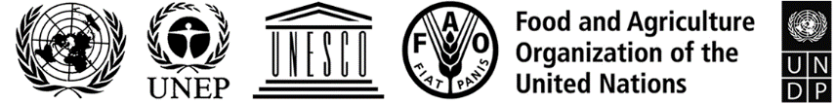 |  |  | BES
 |  |  | IPBES/9/14/Add.2/Corr.1
 |  | Intergovernmental Science-Policy  Platform on Biodiversity and  Ecosystem Services | Distr.: General  24 August 2023  Original: English
Plenary of the Intergovernmental Science-Policy
Platform on Biodiversity and Ecosystem Services
Ninth session
Bonn, Germany, 3–9 July 2022
Report of the Plenary of the Intergovernmental Science-Policy Platform on Biodiversity and Ecosystem Services on the work of its ninth session
Addendum
Summary for policymakers of the methodological assessment regarding the diverse conceptualization of multiple values of nature and its benefits, including biodiversity and ecosystem functions and services (assessment of the diverse values and valuation of nature)
Corrigendum
Table SPM.5, subheading, last sentence
For For each gap category (left column) the most pressing issues (right column) are highlighted {6.4.2; 6.4.3} read For each gap category, the most pressing issues were identified (right column) and some examples of potential solutions are highlighted (left column).

