|  |  |  |  |  |
| --- | --- | --- | --- | --- |
| UNITED  NATIONS |  | | | BES |
|  | |  | **IPBES**/9/INF/20 | |
|  | | Intergovernmental Science-Policy  Platform on Biodiversity and  Ecosystem Services | Distr.: General  9 May 2022  English only | |

Plenary of the Intergovernmental Science-Policy   
Platform on Biodiversity and Ecosystem Services

Ninth session

Bonn, Germany, 3–9 July 2022

Item 9 of the provisional agenda[1]*

Improving the effectiveness of the Platform

Use and impact of the conceptual framework of the Intergovernmental Science-Policy Platform on Biodiversity and Ecosystem Services

Note by the secretariat

1. Objective 6 (b) of the rolling work programme up to 2030, review of the conceptual framework of the Intergovernmental Science-Policy Platform on Biodiversity and Ecosystem Services (IPBES), is aimed at ensuring that the use and impact of the IPBES conceptual framework are reviewed to inform the evolution of the rolling work programme. The Plenary, in decision IPBES‑7/1, requested the Multidisciplinary Expert Panel and the Bureau to review the IPBES conceptual framework in line with that objective.
2. The Plenary adopted the IPBES conceptual framework in decision IPBES-2/4. In decision IPBES-5/1, the Plenary noted that the concept of nature’s contributions to people would be used in current and future IPBES assessments. The concept of “nature’s contributions to people” has replaced the use of the phrase “nature’s benefits to people” that had been used in the framework as initially adopted.
3. In response to the request in decision IPBES-7/1, the Multidisciplinary Expert Panel and the Bureau conducted a study on the use and impact of the framework. As part of the study, the Multidisciplinary Expert Panel and the Bureau conducted two online surveys simultaneously, from 6 April to 29 May 2020, one targeting experts in ongoing and completed IPBES assessments and one targeting national focal points and stakeholders. In addition, the Multidisciplinary Expert Panel and the Bureau conducted a literature review to assess the use and impact of the framework.
4. A draft note on the use and impact of the conceptual framework was made available for external review initially from 1 June to 31 July 2021. The Plenary, in decision IPBES-8/1, invited members, observers and other stakeholders to provide their comments on the draft note to the secretariat by 30 September 2021. Comments were received from five Governments and 15 individual experts. The note was revised in line with the comments received. The final note is set out in the annex to the present document, which is presented without formal editing.

**Annex**[2]*

**Use and impact of the IPBES conceptual framework**

**Contents**

Executive summary 3

1 Introduction 3

1.1 Background 3

1.2 Reader guidance 3

2 Scope and methodology: review of the use and impact of the IPBES conceptual framework 3

2.1 Scope of the study 4

2.2 Methodology: surveys of the use and impacts of the conceptual framework 4

2.2.1 Target respondents 4

2.2.2 IPBES experts 4

2.2.3 IPBES national focal points and stakeholders 5

2.2.4 Structure of the survey questionnaire 5

2.2.5 In-depth analysis of quantitative survey responses 5

2.2.6 How does the expertise of the respondents, including both IPBES experts and national focal points and stakeholders, affect the evaluation results? 6

2.2.7 Did the timing of the assessment make a difference in the evaluation results? 6

2.2.8 Is there a difference in evaluations between experts and national focal points and stakeholders? 6

2.2.9 Analysis of qualitative responses 6

2.3 Methodology of the literature review 7

2.3.1 Related to the IPBES conceptual framework as a whole 7

2.3.2 Related to a component of the IPBES conceptual framework: nature’s contributions to people 7

3 Results of the review of the use and impact of the IPBES conceptual framework 8

3.1 Use of the IPBES conceptual framework according to the two surveys 8

3.1.1 How would you assess the usefulness of the IPBES conceptual framework in the IPBES assessments you were/are involved in? 8

3.1.2 How easy was it for you to use the IPBES conceptual framework as part of your work in the IPBES assessment? 11

3.1.3 In your opinion, which of the following components of the IPBES conceptual framework, if any, would need further improvement/elaboration/clarification to help better structure and facilitate ongoing/future IPBES assessments? 13

3.1.4 Are there any major relevant components, areas or relationships which you feel are not, or incompletely included in the current IPBES conceptual framework? 16

3.1.5 How useful are the existing online documents and e-learning resources on the IPBES conceptual framework and related approach that are available on the IPBES website? 17

3.2 Impacts of the conceptual framework according to the two surveys 19

3.2.1 How often did you use the IPBES conceptual framework in other areas of your work (in addition to your IPBES work)? 19

3.2.2 Could you provide an example? Please select the area of work and share the title as well as a URL or file with further information. 21

3.2.3 Did your country/organisation conduct a national-scale or regional assessment of nature/biodiversity and Nature's contribution to people/ecosystem services? 21

3.3 Use and impact of the conceptual framework according to the literature review 23

4 Conclusions 28

# Executive summary

The Multidisciplinary Expert Panel and Bureau conducted the present study on the use and impact of the conceptual framework in response to a request by the Plenary. The purpose of this study is to understand the current level of use and impact of the conceptual framework with a view to identifying options for further increasing them, if necessary. The study is based on two surveys as well as a literature review.

Both the surveys among IPBES national focal points and IPBES experts and the literature review reflect a consensus that the IPBES conceptual framework is indeed useful and that it already has had various positive impacts, including guiding IPBES work, stimulating further science-policy and scientific work, and stimulating discussion on the relationship between nature and people.

The use and impact of the IPBES conceptual framework have increased since its adoption and publication, and they are continuing to do so. The various uses indicated in the surveys and the increasing numbers of literature citations referring to the IPBES conceptual framework also suggest that the use and impact of the IPBES conceptual framework will continue to increase.

The survey results and the discussion in the scientific literature also suggest that the use and impact of the IPBES conceptual framework, and thus its usefulness for the evolution of the IPBES rolling work programme, could possibly be further enhanced if additional clarification would be provided concerning the individual components of the framework and what they entail, and concerning the interrelations of these components.

# Introduction

## Background

Objective 6 (b) of the rolling work programme up to 2030, review of the IPBES conceptual framework, is aimed at ensuring that the use and impact of the IPBES conceptual framework are reviewed to inform the evolution of the rolling work programme. The Plenary, in its decision IPBES 7/1, requested the Multidisciplinary Expert Panel and the Bureau to review the IPBES conceptual framework in line with that objective.

The Plenary adopted the IPBES conceptual framework in its decision IPBES-2/4. In decision IPBES-5/1, the Plenary noted that the concept of nature’s contributions to people would be used in current and future IPBES assessments. The concept of “nature’s contributions to people” has since replaced the use of the phrase “nature’s benefits to people” that had been used in the conceptual framework as initially adopted.

In response to the request for a review of the use and impact of the conceptual framework set out in decision IPBES-7/1, the Multidisciplinary Expert Panel and Bureau conducted the present study on the use and impact of the conceptual framework.

The study was made available for external review from 1 June to 30 September 2021, revised by the Multidisciplinary Expert Panel and the Bureau in light of the comments received, and finalized for consideration by the Plenary at its ninth session.

## Reader guidance

The present study is based on two surveys as well as a literature review. Section 2 presents the scope of the review as well as methodological considerations regarding the surveys and the literature review. Section 3 presents the results of both surveys as well as the findings from the literature review. Section 4 draws preliminary conclusions on the use and impact of the IPBES conceptual framework based on the preceding sections.

# Scope and methodology: review of the use and impact of the IPBES conceptual framework

## Scope of the study

Objective 6 (b) of the rolling work programme up to 2030, review of the IPBES conceptual framework, is aimed at ensuring that the use and impact of the IPBES conceptual framework are reviewed to inform the evolution of the rolling work programme. Accordingly, the scope of the present study is limited to a review of the use and impact of the conceptual framework.

The use of the conceptual framework includes aspects related to its perceived usefulness, the degree of ease of use of the framework in practice as well as an evaluation of the available resources supporting the use of the framework (e.g., online documents and e-learning resources on the IPBES conceptual framework and related approach that are available on the IPBES website). The impact of the framework includes the various products in which it is applied, and which were generated on its basis. The IPBES conceptual framework is intended to support the analytical work of the Platform and to guide the development, implementation and evolution of its work programme. The framework aims to catalyse a positive transformation in the elements and interlinkages that are the causes of detrimental changes in biodiversity and ecosystems and subsequent loss of their benefits to present and future generations. The framework was adopted by the Plenary in decision IPBES-2/4 and has since served as the foundation of all work of IPBES.

**The purpose** of this study is therefore to understand the current level of use and impact of the conceptual framework with a view to identifying options for further increasing them, if necessary. The scope of this study does not include recommendations for a revision of the conceptual framework.

## Methodology: surveys of the use and impacts of the conceptual framework

### Target respondents

Two online surveys were conducted from 6 April 2020 to 29 May 2020, targeting experts of ongoing and completed IPBES assessments as well as national focal points and stakeholders.

It should be noted that in such surveys the possibility of self-selection among respondents is given, i.e. the possibility that the survey is completed by respondents with a more positive or a more negative view of the IPBES conceptual framework than the average one of the target audiences.

### IPBES experts

The first survey targeted the co-chairs, coordinating lead authors, lead authors and review editors involved in the completed Scenarios and Models Assessment, Pollination Assessment, Regional Assessments of Biodiversity and Ecosystem Services (four IPBES regions), Land Degradation and Restoration Assessment, Global Assessment of Biodiversity and Ecosystem Services, and ongoing sustainable use of wild species assessment, values assessment, and invasive alien species assessment. The total number of IPBES experts invited to complete the survey was 851. Contributing authors, whose role in the assessments was limited to a specific contribution, were not targeted in the survey as they were not involved in the wider assessment process and therefore not necessarily concerned with the use of the IPBES conceptual framework in the assessment. The invitation to participate in the survey was first sent to the experts by the secretariat, with follow-up emails sent by the co-chairs of each assessment to further improve the response rate of the survey.

The survey was responded to by 114 experts covering all the IPBES assessments[3] and roles[4] mentioned above. Regarding disciplinary balance, responding experts with a natural science background accounted for 46.7%, followed by those with an interdisciplinary (27%) and social science (here understood as including humanities and economics) background (13%). The respondents came from all five United Nations regions, as follows: African Group: 17%, Asia-Pacific Group: 28%, Eastern European Group: 8%, Latin American and Caribbean Group (GRULAC): 24%, and Western European and Others Group (WEOG): 22%. In terms of gender, the survey was answered by 58% males and 42% females.

### IPBES national focal points and stakeholders

The second survey was designed for and targeted at IPBES national focal points and stakeholders. The database of IPBES national focal points was used to send an invitation email to the national focal points. For stakeholders, the invitation email was sent to everyone who had subscribed to the IPBES mailing list (more than 17,000 recipients).

The survey was responded to by 231 participants, comprising 45 Government representatives and 186 representatives of other organizations and individuals, including from research and academia (53%), government (19%), non-governmental or civil society organisations (15%), private sector/business (5%), intergovernmental bodies (4%), and other (4%) in descending order. The responses by Governments were well-balanced across the regions: African Group (24%), Asia-Pacific Group (21%), Eastern European Group (14%), GRULAC (14.3%), and WEOG (26%). The fields of expertise which brought respondents to IPBES activities were natural science (46%), followed by interdisciplinary fields (18%), social sciences (9%), indigenous and local knowledge (8%), policymaker/decision-maker (practitioner; 8%), and others. The gender of respondents was skewed toward male with male, female and other/neither accounting for 61%, 38%, and 1%.

### Structure of the survey questionnaire

The surveys are set out in the appendix. Both surveys had three sections: 1) on the use of IPBES conceptual framework, 2) on the impact of IPBES conceptual framework, and 3) about yourself. The content of the first and third section differed slightly between the two surveys as experts and national focal points and stakeholders use/appreciate the IPBES conceptual framework in different situations. To avoid duplicated explanations, the following paragraphs describe the structure and the contents of the survey targeting experts, with additional explanations provided in footnotes for items where the questions differ between the surveys for experts and national focal points and stakeholders.

In the first section, respondents were asked to evaluate overall usefulness and ease of use of the IPBES conceptual framework in IPBES assessments[5], as well as usefulness of the existing online documents and e-learning resources on the IPBES conceptual framework and related approach that are available on the IPBES website. Respondents were also asked to identify the existing components of the IPBES conceptual framework that in their view would need improvement and any other component(s) that they see as missing from the IPBES conceptual framework.

In the second section, respondents were asked in which situations and areas they use the IPBES conceptual framework in addition to their IPBES work, and to provide specific examples. They were also asked to indicate whether their country/organisation conducted a national-scale or regional assessment of nature/biodiversity and nature's contributions to people/ecosystem services. Those who responded “yes” to this question were asked to provide more specific information on these assessments, such as their title, year of publication, coverage or the subjects assessed (in light of the IPBES conceptual framework), number of experts involved, and the type of framework used.

In the final section, respondents were asked to provide information on their profiles. Questions for experts included which assessments they were involved in and their roles, the region of their workplace, sector, background/discipline, years of experience, and gender. In contrast, questions for national focal points and stakeholders included the type of affiliation, representation[6], years of experience, the field of expertise, and gender.

### In-depth analysis of quantitative survey responses

Section 3.1 below presents the results of the survey based on a simple tabulation of the survey responses. In addition, statistical tests (section 2.2.4) were conducted to address the following three questions:

* How does the expertise of the respondents, including both IPBES experts and national focal points and stakeholders, affect the evaluation results?
* Does the timing of the assessment make a difference in evaluation results?
* Is there a difference in evaluations between experts and national focal points and stakeholders?

### How does the expertise of the respondents, including both IPBES experts and national focal points and stakeholders, affect the evaluation results?

Previous studies on the composition of experts involved in the IPBES process pointed out that in general, more natural scientists than social science and humanities scholars are involved in the work of IPBES. Scientists of different disciplines use different language and place their focus differently, even if they work on the same social-ecological system, with the exception of those few with an environmental and ecological economics background [(Stenseke and Larigauderie, 2018)](https://paperpile.com/c/rGVrMd/NK6H). Accordingly, the way in which experts evaluate the usefulness and ease of use of the IPBES conceptual framework could be influenced by their disciplinary background.

The response data from IPBES experts and from national focal points and stakeholders were analysed separately. For IPBES experts, the question items analysed were: (1) usefulness of the IPBES conceptual framework (Questions 4-8, see annex), (2) ease of use of the IPBES conceptual framework (Questions 10-13), (3) usefulness of IPBES web resources (Questions 32-37), and (4) frequency of use of the IPBES conceptual framework other than in IPBES assessments (Questions 38-47). For national focal points and stakeholders, the following question items were analysed: (1) usefulness of the IPBES conceptual framework (Questions 4-11), (2) usefulness of IPBES web resources (Questions 31-36), and (4) frequency of use of the IPBES conceptual framework other than in IPBES assessments (Questions 37-46). Fisher's exact test was used to assess the association between the disciplinary background of the respondents (i.e., either natural science or non-natural science) and their responses. The significance level was set at *5%.*

### Did the timing of the assessment make a difference in the evaluation results?

The second additional question was whether or not the timing of the assessment influenced the evaluation of the usefulness and ease of use of the IPBES conceptual framework. The IPBES conceptual framework was approved by the Plenary at its second session as a guiding framework to capture the key components of intricately linked social-ecological systems, and the relationships between these components for the use by the IPBES assessments. A series of assessments were initiated as part of the first work programme of IPBES from 2014 to 2019. Considering the wide range in the years of assessment initiation, the hypothesis of this note is that later assessments were able to learn a great deal from earlier assessments about how to use the conceptual framework and related challenges, which would influence the respondents’ evaluation of the usefulness and ease of use of IPBES conceptual framework. To examine this question, the responses were divided into two groups: responses from those involved in the assessments initiated between 2014 and 2015 (earlier assessments) and response from those involved in the assessment initiated after 2016 (later assessments). The questions analysed were (1) the usefulness of the IPBES conceptual framework (Questions 4-8), and (2) ease of use of the IPBES conceptual framework (Questions 10-13). Fisher's exact test was used to examine the association between the timing of the assessment (either earlier or later) and the evaluation of each question item. The significance level was set at *5%*.

### Is there a difference in evaluations between experts and national focal points and stakeholders?

The third additional question was whether or not there is a difference in the evaluation of the IPBES conceptual framework between experts and national focal points and stakeholders. To compare the evaluation on the use and impacts of the IPBES conceptual framework between two groups, this study focused on the following question items to which both groups responded: (1) usefulness of IPBES web resources (Questions 32-37) and (2) frequency of use of the IPBES conceptual framework outside of the IPBES process (Questions 38-47). Fisher's exact test was used to examine the association between respondent categories (i.e., either experts or national focal points & stakeholders) and their responses. The significance level was set at *5%.*

### Analysis of qualitative responses

Qualitative analysis was conducted for the “open” questions of the questionnaires on the IPBES conceptual framework, which required non-numerical responses. Not all the respondents responded to the open-ended questions. All responses to the 4 open-ended questions for experts, a total of 328 responses (about 2.8 responses per respondents), and the 4 open-ended questions for national focal points and stakeholders, a total of 852 responses (about 3.6 responses per respondents), were read carefully to identify patterns and emerging themes in the responses. Each response across the 8 sets of questions was summarised and key themes established for each question. The summarised responses were then grouped under the most relevant theme. Key findings were then identified from the thematic groupings for each of the 8 sets of responses. The % of total respondents responding to each theme was

calculated to understand the proportion of people providing a response and the strength of each theme. Extensive data sets of all steps have been maintained to track all analyses. Both tables and graphs were employed to present the results.

## Methodology of the literature review

In addition to the two surveys, the Multidisciplinary Expert Panel and Bureau also conducted a literature review to assess the use and impact of the conceptual framework.

### Related to the IPBES conceptual framework as a whole

To evaluate the use of the IPBES conceptual framework in scientific and grey literature, a literature review was conducted using the databases Web of Science, Scopus, Google Search and Google Scholar. Authors applied the search string [“IPBES” AND “conceptual framework”] to the fields “abstract”, “title” and “key words” in Web of Science and Scopus, and the same string in the search field in Google Search and Google Scholar. Initial searches on 15 and 16 December 2020 were updated on 1 April 2021.

31 results were obtained in Web of Science and 36 results in Scopus and compared to eliminate duplicates, resulting in 45 papers. In addition, 59 relevant results were identified from both Google searches from the first 100 results. This selection was complemented with scientific papers and grey literature sources provided by IPBES experts of ongoing assessments and national focal points through the surveys described in section 2.2 above and with articles provided directly by members of the Multidisciplinary Expert Panel. This brought the total number of publications included in this review to 138.

To describe the different ways in which the IPBES conceptual framework is addressed in the documents reviewed, the following categories were used:

* **Debated**: The IPBES conceptual framework is the main topic of the paper and its use, validity, relevance, or similar, are analysed;
* **Discussed**: The IPBES conceptual framework is not the main topic of the paper, but its use is discussed, for example in comparison to other frameworks;
* **Applied**: The IPBES conceptual framework is applied to assess a specific region or study system;
* **Partly applied**: Some elements of the IPBES conceptual framework are applied;
* **Mentioned**: The IPBES conceptual framework is mentioned;
* **Cited**: The IPBES conceptual framework appears in the citations;
* **None**: The IPBES conceptual framework is not referred to as such in the paper.

### Related to a component of the IPBES conceptual framework: nature’s contributions to people

Subsequently, this study followed a similar approach to evaluate how the concept of nature’s contributions to people is addressed in the literature. A search was conducted in the databases Web of Science, Scopus, Google Search and Google Scholar. The search string ["IPBES" AND ("Nature* contribution* to people" OR "NCP*" )] was applied to the fields “abstract”, “title” and “key words” in Web of Science and Scopus, and the same string in the search field in Google Search and Google Scholar. The searches were performed on 6 April 2021.

12 results were obtained in Web of Science and 23 results in Scopus and compared to eliminate duplicates, resulting in 23 papers (all the results from Web of Science were also listed in the Scopus results). To this, 38 relevant results from both Google searches from the first 100 results were added. This brought the total number of publications related to nature’s contributions to people that were reviewed to 61.

To describe the different ways in which the concept of nature’s contributions to people is addressed in the reviewed documents, the same categories as for the IPBES conceptual framework explained above, except for the category “Partly applied” that was excluded, because under the category “Applied” all the different ways in which the term “nature’s contributions to people” and its different dimensions are used, even if not all of the 18 categories of nature’s contributions to people[7] were evaluated in the document. The search related to nature’s contributions to people did not result in any papers categorized under “Cited” or “None”.

Results of the review of the use and impact of the IPBES conceptual framework

## Use of the IPBES conceptual framework according to the two surveys

In this section, the results of the two survey questionnaires are presented. The question items in the surveys are shown in italics.

### How would you assess the usefulness of the IPBES conceptual framework in the IPBES assessments you were/are involved in?

**Experts** were asked to rate the five-question items listed below according to the level of agreement of the respondent from “*strongly agree*” to “*strongly disagree*”.

*The conceptual framework:*

*1) Provides a common terminology for the different variables under focus in an assessment (87.3%)*

*2) Promotes an integrated approach in the assessment encompassing consideration of direct and indirect drivers, changes in nature, impacts on nature's contributions to people and quality of life, options for action and their interrelationships (88.2%)*

*3) Allows/encourages to embrace different scientific disciplines (natural, social, humanities, engineering sciences) (79.1%)*

*4) Allows/encourages to involve and include diverse stakeholders (scientific community, governments, int. organisations, civil society at different levels), and their different knowledge systems (science, indigenous and local knowledge, etc.) (70.9%)*

*5) Allows to identify gaps in knowledge. (64.8%)*

For item 1) to 5), **the majority of respondents provided a positive evaluation on the use of the IPBES conceptual framework**, with 64.8 to 88.2% of the respondents choosing either “*agree*” or “*strongly agree*” (**Figure 1**). The number in parentheses at the end of each question item shows the percentage of respondents who chose “agree” or “strongly agree”, which indicates that the responses to items 4) and 5) are slightly less positive than those to items 1) to 3). In terms of the rate of respondents who chose “strongly disagree” or “disagree”, item 5) “Allows to identify the gaps knowledge” demonstrated with 12.0% the highest rate of, followed by item 4) with 9.1% and item 3 with 9.1%, which suggested that there exist a small number of challenges in using the conceptual framework for the identification of knowledge gaps, embracing different scientific disciplines and different type of knowledge systems, and involving diverse stakeholders.

Taking into account the disciplinary background of respondents, a significant difference in the evaluation was only observed for item 2 “Promotes an integrated approach in the assessment encompassing consideration of direct and indirect drivers of change”, as those with a natural science background tended to rank the usefulness of the IPBES conceptual framework for this item higher than other respondents (*P* = 0.0266, Fisher's exact test).

There was no significant difference in the rating of the question items by experts that participated in assessments in the earlier phase of the first work programme compared to the ratings by experts that participated in an IPBES assessment in the later phase of the first work programme. **The result**s **suggested that the secretariat and technical support units provided sufficient information to help experts work with the IPBES conceptual framework and experts had a good level of understanding of the framework.**

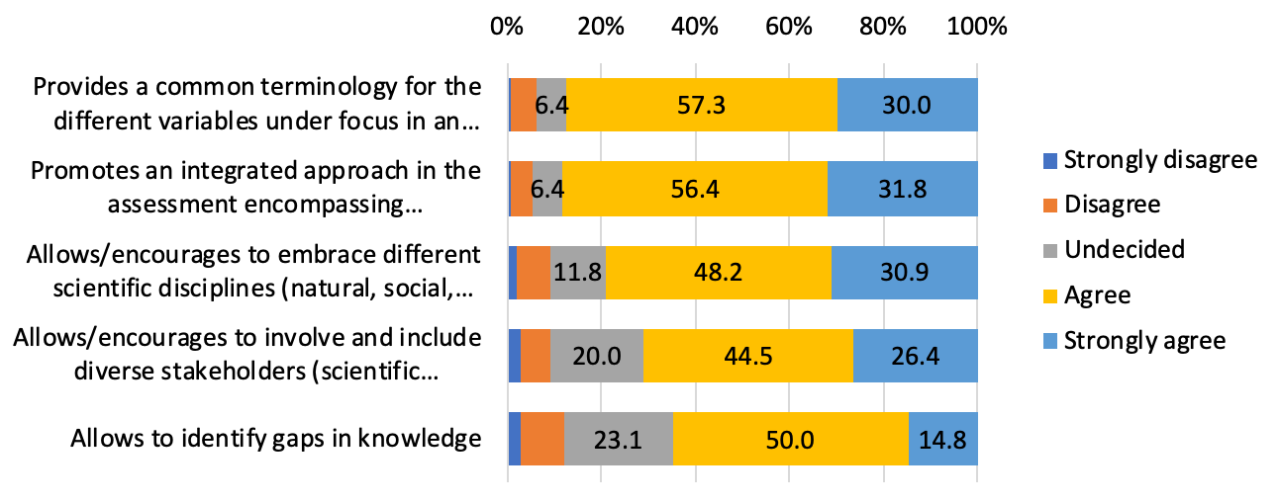

**Figure 1. How would you assess the usefulness of the IPBES conceptual framework in the IPBES assessments you were/are involved in? (responded to by experts)**

In addition, as an item 6), experts were asked to indicate and assess what other use was made possible by the conceptual framework aside from assessments, and 39 respondents (34.2% of the total) left comments. The themes presented in the comments were wide ranging, except for uses related to communication and education, which were often specifically mentioned. 57.5% of respondents identified additional positive uses of the conceptual framework, including use in socio-ecological and alternate people-nature contexts, local-level use and use in science-policy interactions. The 12.5% of respondents with negative perceptions saw limited use of the conceptual framework for economic assessments and flagged a potential for confusion between nature's contributions to people and ecosystem services. An overview of the qualitative responses is presented in **Figure 2**.

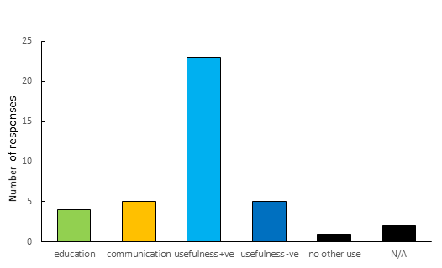

**Figure 2.** **Qualitative responses by experts regarding their use of the conceptual framework, aside from assessments (+ve: positive, -ve: negative)**

**National focal points and stakeholders** were also asked to rate the overall usefulness of the IPBES conceptual framework using the items listed below.

*IPBES assessments:*

*1) Give an integrated representation of the people – nature relationships (89.8%)*

*2) Look not only at status and trends in nature but also at the direct and indirect causes of these changes (88.0%)*

*3) Look at how the contributions that people derive from nature are affected by changes in nature (87.9%)*

*4) Look at how the changes in contributions that people derive from nature, in turn, affect the quality of life of people (83.0%)*

*5) Look at how nature, anthropogenic assets, institutions and governance interact in supporting people’s good quality of life through the provision of nature’s contributions to people/ecosystem services (82.7%)*

*6) Allow the use of different knowledge systems (science, indigenous and local knowledge, etc.) (75.0%)*

*7) Provide a good scientific basis to understand options for action in different contexts (78.2%)*

*8) Involve diverse stakeholders (the scientific community, governments, international organisations, and civil society at different levels) (76.5%)*

**The great majority of respondents provided a positive evaluation on the use of the IPBES conceptual framework** (**Figure 3**), and 75.0% to 89.8% of respondents chose either “*agree*” or “*strongly agree*”. The number in parentheses located at the end of each question item shows the percentage of respondents who chose “*agree*” or “*strongly agree*”, which indicates that the responses to items 6) to 8) were slightly less positive than those to items 1) to 5). In terms of the rate of respondents who chose “*strongly disagree*” or “*disagree*”, only item 7) with 10.7%, followed by item 8) (8.0%) and item 6) (7.6%), suggested that there may be slight challenges for the framework in allowing the use of the different knowledge systems, providing a basis for the identification of policy options and stakeholder involvement.

Among the 8 items, a significant difference in the evaluation depending on the background of respondents was observed only for item 8 *“Involve diverse stakeholders (the scientific community, governments, international organisations, and civil society*” (*P* = 0.046, Fisher's exact test), which was rated higher by respondents with a natural science background than experts with a background in other disciplines.

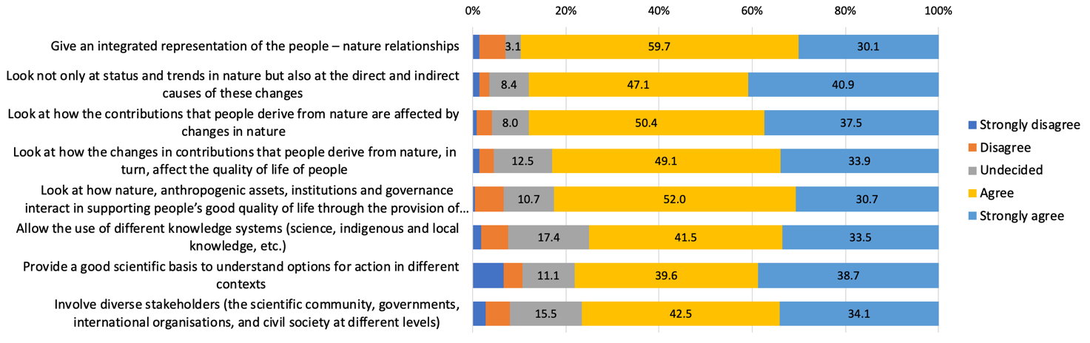

**Figure 3. How would you assess the usefulness of the IPBES conceptual framework in past and ongoing IPBES assessments? (responded to by national focal points and stakeholders)**

In addition, national focal points and stakeholders were asked to leave comments on what else they like about the IPBES vision, based on its conceptual framework (item 9) and what should be improved to implement this vision fully (item 10), and 141 and 152 respondents, respectively, left comments.

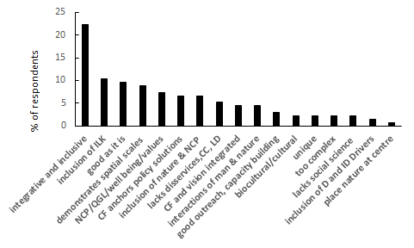58.4% of national focal points and stakeholders responded to the question what they liked about the IPBES vision, based on its conceptual framework. There was a wide range of positive responses which can be seen in **Figure 4**. 22.2% of respondents to the question appreciated the integrative and inclusive nature, while 10.4%, the second greatest response, appreciated the inclusion of indigenous and local knowledge and other knowledge systems, with 9.6% finding the conceptual framework to be “good as it is”. Respondents also liked that spatial scales are demonstrated, that nature, nature’s contributions to people, good quality of life, direct and indirect drivers, well-being and values are included; that the conceptual framework serves as an anchor for policy solutions, that the conceptual framework and vision are integrated, that the interactions of people and nature as well as biocultural and cultural aspects are reflected, the extent of outreach and capacity-building, and that the conceptual framework is unique and places nature at the centre. A small number of respondents expressed the view that “disservices”, climate change, land degradation and social science were not sufficiently covered and that the conceptual framework was too complex.

**Figure 4: % of respondents’ favourable qualitative responses to the IPBES vision and conceptual framework (answered by national focal points and stakeholders**; ILK- indigenous and local knowledge, CC-climate change, LD- land degradation, D-direct, ID - indirect)

### How easy was it for you to use the IPBES conceptual framework as part of your work in the IPBES assessment?

*(This question was asked only to experts)*

Under this question, **experts** were asked to rate the items listed below according to their level of agreement from “*strongly agree*” to “*strongly disagree*”, in order to explore the ease of use of the IPBES conceptual framework.

*How easy was it to use the IPBES conceptual framework:*

1. *To better structure and conceptualise your work for the assessment?*
2. *To take a more integrated approach in your work for the assessment?*
3. *To communicate more easily with other authors, especially from other disciplines and knowledge systems?*
4. *To understand the purposes of IPBES?*

**The respondents provided a positive evaluation of the use of the IPBES conceptual framework**, with 59.6% to 80.7% of respondents choosing either “*strongly agree*” or “*agree*” (**Figure** **5**). Although the majority of the respondents chose “agree” or “strongly agree” for all items, the rate was lowest for item 3), which indicates that there is a slight challenge for the conceptual framework to facilitate communication among experts, especially with those from other disciplines and knowledge systems.Also, in terms of negative responses, **the ratio of “*strongly disagree*” and “*disagree*” was most significant** for the item that the IPBES conceptual framework was easy to use **in taking a more integrated approach in the assessment.**

For all the four items, there was no significant difference observed in the evaluation of the ease of use of the IPBES conceptual framework between natural scientists and respondents with other backgrounds, suggesting that there was no difference in appreciation of the ease of use of the conceptual framework based on disciplinary background.

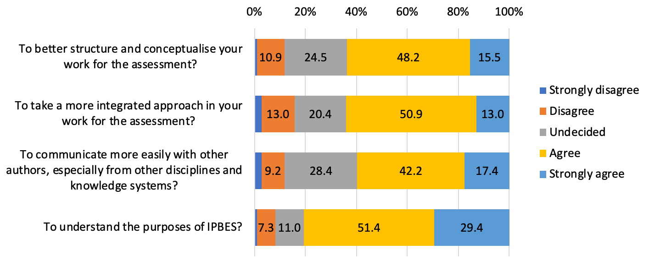

**Figure 5. How easy was it for you to use the IPBES conceptual framework as part of your work in the IPBES assessment? (responded to by experts)**

Expert respondents were also asked to indicate and assess the ease of use of the conceptual framework in any other assessment-related activities in an open-ended question (item 5). 31.6% of the respondents answered this question. 52.8% of those responding found the conceptual framework easy to use in other assessment-related activities, while 33% found it difficult to use (**Figure 6**). Individual responses listed as difficulties the complexity of the framework and limited background information explaining the different boxes and their interlinkages. A few respondents found the conceptual framework diagram too busy and so difficult to understand; this was also the case for those having difficulty with communication of the conceptual framework. Those without difficulties found it easy to implement, for example when working with indigenous peoples and in developing policy

**Figure 6: Expert respondents’ responses to the ease of use of the IPBES conceptual framework in other assessment related activities (+ve: positive, -ve: negative, N/A not applicable).**

### In your opinion, which of the following components of the IPBES conceptual framework, if any, would need further improvement/elaboration/clarification to help better structure and facilitate ongoing/future IPBES assessments?

*Please indicate below the reasons for your choice and/or any comments or recommendations.*

Both **experts and national focal points and stakeholders** were asked to choose the components of the IPBES conceptual framework that, in their view, needed further improvement/elaboration/clarification to help better structure and facilitate ongoing/future IPBES assessments and to indicate the reason for their choice.

For **experts**, about slightly more than a quarter of respondents (27.2%) chose “*None. The components of the IPBES conceptual framework are clear*” or no-response. In contrast, the others indicated one or more components in the IPBES conceptual framework which, in their opinion, required further improvement/elaboration/clarification (**Figure 7-1**). “*Good quality of life*” was the most commented-on component (20.2%), followed by “*Nature's contributions to people*” (19.3%) and “*Institutions, governance, and other indirect drivers*” (19.3%). On the other hand, the three least commented-on components were “*Natural direct drivers*” (2.6%), “*Relationship between Direct drivers and Nature*” (3.5%) and “*Relationship between Anthropogenic assets and Good quality of life*” (7.9%).

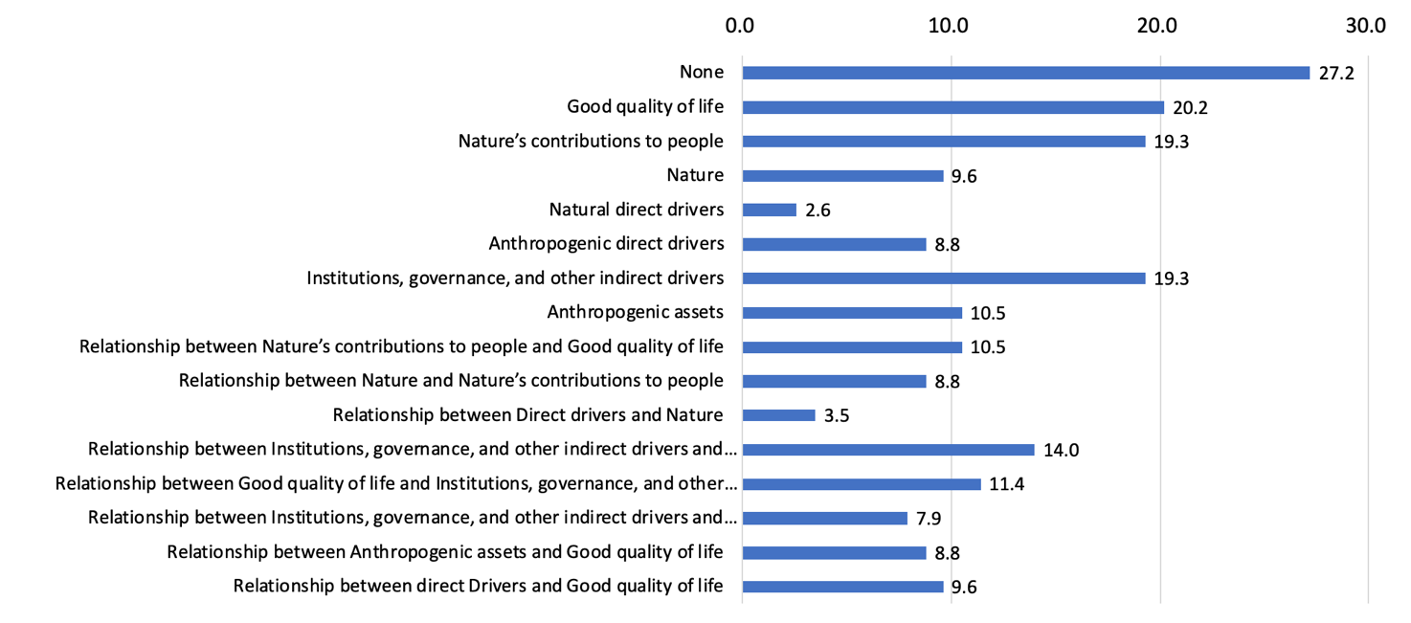

**Figure 7-1. Experts’ response to “*which of the following components of the IPBES conceptual framework would need further improvement/elaboration/clarification to help better structure and facilitate ongoing/future IPBES assessments*?” (% of respondents)**

For the same question, about a quarter of **national focal point and stakeholder respondents** (24.7%) chose “*None*. *The components of the IPBES conceptual framework are clear*” or no-response. In contrast, the remaining respondents indicated one or more components in the IPBES conceptual framework that in their opinion required further improvement/elaboration/clarification. “*Nature’s contributions to people*” was the most commented-on component (17.7%), followed by “*Good quality of life*” (15.6%) and “*Institutions, governance, and other indirect drivers*” (14.3%). The three least commented-on components were “*Natural direct drivers*” (2.2%), “*Relationship between Direct drivers and Nature*” (3.9%) and “*Relationship between Direct drivers and Good quality of life*” (4.8%).

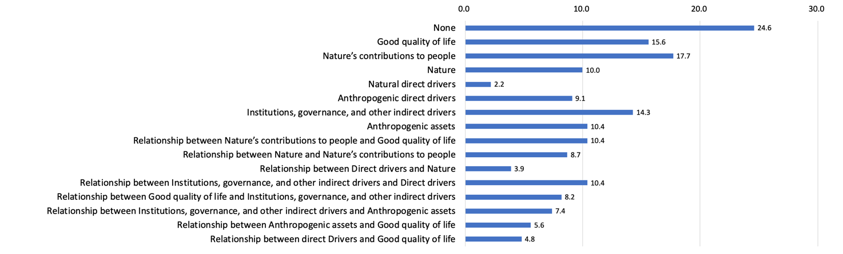

**Figure 7-2. National focal points’ and stakeholders’ response to “*which of the following components of the IPBES conceptual framework would need further improvement/elaboration/clarification to help better structure and facilitate ongoing/future IPBES assessments*?” (% of respondents)**

**It should be noted that both experts and national focal points and stakeholders commented mostly on “*Nature’s contributions to people*”, “*Good quality of life*”, and “*Institutions, governance, and other indirect drivers*”**,while the components that received the least number of comments were not the same between the two groups.

Participants in the surveys were also invited to provide, in an open-ended question, the reasons for the choice and/or provide any comments.

**Figure 8** outlines the responses by **experts**. Across all combinations of elements in Figure 8, there was a repeated request for the definition of terms to better understand the different aspects of the conceptual framework and their interrelationships. This was expressed most strongly for “Good quality of life”. A few respondents were uncomfortable with the term “good” in “Good quality of life”, with one comment noting that its nature may be seen as value-laden. There was a request for a definition of “Nature’s contributions to people” and metrics, including an explanation which outlines the differences between “Nature’s contributions to people” and ecosystem services. Some respondents also identified the need for a definition of “Nature” incorporating the human interactions and interrelationships between nature and people. Considering that the conceptual framework includes definitions of its elements, the Multidisciplinary Expert Panel and Bureau interpret these comments as requests for further information on, more visibility of definitions and explanations of these definitions and relationships among elements of the framework.

20.2% of respondents to the question identified a need for more knowledge on indicators to assess the relationship between “Nature’s contributions to people” and “Good quality of life”. Comments included confusion on the relationship between “Good quality of life” and “Institutions, governance, and other indirect drivers”, in particular about the relevant actors and an understanding of the interlinkages between these. Respondents also identified a need to better understand the differences between direct and indirect drivers. A number of respondents found the interlinkages within the conceptual framework boxes difficult to understand, noting that in their views, arrows and interconnections between the elements of the conceptual framework needed to be bi-directional rather than unidirectional. 13.2% of respondents found the conceptual framework to be too complex and highlighted particularly the need for greater clarity in the relationships between the boxes and connecting lines.

**Figure 8: Number of comments received on improvements/ elaboration/clarification to elements of the IPBES conceptual framework (responses by experts)**

**Figure 9** outlines the responses by national focal points and stakeholders. Across all components, some respondents identified a need for definitions, explanations of meanings, and understanding of the interactions between the different components of the conceptual framework. 13.7% of people providing comments on their selection of “Good quality of life” identified the need for a definition of the term and explanation of the term’s role in establishing links between human well-being, “Nature” and “Nature’s contributions to people”. As with the responses by experts (**Figure 8**) there was a request for an explanation of the differences between “Nature’s contributions to people” and ecosystem services. A further call for clarification was on the relations between “Nature’s contributions to people” and “Good quality of life”. There was also a call for a definition of “Nature” to include living and non-living aspects of nature, including the human components of nature and values. Further, definitions and clarification were also asked for on the interactions between “Institutions, governance, and other indirect drivers” and direct drivers, especially the involvement of institutions which are key for achieving transformative change. To some, the definition of anthropogenic assets was not clear as with respect to the interactions of the term with indigenous and local knowledge. Considering that the conceptual framework includes definitions of its elements, the Multidisciplinary Expert Panel and Bureau interpret these comments as requests for further information on and greater visibility of these definitions, as well as explanations of these definitions and relationships and elements of the framework.

It was also felt by some respondents that many of the arrows between elements of the conceptual framework should be bidirectional. Some respondents suggested the inclusion the term “people’s contributions to nature”.

**Figure 9: Number of comments received on improvements/ elaboration/clarification to elements of the IPBES conceptual framework (responded to by national focal points and stakeholders)**

### Are there any major relevant components, areas or relationships which you feel are not, or incompletely included in the current IPBES conceptual framework?

*Please describe the component/area or relationship and indicate your reasoning.*

About half of the expert respondents (50.9%) and a little less than half of the national focal point and stakeholder respondents (48.4%) left a comment to this question.

For **expert** respondents (**Figure 10),** 22.4%, the greatest response received indicated that there was no need for additional factors to be included in the conceptual framework, while 19% of responders would suggest to include additional cross-disciplinary factors such as policy, indigenous and local knowledge, values, sociology, culture, justice and inequality, economics, action and practice, as well as future trends. A small number of respondents identified an ongoing need for incorporating spatial and temporal change into the conceptual framework. 12% of respondents found the conceptual framework to be too complex for ease of understanding. A few respondents, also in their responses to this question, expressed their view that “people’s contributions to nature” should be included in addition to “Nature’s contributions to people”. Individual responses also indicated a need to include direct and indirect drivers across other components, in particular into “Institutions, governance, and other indirect drivers” and impacts on “Nature” and “Nature’s contributions to people”, while integrating feedbacks and impacts on nature. The Multidisciplinary Expert Panel and Bureau note that many of these suggestions are covered by the current understanding of the conceptual framework, however, may need to be more clearly identified.

**Figure 10: Expert suggestions on additional factors for inclusion in the IPBES conceptual framework (D-direct drivers, ID – indirect drivers)**

13.6 % of **national focal points and stakeholders** (**Figure 11**) identified a need for greater inclusion into the conceptual framework of factors such as values, culture, justice, and sociology. In addition, 12.6% of respondents felt that indigenous and local knowledge should be explicitly included in the conceptual framework. There were a number of other ideas mentioned, including a specific comment to include the “Nature” box at the top of the conceptual framework, with the “Good quality of life” box moved to the bottom and “Nature’s contributions to people” in the centre, with all other components surrounding these three key boxes.

**Figure 11: National focal point and stakeholder respondents’ suggestions on additional inter-disciplinary factors for inclusion in the IPBES conceptual framework (ILK- indigenous and local knowledge, NCP-Natures contribution’s to people, GQL-Good quality of life, HWB-Human well being)**

### How useful are the existing online documents and e-learning resources on the IPBES conceptual framework and related approach that are available on the IPBES website?

In this question, respondents were asked to rate the following six online documents and e-learning resources according to their level of usefulness from “*not useful*” to “*very useful*”.

*1) Explanation of the conceptual framework*

*2) E-learning resources on the IPBES conceptual framework*

*3) Journal article "The IPBES Conceptual Framework - connecting nature and people" by Díaz et al. (2015)*

*4) Journal article "A Rosetta Stone for Nature's Benefits to People" by Diaz et al. (2015)*

*5) Journal article "Valuing nature's contributions to people: the IPBES approach" by Pascual (2017)*

*6) Summary for policymakers of the IPBES Global Assessment of Biodiversity and Ecosystem Services as an example for the application of the conceptual framework in practice*

**The great majority of respondents, from both experts and national focal points and stakeholders, evaluated that the existing online documents and e-learning resources on the IPBES conceptual framework and related approach were useful.** The rating of six items was similar between experts and national focal points and stakeholders (**Figure 12-1, 12-2**). A relatively large number of respondents gave a below-average rating for items 1 (*Explanation of the conceptual framework*), 2 (*E-learning resources on the IPBES conceptual framework*), 4 (*Journal article "A Rosetta Stone for Nature's Benefits to People" by Diaz et al. (2015)*) and 5 (*Journal article "Valuing nature's contributions to people: the IPBES approach" by Pascual (2017)*). However, the rating of items 1, 2 and 4 does not seem to be critically low given that item 3 (*Journal article "The IPBES Conceptual Framework - connecting nature and people" by Díaz et al. (2015)*) provides the same information and its usefulness is highly appreciated by both experts and national focal points and stakeholders.

Regarding the influence of the disciplinary background of respondents, for experts, among the six items, only Question 37 “Summary for policymakers of the IPBES Global Assessment of Biodiversity and Ecosystem Services as an example for the application of the conceptual framework in practice” exhibited a significant difference in the evaluation of usefulness between the natural scientists and the others. Those with a natural science background tended to give a higher rating (*P* = 0.0002, Fisher's exact test). For national focal points and stakeholders, no significant differences were found in the evaluation of the usefulness of IPBES web resources between respondents with natural science background and those with other disciplinary backgrounds.

Regarding the difference between experts and national focal points and stakeholders, for five out of the six items, with the exception of Question 34 “Journal article “The IPBES Conceptual Framework - connecting nature and people” by Díaz et al. (2015)”, IPBES experts rated the usefulness of the IPBES web resources significantly higher than national focal points and stakeholders (Question 32 “Explanation of the conceptual framework” (*P* = 0.0013), Question 33 “E-learning resources on the IPBES conceptual framework” (*P* = 0.0068), Question 35 “Journal article “A Rosetta Stone for Nature's Benefits to People” by Diaz et al. (2015)” (*P* = 0.00460), Question 36 “Journal article “Valuing nature's contributions to people: the IPBES approach” by Pascual (2017)” (*P* = 0.0002), and Question 37 “Summary for policymakers of the IPBES Global Assessment of Biodiversity and Ecosystem Services as an example for the application of the conceptual framework in practice” (*P* = 0.0223)).

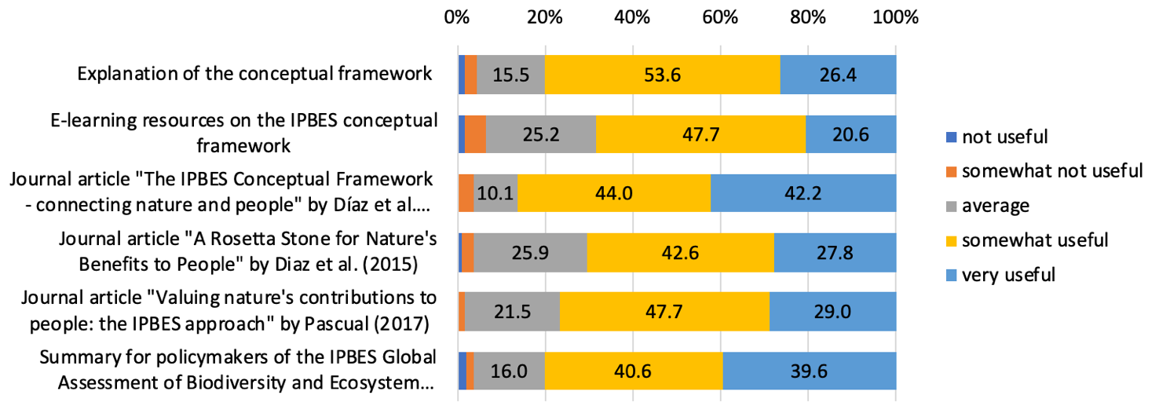

**Figure 12-1. Experts’ response to “*How useful are the existing online documents and e-learning resources on the IPBES conceptual framework and related approach that are available on the IPBES website?*” (% of respondents)**



**Figure 12-2. National focal points’ and stakeholders’ response to “*How useful are the existing online documents and e-learning resources on the IPBES conceptual framework and related approach that are available on the IPBES website?*” (% of respondents)**

## Impacts of the conceptual framework according to the two surveys

### How often did you use the IPBES conceptual framework in other areas of your work (in addition to your IPBES work)?

*Please add examples in the additional fields.*

Respondents were asked to rate how often they used the IPBES conceptual framework in the situations listed below in addition to their IPBES work.

1. *Framing a research project*
2. *Framing a scientific article*
3. *Framing a policy document*
4. *Framing a conference presentation*
5. *Framing a national or regional or local assessment of nature/biodiversity*
6. *Framing communication to decision-makers*
7. *Framing communication to the public*
8. *Guiding policymaking*
9. *Framing management and restoration programmes*

*10) Framing your student's graduate thesis*

The responses by experts indicated that the IPBES conceptual framework was used in various situations (**Figure 13-1**). The responses by national focal points and stakeholders demonstrated a similar situation (**Figure 13-2**). Taking together responses from “rarely” to “very often”, the top three situations where the IPBES conceptual framework was used were, for experts, item 1 (*Framing a research project*, 81.8%), 5 (*Framing a national or regional or local assessment of nature/biodiversity*, 80.0%), and 2 (*Framing a scientific article*, 79.3%), and, for national focal points and stakeholders, items 7 (*Framing a communication to public*, 82.2%), 6 (*Framing communication to decision-makers*, 36.0%), and 4 (*Framing a conference presentation*, 79.7%.) **The results indicate that the IPBES conceptual framework has the strength to help users to systematically analyze and/or explain the complex interdependencies in the social-ecological system for academic and assessment purposes as well as for communication to policymakers, scientists and the general public.**

Regarding the influence of the disciplinary background of respondents, for experts, Fisher’s exact test identified that, among the 10 situations, experts with a natural science background used the IPBES conceptual framework more frequently than scientists from other disciplines for Question 38 “Framing a research project” (*P* =0.0176), Question 39 “Framing a scientific article” (*P* = 0.0342), Question 40 “Framing a policy document” (*P* = 0.00067), Question 42 “Framing a national, regional or local assessment of nature/biodiversity” (*P* = 0.0228), Question 44 “Framing a communication to the public” (*P* = 0.0371) and Question 45 ”Guiding policymaking” (*P* = 0.0224), while there was no significant difference observed for the other situations. For national focal points and stakeholders, a significant difference associated with disciplinary background was found only in Question 45 “Framing management and restoration programmes” (*P* = 0.0224, Fisher's exact test), which respondents with a natural science background indicated more often than other respondents.

Regarding the difference between experts and national focal points & stakeholders, there was no significant difference observed in the frequency of using the IPBES conceptual framework for any of the 10 situations.

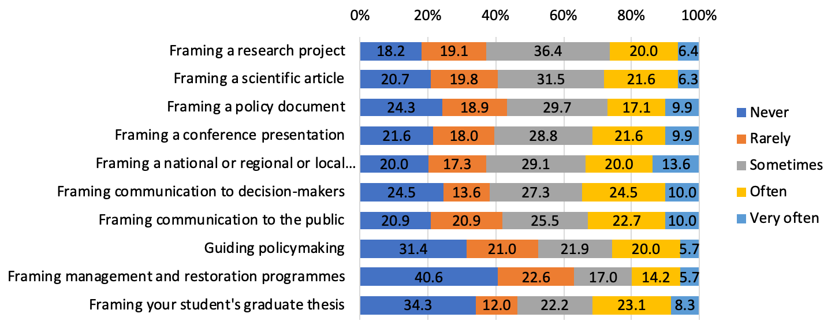

**Figure 13-1. Experts’ response to “*How often did you use the IPBES conceptual framework in other areas of your work (in addition to your IPBES work)?*” (% of respondents)**

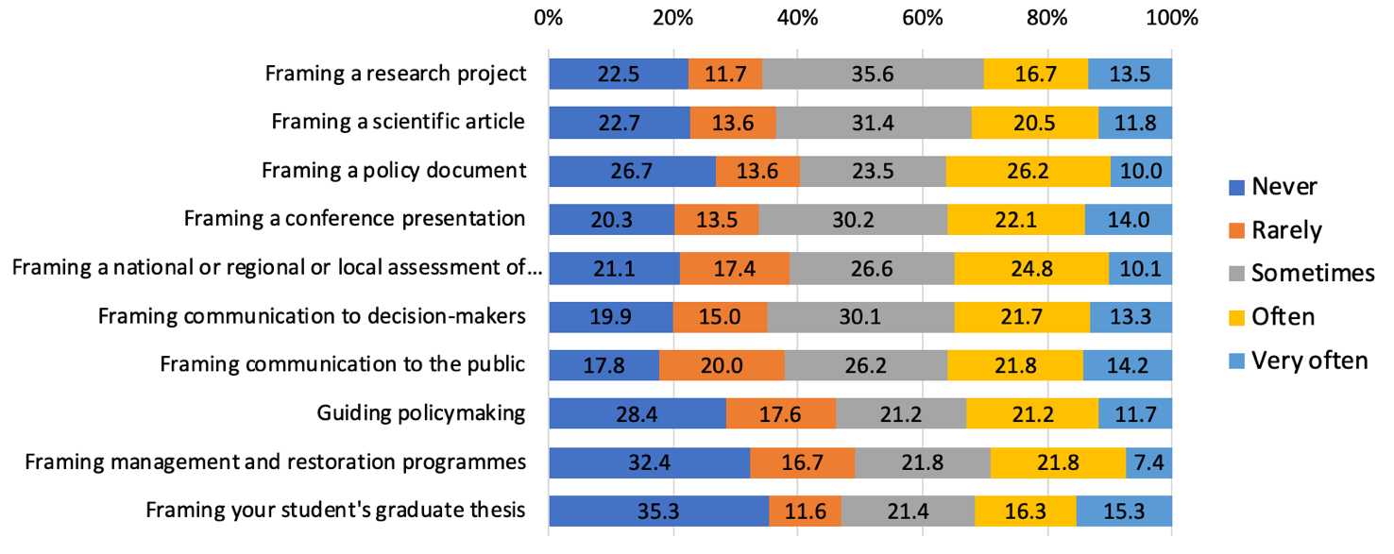

**Figure 13-2. National focal points’ and stakeholders’ response to “*How often did you use the IPBES conceptual framework in other areas of your work (in addition to your IPBES work)?*” (% of respondents)**

National focal points and stakeholders were also asked, in an open-ended question, how they used the IPBES conceptual framework in other areas of their work. 26.4% of respondents provided comments to this question. 36% of those that responded indicated that they made use of the conceptual framework in communication activities, while 26.4% included its use in education activities. 9.5% of respondents found its use to be positive in a variety of activities including project design, policy, research, publications, indigenous and local knowledge projects, and national biodiversity strategies. 21.3% of respondents provided negative responses and indicated that the framework was too complex for many communities of practice to understand (**Figure 14**).

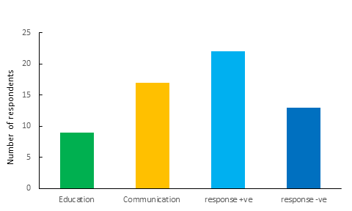

**Figure 14: Qualitative responses by national focal points and stakeholders on their use of the IPBES conceptual framework in other work areas (+ve: positive, -ve: negative, N/A not applicable).**

### Could you provide an example? Please select the area of work and share the title as well as a URL or file with further information.

*Information can be provided in all languages*

In relation to this question, the respondents were asked to provide specific examples for research projects, scientific articles, communications to public, and other items. The most common example presented by the experts was a “*Scientific article*” (14.9%), followed by a “*Communication to the public*” (14.0%), a “*Research project*” (11.4%), and “*Other*” (8.8%). For national focal points and stakeholders, the most frequently submitted examples were a “*Scientific article*” (16.5%), followed by a “*Research project*” (13.0%), a “*Communication to the public*” (9.1%), and “*Other*” (8.7%). In total, 139 titles were provided by respondents: 50 by experts and 89 by national focal points and stakeholders, of which 95 examples (34 from experts and 61 from national focal points and stakeholders) were submitted with web links or files. Further analysis of the specific titles and examples will be included in the final version of this study.

### Did your country/organisation conduct a national-scale or regional assessment of nature/biodiversity and Nature's contribution to people/ecosystem services?

The respondents were asked to answer if their country/organisation conducted a national-scale or regional assessment of nature/biodiversity and nature's contributions to people/ecosystem services. In the following, expert and non-expert responses are described separately, but it should be noted that these responses include information of the same assessments.

1. ***Status of assessments and publication year of assessment reports***

The response from experts indicated that, as of May 2020, 22 national-scale or regional-scale assessments relevant for the context of this report were completed, and 16 ongoing, for which 35 titles and 22 web links were submitted through the online survey. For 24 assessments, the publication year was provided. One assessment was conducted before 2000, 3 assessments between 2000 and 2011, and 20 assessments completed or expected to be completed between 2012 and 2020. The response from national focal points and stakeholders indicated that 36 national-scale or regional-scale assessments were completed and 44 ongoing, for which 71 titles and 1 web link were submitted through the online survey. The publication year was provided for 39 assessments. Three were conducted between 2000 and 2011, and 36 completed or expected to be completed between 2012 and 2023. **The fact that more than half of the assessments were initiated after the establishment of IPBES in 2012 suggests that there has been growing interest in national-scale or regional assessments to better formulate conservation policy.**

1. ***Components assessed in national-scale or regional assessments***

Experts and national focal points and stakeholders were asked to indicate which components of the IPBES conceptual framework were assessed in the above-mentioned assessments (Note that this does not necessarily mean that all the assessments used the IPBES conceptual framework). Responses were received for 31 assessments from experts: Among those 31 assessments, the most frequently assessed components were “*Nature*” (90.3%), followed by “*Anthropogenic direct drivers*” (80.6%), “*Nature’s contributions to people*” (77.4%), “*Natural direct drivers*” (77.4%), and “*Institutions, governance, and other indirect drivers*” (71.0%). “*Good quality of life*” (54.8%) and “*Anthropogenic assets*” (45.2%) were less often assessed compared to the other components (**Figure 15-1**).

For the same question, responses were received for 61 assessments from national focal points and stakeholders: Among those 61 assessments, the most frequently assessed components were “*Nature’s contributions to people*” (80.3%), followed by “*Anthropogenic direct drivers*” (75.4%), “*Institutions, governance, and other indirect drivers*” (68.9%), “*Nature*” (67.2%), and “*Natural direct drivers*” (65.6%). “*Good quality of life*” (47.5%) and “*Anthropogenic assets*” (42.6%) were less often assessed compared to the other components (**Figure 15-2**).

**The results indicate that nature’s contributions to people and natural and anthropogenic direct drivers are commonly assessed in national and regional assessments, followed by nature and indirect drivers (including institutions and governance), while good quality of life and anthropogenic assets are less frequently assessed in national and regional scale assessments.**

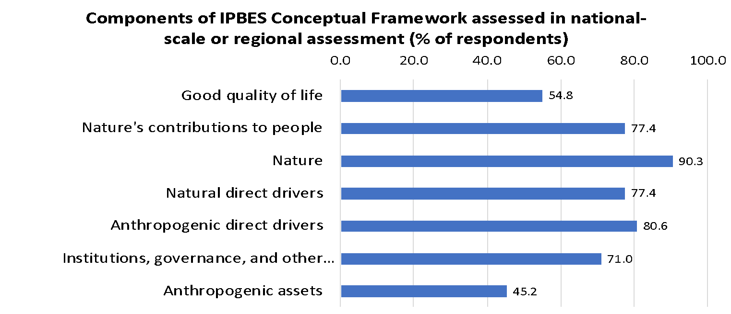

**Figure 15-1. Expert response to *“Which components of IPBES conceptual framework was assessed in******a national-scale or regional assessment of nature/biodiversity and Nature's contribution to people's/ecosystem services” (% of 31 assessments)”***

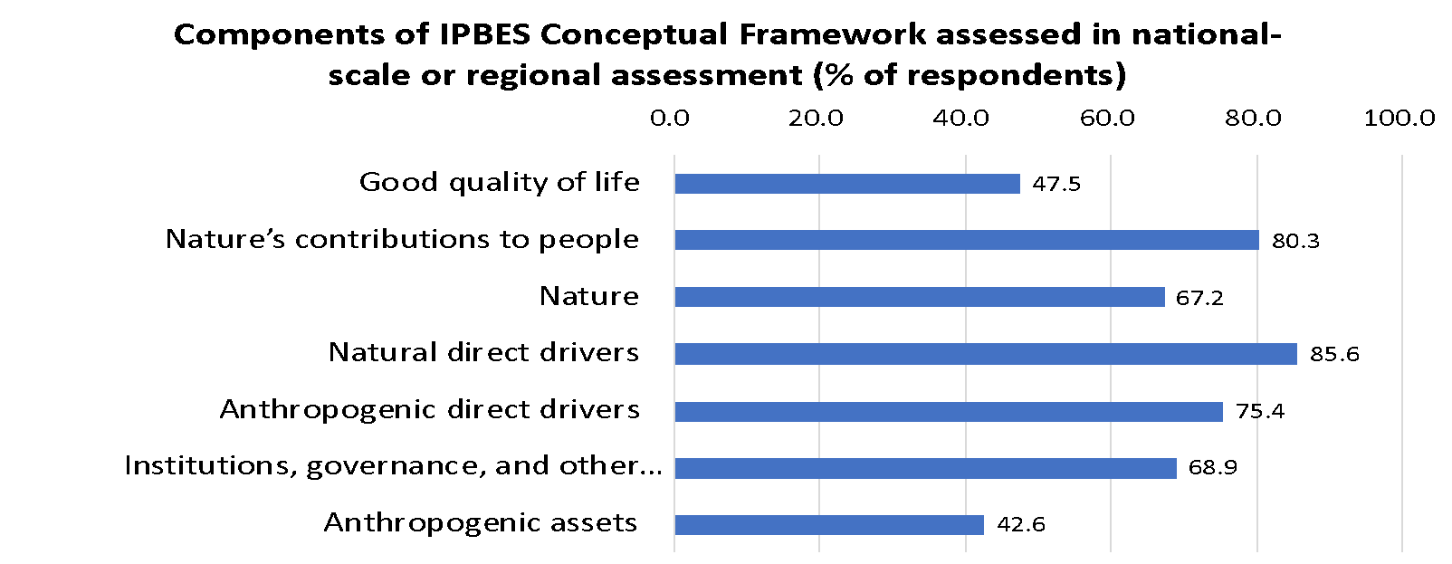

**Figure 15-2. National focal points’ and stakeholders’ response to *“Which components of IPBES conceptual framework were assessed in******a national-scale or regional assessment of nature/biodiversity and Nature's contribution to people's/ecosystem services” (% of 61 assessments)***

1. ***Type of conceptual framework used in*** ***a national-scale or regional assessment of nature/biodiversity and nature's contribution to people's/ecosystem services***

Responses from experts indicated that the IPBES conceptual framework was the most frequently used framework for national-scale or regional-scale assessments (50.0%), followed by the Millennium Ecosystem Assessment framework (25.0%), an original framework (9.4%), and the Driver-Pressure-State-Response (DPSIR) framework (3.1%), while four assessments (12.5% of the total of 32 responses) did not use any framework. Similarly, responses from national focal points and stakeholders indicated that the IPBES conceptual framework was the most frequently used framework for national-scale or regional-scale assessments (39.1%), followed by the Millennium Ecosystem Assessment framework (20.3%), an original framework (18.8%), the Driver-Pressure-State-Response (DPSIR) framework (12.5%), and the Pressure-State-Response (PSR) framework (1.6%), while five assessments (7.8% of the total of 64 responses) did not use any framework. **It is safe to say that IPBES conceptual framework has been widely used for national-scale or regional assessments along with its predecessor, the Millennium Ecosystem Assessment framework.**

1. ***Number of experts involved in the assessments***

The questionnaire also evaluated how many experts are/were involved in the assessments. Among 33 responses from experts, the most frequently selected option was “*equal to or more than 100 experts*” (30.3%), followed by “*1 to 19 experts*”(27.3%), “*80 to 99 experts*” (12.1%), “*20 to 39 experts*” (6.1%), “*30 to 59 experts*” (6.1%), and “*60 to 79 experts*” (6.1%), while the rest (12.1% of respondents) was not sure about how many experts were involved. For the same question, 76 responses were received from national focal points and stakeholders. The most frequently selected option was “*1 to 19 experts*” (31.8%), followed by “*20 to 39 experts*” (16.7%), “*equal to or more than 100 experts*” (13.6%), “*40 to 50 experts*” (12.1%), and “*60-99 experts*” (7.6%) while 18.2% of respondents were not sure about how many experts were involved. **The result indicates that there is a wide variation in the number of experts involved in national-scale or regional assessments.**

## Use and impact of the conceptual framework according to the literature review

The literature review results show that the IPBES conceptual framework has triggered scientific work in a number of directions (**Figure 16**). From 2013 (the publication year of the earliest paper included in this review) until 2015, when the framework was published, there was a low number, but steady increase, of papers mentioning, discussing or debating the framework. In 2016, one year after its publication and the year of the release of the IPBES Pollination Report, there was a further surge in papers mentioning or discussing it. After a dip in 2017, 2018, the year the four IPBES Regional Assessment Reports and the Land Degradation and Restoration Report were approved, saw a sharp increase in papers mentioning or discussing the framework, but also the first papers reporting its application either as a whole or using selected elements, to assess a region or a study system. Since 2018, the annual number of papers mentioning, discussing or applying the framework has more or less stabilized. The surveyed papers published so far in 2021 apply or partly apply the framework.

The 138 papers included in this overview were published in 48 different scientific journals (**Figure 17**). Among those, “Ecosystems and People”, “Environmental Science and Policy”, “Ecosystem Services”, “The European Journal of Social Science Research”, “Ecology and Society” and “Current Opinion in Environmental Sustainability” each published six or more IPBES conceptual framework-related papers since 2013.

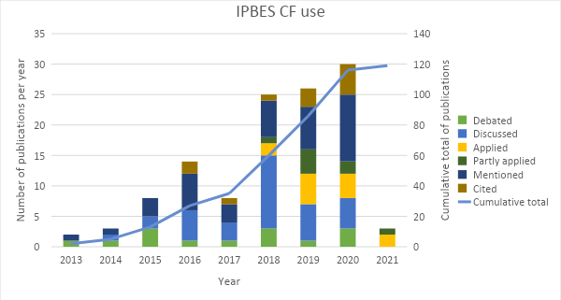

**Figure 16: Use of the IPBES conceptual framework in scientific and grey literature. The documents under the category “none” have not been included in the figure**

**Figure 17: Number of papers referring to the IPBES conceptual framework by journal. The documents under the category “none” have not been included in the figure**

Documents that debated the conceptual framework had different perspectives. Some provided a description of the framework or of the process leading to its development[8]. Other articles acknowledged achievements of the conceptual framework, such as the consideration of human well-being as ultimate end or the inclusion of a diversity of values and knowledge systems.[9] A couple of articles dealt with the consideration of the framework as a boundary object.[10]

Other documents addressed specific elements of the framework, such as the concept of “nature’s contributions to people”. The inclusion of the term “nature’s contributions to people” to replace “ecosystem services” as central part of the conceptual framework was the most common criticism. Some scholars argued that the concept of nature’s contributions to people maintains the one-relational flow between nature and people, emphasising nature as an instrument to human well-being, instead of putting peoples’ plural values of nature in the centre. Others claimed that the concept of nature’s contributions to people does not reflect how people contribute to nature, co-production between ecosystems and people or the role of technology and infrastructure to access nature’s contributions to people. Further, some maintained that ecosystem services are a strong, recognized and broadly used frame for assessing the value of nature to people and to inform decisions, and suggested that the use of a new concept might create confusion.[11] The need to strengthen policy uptake was also mentioned.[12]

The results from the literature search on nature’s contributions to people show that the concept of nature’s contributions to people has generated scientific activity (**Figure 17**). In 2018, following the update of the classification of nature’s contributions to people by IPBES in 2017[13], most of the publications referring to nature’s contributions to people debated the concept, followed by a few publications mentioning it. Since 2019, most publications addressing nature’s contributions to people apply the concept, while the documents discussing it are few, but increasing, and the ones just mentioning it remain stable. The 61 publications reviewed were published in 33 different journals (**Figure 18, 19**). From these “Sustainability Science”, “Ecology and Society”, “Ecosystems and People”, “Current Opinion in Environmental Sustainability”, “Ecosystem Services” and “Biota Neotropica” all published four or more papers related to nature’s contributions to people since 2017.

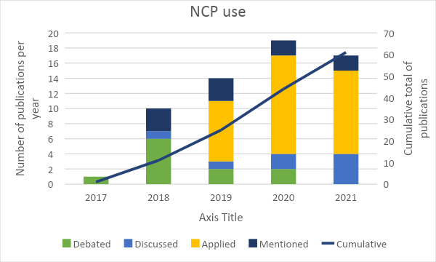

**Figure 18: Use of the concept of “nature’s contributions to people” in scientific and grey literature**

The results of this literature review indicate that the IPBES conceptual framework is used in the scientific and grey literature and that it is starting to have some impact as shown by the increasing number of publications referring to it. However, as the uptake in the scientific literature is only in its beginnings, the results from the IPBES survey among experts and focal points (see sections 3.1 and 3.2 above) are probably more representative of the use and impact of the IPBES conceptual framework than is this literature review. Finally, the concept of nature’s contributions to people has also triggered scientific work, with an increasing number of publications applying the concept since 2019 and an expected continuation of this trend in 2021.

**Figure 19: Number of papers referring to the concept of “nature’s contributions to people” by scientific journal**

**References for this section**

Borie, M. & Hulme, M. Framing global biodiversity: IPBES between mother earth and ecosystem services. *Environ. Sci. Policy* **54**, 487–496 (2015).

Díaz, S., Demissew, S., Joly, C., Lonsdale, W. M. & Larigauderie, A. A Rosetta Stone for Nature’s Benefits to People. *PLOS Biol.* **13**, e1002040 (2015).

Díaz, S. *et al.* The IPBES Conceptual Framework - connecting nature and people. *Current Opinion in Environmental Sustainability* **14**, 1–16 (2015).

Peterson, G. D. *et al.* Welcoming different perspectives in IPBES: “nature’s contributions to people” and “ecosystem services”. *Ecology and Society* **23**, (2018).

Dunkley, R., Baker, S., Constant, N. & Sanderson-Bellamy, A. Enabling the IPBES conceptual

framework to work across knowledge boundaries. *Int. Environ. Agreements Polit. Law Econ.* **18**, 779–799 (2018).

Kenter, J. O. IPBES: Don’t throw out the baby whilst keeping the bathwater; Put people’s values central, not nature’s contributions. *Ecosystem Services* **33**, 40–43 (2018).

Maier, D. S. & Feest, A. The IPBES Conceptual Framework: An Unhelpful Start. *Journal of Agricultural and Environmental Ethics* **29**, 327–347 (2016).

Keller, R., Keune, H. & Maynard, S. Where do IPBES delegates in Europe see challenges, needs, gaps and opportunities in policy uptake of “Nature’s contributions to people”? *Innov. Eur. J. Soc. Sci. Res.* **31**, S116–S124 (2018).

IPBES. Update on the classification of nature’s contributions to people by the Intergovernmental Science-Policy Platform on Biodiversity and Ecosystem Services. IPBES/5/INF/24. in *IPBES/5/INF/24* 8 (2017).

# Conclusions

Both the surveys among IPBES national focal points and IPBES experts and the literature review reflect a consensus that the IPBES conceptual framework is very useful and that it already has had various positive impacts, including guiding IPBES work, stimulating further science-policy and scientific work, and stimulating discussion on the relationship between nature and people.

The use and impact of the IPBES conceptual framework have increased since its adoption and publication, and they are continuing to do so. The various uses indicated in the surveys and the increasing numbers of literature references referring to the IPBES conceptual framework also suggest that the use and impact of the IPBES conceptual framework will continue to increase.

The survey results and the discussion in the scientific literature also suggest that the use and impact of the IPBES conceptual framework, and thus its usefulness for the evolution of the IPBES rolling work programme could be further enhanced. Additional clarification concerning the individual components of the framework and what they entail, and concerning the interrelations of these components would further enhance the operationalisation and usefulness of the conceptual framework.

**Appendix**

**Survey questions**

|  |  |
| --- | --- |
| **Survey for experts** | |
| Q1 | 1. How would you assess the usefulness of the IPBES conceptual framework in the IPBES assessments you were/are involved in? The IPBES conceptual framework:  1）Provides a common terminology for the different variables under focus in an assessment |
|  | 2) Promotes an integrated approach in the assessment encompassing consideration of direct and indirect drivers, changes in nature, impacts on nature's contributions to people and quality of life, options for action and their interrelationships |
|  | 3）Allows/encourages to embrace different scientific disciplines (natural, social, humanities, engineering sciences) |
|  | 4）Allows/encourages to involve and include diverse stakeholders (scientific community, governments, int. organisations, civil society at different levels), and their different knowledge systems (science, indigenous and local knowledge, etc.) |
|  | 5）Allows to identify gaps in knowledge. |
|  | 6）Other: Please indicate and assess what other use was made possible by the conceptual framework |
| Q2 | 2. How easy was it for you to use the IPBES conceptual framework as part of your work in the IPBES assessment? Specifically, how easy was it to use the IPBES conceptual framework:  1）To better structure and conceptualise your work for the assessment? |
|  | 2）To take a more integrated approach in your work for the assessment? |
|  | 3）To communicate more easily with other authors, especially from other disciplines and knowledge systems? |
|  | 4) To understand the purposes of IPBES? |
|  | 5）Other: Please indicate and assess the ease of use of the conceptual framework in any other assessment-related activities |
| Q3 | 3. In your opinion, which of the following components of the IPBES conceptual framework, if any, would need further improvement/elaboration/clarification to help better structure and facilitate ongoing/future IPBES assessments? Please indicate below the reasons for your choice and/or any comments or recommendations. |
|  | Good quality of life |
|  | Nature's contributions to people |
|  | Nature |
|  | Natural direct drivers |
|  | Anthropogenic direct drivers |
|  | Institutions, governance, and other indirect drivers |
|  | Anthropogenic assets |
|  | Relationship between Nature's contributions to people and Good quality of life |
|  | Relationship between Nature and Nature's contributions to people |
|  | Relationship between Direct drivers and Nature |
|  | Relationship between Institutions, governance, and other indirect drivers and Direct drivers |
|  | Relationship between Good quality of life and Institutions, governance, and other indirect drivers |
|  | Relationship between Anthropogenic assets and Good quality of life |
|  | Relationship between Direct drivers and Good quality of life |
|  | Relationship between Institutions, governance, and other indirect drivers and Anthropogenic assets |
| Q4 | 4. Are there any major relevant components, areas or relationships which you feel are not, or incompletely included in the current IPBES conceptual framework? Please describe the component/area or relationship and indicate your reasoning. |
| Q5 | 5. How useful are the existing online documents and e-learning resources on the IPBES conceptual framework and related approach that are available on the IPBES website?  1）Explanation of the conceptual framework |
|  | 2）E-learning resources on the IPBES conceptual framework |
|  | 3）Journal article "The IPBES Conceptual Framework - connecting nature and people" by Díaz et al. (2015) |
|  | 4）Journal article "A Rosetta Stone for Nature's Benefits to People" by Diaz et al. (2015) |
|  | 5）Journal article "Valuing nature's contributions to people: the IPBES approach" by Pascual (2017) |
|  | 6）Summary for policymakers of the IPBES Global Assessment of Biodiversity and Ecosystem Services as an example for the application of the conceptual framework in practice |
| Q6 | 6. How often did you use the IPBES conceptual framework in other areas of your work (in addition to your IPBES work)? Please add examples in the additional fields:  1) Framing a research project |
|  | 2) Framing a scientific article |
|  | 3) Framing a policy document |
|  | 4) Framing a conference presentation |
|  | 5) Framing a national or regional or local assessment of nature/biodiversity |
|  | 6) Framing communication to decision-makers |
|  | 7) Framing communication to the public |
|  | 8) Guiding policymaking |
|  | 9) Framing management and restoration programmes |
|  | 10) Framing your student's graduate thesis |
| Q7 | 7. Could you provide an example? Please select the area of work and share the title as well as a URL or file with further information. Information can be provided in all languages |
|  | 1) Please enter the title of the research project and provide more information by sharing a URL or digital file. Information can be provided in all languages. |
|  | 2) Please enter the title of the scientific article and provide more information by sharing a URL or digital file. Information can be provided in all languages. |
|  | 3) Please enter the title of the communication to the public and provide more information by sharing a URL or digital file. Information can be provided in all languages. |
|  | 4) Please enter the title of other resources(s) and provide more information by sharing a URL or digital file. Information can be provided in all languages. |
| Q8 | 8. Did your country/organisation conduct a national-scale or regional assessment of nature/biodiversity and Nature's contribution to people's/ecosystem services? |
|  | 1）Name of the assessment |
|  | 2）Please provide a URL to or upload a file that provides information on the objective and findings of the assessment |
|  | 3) Year of publication/completion |
|  | 4）Which of the following components of the IPBES conceptual framework were used in the assessment? |
|  | 5）Which of the following frameworks did the assessment use? |
|  | 6）How many experts are/were involved in the assessment? |
| Q9 | 9. In which IPBES assessment(s) were/are you involved? |
|  | Please select the regional assessment(s) that you have participated. |
|  | Please indicate your role in the assessment*s): |
| Q10 | 10. In which UN regional group do you work? Please indicate the one most relevant to you. |
| Q11 | 11. In which sector do you work? Please indicate the one most relevant to you. |
| Q12 | 12. How many years have you been working in the area which brought you to IPBES activities? |
| Q13 | 13. What is your field of expertise which brought you to IPBES activities? |
| Q14 | 14. Gender |

|  |  |
| --- | --- |
| **Survey for national focal points and stakeholders** | |
| Q1 | 1. How would you assess the usefulness of the IPBES conceptual framework in past and ongoing IPBES assessments? The IPBES assessments:  1）Give an integrated representation of the people – nature relationships |
|  | 2）Look not only at status and trends in nature but also at the direct and indirect causes of these changes |
|  | 3）Look at how the contributions that people derive from nature are affected by changes in nature |
|  | 4）Look at how the changes in contributions that people derive from nature, in turn, affect the quality of life of people |
|  | 5）Look at how nature, anthropogenic assets, institutions and governance interact in supporting people’s good quality of life through the provision of nature’s contributions to people/ecosystem services |
|  | 6）Allow the use of different knowledge systems (science, indigenous and local knowledge, etc.) |
|  | 7）Provide a good scientific basis to understand options for action in different contexts |
|  | 8）Involve diverse stakeholders (the scientific community, governments, international organisations, and civil society at different levels) |
|  | 9）What else do you like about the IPBES vision, based on its conceptual framework? |
|  | 10）What should be improved to implement this vision fully? |
| Q2 | 2. In your opinion, which of the following components of the IPBES conceptual framework, if any, would need further improvement/elaboration/clarification to help better structure and facilitate ongoing/future IPBES assessments? Please indicate the reasons for your choice and/or any comments or recommendations. |
|  | Good quality of life |
|  | Nature’s contributions to people |
|  | Nature |
|  | Natural direct drivers |
|  | Anthropogenic direct drivers |
|  | Institutions, governance, and other indirect drivers |
|  | Anthropogenic assets |
|  | Relationship between Nature’s contributions to people and Good quality of life |
|  | Relationship between Nature and Nature’s contributions to people |
|  | Relationship between Direct drivers and Nature |
|  | Relationship between Institutions, governance, and other indirect drivers and Direct drivers |
|  | Relationship between Good quality of life and Institutions, governance, and other indirect drivers |
|  | Relationship between Institutions, governance, and other indirect drivers and Anthropogenic assets |
|  | Relationship between Anthropogenic assets and Good quality of life |
|  | Relationship between direct Drivers and Good quality of life |
| Q3 | 3. Are there any major relevant components, areas or relationships which you feel are not, or incompletely included in the current IPBES conceptual framework? Please describe the component/area or relationship and indicate your reasoning. |
| Q4 | 4. How useful are the existing online documents and e-learning resources on the IPBES conceptual framework and related approach that are available on the IPBES website?  1）Explanation of the conceptual framework |
|  | 2）E-learning resources on the IPBES conceptual framework |
|  | 3）Journal article "The IPBES Conceptual Framework - connecting nature and people" by Díaz et al. (2015) |
|  | 4）Journal article "A Rosetta Stone for Nature's Benefits to People" by Diaz et al. (2015) |
|  | 5）Journal article "Valuing nature's contributions to people: the IPBES approach" by Pascual (2017) |
|  | 6）Summary for policymakers of the IPBES Global Assessment of Biodiversity and Ecosystem Services as an example for the application of the conceptual framework in practice |
| Q5 | 5. How often did you use the IPBES conceptual framework in other areas of your work (in addition to your IPBES work)? Please add examples in the additional fields.:  1）Framing a research project |
|  | 2）Framing a scientific article |
|  | 3）Framing a policy document |
|  | 4）Framing a conference presentation |
|  | 5）Framing a national or regional or local assessment of nature/biodiversity |
|  | 6）Framing communication to decision-makers |
|  | 7）Framing communication to the public |
|  | 8）Guiding policymaking |
|  | 9）Framing management and restoration programmes |
|  | 10）Framing your student's graduate thesis |
|  | 11）Other: please specify and evaluate |
| Q6 | 6. Could you provide an example? Please select the area of work and share the title as well as a URL or file with further information. Information can be provided in all languages |
|  | 1) Please enter the title of the research project and provide more information by sharing a URL or digital file. Information can be provided in all languages. |
|  | 2) Please enter the title of the scientific article and provide more information by sharing a URL or digital file. Information can be provided in all languages. |
|  | 3) Please enter the title of the communication to the public and provide more information by sharing a URL or digital file. Information can be provided in all languages. |
|  | 4) Please enter the title of other resources(s) and provide more information by sharing a URL or digital file. Information can be provided in all languages. |
| Q7 | 7. Did your country/organisation conduct a national-scale or regional assessment of nature/biodiversity and Nature's contribution to people's/ecosystem services? |
|  | 1）Name of the assessment |
|  | 2）Please provide a URL to or upload a file that provides information on the objective and findings of the assessment |
|  | 3) Year of publication/completion |
|  | 4）Which of the following components of the IPBES conceptual framework were used in the assessment? |
|  | 5）Which of the following frameworks did the assessment use? |
|  | 6）How many experts are/were involved in the assessment? |
| Q8 | 8. In which sector do you work? |
| Q9 | 9. Select Government |
| Q10 | 10. Please indicate the name of your organization |
| Q11 | 11. Please indicate whether you are submitting your responses to this questionnaire on behalf of your Government or in your individual capacity |
| Q12 | 12. Please indicate whether you are submitting your responses to this questionnaire on behalf of your organization or in your individual capacity |
| Q13 | 13. How many years have you been working in the area which brought you to IPBES activities? |
| Q14 | 14. What is your field of expertise which brought you to IPBES activities? |
| Q15 | 15. Gender |

|  |  |  |  |  |
| --- | --- | --- | --- | --- |
|  |  |  |  |  |

1. * IPBES/9/1.
2. * The annex has not been formally edited.
3. This questionnaire was most responded to by experts involved in the Regional Assessments (50.5%), followed by the Global Assessment (25.2%), and the sustainable use of wild species assessment (18.9%), while the response from those involved in the Pollination Assessment was quite small (3 respondents, 2.7%). Because some experts contributed to two or more assessments to date, the sum of the percentage exceeds 100%. The number of experts who contributed to only one assessment was 75; 32 experts contributed to 2 assessments, 3 experts to 3 assessments, and 1 expert to 4 assessments.
4. Participating co-chairs accounted for 11.4%, coordinating lead authors for 27.2%, lead authors for 82.5% and review editors for 12.4%. Since some respondents contributed to two or more assessments, the sum of percentages exceeds 100%.
5. The question items for the overall evaluation of the IPBES conceptual framework differ between the two surveys. Also, national focal points and stakeholders were not asked about the ease of use of the IPBES conceptual framework in IPBES assessments.
6. The question inquired if they responded to the survey as a representative of their organization or within their individual capacity.
7. IPBES, 2017.
8. Borie and Hulme, 2015; Díaz et al., 2015a; Díaz et al., 2015.
9. Peterson et al., 2018.
10. Borie and Hulme, 2015; Dunkley et al., 2018.
11. Peterson et al., 2018; Kenter, 2018; Maier and Feest, 2016.
12. Keller et al., 2018.
13. IPBES, 2017.