UNITED  NATIONS | 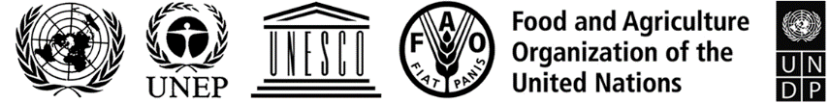 |  |  | BES
 |  |  | IPBES/9/INF/1
 |  | Intergovernmental Science-Policy  Platform on Biodiversity and  Ecosystem Services | Distr.: General  8 April 2022  English only
Plenary of the Intergovernmental Science-Policy
Platform on Biodiversity and Ecosystem Services
Ninth session
Bonn, Germany, 3–9 July 2022
Item 7 (a) of the provisional agenda*
Assessing knowledge: thematic assessment of the sustainable use of wild species
Chapters of the thematic assessment of the sustainable use of wild species
- In section V of decision IPBES-6/1, the Plenary of the Intergovernmental Science-Policy Platform on Biodiversity and Ecosystem Services (IPBES) approved the undertaking of a thematic assessment of the sustainable use of wild species, in accordance with the procedures for the preparation of the Platform’s deliverables set out in annex I to decision IPBES-3/3 and as outlined in the scoping report set out in annex IV to decision IPBES-5/1.
- In response to that decision, an expert group has produced a set of six chapters and a summary for policymakers. The summary for policymakers is set out in document IPBES/9/6. An overview of the process followed for the preparation of the assessment is set out in document IPBES/9/INF/8.
- At its ninth session, the Plenary will be invited to approve the summary for policymakers. It will also be invited to accept the chapters of the report, including their executive summaries, which will be revised after the ninth session to ensure consistency with the summary for policymakers as approved.
- The chapters, including their executive summaries, are available at https://ipbes.net/final_gov_review_sustainable_use. They are presented without formal editing.

* IPBES/9/1.

