UNITED  NATIONS | 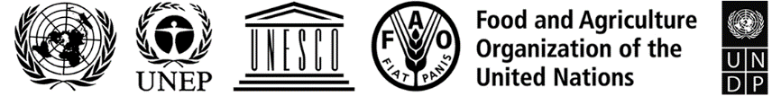 |  |  | BES
 |  |  | IPBES/8/INF/10
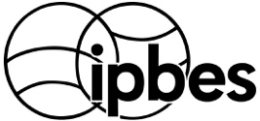 |  | Intergovernmental Science-Policy Platform on Biodiversity and Ecosystem Services | Distr.: General  12 April 2021  English only
Plenary of the Intergovernmental Science-Policy
Platform on Biodiversity and Ecosystem Services
Eighth session
Online, 14–24 June 2021
Item 5 of the provisional agenda*
Report of the Executive Secretary on progress in the
implementation of the rolling work programme up to 2030
Information on enhanced recognition of and work with indigenous and local knowledge systems
Note by the secretariat
- The Plenary of the Intergovernmental Science-Policy Platform on Biodiversity and Ecosystem Services (IPBES), in section II of its decision IPBES-2/5, established a task force on indigenous and local knowledge systems for the period of its first work programme. In section III of its decision IPBES-5/1, the Plenary approved the approach to recognizing and working with indigenous and local knowledge (hereinafter referred to as the IPBES approach to indigenous and local knowledge) set out in annex II to that decision; requested the Multidisciplinary Expert Panel, supported by the task force on indigenous and local knowledge, to implement it; and requested the Executive Secretary to make the arrangements necessary to implement the approach, including arrangements for the establishment of the participatory mechanism, subject to the availability of resources. In the same decision, the Plenary invited indigenous peoples and local communities and their representatives, as well as experts on indigenous and local knowledge, to engage in the activities described in the IPBES approach to indigenous and local knowledge, in particular through the participatory mechanism, and invited Governments, stakeholders, strategic partners and others to support activities mobilizing indigenous and local knowledge where such knowledge was needed.
- The Plenary, at its seventh session, in decision IPBES-7/1, adopted the rolling work programme of the Platform for the period up to 2030, which included, among others, objective 3 (b), enhanced recognition of and work with indigenous and local knowledge systems. The objective focuses on implementing the approach to recognizing and working with indigenous and local knowledge in IPBES, taking into account the special needs of indigenous and local knowledge holders through the implementation of the participatory mechanism established under the approach, and the recommendations and findings set out in document IPBES/7/INF/8 and other relevant future IPBES processes.
- In decision IPBES-7/1, the Plenary recalled the establishment of the task force on indigenous and local knowledge systems and extended its mandate for the implementation of objective 3 (b) of the rolling work programme of IPBES up to 2030 in accordance with the revised terms of reference set out in annex II to that decision, and requested the Bureau and Multidisciplinary Expert Panel, through the Platform’s secretariat, to constitute the task force in accordance with the terms of reference.
- According to its terms of reference, the task force will oversee and take part in the implementation of objective 3 (b) of the IPBES rolling work programme up to 2030, and act in accordance with relevant decisions of the Plenary and its subsidiary bodies, including by building on lessons learned in the implementation of deliverable 1 (c) of the first work programme; supporting the Multidisciplinary Expert Panel in implementing the approach to recognizing and working with indigenous and local knowledge in IPBES; and guiding the secretariat, including the dedicated technical support unit, in supporting the Multidisciplinary Expert Panel in implementing the approach. The Plenary decided to review the mandate and terms of reference of the task force at its tenth session.
- In decision IPBES-7/1, the Plenary also took note of the next steps for the task force for 2019 and 2020 and requested it to develop specific deliverables for each of the priority topics set out in paragraph 8 of the rolling work programme up to 2030, for consideration by the Plenary at its eighth session. The general terms of reference of the task forces, set out in annex II to decision IPBES-7/1, foresee that each task force will, among other activities, provide a regular progress report and, in consultation with the Multidisciplinary Expert Panel and the Bureau, develop and update a workplan that sets out clear milestones and deliverables with regard to the relevant topics and objectives of the rolling work programme up to 2030 for periodic consideration by the Plenary.
- Information on draft deliverables, an interim workplan for objective 3 (a) for the intersessional period 2021–2022 and a draft workplan for the intersessional period 2022–2023 are presented in document IPBES/8/7. An overview of activities carried out by the task force since the seventh session of the Plenary is set out in the report of the Executive Secretary on progress in the implementation of the rolling work programme up to 2030 (IPBES/8/2).
- Further information on activities carried out by the task force in addressing its mandate, activities planned for the next intersessional period, and an overview of possible activities related to the nexus and transformative change assessments are set out in the annex to the present note, which has not been formally edited.

Annex
Information on work related to indigenous and local knowledge
I. Membership of the task force
- On 17 May 2019, a notification (EM/2019/09) was issued in which Governments and relevant stakeholders were invited to nominate candidates for the five IPBES task forces. 57 nominations were received for the task force on indigenous and local knowledge. Of the nominations received: 29 candidates were female and 28 were male, 12 were from Africa, 16 from Asia-Pacific, 4 from Eastern Europe, 9 from Latin America and the Caribbean and 16 from Western Europe and other States.
- The Multidisciplinary Expert Panel and Bureau, at their 13th meetings selected the members of the task force in line with its terms of reference set out in annex II to decision IPBES-7/1. The Multidisciplinary Expert Panel and Bureau decided to select, as part of the task force, an expert on indigenous and local knowledge, defined in the IPBES approach to indigenous and local knowledge as persons from indigenous peoples and local communities who have knowledge about indigenous and local knowledge and associated issues, from each of the five official United Nations regions. One member was selected through the procedure for filling gaps in expertise, as set out in annex III to decision IPBES-4/3, to include an expert on indigenous and local knowledge from Eastern Europe. The Multidisciplinary Expert Panel and Bureau also selected liaison experts from each assessment as members or alternate members of the task force, to enhance connections between the work of the task force and the ongoing assessments.
- The final composition of the task force comprises:
Name | Country | Function
Ana María Hernandez Salgar | Colombia | Task force co-chair, IPBES Chair / Bureau member
Adriana Carolina Flores-Díaz | Mexico | Task force co-chair, Member of the Multidisciplinary Expert Panel
Judith Fisher | Australia | Member of the Multidisciplinary Expert Panel
Bibiana Vila | Argentina | Member of the Multidisciplinary Expert Panel
Zemede Asfaw | Ethiopia | Expert
Eduardo Brondizio | Brazil | Expert
Jocelyn Cariño-Nettleton | Philippines/ UK | Expert
Viviana Elsa Figueroa | Argentina | Expert
Jinlong Liu | China | Expert
Zsolt Molnár | Hungary | Expert
Sherry Pictou | Canada | Expert
Kamal Kumar Rai | Nepal | Expert
Kanyinke Sena | Kenya | Expert
Vyacheslav Shadrin | Russia | Expert
Simone Athayde | Brazil | Liaison expert from the values assessment
Marla Emery | USA | Liaison expert from the sustainable use assessment (alternate member)
Patricia Howard | UK/USA | Liaison expert from the invasive alien species assessment (alternate member)
- The technical support unit located at the United Nations Educational, Scientific and Cultural Organization (UNESCO) in Paris, which had provided technical support to the task force during its first work programme, was selected by the Bureau at its 13th meeting to also provide technical support to the task force under the 2030 rolling work programme until the tenth session of the Plenary. The technical support unit is funded by IPBES and a matching in-kind contribution by UNESCO.
II. First and second meetings of the task force on indigenous and local knowledge
- The first meeting of the task force on indigenous and local knowledge under the rolling work programme of IPBES up to 2030 was organized jointly with the four other IPBES task forces in Bonn, Germany from 11 to 14 November 2019.
- At its first meeting, the task force was introduced to IPBES, the mandate of the task forces, and previous work, and achievements in implementation of the IPBES approach to indigenous and local knowledge in IPBES. The task force also started to develop the interim and draft work plans set out in document IPBES/8/7.
- The second meeting of the task force was held online, on 11 June and 2 July 2020. The task force discussed further refinement of the workplans, and progress and next steps in their implementation. This included setting up smaller working groups to focus on different activities. Highlights of the progress and achievements of this ongoing work by the task force are presented below.
III. Progress in the implementation of objective 3(b): Enhanced recognition of and work with indigenous and local knowledge systems
A. Implementation of the approach to recognizing and working with indigenous and local knowledge in IPBES
- Indigenous and local knowledge liaison groups: For each of the three ongoing assessments (assessment on values, assessment of the sustainable use of wild species and assessment of invasive alien species) liaison groups of assessment authors, which focus on addressing indigenous and local knowledge in the assessments and related methodological questions, were established. The task force and technical support unit continued to work closely with these liaison groups, providing methodological support as needed, including guidance on literature reviews and support for the identification of contributing authors.
- Participation in assessment reviews: The task force participated in the external reviews of the ongoing assessments and the draft scoping documents of the nexus and transformative change assessments, with a focus on providing comments to enhance the inclusion of indigenous and local knowledge.
- A call for contributions on indigenous and local knowledge for the three ongoing assessments (EM/2020/15) was open from 12 June to 15 September 2020. The call provided an opportunity for indigenous peoples and local communities to engage with the assessment process, by submitting papers, reports, videos, artworks or other materials that document or highlight indigenous and local knowledge related to the ongoing assessments. The call received more than 705 documents from 309 contributors (46 contributors from Africa, 92 from Asia-Pacific, 2 from Eastern Europe, 79 from Latin America, 90 from countries in the Western Europe and Others Group). Contributions included academic papers, community reports, videos, websites, news stories, community declarations, maps and artworks. The contributions were sorted and tagged for the ongoing assessments (373 for sustainable use, 368 for values, 30 for invasive alien species) and uploaded to the IPBES library of resources in Zotero that is available to IPBES assessment experts. They were then included in the literature review processes for the ongoing assessments.
- Dialogue workshops were held for the ongoing and new assessments. These allow for direct exchanges on the scope and content of drafts between assessment experts and a selection of experts on indigenous and local knowledge and members of indigenous peoples and local communities. Since the seventh session of the IPBES Plenary, the following dialogue workshops were held:
  - For the assessment of the sustainable use of wild species:
    - On initial framing of key indigenous and local knowledge questions and resources for the assessment: 6 and 7 May 2019, Paris;
    - On the first external review: 8 to 10 October 2019, Montreal, Canada;
    - On the second external review: 17 to 21 May 2021, online (in English and Spanish);
  - For the assessment on values:
    - On the first external review: 10 to 11 September 2019 in Oaxaca, Mexico;
    - On the second external review: 16 to 19 February 2021, online (in English and Spanish);
  - For the assessment of invasive alien species:
    - On initial framing of key questions and resources for the assessment: 18 to 19 November 2019 in Montreal, Canada;
    - On the first external draft review: 29 September to 1 October 2020, online;
  - For the review of the draft scoping document of the nexus and transformative change assessments: 16 July 2020, online.
- Reports on the dialogues for the ongoing assessments have been completed and are being used as resources by the authors of the respective assessments. They are available online here. Dialogue workshops that were held during external review periods also produced comments on the draft documents that were channelled into the official review process.
- Materials from completed assessments: As part of the implementation of the participatory mechanism, a compilation of “Key Messages from the IPBES Global Assessment of particular relevance to Indigenous Peoples and Local Communities” was developed by members of the task force and members of the indigenous and local knowledge liaison group of the Global Assessment of Biodiversity and Ecosystem Services. The document presents a compilation of the messages of most relevance to indigenous peoples and local communities from the summary for policymakers. It is available online in English, French and Spanish here. The document will be highlighted at the stakeholder days prior to the eighth session of the Plenary, with a view to recording the presentations and creating e-resources around the key messages, which will be made available online.
- Enhanced implementation of the participatory mechanism: Part of the IPBES indigenous and local knowledge approach, the objective of the participatory mechanism is to facilitate the effective and meaningful engagement of indigenous and local knowledge holders, indigenous and local knowledge experts and their organizations or networks in order to strengthen their ability to contribute to and benefit from IPBES. Many activities listed in section A above are central to the implementation of the participatory mechanism, including the dialogue workshops and the call for contributions. In addition:
  - The IPBES website has been updated to describe how indigenous peoples and local communities can participate in the work of IPBES;
  - An extended roster of contacts of indigenous peoples and local community organisations and individuals has been developed and used to distribute the call for contributions, identifying participants for the dialogue workshops, and identifying contributing authors for the ongoing assessments;
- The technical support unit provides information to the Multidisciplinary Expert Panel on participation of experts on indigenous and local knowledge and members of indigenous peoples and local communities in dialogue workshops and the call for contributions and of experts on indigenous and local knowledge in ongoing assessments.
B. Development of further methodological guidance on the approach
- A section on conceptualizing local communities and local knowledge was developed, approved by the Multidisciplinary Expert Panel and added to the methodological guidance on implementing the approach to recognizing and working with indigenous and local knowledge in IPBES, including a series of examples of local communities, and a list of local community organizations that could be engaged in the work of IPBES.
- Free, prior and informed consent: The process for working with free, prior and informed consent in dialogue workshops has become an integral part of the dialogue workshop process. New text on how to manage free, prior and informed consent principles in relation to literature reviews was developed by the task force, and approved by the Multidisciplinary Expert Panel.
- Using multiple types of evidence: The task force has been working with the task force on knowledge and data to look at methods for working with and storing videos.
- Scenarios and indigenous and local knowledge: The task force agreed to set up an informal working group including some of its members and members of the task force on scenarios and models. The group met online in September 2020 to discuss potential activities on scenarios and indigenous and local knowledge, as well as potential resources and methods that could be developed using existing materials. This resulted in guidance on working with scenarios and indigenous and local knowledge being developed. The guidance discusses approaches around working with indigenous and local knowledge and scenarios in IPBES assessments, including how to work with indigenous and local knowledge resources that may not be specifically on scenarios, to broaden the knowledge base available to authors.
- The IPBES data management policy: The task force worked with the task force on knowledge and data to develop a process for enhancing consideration of indigenous and local knowledge in the IPBES data management policy. This was approved by the Multidisciplinary Expert Panel, and the task forces will work together on further development of the data management policy.
IV. Overview of possible activities under objective 3(b), enhanced recognition of and work with indigenous and local knowledge systems, related to the nexus and transformative change assessments
- As reflected in the work plan set out in document IPBES/8/7, activities to implement the IPBES approach to recognizing and working with indigenous and local knowledge will be implemented for the nexus and the transformative change assessments. If the task force was to continue its work following the review of its mandate at the tenth session of the Plenary, activities could include dialogue workshops during the second external reviews of the draft assessments and the collation and dissemination of relevant content from the assessments, once approved. An overview of possible activities is set out in the figure below.

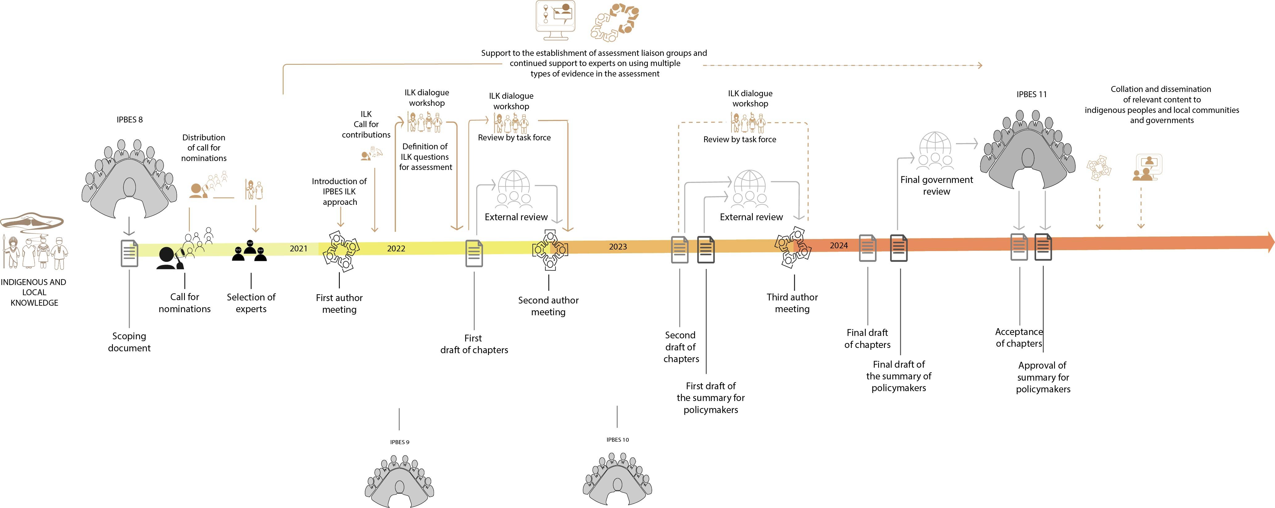
Overview of possible activities under objective 3(b), enhanced recognition of and work with indigenous and local knowledge systems related to the nexus and transformative change assessments

* IPBES/8/1.

