UNITED  NATIONS |  |  | 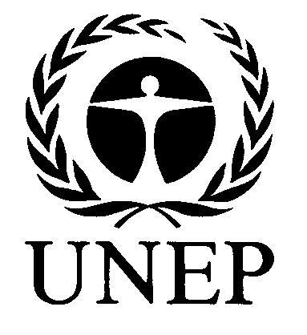 |  | 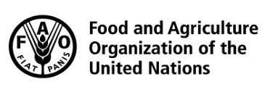 |  |  | BES
 |  |  |  |  |  |  | IPBES/6/INF/27/Rev.1
 |  | Intergovernmental Science-Policy Platform on Biodiversity and Ecosystem Services |  |  |  |  | Distr.: General  8 March 2018  English only
Plenary of the Intergovernmental Science-Policy
Platform on Biodiversity and Ecosystem Services
Sixth session
Medellin, Colombia, 18–24 March 2018
Item 2 (c) of the provisional agenda*
Organizational matters: election of members of the Multidisciplinary Expert Panel
Compilation of curricula vitae of proposed members of the Multidisciplinary Expert Panel: proposals from Asia-Pacific States
Note by the secretariat
The annex to the present note, which is presented without formal editing, sets out a compilation of the curricula vitae of the candidates proposed for membership of the Multidisciplinary Expert Panel, as submitted by Asia-Pacific States. The curricula vitae have been made available, as received, from https://www.ipbes.net/nominations/mep-2017.

Annex
Compilation of curricula vitae of proposed members of the Multidisciplinary Expert Panel:
proposals from Asia-Pacific States
Nominated by | Name | Affiliation | Expertise | Gender | Link to curriculum vitae
Bhutan | Thinley Choden | Ugyen Wangchuck Institute for Conservation and Environmental Research (UWICER) | Forestry | Female | https://www.ipbes.net/sites/default/files/thinley_choden_cv_dec2017.pdf
Bhutan | Sangay Wangchuk | Ugyen Wangchuck Institute for Conservation and Environmental Research (UWICER) | Forestry | Male | https://www.ipbes.net/sites/default/files/cv_sangay_wangchuk.pdf
China | Ning Wu | Chengdu Institute of Biology, Chinese Academy of Sciences | Ecosystem services | Male | https://www.ipbes.net/sites/default/files/cv_of_wu_ning_2017-08.pdf
India | Gaensan Balachander |  | Conservation, socio-economic development | Male | https://www.ipbes.net/sites/default/files/gb_cv_nov_2017.doc
Japan | Shizuka Hashimoto | Graduate School of Agricultural and Life Sciences, University of Tokyo | Landscape policy and planning | Male | https://www.ipbes.net/sites/default/files/cvhashimotonov2017r.pdf
Malaysia | Leng Guan Saw | Penang Botanic Gardens | Plant ecology and taxonomy | Male | https://www.ipbes.net/sites/default/files/curriculum_vitae_-_sawlg.pdf
Maldives | Mohamed Adam | Marine Research Center, Maldives | Marine biology, fisheries | Male | https://www.ipbes.net/sites/default/files/dr._mohamed_shiham_adam_cv_version_3.pdf
Maldives | Abdulla Naseer | Maldives National University | Tropical marine biology, coral reefs | Male | https://www.ipbes.net/sites/default/files/cv_naseer_updated_jan2018.pdf
Nepal | Ram Chaudhary | Tribhuvan University | Biodiversity conservation | Male | https://www.ipbes.net/sites/default/files/1._ram_p._chaudharynepal_cv_mep_ipbes_2018.docx
Nepal | Madhav Karki | Centre for Green Economy Development | Natural resource management | Male | https://www.ipbes.net/sites/default/files/madhavkarkicv2017.pdf
Nepal | Krishna Paudel | Kathmandu Forestry College | Agroforestry | Male | https://www.ipbes.net/sites/default/files/kcp_cv_ipbes_2018.doc
Nepal | Shree Bhagavan Thakur | FAO/Climate Change Adaptation in Agriculture Project, Kathmandu-LDF/GEF | Agriculture | Male | https://www.ipbes.net/sites/default/files/sbthakur_cv_dec_2017.docx
Pakistan | Hamid Ahmad | Pakistan Council of Scientific & Industrial Research (PCSIR) | Food science and technology | Male | https://www.ipbes.net/sites/default/files/cv_ha_food_sci._meat_sci._aw_-_2017-1.pdf
Pakistan | Hussain Ali | Agricultural Research Institute Tarnab | Entomology | Male | https://www.ipbes.net/sites/default/files/dr._hussain_ali_cv_1.pdf
Pakistan | Parveen Ejaz | Ministry of Climate Change, Government of Pakistan | Biogeochemistry | Female | https://www.ipbes.net/sites/default/files/cv_pe_updated_112017_1_1_1.doc
Pakistan | Rizwan Irshad | Ministry of Climate Change, Government of Pakistan | Zoology, conservation | Male | https://www.ipbes.net/sites/default/files/cv_rizwan_irshad_abs_training.docx
Pakistan | Farkhanda Manzoor | Lahore College for Women University | Entomology | Female | https://www.ipbes.net/sites/default/files/cv_farkhanda.pdf
Pakistan | Rahmatullah Qureshi | Pir Mehr Ali Shah Arid Agriculture University | Taxonomy, ethnobotany | Male | https://www.ipbes.net/sites/default/files/cv-dr._rahmat.pdf
Philippines | Theresa Mundita Lim | Department of Environment and Natural Resources - Biodiversity Management Bureau | Veterinary medicine, resource management | Female | https://www.ipbes.net/sites/default/files/curriculum_vitae_tmsl_01052017_1.docx

* IPBES/6/1.

