UNITED  NATIONS | 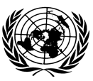 |  | 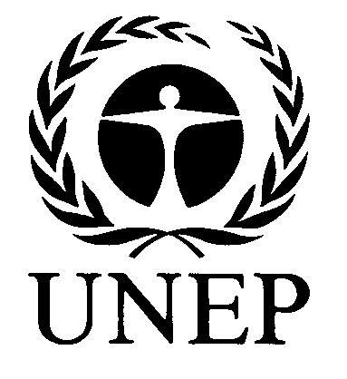 |  | 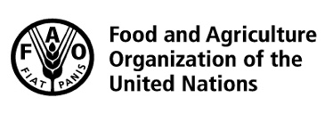 | 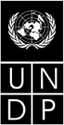 |  | BES
 |  |  |  |  |  |  | IPBES/6/INF/26/Rev.2
 |  | Intergovernmental Science-Policy Platform on Biodiversity and Ecosystem Services |  |  |  |  | Distr.: General  9 March 2018  English only
Plenary of the Intergovernmental Science-Policy
Platform on Biodiversity and Ecosystem Services
Sixth session
Medellin, Colombia, 18–24 March 2018
Item 2 (c) of the provisional agenda*
Organizational matters: election of members of the Multidisciplinary Expert Panel
Compilation of curricula vitae of proposed members of the Multidisciplinary Expert Panel: proposals from African States
Note by the secretariat
The annex to the present note, which is presented without formal editing, sets out a compilation of the curricula vitae of the candidates proposed for membership of the Multidisciplinary Expert Panel, as submitted by African States. The curricula vitae have been made available, as received, from https://www.ipbes.net/nominations/mep-2017.

Annex
Compilation of curricula vitae of proposed members of the Multidisciplinary Expert Panel: proposals from African States
Nominated by | Name | Affiliation | Expertise | Gender | Link to curriculum vitae
Benin | Jean Evans Israel Codjia | Laboratory of Ecology, Botany and Plant Biology University of Parakou | Mycology, forest agronomy | Male | https://www.ipbes.net/sites/default/files/curriculum_vitae_evans.pdf
Burundi | Nderagakura Ferdinand | Ministry of Environment | Agro-  Environment engineering | Male | https://www.ipbes.net/sites/default/files/c.v._ferd.english_2018_1.pdf
Cameroon | Chimere Diaw | African Model Forests | Economic anthropology | Male | https://www.ipbes.net/sites/default/files/cv_version_5b_chimere_diaw_eng_0.pdf
Ethiopia | Woldeamlak Bewket Alemayehu | Addis Ababa University | Geography and environmental studies | Male | https://www.ipbes.net/sites/default/files/w-bewket-cv-ac_jan_2018.pdf
Ghana | Elliot Alhassan | University for Development Studies | Fisheries and aquatic resources | Male | https://www.ipbes.net/system/tdf/curriculum_vitae-eha_dec_-_2017.pdf?file=1&type=entityform&id=979
Liberia | Shadrach Kerwillain | Fauna and Flora International | Protected area management | Male | https://www.ipbes.net/sites/default/files/skerwillain_cv_docx.docx
Madagascar | Voahangy Raharimalala | Office National pour l’Environnement | Plant ecology | Female | https://www.ipbes.net/sites/default/files/curriculum_vitae_mep2018_voahangy_raharimalala.pdf
Malawi | Christopher Manda | Environmental Affairs Department | Natural resource management | Male | https://www.ipbes.net/sites/default/files/christopher_manda_cv_0.pdf
Morocco | Nard Bennas | Universite Abdelmalek Essaadi | Conservation and restoration of freshwater ecosystems | Female | https://www.ipbes.net/sites/default/files/cv_bennas_mep_ipbes.pdf
Morocco | Brahim Haddane | Mohammed VI Foundation for the Protection of the Environment - Rabat | Veterinary medicine | Female | https://www.ipbes.net/sites/default/files/cv_2_haddane.pdf
Morocco | Mohammed Sghir Taleb | Institut Scientifique, Mohammed V University in Rabat | Botany and ecology | Male | https://www.ipbes.net/sites/default/files/cvtaleb_is_aout_2017_0.doc
Nigeria | Edu Effiom | Government of Cross River State | Animal ecology | Female | https://www.ipbes.net/sites/default/files/edu_effiom_cv1_0.pdf
Nigeria | Francis Nwosu | Ministry of Environment/Department of Forestry | Oceanography, fisheries | Male | https://www.ipbes.net/sites/default/files/francis_nwosu_cv.pdf
South Africa | Luthando Dziba | South African National Parks | Rangeland science | Male | https://www.ipbes.net/sites/default/files/dr._luthando_dziba_cv_-_2018.docx
South Africa | Nicholas King | Consultant | Conservation, scenarios | Male | https://www.ipbes.net/sites/default/files/nkingcv-_july_2017_0.pdf
South Africa | Sibusisiwe Ngcobo | Kana U Vhulunga Mvelele- Women in Conservation | Community development | Female | https://www.ipbes.net/sites/default/files/sibusisiwes_cv.pdf
Sudan | Aisha Elfaki | Wildlife Research Center | Wildlife medicine | Female | https://www.ipbes.net/sites/default/files/aisha_cv.pdf
Sudan | Ameer Mohammed | Wildlife Research Centre | Protected areas management | Male | https://www.ipbes.net/sites/default/files/microsoft_word2_-_curriculum_vitae_original_12.pdf
Togo | Raoufou Radji | University of Lomé | Horticulture | Male | https://www.ipbes.net/sites/default/files/radji_cv_2017.pdf
Zambia | Jacob Mwitwa | The Copperbelt University | Ecological physiology | Male | https://www.ipbes.net/sites/default/files/jacob_mwitwa_4page_cv.docx
Zambia | Gertrude Ngenda | Institute for Economic and Social Research, University of Zambia | Rural and urban planning | Female | https://www.ipbes.net/sites/default/files/gertrude_ngenda_cv_1.doc
Zimbabwe | Edson Gandiwa | Chinhoyi University of Technology | Wildlife conservation | Male | https://www.ipbes.net/sites/default/files/edson_gandiwa_-_cv_updated_20_dec_2017.doc
Zimbabwe | Mduduzi Ndlovu | University of the Free State | Zoology and entomology | Male | https://www.ipbes.net/sites/default/files/m_ndlovu_cv_november_2017_0.pdf

* IPBES/6/1.

