UNITED  NATIONS | 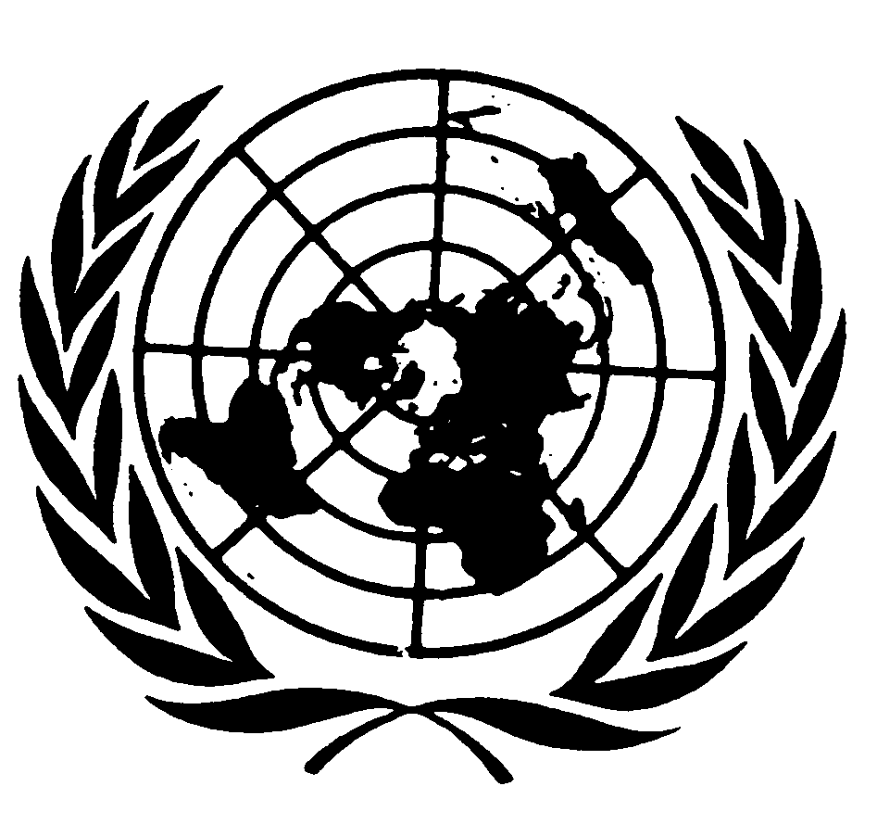 |  | 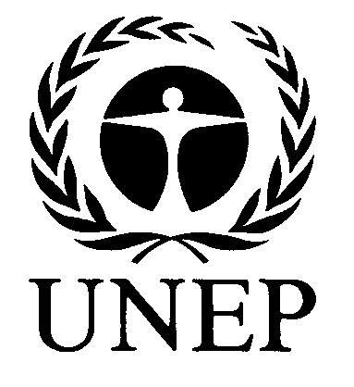 | 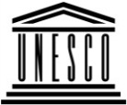 | 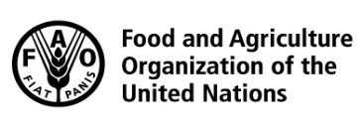 | 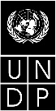 |  | BES
 |  |  |  |  |  |  | IPBES/5/INF/4
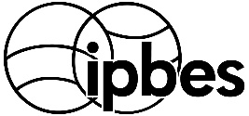 |  | Intergovernmental Science-Policy Platform on Biodiversity and Ecosystem Services |  |  |  |  | Distr.: General  1 February 2017  English only
Plenary of the Intergovernmental Science-Policy
Platform on Biodiversity and Ecosystem Services
Fifth session
Bonn, Germany, 7–10 March 2017
Item 6 (b) of the provisional agenda
Work programme of the Platform: indigenous and
local knowledge systems
Information on work related to indigenous and local knowledge systems (deliverable 1 (c))
Note by the secretariat
- The note by the secretariat on indigenous and local knowledge systems (deliverable 1(c)) (IPBES/5/4) outlines the progress made and the direction of further work to be undertaken.
- The annex to the present note provides additional information on continuing to pilot preliminary approaches and procedures for working with indigenous and local knowledge in the regional assessments of biodiversity and ecosystem services, and on developing an overall approach to working with indigenous and local knowledge in the Intergovernmental Science-Policy Platform on Biodiversity and Ecosystem Services. The annex is presented without formal editing.
Annex
Information on work related to indigenous and local knowledge systems (deliverable 1 (c))
I. Report on continuing to pilot preliminary approaches and procedures to work with indigenous and local knowledge in the regional assessments
- As requested by the Plenary in decision IPBES-4/1, section II, the piloting of dialogue workshops in the preparation of the regional assessments of biodiversity and ecosystem services was continued, with a view to considering the methodology employed thus far in the context of developing an overall approach to working with indigenous and local knowledge in IPBES. The following describes the specific activities undertaken.
- During 2015, the piloted procedures included, as a first step, an initial global call for submissions of relevant indigenous and local knowledge for the four regional assessments. The call was launched in three languages (English, French, Spanish) in June 2015, calling for submissions by end of July 2015. The submissions received were then distributed across the four regional assessments.
A. Progress report for Africa, and Europe and Central Asia
- In the context of the regional assessments for Africa and Europe & Central Asia (ECA), members of the task force on indigenous and local knowledge selected the most relevant submissions for the two regions. The indigenous and local knowledge holders/experts that had submitted the selected case studies were invited to attend the dialogue workshop for the respective region:
  - Dialogue workshop on indigenous and local knowledge for the regional assessment for Africa: 14 to 16 September 2015, UNESCO, Paris (immediately following the third meeting of the task force on indigenous and local knowledge);
  - Dialogue workshop on indigenous and local knowledge for the regional assessment for Europe and Central Asia: 11 to 13 January 2016, UNESCO, Paris;
- The dialogue workshops brought together the selected indigenous and local knowledge holders and experts with co-chairs and authors of the IPBES assessment report, along with relevant indigenous and local knowledge task force members. During the workshops, indigenous and local knowledge holders and experts shared their knowledge on biodiversity and ecosystem services with co-chairs and authors of the assessment. Authors and indigenous and local knowledge holders and experts agreed on key concepts, while discussing the multiple challenges of addressing indigenous and local knowledge within the framework of an IPBES assessment.
- Subsequent to the workshops, follow-up meetings were organized at the local level by the indigenous and local knowledge holders and experts who participated in the dialogue workshops in order to fill gaps identified with the authors, compile additional indigenous and local knowledge relevant to the assessment, and disseminate information about IPBES to participating communities and local authorities.
- During 2016, the case studies on indigenous and local knowledge presented and discussed during the dialogue workshops were compiled as preliminary draft proceedings, organized around key selected case studies. This preliminary compilation was made available to all workshop participants, including to authors for their initial consideration when preparing inputs to the first order draft of the assessment reports. The proceedings from the dialogue workshop were made available online to the author teams in time for citation in the second order draft of the assessment reports as:
  - M. Roué, N. Césard, Y. C. Adou Yao and A. Oteng-Yeboah (eds.). 2016. Indigenous and local knowledge of biodiversity and ecosystem services in Africa. UNESCO: Paris; and
  - Marie Roué and Zsolt Molnár (eds.). 2016. Indigenous and local knowledge of biodiversity and ecosystem services in Europe and Central Asia. UNESCO: Paris.
- The above work was supplemented by an analysis of the scientific and grey literature on relevant indigenous and local knowledge in Africa and Europe and Central Asia, coordinated by the technical support unit for indigenous and local knowledge. The results of these literature reviews were made available to the co-chairs, coordinating lead authors and lead authors for their consideration while drafting the assessments;
  - For the regional assessment for Africa, this review identified 327 sources in two languages (English, French) referring to indigenous and local knowledge (including 268 journal articles, 35 book chapters, reports and theses, and 24 sources from the grey literature). Of these 327 references, 36 were extracted and citations highlighted as they were of potential interest for the assessments.
  - For the regional assessment for Europe and Central Asia, this review identified 219 sources in two languages (English, French) referring to indigenous and local knowledge (including 118 journal articles, 76 book chapters, reports and theses, and 24 sources from the grey literature). The technical support unit extracted citations for every source identified.
B. Progress report for Asia-Pacific and the Americas
- During 2016, two calls for submissions of indigenous and local knowledge relevant to the
Asia-Pacific and Americas regional assessments were widely-circulated in five languages (English, French, Spanish and Portuguese for the Americas, and English, French and Chinese for Asia-Pacific). For Asia-Pacific, the call was issued on 8 April 2016 for submissions by 6 May 2016; for the Americas, the call was issued on 26 April for submissions by 25 May 2016.
  - 137 submissions were received for the Americas, of which 12 case studies were selected by the task force on indigenous and local knowledge. These selected case studies were received from indigenous and local knowledge holders and indigenous and local knowledge experts from Bolivia, Brazil, Canada, Colombia, Ecuador, Haiti, Mexico, Nicaragua, Panama, and Peru;
  - 41 submissions were received for the Asia Pacific region, of which 14 case studies were selected by the task force on indigenous and local knowledge. These selected case studies were received from indigenous and local knowledge holders and indigenous and local knowledge experts from Australia, China, India, Iran, Nepal, New Zealand, Papua New Guinea, the Philippines, Thailand and Vietnam.
- The indigenous and local knowledge holders and experts, whose submissions were selected, met with several authors from the Asia-Pacific and the Americas regional assessment expert groups, as well as relevant members of the indigenous and local knowledge task force, in the context of indigenous and local knowledge dialogue workshops held as follows:
  - Dialogue workshop on indigenous and local knowledge for the regional assessment for Asia-Pacific, 26 to 28 June 2016, Chiang Mai, Thailand, with participation of one co-chair along with coordinating lead authors from chapters 1, 4, 5 and 6, and a lead authors from chapter 2; and
  - Dialogue workshop on indigenous and local knowledge for the regional assessment for the Americas, 20 to 22 July 2016, Sucre, Bolivia, with participation of two co-chairs along with coordinating lead authors from chapters 2, 3, and 6, lead authors from chapters 2 and 4, and liaison experts from chapter 2.
- Subsequent to the workshops, follow-up meetings were organized at the local level by the indigenous and local knowledge holders and experts who participated in the dialogue workshops. In Asia-Pacific, with financial support from the Japanese Biodiversity Fund (JBF) and the technical support unit for the Asia Pacific regional assessment, the following three subregional meetings were organized as an additional follow-up and validation of the case studies:
  - South East and North East Asia, 14 to 17 October 2016, Chiang Mai, Thailand, (organized by the Indigenous Peoples’ Foundation for Education and Environment, IPF);
  - Pacific, 1 to 4 November 2016, Whangarei, New Zealand (organized by the He Puna Marama Trust);
  - South and West Asia, 29 November to 2 December 2016, Dhulikhel, Nepal (organized by the Research Centre for Applied Science and Technology, Tribhuwan University, Nepal).
C. Next steps
- The following work will be completed by the fifth session of the IPBES Plenary:
  - Reports from Asia-Pacific subregional follow-up meetings are to be received and reviewed. The proceedings will contain 21 case studies, 7 of which being supported by additional funds from the Japanese Biodiversity Fund through the technical support unit of the Asia Pacific Assessment. All follow-up meetings have taken place and 13 papers have been received;
  - Local follow-up meetings at 8 sites are to be carried out, reported on and reviewed for the Americas regional assessment. The proceedings will contain 12 case studies, 11 of these requiring local follow-up meetings. Of these, 4 have taken place in 2016, 4 more are confirmed to take place in January/February 2017;
  - Indigenous and local knowledge case studies are to be drafted, reviewed and finalized for the Asia-Pacific and the Americas regional assessments. This is still in process as not all papers have been received (see steps (a) and (b));
  - Proceedings for the indigenous and local knowledge dialogue workshops are to be compiled, laid-out, proofed and published online for the Asia-Pacific and the Americas regional assessments (pending step (c)); and
  - The online proceedings are to be made available to the author teams for the
Asia-Pacific and the Americas regional assessments for use in the second order drafts (pending
step (d)).
II. Development of an approach to work with indigenous and local knowledge in IPBES
- In line with its core mandate and as requested by the Plenary in decision IPBES-4/1, the Multidisciplinary Expert Panel (MEP), supported by the task force on indigenous and local knowledge, continued its reflexion on developing an approach to working with indigenous and local knowledge in IPBES, based on lessons learnt so far.
- In carrying out this work, members of the MEP have benefited from advice from the task force on indigenous and local knowledge, experts involved in the assessments, and the secretariat including its technical support unit on indigenous and local knowledge. All have had the opportunity to experience and analyse the piloted approach and to learn about its strengths and weaknesses.
- These experiences and lessons learned have contributed significantly to the development of the proposed approach to working with indigenous and local knowledge now tabled for consideration by the Plenary at its fifth session (annex to document IPBES-5/4), and will continue to be of value when providing further guidance to the implementation of the approach and procedures that the Plenary may wish to adopt.
- In 2016 progress was made on the further development of approaches to working with indigenous and local knowledge in IPBES at the following meetings:
  - Seventh and eighth meetings of the MEP (6 to 10 June and 24 to 28 October 2016, Bonn, Germany);
  - Fourth meeting of the task force on indigenous and local knowledge systems (20 to 24 June 2016, Chiang Mai, Thailand);
  - First author meeting of the global assessment of biodiversity and ecosystem services (15 to 19 August 2016, Bonn, Germany); and
  - Joint second author meeting of the regional assessments and the land degradation and restoration assessment (22 to 26 August 2016, Bonn, Germany).
- The MEP at its seventh meeting discussed ways to ensure: that the piloted approach and procedures are fully in line with the IPBES rules of procedure, and focus as much on local knowledge as on indigenous knowledge; and that they provide sufficient practical guidance on how to actually bring in different parts and aspects of indigenous and local knowledge into IPBES work. MEP members also emphasized the importance to connect the different mandates and activities undertaken with regard to indigenous and local knowledge and bring them together within one coherent and strategic approach that would take advantage of the full potential of the institutional arrangements at hand to IPBES. Following these discussions, the MEP recommended a strategic way forward for the further development of the approach to working with indigenous and local knowledge, around the following three main axes of work:
  - applying the agreed procedures for bringing indigenous and local knowledge experts and indigenous and local knowledge holders into IPBES assessment expert groups, including the agreed procedure for filling gaps, and the systematic monitoring of their implementation;
  - developing further practical guidance for assessment expert groups on how to work with and bring indigenous and local knowledge into IPBES assessment reports and other IPBES deliverables; and
  - promoting and catalyzing relevant activities that go beyond the mandate and means of IPBES, and would be undertaken by others, to support the work of IPBES regarding indigenous and local knowledge over the longer term.
- At the following meeting of the task force on indigenous and local knowledge, and based on the guidance provided by the MEP, members of the task force develop a coherent framework which brings together the various elements of the task force’s mandate and work, and further developed these various elements.
- The joint second author meeting of the regional assessments in August 2016 provided good opportunities to reflect on the experience of the piloting of the preliminary approach to indigenous and local knowledge from the perspective of the authors of the assessments. Consultations were held within a large setting including all authors having been involved in piloting the preliminary approach to indigenous and local knowledge, as well as within a smaller setting with the Co-chairs of the regional assessments, and of the global assessment. Authors showed appreciation to the work and support provided by the task force on indigenous and local knowledge and the importance of the issue in general. Concerns were raised regarding the lower consideration given to local knowledge (compared to indigenous knowledge), and the representativeness of the small number of case studies taken into account.
- At the first author meeting of the global assessment, the global assessment liaison group on indigenous and local knowledge considered the draft proposal on how to work with indigenous and local knowledge that resulted from the task force meeting and discussed how the global assessment would best work with indigenous and local knowledge. Following this first author meeting, and under the leadership of Eduardo Brondizio, co-chair of the global assessment, and member of the task force on indigenous and local knowledge, the liaison group on indigenous and local knowledge of the global assessment developed an approach to addressing indigenous and local knowledge in the global assessment, including the following main components:
  - Development of a set of questions to be addressed by the assessment, shaping the entire approach as “question based”. The work would begin with the development of questions for each chapter, which would be related to ILK issues of relevance to that chapter.
  - An emphasis on the balanced presentation of evidence between large scale synthesis and spatial up-scaling on one hand (e.g. from literature and geospatial data sources), and case studies, providing a rich illustration of local situations from different parts or the world, on the other hand;
  - Active involvement of the global assessment’s liaison group on indigenous and local knowledge;
  - A consultation process considering multiple forms of consultation, including online consultations through the participatory mechanism, with the aim of mobilizing input and comments from the widest possible number of networks of actors relevant to indigenous and local knowledge; and
  - Stimulating new research outside of IPBES and collaborate with ongoing efforts.
- All of the experiences, reflections, considerations and plans outlined above were taken into account when drafting the proposed approach to working with indigenous and local knowledge as presented in the annex to IPBES-5/4.

IPBES/5/1/Rev.1.
Available at www.unesco.org/new/en/natural-sciences/priority-areas/links/science-policy/projects/indigenous-knowledge-within-the-framework-of-ipbes/publications.

