UNITED  NATIONS |  | EP
 |  | IPBES/2/4
 | United Nations  Environment  Programme | Distr.: General  19 September 2013  Original: English
Plenary of the Intergovernmental Science-Policy
Platform on Biodiversity and Ecosystem Services

Second session

Antalya, Turkey, 9–14 December 2013
Item 4 (b) of the provisional agenda∗
Initial work programme of the Platform:
conceptual framework
Recommended conceptual framework of the Intergovernmental Science-Policy Platform on Biodiversity and Ecosystem Services

Note by the secretariat
The final version of the conceptual framework of the Intergovernmental Science-Policy Platform on Biodiversity and Ecosystem Services, as recommended by the Multidisciplinary Expert Panel, is set out in the annex to the present note.

Annex

Recommended conceptual framework for the Intergovernmental Science-Policy Platform for Biodiversity and Ecosystem Services
A. Introduction and rationale for a conceptual framework for the Platform
1. Human life would not be possible without biodiversity and ecosystems. The intervention in nature by human societies to meet their needs, however, has modified the composition, structure and functions of ecosystems and has caused detrimental changes that seriously threaten the long-term sustainability of societies around the world. In many cases, biodiversity loss and poverty are trapped in a mutually reinforcing vicious circle. Overall, the efforts made on conservation and on the sustainable use of biodiversity and ecosystems have not kept pace with increasing human pressures. A stronger response by Governments, public organizations, communities, the private sector, households and individuals thus requires an improved understanding of such pressures and concerted action to change them.
2. The goal of the Intergovernmental Platform on Biodiversity and Ecosystem Services is to “strengthen the science-policy interface for biodiversity and ecosystem services for the conservation and sustainable use of biodiversity, long-term human well-being and sustainable development”. To achieve this goal, the Platform has four functions: to catalyse the generation of new knowledge; to produce assessments of existing knowledge; to support policy formulation and implementation; and to build capacities relevant to achieving its goal. These interconnected functions are realized in the Platform work programme. A conceptual framework for biodiversity and ecosystems services is required to support the analytical work of the Platform, to guide the development, implementation and evolution of its work programme, and to catalyse a positive transformation in the elements and interlinkages that are the causes of detrimental changes in biodiversity and ecosystems and subsequent loss of their benefits to present and future generations.
3. The conceptual framework set out in figure 1 is a highly simplified model of the complex interactions between the natural world and human societies. The model identifies the main elements, together with their interactions, that are most relevant to the Platform’s goal and should therefore be the focus for assessments and knowledge generation to inform policy and the required capacity-building. The Platform recognizes and considers different knowledge systems, including indigenous and local knowledge systems, which can be complementary to science-based models and can reinforce the delivery of the functions of the Platform. In this sense, the conceptual framework is a tool for the achievement of a shared working understanding across different disciplines, knowledge systems and stakeholders that are expected to be active participants in the Platform. A full alignment between the categories of different knowledge systems or even disciplines is probably unattainable. The Platform’s conceptual framework is intended, however, to be a basic common ground, general and inclusive, for coordinated action towards the achievement of the ultimate goal of the Platform. Within these broad and transcultural categories, different Platform activities may identify more specific subcategories associated with knowledge systems and disciplines relevant to the task at hand, without losing view of their placement within the general conceptual framework.
B. Conceptual framework of the Platform

1. Essential elements of the conceptual framework
4. The Platform’s conceptual framework includes six interlinked elements constituting a social-ecological system that operates at various scales in time and space: nature; nature’s benefits to people; anthropogenic assets; institutions and governance systems and other indirect drivers of change; direct drivers of change; and good quality of life. The framework is graphically depicted in figure 1, below.
Figure 1

Analytical conceptual framework
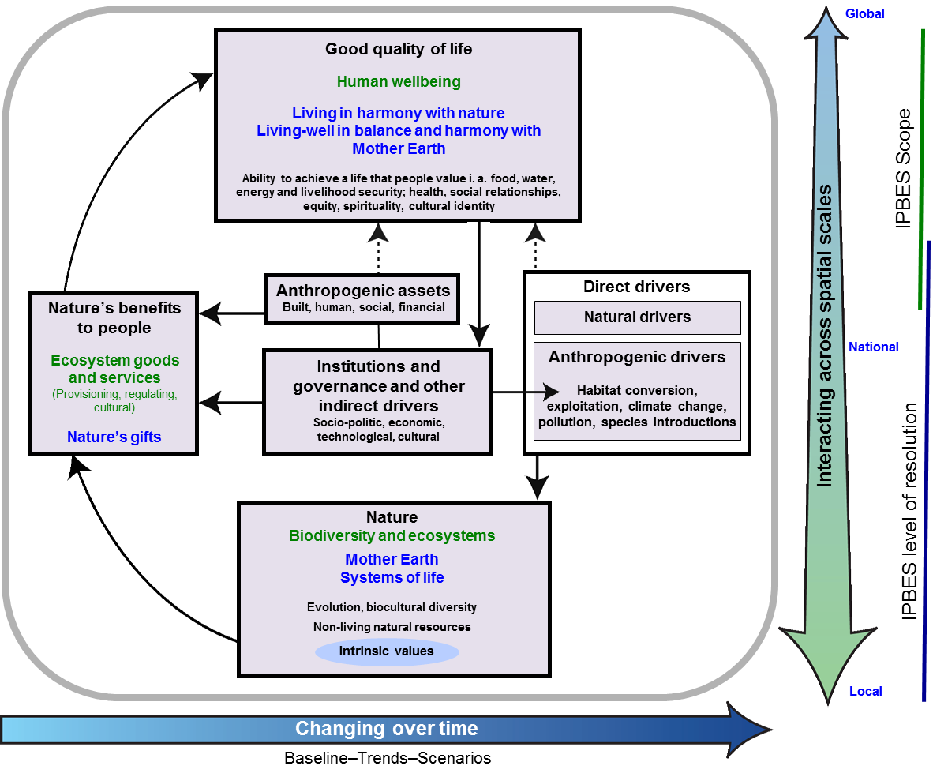
5. Figure 1 demonstrates the main elements and relationships for the conservation and sustainable use of biodiversity and ecosystem services, human well-being and sustainable development. Similar conceptualizations in other knowledge systems include living in harmony with nature and Mother Earth, among others. In the central panel, delimited in grey, nature, nature’s benefits to people and good quality of life (indicated as black headlines) are inclusive of all these world views; text in green denotes the concepts of science; and text in blue denotes those of other knowledge systems. Solid arrows in the main panel denote influence between elements; the dotted arrows denote links that are acknowledged as important, but are not the main focus of the Platform. The thick coloured arrows below and to the right of the central panel indicate different scales of time and space, respectively.
6. “Nature” in the context of the Platform refers to the natural world with an emphasis on biodiversity. Within the context of science, it includes categories such as biodiversity, ecosystems, evolution, the biosphere, humankind’s shared evolutionary heritage, and biocultural diversity. Within the context of other knowledge systems, it includes categories such as Mother Earth and systems of life. Other components of nature, such as deep aquifers, mineral and fossil reserves, wind, solar, geothermal and wave power, are not the focus of the Platform. Nature contributes to societies through the provision of benefits to people (instrumental and relational values, see below) and has its own intrinsic values, that is, the value inherent to nature, independent of human experience and evaluation and thus beyond the scope of anthropocentric valuation approaches.
7. “Anthropogenic assets” refers to built-up infrastructure, health facilities, knowledge (including indigenous and local knowledge systems and technical or scientific knowledge, as well as formal and non-formal education), technology (both physical objects and procedures), and financial assets, among others. Anthropogenic assets have been highlighted to emphasize that a good life is achieved by a co-production of benefits between nature and societies.
8. “Nature’s benefits to people” refers to all the benefits that humanity obtains from nature. Ecosystem goods and services are included in this category. Within other knowledge systems, nature’s gifts and similar concepts refer to the benefits of nature from which people derive a good quality of life. Aspects of nature that can be negative to people, such as pests, pathogens or predators, are also included in this broad category. All nature’s benefits have anthropocentric value, including instrumental values – the direct and indirect contributions of ecosystem services to a good quality of life, which can be conceived in terms of preference satisfaction, and relational values, which contribute to desirable relationships, such as those among people and between people and nature, as in the notion of “living in harmony with nature”.
9. These values can be expressed in diverse ways. They can be material or non-material, can be experienced in a non-consumptive way, or consumed; and they can be expressed from spiritual inspiration to market value. They also include existential value (the satisfaction obtained from knowing that nature continues to be there) and future-oriented. These include bequest value – in other words, the preservation of nature for future generations – or the option values of biodiversity as a reservoir of yet-to-be discovered uses from known and still unknown species and biological processes, or as a constant source, through evolutionary processes, of novel biological solutions to the challenges of a changing environment. Nature provides a number of benefits to people directly without the intervention of society, for example the production of oxygen and the regulation of the Earth’s temperature by photosynthetic organisms; the regulation of the quantity and quality of water resources by vegetation; coastal protection by coral reefs and mangroves; and the direct provision of food or medicines by wild animals, plants and microorganisms.
10. Many benefits, however, depend on or can be enhanced by the joint contribution of nature and anthropogenic assets. For example, some agricultural goods such as food or fibre crops depend on ecosystem processes such as soil formation, nutrient cycling, or primary production as well as on social intervention such as farm labour, knowledge of genetic variety selection and farming techniques, machinery, storage facilities and transportation.
11. Trade-offs between the beneficial and detrimental effects of organisms and ecosystems are not unusual and they need to be understood within the context of the bundles of multiple effects provided by them within specific contexts. For example, wetland ecosystems provide water purification and flood regulation but they can also be a source of vector-borne disease. In addition, the relative contribution of nature and anthropogenic assets to a good quality of life varies according to the context. For example, the level at which water filtration by the vegetation and soils of watersheds contributes to quality of life in the form of improved health or reduced treatment costs is based in part on the availability of water filtration by other means, for example, buying bottled water from another location, or treating water in a built facility. If there are no alternatives to watershed filtration by vegetation, then it will contribute strongly to good lives. If there are cost-effective and affordable alternatives, water filtration by vegetation may contribute less.
12. “Drivers of change” refers to all those external factors that affect nature, anthropogenic assets, nature’s benefits to people and a good quality of life. They include institutions and governance systems and other indirect drivers and direct drivers (both natural and anthropogenic).
13. “Institutions and governance systems and other indirect drivers” are the ways in which societies organize themselves, and the resulting influences on other components. They are the underlying causes of environmental change that are exogenous to the ecosystem in question. Because of their central role, influencing all aspects of human relationships with nature, these are key levers for decision-making. Institutions encompass all formal and informal interactions among stakeholders and social structures that determine how decisions are taken and implemented, how power is exercised, and how responsibilities are distributed. Institutions determine, to various degrees, the access to, and the control, allocation and distribution of components of nature and anthropogenic assets and their benefits to people. Examples of institutions are systems of property and access rights to land, including (e.g., public, common-pool, private), legislative arrangements, treaties, informal social norms and rules, and international regimes such as agreements against stratospheric ozone depletion or the protection of endangered species of wild fauna and flora. Economic policies, including macroeconomic, fiscal, monetary or agricultural policies, play a significant role in influencing people’s decisions and behaviour and the way in which they relate to nature in the pursuit of benefits. Many drivers of human behaviour and preferences, however, which reflect different perspectives on a good quality of life, work largely outside the market system.
14. “Direct drivers”, both natural and anthropogenic, affect nature directly. “Natural drivers” are those that are not the result of human activities and are beyond human control. These include earthquakes, volcanic eruptions and tsunamis, extreme weather or ocean-related events such as prolonged drought or cold periods, tropical cyclones and floods, the El Niño/La Niña Southern Oscillation and extreme tidal events. The direct anthropogenic drivers are those that are the result of human decisions, namely, of institutions and governance systems and other indirect drivers. Anthropogenic drivers include habitat conversion, exploitation, climate change, pollution and species introductions. Some of these drivers, such as pollution, can have negative impacts on nature; others, as in the case of habitat restoration, or the introduction of a natural enemy to combat invasive species, can have positive effects.
15. “Good quality of life” is the achievement of a fulfilled human life, a notion which varies strongly across different societies and groups within societies. It is a context-dependent state of individuals and human groups, comprising access to food, water, energy and livelihood security, and also health, good social relationships and equity, security, cultural identity, and freedom of choice and action. From virtually all standpoints, a good quality of life is multidimensional, having material as well as immaterial and spiritual components. What a good quality of life entails, however, is highly dependent on place, time and culture, with different societies espousing different views of their relationships with nature and placing different levels of importance on collective versus individual rights, the material versus the spiritual domain, intrinsic versus instrumental values, and the present time versus the past or the future. The concept of human well-being used in many western societies and its variants, together with those of living in harmony with nature and living well in balance and harmony with Mother Earth, are examples of different perspectives on a good quality of life.

2. Interlinkages between the elements of the conceptual framework
16. A society’s achievement of good quality of life and the vision of what this entails directly influence institutions and governance systems and other indirect drivers and, through them, they influence all other elements. For example, to the extent that a good life refers to an individual’s immediate material satisfaction and rights, or to the collective needs and rights of present and future generations, it affects institutions that operate from the subnational scale, such as land and water use rights, pollution control, and traditional arrangements for hunting and extraction, to the global scale, as in subscription to international treaties. Good quality of life, and views thereof, also indirectly shape, via institutions, the ways in which individuals and groups relate to nature. For example, nature is viewed by some as a separate entity to be exploited for the benefit of society, while for others it is a sacred living entity of which humans are only one part.
17. Institutions and governance systems and other indirect drivers affect all elements and are the root causes of the direct anthropogenic drivers that directly affect nature. For example, economic and demographic growth (indirect drivers) and lifestyle choices influence the amount of land that is converted and allocated to food crops, plantations or energy crops; accelerated carbon-based industrial growth over the past two centuries has led to anthropogenic climate change at the global scale; synthetic fertilizer subsidy policies have greatly contributed to the detrimental nutrient loading of freshwater and coastal ecosystems. All of these have strong effects on biodiversity ecosystem functioning and their derived benefits and, in turn, influence different social arrangements intended to deal with these problems. This may be seen, for example, at the global level, with institutions such as the United Nations Framework Convention on Climate Change, the Convention on Biological Diversity, the Convention on the Conservation of Migratory Species of Wild Animals or, at the national and subnational levels, arrangements in ministries or laws that have effectively contributed to the protection, restoration and sustainable management of biodiversity.
18. Institutions and governance systems and other indirect drivers also affect the interactions and balance between nature and human assets in the co-production of nature’s benefits to people, for example by regulating urban sprawl over agricultural or recreational areas. This element also modulates the link between nature’s benefits to people and the achievement of a good quality of life, for example, by different regimes of property and access to land and goods and services; transport and circulation policies; and economic incentives as taxations or subsidies. For each of nature’s benefits that contribute to a good quality of life, the contribution of institutions can be understood in terms of instrumental value, such as access to land that enables the achievement of high human well-being, or in terms of relational values, such as regimes of property that both represent and allow human lives deemed to be in harmony with nature.
19. Direct drivers cause a change directly in the ecological system and, as a consequence, in the supply of nature’s benefits to people. Natural drivers of change affect nature directly, for example, the impact by a massive meteorite is believed to have triggered one of the mass extinctions of plants and animals in the history of life on Earth. Furthermore, a volcanic eruption can cause ecosystem destruction, at the same time serving as a source of new rock materials for fertile soils. These drivers also affect anthropogenic assets, such as the destruction of housing and supply systems by earthquakes or hurricanes, and a good life, as may be seen with heat stroke as a result of climate warming or poisoning as a result of pollution. In addition, anthropogenic assets directly affect the possibility of leading a good life through the provision of and access to material wealth, shelter, health, education, satisfactory human relationships, freedom of choice and action, and sense of cultural identity and security. These linkages are acknowledged in figure 1 but not addressed in depth because they are not the main focus of the Platform.

3. Example: the causes and consequences of declining fisheries
20. There are more than 28,000 fish species recorded in 43 ecoregions in the world’s marine ecosystems and probably still many more to be discovered (nature). With a worldwide network of infrastructure such as ports and processing industries, and several million vessels (anthropogenic assets), about 78 million tons of fish are caught every year. Fish are predicted to become one of the most important items in the food supply of over 7 billion people (nature’s benefits). This is an important contribution to the animal protein required to achieve food security (good quality of life).
21. Changes in consumption patterns (good quality of life) have brought about an increased demand for fish in the global markets. This, together with the predominance of private short-term interests over collective long-term interests, weak regulation and enforcement of fishing operations, and perverse subsidies for diesel, are indirect drivers underlying the overexploitation of fisheries by fishing practices (direct drivers) that, because of their technology or spatial scope or time scale of deployment, are destructive to fish populations and their associated ecosystems. The impacts of these practices are combined with those of other direct drivers and include chemical pollution associated with agriculture and aquiculture runoff, the introduction of invasive species, diversions and obstructions of freshwater flows into rivers and estuaries, the mechanical destruction of habitats, such as coral reefs and mangroves, and climate and atmosphere change, including ocean warming and acidification.
22. The steep decline in fish populations can dramatically affect nature, in the form of wildlife, ecological food chains, including those of marine mammals and seabirds, and ecosystems from the deep sea to the coast. Increasingly depleted fisheries have also had a negative effect on nature’s benefits to people and the good quality of life that many societies derive from them, in the form of decreases in catches, reduced access, and the impaired viability of commercial and recreational fishing fleets and associated industries across the globe. In the case of many small-scale fisheries in less developed countries, this disproportionally affects the poor and women. In some cases it also affects nature and its benefits to people well beyond coastal areas, for example by increasing bush-meat harvest in forest areas and thus affecting populations of wild mammals such as primates, and posing threats to human health (good quality of life).
23. Institutions and governance systems and other indirect drivers at the root of the present crisis can be mobilized to halt these negative trends and aid the recovery of many depleted marine ecosystems (nature), fisheries (nature’s benefits to people) and their associated food security and lifestyles (good quality of life). Examples include strengthening and enforcement of existing fishing regulations, such as the Code of Conduct for Responsible Fisheries of the Food and Agriculture Organization of the United Nations (FAO), the zoning of the oceans into reserves and areas with different levels of catch effort, and enhanced control of quotas and pollution. In addition, anthropogenic assets could be mobilized towards this end in the form of the development and implementation of new critical knowledge, such as fishing gear and procedures that minimize by-catch, or a better understanding of the role of no-catch areas in the long-term resilience of exploited fisheries.

4. Application of the conceptual framework across scales
24. The natural and social processes described above occur and interact at different scales of space and time (indicated by the thick arrows around the central panel of figure 1). Accordingly, the conceptual framework can be applied to different scales of management and policy implementation, scales of ecological processes and scales of potential drivers of change. Such a multi-scale and cross-scale perspective also supports the identification of trade-offs within scales, such as between different policy sectors, and across scales, including by limiting the local use of forests for the sake of carbon sequestration goals on the global scale.
25. The Platform will focus on supranational (from subregional to global) geographical scales for assessment. The properties and relationships that occur at these coarser spatial scales will, in part, however, be linked to properties and relationships acting at finer scales, such as national and subnational scales. The Platform’s framework can also be applied to support understanding of interactions among components of the social-ecological system over various temporal scales. Some interactions make very rapid progress, others slower, and there is often a correspondence between the space and time scales. For example, changes in the chemical composition of the atmosphere and the oceans typically occur over centuries or millennia, whereas changes in biodiversity as a consequence of land use at the landscape scale often occur at the scale of years or decades. Processes at one scale often influence, and are influenced by processes that occur at other scales. Because of this, assessments will benefit from contemplating the mutual influences, such as control and propagation, between the scale that is the focus of the assessment and finer and coarser scales.
26. The conceptual framework is also relevant to the analysis of institutional arrangements and ecosystem boundaries at different scales. Understanding the mismatch between ecosystems and institutional arrangements is particularly critical at larger scales where political and administrative boundaries cut across environmental systems, such as the watersheds of major rivers, bio-geo-cultural regions or the territories of nomadic or semi-nomadic peoples.
C. Links between the conceptual framework, work programme and functions of the Platform
1. Work programme
27. The Platform’s work programme aims to enhance the enabling environment and strengthen the knowledge-policy interface on biodiversity and ecosystem services, and the communication and evaluation of Platform activities.
2. Conceptual framework and the functions of the Platform
28. The Platform’s conceptual framework supports the implementation of all four functions of the Platform – knowledge generation, assessments, policy support tools and capacity-building. The conceptual framework helps to ensure coherence and coordination among these four functions. These are best explained in the operational conceptual model of the Platform depicted in figure 2, below, which is a schematic representation of the science-policy interface as an operating system.

Figure 2
Operational conceptual model of the Platform

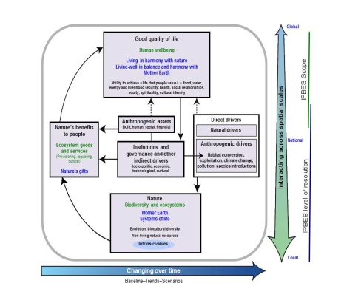
Science and
other knowledge
systems
Science-policy interface on biodiversity and ecosystems services
Analytical
conceptual
framework
IPBES processes, functions,
and deliverables
Deliverables to advise and support policy for decision making
Development and Implementation of work
• Knowledge generation
• Assessments
• Policy tools and methodologies
• Capacity building
Policy and
Decision making

29. Figure 2 describes an interface system interlinking science and other knowledge systems with policy and decision-making through a dynamic process. The figure shows a continuous flow of knowledge from science and other knowledge systems to the interface that is filtered through the analytical conceptual framework, which is shown in greater detail in figure 1, and processed according to the activities defined by the periodically developed work programmes of the Platform to achieve deliverables. The deliverables are produced in order to influence policy and decision-making through the formulation of multi-optional policy advice. The interface features double-sided (thin and thick) arrows and thus also works in more than one direction. The thick one-sided arrow indicates the analytical conceptual framework influencing Platform processes and functions. The dotted arrow indicates that policy and decision-making in turn influence science and other knowledge systems beyond the agency of the Platform.
3. Science-policy interface
30. The science-policy interface is a complex system interlinking the phase of science and other knowledge systems with the phase of policy and decision-making through a dynamic process. The interface works between these two main phases indicated above. The phase of science and other knowledge systems includes the filtration of raw knowledge and knowledge generation in the form of deliverables to advise and support the phase of policy for decision-making governed by the operative function of the work programmes.
4. Operation of the science-policy interface
31. The interface system is operated by a composite function of the four functions of the Platform (knowledge generation, assessment, policy support and capacity-building) and the conceptual model provides a dynamic process that serves at the same time as the mechanism for the realization of the four functions.
(a) Knowledge generation
32. Although the Platform will not carry out new research to fill knowledge gaps, it will play a vital role in catalysing new research by identifying knowledge gaps and working with partners to prioritize and fill these gaps. The knowledge would come from the scientific community in the natural, social and economic sciences and other knowledge systems.
(b) Assessment
33. Assessments, whether global, regional or thematic, need coherence in their approach, which will provide opportunities for synthesis between the assessments, the scaling up and down of assessments done at different scales, and also comparison among assessments performed at specific scales or on different themes. The analytical conceptual framework set out in figure 1 illustrates the multidisciplinary issues to be assessed, spatially and temporally, within thematic, methodological, regional, subregional and global assessments. The ensemble of assessments will assess the current status, trends and functioning of biodiversity and ecosystems and their benefits to people, and the underlying causes, such as the impacts of institutions, governance and other indirect drivers of change, anthropogenic and natural direct drivers of change, and the anthropogenic assets.
34. The implications of changes in nature’s benefits to people for a good quality of life will be assessed, together with changes in the multidimensional value of nature’s benefits to people. The conceptual framework incorporates all knowledge systems and beliefs or philosophical values, and ensures coherence among the different assessment activities. A global assessment would be informed and guided by a set of regional and subregional assessments and a set of thematic issues consistently self-assessed within the regional and subregional assessments. The assessment activities described above will also identify what is known and what is unknown and will identify where the generation of new knowledge will strengthen the science-policy interface.
(c) Policy support
35. The policy support would include the identification of policy tools and methodologies, such as the policy process and actors, policy priorities, policy measures, and institutions and organizations, that would help to address the detrimental changes to biodiversity and ecosystem services.
(d) Capacity-building
36. The conceptual framework could support capacity-building in many ways, including by facilitating the engagement of a broad range of stakeholders in the implementation of the work programme in support of national and subnational assessment activities beyond the direct scope of the Platform.

∗ IPBES/2/1.

