UNITED  NATIONS |  |  | 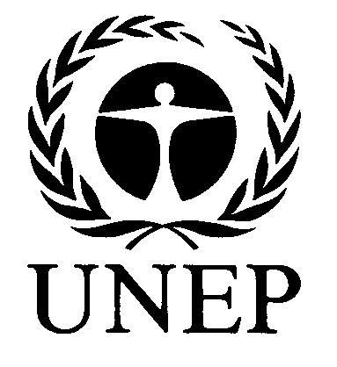 | 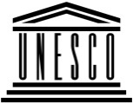 |  |  |  | BES
 |  |  |  |  |  |  | IPBES/4/INF/21
 |  | Intergovernmental Science-Policy Platform on Biodiversity and Ecosystem Services |  |  |  |  | Distr.: General  8 February 2016  English only
Plenary of the Intergovernmental Science-Policy
Platform on Biodiversity and Ecosystem Services
Fourth session
Kuala Lumpur, 22–28 February 2016
Update on the implementation of the Biodiversity and Ecosystem Services Network and links with the work programme of the Platform
Note by the secretariat
The annex to the present note sets out a report by the United Nations Development Programme on progress regarding the Biodiversity and Ecosystem Services Network (BES-Net) and links with the work programme of the Intergovernmental Science-Policy Platform on Biodiversity and Ecosystem Services. The report is reproduced as received, without formal editing.

Annex
Update on the implementation of the UNDP-managed Biodiversity and Ecosystem Services Network (BES-Net) and links with the IPBES Work Programme
I. Background on BES-Net
The BES-Net concept stemmed from the call made in Busan¹ for UNDP to support the capacity building work of IPBES. BES-Net was developed with inputs from multiple stakeholders and in response to requests from Member States, in particular developing countries.
Through partnerships with the Norwegian Environment Agency and SwedBio at the Stockholm Resilience Centre, UNDP is therefore developing and implementing a Biodiversity and Ecosystem Services Network (BES-Net), to help countries tackle science-policy questions critical to effective management of biodiversity and ecosystems worldwide, thereby contributing to long-term human well-being and sustainable development.
The Network is supported by face-to-face capacity building activities (the BES-Net Trialogues), a matchmaking facility, and a cutting-edge web portal – with all components mutually reinforcing.
UNDP’s commitment to supporting IPBES is set out in its biodiversity strategy, UNDP’s Biodiversity and Ecosystems Global Framework 2012-2020, which was approved by the UNDP Executive Group in September 2012. This agreed strategy constitutes the basis for UNDP support for the development of the BES-Net Platform. This support, reflected in the collaborative partnership arrangement with UNEP, FAO and UNESCO, is aligned with UNDP’s mission to help countries achieve the simultaneous eradication of poverty and significant reduction of inequalities and exclusion.
Through BES-Net, UNDP wishes to contribute its capacity building expertise at the country level, capitalize on the accumulated knowledge of best practices and challenges in the field, and bring practitioners into the science-policy arena.
All the BES-Net activities are guided by the BES-Net Advisory Committee, composed of the BES-Net donors, the IPBES Secretariat, various IPBES groups and bodies (technical support unit for the capacity building task force), and other resource organisations, such as the secretariats of the CBD, and SGA Network. The co-chairs of the capacity building task force are kept informed of the Committee’s process and the other UN Agencies supporting the IPBES process have been invited as observers.
In addition to managing BES-Net, UNDP provides technical backstopping on capacity building, contributing ideas and knowledge to the formulation of the IPBES work programme and its implementation in regions, and contributing to the task force on capacity building as a resource organisation.
For more information, please refer to the BES-Net concept note (Annex I) and to the BES-Net strategy, as presented to IPBES (IPBES/3/INF19).
II. BES-Net and links with the IPBES work programme
BES-Net strives to support the needs of IPBES in terms of capacity building (deliverable 1(a)), policy support, as well as stakeholder engagement and communications (deliverable 4(d)).
UNDP and IPBES are currently working to establish an agreement defining the scope, roles and responsibilities, issues related to branding and intellectual property and other legal requirements regarding the collaboration between BES-Net (UNDP) and IPBES.
In the meantime, until such agreement has been established, BES-Net and IPBES have already engaged in preliminary work at the technical level, in coordination with the IPBES secretariat, the IPBES task force on capacity building and its technical support unit and the expert group on policy support tools and methodologies on:
- the prototype IPBES capacity building matchmaking facility (deliverable 1(a)); and
- the prototype IPBES catalogue of policy support tools and methodologies (deliverable 4(c)).
BES-Net has also developed specific webpages and online collaboration tools to support the coordination work of the IPBES Stakeholder Network.
UNDP and IPBES are looking forward to develop the BES-Net web-portal as complementary to the IPBES website, supporting capacity building in IPBES through online learning, networking and collaboration and allowing for support in terms of communication and stakeholder engagement.
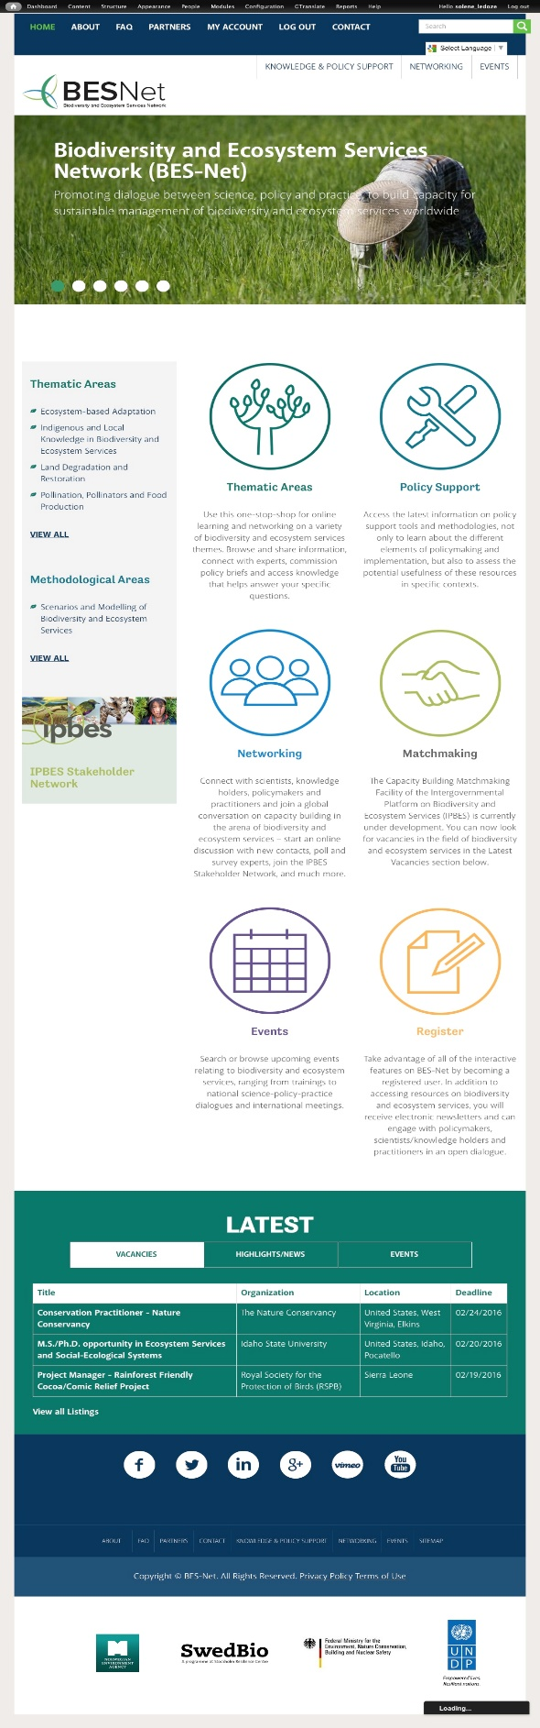

Screen shot of the BES-Net web-portal home page.
III. Update on BES-Net activities
While an agreement is being established, BES-Net and IPBES have already engaged in preliminary work at the technical level, and in coordination with the IPBES secretariat, the IPBES task force on capacity building and its technical support unit and the expert group on policy support tools and methodologies on:
- the prototype IPBES capacity building matchmaking facility (deliverable 1(a)); and
- the prototype IPBES catalogue of policy support tools and methodologies (deliverable 4(c)).
BES-Net has also developed specific webpages and online collaboration tools to support the coordination work of the IPBES Stakeholder Network.
Further, UNDP BES-Net has recently received funding to begin with its work on face-to-face capacity building activities addressing capacity building needs prioritized by IPBES.
All of these activities are described in some more detail in the following sections.
A. Online element of the prototype IPBES capacity building matchmaking facility
- This is currently being developed as an in-kind contribution from UNDP to IPBES, in coordination with the IPBES capacity building task force (CB TF) through its technical support unit (TSU), and the IPBES Secretariat.
- The wireframes for the IPBES matchmaking facility, to be hosted on the BES-Net portal, as well as a full proposal were presented at the CB TF meeting held in April 2015. The feedback received was very positive and was taken into account for the design and web-development phases.
- A prototype was presented to the first IPBES capacity building Forum, held in Dehradun, India, in October 2015 to receive feedback.
- The TSU has provided content and a disclaimer has been included on the web portal to reflect that IPBES is in charge of its content.
- The TSU has been trained on managing all of its content.
- The prototype is now available to the task force as private working version for discussion and further development.
B. The IPBES catalogue of policy support tools and methodologies
- BES-Net attended the meeting of the expert group in charge of the catalogue, held in Budapest, Hungary, on 8-11 June 2015 to provide technical advice on the web development aspects of the Catalogue.
- As requested, BES-Net has developed a prototype for the IPBES catalogue of Policy Support Tools and Methodologies as per the inception report developed at the Budapest meeting. This prototype is available as private working version for further development by the expert group.
C. Support to the IPBES Stakeholder Network
- A public and a private webpages supporting the coordination and visibility of the IPBES Stakeholder Network have been developed on the BES-Net web-portal (see Annex IV).
- Those pages will be managed by the Network itself.
- Further discussions with the IPBES Communication and Stakeholder Engagement Officer and the IPBES Stakeholder Network will clarify the links with the IPBES registry of stakeholders to ensure that complementarity is achieved.
D. Face-to-face Capacity Building Activities: the BES-Net Trialogues
IPBES has highlighted that developing countries face issues in addressing pressing sustainable development questions due to a weak interface between science/traditional knowledge, policy and practice, and lack of trained national-level experts to conduct national level assessments and to integrate their findings into national policy and decision-making. Further, many countries still need support to contribute to the IPBES assessments and other deliverables and to make the most use of IPBES’s future products. This project responds to calls from developing countries for UNDP to play a role in capacity building for IPBES.
Over the period 2016-2020, the German BMUB will support a project for « Supporting developing country capacity to address science-policy questions through IPBES via the UNDP managed Biodiversity and Ecosystem Services Network (BES-Net) and the UNEP-WCMC hosted Sub-Global Assessment Network (SGA Network).
The project aims at supporting developing countries to address science-policy questions highlighted through IPBES, through:
1. Enhancing capacity at the national and regional levels to apply the findings of IPBES assessments. This is achieved through the UNDP-managed BES-Net capacity network hosting “Trialogue” events bringing together scientists, policy-makers and practitioners to address pressing development questions.
2. Providing technical and capacity building support to specific countries to conduct national assessments of scientific evidence on policy issues, complementing IPBES regional and thematic assessments – achieved through customized support to countries via centres of excellence and the SGA Network.
The tools and methods used in this project will be captured and made available for replication across other countries and regions. They will be organised in two packages of capacity building support, one at the national level and one at the regional level. Multiplying effects will be enabled by the fact that participants to this project will belong to a global capacity building network allowing for knowledge and experience sharing, participate in national and regional multi-stakeholder dialogues, and provide input and feedback on their experience to the IPBES community.
The project will pilot a model at the national and regional levels to strengthen science-policy-practice platforms to contribute to and benefit from IPBES. This includes linking national assessments and Trialogue events to IPBES global and thematic assessments, and communicating the outcome of the national and regional activities into the IPBES arena.
UNDP will be working in close partnerships with all the relevant IPBES bodies IPBES, in particular its capacity building task force, with IPBES national focal points and technical support units supporting the IPBES assessments to ensure the best capacity building support in the context of IPBES.

ANNEXES
Annex I: BES-Net Concept Note
The Biodiversity and Ecosystem Services Network
The Biodiversity and Ecosystem Services Network (BES-Net) is a capacity building “network of networks” that promotes dialogue among science, policy and practice for more effective management of biodiversity and ecosystems, contributing to long-term human well-being and sustainable development.
The Network is supported by face-to-face capacity building activities (the BES-Net Trialogues), a matchmaking facility, and a cutting-edge web portal – with all components mutually reinforcing.
BES-Net is hosted by the United Nations Development Programme (UNDP) and implemented through partnerships with the Norwegian Environment Agency and SwedBio at the Stockholm Resilience Centre.
Through BES-Net, UNDP contributes to the capacity building work of the Intergovernmental Platform for Biodiversity and Ecosystem Services (IPBES). BES-Net is aligned with the thematic and methodological areas of work of IPBES, as well as with its capacity building priorities.
BES-Net harnesses UNDP’s capacity building expertise at the country level, capitalizes on the accumulated knowledge of best practices and challenges in the field, and brings practitioners into the science-policy arena.
In implementing its mandate, BES-Net follows an inclusive approach, collaborating with relevant Multilateral Environmental Agreements, and drawing on the support of many other partner organizations.
BES-Net activities
BES-Net web-Portal
The BES-Net web portal provides a “one-stop shop” for policy relevant information and learning material, guiding users through the existing sources of thematic information and methodological tools and providing access to learning material and policy briefs. It will promote dialogue around the same thematic areas in which IPBES assessments are being conducted, as well as in key areas of UNDP’s work on biodiversity and ecosystems management for development and provide interactive features for the members of the network to interact on specific policy questions.
Each fully developed thematic or methodological module on the BES-Net web portal will comprise:
1. An introduction providing background information on each theme
2. A list of organisations working on this theme, with external links to their website and a short explanation of what they are doing
3. A searchable library of scientific articles, grey literature, information on best practices, videos,
e-learning material, guides and protocols for practitioners, etc.
4. A list of international experts working in this field with a short description of their profiles and expertise.
Interactive features allow users to:
- suggest new content (organisation, library entry, expert) ;
- ask for the development of a policy brief ;
- identify a knowledge gap ;
- ask experts a specific questions and poll various experts on the same science-policy topic ; and
- share experience and feedback through online fora.
Full modules have been developed on land degradation and restoration, pollinators, pollination and food production, and lighter modules with an introduction and a list of organisations on ecosystem-based adaptation, models and scenarios in biodiversity and ecosystem services, and indigenous and local knowledge.
Matchmaking Facility
The BES-Net web portal will host the online component of the prototype IPBES Capacity Building Matchmaking Facility, which brings together individuals and organizations wishing to contribute to and participate in IPBES capacity building. BES-Net provides web support to the dedicated Technical Support Unit working on Capacity Building in IPBES. This unit manages the content of the IPBES Matchmaking Facility in an independent manner.
In addition, BES-Net manages a Vacancies section providing information on jobs and internships available in the field of biodiversity and ecosystem services.
BES-Net Trialogues
The face-to-face capacity building activities – the BES-Net “Trialogues” – are multi-stakeholder dialogues focusing on specific policy questions at the national and regional levels. By facilitating fruitful discussions among the three BES-Net communities of policy, science and practice, the trialogues will contribute to addressing specific policy issues to help unlock shifts in the development trajectory of societies towards sustainability.

Annex II: Screen shots of the Prototype IPBES capacity building matchmaking facility
Note that the IPBES matchmaking facility is still under development and is likely to change in concept, function and appearance. Also note that the branding and appearance of collaboratively managed sites between BES-Net and IPBES is still part of on-going discussions.
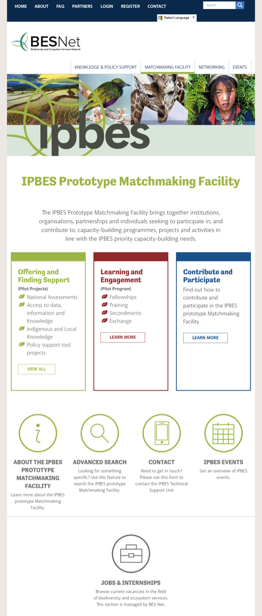 | 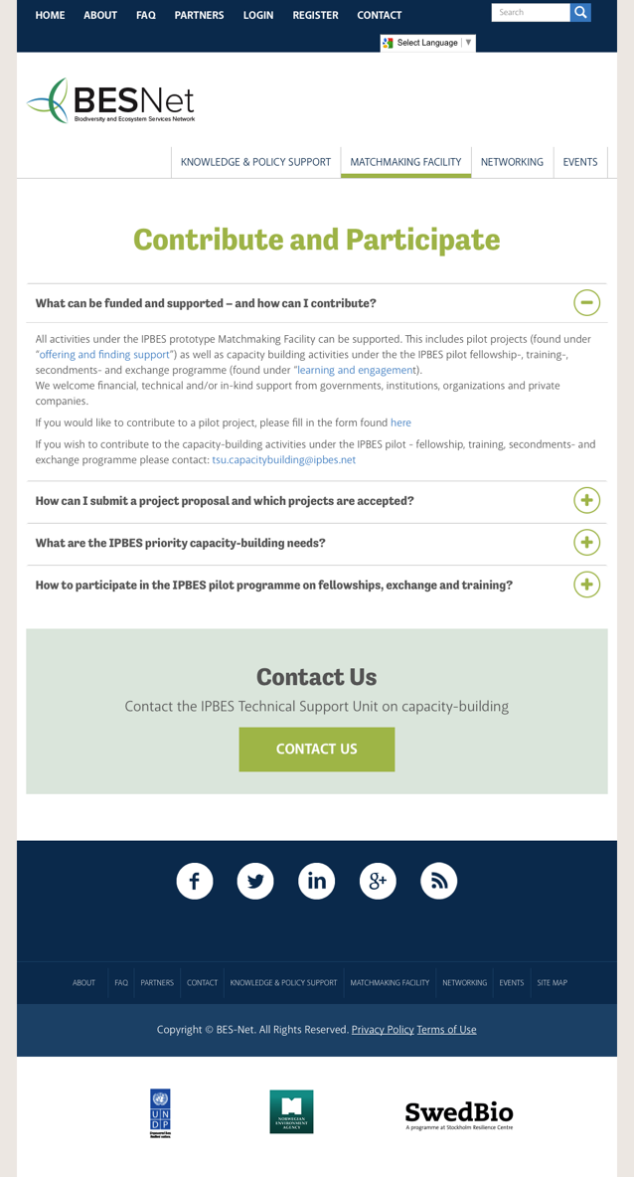
The landing page of the IPBES Prototype  Capacity Building matchmaking facility | The webpage on contributing and participating

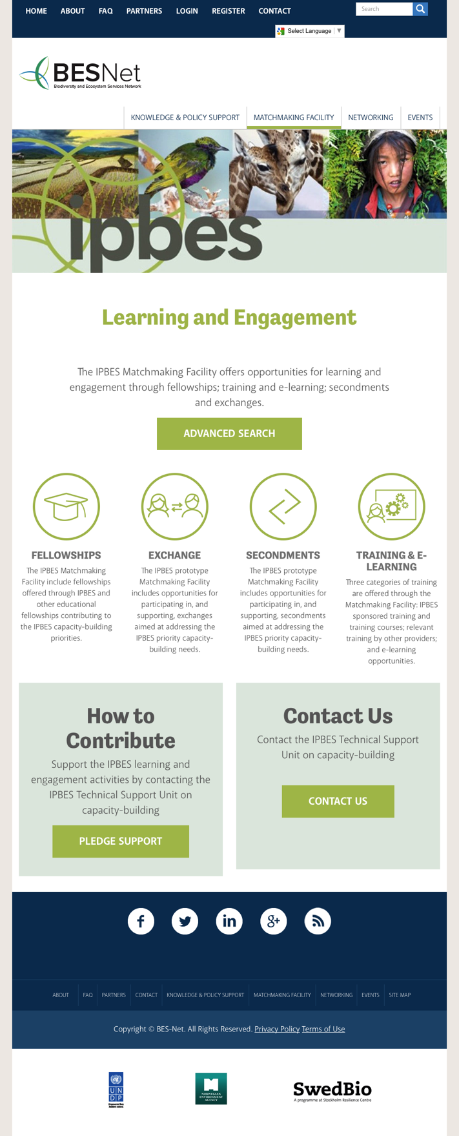

The learning and engagement landing page

Annex III: Screen shots of the Knowledge and Policy Support landing page on the BES-Net web-portal

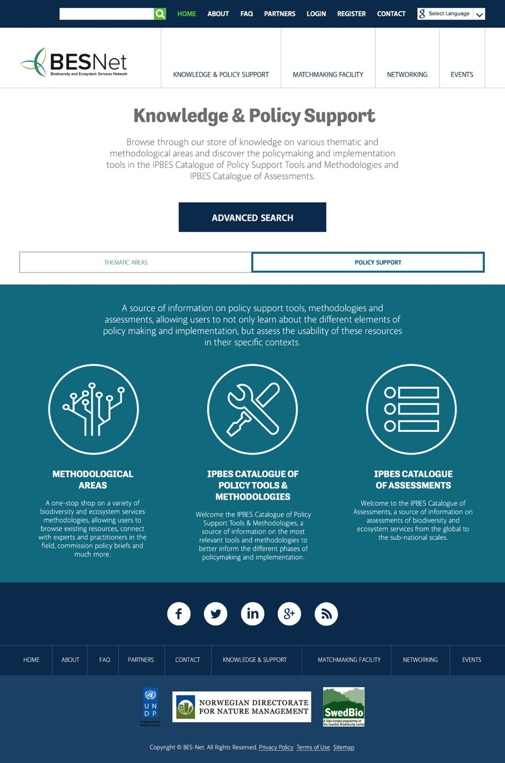
Screen shot showing the entry point for the IPBES catalogue of policy tools and methodologies on the BES-Net portal.

Annex IV: Screen shots of the public and private pages of the IPBES Stakeholder Network on the BES-Net web-portal
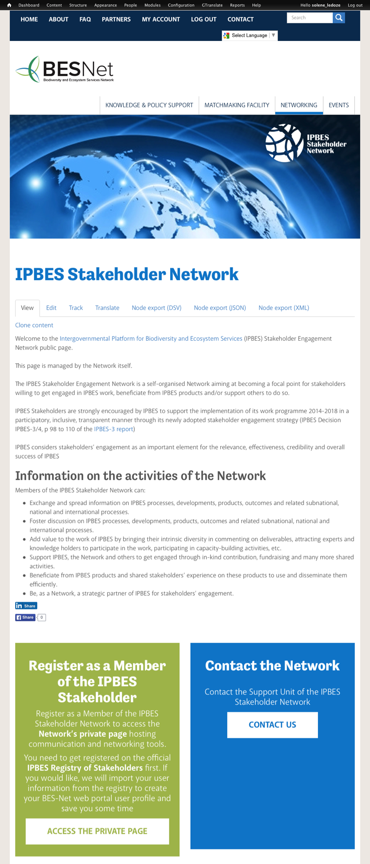 | 