UNITED  NATIONS |  |  |  |  |  |  |  |  | BES
 |  |  |  |  |  |  |  | IPBES/4/INF/17/Add.5
 |  | Intergovernmental Science-Policy Platform on Biodiversity and Ecosystem Services |  |  |  |  |  | Distr.: General  10 December 2015  English only
Plenary of the Intergovernmental Science-Policy
Platform on Biodiversity and Ecosystem Services
Fourth session
Kuala Lumpur, 22–28 February 2016

Item 7(a) of the provisional agenda∗
Rules and procedures for the operation of the Platform: nomination and selection of members of the Bureau
Curricula vitae of proposed members of the Bureau
Proposed members from Western European and other States
Note by the secretariat
- As referred to in document IPBES/4/INF/17, the annex to the present note, prepared by the secretariat of the Intergovernmental Science-Policy Platform on Biodiversity and Ecosystem Services, reproduces the curricula vitae of the candidates proposed for the Bureau by the Western European and other States. The curricula vitae are reproduced as received, without formal editing or translation.
- The candidates are the following:
Ivar Andreas Baste, Norway
Robert Watson, United Kingdom of Great Britain and Northern Ireland
Annex
Curricula vitae of proposed members of the Bureau from Western European and other States
Ivar Andreas Baste, Norway 3
Robert Watson, United Kingdom of Great Britain and Northern Ireland 8
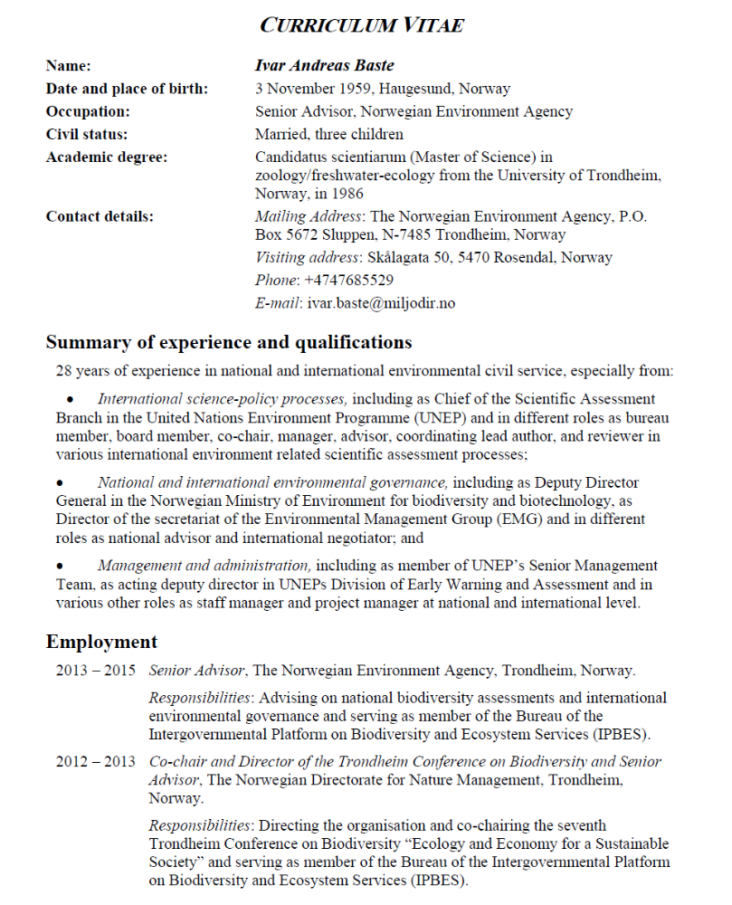
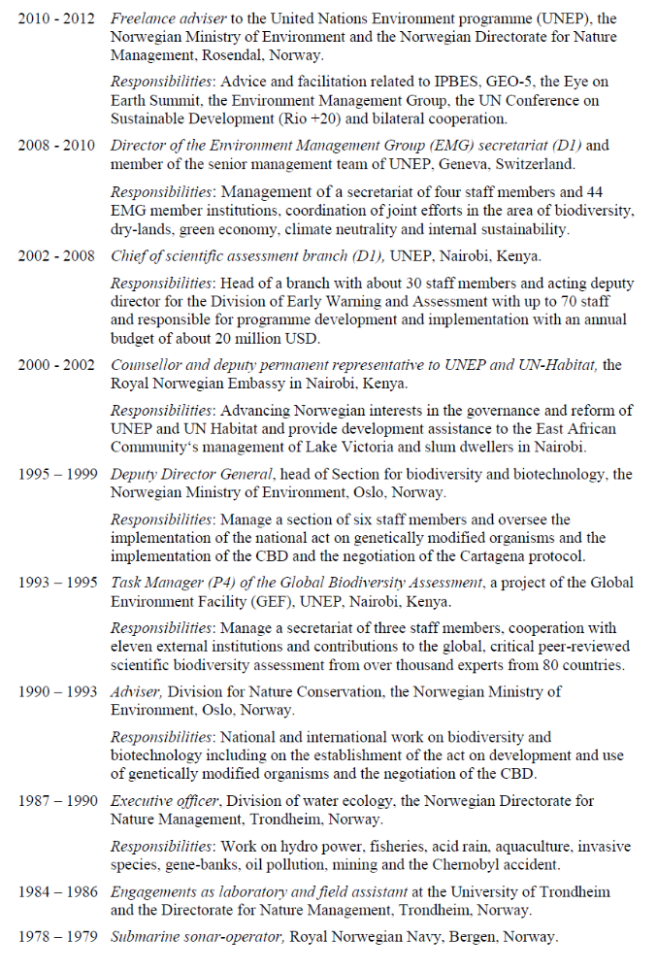
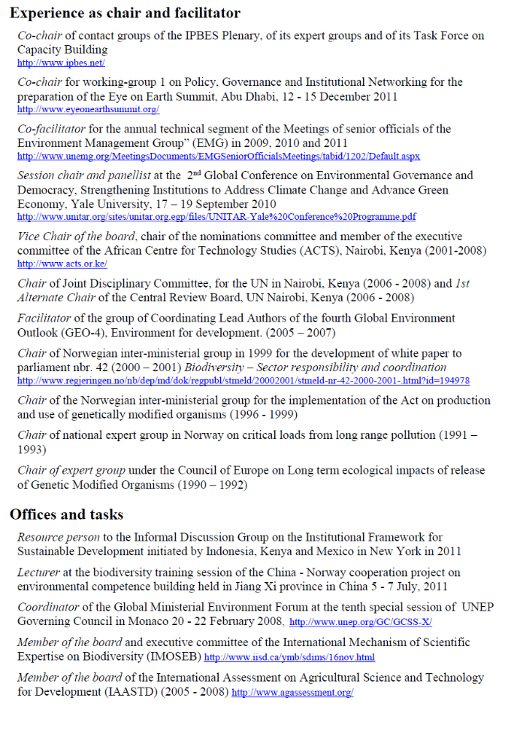
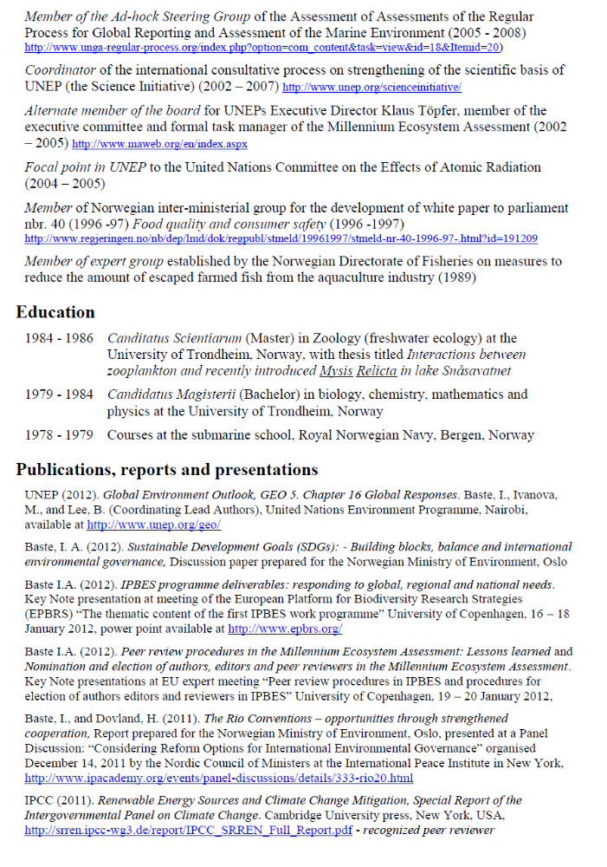
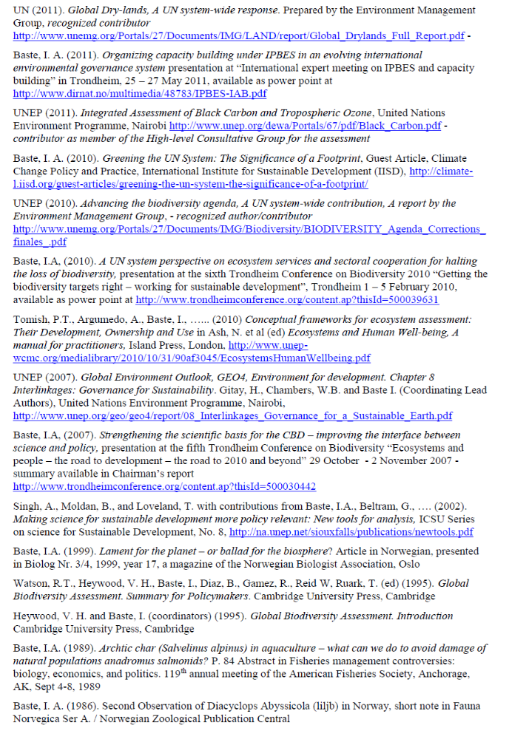
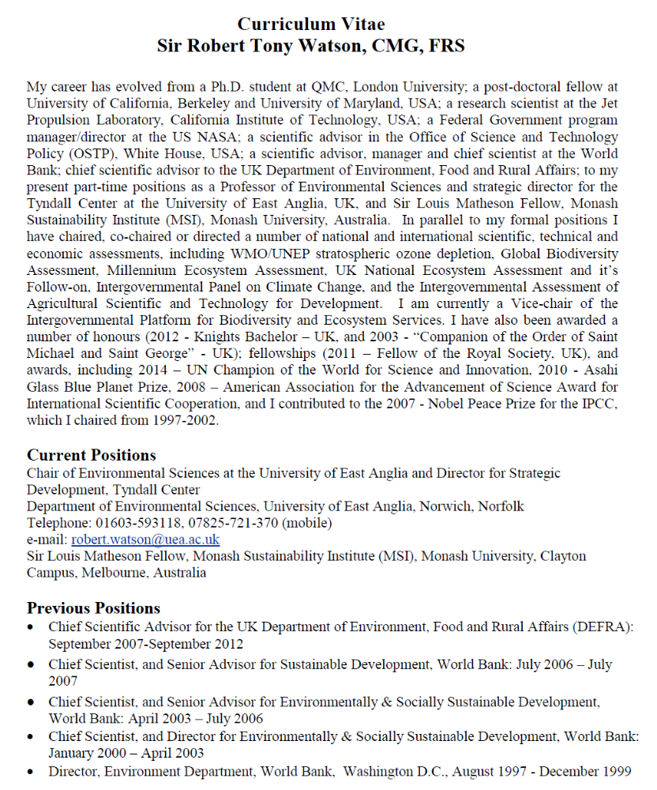
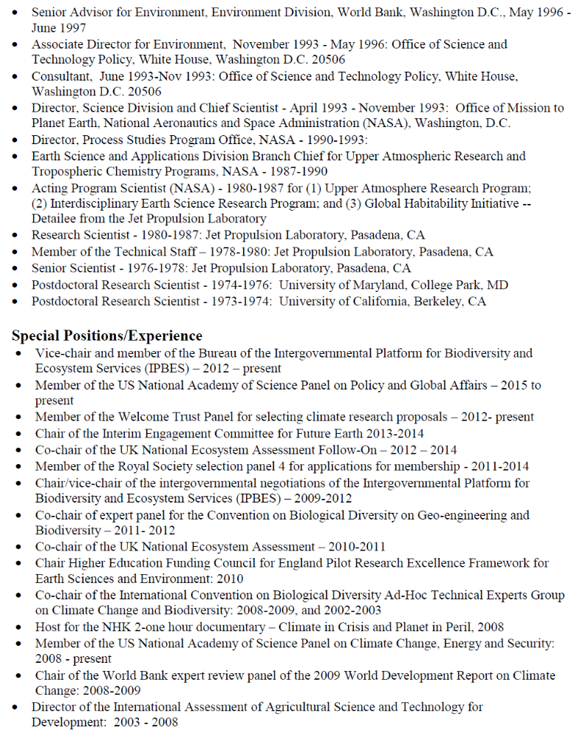
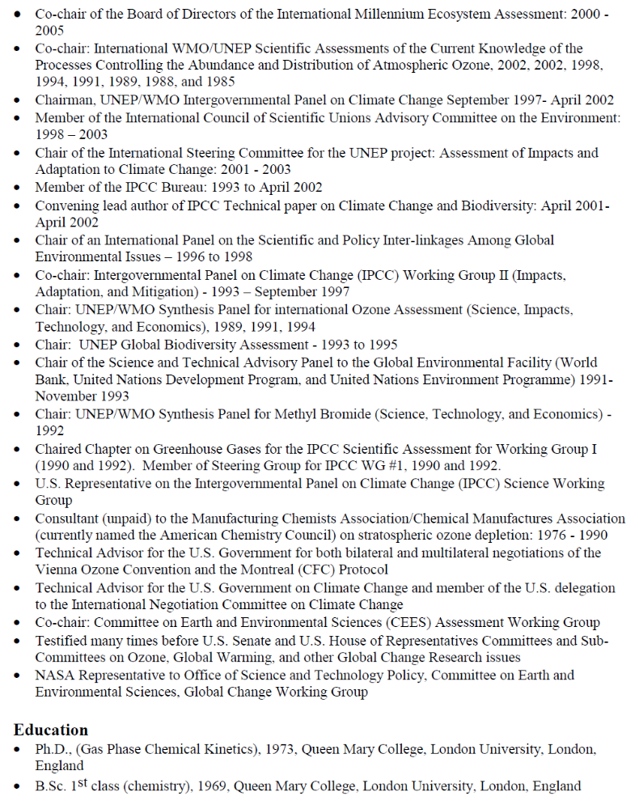
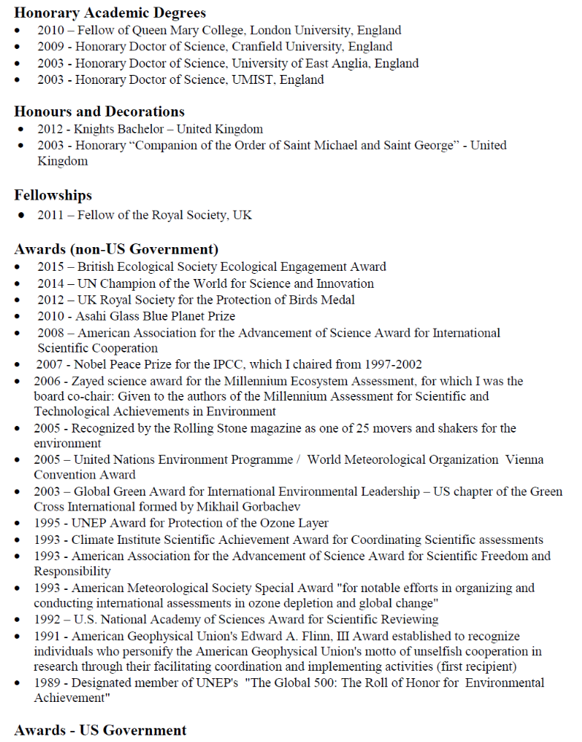
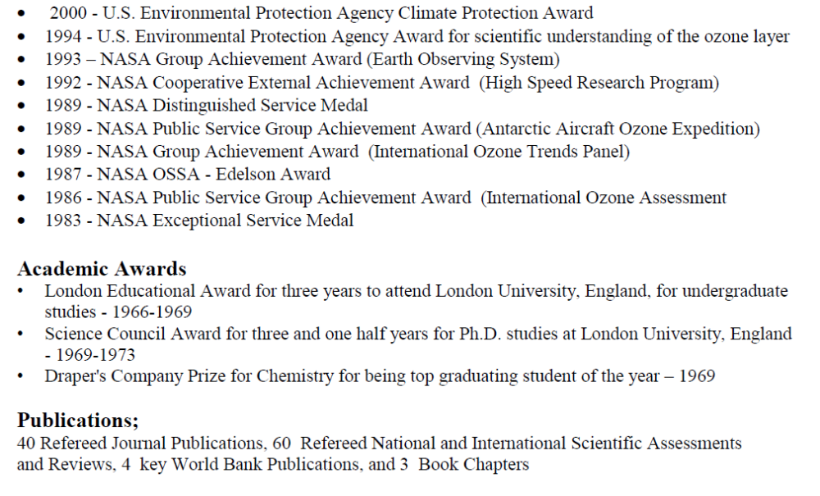

* IPBES/4/1

