UNITED  NATIONS |  |  |  |  |  |  |  |  | BES
 |  |  |  |  |  |  |  | IPBES/4/INF/17/Add.1
 |  | Intergovernmental Science-Policy Platform on Biodiversity and Ecosystem Services |  |  |  |  |  | Distr.: General  8 December 2015  English only

Plenary of the Intergovernmental Science-Policy
Platform on Biodiversity and Ecosystem Services

Fourth session

Kuala Lumpur, 22–28 February 2016

Item 7 (a) of the provisional agenda∗
Rules and procedures for the operation of the Platform: nomination and selection of members of the Bureau
Curricula vitae of proposed members of the Bureau
Proposed member from the African States
Note by the secretariat
As referred to in document IPBES/4/INF/17, the annex to the present note, prepared by the secretariat of the Intergovernmental Science-Policy Platform on Biodiversity and Ecosystem Services, reproduces the curriculum vitae of the candidate for the Bureau proposed by the African States, Larbi Sbaï (Morocco). The curriculum vitae is reproduced as received, without formal editing or translation.

Annex
Curriculum vitae of Larbi Sbaï, the proposed member of the Bureau from the African States
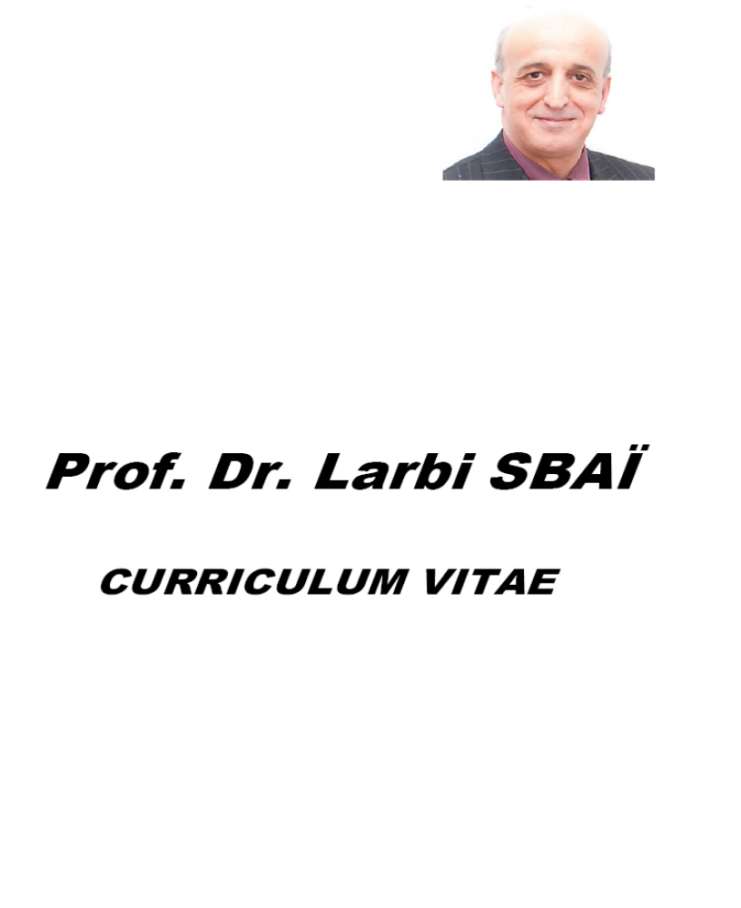

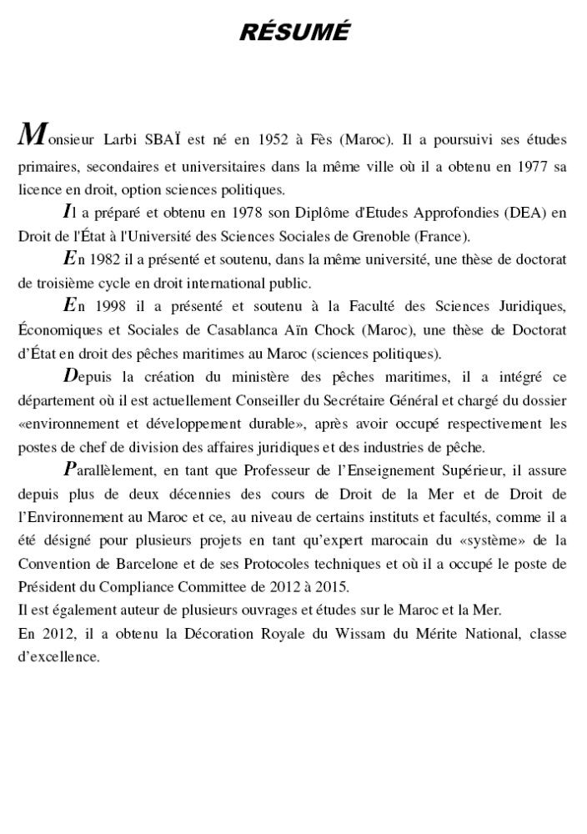
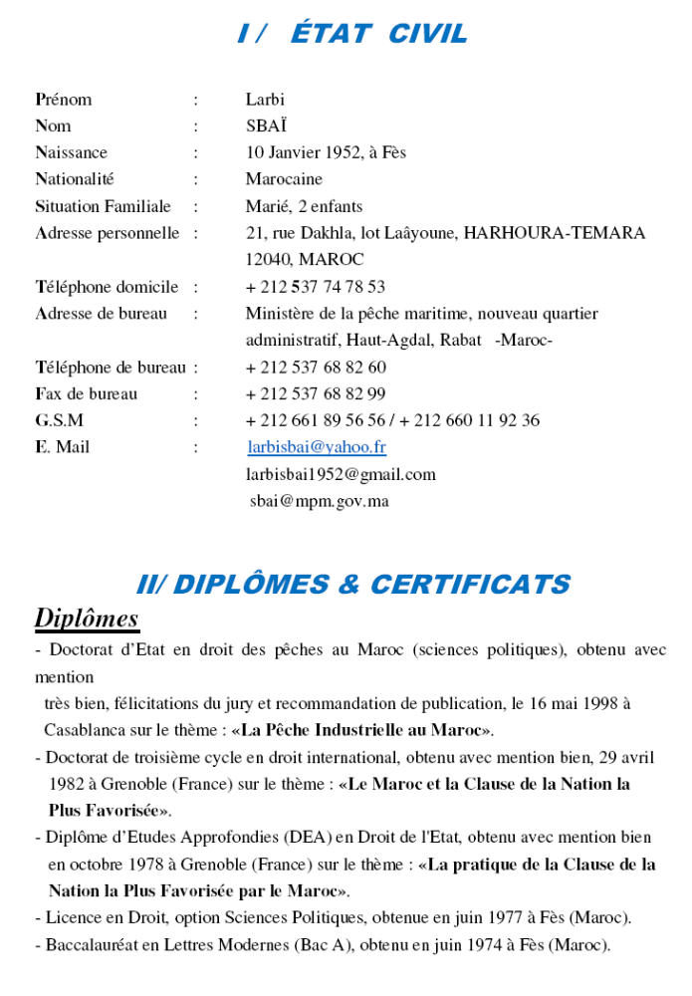

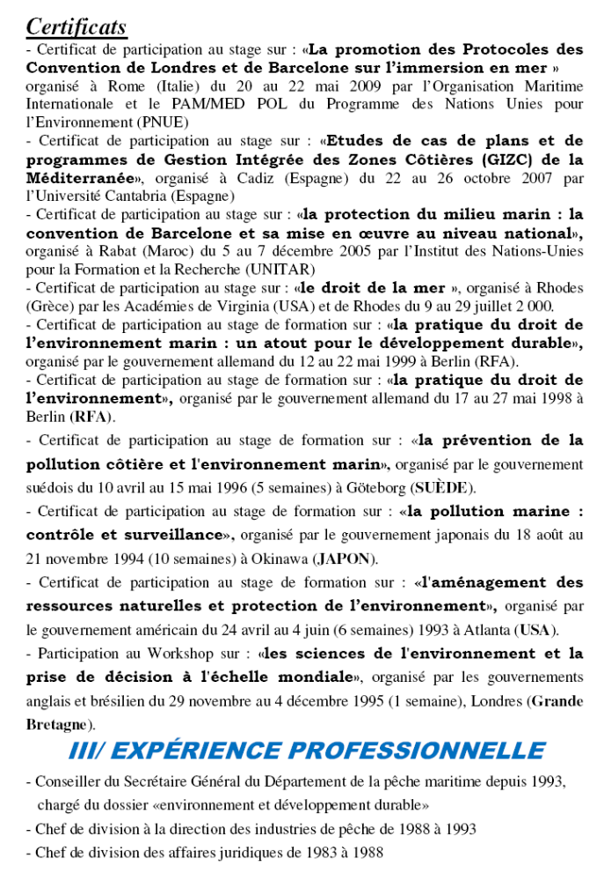
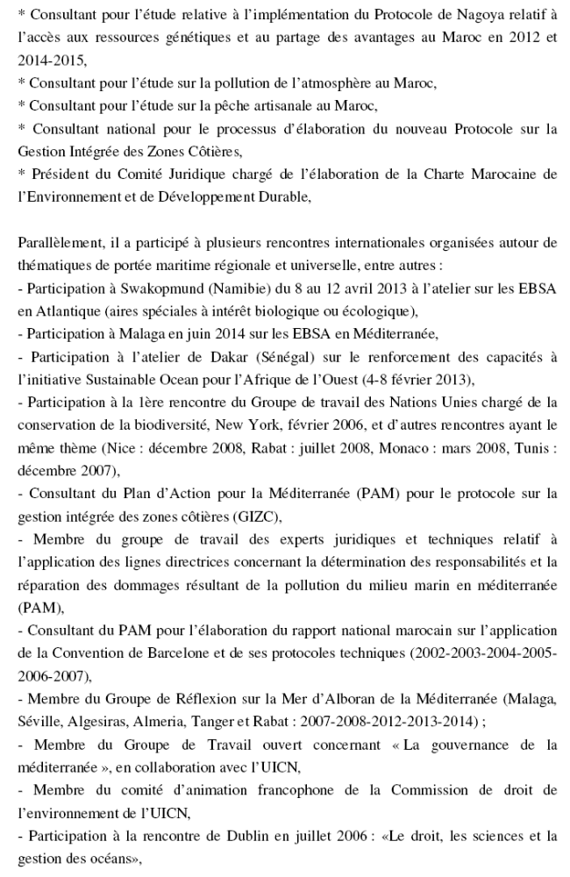
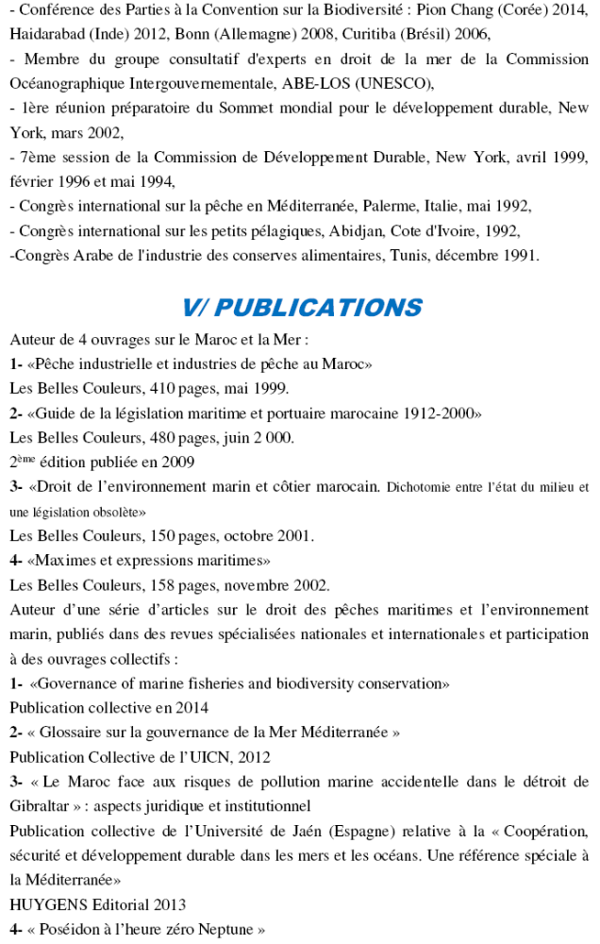
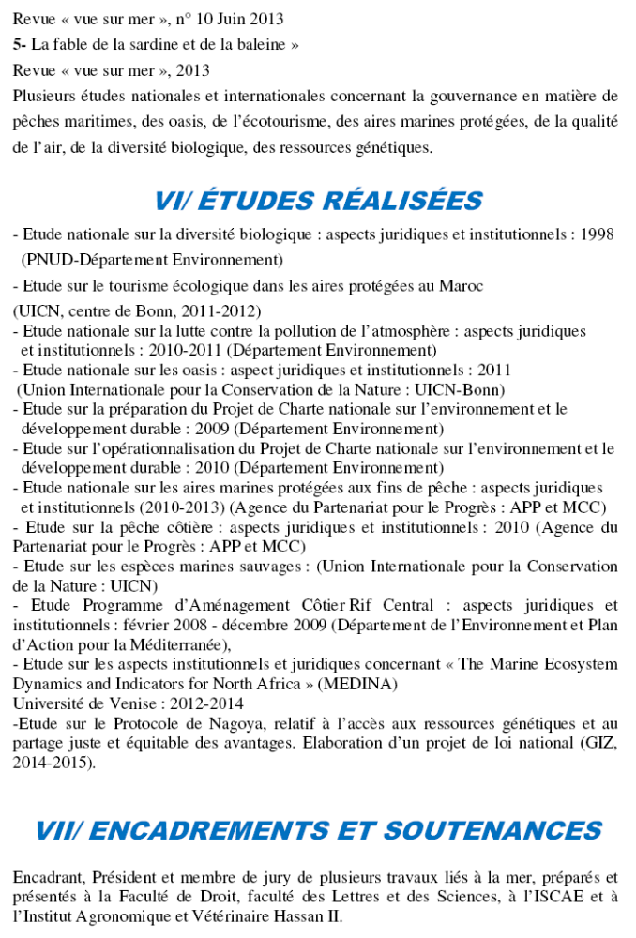
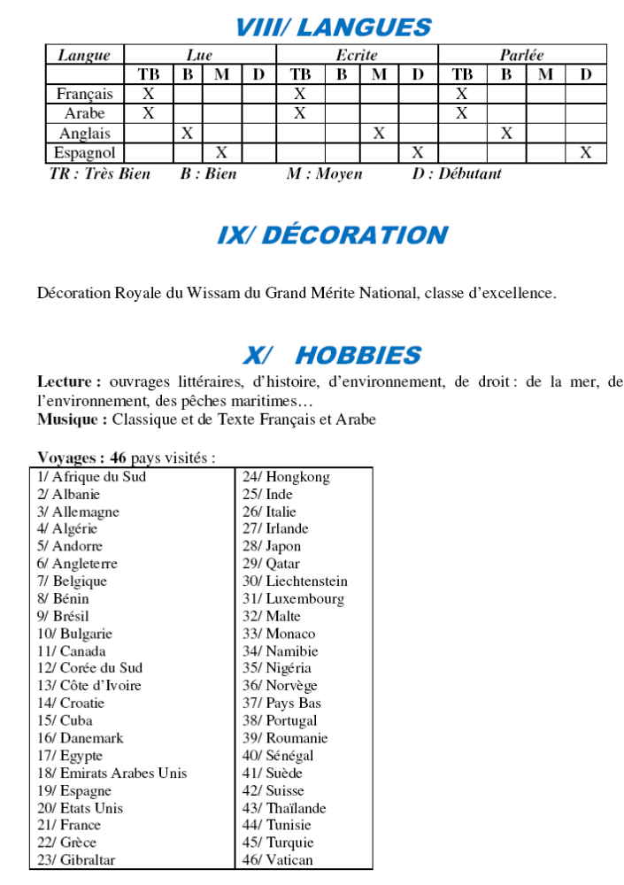

* IPBES/4/1.

