UNITED  NATIONS |  |  |  |  | 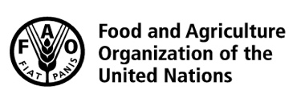 |  |  | BES
 |  |  |  |  |  |  | IPBES/7/INF/11
 |  | Intergovernmental Science-Policy Platform on Biodiversity and Ecosystem Services |  |  |  |  | Distr.: General  25 March 2019  English only
Plenary of the Intergovernmental Science-Policy
Platform on Biodiversity and Ecosystem Services
Seventh session
Paris, 29 April–4 May 2019
Item 5 of the provisional agenda*
Report of the Executive Secretary on the implementation
of the first work programme for the period 2014–2018
Information on work related to scenarios and models
Note by the secretariat
- In section V of its decision IPBES-4/1, the Plenary of the Intergovernmental Science-Policy Platform on Biodiversity and Ecosystem Services (IPBES) approved the summary for policymakers of the methodological assessment of scenarios and models and accepted the individual chapters of the assessment.
- In the same decision, the Plenary requested the Multidisciplinary Expert Panel to oversee further work related to scenarios and models, according to the terms of reference set out in annex V to the decision, and to appoint an expert group to perform that work. At its eighth meeting, in October 2016, the Panel approved the composition of the expert group. Further work, referred to as the “second phase”, has focused on two activities: to provide advice to all IPBES expert groups, in particular those working on the thematic, regional and global assessments on the use of scenarios (activity 1); and to catalyse the further development of scenarios and models of biodiversity and ecosystem services (activity 2).
- In section VI of its decision IPBES-5/1, the Plenary requested the expert group on scenarios and models to continue its work and to report on progress at the sixth and seventh sessions of the Plenary. In section VI of its decision IPBES-6/1, the Plenary welcomed the progress made and next steps planned by the expert group on scenarios and models based on document IPBES/6/INF/15, and on presentation of these next steps to the Plenary by the Executive Secretary in her report (document IPBES/6/2).
- At their eleventh meetings, the Multidisciplinary Expert Panel and the Bureau welcomed the plans of the expert group to continue supporting the global assessment and to consider supporting the assessment on values and the assessment of the sustainable use of wild species, as appropriate; and to continue the work on scenario development, including the development of storylines and a modelling exercise for the construction of nature futures scenarios.
- The annex to the present note, which is presented without formal editing, sets out information on the progress in the work of the expert group on scenarios and models, as well as suggested next steps that would be undertaken by a task force on scenarios and models, should the Plenary decide to establish such a task force as part of the next work programme of IPBES.

Annex
Information on work related to scenarios and models of biodiversity and ecosystem services
I. The expert group on scenarios and models
- At its eighth meeting, the Multidisciplinary Expert Panel approved the list of members of the expert group on scenarios and models for the second phase of IPBES work on scenarios and models of biodiversity and ecosystem services. The final list of 23 experts is set out in appendix II to IPBES/5/INF/2. The expert group was co-chaired by Carolyn Lundquist and Henrique Pereira. Rovshan Abbasov, Chimère Diaw, Shizuka Hashimoto, Sandra Lavorel and Roldán Chacón oversaw progress in the implementation of the second phase of deliverable 3(c) of the first work programme of IPBES on behalf of the Multidisciplinary Expert Panel; Asghar Mohammadi Fazel and Robert Watson on behalf of the Bureau.
- The technical support unit for the IPBES work on scenarios and models, based at PBL – the Netherlands Environmental Assessment Agency, continued its support during this second phase of work. Its members included Eefje den Belder, Rob Alkemade, since 6 November 2017 Machteld Schoolenberg, since 1 March 2018 Rainer Krug and since 1 August 2018 Sana Okayasu.
- The mandates of the expert group and of the technical support unit on scenarios and models come to an end at the seventh session of the Plenary.
- The draft work programme for IPBES up to 2030 includes a proposal for the establishment of a task force on scenarios and models of biodiversity and ecosystem services. The proposed terms of reference for this task force and the necessary institutional arrangements for a technical support unit on scenarios and models are set out in document IPBES/7/6.
II. Progress in supporting the use of scenarios and models in IPBES assessments: Activity 1
A. Specific support to assessment expert groups
- Technical support for chapter 4, and to a lesser extent chapter 5, of the global assessment of biodiversity and ecosystem services included support to mobilising literature for experts, support to the literature review, maintenance of the literature references used, compilation of all contributions from authors into a chapter, and production of graphics. Support to the literature review included an analysis of data retrieved from the literature by the experts. The literature list, reviews, and code used for the processing, analysis and production of graphics will be available as open source in a repository on GitHub, a web-based hosting service for version control. Members of the technical support unit on scenarios and models attended the third author meeting of the global assessment (30 July - 3 August 2018, Frankfurt, Germany) to provide support to chapters 4 and 5.
- Technical support to chapter 5 of the thematic assessment of the sustainable use of wild species included support to the management committee of the assessment by suggesting names of experts on scenarios and models to fill gaps in expertise and regional balance. Informal exchanges between the assessment expert group and the expert group on scenarios and models were initiated to guide the application of the results of the methodological assessment on scenarios and models of biodiversity and ecosystem services and the framing of chapter 5 based on content on scenarios and models from other completed assessments.
B. Additional work in support of IPBES assessments
- The expert group on scenarios and models, supported by the technical support unit, mobilized research groups to apply an array of different biodiversity and ecosystem services models to evaluate the Shared Socioeconomic Pathways scenarios developed for the Intergovernmental Panel on Climate Change (IPCC) in a consistent and harmonized fashion. Two workshops on ‘Biodiversity and Ecosystem Services Scenarios for IPBES using the Shared Socioeconomic Pathways scenarios’ were held in Leipzig, Germany (4-6 October 2017) and in Cambridge, United Kingdom of Great Britain and Northern Ireland (10-11 January 2018). The results of both workshops served as an input to chapters 4 and 5 of the global assessment and strengthened the ties between the expert communities of IPBES and IPCC. In total, 15 research groups participated in this exercise and delivered harmonized results to the authors of chapter 4 of the global assessment. The methodology of this multi-model analysis was published as Kim et al. (2018) in the open access journal Geoscientific Model Development. The overall results, as well as the results from each of the research groups, will be published in scientific papers and a special issue is being prepared in a journal to bring many of these papers together.
- In line with the aforementioned activity, the technical support unit and expert group on scenarios and models engaged IPBES stakeholders in identifying policy options to enrich the Shared Socioeconomic Pathways scenarios through an online questionnaire which was made available on the IPBES website. Responses were received from 174 stakeholders and analysed by the expert group. These outputs will serve as an input to activity 2 of this group on catalysing the further development of scenarios and models.
- On behalf of the expert group, a member of the technical support unit on scenarios and models attended the meeting of the expert group on policy support tools and methodologies (7-9 August 2018, Cambridge, United Kingdom). At the meeting, the technical support unit contributed to the discussions on the further development of the policy support gateway, and on how to link information on scenarios and models contained in the gateway to other information on scenarios and models on the IPBES website. For next steps in the work on policy support tools and methodologies see document IPBES/7/INF/13
III. Progress in catalysing the development of scenarios and models by the broader scientific community: Activity 2
A. Meeting on Nature Futures
- The first workshop on scenario development for IPBES, held from 3 to 6 October 2016 in Leipzig, Germany, resulted in the scientific paper ‘Multi-scale scenarios for nature and nature’s contributions to people’ (Rosa et al., 2017) which presented a way forward for IPBES scenario development.
- The development of scenarios comprises three steps, with repeating stakeholder consultations at each step (see appendix III):
  - The definition of a set of visions. Visions are qualitative descriptions of desirable futures. Building on the outcomes of the first workshop held in 2016 in Leipzig, the process for the development of scenarios supporting IPBES’ objectives started by consulting stakeholders to define a set of visions. The expert group on scenarios and models supported by the technical support unit organized a workshop on ‘New visions for nature and nature’s contributions to people for the 21st century’ hosted by the National Institute of Water and Atmospheric Research of New Zealand and the University of Auckland from 4 to 8 September 2017 in Auckland, New Zealand. The workshop engaged 73 participants with a diversity of views on nature and its contributions to people from international organizations, governments, the private sector, indigenous and local communities, non-governmental organizations and the wider scientific community from the local to the global scale. The full report can be found on the website of the National Institute of Water and Atmospheric Research. Multiple consultations were held on the initial set of visions. Using a booth set-up in the margins of the sixth session of the Plenary of IPBES (17-24 March 2018, Medellin, Colombia), participants were invited to provide feedback through an offline and online survey on the visions developed during the workshop held in 2017 in Auckland, presented on a poster, as well as to propose additional visions. Ultimately, 78 respondents completed the survey. At the Natural Capital Symposium held at Stanford University (19-22 March 2018, Palo Alto, United States of America), symposium participants were invited to further enrich, complement, and fill the gaps in the set of visions from the Auckland workshop. Twenty people participated in a workshop at the symposium organized by the expert group on scenarios and models. The outcomes of both consultations contributed to the design of a more complete set of visions reflecting a diversity of views;
  - The construction of consistent storylines from these visions through consultation of relevant stakeholders and the broad scientific community. Storylines consist of corresponding visions developed for different sectors or topics following the same basic idea. The technical support unit on scenarios and models organized a meeting of the expert group on the ‘Next steps in developing Nature Futures’ from 25 to 28 June 2018 in The Hague to discuss the three steps of the process for building scenarios. The meeting was hosted by PBL - the Netherlands Environmental Assessment Agency and aimed at the development of a detailed work plan for scenario development for IPBES, including stakeholder consultations and the engagement of modelers’ working groups, and the development of a conceptual nature futures framework building on positive visions from earlier consultations, and supporting further iterative cycles of stakeholder consultation, modelling and analysis. The nature futures framework consists of three different perspectives on how people value nature (see also Pascual et al., 2017). The main outputs of the workshop were (i) a proposal for the organisation of working groups for the implementation of activities by experts in the coming years (appendix I), (ii) a proposed timeline and a list of proposed activities as well as their interconnections across working groups (appendix II), and (iii) a plan to draft a high-impact paper on the nature futures framework developed during the workshop. The full report can be found on the website of PBL- the Netherlands Environmental Assessment Agency. The technical support unit on scenarios and models together with the expert group organized a full-day programme at the Rio Conventions Pavilion, held as part of the United Nations Biodiversity Conference 2018 (20 November 2018, Sharm El-Sheik, Egypt), in which they presented the nature futures framework. Also, as consultation activity, a participatory scenario building exercise was organized with stakeholders to explore policy options and identify pathways for achieving positive future visions for human-nature relationships, of relevance across different regions and sectors. The objective was to illustrate the power of scenario building approaches in informing policies and targets for the post-2020 strategy for biodiversity. Results of this ‘Nature Futures day’ was covered extensively in the Earth Negotiations Bulletin;
  - The combination of model projections and storylines into scenarios. Scenarios are representations of possible futures for one or more components of a system, particularly, in the case of IPBES, for drivers of change in nature and nature’s contributions to people, including alternative policy or management options. Scenarios include a set of consistent storylines and a quantitative analysis of its consequences by using models. The expert group has started to involve modelling groups for scenario analysis. The storylines need to be quantified by using a series of indicators to describe biodiversity and ecosystem services relevant to the three perspectives of the nature futures framework. These indicators serve as the inputs to models that will provide future projections for biodiversity and ecosystem services. Based on both these qualitative storylines and quantitative projections, scenarios will be developed through an iterative consultation process with a network of modelling groups and with stakeholders in all stages of the process. These new scenarios may also correspond to plausible socio-economic developments as explored in other scenario exercises, including those of the IPCC. The expert group meeting “From visions to scenarios for nature and nature’s contributions to people for the 21st century” (25-27 March 2019, Vancouver, Canada) is the first step towards modelling, which would be implemented from 2019 onwards, with the delivery of scenarios foreseen for 2021/22.
IV. Suggested activities under the second work programme of IPBES
A. Task force
- Increased awareness of nature’s role in ensuring a sustainable future, such as in Sustainable Development Goals, provides an opportunity where the value of biodiversity can be better acknowledged within the global governance of human and societal development. A continuation of the IPBES work on scenarios and models would produce a next generation of scenarios that explore alternative visions to reach intertwined global targets, including potential synergies and trade-offs between nature conservation and other development goals. Ultimately, these scenarios would support future assessments of IPBES with modelled results on status, trends, and projections of interactive impacts of nature and society. This would help researchers, policymakers and practitioners to identify areas of concern based on scientific evidence and to further explore alternative pathways.
- To ensure continuity, this work would be implemented by a task force consisting of 24 members. The proposed terms of reference for this task force and the necessary institutional arrangements for a technical support unit on scenarios and models are set out in document IPBES/7/6.
- The work on scenarios and models in the period up to 2030 builds on the two main activities of the expert group as outlined under sections II and III, and would include:
For activity 1: to support authors of chapters on scenarios and models in ongoing assessments. In particular:
  - To provide technical support for chapters 4 and 5 of the global assessment (until 1 August 2019);
  - To facilitate access to scenarios and models outputs;
  - To provide support to new and ongoing assessments addressing scenarios and models by (i) sharing experiences of the assessment process on scenarios and models, and (ii) ensuring the results of the methodological assessment of scenarios and models are used;
  - To support the development of an online guidance tool in co-operation with the technical support unit on policy support tools.
For activity 2: to further catalyse, support and facilitate the development of scenarios, such as the nature futures scenarios, and models including:
  - To continue catalysing the filling of gaps in knowledge on scenarios and models, including by communicating the gaps identified in the assessment report on scenarios and models as well as future gaps identified through the work of IPBES to the scientific community;
  - To continue catalysing the development, for future use by IPBES, of new scenarios of direct and indirect drivers, in collaboration with research centres working on relevant scenarios, including in collaboration with researchers developing the shared socioeconomic pathways being catalysed by IPCC;
  - To support the organization of follow-up activities on both existing and new scenarios, including capacity-building aimed at improving the uptake and use of scenarios and models by a broad range of policymakers and stakeholders
- The work on scenarios and models in the period up to 2030 would be implemented in line with the work plan set out in appendix II. The work would include support regarding existing scenarios to the chapters on scenarios and models of the assessment of the sustainable use of wild species, scheduled for consideration at the ninth session of the Plenary, and of the assessment of invasive alien species, for consideration at the tenth session of the Plenary. Support would also be provided to the assessment on values, where appropriate, until the ninth session of the Plenary. The work would also include support to any future assessments using the new scenarios rooted in the nature futures framework.
- The work plan assumes that the task force on scenarios and models would work in four working groups and allocates several tasks to each of them. Additional groups may be created in the future. Each working group would consist of a small team of experts from the task force and two members of the technical support unit. All working groups would support activities 1 and 2. See appendix I for the organization of the four working groups for the implementation of activities by experts in the coming years.
- The timeline in appendix II provides an overview of the nature futures scenario development process up to 2021. The work is organized in iterative cycles of stakeholder consultation, modelling and analysis, and storyline development of the nature futures, which will result in a set of nature futures scenarios. These scenarios will be connected to the SSP-RCP scenario framework developed for IPCC, where appropriate (SSP: Shared Socio-economic Pathways; RCP: Representative Concentrations Pathways). The initial visions developed from the Auckland workshop and the expert group meeting on the ‘Next steps in developing Nature Futures’ (The Hague, 25-28 June 2018) are the first steps in the 4-year process of developing scenarios for nature futures. The set of scenarios will become available in 2021 as an input to new IPBES assessments.
- The stakeholders’ consultations include representatives from different sectors operating at various levels, including from public administration agencies, intergovernmental organizations, non-governmental organizations, the private sector, civil society, indigenous peoples and local communities, as well as from the scientific community.
- The taskforce would focus on catalysing the development of global level nature futures scenarios exploring pathways towards achieving the 2050 vision for Biodiversity, adopted as part of the Strategic Plan for Biodiversity 2011-2020 under the Convention on Biological Diversity, in the context of the Sustainable Development Goals. The development of regional and national nature futures scenarios will not be initiated. However, such initiatives, if undertaken by others, could be supported especially if national scenario exercises can serve as case studies on how to link biodiversity scenarios to decision-making, while being inclusive of the diversity of values held by different local actors.
- The tasks planned for the first 4 years are organised along four topics and corresponding working groups:
  - Working Group 1 (WG1): Facilitating the development and rolling-out of a long-term research agenda on methodologies to formulate positive scenarios for nature and natures’ contributions to people in conjunction with stakeholders. The role of this working group will be to ensure overall coordination and coherence between the participatory development of qualitative storylines, and their translation into quantitative terms through models and indicators. Through this process, this working group will outline a methodology that encompasses the overall cycle of envisioning positive futures for nature and people in collaboration with stakeholders, identifying pathways towards its realisation, and applying them to quantitative models. This working group will also facilitate the alignment between the nature futures framework and other global scenario processes (working group 1 covers activities 2(a), (b), (c) set out in paragraph 14 above);
  - Working Group 2 (WG2): Facilitating engagement of stakeholders and broad scale consultations to further flesh out the positive future visions into consistent storylines using the nature futures framework (focusing on activity 2 (b) set out in paragraph 14 above). This will include engagement of global, regional and national stakeholders and other networks with potential for synergies with the work of the task force and consultations with thus far underrepresented stakeholders such as the private sector and other sector groups. The working group will facilitate this through iterative cycles taking into account different contexts and geographies (with working groups 1 and 4) in order to ensure the inclusiveness of resulting visions and scenarios. In parallel, this working group will create communication and engagement materials based on the outcomes of the other working groups. This may include the creation of a stakeholder engagement platform on scenarios and models and of online resources on scenarios and models;
  - Working Group 3 (WG3): Facilitating the iterative development of indicators and models to support the nature futures framework (focusing on activity 2 (a) set out in paragraph 14 above). This working group will facilitate the translation of positive visions and storylines into quantitative terms, through mobilization of a broad community of modelling experts. This community will contribute to the development of indicators to measure progress towards the positive future visions, and to the production of future projections of drivers of change and associated policy options. For each nature futures scenario, detailed projections will be produced at global and sub-global scales focusing on changes in both biodiversity and in ecosystem services. This will further be used to analyse socio-ecological feedbacks to the human system, such as health, livelihoods and social attitudes towards nature and decision-making;
  - Working group 4 (WG4): Facilitating engagement of a network of existing scenario development initiatives across various scales. This working group will focus on the development of a strategy for promoting and supporting sub-global scenario-building initiatives that serve as case studies to introduce and adapt the nature futures framework across various geographical scales (focusing on activity 2 (c) set out in paragraph 14 above). Coordination across case studies will be sought through the development of a common toolkit which can guide the scenario-building process while being tailored to the needs of the specific initiative.
- Implementation of the nature futures scenarios in new IPBES assessments is expected to lead to new questions and pathways to explore, which would form the basis of a second-round development of nature futures scenarios after 2021.
B. Proposed schedule of work 2019-2020
- The following table sets out a proposed schedule of activities for the intersessional period 2019-2020. Elements in bold in the table below indicate activities that will require funding from the trust fund or from other sources. These activities would be implemented by different working groups within the task force.
Actions and institutional arrangements
2019 | Continuation of:  Activity 1 (a): facilitate access to relevant literature on scenarios and models  Activity 1 (b): facilitate access to scenarios and model outputs  Activity 1 (c): coordinate the use of scenarios and models within the Platform  - Finalise support to the global assessment  - Support sustainable use assessment  - Support values assessment  - Support invasive alien species assessment  Activity 1 (d): further support the development of an online guidance tool on the use of scenarios and models  Activity 2 (a): catalyse the filling of gaps in knowledge on scenarios and models  - Modellers’ workshop  Activity 2 (b): catalyse the development of new scenarios  - Workshop of the task force, other scientists, and stakeholders on developing new scenarios for IPBES  - Support the participation of IPBES fellows in the scenario development process  Activity 2 (c): capacity-building to improve the uptake of participatory scenarios development  - Sub-global case studies to introduce and/or regionalize the nature futures framework across various scales  - Support scenario training fellows/young scientists
2020 | Continuation of:  All activity 1 components
Activity 2 (a): catalyse the filling of gaps in knowledge on scenarios and models
- Workshop with stakeholders on gap filling based on previous consultation rounds
Activity 2 (b): catalyse the development of new scenarios
- Task force meeting to coordinate the analysis of storylines/scenarios
Activity 2 (c): capacity-building to improve the uptake of participatory scenarios development
- Sub-global case studies to introduce and/or regionalize the nature futures framework across various scales
- Improve the uptake of participatory scenario development outcomes in modelling and analysis
Presentation of progress in the work of the task force to the Plenary at its 8th session

Appendix I
Proposed work plan of the IPBES task force on scenarios and models of biodiversity and ecosystems services
Building on the activities from the work plan of the expert group on scenarios and models as formulated during the expert meeting in 2018 in The Hague, the proposed plan lays out the activities foreseen for the task force on scenarios and models as part of the IPBES work programme up to 2030. The plan consists of several tasks allocated to four working groups, which are envisaged to be complemented by additional tasks in the future, as requested or needed.

Working Group 1: Overall coordination of a long-term research agenda on scenarios for nature and nature’s contributions to people
Task 1.1 Long term research agenda for development of new scenarios | Date
- Scientific paper ‘nature futures framework’ (and report)  The nature futures framework developed during the workshop “Next steps in developing Nature Futures” (June 2018, The Hague) would be laid out in a scientific paper. The paper would introduce the new framework, summarizing how the expert group arrived at this framework using the visions from the workshop held in Auckland, New Zealand, in 2017, and briefly discuss key aspects of new research needed to support this new scenario framework. | Q3/2019
Task 1.2 Methodology development for envisioning futures for nature and people with stakeholders | Date
- Follow up on development of tools used in the formulation of visions for nature futures  Outputs could include a methodology for developing nature futures visions, mapping the nature futures framework into a global scenarios process, and the outcomes of the policy options survey conducted by the expert group in 2018. | 2019 onwards
Task 1.3 Conceptual development to support the nature futures framework | Date
- Conceptualization of the nature futures framework  The task force would address how the nature futures framework connects across scales (multi-scale functionality) and how it could be used to develop scenarios and integrate interventions (proof of concept). The task force would also set out how to transition from scenarios to using the nature futures framework to inform nature assessments. | Q2/2019
- Initial storyline development  Development of storylines on “what the world looks like” within each of the nature perspectives, and policy options and interventions required for these visions. | Q3/2019
- Ongoing exchange between storyline development, indicator development and models | 2019 and onwards

Working Group 2: Stakeholder engagement and consultations to further elaborate on the nature futures framework, visions, and storylines
Task 2.1 Stakeholder strategy and in-depth consultations on iterative nature futures storyline development | Date
- Stakeholder consultation workshop on storylines  Stakeholder consultation workshops would be organized to integrate the outcomes of previous consultations and expert meetings (see task 2.2 below) into storylines, consult on these storylines, and integrate these into models. | 2019 and onwards
- Regular task force meetings | 2019 and onwards
- Stakeholder consultation workshops on scenarios & model trials | 2020 and onwards
Task 2.2 Stakeholder engagement and broad scale outreach/consultations on nature Futures Framework | Date
Consultations at relevant meetings of the Conference of the Parties and the Subsidiary Body for Scientific, Technical and Technological Advice of the Convention on Biological Diversity | 2019 and onwards
Task 2.3 Internal communication of these activities | Date
- Preparation of documents and reports to IPBES bodies by the technical support unit on scenarios and models, including:  - Information documents and presentations to the Multidisciplinary Expert Panel  - Information documents and presentations to the Plenary of IPBES  - Newsletter for members of the task force | 2019 and onwards
Task 2.4 External communications to stakeholders, governments etc. to enable or enhance the uptake of the nature futures framework | Date
Outreach for and the creation of communication and engagement material for the events under tasks 2.1 and 2.2 and the creation and dissemination of laid out versions and final reporting of the outcomes of the other working groups. This may include the creation of a stakeholder engagement platform on scenarios and models and would include regular updates of the IPBES webpages on scenarios and models. | 2019 and onwards

Working Group 3: Iterative model development between scenario outcomes and the participating stakeholders and modeler groups using the nature futures framework
Task 3.1 Coordination of modelling community | Date
- The mobilization of relevant modelling communities (e.g. integrated assessment models community) to determine which models would be run and engagement with other communities to inform models and scenarios | Up to Q4/2019
- Ensuring the interoperability of models and the linking or harmonizing of models | 2020 and onwards
Task 3.2 Indicators for successful nature futures based on three perspectives | Date
- Indicator development  Developing indicators would include an inventory of existing indicators for models across three perspectives identified in the nature futures framework; the identification of gaps in indicators relevant to perspectives on the relational and intrinsic values of nature; and a process for incorporating qualitative indicators, data-poor indicators, and indicators which cannot yet be modelled. A paper proposing indicators for different perspectives under the nature futures framework would be developed. | Up to Q3/2019
- Develop simple policy options using these indicators within the nature futures framework. | 2021 and onwards
Task 3.3 Drivers and policy options | Date
Production of projections for trajectories of drivers of change (e.g. land-use change or harvesting of natural resources) and associated policy options related to each of the nature future scenarios. This will be piloted at multiple scales in coordination with working group 4 of the task force. These projections would also link to other scenarios work on indirect and direct drivers (e.g. Shared Socioeconomic Pathways). | 2019-2020
Task 3.4 Biodiversity, ecosystem services and their interlinkages | Date
Detailed biodiversity projections for each nature future at the global scale and at sub-global scales would be developed in coordination with working group 4 of the task force. Changes in ecosystem services would be projected based on changes in biodiversity and direct drivers in each nature future at the global and sub-global scales. | 2020-2022
Task 3.5 Socio-ecological feedbacks | Date
An analysis of socio-ecological feedbacks in nature futures scenarios from biodiversity and ecosystem services to people would be conducted, including aspects such as human health, livelihoods and influence on social attitudes towards nature and decision-making. | Q3/2019 and onwards

Working Group 4: Network of sub-global case studies that regionalize the nature futures framework across various scales.
Task 4.1 Development of strategy for sub-global nature futures scenarios | Date
- Development of toolkit to coordinate across case studies, i.e. guidelines for stakeholder workshops that introduce and/or regionalise the nature futures framework. | Q1/2019 and onwards
Task 4.2 to 4.5 Development of nature futures scenarios in several sub-regions | 2019 and onwards
Task 4.6 Broader engagement of partners on biodiversity scenarios | 2019 and onwards

Appendix II
Timeline of activities on scenarios and models of biodiversity and ecosystems services towards the work programme of IPBES up to 2030 (prepared by the expert group in June 2018)
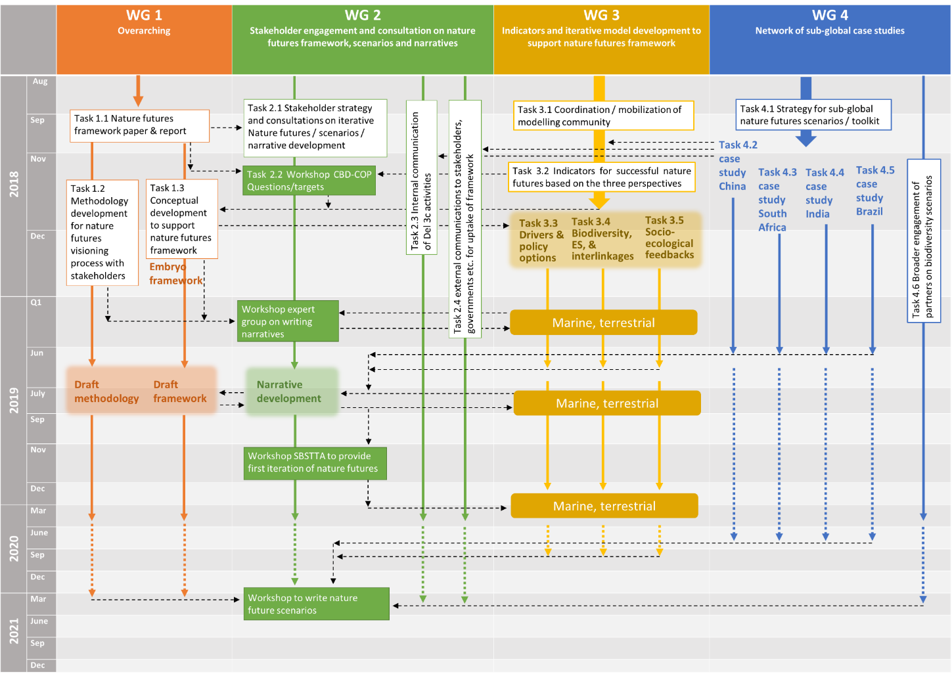

Appendix III
Iterative steps in the participatory development of positive scenarios on the future of nature and nature’s contributions to people
The development of scenarios comprises three steps, with repeating stakeholder consultations:
- Formulation of (positive) visions for nature and nature’s contributions to people, based on examples of actions with potential to be expanded in the future (seeds). Single visions encompassing various sectors and ecosystems such as agriculture, rural areas, urban areas, marine areas, etc., can be developed.
- Development of storylines: describing “what the world looks like” as seen from one or a combination of the perspectives of the nature futures framework⁴.
- Storylines are quantified by assessing plausible socio-economic developments that fit the qualitative storylines. Indirect and direct drivers are described for each storyline, with reference to existing pathways of global change and potential new pathways. For future development this will be based on models such as integrated assessment models. The drivers are linked to biodiversity and ecosystem services models to provide indicators of change in nature and nature’s contributions to people.
Scenarios, defined as a consistent and plausible picture of a possible future, are combinations of the qualitative storyline and the quantitative model output.
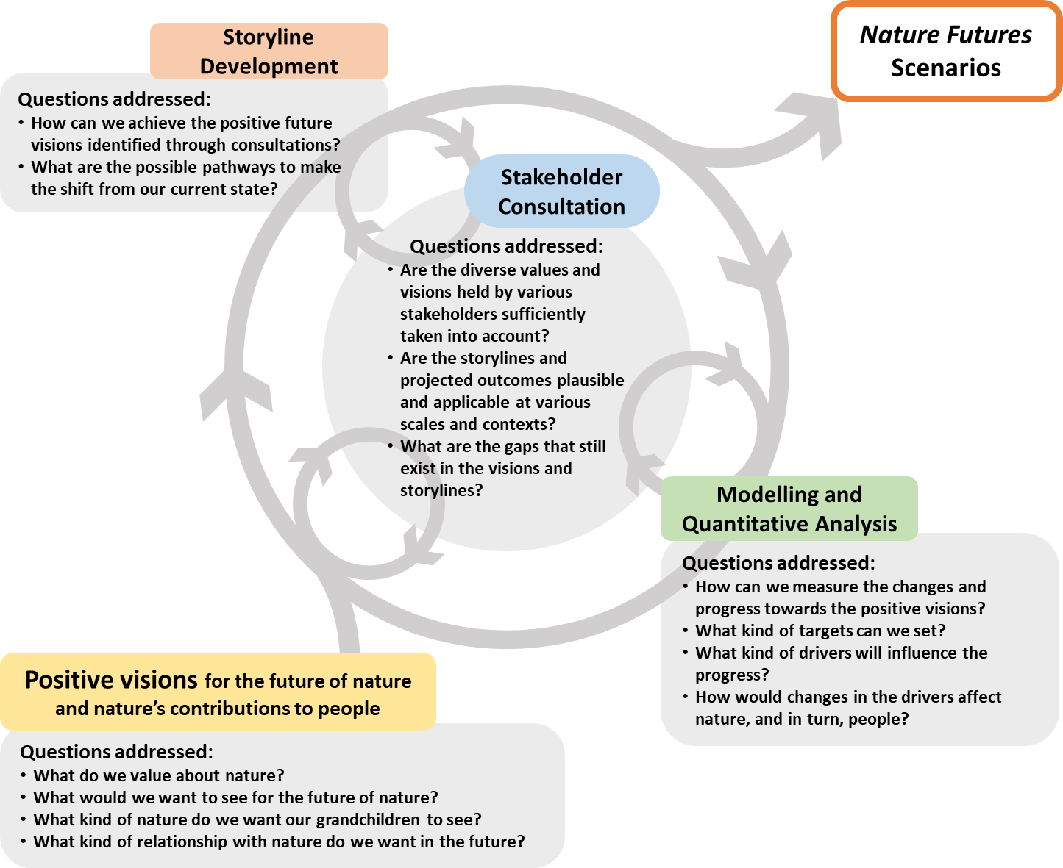

* IPBES/7/1/Rev.1.
Available at: https://www.biorxiv.org/content/early/2018/04/16/300632.
Available at: https://www.nature.com/articles/s41559-017-0273-9.
Available at: https://www.niwa.co.nz/naturefutures.
These perspectives are: nature for nature, in which nature is regarded as having value in and of itself, and the preservation of nature’s functions is of primary importance; nature for people, in which nature is primarily valued for the interest of people, and focus is on the multiple uses of nature; and nature as culture, in which humans are perceived as an integral part of nature and its functions. These three perspectives form a continuum, or gradient, that is represented in a triangular nature futures framework, and which can be discussed across different scales and sectors.
Available at: https://www.pbl.nl/en/publications/report-on-the-workshop-next-steps-in-developing-nature-futures.
Available at: http://enb.iisd.org/biodiv/cop14/riopavilion/20nov.html.

