UNITED
NATIONS

IPBES/10/INF/13

 | Intergovernmental Science-Policy  Platform on Biodiversity and  Ecosystem Services | Distr.: General  3 July 2023  English only

Plenary of the Intergovernmental Science-Policy
Platform on Biodiversity and Ecosystem Services
Tenth session
Bonn, Germany, 28 August–2 September 2023
Item 8 of the provisional agenda*
Building capacity, strengthening knowledge foundations and supporting policy
Information on advanced work on scenarios and models of biodiversity and ecosystem functions and services
Note by the secretariat
- In section V of decision IPBES-4/1, the Plenary of the Intergovernmental Science-Policy Platform on Biodiversity and Ecosystem Services (IPBES) approved the summary for policymakers of the methodological assessment of scenarios and models of biodiversity and ecosystem services and accepted the individual chapters of the assessment. In the same decision, the Plenary requested the Multidisciplinary Expert Panel to oversee further work related to scenarios and models, and to appoint an expert group to perform that work.
- At its seventh session, in decision IPBES-7/1, the Plenary adopted the rolling work programme of IPBES for the period up to 2030, which includes among its six objectives advanced work on scenarios and models of biodiversity and ecosystem functions and services (objective 4 (b)). The objective consists of providing advice to expert groups assessing the use of existing models and scenarios, and catalysing the development of new scenarios and associated models for the future work of IPBES and application in policy development, while also promoting coherence with similar work carried out by the Intergovernmental Panel on Climate Change and other bodies, as appropriate.
- In the same decision, the Plenary established a task force on scenarios and models of biodiversity and ecosystem services for the implementation of objective 4 (b) of the rolling work programme of IPBES up to 2030, in accordance with the revised terms of reference set out in sections I and V of annex II to the decision, and building on the work of the former expert group on scenarios and models, whose mandate ended at the seventh session of the Plenary. The Plenary requested the Bureau and the Multidisciplinary Expert Panel, through the IPBES secretariat, to constitute the task force in accordance with the terms of reference. The Plenary also decided to review the mandate and terms of reference of the task force at its tenth session.
- According to its terms of reference, the task force oversees and takes part in the implementation of objective 4 (b) of the rolling work programme up to 2030, “Advanced work on scenarios and models of biodiversity and ecosystem functions and services”, and acts in accordance with relevant decisions by the Plenary and its subsidiary bodies, including by building on lessons learned in the implementation of deliverable 3 (c) of the first work programme. Also according to its terms of reference, the task force implements the work on scenarios and models to facilitate the provision of advice to all the expert teams, in particular those working on assessments, with regard to the use of scenarios; to catalyse the further development of scenarios and models for future IPBES assessments; and to guide the secretariat, including the dedicated technical support units, in the provision of support. The task force exchanges information and collaborates with other bodies developing relevant scenarios and models under the guidance of the Bureau.
- The task force was constituted following the seventh session of the Plenary. Information on its work and membership is available here: https://www.ipbes.net/scenarios-models.
- In decision IPBES-7/1, the Plenary requested the task force to develop specific deliverables for each of the priority topics of the rolling work programme up to 2030. In response, the task force prepared the following deliverables for objective 4 (b), which were welcomed by the Plenary in decision IPBES-9/1:
  - Provision of support on scenarios and models for IPBES assessments;
  - Catalysing of the further development of scenarios and models for future IPBES assessments.
- The general terms of reference of the task forces, set out in annex II to decision IPBES-7/1, stipulate that each task force will, among other activities, provide a regular progress report and, in consultation with the Multidisciplinary Expert Panel and the Bureau, develop and update a workplan that sets out clear milestones and deliverables with regard to the relevant topics and objectives of the rolling work programme up to 2030 for periodic consideration by the Plenary. In section V of decision IPBES-9/1, the Plenary welcomed the progress made by the task force on scenarios and models of biodiversity and ecosystem services in the implementation of objective 4 (b) of the work programme of IPBES up to 2030 and approved the workplan of the task force for the intersessional period
2022–2023 (between the ninth and tenth sessions of the IPBES Plenary), as set out in annex VII to the decision.
- An overview of activities carried out by the task force since the ninth session of the Plenary is set out in the report of the Executive Secretary on progress in the implementation of the rolling work programme up to 2030 (IPBES/10/4).
- The annex to the present document provides further information on activities carried out by the task force in implementing its workplan (sections I and II). Section III sets out additional information on the proposed workplan for the task force for the intersessional period 2023–2024, presented in document IPBES/10/8. Sections IV and V contain draft workplans for the implementation of work programme objective 4 (b) for the intersessional periods 2024–2025 and 2025–2026. Appendix I sets out a synthesis of literature on work catalysed by the Nature Futures Framework prepared by the task force in line with its workplan. Appendix II sets out, in part I, the Nature Futures Framework, a flexible tool to support the development of scenarios and models of desirable futures for people, nature and Mother Earth, as welcomed by the Plenary at its ninth session (annex VI to decision IPBES-9/1), as well as a new section II.D, on the relation between the Nature Futures Framework and the IPBES conceptual framework, and between the Nature Futures Framework and the Assessment Report on the Diverse Values and Valuation of Nature. Part II of appendix II contains the updated methodological guidance on how the framework can be used for scenario development. The annex and its appendices are presented without formal editing.

Annex*
Information on advanced work on scenarios and models of biodiversity and ecosystem functions and services
I. Membership of the task force
- The Multidisciplinary Expert Panel and Bureau, at their 13th meetings, selected the members of the task force in line with its terms of reference set out in annex II to decision IPBES-7/1.
- The current composition of the task force is as follows:
Name | Country | Function
Douglas Beard | United States of America | Bureau member
Rovshan Abbasov | Azerbaijan | Member of the Multidisciplinary Expert Panel
Shizuka Hashimoto | Japan | Task force co-chair, member of the Multidisciplinary Expert Panel
Carolyn Lundquist | New Zealand | Task force co-chair, member of the Multidisciplinary Expert Panel
Lilibeth Acosta-Michlik | Philippines | Expert
Mekuria Argaw Denboba | Ethiopia | Expert
William Cheung | Canada | Expert
Ana Paula Dutra De Aguiar | Brazil | Expert
Maria Gasalla | Brazil | Expert
Khaled Allam Harhash | Egypt | Expert
Paula Harrison | United Kingdom of Great Britain and Northern Ireland | Expert
Sathyapalan Jyothis | India | Expert
Sylvia Karlsson-Vinkhuyzen | Sweden | Expert
Paul Leadley | France | Expert
Claudia Munera-Roldan | Colombia | Expert
Maria Gabriela Palomo | Argentina | Expert
Henrique Pereira | Portugal | Expert
Laura Pereira | South Africa | Expert
Garry Peterson | Canada | Expert
Ramon Pichs-Madruga | Cuba | Expert
Ali Kerem Saysel | Türkiye | Expert
Dandan Yu | China | Expert
Carlos Zambrana-Torrelio | Bolivia | Expert
América Paz Durán | Chile | Fellow
Ghassen Halouani | Tunisia | Fellow
HyeJin Kim | Republic of Korea | Fellow
Jan Kuiper | The Netherlands | Fellow
Brian Miller | United States of America | Fellow
- PBL – the Netherlands Environmental Assessment Agency, which had hosted the technical support unit for the IPBES Assessment of Scenarios and Models of Biodiversity and Ecosystem Services and for the expert group on scenarios and models that had been mandated to work between the fourth and seventh sessions of the Plenary, was selected by the Bureau at its 13th meeting to also host the technical support unit to support the task force under the 2030 rolling work programme until the tenth session of the Plenary.
II. Report on progress
- This section sets out activities undertaken by the task force since IPBES 9 under objective 4 (b), advanced work on scenarios and models of biodiversity and ecosystem functions and services.
A. Deliverable 1: Provision of support on scenarios and models for IPBES assessments
- To provide support on scenarios and models for IPBES assessments, the task force conducted the following activities.
  - The task force distributed the call for nominations for authors and fellows for the assessment of the impact and dependence of business on biodiversity and nature’s contributions to people through relevant networks to encourage the application of experts on scenarios and models.
  - Task force members were identified to serve as informal liaison experts for the nexus and transformative change assessments, to ensure smooth communication on the needs of the assessments regarding scenarios and models and the provision of appropriate support from the task force. For each of the two assessments, two members of the task force have been designated to serve as informal liaisons and continue to support assessment authors via online communications, including calls. One of these four task force members serving as liaisons is a co-chair in the nexus assessment, another one is a lead author on the same assessment, and one is a contributing author on the transformative change assessment.
  - The task force reviewed the first drafts of the chapters of the nexus assessment and transformative change assessment and disseminated the invitations to participate in the first external reviews of these assessments through relevant networks.
  - The task force continued to catalyse the production of publications by the scientific community to inform upcoming assessments, which included work on a special issue of the journal “Sustainability Science”, entitled ‘Operationalizing the Nature Futures Framework to catalyse the development of nature‑future scenarios’. The articles published thus far as part of this special issue are available here.
  - The second Indigenous and local knowledge dialogue workshop for the IPBES assessment of transformative change and scenarios of the future was organized, in collaboration with the task force on Indigenous and local knowledge and experts of the IPBES transformative change assessment, from 13 to 16 February 2023 in Leticia, Colombia. The aim of the dialogue was to bring together representatives of Indigenous Peoples and local communities and IPBES experts to discuss the transformative change assessment, and to further enhance work with Indigenous and local knowledge around future visions and scenarios to provide input to the work of the IPBES task force on scenarios and models. The workshop was attended by 19 representatives of Indigenous Peoples and local communities and an additional 10 participants, comprising members of the task force on Indigenous and local knowledge, and of the task force on scenarios and models, and experts of the transformative change assessment.
B. Deliverable 2: Catalyse the further development of scenarios and models for future IPBES assessments
- To catalyse the further development of scenarios and models for future IPBES assessments, the task force conducted the following activities.
  - The task force on scenarios and models further updated the foundations of the Nature Futures Framework based on considerations put forth at IPBES 9, including, but not limited to, alignment with the IPBES conceptual framework and the findings of the IPBES Assessment of the Diverse Values and Valuation of Nature. In addition, a synthesis of literature on work catalysed by the Nature Futures Framework was prepared and is set out in appendix I. A library of catalysed work has been set up in Zotero (Nature Futures Framework | Zotero), in collaboration with the task force on knowledge and data. The library also includes references to case studies, presentations of sessions at major conferences, and other publications by members of the scientific community in peer-reviewed journals and grey literature on scenarios and models, which resulted from efforts of the task force to catalyze the development of new scenarios and models of biodiversity and ecosystem services.
  - As part of the further development of the draft methodological guidance on the use of the Nature Futures Framework, a government review of the guidance was organized from 5 September to 14 October 2022. In addition to the government review process, an online dialogue with national focal points was held in two sessions on 20 September 2022 (in collaboration with the task force on capacity-building).
  - A workshop to catalyse the further development of scenarios, including using the Nature Futures Framework, organized by the task force and technical support unit on scenarios and models was held in Acornhoek, South Africa, from 14 to 16 November 2022. The objectives of the workshop were to: a) Catalyse further development of scenarios and models for future IPBES assessments, including by testing the Nature Futures Framework and discussing its limits and opportunities; b) Collect additional feedback on the methodological guidance for using the Nature Futures Framework, including potential challenges involved in its application; and c) Further catalyse the development of qualitative and quantitative case studies that would be available for the nexus and transformative change assessments. 17 experts on scenarios and models, 16 members of the task force on scenarios and models and 3 members of its technical support unit attended the workshop. The report of the workshop is available from the event page.
  - The task force further developed the draft methodological guidance of the Nature Futures Framework, which had been presented at IPBES 9 in document IPBES/9/INF/16, based on feedback received during the Government review held from 5 September to 14 October 2022, the dialogue with national focal points held online on 20 September 2022, and the workshop with experts on scenarios and models held from 14 to 16 November 2022 in Acornhoek, South Africa. The revised methodological guidance is set out in appendix II to this annex, together with the foundations of the Nature Futures Framework.
  - In line with the work plan activity to organize capacity-building activities on broader scenarios to facilitate the use of existing scenarios and models in IPBES assessments and catalyse the development of new scenarios and models, the task force on capacity-building in collaboration with the task force on scenarios and models organized a youth workshop, which was held from 19 to 23 October 2022 on the Isle of Vilm, Germany. The youth participants were invited to explore future scenarios for nature and to engage with the work on scenarios and models. Further information on the meeting can be found in IPBES/10/INF/9 and on the IPBES website.
C. Other task force activities
- The fourth meeting of the task force wаs organized back-to-back with the workshop on scenarios and models in Acornhoek, South Africa, on 17 November 2022. The aims of the meeting were to: a) discuss plans for the implementation of the workplan up to the end of the task force’s mandate at IPBES 10; b) review the experiences and lessons learned from the work of the task force conducted since IPBES 7, and develop a list of major activities required to be implemented between IPBES 10 and IPBES 13; and c) discuss how to revise the methodological guidance of the Nature Futures Framework based on the inputs received through the government review, the dialogue with national focal points, and through the workshop to catalyse further development of scenarios including using the Nature Futures Framework that was held on the days prior to the task force meeting.
III. Additional information on the workplan for the implementation of work programme objective 4 (b) for the intersessional period 2023–2024
- In decision IPBES-7/1, the Plenary decided to review the mandate and terms of reference of the task force at its tenth session. Revised terms of reference for the task force are presented in document IPBES/10/8 for consideration by the Plenary. In the same document, a workplan for the implementation of objective 4 (b) of the IPBES rolling work programme up to 2030 is presented together with workplans for objectives 2, 3 (a – data); 3 (a – knowledge generation); 3 (b) and 4 (a). The workplans, which are presented for consideration by the Plenary, cover the period between IPBES 10 and IPBES 11 (intersessional period 2023-2024). Figure 1 presents the institutional structure proposed for the implementation of these workplans.
Figure 1
Illustration of the change in bodies responsible for the implementation of objectives 2, 3 and 4 of the IPBES rolling work programme up to 2030. Bolded text and orange arrows indicate a change in responsible body.
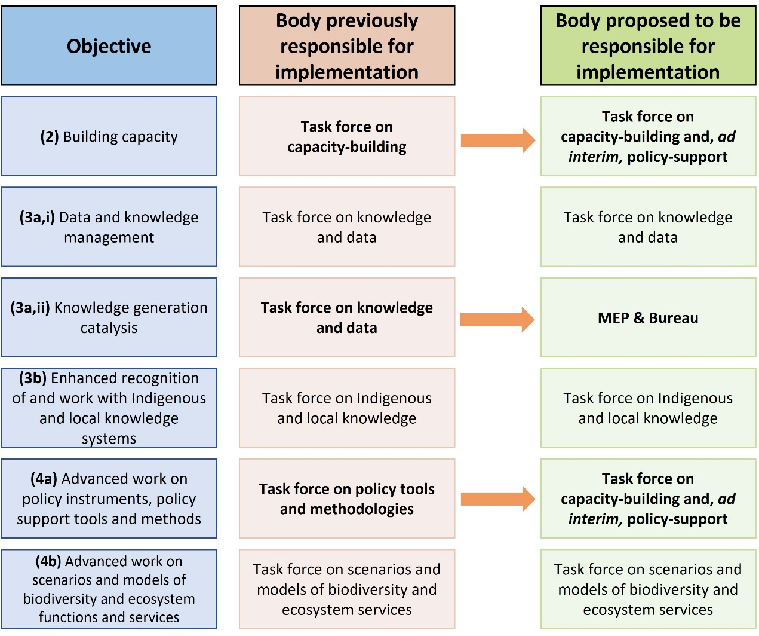
- Draft workplans for the implementation of objective 4 (b), covering the intersessional period between IPBES 11 and IPBES 12 (intersessional period 2024-2025) and between IPBES 12 and IPBES 13 (intersessional period 2025-2026) are presented in sections IV and V below. Figure 2 schematically illustrates the interactions of the task force on scenarios and models with IPBES assessment processes, as reflected in the activities presented as part of the workplans to implement objective 4 (b) of the IPBES rolling work programme. The task force provides input into assessment processes at several stages. At the commencement of an IPBES assessment, the task force on scenarios and models is responsible for distributing the call for authors and fellows to networks of scenarios and modelling experts. Once assessment experts have been selected, the task force provides methodological guidance on scenarios and models to them. The task force reviews the draft text as part of the external review process. Once an IPBES assessment has been approved/accepted by the Plenary, the task force on scenarios and models builds on the completed assessment to catalyse the development of scenarios and models. For all new IPBES assessments, the task force on scenarios and models will continue to engage with the assessment process in this manner.
- With regard to the collection of examples of the development of scenarios using the Nature Futures Framework presented in document IPBES/10/8 as part of the workplan for the intersessional period 2023-2024, it is proposed to conduct a systematic search of existing literature in the fourth quarter of 2024. There is an increasing number of examples of applications of the Nature Futures Framework, which have been catalysed by the former expert group and the task force on scenarios and models in recent years. These applications have been carried out at various places, localities, and scales, and can cover different thematic contexts. By systematically collecting these applications and making them available via the Zotero library, the task force would support the further catalysation of scenarios and modelling work among the broader scientific and stakeholder communities. Compiling related information across these examples would also allow the identification of remaining gaps in scenarios and model development, and comments and critiques raised through these examples would contribute to further development and refining of methodologies.

Figure 2
Interaction of the activities to implement objective 4 (b) of the IPBES rolling work programme up to 2030 with the assessment process. The standard process for the production of an IPBES assessment is shown along the multi-coloured horizontal arrow, with activities to implement objectives 2 and 4 (b) shown in green lines and arrows. The dotted line for scoping indicates that this process is not carried out for every assessment.
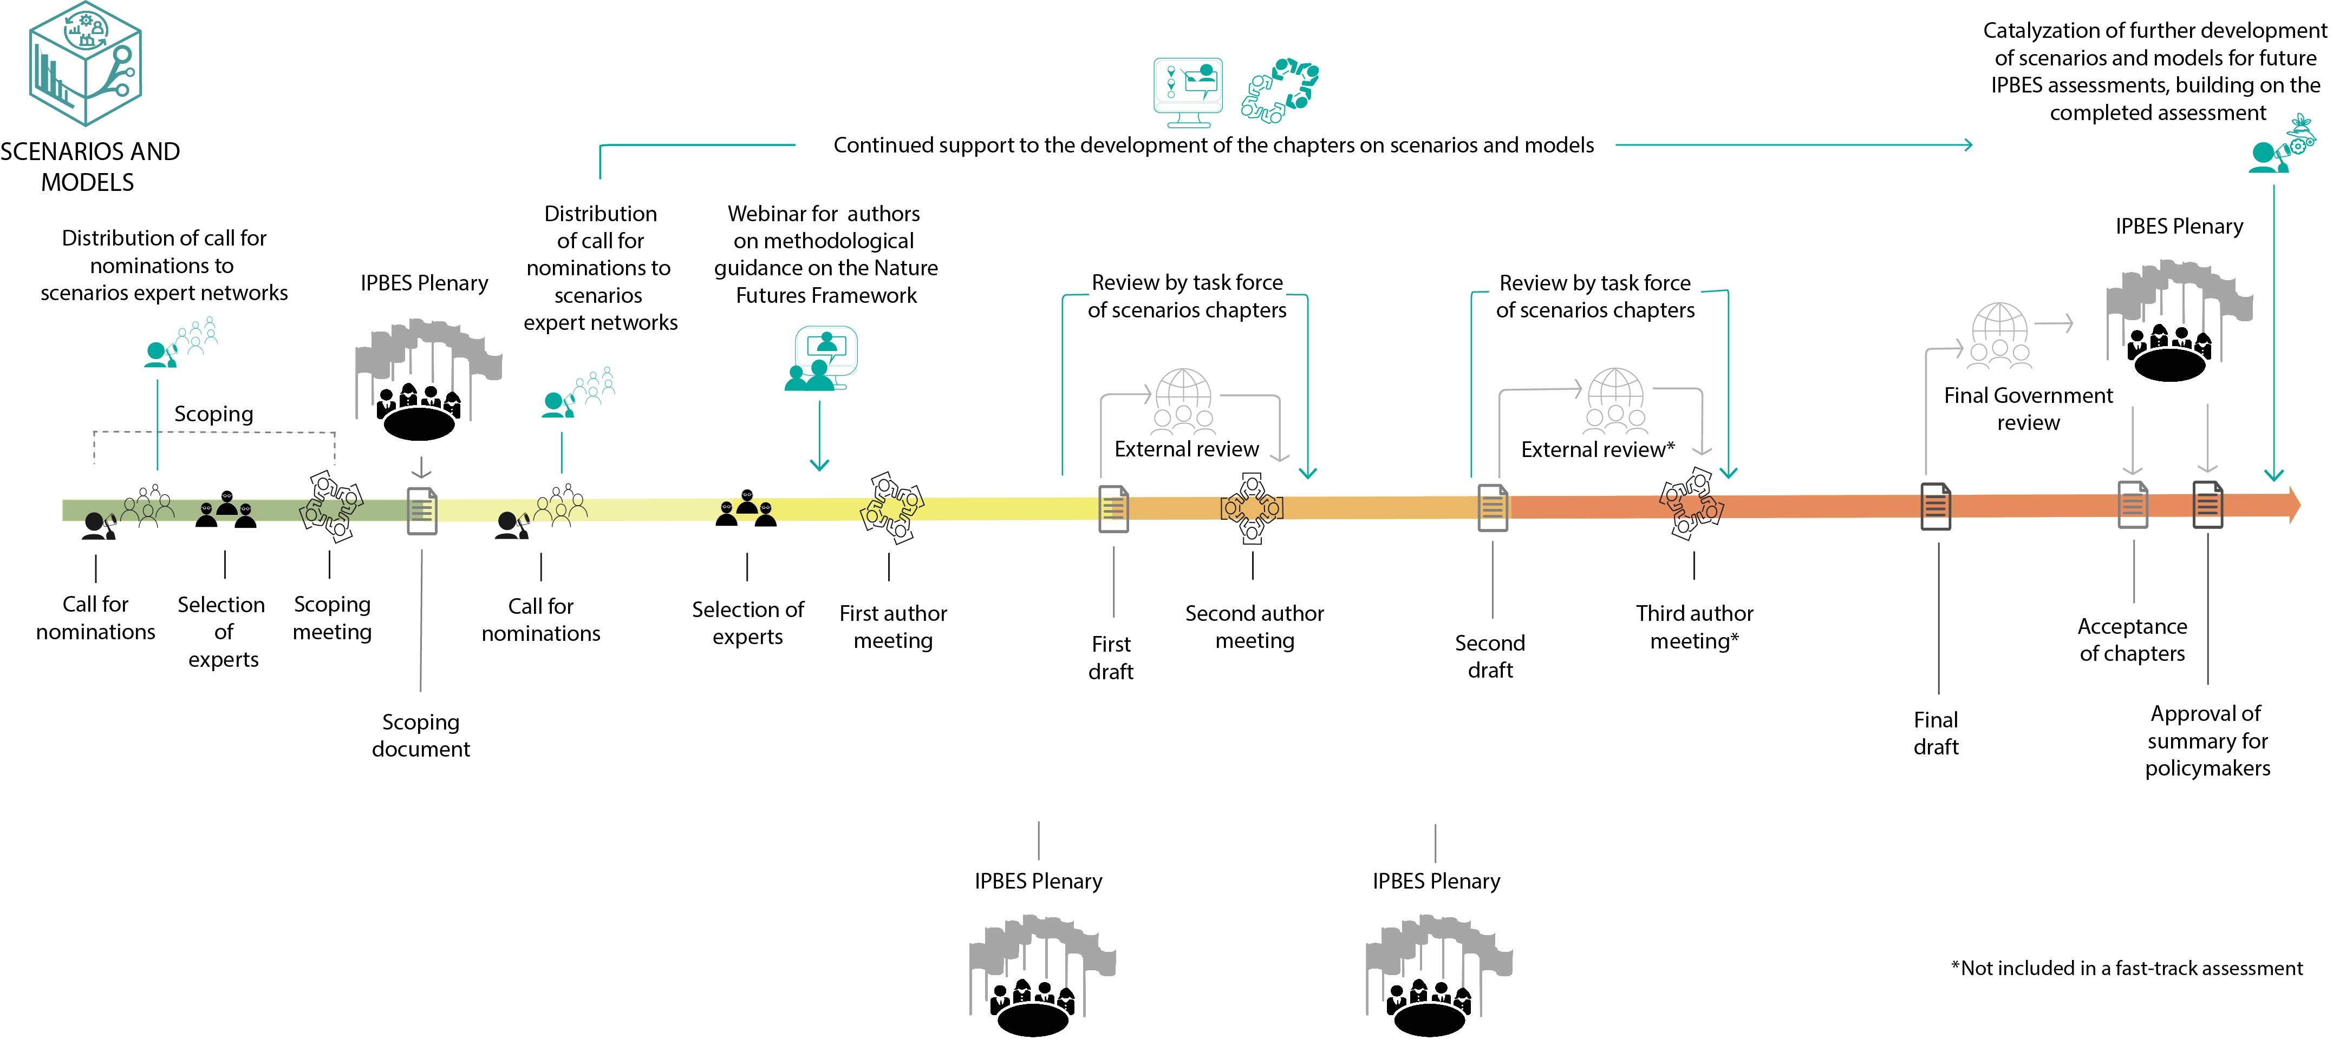

IV. Draft workplan for the intersessional period 2024–2025 (for information)
- Activities to provide support on scenarios and models for IPBES assessments would include:
  - Peer review by the task force of the summary for policymakers of the business and biodiversity assessment, and drafts, as applicable, of any new assessments;
  - Mobilizing experts on scenarios and models and other futures studies beyond the task force to encourage their contribution to upcoming assessments, e.g., by disseminating the call for nominations of assessment authors for any new assessments, and the notifications inviting participation in the external review of IPBES assessments;
  - Providing advice and input on scenarios and models to IPBES assessment author groups, including through engagement of task force members as contributing authors, or through holding webinars and providing materials, upon request;
  - Engaging with scenarios and models experts from other intergovernmental processes to foster coherence and an exchange of ideas among assessment processes.
- Activities to promote a dialogue between IPBES and the community of practice on scenarios and models and to catalyse the further development of scenarios and models for future IPBES assessments would include:
  - Mobilizing existing communities working on scenarios and models and other futures studies to facilitate the development of scenarios and models relevant to the work of IPBES, thereby also supporting the work of biodiversity-related multilateral environmental agreements, including through a call for relevant organizations to conduct workshops to continue the dialogue regarding further work (third quarter of 2025);
  - Provision of guidance and information on the work of IPBES with regard to scenarios and models, including the Nature Futures Framework, at workshops organized by existing communities working on scenarios and models and other futures studies (third quarter of 2025);
  - Collection of examples for the development of scenarios using the Nature Futures Framework at various places, localities, and scales for different thematic contexts, identification of remaining gaps, and compilation of related information including comments and critiques contributing to further development and refining of methodologies (fourth quarter of 2025);
  - Engaging with various stakeholders including those with backgrounds in modelling, social sciences and humanities, those with Indigenous and local knowledge, as well as policymakers and the private sector, through participation in relevant international meetings and conferences to disseminate, discuss, and further develop the work of IPBES on scenarios and models.
- Activities to ensure the effectiveness of the implementation of the workplan include the monitoring of a set of relevant indicators for measuring the effectiveness of the workplan.
V. Draft workplan for the intersessional period 2025–2026 (for information)
- Activities to provide support on scenarios and models for IPBES assessments would include:
  - Peer review by the task force of drafts of any new assessments, as appropriate, subject to their initiation;
  - Mobilizing experts on scenarios and models and other futures studies beyond the task force to encourage their contribution to upcoming assessments, e.g., by disseminating the call for nominations of assessment authors for any new assessments and the notifications inviting participation in the external review of IPBES assessments;
  - Providing advice and input on scenarios and models to IPBES assessment author groups, including through engagement of task force members as contributing authors, or through holding webinars and providing materials, upon request;
  - Engaging with scenarios and models experts from other intergovernmental processes to foster coherence and an exchange of ideas among assessment processes.
- Activities to promote a dialogue between IPBES and the community of practice on scenarios and models and to catalyse the further development of scenarios and models for future IPBES assessments will include:
  - Mobilizing existing communities working on scenarios and models and other futures studies to facilitate the development of scenarios and models relevant to the work of IPBES, thereby also supporting the work of biodiversity-related multilateral environmental agreements, including through a call for relevant organizations to conduct workshops to continue the dialogue regarding further work (third quarter of 2026);
  - Provision of guidance and information on the work of IPBES with regard to scenarios and models, including the Nature Futures Framework, at workshops organized by existing communities working on scenarios and models and other futures studies (third quarter of 2026);
  - Engagement with the climate scenarios and models community on the development of new scenarios of relevance across intergovernmental processes (fourth quarter of 2026);
  - Engaging with various stakeholders including those with backgrounds in modelling, social sciences and humanities, those with Indigenous and local knowledge, as well as policymakers and the private sector, through participation in relevant international meetings and conferences to disseminate, discuss, and further develop the work of IPBES on scenarios and models.
- Activities to ensure the effectiveness of the implementation of the workplan include the monitoring of a set of relevant indicators for measuring the effectiveness of the workplan.

Appendix I
Synthesis of literature on work catalysed by the Nature Futures Framework
I. Introduction
- This synthesis is based on publications identified through a systematic search of literature on the Nature Futures Framework (NFF), conducted in March 2023 (data management report: https://zenodo.org/record/7885022#.ZFCcUtpBy3A). The systematic search of literature on the NFF identified 81 publications which either use or mention the Nature Futures Framework, 39 of which were published since the last systematic literature search in March 2022 (data management report: https://zenodo.org/record/6396543#.ZEoboc5By3A). 34 of these 81 publications provide in-depth discussion of the NFF, and are further analysed below, while the 47 remaining ones mention the NFF without further discussion. The 81 publications correspond to peer-reviewed as well as to ‘grey’ literature produced outside commercial or academic publishing channels (e.g., technical reports, government documents, working papers). The results of the literature search and its synthesis aim to provide an indication of the uptake of the NFF and its use. The literature identified through the systematic search was uploaded to a library on Zotero.org, available at: https://www.zotero.org/groups/4937409/nature_futures_framework/items/97JRX9TV/library. The synthesis provided below is based on the 34 publications mentioned above that use the NFF or provide in-depth discussion on its possible uses, available in the folder ‘Literature which uses the NFF’ at the link above. This synthesis excludes the 47 other publications that only mention the NFF without further discussions.
- There are several reports on workshops of the task force on scenarios and models, which were not included in the synthesis but do list currently unpublished and ongoing projects on the NFF: IPBES, 2021a, IPBES, 2022, IPBES 2021b, IPBES (in prep).
II. Synthesis and key messages
- Table 1 below provides a detailed overview of the 34 publications analysed. The following key messages emerged from the analysis:
  - The NFF has been applied in a number of regional and global studies;
  - Publications on the NFF consist of workshop reports, book chapters and peer-reviewed papers;
  - The NFF has been used for a variety of purposes, including for developing visions and scenarios (10 publications), as a classification tool (5), to position new concepts, theories and methods (5), as an exploration tool (4), as a tool for translating existing scenarios (3), and for adapting and developing models (2);
  - Overall, the NFF was positively evaluated as enabling a shift towards a more inclusive and pluralistic approach to scenario development;
  - Palacios-Abrantes et al. (2022) mentioned that the NFF can provide insights into the trade-offs and synergies that may occur between different value perspectives and within value perspectives, thereby allowing policymakers to make better informed decisions. However, they also state that such insight into trade-offs does not necessarily facilitate decision-making, as indicators on each side of the trade-off or synergy can be difficult to measure and implement;
  - Some users of the NFF indicated that assigning indicators to the relational “nature as culture” value perspective is challenging (Haga et al., 2023; Lavery et al., 2022; Rosa et al., 2020). It was also suggested that the concept of a science-based framework can be considered per se as Western-centric (Stronge et al., 2023);
  - There has also been a call for better comparability between the IPCC and IPBES scenarios, as it was found difficult to develop degrowth scenarios that are compatible with both (Otero et al., 2022);
  - In addition to scenarios that could be developed using the NFF, or translated into the NFF, some researchers found that it was necessary to use supplemental scenarios. For example, Quintero-Uribe et al. (2022) included a ‘business as usual’ scenario to reflect that not all scenarios include narratives that improve nature values.
III. Conclusion
- Since the publication of the NFF, there has been a continuous uptake of the framework. A number of visioning and scenario development exercises have been conducted using the NFF, and the framework has been discussed extensively in the scientific literature. Even though some limitations have been identified, overall, the NFF is valued for allowing the consideration of diverse perspectives on nature and the development of scenarios that reflect pluralistic values.
- The framework was considered useful for a variety of places, scales, thematic areas and purposes.
- The significant use of the framework in the literature shows that the consultations and discussions with a variety of stakeholders during the development of the NFF in recent years have resulted in uptake of the framework in practice. It is expected that the uptake and use of the NFF will continue to increase, also supported by the updated methodological guidance, which is presented to the Plenary for its information in appendix II to this annex.

Table 1
Overview of publications which use the Nature Futures Framework (NFF) published before 21 March 2023. Of the 34 publications listed below, those shaded in grey have been excluded from the analysis due to various reasons: Chibwe et al. (2021) and Pereira et al. (2022) are based on the same study as Pereira et al. (2023); Lundquist et al. (2021a) is a correspondence to clarify the objectives of the IPBES task force on scenarios and models; and Lundquist et al. (2021b) is a call for papers for a special issue on the Nature Futures Framework.
Publication | Publication type, Publication name | What is the NFF used for in the publication - findings | Region/Location | Limitations | Feedback on the NFF | Categorization of publications
Resende et al., 2020, DOI: 10.1590/1676-0611-bn-2019-0899 | Scientific article, Biota Neotropica Journal | The NFF was used to identify how water-related ecosystem services can be valued. | Brazil | A challenge faced was the development of scenarios that represent a future that humanity could strive for, aligned with the NFF. | – | Exploration tool
Sarkar et al., 2020, DOI: 10.1590/1676-0611-bn-2019-0913 | Scientific article, Biota Neotropica Journal | The NFF was used to depict the diverse values of inland wetlands contributing to human wellbeing in India and Brazil, and to identify indicators to measure and monitor changes in wetland values. | India and Brazil | – | – | Exploration tool
Karki, 2022 | Master of Science, Thesis, Albert-Ludwigs-Universitat Freiburg | This master’s thesis explored the effects of the attitude towards risk, uncertainty and climate change of forest professionals on their behaviour regarding adaptation to climate change (adaptative decision-making and adaptation intensity) and their management behaviour in relation to NFF value perspectives’ narratives in Nepal.  Forest professionals were asked to attribute a value (percentage) to each of the NFF value perspectives, based on their personal work in forest management; with the sum of the different values amounting to 100%. The NFF also served as the basis for a questionnaire, in which participants were asked to rank goals associated with specific value perspectives according to their personal work in forest management. | Nepal | – | – | Exploration tool
Palacios-Abrantes et al., 2022, DOI: 10.1007/s11625-022-01200-4 | Scientific article, Sustainability Science Journal | The NFF was discussed as a tool to inform management in social-ecological systems facing climate change. Using three case studies from the global South, the study illustrates the potential of the NFF to generate alternative pathways under climate change.  The authors conclude that the NFF can help identify trade-offs between alternative climate adaptation pathways. | Global South | The study finds that insight in the alternative pathways with underlying trade-offs as management options does not necessarily facilitate decision-making.  Indicators used on each side of a trade-off often differ significantly, making it difficult for modelers and decision-makers to measure and implement them.  The study finds that operationalization of the NFF ‘will require an unprecedented degree of engagement between stakeholders, policymakers, natural and social scientists to properly account and differentiate between values as well as incorporate qualitative metrics into modelling frameworks.’ | The NFF provides transparency of the different potential pathways for biodiversity management and makes explicit the trade-offs between different value perspectives and within value perspectives. This allows policy makers to make decisions that are better informed.  The NFF approach may open up discussions on how biodiversity can be managed more effectively, allowing for the consideration of multiple values. | Exploration tool
Dib et al., 2020, DOI: 10.1590/1676-0611-bn-2019-0915 | Scientific article, Biota Neotropica Journal | The NFF was used to develop a conceptual model of the Cantareira System Protected Area. Selected components of the system were assigned to the three different value perspectives of the NFF. | Cantareira System Protected Area, Brazil | – | – | Classification tool
De Bruin et al., 2022, DOI: 10.1016/j.envsci.2023.03.015 | Scientific article, Environmental Science & Policy Journal | In this study, the NFF was used to evaluate experts’ attitudes to nature and the “Half Earth and Sharing the Planet” scenario, providing a simple representation of the diversity of respondents’ attitudes. | Global | – | The study states that the NFF is a widely accepted IPBES framework, which has been developed to make the values of nature actionable for the modelling and scenarios community. | Classification tool
Diprose et al., 2022, DOI: 10.5334/cstp.442 | Scientific article, Citizen Science: Theory and Practice Journal | The NFF is used to organize the results of a self-reported citizen science initiative, the New Zealand Garden Bird Survey (NZGBS). By using the NFF, the diverse values of nature that are fostered through the NZGBS are made visible. |  |  | The study states that using the NFF allows for better visibility and creates space for the relational values (nature as culture value perspective) that citizen science projects can foster. | Classification tool
Kim et al., 2022 | Doctoral Thesis, Martin Luther University Halle-Wittenberg | In chapter 5 of this dissertation, the NFF is used to evaluate the state and performance of protected areas and indigenous land. | Global | – | The dissertation states that ‘the NFF can be used with essential biodiversity and ecosystem services variables in diversifying the roles, values, and benefits of nature to retrospectively evaluate the performance of biodiversity interventions.’ | Classification tool
Stronge et al., 2023, DOI: 10.1007/s11625-022-01269-x | Scientific article, Sustainability Science Journal | The NFF was used to analyse how New Zealand’s agricultural productive sectors express their relationship with soil and soil health. The results are consistent with work undertaken on Indigenous Māori perspectives of soil and soil health. | New Zealand | While the NFF broadens the perspective on, e.g. how soils are valued, the study considers it as a Western-centric framework. | The study states that ‘the strength of the NFF is that it encourages people to think more holistically about a plural set of values, especially those they assign to the environment’.  The NFF enables a dialogue on values which enriches our understanding of soils and soil health. | Classification tool
Dasgupta et al., 2022, DOI: 10.1007/978-981-19-2738-6 | Book, Springer Publishing Company | The NFF is mentioned in Chapter 4 of this book: Ecosystem Services and Their Future Scenarios Centering on Mangrove Ecosystem in Ishigaki Island, Japan. As part of the chapter, existing scenarios are mapped into the NFF. | Japan | – | – | Translating scenarios
Lavery et al., 2022 | Article, Vector Journal | The authors propose using storytelling, and specifically African speculative fiction, as inspiration for potential nature futures. They assign several African futurist sci-fi short stories to their respective position in the NFF. In the stories, values that are located along the “nature as culture”-“nature for nature” axis are most prevalent. | Africa | It is mentioned that for experts not directly involved in work on plural values, it can be difficult to conceptualise futures that draw on the NFF perspectives.  According to the authors, African futurist speculative fiction may aid in addressing the gaps within the NFF, specifically the lack of indicators along the “nature as culture”-“nature for nature” axis. |  | Translating scenarios
Quintero-Uribe et al., 2022, DOI: 10.1111/ecog.06292 | Scientific article, Ecography Journal | The study analyses how the future of nature has been envisioned in participatory scenarios in Europe. The NFF was used to assess how pluralistic perspectives of nature and the outcomes of restoration efforts for both people and nature are portrayed in different participatory scenario narratives. In addition, “business as usual” archetypes were used to map the scenarios. “Nature as culture” was the main archetype found in the scenarios. | Europe | The researchers had to include a fourth ‘business as usual’ archetype in their study to ‘accommodate for the fact that some scenarios do not incorporate narratives that improve any nature values and therefore cannot be mapped into the [NFF]’  The study highlighted the need to explore the synergies between different value archetypes of the NFF. For example, to avoid associating rewilding solely to the “nature for nature” perspective. | The NFF was useful to synthesise the pluralistic perspectives of nature found in the scenario narratives. The authors classify this as ‘a major advantage over other frameworks such as the SSPs that focuses more on the socio-economic dynamics of society’. | Translating scenarios, Developing visions and scenarios
Lembi et al., 2020, DOI: 10.1590/1676-0611-bn-2019-0904 | Scientific article, Biota Neotropica Journal | The study used the NFF for envisioning positive scenarios for cities in the Atlantic Forest. | Brazil | – | The study found that applying the NFF value perspectives can contribute to disentangle complexities and to better understand and navigate urban growth problems, by offering a multiple value perspective that enables the visualization of positive and desirable futures for nature and our world. | Developing visions and scenarios
Rana et al., 2020, DOI: 10.1080/26395916.2020.1821095 | Scientific article, Ecosystems and People Journal | The study uses the NFF to capture the voices of youth in visions of positive futures for nature and people. | Global | More work is required to identify the extent of the influence, which the NFF had in framing group discussions, i.e. whether it is useful as a heuristic device for participants to reflect on the multiple values of nature which they hold. | – | Developing visions and scenarios
Siqueira-Gay et al., 2020, DOI: 10.1590/1676-0611-bn-2019-0905 | Scientific article, Biota Neotropica Journal | The aim of the study was to understand the drivers of forest cover change in order to produce positive scenarios for the future of the Amazon forest in Pará state. The authors used the NFF to identify trajectories leading to positive futures, including not only the protection of ecosystems, but also the conservation of nature’s values related to key nature’s contributions to people. | Brazil | – | – | Developing visions and scenarios
Carpenter-Urquhart et al., 2022 | Workshop Report, Stockholm Resilience Center | Workshop report of the two future envisioning workshops convened by the African Futures Project, Mabilabo Social Support Forum (MSSF) and the Mzimba Heritage Association (Mziha). Participants were traditional leaders (amakhosi), women and youth of the M'mbelwa Ngoni Kingdom of Mzimba, Northern Region, Malawi. Three short speculative fiction stories were written, and three artworks were created, each highlighting a future dominated by one of the three NFF value perspectives. | Malawi | – | The NFF resonated with the participants and prompted interesting discussions, especially with regard to the “nature as culture” perspective. | Developing visions and scenarios
Henry et al., 2022, DOI: 10.1038/s41893-021-00844-x | Scientific article, Nature Sustainability Journal | The study only mentions the NFF to give context to the two protection scenarios that are used in the study. Both scenarios are aligned with the “nature for nature” value perspective. | Global | – | – | Developing visions and scenarios
Kuiper et al., 2022, DOI: 10.1080/26395916.2022.2065360 | Scientific article, Ecosystems and People Journal | The NFF was used at a workshop to explore desirable futures for nature in the Nationaal Park Hollandse Duinen in the Netherlands, and the pathways to get there. The NFF was tested at regional scale. | Hollandse Duinen, Netherlands | – | The study states that the NFF enabled the discovery of diverse perspectives on nature and enabled exploring pathways. While this was only a first step, the NFF was considered suitable to support change processes towards more sustainable futures. | Developing visions and scenarios
Dasgupta & Shakya, 2023, DOI: 10.1007/s10113-022-02022-x | Scientific article, Regional Environmental Change Journal | The NFF is used to develop an analytical framework for the region, in which ecosystem service-oriented action pathways for attaining sustainability are considered. | Hindu Kush Himalaya (Central and South Asia) | – | The NFF was seen as an appropriate tool for developing a ‘prosperous’ future scenario for the region, allowing for strategies and actions that can be aimed for. | Developing visions and scenarios
Pereira et al., 2023, DOI: https://doi.org/10.1016/j.marpol.2023.105644 | Scientific article, Marine Policy Journal | The study defines transformative visions for the high seas in line with the three corners of the NFF. | Global | Participatory processes are resource-intensive, both in terms of time and finances. It is not possible to achieve complete inclusivity at the global level. | The study states that the NFF could be used as a mechanism to include more “transformative energy” into the ways in which humans conceptualise the high seas and options for governing them. | Developing visions and scenarios
Sarkki et al., 2023, DOI: 10.1016/j.biocon.2023.109958 | Scientific article, Biological Conservation Journal | The authors of this study proposed a novel scenario skeleton titled “Rights for Life”, which is intended to support the achievement of ambitious biodiversity targets in a socially equitable way, by focusing on the rights of nature and Indigenous Peoples and local communities.  The study assesses governance aspects in positive nature-based future scenarios by identifying governance approaches that could be used to achieve the “Rights for Life” scenario in a way that balances the value perspectives of “nature for nature”, “nature for society”, and “nature as culture”. | Global | The recognition of the knowledge and relational values of IPLCs by the “nature as culture” perspective may not suffice to reach social equity goals without strong explicit recognition of IPLCs' rights when implementing transformative policies. | – | Developing visions and scenarios
Otero et al., in preprint, DOI: 10.31235/osf.io/fcvpd | Scientific article, in preprint | This study describes how the NFF could be used to generate a degrowth scenario for biodiversity, nature’s contributions to people and good quality of life based on multiple societal values. It calls for a community of practice composed by experts from different academic and non-academic communities all over the world. | Global | Developing degrowth scenarios that are compatible with both the IPBES and the IPCC frameworks is mentioned as a challenge. The authors propose to develop a new SSP from the NFF-derived degrowth visions, which would allow for the comparison of the degrowth scenario with currently available scenarios for both climate and biodiversity. This is considered a temporary solution, and the authors call for an increased focus on ways to ensure the comparability between IPCC and IPBES scenarios. | – | Developing visions and scenarios
Haga et al., 2023, DOI: 10.1007/s11625-023-01301-8 | Scientific article, Sustainability Science Journal | The authors developed a protocol for applying the NFF to scenarios and models at a landscape scale with 3 specifications: ‘(1) exploring nature-positive futures, (2) seeking alternative pathways for targets satisfying visions of plural values, and (3) screening key direct drivers to achieve the targets.’  This study also includes a modelling case study in Japan, to assess the utility of the proposed protocol. | Japan | It is a challenge to assign NFF indicators to relational values ascribed to nature.  A protocol for mapping existing local strategies, such as environmental and sustainability policies, to the NFF, helps in operationalizing the NFF at the local scale. | The NFF can be applied to scenarios and models at landscape scale. | Adapting and developing models
Kim et al., in review, DOI: https://doi.org/10.31235/osf.io/93sqp | Scientific Article, Global Environmental Change Journal | The study describes how the NFF can be applied in modelling to support decision-making. | – | – | The study states that the NFF bridges knowledge systems and communities of practice through continuous dialogue, creating a culture of stakeholder-driven scenario development and their co-implementation, while maintaining minimum consistency and comparability among scenarios. | Adapting and developing models
Pereira et al., 2020, DOI: 10.1002/pan3.10146 | Scientific article, People and Nature Journal | This is a general review of the development and use of the NFF by members of the IPBES task force on scenarios and models. | – | – | – | Discussing the NFF
Rosa et al., 2020, DOI: 10.1590/1676-0611-bn-2020-1101 | Scientific article, Biota Neotropica Journal | This publication contains the report on a summer school (São Paulo School of Advanced Science on Scenarios and Modelling on Biodiversity and Ecosystem Services to Support Human Well-Being) and announces nine papers developed as a result of this summer school. | Brazil | The report states that the “nature for nature” and the “nature for society” perspectives were typically easy to envision for students. However, the “nature as culture” value perspective sparked more discussion: ‘many case studies had indigenous communities as integral components of their conceptual model, allowing them to envision how indicators of success for this nature perspective were often quite different from many of the typical metrics utilised by biodiversity scenarios’. | The report states that ‘the emergence of the NFF is a positive shift towards a more inclusive and pluralistic approach to scenario development. This is a crucial first step that can be then followed by implementation of qualitative and quantitative approaches that aim to translate such scenarios into projections of impacts on biodiversity, ecosystem services, and ultimately human well-being.’ | Discussing the NFF
Gasalla et al., 2022, DOI: 10.5281/ZENODO.6451922 | Report, IPBES | The study demonstrates how case studies can be developed in which the NFF is applied to the sustainable use of wild species. It summarizes existing publications on the NFF and republishes figures from those papers. | Global | – | The study finds that ‘the nature futures framework can be applied to the sustainable use of wild species to help envisage positive futures centered around human-nature relationships and multiple values. By promoting participatory and inclusive approaches to scenario development through co-creating narratives and frameworks with stakeholders, the nature futures framework can help facilitate and enable transformative change’. | Discussing the NFF
Greenway, 2022, DOI: 10.1002/rra.4097 | Scientific article, River Research and Applications Journal | This paper concludes that the NFF can accommodate new materialist thinking and therefore provides an opportunity for further exploring and examining possibilities for building harmonious coexistent river-human relationships. | – | – | The study concludes that the NFF can accommodate new materialist thinking and therefore provides an opportunity for further exploring and examining possibilities for building harmonious coexistent river-human relationships. | Discussing the NFF
Mansur et al., 2022, DOI: 10.1016/j.envsci.2022.01.013 | Scientific article, Environmental Science & Policy Journal | This paper presents a new framework based on the NFF that is specifically tailored to scenario building for cities: the Urban Nature Futures Framework (UNFF)’. | – | The authors state that the NFF does not explicitly address the urban context, and then apply the NFF to the urban context. | – | Discussing the NFF
Yu et al., 2021, DOI: 10.19741/j.issn.1673-4831.2021.0237 | Scientific article, Journal of Ecology and Rural Environment | The paper reviews the NFF, proposes the key points for creating scenarios for biodiversity targets in China, and establishes three sets of positive scenarios for ‘Beautiful China’, ‘Harmonious China’ and ‘Smart China’ based on the NFF. | China | The paper points out that although there are still some limitations for the application of the NFF at present, the framework has a lot of potential. One of the challenges ahead is to develop more integrated and flexible scenario tools so as to achieve accurate depiction, simulation and comprehensive comparison of the three sets of positive scenarios (i.e. ‘Beautiful China’, ‘Harmonious China’, ’Smart China’), which aligned with the NFF, in order to promote the role of scenario studies in guiding national biodiversity conservation goals and related policy development. | In the discussion of this paper, it is pointed out that:  - Scenario development is an iterative process. The further development of the NFF and its application at different scales and regions can provide reference cases for China to help with the further development and improvement of multi-scale biodiversity conservation target scenarios.  - It is important that scenarios developed with the help of the NFF are combined with modelling at various scales, in order to quantitatively depict the impact of different futures on biodiversity, NCP, and human wellbeing.  - The further development of the NFF over the next years can facilitate multi-scale, systematic and standardized scenario development, increase the comparability of future scenarios, provide coordinated information for the implementation of post-2020 global biodiversity conservation and sustainable development goals, and facilitate scenarios and modelling tools to better serve global sustainable development-related conservation program design and decision-making. | Developing visions and scenarios,  Discussing the NFF
Chibwe et al., 2021 | Workshop Report | The report is based on the same study as Pereira et al., 2022 and Pereira et al., 2023. | – | – | – | –
Lundquist et al., 2021a, DOI: 10.1111/conl.12772 | Correspondence, Conservation Letters Journal | Correspondence to clarify the objectives of the IPBES task force on scenarios and models, in response to an article by Otero et al., 2020. | – | – | – | –
Lundquist et al., 2021b, DOI: 10.1007/s11625-021-01014-w | Announcement, Sustainability Science Journal | The publication is only an announcement of a special feature on the NFF. | – | – | – | –
Pereira et al., 2022 | Article, Vector Journal | This article is based on the same study as Pereira et al., 2023 and Chibwe et al., 2021. | – | – | – | –

Appendix II
The Nature Futures Framework, a flexible tool to support the development of scenarios and models of desirable futures for people, nature and Mother Earth, and its methodological guidance
Table of contents
Background…………………… ….. 23
Part I of appendix II: Foundations of the Nature Futures Framework 24
Introduction………………. . 24
I. How scenarios are used in policymaking and decision-making on biodiversity and ecosystem services… 24
A. Use of scenarios and models 24
B. Limitations of current scenarios and models 25
C. Addressing shortcomings for the development and use of scenarios and models in the context of nature and nature’s contributions to people 25
D. Development of a new framework to promote the effective use of scenarios for nature and nature’s contributions to people 26
II. Foundations of the Nature Futures Framework 27
A. History of the Nature Futures Framework and its contribution to catalysing the development of scenarios and models 27
B. Description of the Nature Futures Framework 28
C. What is unique in the Nature Futures Framework? 30
D. Relation between the Nature Futures Framework and the IPBES conceptual framework, and between the Nature Futures Framework and the Assessment Report on the Diverse Values and Valuation of Nature 31
Part II of appendix II: Methodological guidance for using the Nature Futures Framework (NFF) 31
Introduction…………… ….. 31
I. Methods for using the Nature Futures Framework 31
1) Common and specific features 33
2) Visioning…... 34
3) Pathways…… 35
4) Narratives…… . 35
5) Modelling…… 35
6) Indicators…… 36
7) Combining methods 37
II. Knowledge gaps and future work 38
III. Concluding remarks... 38
Annex I to appendix II: Additional material to support the Nature Futures Framework methodological guidance…………………… 39
I. Common and specific features 39
II. Visioning…………… 40
III. Narratives………….. 49
IV. Modelling and social-ecological feedbacks 53
V. Indicators…………… 56
Annex II to appendix II: References 60
Annex III to appendix II: Glossary of terms used in the Nature Futures Framework 68

Background
- The Nature Futures Framework is a flexible tool to support the development of scenarios and models of desirable futures for people, nature and Mother Earth. The framework was developed in direct response to the conclusions of the Methodological Assessment Report on Scenarios and Models of Biodiversity and Ecosystem Services, which identified limitations of existing scenario approaches in their usefulness for biodiversity and ecosystem services. It fills a gap by providing a tool for the development of nature-centric scenarios that address the diversity of human-nature relationships to inform context- and place-specific policy options based on locally held values of nature in order to achieve a good quality of life (including human well-being and living well in balance and harmony with Mother Earth).
- At IPBES 9, held from 3 to 9 July 2022, the IPBES Plenary, in decision IPBES-9/1, welcomed the progress made by the task force on scenarios and models of biodiversity and ecosystem services in the implementation of objective 4 (b) of the work programme of the Platform up to 2030, including the foundations of the Nature Futures Framework, a flexible tool to support the development of scenarios and models of desirable futures for people, nature and Mother Earth, as set out in annex VI to that decision.
- The Plenary also approved the workplan for the task force on scenarios and models for the intersessional period 2022–2023, which foresaw further development of the foundations of the Nature Futures Framework including but not limited to alignment with the IPBES conceptual framework and the findings of the IPBES Methodological Assessment Report on the Diverse Values and Valuation of Nature. The workplan also foresaw the further development of the draft methodological guidance on the use of the Nature Futures Framework, based on the organization of a government review and an online dialogue with IPBES national focal points, in collaboration with the IPBES capacity-building task force. This work was to be undertaken with consideration for technical and capacity gaps in adapting the Nature Futures Framework to specific contexts.
- The document below provides the latest work on the foundations of the Nature Futures Framework and the further-developed methodological guidance. The text of Part I on the foundations of the Nature Futures Framework is identical to the document welcomed by the Plenary at IPBES 9 in decision IPBES-9/1 but has been complemented by the updates prepared in line with the workplan of the task force, consisting of an additional paragraph on the alignment with the IPBES conceptual framework and the findings of the IPBES Methodological Assessment Report on the Diverse Values and Valuation of Nature (Section II/D), and a synthesis of catalysed work on scenario development across knowledge systems, which has been uploaded to Zotero (Nature Futures Framework | Zotero). The subsequent sections of Part II provide the methodological guidance which is a living document and was first presented at IPBES 9 in document IPBES/9/INF/16. This was further made available for review by governments from 5 September to 14 October 2022 (6 weeks). To support the review, an online dialogue was held on 20 September 2022. The sections on the methodological guidance were revised based on the comments received to provide a clearer structure and distinction between the various methods in which the Nature Futures Framework can be used.

NB: The following reproduces annex VI to decision IPBES-9/1:
Part I of appendix II: Foundations of the Nature Futures Framework
A flexible tool to support the development of scenarios and models of desirable futures for people, nature and Mother Earth
Introduction
- The Nature Futures Framework is a flexible tool to support the development of scenarios and models of desirable futures for people, nature and Mother Earth. The framework was developed in direct response to the conclusions of the Methodological Assessment Report on Scenarios and Models of Biodiversity and Ecosystem Services (IPBES, 2016a), which identified limitations of existing scenario approaches in their usefulness for biodiversity and ecosystem services. It fills a gap by providing a tool for the development of nature-centric scenarios that address the diversity of human-nature relationships to inform context- and place-specific policy options based on locally held values of nature in order to achieve a good quality of life (including human well-being and living well in balance and harmony with Mother Earth).
I. How scenarios are used in policymaking and decision-making on biodiversity and ecosystem services
A. Use of scenarios and models
- Scenarios and models of changes in biodiversity and ecosystem services are powerful tools for informing decision makers and other stakeholders on potential future impacts of changes across scales on nature, nature’s contributions to people and good quality of life. “Nature”, “nature’s contributions to people” and “good quality of life”, as well as “instrumental values”, “intrinsic values” and “relational values”, are terms used in the conceptual framework of the Intergovernmental Science-Policy Platform on Biodiversity and Ecosystem Services (IPBES), in the preliminary guide on values and throughout IPBES assessments and documents, noting that nature embodies different concepts for different people, including biodiversity, Mother Earth, systems of life and other analogous concepts.
- In line with this terminology, scenarios are alternative pathways to possible futures for one or more key components in a system, particularly for drivers of change in nature and nature’s contributions to people, including alternative policy or management options (IPBES, 2016a; Díaz et al., 2018). Models are qualitative or quantitative representations of key components of a system and of relationships between those components, and can be used to translate scenarios of possible futures for drivers of change or policy interventions into projected consequences for nature and nature’s contributions to people (IPBES, 2016a). In combination, scenarios and models can play important roles in relation to the major phases of the policy cycle, which are (i) agenda setting, (ii) policy design, (iii) policy implementation and (iv) policy review, as described in the Methodological Assessment Report on Scenarios and Models (figure 4). “Exploratory scenarios” can contribute to problem identification and agenda setting by examining a range of plausible futures, while “intervention scenarios” can contribute to policy design and implementation by valuating alternative policy or management options, through either “target-seeking” or “policy-screening” analysis (IPBES, 2016b, figure 4). Scenarios and models have been used in the IPBES Global Assessment Report on Biodiversity and Ecosystem Services (IPBES, 2019a) and its Summary for Policymakers (2019b) and regional assessments of biodiversity and ecosystem services (IPBES, 2018a; 2018b; 2018c; 2018d) to provide assessments of the current status of biodiversity and ecosystem services and to explore projections under different potential futures.
- The Global Assessment Report indicates that the decline of biodiversity and ecosystem services is projected to continue or worsen in many future scenarios that consider rapid human population growth, unsustainable consumption, and declining production (see, for example, figure SPM.8 of the Global Assessment Report, IPBES, 2019b). In contrast, scenarios with assumptions of low-to-moderate human population growth across scales, low carbon growth, a circular economy, and transformative changes will better support long-term sustainability and good quality of life (IPBES, 2019a, figure SPM.8; 2019b).
B. Limitations of current scenarios and models
- As is pointed out in the IPBES Methodological Assessment Report on Scenarios and Models, most existing scenario approaches for biodiversity and nature’s contributions to people have a number of shortcomings. The obvious main limitation is the extent of knowledge about the properties of nature and of its components, and about the interactions and feedback processes associated with those components. Most existing scenario approaches, especially at the global and regional scales, have been developed to address climate change issues rather than biodiversity and ecosystem services issues per se, and are limited to assessing the impacts of drivers on states of nature and nature’s contributions to people. They often consider biodiversity gains or losses as an endpoint, rather than recognizing the full range of interconnections and feedback between nature and people that are central to the IPBES conceptual framework (Seppelt et al., 2020).
- Existing scenario approaches are also limited in their ability to incorporate diverse values, norms and policy objectives related to nature conservation, sustainable use, and good quality of life (IPBES, 2016a). As a result of limited stakeholder involvement, scenarios have often underrepresented the diversity of worldviews and indigenous and local knowledge (Obermeister, 2019). Furthermore, institutional barriers to the use of scenario outcomes and the timing of presenting scenarios to governments (e.g. “windows of opportunity” – see Kingdon, 1984) may need to be addressed, with a view to increasing the chance that scenario-related insights are taken up in political agendas. Capacity and technological constraints often limit the ability to monitor the status and trends of biodiversity and further deepen institutional barriers.
- Because all models have strengths and weaknesses (IPBES, 2016a), it is vital that their capacities and limitations be carefully evaluated and communicated in assessment and decision-making processes (see Sietz & van Dijk, 2015; Fonte et al., 2012). The limitations of current scenarios and models are not necessarily a reflection of deficiency in approach – rather, they are a reflection of the degree of complexity involved in solving current problems. Existing approaches often explore the impacts of direct and indirect drivers on nature and people (e.g. adverse climate change impacts on biodiversity and ecosystem services), rather than focusing on the transformative changes required to achieve international goals for people and nature under relevant multilateral environmental agreements and the 2030 Agenda for Sustainable Development.
C. Addressing shortcomings for the development and use of scenarios and models in the context of nature and nature’s contributions to people
- Addressing the shortcomings of existing scenario approaches for nature and nature’s contributions to people at different scales requires better integration of the feedback processes between nature and good quality of life for people. Participatory approaches are also required to involve stakeholders in the development of future scenarios for nature and people and to incorporate multiple value perspectives and different pathways to achieve societal goals and to address the social, economic and environmental dimensions of sustainable development (IPBES, 2016a; Rosa et al., 2017; Pereira et al., 2020; Kim et al., 2023; Durán et al., 2023). The inclusion of values of nature can enhance the development of new global scenarios for nature and nature’s contributions to people, as it allows the diversity of human-nature relationships to inform context- and place-specific policy options based on locally held values of nature (Braun & Castree, 2005; Cronon, 1996; Descola, 2013; Head, 2016; Latour, 2004; Robin et al., 2013).
- To address these requirements, the IPBES Plenary mandated the expert group (2016–2019) and task force (2019–2023) on scenarios and models to catalyse the development of new scenarios that can better inform policymaking for nature and nature’s contributions to people (see the terms of reference of the task force, set out in annex II to decision IPBES-7/1), building on the IPBES Methodological Assessment Report on Scenarios and Models. To capture the plurality of value perspectives on nature, the former expert group and current task force have worked on a new framework for the development of nature-centred and Mother Earth–centred scenarios, called the “Nature Futures Framework”. Having a framework that is applicable across different scales, regions and value perspectives allows the development of comparable new scenarios to better support future IPBES assessments.
D. Development of a new framework to promote the effective use of scenarios for nature and nature’s contributions to people
- This framework is consistent with the conceptual framework of IPBES. Ideally, scenarios based on the Nature Futures Framework will include all six primary interlinked elements of the IPBES conceptual framework representing natural and social systems and their interrelationships: nature; nature’s contributions to people; anthropogenic assets; institutions and governance systems and other indirect drivers of change; direct drivers of changes; and good quality of life (Diaz et al., 2015, 2018). The Nature Futures Framework provides a tool to help identify which of these elements are emphasized when creating scenarios of desirable futures. Scenarios focusing on “nature for society” place a greater emphasis on nature’s material and regulating contributions to people. Scenarios focusing on “nature for nature” place a greater emphasis on the nature element of the IPBES conceptual framework. Scenarios focusing on “nature as culture”/ “one with nature” have a more complex relationship to the IPBES conceptual framework and are best understood as emphasizing the cultural contexts that permeate all relationships between people and nature (Diaz et al., 2018). Nature futures framework scenarios aim to achieve good quality of life, including eliminating poverty, eliminating hunger, and achieving education for all and gender equality.
- Specifically, the framework aims to catalyse the development of scenarios that focus on achieving a world that realizes the 2050 Vision for Biodiversity of “Living in harmony with nature” (Convention on Biological Diversity, 2010), the goals of other relevant multilateral environmental agreements and the 2030 Agenda for Sustainable Development and its Sustainable Development Goals. These visions and goals require reversing declines in biodiversity and nature’s contributions to people (Pereira et al., 2020). The framework is explicitly designed to include multiple specific values of nature in scenarios and models. Positive or desirable nature futures represent scenarios in which biodiversity and nature’s contributions to people are improved in one or more value perspectives in relation to the current situation.
- Creating scenarios and models based on multiple values can make them more inclusive. The explicit inclusion of multiple values of nature enables scenarios and models to better consider and incorporate indigenous and local knowledge systems and values, as well as to better consider sociocultural contexts and alternative governance and economic systems, diverse methods of sustainable resource utilization and diverse approaches to biodiversity conservation. The IPBES task force on scenarios and models is developing methodological guidance on how to apply the Nature Futures Framework to the development of quantitative and qualitative scenarios for a diverse range of settings and scales. A draft of the methodological guidance was presented in appendix I to the annex to document IPBES/9/INF/16, and further dialogues were held with national focal points, indigenous and local knowledge experts, scientific communities and IPBES stakeholders to further iterate the methodological guidance of the Nature Futures Framework between the ninth and tenth sessions of the IPBES Plenary. Part II of this document provides the methodological guidance, which has been further developed based on comments received through a government review held from 5 September to 14 October 2022 (6 weeks). To support the review, an online dialogue was held on 20 September 2022.
- The present document does not contain actual scenarios developed on the basis of the Nature Futures Framework. Scenario development by the scientific community with models and other tools, and narrative development and refinement with stakeholders, still need to be carried out and are planned for the next four years, with final outputs available in time for use in a potential second edition of the Global Assessment Report on Biodiversity and Ecosystem Services (see figure 1).
Figure 1
Envisioned process for catalysing a community of practice for developing scenarios based on the Nature Futures Framework over timeª
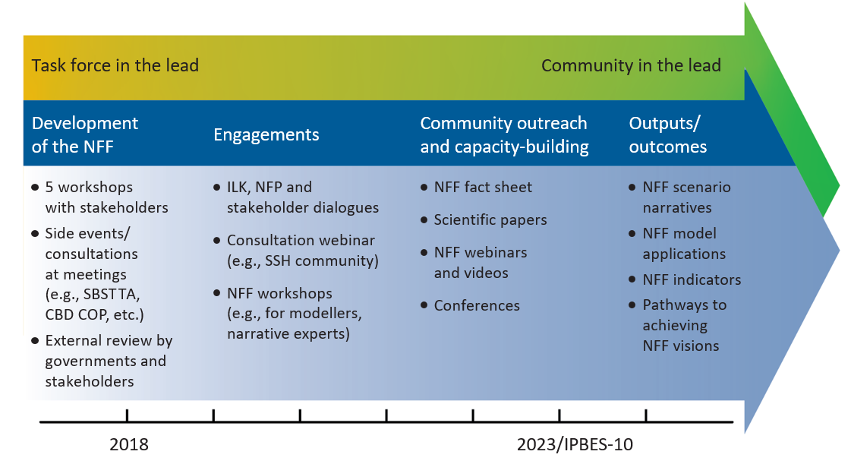

Abbreviations: CBD – Convention on Biological Diversity; COP – Conference of the Parties; ILK – indigenous and local knowledge; NFF – Nature Futures Framework; NFP – national focal points; SBSTTA – Subsidiary Body on Scientific, Technical and Technological Advice; SSH – social sciences and humanities.
ª The yellow-green colour gradient represents transitions in the lead of the listed activities from the IPBES task force on scenarios and models to the broader community. While the weight of the involvement of the task force is transferred to the broader community over time, there has been strong stakeholder engagement from the onset of the process. The blue arrow presents the activities of the task force on scenarios and models. It is anticipated that community engagement and outreach activities will lead to the formation of research consortiums and funded research projects that will achieve the goal of creating multi-scale (from local to global) scenarios based on the Nature Futures Framework, which would continue to be developed and refined over the long term.
II. Foundations of the Nature Futures Framework
A. History of the Nature Futures Framework and its contribution to catalysing the development of scenarios and models
- The Nature Futures Framework can be used to describe a diverse set of desirable futures for nature and people that differ in their emphasis on the types of values that people assign to nature (Pereira et al., 2020). It takes into consideration the call for plural values of nature and nature’s contributions to people to be recognized, referring to the preliminary guide regarding diverse conceptualization of multiple values of nature and its benefits, including biodiversity and ecosystem services, developed under the first IPBES work programme. This preliminary guide on values, as well as the Methodological Assessment Report on the Diverse Values and Valuation of Nature (IPBES, 2022), are underpinned by the view that the use of diverse conceptualizations of multiple values of nature and its benefits to people must be acknowledged and fostered in order to adequately address the challenge of global sustainability (Pascual et al., 2017; IPBES, 2015). Whereas both the Methodological Assessment Report on the Diverse Values and Valuation of Nature and the Nature Futures Framework incorporate values of nature, they have different purposes. The former assesses existing literature and describes different approaches to the conceptualization of values of nature, whereas the latter serves as a starting point for co-development of scenarios of desirable futures for nature. The framework emphasizes the intrinsic (“nature for nature”), instrumental (“nature for society”) and relational (“nature as culture”/”one with nature”) values, identified as the specific values referred to in the Methodological Assessment Report on the Diverse Values and Valuation of Nature (figure SPM.2 in IPBES, 2022).
- Taking into account the properties, interactions and feedback that operate in nature, the Nature Futures Framework emerged from stakeholder consultations that gathered a wide range of visions of desirable futures for biodiversity and people (Lundquist et al., 2017; Pereira et al., 2020). This framework allows those involved in scenario-building to recognize and address, in a more explicit manner, plural values ascribed to nature and nature’s contributions to people, which conventional scenario-building methods often fail to capture. The framework places the specific values that humans assign to nature at its core. The underlying assumption for formulating any type of desirable future vision of nature is that nature is valued much more in the future, but the reasons why it is valued – the underlying value perspectives – can vary widely. The diverse ways in which humans value nature can be used to develop a diverse range of possible future scenarios that address current declines in nature and nature’s contributions to people across all three value perspectives, as evidenced in the IPBES Global Assessment Report on Biodiversity and Ecosystem Services. The framework is novel in that it explicitly provides a space for the inclusion of relational values within a global biodiversity scenarios framework, acknowledging that relational values, such as cultural identity, sense of place, traditions, and reciprocity with nature, are often poorly represented or marginalized in assessments of biodiversity and ecosystem services.
B. Description of the Nature Futures Framework
- The Nature Futures Framework represents the plurality of value perspectives on human-nature relationships that forms the foundation for the development of desirable future scenarios for people and nature (figure 2). Within the triangle in figure 2, each corner of the triangle illustrates the orientation towards one of the following three value perspectives on the relationship between humans and nature: nature for nature, emphasizing intrinsic values: nature as culture/one with nature, emphasizing relational values; and nature for society, emphasizing instrumental values (see glossary in appendix I). The space within the triangle represents a continuum or gradient between these three value perspectives. As such, all the potential locations within the triangle relate to each of the three corners and thus offer some combination of all three value perspectives. It is important to bear in mind that the vertices, or corners, of the triangle offer extreme cases of what could be considered specific value perspectives to navigate to a “desirable future for nature”.
- The Nature Futures Framework has been developed together with different stakeholders through engagement with them since 2016 in order to address gaps in current scenarios and modelling processes for nature and nature’s contributions to people by opening up to more diverse perspectives on how the future is conceptualized. However, while it attempts to be as inclusive as possible, like all tools, it has limitations, including the fact that it may not be able to fully encapsulate all ontologies, cosmologies, knowledge systems and world-views. The examples in the right-hand part of figure 2 are taken from the IPBES conceptual framework but are not an exhaustive list of knowledge systems and world-views. The bands and dots indicate that the left- and right-hand parts of the figure are intimately related, but in complex ways that cannot be described in a one-to-one relationship. Currently available scenarios and models are not well adapted to the right-hand part of the figure, and so one objective of the scientific community should be to find tools that can be used to work with it.
- Desirable futures developed through the Nature Futures Framework may be place- or context-specific, subject to local cultures and values. Examples of the use of the framework to develop “desirable futures for nature” are provided in the methodological guidance in Part II of this document, as well as Annex I. The framework does not aim to identify any particular narratives or scenarios as preferred based on their location in the Nature Futures Framework, reflecting the fact that value preferences vary culturally and geographically.
Figure 2
The Nature Futures Framework, a flexible tool to support the development of scenarios and models of desirable futures for people, nature and Mother Earthª
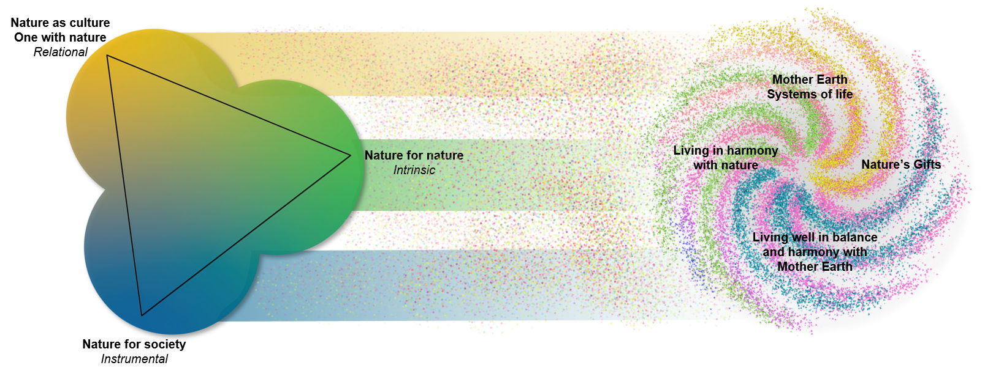

ª The Nature Futures Framework presents three value perspectives of nature in a triangle. In the “nature for nature” perspective, people view nature as having intrinsic value, and value is placed on the diversity of species, habitats, ecosystems and processes that form the natural world, and on nature’s ability to function autonomously. The “nature as culture”/“one with nature” perspective primarily highlights relational values of nature, where societies, cultures, traditions and faiths are intertwined with nature in shaping diverse biocultural landscapes. The “nature for society” perspective highlights the utilitarian benefits and instrumental values that nature provides to people and societies. The coloured circles associated with each value perspective blend together where they intersect, indicating that they are not mutually exclusive. The specific value perspectives that define the corners of the triangular representation of nature futures emerged through numerous stakeholder consultations with a focus on providing a framework for scenario development. According to other knowledge systems and world-views, as portrayed in the right-hand part of the figure, human-nature relationships may be perceived in different ways. The examples in the right-hand part of the figure are taken from the IPBES conceptual framework but are not an exhaustive list of knowledge systems and world-views. The bands and dots indicate that the right-hand part of the figure and the left-hand part of the figure are intimately related, but in complex ways that cannot be described in a one-to-one relationship.
- In the “nature for nature” perspective, people view nature as having intrinsic value, and value is placed on the diversity of species, habitats, ecosystems and processes that form the natural world, and on nature’s ability to function autonomously. The “nature as culture”/ “one with nature” perspective primarily highlights relational values of nature, where societies, cultures, traditions and faiths are intertwined with nature in shaping diverse biocultural landscapes. The “nature for society” perspective highlights the utilitarian benefits and instrumental values that nature provides to people and societies. The task force will undertake further development of the Nature Futures Framework and through that work provide a more comprehensive list of examples of how different locations in the framework could be operationalized. Some examples are presented in Annex I.
- While the Nature Futures Framework builds on the concepts of intrinsic, relational and instrumental values, the three value perspectives do overlap to some degree and the framework allows for their coexistence and complementarity, addressing some of the criticisms expressed by Piccolo (2017) about value dimensions. The framework allows recognition of the diversity of ways in which people define “nature”, and of the understanding that knowledge-scapes, interactions and identity influence the values that individuals attribute to nature (Berghöfer et al., 2022). “Nature for nature” both represents intrinsic values and indirectly provides instrumental values though the non-material benefits of healthy ecosystems. “Nature for society” is dominated by the direct and indirect use of a subset of instrumental values, while “nature as culture” captures relational values, including the non-material contributions of nature. The intrinsic value of nature is integral to many cultures, which is where “nature for nature” and “nature as culture” meet one another.
- The state of the planet or any place on the planet can be assessed across these three perspectives (figure 3). The goal for scenario development with the Nature Futures Framework is to improve the state of a place across one or more of these three perspectives. Therefore, one aims to move a place from a current condition, one that is often degraded from one or more of these perspectives (figure 3), to a higher score. As one approaches high scores in one of the perspectives, there may be trade-offs with others. Trade-offs (and potential conflicts of interests to be resolved) might arise between different spatial-temporal scales within and among particular perspectives of nature. At the global level, one may be speaking of multi-decadal timescales (e.g. 2020–2050), while at the local scale, multi-year timescales for scenario development (e.g. 5–10 years) may be more adequate.
Figure 3
Conceptual illustration of how the Nature Futures Framework, a flexible tool to support the development of scenarios and models of desirable futures for people, nature and Mother Earth, can be used to define pathways toward desirable futuresª
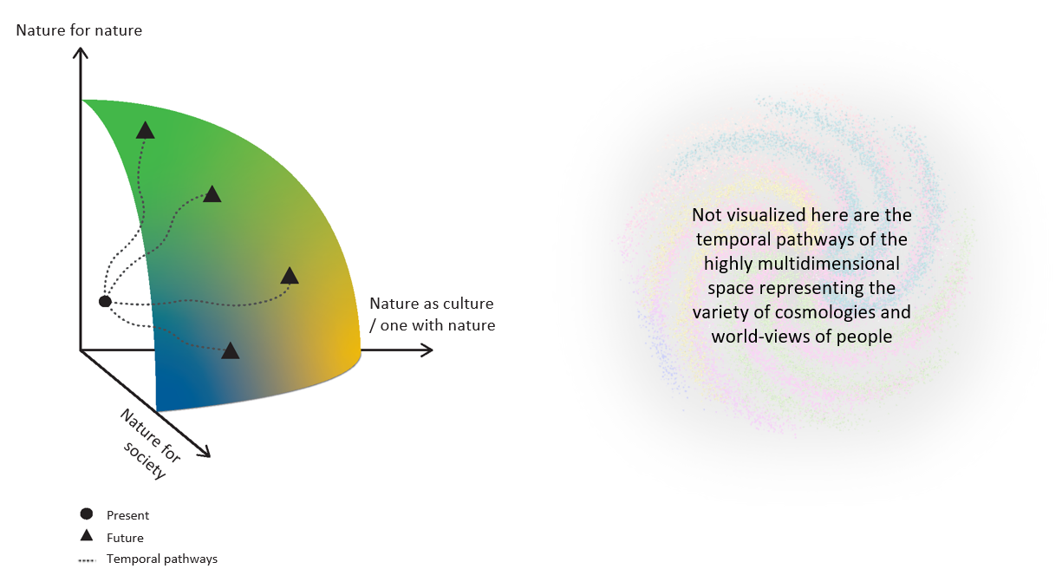

ª Each axis corresponds to one of the three value perspectives for nature. In this example, actions take place to improve nature and nature’s contributions to people across one or more of the value perspectives toward a more desirable nature futures frontier. Therefore, temporal pathways (represented by the dotted lines in the figure) can be plotted from the present state to the future. Increasing scores for one value perspective may require trade-offs with another value perspective (modified from Kim et al., 2023). Not visualized here are the temporal pathways of the highly multi-dimensional space representing the variety of cosmologies and world-views of people (as depicted in the right-hand part of figure 2).
C. What is unique in the Nature Futures Framework?
- In the context of the conceptual framework of IPBES, the Nature Futures Framework is intended to catalyse the development of scenarios that can be compared and does not pre-define specific characteristics for individual scenarios; rather, it allows the development of place- and context-specific scenarios that represent local, national, and regional priorities, ecologies and values. The use of a single framework combining different specific value perspectives for nature facilitates its application to a diverse range of regional and socioeconomic contexts, where common and specific features allow for technical comparison across scenarios. It also promotes investigation of cross-scale interactions that cannot be suitably captured at single or multiple independent scales.
- Common features reflect shared global goals for nature and nature’s contributions to people across all scenarios based on the Nature Futures Framework. In contrast, specific features reflect commonalities for scenarios at a particular location within the Nature Futures Framework (see section I/1 of the methodological guidance).
- To apply the framework, users can develop scenarios based on the Nature Futures Framework within a range of sociocultural, economic and political contexts and across a wide range of spatial scales, which may identify pathways towards desirable futures that achieve the goals of relevant multilateral environmental agreements and the Sustainable Development Goals. The specificity of individual scenarios can thus be easily translated to local conditions and applied to issues of interest to local policymakers.
- The Nature Futures Framework can be differentiated from scenario approaches such as representative concentration pathways (RCPs) and shared socioeconomic pathways (SSPs), developed in support of the assessments of the Intergovernmental Panel on Climate Change (van Vuuren et al., 2014). The SSP-RCP framework may be perceived as prescriptive in terms of outcomes for greenhouse gas concentrations and many other direct and indirect drivers of climate change, such as human population growth, economic growth and agricultural productivity (O'Neill et al., 2017). Box 6 in Annex I to appendix II/section IV illustrates how the Nature Futures Framework can be matched across shared socioeconomic pathways and representative concentration pathways and sets out various efforts currently in place to use SSPs as entry points into novel scenarios based on the Nature Futures Framework.
NB: Part D below was not contained in annex VI to decision IPBES-9/1, and represents the update mentioned in paragraph 4 of the background section.
D. Relation between the Nature Futures Framework and the IPBES conceptual framework, and between the Nature Futures Framework and the Assessment Report on the Diverse Values and Valuation of Nature
- The Nature Futures Framework and the IPBES Assessment Report on the Diverse Values and Valuation of Nature were developed in parallel with values at their centre yet with distinctly different objectives. The values assessment sought to identify both the diverse conceptualization of multiple values of nature and its contributions, including biodiversity and ecosystem functions and services, and the diverse methodologies for the valuation of nature. The Nature Futures Framework, in contrast, was developed to serve as a flexible tool to support the development of scenarios and models of desirable futures for nature. The values assessment was thus from the very start based on the recognition that the way people value nature (and the way people measure that value) plays an important role in societies’ management of nature. The Nature Futures Framework on the other hand, reflects the importance that values play in the kind of desirable futures for nature that people imagine/have/develop/formulate, an importance that emerged through the analysis of desirable futures co-created by a large diversity of stakeholders. Irrespective of these differences, the values assessment and the natures futures framework are directly aligned on the type of specific values of nature that they depict: instrumental, intrinsic and relational values (See figure SPM.2 from IPBES, 2022). The same figure illustrates how these specific values for nature are embedded in a broad range of values, knowledge systems and worldviews.
- The IPBES conceptual framework places dynamic social-ecological feedbacks at its centre (Díaz et al., 2015). Understanding these feedbacks is key to identifying the levers that can transform the world towards desirable futures for nature and people, and how these feedbacks connect actions and responses across local, national, regional, and global scales. The objective of nature futures scenarios is to improve how nature is valued from diverse perspectives and worldviews and trigger synergies and positive tipping points in social-ecological systems.
Part II of appendix II: Methodological guidance for using the Nature Futures Framework (NFF)
Introduction
- This section presents the NFF methodological guidance, which illustrates how the framework could be used to develop novel scenarios that incorporate the multiplicity of specific value perspectives for nature. The methodological guidance primarily targets research communities and other knowledge holders who work towards generating new research serving the upcoming IPBES assessments, while accommodating the needs of policymakers. This methodological guidance aims to catalyse the development of new scenarios for nature, but is not intended to be prescriptive, nor to provide highly specific and pre-defined characteristics for scenarios. Rather, the framework is flexible to allow its application to a variety of contexts. It is anticipated that new scenarios of desirable futures for people and nature catalysed by the NFF will serve as potential input for upcoming IPBES assessments and facilitate comparison of existing and new scenarios and models in IPBES assessments.
I. Methods for using the Nature Futures Framework
- The NFF is designed to be a flexible tool that can be applied to many contexts and does not specify either the number of future scenarios to be developed nor the specific methods for generating these scenarios. Rather, it allows users to develop scenarios in a creative and relevant manner applicable to their context, applying elements of the methodological guidance as needed, and drawing on the wealth of existing literature on scenario development. In order to address gaps in the literature, the NFF is unique in that it puts nature and nature’s contributions to people at the centre of the process and aims to catalyse the development of scenarios based on desirable perspectives on nature in diverse contexts and across scales. These diverse ways in which people value nature can be used to characterise a diverse range of relationships that people have with nature, and based on these, develop possible future scenarios. NFF-based scenario applications could be helpful to illuminate possibilities for achieving the 2050 Vision for Biodiversity of ‘Living in harmony with nature’, where ‘biodiversity is valued, conserved, restored and wisely used, maintaining ecosystem services, sustaining a healthy planet and delivering benefits essential for all people’ (CBD, 2010), and to give support to the implementation of the Kunming-Montreal Global Biodiversity Framework. By generating scenarios based on desirable perspectives on nature, applying the NFF guidance further allows for the identification of transformative policy options that can enable these futures, including pathways to achieve the Sustainable Development Goals across economic, social and environmental criteria as well as the synergies between sustainability goals.
- As such, the NFF combines a target-seeking approach to scenario development (to determine what is inside versus outside the triangle, i.e. desirable versus undesirable) with an exploratory approach (to represent the diverse range of values that underlie desirable futures within the triangle). The NFF can also be used to evaluate the effectiveness of alternative policy, management and transformative options (policy-screening approach; figure 4; see section 3 and table 2 of Kim et al., 2023) for different uses and challenges of scenarios modelling in policy processes). With this in mind, it is important to emphasise that the corners of the triangle are not antagonistic, but rather relative: moving closer to one value perspective means moving away from one of the others. This relativity between extreme value perspectives ensures that emerging scenarios are inclusive, pluralistic, and representative of the many sustainable combinations that can take place within the triangle. How to capture this complexity of plural values in the NFF will depend on the goals/targets of the study and this will determine the most appropriate methods. Hence, it is important to start by explicitly defining these goals/targets and then to think critically about the process that is required to meet these goals. In particular, it may be necessary to think through the need for participation in defining the goals and then how to ensure that the process is inclusive. Reflexivity on goals, process and methods is important to ensure that all elements of the IPBES conceptual framework as well as diverse value perspectives on nature are taken into account when using the NFF for scenario development. Finally, the NFF is not only useful for scenario development, but can also be useful to open dialogue on existing scenarios or ongoing processes to discuss possible futures.
Figure 4
This figure shows the roles played by different types of scenarios corresponding to the major phases of the policy cycle. Types of scenarios are illustrated by graphs of changes in nature and nature's contributions to people over time. The four major phases of the policy cycle are indicated by the labels and grey arrows outside the blue-coloured quarters of the circle. In "exploratory scenarios", the dashed lines represent different plausible futures, often based on storylines. In "target-seeking scenarios" (also known as "normative scenarios"), the diamond represents an agreed-upon future target and the coloured dashed lines indicate scenarios that provide alternative pathways for reaching this target. In "policy-screening scenarios" (also known as "ex-ante scenarios"), the dashed lines represent various policy options under consideration. In "retrospective policy evaluation" (also known as "ex-post evaluation"), the observed trajectory of a policy implemented in the past (solid black line) is compared to scenarios that would have achieved the intended target (dashed line) (Figure SPM.2, IPBES, 2016).
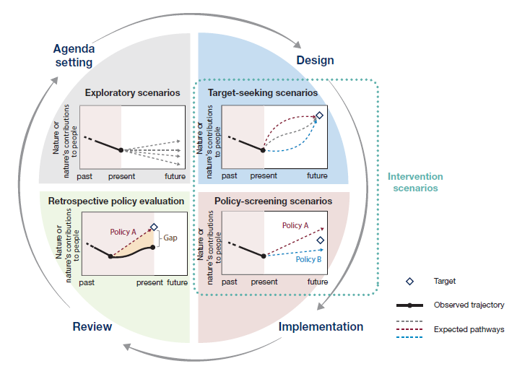
- Once the goals/targets of the study have been clearly defined, the methods for building new scenarios at different locations within the NFF or translating existing scenarios to particular locations in the NFF can be chosen. Many methods for scenario development have been described in the scientific literature. In this section, methods related to (1) common and specific features, (2) visioning, (3) pathways, (4) narratives, (5) modelling, and (6) indicators, are described. For each method, there is a brief description of what the method involves and how it could be applied or tested for the NFF and further information is provided in the Annex. Where possible, links to publications describing the method and its application to the NFF in more detail, are included. The reader is also referred to the Zotero library on NFF publications for further examples (Nature Futures Framework | Zotero). As stated, the method chosen will depend on the goals of the study. Furthermore, methods are commonly combined within studies to develop scenarios that have both qualitative and quantitative elements, as described in (7) combining methods.
1) Common and specific features
- Common and specific features can be a useful methodological approach for defining themes that are important to describe in scenarios and are dependent on the goal of the study (figure 5). Common features are shared across all scenarios within a scenario framework, whilst specific features are unique to the position of the scenario within the framework being used for a study. If scenarios are being developed from scratch, common and specific features can be used to identify the main building blocks of the scenarios. If a study is using existing scenarios, they can help in analysing and comparing characteristics between scenarios. Scenarios with shared specific features may be referred to as a ‘scenario family’. Archetype analysis may be useful for defining ‘scenario families’ or ‘scenario archetypes’ that have shared specific features or characteristics (Harrison et al., 2019; Sitas et al., 2019).
- In the case of the NFF, common features reflect shared global goals for nature and nature’s contributions to people across all NFF-based scenarios (Kim et al., 2023). In this respect they help in defining what is inside the triangle, i.e. what features are essential for a future to be desirable for nature and people, regardless of value perspective. Common features will depend on the study goals, but examples include halting biodiversity loss, keeping global warming to below 2°C, and controlling invasive alien species. In contrast, specific features relate to a particular position in the NFF triangle and reflect the value perspective (or combination of value perspectives) that is associated with that position (figure 5). Specific features should be able to differentiate between scenarios in different positions in the NFF triangle and help to ensure that the set of scenarios developed within a study are distinct from each other. Examples of specific features could include the species that are the primary focus of conservation and restoration efforts, and the extent and types of protected area designations, i.e. those with primary objectives on sustaining intrinsic, instrumental and cultural values of nature and nature’s contributions to people. Common and specific features can be defined through a participatory process with stakeholders, expert elicitation, literature survey or a combination of these methods. Further information is given in Annex I/I.
Figure 5.
Common and specific features and scenario families
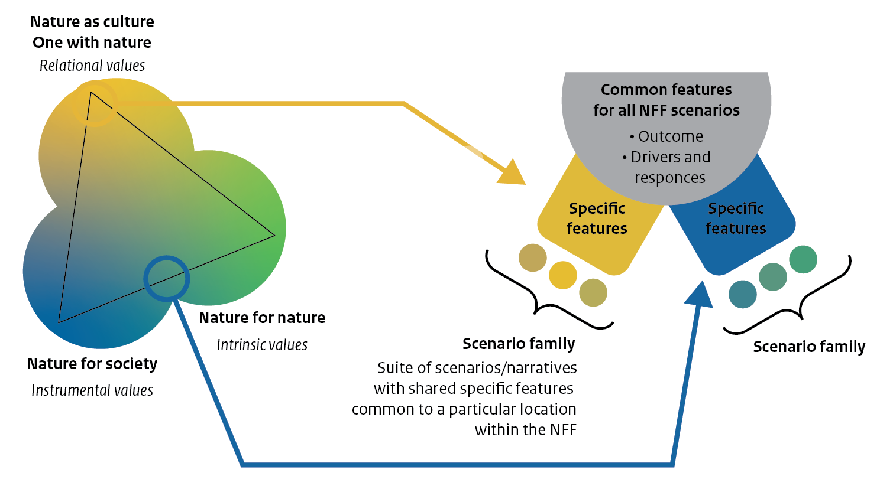
2) Visioning
- A vision is a description (narrative, image, etc.) of a desirable future state and usually depicts the explicit desires, assumptions, beliefs, and paradigms that underlie the desired future of those undertaking the visioning process. Importantly, visions of a desired future state can form the target space for target-seeking scenarios (or an orientation for transformative change) that describe how the future unfolds towards making the visions a reality. As part of a visioning process, the NFF can be used to help participants in the visioning process to articulate their diverse values, preferences and types of relationships with nature, in order to envision a desirable future that is shaped by these aspirations. The NFF ensures that nature and people are at the centre of these co-produced visions, and, importantly, provides a tractable link between the envisioned futures and their underpinning value expressions.
- An illustrative example can be found in the application of the NFF at the first IPBES youth workshop to envision desirable futures (Rana et al., 2020; Annex I/II, Box 1). Other examples include the use of the NFF to structure a participatory process with key stakeholders of a new National Park in the Netherlands to collaboratively explore desirable nature futures for the park (Kuiper et al., 2022; Annex I/II, Box 3), and a creative participatory visioning process for the high seas (Annex I/II, Box 2). Dialogues held with indigenous and local communities as part of the engagement process with the NFF also resulted in nature future visions based on perspectives discussed at three regional indigenous and local knowledge workshops, and a plenary dialogue session where commonalities across the regional visions were identified (Annex I/II, Box 4).
3) Pathways
- Pathways are descriptions of strategies for moving from the present situation towards a predefined vision or set of specified targets. They describe purposive courses of actions that build on each other, from short-term to long-term actions into broader transformation (Ferguson et al., 2013; Frantzeskaki et al., 2012; Wise et al., 2014). Thus, building and analysing pathways is key to evaluating the effectiveness of possible policies or sets of policy options for achieving desirable futures for nature and people. For the development of new pathways, the NFF can be combined with existing frameworks or methodological approaches. One such framework is the Three Horizons Framework and its adaptations, which helps to identify and describe the features of the current system that would need to be fostered and those that would need to decline, as well as the transient dominance of certain phenomena that, collectively, constitute pathways from the current system to particular, desirable visions of the future (Sharpe et al., 2016). A particularly important adaptation is the move away from a singular endpoint, to allow for branching pathways based on key decisions or extreme or shock events (Pereira et al., 2021a), as well as a recognition of the complex interactions and disruptions in the transition pathways (Hebinck et al., 2022).
- The use of the NFF in the development of pathways for achieving desirable futures for nature and people is an active area of development and innovation. A recent IPBES youth workshop served as a pilot for developing NFF-based pathways (report forthcoming). This effort leveraged previous work, including the development of NFF-based visions with youth (Rana et al. 2020; Annex I/II Box 1), existing NFF narratives (Durán et al., 2023; Annex I/III Box 5) and experience in applying the NFF and three horizons framework (Kuiper et al., 2022; Annex I/II, Box 3).
4) Narratives
- Narratives (or scenario narratives) are qualitative descriptions of the future, typically in the form of written stories. They communicate the underlying characteristics, general logic and developments (including common and specific features) of a scenario. As such, a narrative can be used to weave together a vision with a pathway into a coherent story. A narrative can also be outlined first, after which a compelling vision and concrete pathway can be developed. Indeed, narratives can provide the basis for further development, discussion and dissemination of the ideas behind the narrative, for example through the formulation of quantitative scenarios using models. Based on the NFF, an unlimited number of narratives of desirable nature futures may be produced.
- A narrative family (or scenario family) is a non-exhaustive group of narratives or scenarios that correspond to a particular position within the NFF. This provides a means of classifying NFF-based scenarios and other existing scenarios into groups with similar assumptions and options to facilitate comparison and synthesis for IPBES and other assessments. This is similar to the approach of grouping scenarios into ‘scenario archetypes’ that was used in the IPBES Global Assessment and Regional Assessments of Biodiversity and Ecosystem Services (IPBES, 2018a; 2018b; 2018c; 2018d; 2019a; Sitas et al., 2019). Narrative families could also be used to explore how different narratives for any single position in the NFF differ in terms of assumptions, options and outcomes for nature, nature’s contributions to people, and human well-being. In 2019, the task force developed six narratives as illustrative examples (briefly described in Annex I/III, Box 5; and see PBL, 2020; Durán et al., 2023). These six narratives, co-developed as part of a narrative development exercise based on visioning by consulted stakeholders, reflect just a portion of many possible narratives for particular locations in the NFF. These illustrative narratives are not prescriptive for the corresponding locations in the NFF and users of the NFF can develop narratives that are best suited for and reflective of their locations and context.
5) Modelling
- Models can be used to assess the consequences of different policy interventions in NFF-based scenarios for biodiversity and nature contributions to people (Kim et al., 2023). NFF-based scenarios can also be used to examine how policy interventions that lead to changes in nature’s contributions to people may result in feedbacks, and for instance reinforce the effect of those policy interventions (for example in an urban context, see Mansur et al., 2022). Models can range from correlative relationships between variables in a social-ecological system to mechanistic models that can simulate complex social-ecological dynamics through mathematical equations or agent-based modelling (IPBES, 2016a; Brown & Rounsevell, 2021). Quantitative modelling does not replace other qualitative tools that can be used in the development of NFF-based scenarios (e.g. participatory tools, local and expert knowledge). Initial narratives produced with qualitative tools may need to be refined in response to results from models, while models themselves may need to be refined to best capture key dynamics or priorities informed by local and expert knowledge.
- Depending on the time and spatial scales of scenarios, different models may be used to develop NFF-based scenarios. For short-term to medium-term projections (years to one decade) and at landscape to regional scales, one can explore how different management regimes acting on direct drivers may lead to different outcomes for nature and nature’s contributions to people. For instance, one could explore three management regimes for a landscape, across the three corners of the NFF (O'Connor et al., 2021) and compare them with the current management regime. A map of current land-use could be modified in consultation with managers and other key stakeholders, to allocate more areas of the landscape to strict nature protection (‘nature for nature’), or nature-based solutions (‘nature for society’), or cultural landscapes (‘nature as culture/one with nature’). Different levels of ambition for each of the NFF-based scenarios could also be explored, for instance by allocating increasing proportions of the landscape to one of the management regimes (e.g. Nelson et al., 2009). Then biodiversity models that project species’ responses to land-use change could be used to project biodiversity, while ecosystem service models that project ecosystem services delivered by different biophysical elements could be used to project nature's contributions to people (for a list of models, see Kim et al., 2018). Economic models can be used to assess costs, benefits and trade-offs for individual stakeholders. Long-term scenarios, involving multi-decadal time scales, and often carried out at global scales, require that the trajectories of the direct drivers (e.g. land-use and harvest regime) themselves are modelled by examining the dynamics and the policy options for indirect drivers (e.g. population growth and lifestyle). Dynamics of indirect drivers have been explored for instance in the Shared Socioeconomic Pathways (SSPs; van Vuuren et al., 2017) and have been analysed with Integrated Assessment Models (IPBES, 2016a) and further explored with biodiversity and ecosystem service models (Chaplin-Kramer et al., 2019; Kim et al., 2018). However, the Shared Socioeconomic Pathways may not be sufficient to achieve any of the nature futures, and it may be necessary to explore more sustainable pathways (e.g. Aguiar et al., 2020). Global modelling studies are also important to understand remote impacts and displacement effects (Marques et al., 2019). For further details, see Annex I/IV, Box 6.
6) Indicators
- Indicators are another important tool for scenarios and models. Indicators can be used to construct coherent descriptions of narratives in qualitative or quantitative terms. They also enable models to quantify the narratives for comparison of various policy options. For the NFF scenarios, an integrative use of quantitative and qualitative indicators is needed given the limited availability of indicators for certain nature value perspectives, in particular, nature as culture/one with nature. Furthermore, indicators can be identified across the elements of the IPBES conceptual framework using common and specific features of the NFF and these indicators can be mapped onto policy frameworks such as the Kunming-Montreal Global Biodiversity Framework to evaluate and set milestones that represent the complex systems dynamics and nexus interactions between diverse drivers and nature and nature’s contributions to people (Kim et al., 2023, see Table 1 and 2).
- The task force on scenarios and models seeks to catalyse the use of existing indicators and identify potential gaps in indicators concerning more comprehensive and inclusive representation of diverse nature values in new scenarios. Most current global scenarios and models do not use indicators that adequately represent all NFF specific value perspectives. Some ‘missing’ indicators relevant for global NFF-based scenarios can be inferred or derived from existing scenarios and models, but in other cases, efforts will be required to identify or develop these indicators. However, it is not in the mandate of the task force to develop new indicators, rather its role is to identify indicators made available such as those identified by the Biodiversity Indicator Partnership and indicators derived from the essential biodiversity and ecosystem services variables. Some initial efforts to map indicators into suites of existing global indicators based on the different specific value perspectives of the NFF, including those used for the Convention on Biological Diversity (GEO BON, 2020; Larsson et al., 2023) and the Sustainable Development Goals (see Annex I/V, Box 7), have been catalysed by the task force members in collaboration with other scientific networks and indigenous community members. The initial results show that very few existing indicators represent specific features of the nature as culture/one with nature value perspective. One example demonstrated an indicators analysis approach through application of the NFF in a spatial prioritization of protected areas in Europe, which entailed mapping the diverse values of nature and prioritizing areas where values co-occurred (O’Connor et al., 2021).
7) Combining methods
- In order to address the challenge of offering useful and relevant information for decision-making, it has been suggested that a toolbox of mixed methods for approaches to formulate futures is needed for developing scenarios and models for global environmental assessments such as those undertaken by IPBES (Pereira et al., 2021a). Such a toolbox of approaches to formulating futures that harness complementarities between top-down and bottom-up methods would be better able to address current knowledge gaps and would be employed depending on the specific aim that they seek to achieve. Based on a review by Muiderman et al., (2020) across research communities engaging with futures and anticipatory governance, there is a typology of aims that generally underpins scenarios research, of which three are relevant for global environmental assessments: 1) risk assessment and mitigation; 2) exploring diverse, possible futures to enhance preparedness; and 3) collectively envisioning desirable futures.
- Table 1 below maps how the different methods relevant to the NFF might offer unique and complementary contributions to multi-scale scenarios, based on the three different aims.
Table 1
Matrix showcasing toolbox of mixed methods for approaches to formulate futures (Adapted from Pereira et al., 2021b)
Main outcome |  | Risk assessment | Preparedness | Action mobilisation and inclusion
Approach | Method | Aim 1: To assess risk of plausible futures | Aim 2: To explore multiple possible futures | Aim 3: To co-create desirable futures
Top-down contributions (deductive) | Integrated Assessment Models | ✔
 | Illustrative narratives/ other expert-driven scenarios |  | ✔
 | Other modelling | ✔ | ✔
Bottom-up contributions (inductive) | Participatory modelling | ✔ | ✔ | ✔
 | Agent-based modelling | ✔ | ✔
 | Participatory scenarios | ✔ | ✔ | ✔
Methods that can be adapted across multiple scales | Visioning |  | ✔ | ✔
 | Pathways |  |  | ✔
 | Common and specific features |  | ✔
 | Economic modelling | ✔ | ✔ | ✔
 | Mechanistic modelling | ✔
II. Knowledge gaps and future work
- The methodological guidance of the NFF is still evolving and should therefore be considered as work in progress. Ongoing efforts to apply the NFF to scenario development, and ultimately to policymaking, will help catalyse further refinement of the NFF’s methodological guidance and associated modelling tools. Users of the NFF, including the modelling community and other stakeholders, may be interested in filling some key knowledge gaps, including: 1) developing additional illustrative narratives as examples to showcase the plurality of scenario narratives that can be created using the NFF (Annex I/III); 2) identifying and using indicators for the NFF that can be associated with different specific value perspectives (Annex I/V); 3) addressing knowledge gaps in social-ecological feedbacks (Annex I/IV); and 4) advancing current modelling frameworks to facilitate the application of the NFF (Annex I/IV).
- The task force is not mandated to undertake these activities itself; rather, it aims to catalyse them. As shown in figure 1, the involvement of the task force is envisioned to gradually reduce as the task force catalyses further work on scenarios and models, and community interest and participation increases. Ultimately, the development of NFF-based scenarios across scales, in different regions of the world, and in different knowledge systems, will depend on adoption of the NFF by the scientific and practitioner communities. Capacity-building efforts are part of that catalysation process, and together with the IPBES task force on capacity-building, the task force on scenarios and models will consider different methods, such as webinars, downloadable content on the NFF and NFF-based scenarios tailored to different audiences. These priorities are envisioned as necessary elements to enhance the use of the NFF in supporting ongoing IPBES assessments. Other priorities may, however, emerge during the ongoing development and utilisation of NFF-based scenarios by governments and the scientific community.
III. Concluding remarks
- Positive scenarios for nature and people, and the participatory processes involved in their development, are needed to facilitate policymaking by governments globally and nationally, and decision-making by other stakeholders, that can achieve sustainable futures. The development of such new scenarios needs to take into account various perspectives on people’s relationships to nature and different stakeholder needs across scales. The NFF provides a framework for doing so. The use of the NFF by the scientific community and other stakeholders can lead to the further development, identification and utilisation of new qualitative and quantitative scenarios. In turn, increased availability of NFF-based scenarios can provide valuable input for future IPBES assessments and trigger the much-needed actions and societal transformations towards a desirable future for nature and people.

Annex I to appendix II: Additional material to support the Nature Futures Framework methodological guidance
I. Common and specific features
1.1 Description
Common and specific features are themes or elements that can be used to conceptualise and build scenarios at different locations within the NFF. They represent a minimal set of features that are compatible with the NFF and needed to build desirable visions of the future. In some cases, these features are common across the three NFF specific value perspectives (‘nature for nature’; ‘nature as culture/one with nature’ and ‘nature for society’). In other cases, the features are relatively well differentiated and are specific to a particular position in the NFF (see figure Annex 1). Scenarios based on positions near the centre of the NFF represent a compromise between the three values perspectives. Both common and specific features can be either features relating to outcomes or features relating to direct and indirect drivers.
Some of the features that are common to all NFF-based scenarios are related to changes in the direct and indirect drivers that are essential for halting and reversing biodiversity loss. For example, many studies have shown that keeping global warming to below 2°C, and if possible, to 1.5°C, controlling invasive alien species, and substantially reducing pollution from fertilizer and pesticides are essential to achieve positive outcomes for nature and nature’s contributions to people (IPBES, 2019a). As such, these are essential, common features of any scenarios and modelling efforts that intend to be compatible with the NFF. In terms of outcomes for nature and nature’s contributions to people, it is possible to identify a few broad objectives that should be met by all NFF-based scenarios. For example, there is broad agreement that species extinction rates are currently much higher than in the geological past and should be brought down (IPBES, 2019a), that populations of threatened species should generally be restored (see figure Annex 1), and that regulating services like nature’s contributions to climate change mitigation should be reinforced (Pörtner et al., 2021).
By contrast, specific features of scenarios should be unique to the position in the NFF triangle, reflecting the value perspective (or combination of value perspectives) that are associated with that position. As such, specific features can be used to check whether the NFF scenarios developed for a study are sufficiently distinct from one another. Examples of specific features include the goal for species conservation (in terms of which species are considered to be of most concern for conservation and restoration; see figure Annex 1), the dominant economic system (in terms of an emphasis, for example, on green growth or post growth), the use of land (in terms of approaches such as land sharing or land sparing), and the objectives for protected areas (in terms of an emphasis on strictly protected areas for nature or more emphasis on nature’s contributions to people.
Figure Annex 1
The concept of common and specific features illustrated by an example for species conservation. All narratives that are derived from the NFF have shared outcomes referred to as common features. In this example, the conservation of threatened species should be achieved in all visions of the NFF. Narratives are distinguished from one another by their specific features, such as the species that are the primary focus of conservation and restoration efforts.
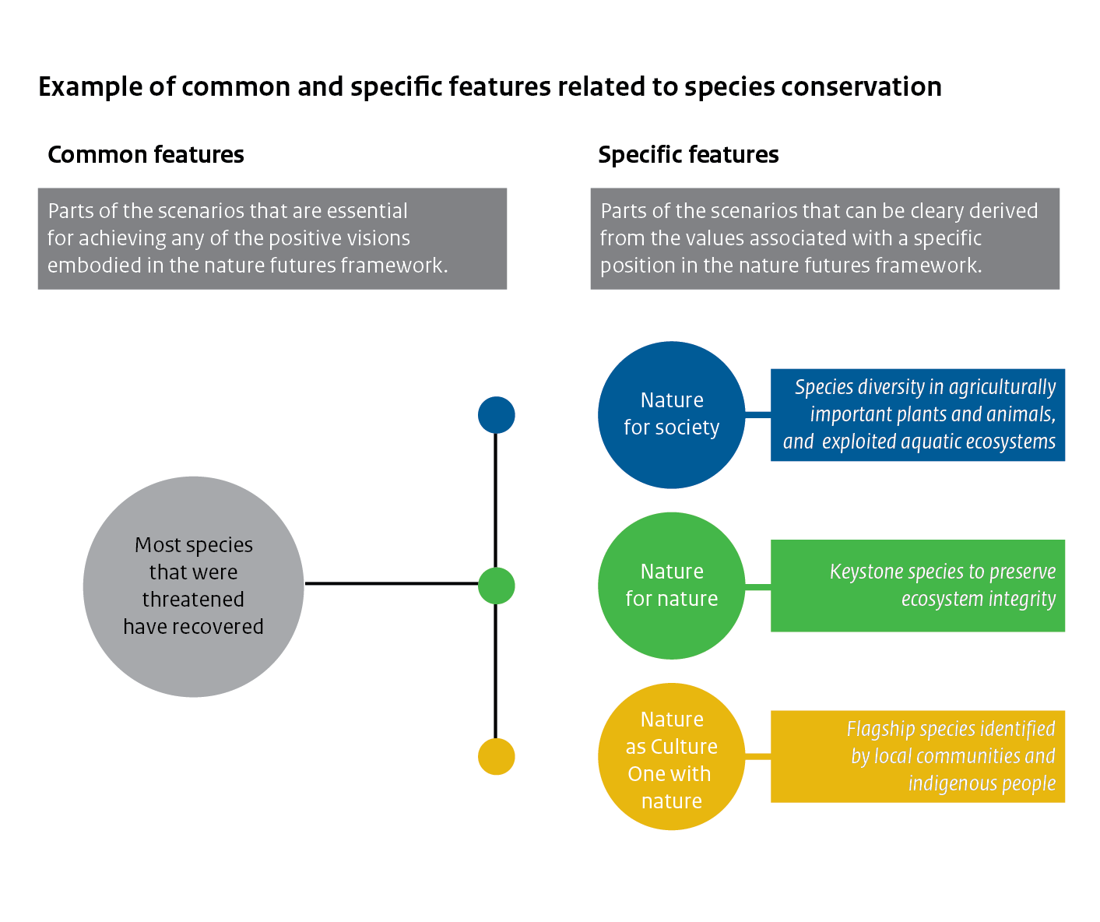

II. Visioning
2.1 Description
Achieving a future in which people live in harmony with nature requires most societies to reimagine their relationship with the biosphere. Visioning can be used to help people imagine a desirable future. Once articulated, a vision of the future can be a powerful attractor, or boundary object, to guide change processes. However, it is not necessarily easy to imagine what a desirable future for humans and nature looks like. People have different ideas, hopes and aspirations for the future, including different preferred relationships to nature.
The NFF can be used as a heuristic device for participatory visioning processes. It can help people identify and articulate their own desired relationship with nature and understand the diversity and plurality of people's value perspectives of nature. Thus, the NFF ensures that nature is at the centre of produced visions, and, importantly, provides a tractable link between the envisioned futures and the underpinning values. These visions can then serve as the desired future state of fully-fledged NFF-based scenarios to guide planning processes and decision making. Visions can be generated around common and specific features, or further specified by mapping common and specific features to existing visions. As part of visioning exercises, the NFF can be flexibly used in combination with existing participatory methods for the creation of future visions, such as the Manoa mash-up method (Pereira et al., 2018; Box 1).
The three value perspectives are easy to communicate to a wide audience during a participatory visioning exercise. By being positioned in the vertices of a triangular space, the value perspectives draw attention to being different, without judgement of rightness or wrongness, but emphasising that when taken to the extreme, trade-offs of aspirations among these value perspectives are inevitable. Indeed, visions generated for the three value perspectives clearly show how very different nature futures can be imagined (e.g. see Box 1 and 2). At the same time, the interior space of the triangle facilitates the discovery of diversity, relativity, and plurality. In fact, most people will identify with a mix of the three value perspectives. Hence, visions can also be created that express a mix of values (e.g. Box 3).
2.2 Knowledge gaps on visioning
Derived from knowledge gaps identified by IPBES assessments (Gasalla et al., 2022; Martin et al., 2022), the following recommendations for research and practice are proposed:
- Co-development of new visions of nature futures that address key components of the IPBES conceptual framework (nature, nature’s contributions to people, and good quality of life), across diverse socio-ecological contexts and multiple spatial scales, and with diverse stake- and knowledge holders, including indigenous peoples, local communities and faith groups.
- Co-development of radical, transformative visions of nature futures, bending the curve of biodiversity loss and reweaving the web of life.
- Co-development of new visions of nature futures that engage with, and make explicit people’s diverse values of nature (relational values in particular) and that explore other cultural aspects.
- Co-development of new visions that engage with, and make explicit, power, equity and justice dimensions, including the intersection with broad top-down management and governance regimes.
- Co-development of new visions of nature futures for the freshwater and marine biomes.
- Co-development of new visions of nature futures that make explicit feedbacks, trade-offs, synergies, cross-scale interactions.
- Implementation of cross-case assessments to understand shared elements versus context specific elements.
- Analysis of performance of visions against the SDGs and Kunming-Montreal Global Biodiversity Framework to understand how visions, if realised, contribute to achieving global environmental goals.
2.3 Case study examples on visioning
The NFF has proven to be an effective tool for facilitating visioning exercises to collaboratively imagine desirable nature futures. The NFF has already been used in various settings across the world. For example, the NFF was used to create visions of young people during the first IPBES youth workshop with youth representatives from all around the globe (Box 1). Other examples include the creation of desirable future visions of the high seas (Box 2), collaboratively crafted visions of the future of a newly developed national park in the Netherlands (Box 3), and indigenous peoples and local communities’ visions as one of the fundamental inputs to the development of the NFF (Box 4).

BOX 1 - Nature futures youth workshop (organized by the IPBES task force on capacity building - based on paper by Rana et al., 2020)
Engaging young people is critical in shaping societies’ futures and can help to elevate factors that youth consider pivotal and significant. However, younger generations remain insufficiently integrated into science-policy and decision-making arenas regarding their future, which is tightly linked to the future of the planet (Lim et al., 2017). In order to start addressing this gap, and to increase the diversity of stakeholders and disciplines that had been engaged in the NFF, an NFF visioning exercise was organised as part of a youth workshop that took place in São Pedro, Brazil from 27 June to 28 June 2019. The workshop was organised by the IPBES task force on capacity-building, in collaboration with the former expert group on scenarios and models, amongst others, and was facilitated by IPBES experts and fellows of the Global Assessment, the Americas Regional Assessment, and the Europe and Central Asia Regional Assessment (IPBES, 2018b; 2018d; 2019b).
The facilitators used the NFF as a starting point for the visioning exercise. First, a triangle was drawn on the floor to represent the NFF with the three different values of nature: ‘nature for nature’, ‘nature for society’ and ‘nature as culture/one with nature’. Participants were asked to reflect on ‘why they value nature’, thinking of a particular context and situation, and, based on this, position themselves within the triangle. They then paired up in groups of two, with their closest neighbours in the triangle, to discuss their respective examples and associated values of nature. Subsequently, the pairs merged into groups of four, and so on for further rounds of discussion. This process had two aims: (1) to familiarise the participants with the NFF and to facilitate thinking about diverse values of nature and how these fit in a desirable future vision; and (2) to divide participants into groups for the visioning exercise without pre-allocating them. This method increases the likelihood of affinity between group members in terms of how they perceive nature. By ensuring that the full space of the NFF had been covered by the four groups, it was hoped that the resulting visions would showcase diverse appreciation of values of nature across groups, even if this was not made explicit in the instructions. Groups were then allocated a theme (cities, rural landscapes or coastal landscapes) to focus their discussions on. They developed their visions, starting with an identification of ‘seeds’ or initiatives that they hoped would shape a more desirable future for people and nature, then answering a set of questions of what this future could look like and concluding with a presentation of these visions to the whole group (adapted Manoa mashup-method from Pereira et al., 2018).
The groups used the NFF to develop visions of the future that had some similarities, but also differences (figure Box 1). For example, the Econetlands vision - with participants from the ‘nature as culture/one with nature’ region of the NFF - prominently captured aspects of traditional knowledge and indigenous ways of knowing; the Rural Transformers - with participants from the ‘nature for society’ region of the NFF - included themes that highlighted instrumental values, where people value and conserve nature for a sustained flow of ecosystem services; Iandé Etama - with participants from the ‘nature for nature’ region of the NFF - explicitly included aspects of protected areas, which are often established to conserve biodiversity for its intrinsic value; and Anthropocene 2.0 - with participants from the centre region of the NFF - included transformative behavior change as the key leverage point to sustaining nature in the long-term. An interesting commonality across the groups was the discussion of the need for alternative economies and new metrics that recognise well-being and happiness, moving beyond simply economic growth, and proposing a post-monetary economy.
The visioning exercise was framed around the NFF and set up around three seeds, but also designed to work within a timeframe of 1.5 days. While the methodological approach allowed for more focussed, in-depth discussions on certain aspects of the desirable futures, there was insufficient time to capture tensions and feedbacks between different NFF specific value perspectives. Further, while this exercise was not meant to represent all the diverse voices of the global youth, it can serve as a starting point for similar initiatives to take place, possibly led by the participants themselves in their communities. There is learning from this workshop on how to invest in participatory processes that tap into the vast potential of young people, including researchers. The process in this workshop was unique in that it was completely youth-led. Although it seems that there has been little space for the voices of the youth to be clearly articulated in intergovernmental processes, initiatives like these, using the NFF, are able to take a small step forward in galvanising a more youth-oriented discussion of better futures.
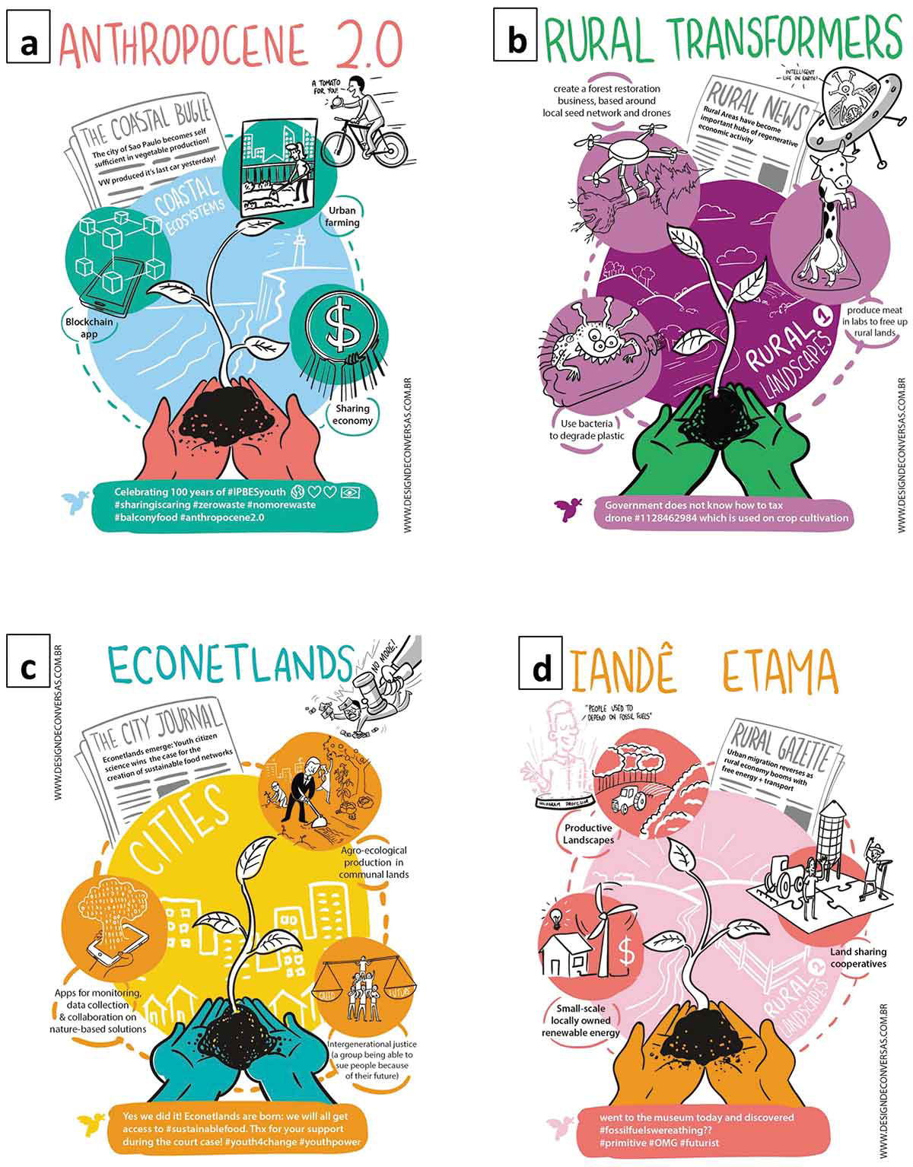

Figure Box 1. Graphical representation of the youth visions of desirable nature futures. a) Anthropocene 2.0; b) Rural transformers; c) Econetlands; and d) Iandé Etama. Each representation includes an image of each mature “seed”, the tweet and the newspaper headline describing what the world would look like in their desirable future. Visualisations by Design de Conversas, Brazil.

BOX 2 - Use of the Nature Futures Framework for the High Seas
The remoteness and vastness of the open ocean has inadvertently created a physical, psychological and perhaps even cultural barrier between most cultures and the global ocean. Four decades after the UN Convention on the Law of the Sea (UNCLOS) was ratified, the governance landscape for the management of human activities and their impacts in the high seas remains fragmented, sectoral in nature, and largely failing to achieve their sustainability mandates. To address the looming gap hindering the adoption of a transformative framework that places human-nature relationships at the centre of the discussion, a visioning exercise with some key experts on the high seas was undertaken using the NFF. The aim of this exercise was to start invigorating a discussion on transformative change for more desirable futures for the high seas, which takes multiple values into account and allows for nature and people to thrive.
During the course of 2021, three online workshops (of two sessions each due to time zones) were held with 29 participants from diverse backgrounds, ages and geographies, totalling 21 hours of engagement. One in-person workshop took place in February 2022 for 4 days of discussions. This expert-driven visioning exercise relied on the exploration of diverse and rich dialogues between key stakeholders in the ocean system, with the high seas being the focus. The three online workshops were designed around an adapted Three Horizons framework (Sharpe et al., 2016), and aimed at unpacking Horizon 1 in the first workshop, Horizon 3 in the second, and Horizon 2 in the third and final online workshop. The NFF was the main focus of the second workshop, i.e. the creative visioning of a more desirable, transformed future for the high seas. A pilot workshop to test the method was also run, resulting in seven final visions. The method bridged a ‘seeds’ approach with science-fiction prototyping: participants had been asked to fill in a questionnaire beforehand outlining a process, initiative or way of seeing the world that was currently marginal, but that they thought could contribute to a better future for the high seas. After sharing this ‘seed’ idea, participants were placed into groups based on where in the NFF their seed initiative most resonated and then tasked to envision a future that builds on these seeds, and to develop a short science-fiction narrative to help describe what this world looked like. In order to push the participants to think about a much more radical future, seven characters were developed, each with a bit more of an affinity to a particular corner. The stories are available in their entirety in the paper by Pereira et al. (2022a). The final workshop report (Pereira et al., 2022b) provides more substance to the methods and outcomes of the workshop, but to give a flavour of what resulted, the names of the groups offer an indication of their core components (table Box 2). Artwork was also commissioned to give a visual sense of what futures were emerging from the discussions (figure Box 2).
Table Box 2: Scenario names for the High Seas future visions.
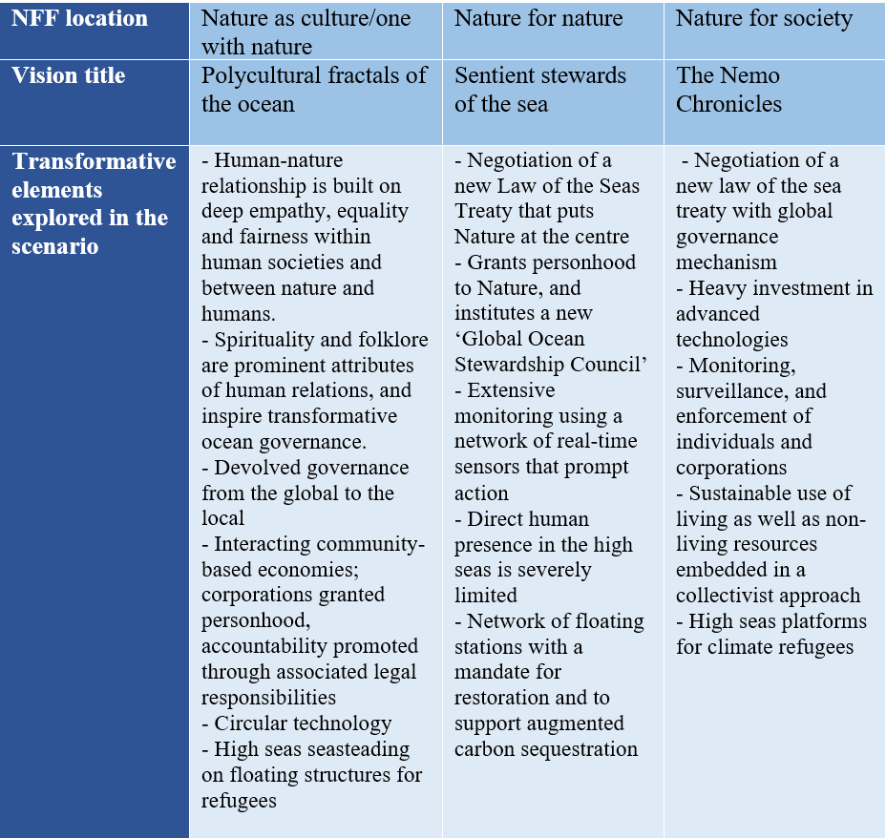
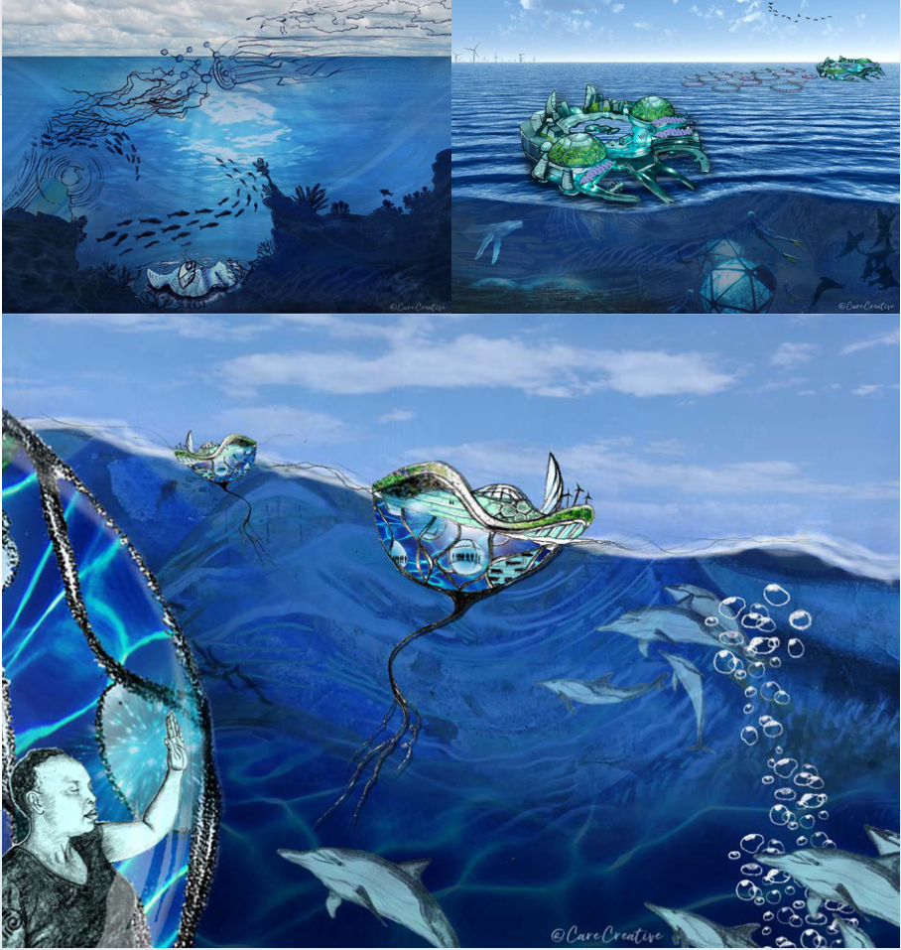

Figure Box 2. Graphical representations of High Seas futures: top left - nature for nature, top right - nature for society, bottom - nature as culture/one with nature, ©CareCreative

BOX 3 - Using the NFF to explore desirable nature futures of National Park Hollandse Duinen
National Park Hollandse Duinen in the Netherlands is being developed in one of the most densely populated regions of Europe. It aims to showcase how humans and nature can coexist. The surface area of the park is ~450 km² and covers the entire coastline of the province of Zuid Holland, including sea, beaches, dunes and forests, but also agriculture, infrastructure and cities. The development of the national park occurred bottom-up. A diverse group of local land managers and other stakeholders recognised that, in the face of Anthropocene pressures, the preservation of high biodiversity values in this unique landscape requires an integrated and collective effort and started exploring new ways of interacting with each other and with nature.
In 2019, the NFF was applied to structure a participatory visioning process to inform the bottom-up development of National Park Hollandse Duinen (Kuiper et al., 2022). The process, collaboratively designed by researchers and key stakeholders, combined the NFF with the Three Horizons framework, a foresight tool for collaborative exploration of transformative change (Sharpe et al., 2016), and the Sustainable Development Goals. The purpose was to envision desirable futures for the national park, explore transformational pathways to get there, and assess the potential contribution to the Agenda 2030.
More specifically, the NFF was used as a tool to help stakeholders identify and articulate their own desired relationship with nature, understand the diversity and plurality of people’s perspectives on nature, and identify shared values as fertile grounds for the development of rich, pluralistic visions in which multiple values of nature are enhanced. The Three Horizons Framework was used to explore transformative pathways, connecting the visions to the present. An SDG target analysis was used to assess how the envisioned futures of the national park would benefit the 2030 Agenda. This case provides an example of the application of the NFF in an ‘on the ground’ development process; an example of how the nature as culture/one with nature perspective is understood in a Western-European setting; an example of how visions can be built up from value expressions from across the NFF space, instead of creating visions that represent a specific area of the NFF.
The ‘nature as culture/one with nature’ perspective was appreciated by the participants because it extended existing discussions on the dichotomy between intrinsic and instrumental values, opening-up a broader appreciation of nature based on which new partnerships between stakeholders could be explored. The visions that emerged facilitated a discussion of trade-offs and opportunities for synergies in the area of the National Park. Through the participants, these discussions fed into the development of a landscape strategy document that was presented in 2020, which in turn paved the way for the first implementation program 2021-2025. Both documents (in Dutch) can be retrieved from the website of National Park Hollandse Duinen (www.nationaalparkhollandseduinen.nl).

BOX 4 - Indigenous peoples and local communities’ visions as a bedrock for the development of the NFF and the operationalisation of its value perspectives
The NFF was developed with close involvement by indigenous peoples and local communities (IPLC) from the beginning. Its inclusion of relational values of nature as one of the three specific value perspectives was a result of strong IPLC participation in the first stakeholder workshop in 2017 where seven desirable nature future visions were developed – visions which the task force later used to derive the NFF. Indigenous participants in this workshop decided to form one thematic group and developed a vision that strongly reflected relational values of nature. Their vision featured a world where “human-nature relations are based on reciprocity, harmony and relationality supported by educational systems infused by these values”, where “food is predominantly produced in bio-culturally diverse and autonomous local food systems” and where “strong cultural institutions ensure respectful sharing among diverse knowledge systems and governance systems share universal recognition of local small producers and indigenous peoples’ sovereignty over territories, resources and knowledge” (Lundquist et al., 2017).
The task force found in its subsequent stakeholder interactions strong receptivity from a range of stakeholders beyond indigenous communities for the ‘nature as culture/one with nature’ perspective that encapsulates relational values in the NFF (PBL, 2019a; PBL, 2020; Pereira et al., 2020). Such broad support illustrates the value of indigenous and local knowledge for the broader work of IPBES and nature conservation. Much work remains, with one significant challenge being the operationalisation of the “nature as culture/one with nature” specific value perspective as it is almost entirely absent in existing global nature-related indicators, scenarios and models. A key element of developing indigenous scenarios is identifying and harnessing those tools which already exist, and are accessible and easily applied to new contexts, as well as those which are not well known, and are difficult to apply outside of their original context.
Involving IPLC in the subsequent work to operationalise relational values in the NFF is of paramount importance and the task force on scenarios and models is actively seeking such involvement, for example through regular dialogue with the IPBES task force on indigenous and local knowledge. In 2021 the two task forces jointly organised an online workshop on scenarios and the NFF, with participation of indigenous and local knowledge holders. The dialogues ran over four days with regional sessions and a final plenary session. The workshop objectives were to engage IPLC in reviewing the draft NFF and its methodological guidance and to work with IPLC to start building regional-scale scenarios of futures, both as a capacity building exercise for IPLC to develop scenarios in their communities, and to inform future IPBES assessments and work on scenarios and models. While local scale NFF scenarios may be most relevant for IPLC in representing the different and diverse worldviews held by different IPLC, the regional scale was chosen for the dialogues as a way of engaging participants in this new scenarios framework, as most of them represented different IPLC.
IPLC participant feedback is critical for co-designing future scenarios with shared conceptual and methodological frameworks, using innovative tools of co-learning and combinations of diverse visions. Participants’ feedback included appreciation of being able to see ‘people’s contribution to nature’ in the nature as culture/one with nature perspective and of the potential of the NFF to create a dialogue across value systems and also be a helpful awareness-raising tool for IPLC. Key messages from participants were that: IPLC cannot create future pathways without also considering past and present; future projections are essential to try to understand the complexity of the universe without placing the human being at the centre of it; indigenous conceptualizations of time can be more in the forms of cycles rather than linear trajectory; and that many science-based scenarios and models are based on achieving targets or attaining novel future states, whereas indigenous peoples may be aiming for maintaining and revitalising cultural practices, and a preference of minimal change. It was also mentioned that while IPLC envision their own futures, it is important for them to know the visions of scientists and engage in co-production of scenarios. Such co-production, however, may require new methods, and the IPLC perceptions of time and human-nature relations discussed should be central in such work.
Following up on the 2021 dialogue workshops, the two task forces held a second joint indigenous and local knowledge dialogue workshop in Leticia, Colombia in February 2023, on the transformative change assessment and scenarios of the future. In recognition of the synergies between these themes, the workshop was designed around visioning and pathways-building exercises, combining the scenario-building methods with the topics covered in each of the chapters of the transformative change assessment. During the workshop, there were further discussions of indigenous and local knowledge and scenarios, including how to address IPLC scenarios in on-going and future IPBES assessments. This further dialogue workshop included local as well as global IPLC participants to inform both local and regional/global elements to guide co-development of further IPLC scenarios.
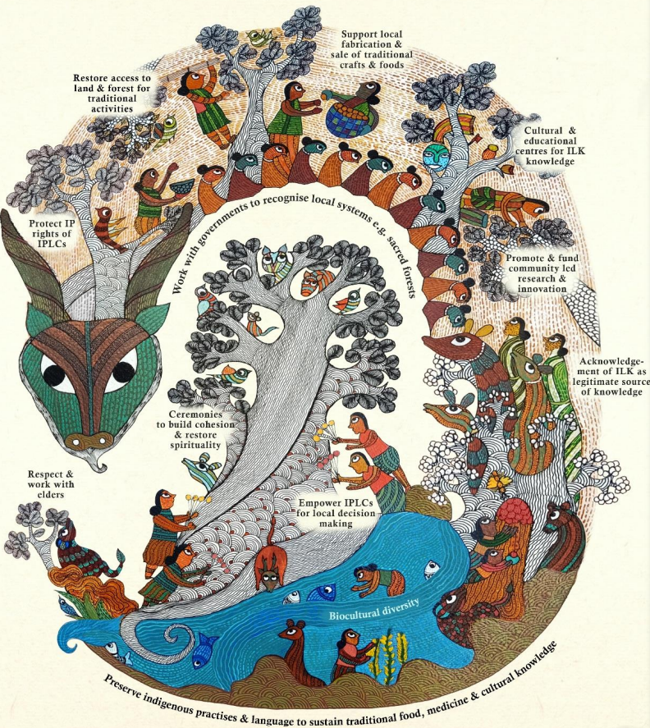
Figure Box 4. Representation of the Africa session of the 2021 dialogue workshop, created by Anjali Choudhary (IPBES, 2021).
III. Narratives
3.1 Description
Narratives (or scenario narratives) are qualitative descriptions of the future, describing the underlying characteristics, general logic and developments, typically in the form of written stories. Narratives provide the framework for further development, discussion and dissemination of the ideas behind the narrative, for example by formulation of quantitative scenarios using models. Based on the NFF an unlimited number of narratives of desirable nature futures may be produced. Captured in the narrative can be a vision, common and specific features, and a pathway that links the present to the vision through actions.
A narrative family is a non-exhaustive group of narratives that correspond to a particular position within the NFF. All narratives within a narrative family should be coherent with the corresponding NFF specific value perspectives and specific features aligned with these. This provides a means of classifying NFF-based scenarios and other existing scenarios into groups with similar assumptions to facilitate comparison and synthesis for IPBES and other assessments. Narratives based on the Nature for Nature value perspective describing the future of the high seas (Pereira et al., 2022; Box 2) or the future of urban areas (Mansur et al., 2022) may fall in the same narrative family. This is similar to the approach of grouping scenarios into ‘scenario archetypes’ that was used in the IPBES Global Assessment and Regional Assessments of Biodiversity and Ecosystem Services (IPBES, 2018a; 2018b; 2018c; 2018d; 2019a; Sitas et al., 2019). Narrative families could also be used to explore how different narratives for any single position in the NFF differ in terms of assumptions and outcomes for nature, nature’s contributions to people, and human well-being. The most distinct narrative families are located at the three vertices of the NFF (figure Box 5). Other possible narrative families could correspond to intermediate positions between the vertices and at the centre of the Framework.
IPBES will not develop a specific set of narratives based on the NFF. Rather the IPBES task force on scenarios and models envisions that narratives will be developed by different scientific communities and other stakeholders, which can serve as input to upcoming IPBES assessments. However, the task force has developed six narratives as illustrative examples that are described briefly in Box 5 and are explained in detail in Durán et al. (2023) (preliminary versions of these illustrative narratives are also described in PBL (2020)). Each of these six narratives, co-developed as part of a narrative development exercise, reflect just one of many possible narratives for particular locations in the NFF, and are not prescriptive for narratives in those locations in the NFF. The flexibility of the NFF allows others to create narratives that utilise elements particular to their own sociocultural, economic and political context for that particular location in the framework, within the constraints of the common and specific features for that location (figure Annex 1).
Collaboration amongst disciplines, including social sciences and humanities, and modelling communities, and with stakeholders, including indigenous peoples, local communities and faith groups, can assist in identifying narratives that represent the pathways for the transformative changes that are required to achieve local, regional, national, and/or international targets for nature, nature’s contributions to people and good quality of life, and to co-explore desirable and feasible solutions/ arrangements between actors. This collaboration can further be of benefit to the development of a new generation of scenarios and associated indicators and can facilitate dialogue between different stakeholders to contribute to conflict resolution and to inform and give voice to those interested parties whose input is often marginalised in these decisions.
3.2 Knowledge gaps on narratives
The process of creating illustrative narratives using the NFF highlighted one of many possible methods for operationalising the framework (Durán et al., 2023; PBL, 2020) that could be expanded to apply the NFF to diverse sociocultural and geographical contexts. Many of the knowledge gaps identified for visioning (section 2.2) also apply to narratives. More areas for future engagement and illustrative narrative development include:
- Use of NFF-based narratives to engage diverse communities to explore and identify transformative interventions and sustainability solutions
A given narrative might be consistent with a range of potentially transformative options, such as different economic concepts like post-growth, degrowth, circular economy, and decoupling, as well as different knowledge systems and ways of thinking about human-nature relations. These options can be harnessed to inform the development of narratives that represent potentially transformative futures. At the same time, NFF-based narratives can also serve to unpack existing concepts such as continued, but ‘green’ growth, by exploring what would be required to enable this development pathway and by describing the future that might emerge. Using NFF-based narratives enable further exploration of possible actions and pathways to achieve transformative change as presented in Table SPM.1 of the IPBES Global Assessment (IPBES, 2019a). Creative engagement that leverages the imagination is increasingly recognised as an important capacity to mobilise in the global assessment community and more can be done to enable its uptake for the formulation of diverse futures.
- Articulation and assessment of the different values ascribed to nature and nature’s contributions to people within the NFF
A strength of the NFF is that it accommodates a multitude of different specific value perspectives, but delineating what falls outside the framework’s triangle and ensuring consistency among NFF-based scenarios are challenging, as existing scenario approaches often focus on drivers and consequences that are outside of that triangle. It is important to realise that the inside of the triangle is relative to the three corners, that relativity (of goals, targets, and mechanisms for change) needs to be maintained, and that the framework can be used to identify both synergies and trade-offs between different specific value perspectives. While narratives based on the corners of the NFF triangle may be particularly useful to show contrasts and illuminate trade-offs, narratives based on the centre space may be developed to highlight how value perspectives, or associated policy options, may reinforce each other to produce synergies.
- Appreciation and engagement with the diverse range of values of nature and visions of the future as highlighted by the IPBES values assessment
While the aim of the NFF is to allow for a plurality of perspectives to emerge, these perspectives are ultimately narrowed down as soon as scenarios are created. It is important to recognise that the illustrative narratives do not imply a singular, restrictive story to capture a particular perspective. Encouraging variations to the stories created by different groups in different spaces is one way to address this.
3.3 Case study examples on narratives
Various case studies have developed short narratives based on the NFF, mostly to describe future visions (e.g. see Mansur et al., 2022; Pereira et al., 2022b, Box 5). To show how the NFF may be used to generate diverse narratives of nature futures, the IPBES task force on scenarios and models has created six ‘illustrative narratives’ (Box 5).

BOX 5 Brief illustrative narrative examples
Summary description of the six illustrative narratives developed by the IPBES task force on scenarios and models through an iterative, co-development process (source: Durán et al., 2023; titles and characteristics are subject to change; for full descriptions of the narratives, please refer to the paper). The illustrative narratives were created at the corners and edges of the NFF so that they are clearly different while still all holding nature at the core (figure Box 5). Indeed, scenarios are typically created to provide contrasts, to open-up for a wide range of future possibilities while illuminating implications and trade-offs so that these can be properly evaluated. It does mean that these illustrative narratives are on the edge of what people generally may still consider to be desirable. Also, by focusing on the corners and edges, no narratives are presented that represent the middle of the NFF space whilst such narratives could highlight how value perspectives may reinforce each other. Additional illustrative narratives may be created that focus more on synergies than trade-offs.
Optimising nature
- ‘Nature for society’
A highly connected world that shares knowledge and technology to maximise efficient and sustainable utilisation of nature’s contributions to people while ensuring maintenance of the key ecosystem functions that underpin them.
Key words: eco-efficiency, green growth, smart cities, urban-rural integration, land-sharing, optimised ecosystem services, engineered ecosystems
Reciprocal stewardship
- ‘Nature as culture/one with nature’
In this world, values of reciprocity and harmony drive the relationships of humans with nature at all levels of human organisation. Biological and cultural diversity are co-conserved and co-managed across a wide range of interconnected bio-cultural systems.
Key words: bio-cultural heritage, stewardship, commons, post-growth, cultural landscapes, engineered ecosystems, self-sufficient settlements
Arcology
- ‘Nature for nature’
People respect and value all life on Earth intrinsically. This world is characterised by extreme land-sparing as vast areas of land and sea are strictly protected from human interventions. People live in dense self-sustaining urban areas designed to minimise the role of humans in the biosphere.
Key words: planetary stewardship, post-growth, smart cities, blue-green infrastructure, protected area, large scale ecological dynamics, rewilding, self-sufficient settlements
Innovative commons
- Balancing ‘nature for society’ and ‘nature as culture/one with nature’
People have built a world of innovative ecological commons and live in interconnected green-blue cities and rural settlements across land- and seascapes. People use their local and traditional knowledge, and technology, to manage and expand the use of ecosystems and biodiversity and to also enhance their culture.
Key words: bio-cultural heritage, commons, post-growth, blue-green infrastructure, urban-rural integration, cultural landscapes, land-sharing, optimised ecosystem services
Dynamic futures
- Balancing ‘nature as culture/one with nature’ and ‘nature for nature’
Dynamic, connected and biodiverse ecosystems are valued to allow traditions and culture, spiritual values and connections to be re-established and new ones to be shaped. Society accommodates the dynamics of nature through both traditional and innovative lifestyles which take into consideration cultural heritage and traditional ecological knowledge, by for example, allowing space for migrations.
Key words: planetary stewardship, post-growth, urban-rural integration, engineered ecosystems, large scale ecological dynamics, rewilding, self-sufficient settlements
Sharing through sparing
- Balancing ‘nature for nature’ and ‘nature for society’
People favour the utilisation of nature but also value and protect the self-regulating capacity of the biosphere as biodiversity and natural processes provide the resilience that enables humanity to stay within planetary boundaries. While sparing space for nature, remaining areas are used intensively but efficiently and sustainably.
Key words: eco-efficiency, green growth, blue-green infrastructure, urban-rural integration, optimised ecosystem services, protected area, engineered ecosystems, rewilding
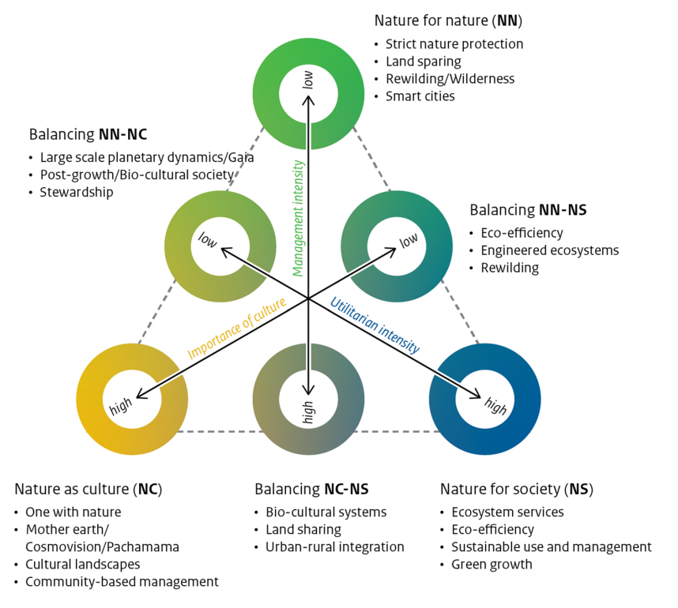
Figure Box 5. Placement of the illustrative narrative examples within the NFF. The illustrative narratives were created to provide methodological guidance and inspiration for using the NFF. They show how diverse, pluralistic narratives may be produced out of the NFF. As the NFF does not capture the full variety of people-nature relationships as perceived by the different cosmologies and world-views of people (as depicted in the right-hand part of figure 2), neither do the narratives produced from them.

IV. Modelling and social-ecological feedbacks
4.1 Description
Models can be used to assess the consequences of different policy interventions in NFF-based scenarios and/or explore the plausible pathways towards achieving alternative sustainable and desirable futures envisioned through NFF. Models can range from qualitative descriptions of causal relationships between the states of different components of a social-ecological system, to quantitative models based on statistical or correlative relationships between variables or indicators in the social-ecological system, and to mechanistic models that can simulate complex social-ecological dynamics through mathematical equations or agent-based modelling (IPBES, 2016a). The choice of modelling approaches to develop NFF-based scenarios depend on the time and spatial scales of scenarios and the objectives of building the scenarios. The choices of models are not mutually exclusive, application of multiple modelling approaches can complement each other and/or enable the exploration of model uncertainties. For example, exploring the outcomes of different biodiversity conservation and ecosystem services management policies for nature and nature’s contributions to people often requires short-term to medium-term projections (years to one decade) at landscape to regional scales (Box 7). Scenarios of conservation and management regimes for a land- or sea- scape that are developed based on different NFF perspectives can be compared with the current management regime. An example of such NFF-based policy scenario may include strict nature protection (‘nature for nature’), or nature-based solutions (‘nature for society’), or cultural land-/seascapes (‘nature as culture/one with nature’). Qualitative systems modelling approaches can be applied to co-develop models describing the social-ecological systems and their dynamics under different NFF-based scenarios with stakeholders, right-holders, knowledge-holders and decision makers. Such qualitative modelling could provide insights into the complex interactions between components of the natural and human systems and their relationship with the values and cultures of people, including potential trade-offs, constraints, co-benefits associated with the NFF-based policy scenarios. Meanwhile, quantitative models that project biodiversity responses and ecosystem services delivered by different biophysical elements under NFF-based scenarios could project biodiversity and nature's contributions to people (for a list of models, see Kim et al., 2018; and for examples of scenario development at local and global scales, see Nelson et al., 2009 and Chaplin-Kramer et al., 2019). This approach allows users of the framework to explore the specific features associated with each NFF-based scenario. It can also be used to explore the relationship between different distributions of biodiversity features in a landscape and the resulting nature’s contributions to people (Rieb et al., 2017).
Long-term scenarios, involving multi-decadal time scales, and often carried out at global scales, require that the trajectories of the direct drivers (e.g. land-use and harvest regime) themselves are modelled by examining the dynamics and the policy options for indirect drivers (e.g. population growth and lifestyle). Dynamics of indirect drivers have been explored for instance in the Shared Socioeconomic Pathways (SSPs) (van Vuuren et al., 2017) and have been analysed with Integrated Assessment Models (IPBES, 2016a). NFF-based scenarios associated with specific features can be combined with different Shared Socioeconomic Pathways (SSPs) and with an assessment of the common features of indirect drivers required to achieve different NFF-based scenarios and levels of ambition for positive outcomes for biodiversity or nature’s contributions to people. In some way, this approach is similar to the combination of Shared Socioeconomic Pathways (SSPs) and Relative Concentration Pathways (RCPs) used to explore climate change scenarios (Riahi et al., 2017). However, the common features associated with indirect drivers required to meet a given level of positive outcomes for an NFF-based scenario may require the modification of the Shared Socioeconomic Pathways (see Box 6). For instance, it may be that only certain demographic and lifestyle trajectories are consistent with specific NFF-based interventions on direct drivers that lead to positive trajectories for biodiversity or nature’s contributions to people. Finally, long-term scenarios can also be used to close social-ecological feedback loops, at the local or global scale. This is important because coupled social-ecological dynamics may lead to the reinforcement of regime shifts (Figueiredo & Pereira, 2011; Scheffer, 2009). Here, NFF-based scenarios can be used to examine how policy interventions that lead to changes in nature’s contributions to people may result in feedbacks, and for instance reinforce the effect of those policy interventions (for example in an urban context, see Mansur et al., 2022).
Quantitative modelling does not replace other qualitative tools that can be used in the development of NFF-based scenarios (e.g. participatory tools, local and expert knowledge), and they should be used complementarily. Initial narratives produced with qualitative tools may need to be refined in response to results from models, while models themselves may need to be refined to best capture key dynamics or priorities informed by local and expert knowledge. This can result in an iterative cycle of scenario development (Dietze et al., 2018) where narratives are refined with modelling results until a consistent set of narratives is produced.
Through stakeholder and expert workshops and consultations, the former IPBES expert group and current task force on scenarios and models are developing modelling approaches for NFF-based scenarios to support policy processes, a part of which has been presented in a paper (Kim et al., 2023, PBL, 2019a; PBL, 2019b).
4.2 Knowledge gaps on modelling
The NFF’s multi-scale and multi-perspective approach and focus on dynamic interactions between humans and nature demands advancement from existing modelling frameworks. Such advancement and development would facilitate the application of the NFF to tackle key questions on nature, nature’s contributions to people and quality of life, particularly in relation to the nexus between different global and local changes, telecoupling, and projections of transformative actions. Specific suggestions for future research include (see also Rosa et al., 2020 and IPBES, 2016a):
- Development of integrated assessment models that represent the dynamic interactions between social (including economic components) and ecological systems (as detailed in section 4.3);
- Practices in multi-scale modelling that account for diverse drivers and policy responses at multiple spatial, organisational and temporal scales (Carpenter et al., 2009);
- Development of linkages between qualitative models and tools (e.g. Moon et al., 2019) and quantitative models;
- Integration of the use of local and traditional knowledge together with scientific knowledge in modelling (Tengö et al., 2014);
- Integration of biodiversity time series monitoring into calibration of biodiversity models (Ferrier et al., 2017), to overcome current reliance on space for time distribution with static biodiversity data. Changes to collecting time series data and developing long-term monitoring also need to be implemented, particularly in regions with insufficient data;
- Connection of biodiversity at multiple levels, to nature’s contributions to people, and of nature’s contributions to people to human demand for those services and their relative contribution to human wellbeing (Chaplin-Kramer et al., 2019);
- Improvement in the ability to incorporate relational values and intangible values of nature in scenarios and models (Schröter et al., 2020);
- Models of the influence of societal barriers and challenges, entrenched interests and power dynamics in society;
- Development of approaches to modelling that are inclusive, diverse and equitable and that leverage stakeholder engagement.
In combination, these knowledge gaps reflect the various aspects of the methodological guidance of the NFF that require further development.
4.3 Knowledge gaps on social-ecological feedbacks
The IPBES Global Assessment identified ‘improved understanding of social-ecological interactions and associated positive and negative feedbacks across space and time’ as a key knowledge gap. These social-ecological feedbacks are rarely included in current scenarios frameworks, and include interactions in which social, economic, and ecological variables mutually influence each other. Feedback can amplify or dampen change, consequently understanding feedbacks is essential to building scenarios that focus on change. Whether a particular feedback is judged to be useful or harmful depends on the values attached to the processes it is amplifying or dampening.
A wide variety of feedbacks are integral aspects for the development of many new scenarios for nature, but understanding of social-ecological dynamics is highly uneven. While researchers have extensively documented the many ways social dynamics shape nature and biodiversity, there is much less understanding of how ecological change feeds back to influence social dynamics. However, there is a greater understanding of economic and agricultural feedbacks that are strongly related to the ‘nature for society’ perspective. There is much less knowledge of feedbacks related to social and cultural dynamics associated with the ‘nature as culture/one with nature’ perspective or the stewardship and ecological dynamics related to the ‘nature for nature’ perspective.
Fisheries research provides an example of this unevenness. There is a long history of studying and modelling how different types of fishing interact with each other and with fish population dynamics to influence catch, who benefits from the fishery, and what fishing approaches grow or shrink. These feedbacks strongly relate to ‘nature for society’ values (i.e. fish as a resource). There is less research on how social institutions use ceremony to maintain cultural fishing practices, that have sustainable and fair ways to cope with fish population fluctuations, while maintaining social institutions and cultural practices. Some specific models have included such feedbacks, which relate to ‘nature as culture/one with nature’ (i.e. fish as culture), but such approaches have not been widely used. Furthermore, research on fisheries has focussed on individual species, and while there are many calls for ecosystem-based management, there is still poor understanding on how multiple human processes are shaping the mechanisms that sustain fish populations, such as marine food webs, marine biogeochemistry, river flows, and benthic communities, as well as on feedbacks that are important for ‘nature for nature’ values.
Social-ecological feedbacks can drive or slow change, so it is important to include these feedbacks within NFF-based scenarios and models that aim to identify pathways towards the Convention on Biological Diversity goal of “living in harmony with nature”. Knowledge of social-ecological feedbacks is rapidly developing, however there are multiple knowledge gaps that should be addressed by the scientific community and other relevant stakeholders to achieve the goals of the Global Biodiversity Framework. Suggestions for further development include:
- Identification of key feedbacks that need to be included in NFF-based scenarios, and the preparation of guidance on to how to include the complexity of feedbacks across the different value perspectives.
- Exploration of feedbacks that are often missing from models, particularly feedbacks that are important for the ‘nature for nature’ and ‘nature as culture/one with nature’ perspectives. More effort is needed to produce models that represent multiple types of feedbacks from these different specific value perspectives.
- Inclusion of a wider variety of human behaviour in models is needed to capture important social-ecological feedbacks. Doing this requires developing approaches that can model psychological, cognitive, cultural, and social processes, which create a sense of place or stewardship, across people and regions.
- Development of a trans-disciplinary approach to identify and analyse feedbacks that functions effectively across knowledge systems, and development of understanding on how feedbacks vary regionally as a result of historical, ecological, geographic, cultural, social, technological, and economic factors, as requirements for creating new, desirable scenarios for nature.
- Identification of mutually reinforcing feedbacks between multiple values of nature that have the potential to produce synergies among multiple values.
- Identification of key feedbacks for different places and systems (including methods for stakeholders to identify such feedbacks), which could be reflected in scenarios and modelling applications for informing decisions.
- Development of guidance for modelling social-ecological feedbacks that act across scales, including how to integrate cross-scale and tele-coupled dynamics into NFF-based scenarios. This requires better combined understanding of ecological tele-connections, such as contagious disturbances, species migration and long-distance movement, and social tele-connections, such as human migration, supply chains, and media.
4.4 Case study examples on modelling
BOX 6 – Implementing the NFF with existing global scenario frameworks: The case of Shared Socioeconomic Pathways
Shared Socioeconomic Pathways (SSPs) are scenarios of projected socioeconomic developments to 2100, incorporating human population trends, economic growth, urbanisation, etc. They are used together with the Representative Concentration Pathways (RCPs) of climate change scenarios to explore a range of climate and development pathways (Popp et al., 2017). There are five SSPs: SSP1 Sustainability (Taking the Green Road, see van Vuuren et al., 2017); SSP2: Middle of the Road; SSP3: Regional Rivalry (A Rocky Road); SSP4: Inequality (A Road divided), and SSP5: Fossil-fuelled Development (Taking the Highway; see Riahi et al., 2017). However, except for the SSP1, SSP scenarios do not account for biodiversity conservation or the interaction between biodiversity and climate (O’Neill et al., 2014). In this context, NFF scenarios can be regarded as extensions of the SSP1 that explore a diversity of futures that are focused on environmental sustainability and human wellbeing. Furthermore, the NFF complements the SSPs by explicating diverse value perspectives on nature in co-developing the visions, narratives, modelling frameworks, and indicators used in informing decisions. The NFF aspires to overcome the limitations of SSP scenarios through more integrative analysis across a broader range of drivers, sectors and policies by exploring and modelling the future of human and natural systems in relation to the three specific value perspectives for nature. The SSP framework is currently being applied in the marine environment to assess the future of the fisheries sector (Cheung, 2019; Cheung & Oyinlola, 2019; Maury et al., 2017) by attributing one or multiple NFF specific value perspectives to the SSP scenarios and expanding the range of drivers, sectors, and policies that are included. Modelling approaches could range from heuristic to dynamically-coupled integrated models (Cheung & Oyinlola, 2019).
Along these lines, a collaborative consortium project including experts working with integrated assessment models, the SHAPE project (Sustainable development pathways achieving Human well-being while safeguarding the climate And Planet Earth (SHAPE); see http://shape-project.org/), has put in place a process to co-create a new generation of target-seeking global scenarios called the Sustainable Developing Pathways (SDPs). The SDPs are an evolution of SSP1 that aims to simultaneously achieve the Sustainable Development Goals in 2030 and the climate targets set out in the Paris Agreement (Soergel et al., 2021; van Vuuren et al., 2022). The narratives for the SDPs followed an innovative co-designing approach (Aguiar et al., 2020), in which the NFF was used as a basis for the multiple perspectives about nature embedded in the alternative scenarios (Aguiar et al., 2021; Aguiar et al., 2022).
V. Indicators
5.1 Description
There are different ways to identify indicators in the development of NFF-based scenarios, reflecting the diversity of ways to develop these scenarios (see examples in boxes). The selection and the role of indicators in NFF-based and other scenarios vary considerably with their intended use and it is important to consider the constraints in data availability and accessibility of indicators that many countries (and communities) will face. Countries need to work with data they have available, but it is advisable to scan relevant indicators across the wide range of data sources that are collected regularly including those beyond nature conservation. When aiming to co-develop scenarios for planning and decision making in a community setting, existing, i.e. community produced data could take priority and be used to inform indicator development.
Some initial efforts have been made to align indicators in existing global indicator lists with the different specific value perspectives of the NFF, including those used for the Convention on Biological Diversity’s Aichi targets, the Sustainable Development Goals, indicators made available by the Biodiversity Indicator Partnership and additional indicators derived from the Indigenous Navigator and the Local Biodiversity Outlook 2. This is work in progress, see Larsson et al., (2023) and table Annex 1.
These indicators can support scenario development by providing historical trends and facilitate dialogue on projections to the future on a range of common and specific features for each of the NFF specific value perspectives. These indicators can be used in scoring and mapping systems or places comparatively or across time within the NFF triangle space. The indicators approach followed by the IPBES task force on knowledge and data and the authors of the IPBES values assessment, including indigenous and local knowledge indicators, can also be used as reference in the development of NFF-based scenarios (IPBES, 2022). Indicators can be identified across the elements of the IPBES conceptual framework and across the three NFF specific value perspectives in the context of the focal research or policy question (see Tables 1 and 2 of Kim et al., 2023 for illustrative examples). Then using those indicators, systems or places can be assessed on their status and trends towards different policy targets.
Table Annex 1.
Examples of indicators from the Biodiversity Indicator Partnership and their preliminary alignment with NFF value perspectives
NFF Perspective | ID | Indicator Name
Nature for nature | IPBES H11 | Living Planet Index
 | IPBES C21 | Species Protection Index
Nature for society | BIP11 SDG6.4.2 | Level of water stress: Freshwater withdrawal as a proportion of available freshwater resources
 | IPBES C14 | Estimated Fish Catch
 | IPBES C9 | MSC Certified Catch
Nature as culture/ One with nature | BIP 93 | Index of linguistic diversity

Furthermore, indicators can be used to measure the effectiveness of different interventions in mitigating impacts of direct and indirect drivers, using representative indicators mapped to different NFF value perspectives (see Box 7). In some cases, these indicators may be outputs of scenarios and models. Currently, global scenarios and models do not use indicators that adequately represent all NFF value perspectives. Some ‘missing’ indicators relevant for NFF-based scenarios can be inferred or derived from existing scenarios and models, but in other cases, efforts will be required to identify or develop new indicators (e.g. indicators linking biodiversity and human health). In particular, the ‘nature as culture/one with nature’ perspective requires a variety of indicators, and few are available in existing indicator sets (see section 5.2).
5.2 Knowledge gaps on indicators
Indicators are valuable for communicating the potential success of different scenarios at achieving biodiversity or sustainability goals and should be able to capture both positive and negative outcomes across the three specific value perspectives. Hence, the NFF requires identification and development of additional indicators that can be associated with the different specific value perspectives. Reviews of existing global indicator sets led by members of the task force on scenarios and models showed that the availability of indicators is not balanced across the three NFF specific value perspectives, with most of them illustrating specific features of the ‘nature for society’ and ‘nature for nature’ perspectives, and few available indicators for ‘nature as culture/one with nature’. For example, from 193 ‘ready to use’ indicators from various global policy related indicator sets, only two indicators were categorised exclusively as specific features of the ‘nature as culture/one with nature’ perspective, while close to 75 could represent both this and one other value perspective or all three perspectives (Larsson et al., 2023). This finding is in line with the knowledge gaps identified in earlier IPBES assessments which pointed to a lack of indicators of nature’s non-material contributions to people and associated aspects of good quality of life (IPBES 2018d; 2019a). Noticing the gap in ‘nature as culture/one with nature’ indicators, efforts are in progress to identify possible indicators for this perspective, including from the sources developed by the indigenous and local knowledge community such as the local cases and worldwide transitions described in the Local Biodiversity Outlook 2, a report produced by indigenous organizations for the CBD (Forest Peoples Programme et al., 2020; Larsson et al., 2023). Furthermore, more than 40 indicators associated with the NFF specific value perspectives (existing and aspirational) were collated from the use of Essential Biodiversity Variables (EBVs) and Essential Ecosystem Services Variables (EESVs) for modelling NFF-based scenarios across all three value perspectives (Kim, 2022). The EBV- and EESV-based indicators can be used or developed as common and specific indicators. Remote-sensing and in-situ data can be used in models to assess the status, trends, and dynamics of nature and nature’s contributions to people. The gaps identified in these lists imply similar gaps in the indicators (representing each specific value perspective) that have been used in existing models and scenarios.
The task force on scenarios and models, while not having a mandate to develop indicators itself or to provide any list thereof, encourages the scientific community to further develop indicators for NFF-based scenarios in doing the following:
- Continued work on developing more detailed guidance for the process of identifying appropriate indicators for the three specific NFF value perspectives, through illustrating potential example indicators.
- Selection of some example indicators for each illustrative NFF narrative, and work with the scientific community to define the baseline conditions and relevant context-specific data to inform the indicators, analyse their trends, and identify the models available to examine their dynamics from local to global levels; this initial indicator exercise could provide guidance and help to catalyse the development by the scientific community of representative indicators for each illustrative NFF narrative.
- Identification of additional ready-to-use indicator sets relevant for NFF-based scenarios and models, particularly from other (non-biodiversity) sectors representing indirect and direct drivers, responses and other feedbacks.
- Integration of advancements on modelling and/or indicators related to biodiversity and ecosystem services to improve existing indicators by, for example, integrating the latest scientific advancement and data, hence filling critical gaps.
- Identification, in collaboration with the IPBES task force on indigenous and local knowledge, and the community of indigenous peoples and local communities, of existing indicators or development of new indicators that can illustrate relational values of nature (‘nature as culture/one with nature’), particularly at national to global scales. There are also many examples of development of biocultural indicators by local indigenous communities often in collaborative processes with scholars, see for example Caillon et al. (2017), Dacks et al. (2019) and Sterling et al. (2020) that will be relevant for relational values of nature.
- Development of some methodological guidance for NFF users, including the modelling community, on approaches for developing new indicators for the different NFF specific value perspectives, including how to capture non-material aspects of culture.
- Through impact evaluations and evidence synthesis, further development of the evidence base describing effectiveness of a broad range of management actions (e.g. nature protection, indigenous management, sustainable management practices) regarding the most representative indicators for each illustrative NFF narrative.
- Closure of the gaps in available indicators with support of the international community in order to allow measurement and monitoring of changes in nature, drivers and socioeconomic and ecological implications.
It is important to note that gaps in indicators, while providing initial constraints for certain (global) modelling to adequately represent the three value perspectives in the NFF, should not provide a constraint for engaging with the NFF in scenario development, particularly in the participatory processes initially starting with qualitative scenarios. It is in those very discussions that the space will open to look for more diverse perspectives on people’s relationship with nature and in turn can direct the search for indicators towards unexpected policy arenas.
5.3 Case study examples on indicators
BOX 7 Use of NFF in scenarios, models and indicators in informing the implementation of the Kunming-Montreal Global Biodiversity Framework
Spatially explicit time-series indicators on nature and nature’s contributions to people can inform setting milestones and tracking progress towards the goals and targets of policy frameworks such as the Kunming-Montreal Global Biodiversity Framework (CBD, 2021, see section 3 and table 2 of Kim et al., 2023). Scientists in the Group on Earth Observations Biodiversity Observation Network (GEO BON) are applying the NFF and its modelling approaches to retrospectively evaluate the impact of protected areas on biodiversity, ecosystems and nature’s contributions to people (Kim, 2022, see Chapter 5). This study assigns protected areas with limited access for humans (IUCN categories I to III) as valuing primarily intrinsic values of nature (‘nature for nature’), protected areas with human access for recreational benefits and sustainable use (IUCN categories IV and VI) as representing instrumental values of nature (‘nature for society’), and protected areas of cultural landscape (IUCN category V) and indigenous land (Garnett et al., 2018) as co-created and co-inhabited space representing cultural values of nature (‘nature as culture/one with nature’). This study evaluates how value-reflected decisions may have influenced nature and people (Kim, 2022). It uses a suite of essential variables for biodiversity (e.g. area of habitat for species), ecosystems (e.g. area of natural and semi-natural ecosystems), and nature’s contributions to people (e.g. pollinated crops, nitrogen retention, and coastal risk reduction) to quantify benefits to people near protected areas. This retrospective analysis utilises selected essential variables as indicators generated from the models of nature and nature’s contributions to people, which have been used previously in the Biodiversity and Ecosystem Services Scenarios-based Model Intercomparison (BES-SIM) on the impact of Representative Concentration Pathways (RCPs) and Shared Socioeconomic Pathways (SSPs) climate scenarios that informed the IPBES Global Assessment (Rosa et al., 2020). The indicators derived from these variables can therefore further inform the setting of future milestones for Target 3, Goal A and Goal B of the Kunming-Montreal Global Biodiversity Framework based on observed or retrospectively estimated effect of the expansion in natural ecosystems areas, reduction of threatened species, and nature’s contributions to people (CBD, 2021; Kim 2022).
This is an illustrative and integrative application of multiple global frameworks – NFF, the Kunming-Montreal Global Biodiversity Framework, the EBV and EESV frameworks on biodiversity and ecosystem services to see how decisions on land protection and management have affected nature and people over time. Similar analyses can be conducted on other targets (e.g. climate mitigation, pollution control) and components of goals (e.g. ecosystem disturbance, soil erosion control) of the Kunming-Montreal Global Biodiversity Framework to continually assess and monitor their impacts on nature and people (see figure Box 7). This study illustrates how the NFF can be used in informing future decisions by evaluating the observed impact of interventions reflecting diverse values of nature.
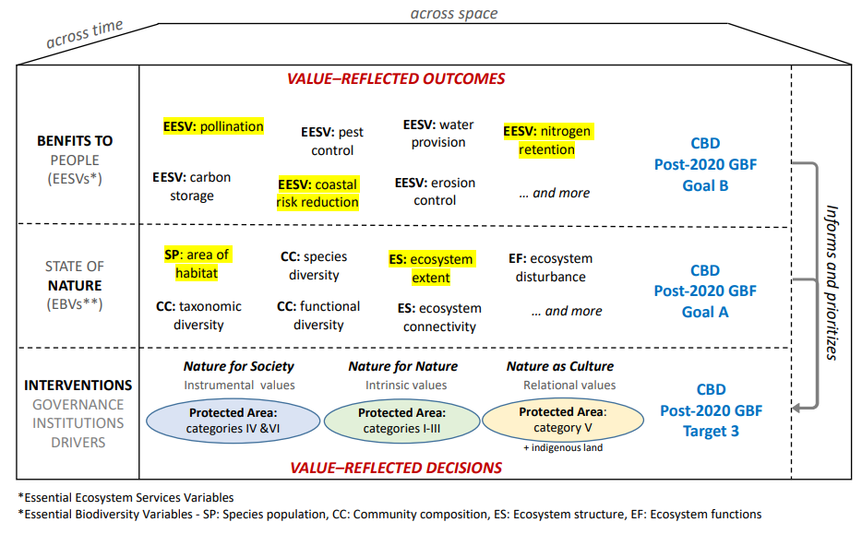
Figure Box 7. The NFF and simplified IPBES conceptual framework applied on Essential Biodiversity Variables (EBV)-based and Essential Ecosystem Services Variables (EESV)-based data analyses to inform the Kunming-Montreal Global Biodiversity Framework. The specific value perspectives for nature are mapped to different categories of protected areas (Kunming-Montreal Global Biodiversity Framework Target 3) as interventions for impact assessment. The “State of Nature” is assessed using the essential variables on biodiversity and ecosystems (Kunming-Montreal Global Biodiversity Framework Goal A), and “Benefits to People” using the essential variables on nature’s contributions to people (Kunming-Montreal Global Biodiversity Framework Goal B). Such impact assessments can evaluate the consequences of value-reflected decisions on land and ocean protection and management on nature and people retrospectively and inform future decisions (yellow highlights correspond to the examples provided in the explanation of the analysis above). Source: Kim, 2022.

Annex II to appendix II: References
Aguiar, A., Collste, D., Harmáčková, Z., Pereira, L., Selomane, O., Galafassi, D., Vuuren, van D. & Van der Leeuw, S. (2020). Co-designing global target-seeking scenarios: A cross-scale participatory process for capturing multiple perspectives on pathways to sustainability. Global Environmental Change, 65, 102198. https://doi.org/10.1016/j.gloenvcha.2020.102198
Aguiar, A., Cornell, S., Remy, M., & Schmidt, F. (2021). SHAPE - Report on the first phase of the Multi-Stakeholder Dialogue. Zenodo. https://doi.org/10.5281/zenodo.7432337
Aguiar, A., Cornell, S., Cortes-Calderon, S., & Remy, M. (2022). SHAPE - Report on the Second Multi-Stakeholder Workshop. Zenodo. https://doi.org/10.5281/zenodo.7432489
Balvanera, P., Brauman, K.A., Cord, A.F., Drakou, E.G., Geijzendorffer, I.R., Karp, D.S., Martin-Lopez, B., Mwampamba, T.H., & Schröter, M. (2022). Essential Ecosystem Service Variables for monitoring progress towards sustainability. Current Opinion in Environmental Sustainability, 54, 101152. https://doi.org/10.1016/j.cosust.2022.101152
Berghöfer, U., Rode, J., Jax, K., Förster, J., Berghöfer, A., & Wittmer, H. (2022). ‘Societal Relationships with Nature’: A framework for understanding nature-related conflicts and multiple values. People and Nature, 4(2), 534-548. https://doi.org/10.1002/pan3.10305
Braun, B., & Castree, N. (Eds.) (2005). Remaking reality: nature at the millenium. Routledge.
Brown, C., & Rounsevell, M. (2021). How can social–ecological system models simulate the emergence of social–ecological crises? People and Nature, 3(1), 88–103. https://doi.org/10.1002/pan3.10167
Caillon, S., Cullman, G., Verschuuren, B. & Sterling, E. (2017). Moving beyond the human–nature dichotomy through biocultural approaches: Including ecological well-being in resilience indicators. Ecology and Society, 22. https://doi.org/10.5751/ES-09746-220427
Carpenter, S. R., Mooney, H. A., Agard, J., Capistrano, D., Defries, R. S., Díaz, S., Duraiappah, A.K., Oteng-Yeboah, A., Pereira, H.M., Perrings, C., Reid, W.V., Sarukhan, J., Scholes, R.J., & Whyte, A. (2009). Science for managing ecosystem services: Beyond the Millennium Ecosystem Assessment. Proceedings of the National Academy of Sciences of the United States of America, 106(5), 1305–1312. https://doi.org/10.1073/pnas.0808772106
CBD (2010). The Strategic Plan for Biodiversity 2011-2020 and the Aichi Biodiversity Targets. Decision UNEP/CBD/COP/DEC/X/2. https://www.cbd.int/doc/decisions/cop-10/cop-10-dec-02-en.pdf
CBD (2021). ‘1st Draft of The Post-2020 Global Biodiversity Framework’. Open ended working group on the post-2020 global biodiversity framework. Third meeting. Online, 23 August – 3 September 2021. Item 4 of the provisional agenda. UNEP/CBD/WG2020/3/3 https://www.cbd.int/doc/c/914a/eca3/24ad42235033f031badf61b1/wg2020-03-03-en.pdf
Chaplin-Kramer, R., Sharp, R. P., Weil, C., Bennett, E. M., Pascual, U., Arkema, K. K., Brauman, K.A.,Bryant, B.P., Guerry, A.s., Haddad, N.M., Hamann, M., Hamel, P., Johnson, J.A., Mandle, L., Pereira, H.M.,, Polasky, S., Ruckelsaus, M., Shaw, M.R., Silver, J.M., … Daily, G. C. (2019). Global modeling of nature’s contributions to people. Science, 366(6462), 255–258. https://doi.org/doi:10.1126/science.aaw3372
Cheung, W. W. L. (2019). Chapter 1 - Predicting the future ocean: pathways to global ocean sustainability. In A. M. Cisneros-Montemayor, W. W. L. Cheung, & Y. Ota (Eds.), Predicting Future Oceans (pp. 3-15). Elsevier. https://doi.org/https://doi.org/10.1016/B978-0-12-817945-1.00001-0
Cheung, W. W.L., & Oyinlola, M.A. (2019). Dynamic Integrated Marine Climate, Biodiversity, Fisheries, Aquaculture and Seafood Market Model (DIVERSE). Fisheries Centre Research Reports, 27(3): 125pp. https://dx.doi.org/10.14288/1.0387414
Cronon, W. (Ed.) (1996). Uncommon ground: Rethinking the human place in nature. WW Norton & Company.
Descola, P. (2013). Beyond nature and culture. University of Chicago Press.
Díaz, S., Demissew, S., Carabias, J., Joly, C., Lonsdale, M., Ash, N., Larigauderie, A., Adhikari, J.R., Arico, S., Báldi, A., Bartuska, A., Baste, I.A., Bilgin, A., Brondizio, E., Chan, K.M.A., Figueroa, V.E., Duraiappah, A., Fischer, M., Hill, R., … Zlatanova, D. (2015). The IPBES Conceptual Framework — connecting nature and people. Current Opinion in Environmental Sustainability, 14, 1-14. https://doi.org/10.1016/j.cosust.2014.11.002
Díaz, S., Pascual, U., Stenseke, M., Martín-López, B., Watson, R., Molnár, Z., Hill, R., Chan, K., Baste, I., Brauman, K., Polasky, S., Church, A., Lonsdale, M., Larigauderie, A., Leadley, P., Van Oudenhoven, A., Van der Plaat, F., Schröter, M., Lavorel, S., … Shirayama, Y. (2018). Assessing nature's contributions to people. Science, 359(6373), 270-272. https://doi.org/doi:10.1126/science.aap8826
Dacks, R., Ticktin, T., Mawyer, A., Caillon, S., Claudet, J., Fabre, P., Jupiter, S.D., McCarter, J., Mejia, M., Pascua, P., Sterling, E. & Wongbusarakum, S. (2019). Developing biocultural indicators for resource management. Conservation Science and Practice, 1(6). https://doi.org/10.1111/csp2.38
Dietze, M.C., Fox, A., Beck-Johnson, L.M., Betancourt, J.L., Hooten, M.B., Jarnevich, C.S., Keitt, T.H., Kenney, M.A., Laney, C.M., Larsen, L.G., Loescher, H.W., Lunch, C.K., Pijanowski, B.C., Randerson, J.T., Read, E.K., Tredennick, A.T., Vargas, R., Weathers, K.C., & White, E.P. (2018). Iterative near-term ecological forecasting. Proceedings of the National Academy of Sciences, 115(7), 1424-1432. https://doi.org/10.1073/pnas.1710231115
Durán, A.P., Kuiper, J.J., Aguiar, A.P.D., Cheung, W.W.L., Diaw, M.C., Halouani, G., Hashimoto, S., Gasalla, M.A., Peterson, G.D., Schoolenberg, M.A., Abbasov, R., Acosta, L.A., Armenteras, D., Davila, F., Denboba, M.A., Harrison, P.A., Harhash, K.A., Karlsson-Vinkhuyzen, S., Kim, H., & Pereira, L.M. (2023) Bringing the Nature Futures Framework to life: creating a set of illustrative narratives of nature futures. Sustainability Science. https://doi.org/10.1007/s11625-023-01316-1
Ferguson, S.M., Phillips, P.E.M., Roth, B.L., Wess, J., & Neumaier, J.F. (2013). Direct-Pathway Striatal Neurons Regulate the Retention of Decision-Making Strategies. Journal of Neuroscience, 33, 11668–11676. https://doi.org/10.1523/JNEUROSCI.4783-12.2013
Ferrier, S., Jetz, W., & Scharlemann, J. (2017). Biodiversity Modelling as Part of an Observation System. In M. Walters & R. J. Scholes (Eds.), The GEO Handbook on Biodiversity Observation Networks (pp. 239-257). Springer International Publishing. https://doi.org/10.1007/978-3-319-27288-7_10
Figueiredo, J., & Pereira, H. M. (2011). Regime shifts in a socio-ecological model of farmland abandonment. Landscape Ecology, 26, 737–749. https://doi.org/10.1007/s10980-011-9605-3
Fonte, S. J., Vanek, S. J., Oyarzun, P., Parsa, S., Quintero, D. C., Rao, I. M., & Lavelle, P. (2012). Chapter Four - Pathways to Agroecological Intensification of Soil Fertility Management by Smallholder Farmers in the Andean Highlands. In D. L. Sparks (Ed.), Advances in Agronomy (Vol. 116, pp. 125-184). Academic Press. https://doi.org/https://doi.org/10.1016/B978-0-12-394277-7.00004-X
Forest Peoples Programme, International Indigenous Forum on Biodiversity, Indigenous Women’s Biodiversity Network, Centres of Distinction on Indigenous and Local Knowledge and Secretariat of the Convention on Biological Diversity (2020). Local Biodiversity Outlooks 2: The contributions of indigenous peoples and local communities to the implementation of the Strategic Plan for Biodiversity 2011–2020 and to renewing nature and cultures. A complement to the fifth edition of Global Biodiversity Outlook. Moreton-in-Marsh, England: Forest Peoples Programme. Available at: www.localbiodiversityoutlooks.net
Frantzeskaki, N., Loorbach, D., & Meadowcroft, J. (2011). Governing societal transitions to sustainability. International Journal of Sustainable Development, 15, 19-36. https://doi.org/10.1504/IJSD.2012.044032
Garnett, S. T., Burgess, N. D., Fa, J. E., Fernández-Llamazares, Á., Molnár, Z., Robinson, C. J., Watson, J. E. M., Zander, K. K., Austin, B., Brondizio, E. S., Collier, N. F., Duncan, T., Ellis, E., Geyle, H., Jackson, M. V., Jonas, H., Malmer, P., McGowan, B., Sivongxay, A., & Leiper, I. (2018). A spatial overview of the global importance of Indigenous lands for conservation. Nature Sustainability, 1(7), 369-374. https://doi.org/10.1038/s41893-018-0100-6
Gasalla, M. A., Tittensor, D. P., Kok, K., Archer, E., Borokini, I., Halouani, G., Matias, D.M., Mbiba, M., Milner-Gulland, E.J., Pacheco, P., Fabricius, C., & Kieling, D. (2022). Chapter 5: Future scenarios of sustainable use of wild species. In: Thematic Assessment Report on the Sustainable Use of Wild Species of the Intergovernmental Science-Policy Platform on Biodiversity and Ecosystem Services. Fromentin, J.M., Emery, M., Donaldson, J., Danner, M.C., Hallosserie, A., and Kieling, D. (eds.). IPBES secretariat, Bonn, Germany. https://doi.org/10.5281/zenodo.6451922
GEO BON (2020) Essential Biodiversity Variables 2020 Initiative (EBV2020) for Post-2020 Global Biodiversity Conservation. https://geobon.org/essential-biodiversity-variables-2020-initiative-ebv2020-for-post-2020-global-biodiversity-conservation/
Harrison, P. A., Harmá, ková, Z. V., Aloe Karabulut, A., an, Brotons, L., Cantele, M., Claudet, J., Dunford, R. W., Guisan, A., Holman, I. P., Jacobs, S., Kok, K., Lobanova, A., Morán-Ordóñez, A., Pedde, S., Rixen, C., Santos-Martín, F., Schlaepfer, M. A., . . . Hauck, J. (2019). Synthesizing plausible futures for biodiversity and ecosystem services in Europe and Central Asia using scenario archetypes. Ecology and Society, 24(2), Article 27. https://doi.org/10.5751/ES-10818-240227
Head, L. (2016). Hope and grief in the Anthropocene: Re-conceptualising human–nature relations. Routledge.
Hebinck, A., Diercks, G., von Wirth, T., Beers, P.J., Barsties, L., Buchel, S., Greer, R., van Steenbergen, F & Loorbach, D. (2022). An actionable understanding of societal transitions: the X-curve framework. Sustainability Science, 17, 1009-1021. https://doi.org/10.1007/s11625-021-01084-w
IPCC (2018) Glossary, IPCC SR1.5. sr15_glossary.pdf (ipcc.ch)
IPBES (2015). Preliminary guide regarding diverse conceptualization of multiple values of nature and its benefits, including biodiversity and ecosystem functions and services (deliverable 3 (d)). IPBES/4/INF/13. Secretariat of the Intergovernmental Science-Policy Platform on Biodiversity and Ecosystem Services, Bonn, Germany.
IPBES (2016a). The methodological assessment report on scenarios and models of biodiversity and ecosystem services. S. Ferrier, K. N. Ninan, P. Leadley, R. Alkemade, L. A. Acosta, H. R. Akçakaya, L. Brotons, W. W. L. Cheung, V. Christensen, K. A. Harhash, J. Kabubo-Mariara, C. Lundquist, M. Obersteiner, H. M. Pereira, G. Peterson, R. Pichs-Madruga, N. Ravindranath, C. Rondinini and B. A. Wintle (eds.). Secretariat of the Intergovernmental Science-Policy Platform on Biodiversity and Ecosystem Services, Bonn, Germany. 348 pages.
IPBES (2016b). Summary for policymakers of the methodological assessment of scenarios and models of biodiversity and ecosystem services of the Intergovernmental Science-Policy Platform on Biodiversity and Ecosystem Services. S. Ferrier, K. N. Ninan, P. Leadley, R. Alkemade, L.A. Acosta, H. R. Akçakaya, L. Brotons, W. Cheung, V. Christensen, K. A. Harhash, J. Kabubo-Mariara, C. Lundquist, M. Obersteiner, H. Pereira, G. Peterson, R. Pichs-Madruga, N. H. Ravindranath, C. Rondinini, B. Wintle (eds.). Secretariat of the Intergovernmental Science-Policy Platform on Biodiversity and Ecosystem Services, Bonn, Germany. 32 pages.
IPBES (2018a). The IPBES regional assessment report on biodiversity and ecosystem services for Africa. Archer, E. Dziba, L., Mulongoy, K. J., Maoela, M. A., and Walters, M. (eds.). Secretariat of the Intergovernmental Science-Policy Platform on Biodiversity and Ecosystem Services, Bonn, Germany. 492 pages. http://doi.org/10.5281/zenodo.3236178
IPBES (2018b). The IPBES regional assessment report on biodiversity and ecosystem services for the Americas. Rice, J., Seixas, C. S., Zaccagnini, M. E., Bedoya-Gaitán, M., and Valderrama N. (eds.). Secretariat of the Intergovernmental Science-Policy Platform on Biodiversity and Ecosystem Services, Bonn, Germany. 656 pages. https://doi.org/10.5281/zenodo.3236252
IPBES (2018c). The IPBES regional assessment report on biodiversity and ecosystem services for Asia and the Pacific. Karki, M., Senaratna Sellamuttu, S., Okayasu, S., and Suzuki, W. (eds). Secretariat of the Intergovernmental Science-Policy Platform on Biodiversity and Ecosystem Services, Bonn, Germany. 612 pages. https://doi.org/10.5281/zenodo.3237373
IPBES (2018d). Summary for policymakers of the regional assessment report on biodiversity and ecosystem services for Europe and Central Asia of the Intergovernmental Science-Policy Platform on Biodiversity and Ecosystem Services. M. Fischer, M. Rounsevell, A. Torre-Marin Rando, A. Mader, A. Church, M. Elbakidze, V. Elias, T. Hahn, P.A. Harrison, J. Hauck, B. Martín-López, I. Ring, C. Sandström, I. Sousa Pinto, P. Visconti, N.E. Zimmermann and M. Christie (eds.). IPBES secretariat, Bonn, Germany. 48 pages https://doi.org/10.5281/zenodo.3237428
IPBES (2019a). Global assessment report on biodiversity and ecosystem services of the Intergovernmental Science-Policy Platform on Biodiversity and Ecosystem Services. E. S. Brondizio, J. Settele, S. Díaz, and H. T. Ngo (eds.). IPBES secretariat, Bonn, Germany. 1148 pages. https://doi.org/10.5281/zenodo.3831673
IPBES (2019b). Summary for policymakers of the global assessment report on biodiversity and ecosystem services of the Intergovernmental Science-Policy Platform on Biodiversity and Ecosystem Services. S. Díaz, J. Settele, E. S. Brondízio E.S., H. T. Ngo, M. Guèze, J. Agard, A. Arneth, P. Balvanera, K. A. Brauman, S. H. M. Butchart, K. M. A. Chan, L. A. Garibaldi, K. Ichii, J. Liu, S. M. Subramanian, G. F. Midgley, P. Miloslavich, Z. Molnár, D. Obura, A. Pfaff, S. Polasky, A. Purvis, J. Razzaque, B. Reyers, R. Roy Chowdhury, Y. J. Shin, I. J. Visseren-Hamakers, K. J. Willis, and C. N. Zayas (eds.). IPBES secretariat, Bonn, Germany. 56 pages.
IPBES (2021). Report of the IPBES task force on scenarios and models on its workshop on modelling Nature Futures scenarios under the 2030 IPBES rolling work programme. Online, 12-15 January 2021. https://www.ipbes.net/events/task-force-scenarios-and-models-modellers-workshop
IPBES (2021). Report of the indigenous and local knowledge dialogue workshop on scenarios and the Nature Futures Framework. Online, 28-30 September 2021 and 19 October 2021. https://www.ipbes.net/ilk-dialogue-reports
IPBES (2022). Summary for Policymakers of the Methodological Assessment Report on the Diverse Values and Valuation of Nature of the Intergovernmental Science-Policy Platform on Biodiversity and Ecosystem Services. Pascual, U., Balvanera, P., Christie, M., Baptiste, B., González-Jiménez, D., Anderson, C.B., Athayde, S., Barton, D.N., Chaplin-Kramer, R., Jacobs, S., Kelemen, E., Kumar, R., Lazos, E., Martin, A., Mwampamba, T.H., Nakangu, B., O’Farrell, P., Raymond, C.M., Subramanian, S.M., … Vatn, A. (eds.). IPBES secretariat, Bonn, Germany. https://doi.org/10.5281/zenodo.6522392
Kim, H., Rosa, I. M. D., Alkemade, R., Leadley, P., Hurtt, G., Popp, A., van Vuuren, D. P., Anthoni, P., Arneth, A., Baisero, D., Caton, E., Chaplin-Kramer, R., Chini, L., De Palma, A., Di Fulvio, F., Di Marco, M., Espinoza, F., Ferrier, S., Fujimori, S., … Pereira, H. M. (2018). A protocol for an intercomparison of biodiversity and ecosystem services models using harmonized land-use and climate scenarios. Geoscientific Model Development, 11(11), 4537-4562. https://doi.org/10.5194/gmd-11-4537-2018
Kim, H., Peterson, G., Cheung, W.W.L, Ferrier, S., Alkemade, A., Arneth, A., Kuiper, J.J., Okayasu, S., Pereira, L., Acosta, L.A., Chaplin-Kramer, R., Den Belder, E., Eddy, T., Johnson, J.A., Karlsson-Vinkhuyzen, S., Kok, M.T.J., Leadley, P.. Leclere, D., Lundquist, C.J., … Pereiera, H. (2023). Towards a better future for biodiversity and people: modelling the Nature Futures. Global Environmental Change. https://doi/org/10.1016/j.gloenvcha.2023.102681
Kim (2022). Enhancing the use of scenario-based biodiversity information in conservation policy and practice. Martin Luther University Halle-Wittenburg. Halle (Salle).
Kingdon, J. W. (1984). Agendas, Alternatives and Public Policies. Boston: Little Brown.
Kuiper, J.J., van Wijk, D., Mooij, W.M., Remme, R.P., Peterson, G.D., Karlsson-Vinkhuyzen, S., Mooij, C.J., Leltz, G.M., & Pereira, L.M. (2022). Exploring desirable nature futures for National Park Hollandse Duinen. Ecosystems and People, 18(1), 329-347. https://doi.org/10.1080/26395916.2022.2065360
Larsson, R., Lockne, E., Lopez Malaga, C. & Karlsson-Vinkhuyzen, S. (2023) Developing Global Indicators for Relational Nature Values. Searching for Concepts, Indicators and Data. Wageningen University: Public Administration and Policy Group, Wageningen University and SLAAK: Futures Research, Modelling and Simulation Team; Wageningen and Stockholm.
Latour, B. (2004). Politics of nature. Harvard University Press.
Lim, M., Lynch, A. J., Fernández-Llamazares, Á., Balint, L., Basher, Z., Chan, I., Jaureguiberry, P., Mohamed, A. A. A., Mwampamba, T. H., Palomo, I., Pliscoff, P., Salimov, R. A., Samakov, A., Selomane, O., Shrestha, U. B., & Sidorovich, A. A. (2017). Early-career experts essential for planetary sustainability. Current Opinion in Environmental Sustainability, 29, 151-157. https://doi.org/10.1016/j.cosust.2018.02.004
Lundquist, C. J., Pereira, H., Alkemade, R., den Belder, E., Carvalho Ribeira, S., Davies, K., Greenway, A., Hauck, J., Karlsson-Vinkhuyzen, S., Kim., H., King, N., Lazarova, T., Pereira, L., Peterson, G., Ravera, F., van den Brink, T., Argumendo, A., Arida, C., Armenteras, D., … Zulfikar, D. (2017). Visions for nature and nature's contributions to people for the 21st century, NIWA Science and Technology Series 83, 1–123. Auckland, New Zealand: NIWA.
Mansur, A.V., Mcdonald, R.I., Güneralp, B., Kim, H., Puppim de Oliveira, J.A., Callaghan, C.T., Hamel, P., Kuiper, J.J., Wolff, M., Liebelt, V., Martins, I.S., Elmqvist, T., & Pereira, H.M. (2022). Nature futures for the urban century: Integrating multiple values into urban management. Environmental Science & Policy, 131, 46-56.
Marques, A., Martins, I. S., Kastner, T., Plutzar, C., Theurl, M. C., Eisenmenger, N., Huijbregts, M.A., Wood, R., Stadler, K., Bruckner, M., Canelas, J., Hilbers, J.P., Tukker, A., Erb, K. & Pereira, H. M. (2019). Increasing impacts of land use on biodiversity and carbon sequestration driven by population and economic growth. Nature Ecology & Evolution, 3(4), 628–637. https://doi.org/10.1038/s41559-019-0824-3
Martin, A., O'Farrell, P., Kumar, R., Eser, U., Faith, D.P., Gomez-Baggethun, E., Harmackova, Z., Horcea-Milcu, A.I., Merçon, J., Quaas, M., Rode, J., Rozzi, R., Sitas, N., Yoshida, Y., Ochieng, T.N., Koessler, A.K., Lutti, N., Mannetti, L., & Arroyo-Robles, G. (2022). Chapter 5: The role of diverse values of nature in visioning and transforming towards just and sustainable futures. In: Methodological Assessment Report on the Diverse Values and Valuation of Nature of the Intergovernmental Science-Policy Platform on Biodiversity and Ecosystem Services. Christie, M., Balvanera, P., Pascual, U., Baptiste, B., and González-Jiménez, D. (eds). IPBES secretariat, Bonn, Germany. https://doi.org/10.5281/zenodo.6522326
Maury, O., Campling, L., Arrizabalaga, H., Aumont, O., Bopp, L., Merino, G., Squires, D., Cheung, W., Goujon, M., Guivarch, C., Lefort, S., Marsac, F., Monteagudo, P., Murtugudde, R., Österblom, H., Pulvenis, J.F., Ye, Y., & van Ruijven, B.J. (2017). From shared socio-economic pathways (SSPs) to oceanic system pathways (OSPs): Building policy-relevant scenarios for global oceanic ecosystems and fisheries. Global Environmental Change, 45, 203-216. https://doi.org/10.1016/j.gloenvcha.2017.06.007
Moon, K., Guerrero, A. M., Adams, V. M., Biggs, D., Blackman, D. A., Craven, L., Dickinson, H., & Ross, H. (2019). Mental models for conservation research and practice. Conservation Letters, 0(0), e12642. https://doi.org/10.1111/conl.12642
Muiderman, K., Gupta, A., Vervoort, J. & Biermann, F. (2020). Four approaches to anticipatory climate governance: Different conceptions of the future and implications for the present. WIREs Climate Change, 11(6). https://doi.org/10.1002/wcc.673
Nelson, E., Mendoza, G., Regetz, J., Polasky, S., Tallis, H., Cameron, D., Chan, K. M. A., Daily, G. C., Goldstein, J., Kareiva, P. M., Lonsdorf, E., Naidoo, R., Ricketts, T. H., & Shaw, M. (2009). Modeling multiple ecosystem services, biodiversity conservation, commodity production, and tradeoffs at landscape scales. Frontiers in Ecology and the Environment, 7(1), 4-11. https://doi.org/https://doi.org/10.1890/080023
Obermeister, N. (2019). Local knowledge, global ambitions: IPBES and the advent of multi-scale models and scenarios. Sustainability Science, 14, 843–856. https://doi.org/10.1007/s11625-018-0616-8
O’Connor, L. M. J., Pollock, L. J., Renaud, J., Verhagen, W., Verburg, P. H., Lavorel, S., Maiorano, L. & Thuiller, W. (2021). Balancing conservation priorities for nature and for people in Europe. Science, 372(6544), 856–860. https://doi.org/10.1126/science.abc4896
O’Neill, B.C., Kriegler, E., Riahi, K., Ebi, K.L., Hallegatte, S., Carter, T.R., Mathur, R., & van Vuuren, D.P. (2014). A new scenario framework for climate change research: the concept of shared socioeconomic pathways. Climate Change, 122, 387-400. https://doi.org/10.1007/s10584-013-0905-2
O’Neill, B.C., Kriegler, E., Ebi, K.L., Kemp-Benedict, E., Riahi, K., Rothman, D.S., van Ruijven, B.J., van Vuuren, D.P., Birkmann, J., Kok, K., Levy, M., & Solecki, W. (2017). The roads ahead: Narratives for shared socioeconomic pathways describing world futures in the 21st century. Global Environmental Change, 42, 169-180. https://doi.org/10.1016/j.gloenvcha.2015.01.004
Pascual, U., Balvanera, P., Díaz, S., Pataki, G., Roth, E., Stenseke, M., Watson, R. Başak Dessane, E., Islar, M., Kelemen, E., Maris, V., Quaas, M., Subramanian, S., Wittmer, H., Adlan, A., Ahn, S., Al-Hafedh, Y., Amankwah, E., Asah, S., … Yagi, N. (2017). Valuing nature’s contributions to people: the IPBES approach. Current Opinion in Environmental Sustainability, 26–27, 7–16. https://doi.org/10.1016/j.cosust.2016.12.006
PBL (2019a). Report on the workshop ‘From visions to scenarios for nature and nature’s contributions to people for the 21st century’. PBL Netherlands Environmental Assessment Agency, The Hague. https://www.pbl.nl/en/publications/from-visions-to-scenarios-for-nature-and-nature%E2%80%99s-contributions-to-people-for-the-21st-century-workshop-report
PBL (2019b). Report on the workshop ‘Global Modelling of Biodiversity and Ecosystem Services’. PBL Netherlands Environmental Assessment Agency, The Hague. https://www.pbl.nl/sites/default/files/downloads/workshop_report_global_modelling_of_bes.pdf
PBL (2020). Report on the Workshop ‘New Narratives for Nature: operationalizing the IPBES Nature Futures Scenarios’. PBL Netherlands Environmental Assessment Agency, The Hague. https://www.pbl.nl/en/publications/report-on-the-workshop-new-narratives-for-nature-operationalizing-the-ipbes-nature-futures-scenarios
Pereira, H. M., Ferrier, S., Walters, M., Geller, G. N., Jongman, R. H. G., Scholes, R. J., Bruford, M. W., Brummitt, N., Butchart, S. H. M., Cardoso, A. C., Coops, N. C., Dulloo, E., Faith, D. P., Freyhof, J., Gregory, R. D., Heip, C., Höft, R., Hurtt, G., Jetz, W., . . . Wegmann, M. (2013). Essential Biodiversity Variables. Science, 339(6117), 277-278. https://doi.org/doi:10.1126/science.1229931
Pereira, L. M., Hichert, T., Hamann, M., Preiser, R., & Biggs, R. (2018). Using futures methods to create transformative spaces: visions of a good Anthropocene in southern Africa. Ecology and Society, 23(1), 19. https://doi.org/10.5751/ES-09907-230119
Pereira, L. M., Davies, K. K., den Belder, E., Ferrier, S., Karlsson-Vinkhuyzen, S., Kim, H., Kuiper, J. J., Okayasu, S., Palomo, M. G., Pereira, H. M., Peterson, G., Sathyapalan, J., Schoolenberg, M., Alkemade, R., Carvalho Ribeiro, S., Greenaway, A., Hauck, J., King, N., Lazarova, T., . . . Lundquist, C. J. (2020). Developing multiscale and integrative nature–people scenarios using the Nature Futures Framework. People and Nature, 2(4), 1172-1195. https://doi.org/https://doi.org/10.1002/pan3.10146
Pereira, L. M., Morrow, D. R., Aquila, V., Beckage, B., Beckbesinger, S., Beukes, L., Buck, H.J., Carlson, C.J., Geden, O., Jones, A.P., Keller, D.P., Mach, K.J., Mashigo, M., Moreno-Cruz, J.B., Visioni, D., Nicholson, S. & Trisos., C.H. (2021a). From fAIrplay to climate wars: making climate change scenarios more dynamic, creative, and integrative. Ecology and Society, 26(4):30. https://doi.org/10.5751/ES-12856-260430
Pereira, L., Kuiper, J.J., Selomane, O., Aguiar, A.P.D., Asrar, G.R., Bennett, E.M., Biggs, R., Calvin, K., Hedden, S., Hsu, A., Jabbour, J., King, N., Köberle, A.C., Lucas, P., Nel, J., Norström, A.V., Peterson, P., Sitas, N., Trisos, C., … Ward, J. (2021b). Advancing a toolkit of diverse futures approaches for global environmental assessments. Ecosystems and People, 17(1), 191-204, https://doi.org/10.1080/26395916.2021.1901783
Pereira, L. M., Ortuño Crespo, Juri, S., Keys, P., Lübker, H., Merrie, A., Superchi, E., Terry, N., Chibwe, B., Palacios-Abrantes, J., Yasuhara, M., Obaidullah, F., Carmine G., Bandeira, S., Amon, D.J., Halouani, G., Johnson, D.E., Shannon, L.J., Jouffray, J.-B., Wabnitz, C.C.C., & Fulton, B. (2022a). The living infinite. Vector. The Living Infinite (vector-bsfa.com)
Pereira, LM., Ortuño Crespo, G., Merrie, A. & Homewood, C. (2022b). Operationalising the Nature Futures Framework in the High Seas. Nereus Workshop report, Stockholm.
Piccolo, J. (2017). Intrinsic values in nature: Objective good or simply half of an unhelpful dichotomy? Journal for Nature Conservation, 37, 8-11. https://doi.org/10.1016/j.jnc.2017.02.007
Popp, A. Calvin, K. Fujimori, S., Havlik, P., Humpenöder, F., Stehfest, E., Bodirsky, B.L., Dietrich, J. P., Doelmann, J. C., Gusti, M., Hasegawa, T., Kyle, P., Obersteiner, M., Tabeau, A., Takahashi, K., Valin, H., Waldhoff, S., Weindl, L., Wise, M., … van Vuuren, D.P. (2017). Land-use futures in the shared socio-economic pathways. Global Environmental Change, 42, 331-345. https://doi.org/10.1016/j.gloenvcha.2016.10.002
Pörtner, H.O., Scholes, R.J., Agard, J., Archer, E., Arneth, A., Bai, X., Barnes, D., Burrows, M., Chan, L., Cheung, W.L., Diamond, S., Donatti, C., Duarte, C., Eisenhauer, N., Foden, W., Gasalla, M. A., Handa, C., Hickler, T., Hoegh-Guldberg, O., … Ngo, H.T. (2021). IPBES-IPCC co-sponsored workshop report synopsis on biodiversity and climate change. IPBES and IPCC, https://doi.org/10.5281/zenodo.4659158
Rana, S., Ávila-García, D., Dib, V., Familia, L., Gerhardinger, L.C., Martin, E., Martins, P.I., Pompeu, J., Selomane, O., Tauli, J.I., Tran, D.H.T., Valle, M., von Below, J., & Pereira, L.M. (2020). The voices of youth in envisioning positive futures for nature and people. Ecosystems and People, 16(1), 326-344. https://doi.org/10.1080/26395916.2020.1821095
Riahi, K., van Vuuren, D. P., Kriegler, E., Edmonds, J., O’Neill, B. C., Fujimori, S., Bauer, N., Calvin, K., Dellink, R., Fricko, O., Lutz, W., Popp, A., Cuaresma, J. C., Kc, S., Leimbach, M., Jiang, L., Kram, T., Rao, S., Emmerling, J., . . . Tavoni, M. (2017). The Shared Socioeconomic Pathways and their energy, land use, and greenhouse gas emissions implications: An overview. Global Environmental Change, 42, 153-168. https://doi.org/https://doi.org/10.1016/j.gloenvcha.2016.05.009
Rieb, J. T., Chaplin-Kramer, R., Daily, G. C., Armsworth, P. R., Böhning-Gaese, K., Bonn, A., Cumming, G. S., Eigenbrod, F., Grimm, V., Jackson, B. M., Marques, A., Pattanayak, S. K., Pereira, H. M., Peterson, G. D., Ricketts, T. H., Robinson, B. E., Schröter, M., Schulte, L. A., Seppelt, R., . . . Bennett, E. M. (2017). When, Where, and How Nature Matters for Ecosystem Services: Challenges for the Next Generation of Ecosystem Service Models. BioScience, 67(9), 820-833. https://doi.org/10.1093/biosci/bix075
Robin, L., Sörlin, S., & Warde, P. (2013). The future of nature. New Haven/London.
Rosa, I. M. D., Pereira, H. M., Ferrier, S., Alkemade, R., Acosta, L. A., Akcakaya, H. R., den Belder, E., Fazel, A. M., Fujimori, S., Harfoot, M., Harhash, K. A., Harrison, P. A., Hauck, J., Hendriks, R. J. J., Hernández, G., Jetz, W., Karlsson-Vinkhuyzen, S. I., Kim, H., King, N., . . . van Vuuren, D. (2017). Multiscale scenarios for nature futures. Nature Ecology and Evolution, 1(10), 1416-1419. https://doi.org/10.1038/s41559-017-0273-9
Rosa, I. M. D., Purvis, A., Alkemade, R., Chaplin-Kramer, R., Ferrier, S., Guerra, C. A., Hurtt, G., Kim, H., Leadley, P., Martins, I. S., Popp, A., Schipper, A. M., van Vuuren, D., & Pereira, H. M. (2020). Challenges in producing policy-relevant global scenarios of biodiversity and ecosystem services. Global Ecology and Conservation, 22, e00886. https://doi.org/https://doi.org/10.1016/j.gecco.2019.e00886
Sharpe, B., Hodgson, A., Leicester, G., Lyon, A., & Fazey, I. (2016). Three horizons: a pathways practice for transformation. Ecology and Society, 21(2):47. http://dx.doi.org/10.5751/ES-08388-210247
Scheffer, M. (2009). Critical Transitions in Nature and Society. Princeton, N.J.: Princeton University Press.
Schröter, M., Başak, E., Christie, M., Church, A., Keune, H., Osipova, E., Oteros-Rozas, E., Sievers-Glotzbach, S., van Oudenhoven, A. P. E., Balvanera, P., González, D., Jacobs, S., Molnár, Z., Pascual, U., & Martín-López, B. (2020). Indicators for relational values of nature’s contributions to good quality of life: the IPBES approach for Europe and Central Asia. Ecosystems and People, 16(1), 50-69. https://doi.org/10.1080/26395916.2019.1703039
Seppelt, R., Arndt, C., Beckmann, M., Martin, E.A., & Hertel, T.W. (2020). Deciphering the Biodiversity–Production Mutualism in the Global Food Security Debate. Trends in Ecology & Evolution , 35(11), 1011–20. https://doi.org/10.1016/j.tree.2020.06.012
Sietz, D., & van Dijk, H. (2015). Land-based adaptation to global change: What drives soil and water conservation in western Africa? Global Environmental Change, 33, 131-141. https://doi.org/10.1016/j.gloenvcha.2015.05.001
Sitas, N., Harmá, ková, Z. V., Anticamara, J. A., Arneth, A., Badola, R., Biggs, R., Blanchard, R., Brotons, L., Cantele, M., Coetzer, K., DasGupta, R., den Belder, E., Ghosh, S., Guisan, A., Gundimeda, H., Hamann, M., Harrison, P. A., Hashimoto, S., . . . Valle, M. (2019). Exploring the usefulness of scenario archetypes in science-policy processes: experience across IPBES assessments. Ecology and Society, 24(3), 35. https://doi.org/10.5751/ES-11039-240335
Soergel, B., Kriegler, E., Weindl, I., Rauner, S. Dirnaichner, A., Ruhe, C., Hofmann, M., Bauer, N., Bertram, C., Bodirsky, B.L., Leimbach, M., Leininger, J., Levesque, A., Luderer, G., Pehl, M., Wingens, C., Baumstark, L., Beier, F., Dietrich, J.P., . . . Popp, A. (2021). A sustainable development pathway for climate action within the UN 2030 Agenda. Nature Climate Change, 11, 656–664 (2021). https://doi.org/10.1038/s41558-021-01098-3
Sterling, E.J., Filardi, C., Toomey, A., Sigouin, A., Betley, E., Gazit, N., Newell, J., Albert, A., Alvira, D., Bergamini, N., Blair, M., Boseto, D., Burrows, K., Bynum, N., Caillon, S., Caselle, J.E., Claudet, J., Cullman, G., Dacks, R., … Jupiter, S.D. (2017). Biocultural approaches to well-being and sustainability indicators across scales. Nature Ecology & Evolution, 1, 1798–1806. https://doi.org/10.1038/s41559-017-0349-6
Sterling, E. J., Mandle, L., Aini, J., Simon, A., Caselle, J. E., Cheng, S. H., Dacks, R., Darling, E. S., Filardi, C., Jupiter, S. D., Mawyer, A., Mejia, M., Winifereti, N., Parks, J., Tanguay, J., & McCarter, J. (2020). Creating a space for place and multidimensional well-being: lessons learned from localizing the SDGs. Sustainability Science, 15(4), 1129-1147. https://doi.org/10.1007/s11625-020-00822-w
Tengö, M., Brondizio, E. S., Elmqvist, T., Malmer, P., & Spierenburg, M. (2014). Connecting diverse knowledge systems for enhanced ecosystem governance: the multiple evidence base approach. Ambio, 43(5), 579–591. https://doi.org/10.1007/s13280-014-0501-3
UNEP (2021). Resolution adopted by the United Nations Environment Assembly on 2 March 2022, UNEP/EA.5/Res.5, United Nations Environment Assembly of the United Nations Environment Programme. https://wedocs.unep.org/bitstream/handle/20.500.11822/39864/NATURE-BASED%20SOLUTIONS%20FOR%20SUPPORTING%20SUSTAINABLE%20DEVELOPMENT.%20English.pdf?sequence=1&isAllowed=y
van Vuuren, D. P., & Carter, T. R. (2014). Climate and socio-economic scenarios for climate change research and assessment: reconciling the new with the old. Climatic Change, 122(3), 415-429. https://doi.org/10.1007/s10584-013-0974-2
van Vuuren, D. P., Riahi, K., Calvin, K., Dellink, R., Emmerling, J., Fujimori, S., Kc, S., Kriegler, E., & O’Neill, B. (2017). The Shared Socio-economic Pathways: Trajectories for human development and global environmental change. Global Environmental Change, 42, 148-152. https://doi.org/https://doi.org/10.1016/j.gloenvcha.2016.10.009
van Vuuren, D. P., Zimm, C., Busch, S., Kriegler, E., Leininger, J., Messner, D., Nakicenoveic, N., Rockstrom, J., Riahi, K., Sperling, F., Bosetti, V., Cornell, S., Gaffney, O., Lucas, P.L., Popp, A., Ruhe, C., von Schiller, A., Schmidt, J. O., Soergel, B. (2022). Defining a sustainable development target space for 2030 and 2050. One Earth, 5(2), 142-156. https://doi.org/10.1016/j.oneear.2022.01.003
Wiek, A., & Iwaniec, D. (2014). Quality criteria for visions and visioning in sustainability science. Sustainability Science, 9, 497- 512. https://doi.org/10.1007/s11625-013-0208-6
Wise, R.M., Fazey, I., Stafford Smith, M., Park, S.E., Eakin, H.C., Archer Van Garderen, E.R.M., & Campbell, B. (2014). Reconceptualising adaptation to climate change as part of pathways of change and response. Global Environmental Change, 28, 325–336. https://doi.org/10.1016/j.gloenvcha.2013.12.002

Annex III to appendix II: Glossary of terms used in the Nature Futures Framework
Desirable futures: Futures that incorporate transformative changes in order to improve the chances for societies to surmount biodiversity, climate or other crises, which are influenced by disparate human values and aspirations.
Drivers (direct and indirect): In the context of IPBES, drivers of change are all the factors that, directly or indirectly, cause changes in nature, anthropogenic assets, nature’s contributions to people and a good quality of life. Direct drivers of change can be both natural and anthropogenic. Direct drivers have direct physical (mechanical, chemical, noise, light etc.) and behaviour-affecting impacts on nature. They include, inter alia, climate change, pollution, different types of land use change, invasive alien species and zoonoses, and exploitation. Indirect drivers are drivers that operate diffusely by altering and influencing direct drivers, as well as other indirect drivers. They do not impact nature directly. Rather, they do it by affecting the level, direction or rate of direct drivers. (IPBES online glossary accessed 26 November 2021)
Good quality of life: Within the context of the IPBES conceptual framework – the achievement of a fulfilled human life, a notion which may vary strongly across different societies and groups within societies. It is a context-dependent state of individuals and human groups, comprising aspects such as access to food, water, energy and livelihood security, and also health, good social relationships and equity, security, cultural identity, and freedom of choice and action. ‘Living in harmony with nature’, ‘living-well in balance and harmony with Mother Earth’ and ‘human well-being’ are examples of different perspectives on a ‘Good quality of life’. (IPBES online glossary accessed 26 November 2021)
Heuristic: A method of learning or solving problems that allows people to discover things themselves and learn from their own experiences (Cambridge Dictionary, 17.12.21)
Indicators: A quantitative or qualitative factor or variable that provides a simple, measurable and quantifiable characteristic or attribute responding in a known and communicable way to a changing environmental condition, to a changing ecological process or function, or to a changing element of biodiversity (IPBES online glossary accessed 13 May 2021; Kim et al., 2023).
Intrinsic value: This concept refers to inherent value, that is the value something has independent of any human experience or evaluation. Such a value is viewed as an inherent property of the entity and not ascribed or generated by external valuing agents (Pascual et al., 2017).
Instrumental value: The value attributed to something as a means to achieving a particular end (Pascual et al., 2017).
Modelling community: Historically composed of primarily biodiversity and ecosystem services modellers but it is envisaged that the community is broadened to other sectoral and disciplinary modelling and narrative development groups, including social science and humanities and indigenous knowledge holders, to best develop nature futures scenarios.
Models: Qualitative or quantitative representations of key components of a system and of relationships between the components (IPBES online glossary accessed 28 July 2020; Kim et al., 2023).
Mother Earth: An expression used in a number of countries and regions to refer to the planet Earth and the entity that sustains all living things found in nature with which humans have an indivisible, interdependent physical and spiritual relationship (see ‘nature’) (IPBES online glossary accessed 19 January 2022).
Narratives (or scenario narratives): Qualitative descriptions of plausible future world evolutions, describing the characteristics, general logic and developments underlying a particular quantitative set of scenarios. Narratives are also referred to in the literature as “storylines”. (IPCC, 2018)
Narrative family: The concept of Narrative Families has been developed to help people understand how narratives are related to diverse values, as well as the commonalities and differences between narratives. In particular, Narrative Families provide a structure for translating diverse values into more detailed descriptions of desirable futures (i.e. narratives) that can be easily understood by experts and non-experts alike. Narrative Families also provide a well-organised set of features that can be used by the scientific community and other stakeholders for developing qualitative or quantitative scenarios that are consistent with the Nature Futures Framework. They also offer a means of classifying NFF-based scenarios into groups with similar assumptions to facilitate synthesis for IPBES assessments (IPBES/MEP-Bureau/15/11).
Nature: In the context of IPBES, refers to the natural world with an emphasis on its living components. Within the context of western science, it includes categories such as biodiversity, ecosystems (both structure and functioning), evolution, the biosphere, humankind’s shared evolutionary heritage, and biocultural diversity. Within the context of other knowledge systems, it includes categories such as Mother Earth and systems of life, and it is often viewed as inextricably linked to humans, not as a separate entity (see ‘Mother Earth’) (IPBES online glossary accessed 19 January 2022).
Nature-based solutions: Actions to protect, conserve, restore, sustainably use and manage natural or modified terrestrial, freshwater, coastal and marine ecosystems, which address social, economic and environmental challenges effectively and adaptively, while simultaneously providing human well-being, ecosystem services and resilience and biodiversity benefits. (UNEP, 2021)
Nature’s contributions to people: Nature's contributions to people are all the contributions, both positive and negative, of living nature (i.e. diversity of organisms, ecosystems, and their associated ecological and evolutionary processes) to the quality of life for people. Beneficial contributions from nature include such things as food provision, water purification, flood control, and artistic inspiration, whereas detrimental contributions include disease transmission and predation that damages people or their assets. Many nature’s contributions to people may be perceived as benefits or detriments depending on the cultural, temporal or spatial context. (IPBES online glossary accessed 26 November 2021)
Nature Futures: Future states of nature that ‘represent a wide range of human–nature interactions, based on the perspectives of different stakeholders, and include a variety of different types of human-modified ecosystems encompassing different degrees of human intervention’ (Rosa et al., 2017; Kim et al., 2023).
Nature futures framework, a flexible tool to support the development of scenarios and models of desirable futures for people, nature and Mother Earth (NFF): A heuristic that captures diverse, positive values of human-nature relationships along three types of specific value perspectives on nature: intrinsic (also known as ‘nature for nature’), instrumental (‘nature for society’), and relational (‘nature as culture/one with nature’) values. These values of nature are not mutually exclusive and intricately intertwined by nature. In the context of Western science, these positive values can be located in a triangular space whose tips represent the three types of value perspectives on nature (Pereira et al. 2020a; Durán et al., 2023; Kim et al., 2023).
Pathways: Different strategies for moving from the current situation towards a desired future vision or set of specified targets. They are purposive courses of actions that build on each other, from short-term to long-term actions into broader transformation (Ferguson et al., 2013; Wise et al., 2014). The Three Horizons approach is often used to define such pathways in future visioning processes (Sharpe et al., 2016; Pereira et al., 2020)
Relational value: The values that contribute to desirable relationships, such as those among people or societies, and between people and nature, as in ‘Living in harmony with nature’ (IPBES/4/INF/13). (IPBES online glossary accessed 26 November 2021)
Scenarios: Representations of possible futures for one or more components of a system, particularly for drivers of change in nature and nature’s benefits, including alternative policy or management options (IPBES online glossary accessed 28 July 2020; Kim et al., 2023).
Scenario family: Scenarios that have a similar demographic, societal, economic and technical change storyline (IPCC glossary: Glossary of terms on the IPCC-Data Distribution Centre)
Specific values: Judgements regarding the importance of nature in particular contexts, grouped into instrumental values (i.e. means to a desired end often associated with the notion of “ecosystem services”), relational values (i.e. the meaningfulness of human-nature interactions) (IPBES, 2022).
Value: A principle or core belief underpinning rules and moral judgments. Values as principles vary from one culture to another and also between individuals and groups (IPBES/4/INF/13; Kim et al., 2023).
Visions: A desirable state in the future and therefore, a component of scenarios (the possible future states), demarcated from predictions (likely future states) and pathways (that lead up to the vision). Visions are usually seen as a desirable image of the future and can be defined as a compelling, inspiring statement of the preferred future that the authors and those who subscribe to the vision want to create (Wiek & Iwaniec, 2014; Pereira et al., 2020)
Visioning: “the process of creating a vision, i.e. a representation of a desirable future state, as opposed to scenario building (possible future states), forecasting (likely future states), and backcasting (pathways to desirable future states)”. (Wiek & Iwaniec, 2014)

* IPBES/10/1.
Though this subtitle is not repeated every time throughout the present document after “Nature Futures Framework”, it is understood that any mention of the framework implicitly includes the subtitle.
* The annex has not been formally edited.
https://www.ipbes.net/ipbes-youth-workshop-2022.
Any new assessments or scoping processes referred to in this document are subject to their initiation by the Plenary.
Through a systematic search of existing literature.
Please note that out of those 34 items, three (Chibwe et al., 2021, Pereira et al., 2022 and Pereira et al., 2023) are based on the same study; Lundquist et al. 2021a is a correspondence to clarify the objectives of the IPBES task force on scenarios and models and was therefore not included in the analysis; Lundquist et al., 2021b, which is a call for papers for a special issue on the Nature Futures Framework, was excluded from the analysis;
IPBES (2021a) Report of the IPBES task force on scenarios and models on its workshop on modelling Nature Futures scenarios under the 2030 IPBES rolling work programme, Online, 12-15 January 2021.
IPBES (2022) Report of the IPBES task force on scenarios and models on the second part of its workshop on modelling nature futures scenarios under the 2030 IPBES rolling work programme, Online, 25 and 28 April 2022.
IPBES (2021b) Report of the indigenous and local knowledge dialogue workshop on scenarios and the Nature Futures Framework, Online, 28-30 September and 19 October 2021.
IPBES (in prep) Report of the second indigenous and local knowledge dialogue workshop on the IPBES assessment of transformative change and scenarios of the future, Leticia, Colombia, 13-16 February 2023.
The categorization that is applied was developed by task force members Jan Kuiper and Garry Peterson from the Stockholm Resilience Centre (SRC) and used on the Biospheres Futures website off the SRC: https://www.biospherefutures.net/nff.
For more information on the term ‘Mother Earth’ in the IPBES context, please refer to the IPBES Conceptual Framework - Díaz, S., Demissew, S., Carabias, J., Joly, C., Lonsdale, M., Ash, N., Larigauderie, A., Adhikari, J.R., Arico, S., Báldi, A., Bartuska, A., Baste, I.A., Bilgin, A., Brondizio, E., Chan, K.M.A., Figueroa, V.E., Duraiappah, A., Fischer, M., Hill, R., … Zlatanova, D. (2015). The IPBES Conceptual Framework — connecting nature and people. Current Opinion in Environmental Sustainability, 14, 1-14. https://doi.org/10.1016/j.cosust.2014.11.002.
Though not repeated every time throughout the present document after “Nature Futures Framework”, it is understood that any mention of the framework implicitly includes this subtitle.
IPBES (2022). Methodological Assessment Report on the Diverse Values and Valuation of Nature of the Intergovernmental Science-Policy Platform on Biodiversity and Ecosystem Services. P. Balvanera, U. Pascual, M. Christie, B. Baptiste, D. González-Jiménez (eds.). IPBES secretariat, Bonn, Germany. https://doi.org/10.5281/zenodo.6522522.
As presented in annex VI to decision IPBES-9/1.
Though not repeated every time throughout the present document after “Nature Futures Framework”, it is understood that any mention of the framework implicitly includes this subtitle.
IPBES/4/INF/13, annex III.
Scenario family: Scenarios that have a similar demographic, societal, economic and technical change storyline (IPCC glossary: Glossary of terms on the IPCC-Data Distribution Centre).
The extent to which the characteristics of protected areas, such as types of uses subject to regulation and strength of regulation, can be taken into account often depends on the model's capacity and thus requires transparent reporting.
Links between biodiversity, ecosystem functioning, and ecosystem services are only partially accounted for in the existing assessments, in part, due to the need for more capacities of biodiversity models. For more information, please refer to the methodological assessment report on scenarios and models of biodiversity and ecosystem services (IPBES, 2016a) and its SPM (IPBES, 2016b).
The task force has noticed this gap in its interactions with the scientific modelling community and in its analysis of existing indicators. For an exception, see Schröter et al. (2020). Global indigenous visions and scenarios can, however, be found in the Local Biodiversity Outlook 2 (Forest Peoples Programme et al. (2020)) and there are many documented local examples of indicator development in indigenous communities, see e.g. Sterling et al. (2017). There are also efforts emerging among modellers working with the NFF that include the “nature as culture/one with nature” perspective (Pereira et al., 2013).
An example of current analysis of the future from indigenous Mayan communities from Mexico: https://www.frontiersin.org/articles/10.3389/fsufs.2021.618453/full.
For a detailed description of the workshop see IPBES (2021).
The Essential Biodiversity Variables (EBVs) cover the key dimensions of biodiversity spanning six classes (Species populations, Species Traits, Genetic Composition, Community Composition, Ecosystem Structure, and Ecosystem Function) (Pereira et al., 2013). In addition, a new framework is being developed for Essential Ecosystem Services Variables (EESVs) that provides a flexible means for measuring change in a wide range of material, non-material and cultural services that biodiversity and ecosystems provide (Balvanera et al., 2022). Both the EBVs and EESVs will include data products that can inform a wide range of policy frameworks, including the CBD, SDGs, and other multilateral environmental agreements.
The definition of 'nature' from the IPBES glossary has been used by the IPBES Land Degradation and Restoration Assessment, Europe and Central Asia assessment and Sustainable Use Assessment.

