UNITED  NATIONS |  |  |  | BES
 |  |  | IPBES/9/14/Add.1
 |  | Intergovernmental Science-Policy  Platform on Biodiversity and  Ecosystem Services | Distr.: General  1 August 2022  Original: English
Plenary of the Intergovernmental Science-Policy
Platform on Biodiversity and Ecosystem Services
Ninth session
Bonn, Germany, 3–9 July 2022
Report of the Plenary of the Intergovernmental Science-Policy Platform on Biodiversity and Ecosystem Services on the work of its ninth session
Addendum
Summary for policymakers of the thematic assessment of the sustainable use of wild species of the Intergovernmental Science-Policy Platform on Biodiversity and Ecosystem Services
At its ninth session, in decision IPBES-9/1, section II, paragraph 1, the Plenary of the Intergovernmental Science-Policy Platform on Biodiversity and Ecosystem Services approved the summary for policymakers of the thematic assessment of the sustainable use of wild species, as set out in the annex to the present addendum.

Annex
Summary for policymakers of the thematic assessment of the sustainable use of wild species of the Intergovernmental Science-Policy Platform on Biodiversity and Ecosystem Services
Authors
Jean-Marc Fromentin (Co-Chair, France), Marla R. Emery (Co-Chair, United States of America/Norway), John Donaldson (Co-Chair, South Africa).
Marie-Claire Danner (IPBES), Agnès Hallosserie (IPBES), Daniel Kieling (IPBES), Ganesan Balachander (India), Elizabeth S. Barron (United States of America, Norway/Norway), Ram Prasad Chaudhary (Nepal), Maria Gasalla (Brazil, Spain/Brazil), Marwa Halmy (Egypt), Christina Hicks (United Kingdom of Great Britain and Northern Ireland, Kenya/United Kingdom of Great Britain and Northern Ireland), Mi Sun Park (Republic of Korea), Brenda Parlee (Canada), Jake Rice (Canada), Tamara Ticktin (United States of America, Canada/United States of America), Derek Tittensor (Canada, United Kingdom of Great Britain and Northern Ireland/Canada).
Members of the management committee who provided guidance for the preparation of this assessment
Germán Ignacio Andrade Pérez, Sebsebe Demissew, Ana María Hernandez Salgar, Leng Guan Saw, Marie Stenseke, Mohammed Sghir Taleb, Ning Wu.
Disclaimer
The designations employed and the presentation of material on the maps used in the present report do not imply the expression of any opinion whatsoever on the part of the Intergovernmental Science-Policy Platform on Biodiversity and Ecosystem Services concerning the legal status of any country, territory, city or area or of its authorities, or concerning the delimitation of its frontiers or boundaries. These maps have been prepared for the sole purpose of facilitating the assessment of the broad biogeographical areas represented therein.

Key messages

A. Sustainable use of wild species is critical for people and nature
A.1 Billions of people in all regions of the world rely on and benefit from the use of wild species for food, medicine, energy, income and many other purposes.
A.2 Sustainable use of wild species is central to the identity and existence of many indigenous peoples and local communities.
A.3 Ensuring sustainability of the use of wild species, including by promoting sustainable use and halting overexploitation, is critical to reverse the global trend in biodiversity decline.
B. Status and trends in uses of wild species
B.1 Status and trends in uses of wild species vary depending on types and scales of use, and social-ecological contexts.
B.2 The sustainability of the use of wild species is influenced negatively or positively by multiple drivers.
B.3 Key elements of sustainable use of wild species have been identified in relevant international and regional standards, agreements and certification schemes, but indicators are incomplete, most notably for social components.
C. Key elements and conditions for the sustainable use of wild species
C.1 Policy instruments and tools are most successful when tailored to the social and ecological contexts of the use of wild species and support fairness, rights and equity.
C.2 Policy instruments and tools are more effective when they are supported by robust and adaptive institutions and are aligned across sectors and scales. Inclusive, participatory mechanisms enhance the adaptive capacity of policy instruments.
C.3 Effective monitoring of social, including economic, and ecological outcomes supports better decision-making. Scientific evidence is often limited, and indigenous and local knowledge is underutilized and undervalued.
D. Pathways and levers to promote sustainable use and enhance the sustainability of the use of wild species in a dynamic future
D.1 The sustainability of the use of wild species in the future is likely to face challenges due to climate change, increasing demand and technological advances. Addressing and meeting these challenges will require transformative changes.
D.2 To address current and projected future pressures, concerted interventions will be needed to implement and scale up policy actions that have been shown to support the sustainable use of wild species.
D.3 The world is dynamic and to remain sustainable, use of wild species requires constant negotiation and adaptive management. It also requires a common vision of sustainable use and transformative change in the human-nature relationship.

Introduction
The thematic assessment of the sustainable use of wild species of the Intergovernmental Science-Policy Platform on Biodiversity and Ecosystem Services (IPBES) evaluates the sustainable use of wild species through the lenses of practices, environmental and spatial contexts, human communities, policies, governance systems and institutions. The aim of the assessment is to consider various approaches to enhance the sustainability of the use of wild species besides their existence values and identify challenges and opportunities that ensure and promote the sustainable use of wild species, in order to reduce and eventually eliminate unsustainable and illegal uses of wild species within the ecosystems that they inhabit, and to strengthen related practices, measures, capacities and conservation approaches that arise from such uses. The assessment builds on previous IPBES assessments, most recently the Global Assessment Report on Biodiversity and Ecosystem Services, which evaluated the status of wild species worldwide and documented the impacts of human uses on wild populations.
For purposes of the assessment, sustainable use and wild species are interpreted and defined as follows:
- Sustainable use was defined in article 2 of the Convention on Biological Diversity in 1992 as “the use of components of biological diversity in a way and at a rate that does not lead to the long-term decline of biological diversity, thereby maintaining its potential to meet the needs and aspirations of present and future generations.” The assessment notes that sustainable use is also an outcome of social-ecological systems {1.1.1} that aim to maintain biodiversity and ecosystem functions in the long term, while contributing to human well-being. It is a dynamic process as wild species, the ecosystems that support them and the social systems within which uses occur change over time and space {1.3.1, 2.2.2, 2.2.3, 2.2.4, 2.2.5}. The assessment takes into account the social, economic and environmental dimensions of sustainability, as identified by the 2030 Agenda for Sustainable Development and its Sustainable Development Goals.
- Wild species refers to populations of any species that have not been domesticated through multigenerational selection for particular traits, and which can survive independently of human intervention that may occur in any environment. This does not imply a complete absence of human management and recognizes various intermediate states between wild and domesticated{1.3.2}.
Use of wild species involves both the practices associated with harvest or other direct interactions with wild species, as well as the end purpose for which the species is used. Practices and uses are defined in chapter 1 of the assessment. All other technical terms used in the present summary for policymakers, and in particular definitions of different practices and uses, are further defined in the glossary of the assessment and appendix I to the present annex. For the assessment, four main groups of wild species inhabiting different types of biomes, ecoregions or ecosystems, four extractive practices, one non-extractive practice and nine types of use are considered (figure SPM.1) {1.3.4}.
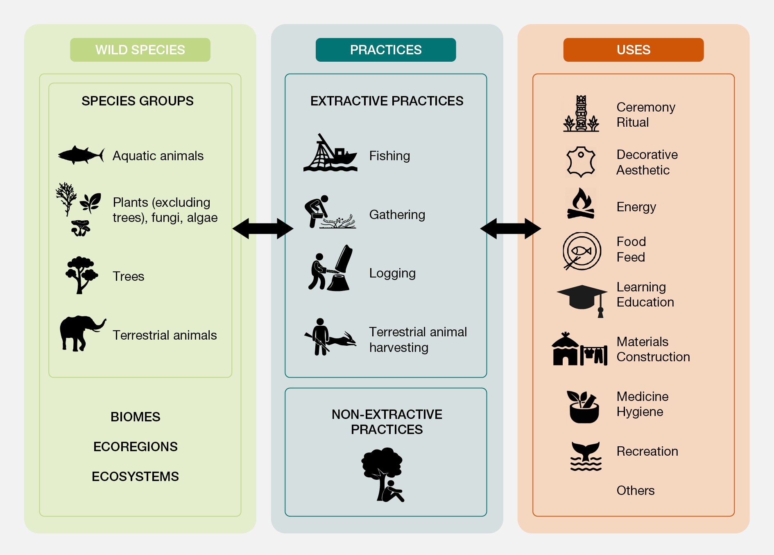Figure SPM.1. Organizing structure of the sustainable use assessment.
A. Sustainable use of wild species is critical for people and nature
The use of wild species is widespread and occurs across almost all aquatic and terrestrial ecosystems, in subsistence to global economies, and is embedded in local and global systems, including for food, medicine, hygiene, energy and many other uses. Addressing the causes of unsustainable use and promoting and ensuring the sustainable use of wild species are critical for people and to address biodiversity decline.
A.1. Billions of people in all regions of the world rely on and benefit from the use of wild species for food, medicine, energy, income and many other purposes.
(A.1.1) The use of wild species directly contributes to the well-being of billions of people globally on a day-to-day basis and is particularly important to people in vulnerable situations (well established) (see appendix II) {1.5, 3.2.1, 3.3.1, 3.3.4.4.2}. Wild species contribute to human well-being through many different types of uses (figure SPM.1), which can be continuous, daily or irregular. In many cases, a single species may have multiple uses and contribute to human well-being in multiple ways (well established) {1.3.4, 3.4.3.1, 4.3.4}. For example, wild plants, algae and fungi provide food, nutritional diversity and income for an estimated one in five people around the world, in particular women, children, landless farmers and others in vulnerable situations (well established) {3.3.2}. 2.4 billion people (approximately one third of the global population) rely on fuelwood for cooking and an estimated 880 million people globally log firewood or produce charcoal, particularly in developing countries (established but incomplete) {3.3.4.4.2}. Small-scale fisheries are strongly anchored in local communities’ ways of life on all continents and support over 90 per cent of the 120 million people engaged in capture fisheries globally. About half of the people involved in small-scale fisheries are women (well established) {3.4.3.1}. People in vulnerable situations are often most reliant on wild species and are most likely to benefit from more sustainable forms of use of wild species to secure their livelihoods (well established) {1.5, 1.6, 3.2.1, 4.2.3.5}. An estimated 70 per cent of the world’s poor depend directly on wild species and on businesses fostered by them (well established) {3.2.1}.
(A.1.2) About 50,000 wild species are used for food, energy, medicine, materials and other purposes through fishing, gathering, logging and terrestrial animal harvesting globally. People all over the world directly use about 7,500 species of wild fish and aquatic invertebrates, 31,100 species of wild plants, of which 7,400 species are trees, 1,500 species of fungi, 1,700 species of wild terrestrial invertebrates and 7,500 species of wild amphibians, reptiles, birds and mammals (well established) {3.2.1.3, 3.3, 3.3.2.3.4}. Among the wild species that are used, more than 20 per cent (over 10,000 species) are used for human food, making the sustainable use of wild species critical to achieving food security and improving nutrition in rural and urban areas worldwide (well established) {3.3}. Fisheries constitute a major source of food from wild species, with a total annual harvest of 90 million tons over recent decades, of which about 60 million tons go to direct human consumption, with the rest used as feed for aquaculture and livestock (well established) {3.2.1.1}. Terrestrial animal harvesting (which includes hunting) contributes to the food security of many people living in rural and urban areas worldwide, especially in developing countries (well established) {3.3.3.3.3}. Wild aquatic and terrestrial animals constitute key sources of protein, fat, and micronutrients, such as calcium, iron, zinc and fatty acids, for the global human population (well established) {3.3.1.5.1, 3.3.2.3.4, 3.3.3.3.3}.
(A1.3) Wild species are important sources of subsistence resources and income. Uses of wild species form the basis for economically and culturally important activities worldwide (established but incomplete) {3.3.2}. Trade in wild plants, algae and fungi is a billion-dollar industry and the establishment of supply chains can fuel economic development and diversification (well established) {3.3.2.1}. People in economically disadvantaged urban and rural areas rely on wild plants, algae and fungi as sources of essential calories, micronutrients and medicine (well established) {3.3.2, 3.3.2.2.2}. Fishing, terrestrial animal harvesting, logging and nature-based tourism are vital to regional and local employment and economies in many developing and developed countries and further contribute to public infrastructure, development and provisioning of related goods and services (well established) {3.3}. The use of wild species also provides non-material contributions by enriching people’s physical and psychological experiences, including their religious and ceremonial lives (well established) {1.3.4, 3.3.5.2.1}.
(A.1.4) Gathering wild plants, fungi and algae takes place in both developed and developing countries worldwide. Such a practice is closely associated with cultural and subsistence practices, and can also supply global markets (established but incomplete) {3.3.2}. Gathering is often assumed to be an activity more prevalent in the global South. However, estimates of individuals and households participating in gathering in Europe and North America range from 4 to 68 per cent, with the highest rates of gathering by households in Eastern Europe (established but incomplete) {3.3.2.2.1}, often irrespective of economic status (established but incomplete) {3.3.2.2.3}. Gathering is not confined to rural areas, with dozens to hundreds of wild plant and fungi species gathered for food, medicine, firewood, decoration and cultural practices in urban ecosystems worldwide (well established) {3.3.2.2.2}. Gathering wild products is often a gendered activity in many parts of the world, with roles depending on cultural rules, on the type of harvested wild plants, fungi or algae and the places where they are harvested. In many countries, women perform the bulk of gathering and processing wild plants for food, medicine, fuel and handicrafts for subsistence purposes and sale in local markets (well established) {3.3.2.2.3, 4.2.3.6.2}.
(A.1.5) Wild tree species are currently the major source for wood and wood products and will continue to be so in the coming decades (well established) {3.3.4.1}. Logging is an important source of subsistence resources and income for millions of people worldwide (well established) {3.3.4.3}. Globally, wild tree species provide two thirds of industrial roundwood {3.3.4.3.3} and half of all wood consumed for energy (established but incomplete) {3.3.4.4.2}. Logging is carried out by smallholders, communities and industrial entities (established but incomplete) {3.3.4.3}. For example, logging by smallholders provides thousands of jobs in Central African countries (well established) {3.3.4.3.1}. An estimated 15 per cent of global forests are managed as community resources by indigenous peoples and local communities, often with a strong focus on multiple use management (established but incomplete) {3.3.4.3.2}, while industrial logging occurs in over one quarter of the world’s forests (well established) {3.3.4.3.3}.
(A.1.6) Nature-based tourism, including wildlife watching, supports mental and physical well-being, raises awareness and facilitates connections to nature, in addition to bringing local benefits such as direct income generation to local communities (well established) {3.3.5}. Although non-extractive practices using wild species are common across all human societies, the nature of the practice differs among cultures and locations (well established) {3.3.5}. Wildlife watching generates substantial revenue, contributing US$ 120 billion in 2018 to global gross domestic product (five times the estimated value of the illegal wild species trade) and sustaining 21.8 million jobs (well established) {3.3.4.2.3}. Prior to the coronavirus disease (COVID-19) pandemic, globally, protected areas received 8 billion visitors and generated US$ 600 billion per year, with species-rich countries experiencing the highest increases in rates of tourism visitation (established but incomplete) {3.3.5.2.3}. Wildlife watching is crucial for local livelihoods, provides employment and promotes development of tourism-related infrastructure, particularly in some remote locations (well established) {3.3.5.2.3, 3.4.4.2}.
(A.1.7) Potential contributions from sustainable use of wild species to meeting the Sustainable Development Goals are substantial, but largely overlooked (established but incomplete) {1.6}. Measures to ensure and promote the sustainable use of wild species will make direct contributions to meeting many of the Sustainable Development Goals. While the contributions of the sustainable use of wild species have been identified for Goal 14 (life below water) and Goal 15 (life on land), there is untapped potential for contributions to the rest of the Sustainable Development Goals (figure SPM.2) (established but incomplete) {1.6}. Further attention to ways in which the sustainable use of wild species can support good quality of life for people and the planet will contribute to realizing these global goals (well established) {1.6, 2.2.10}.
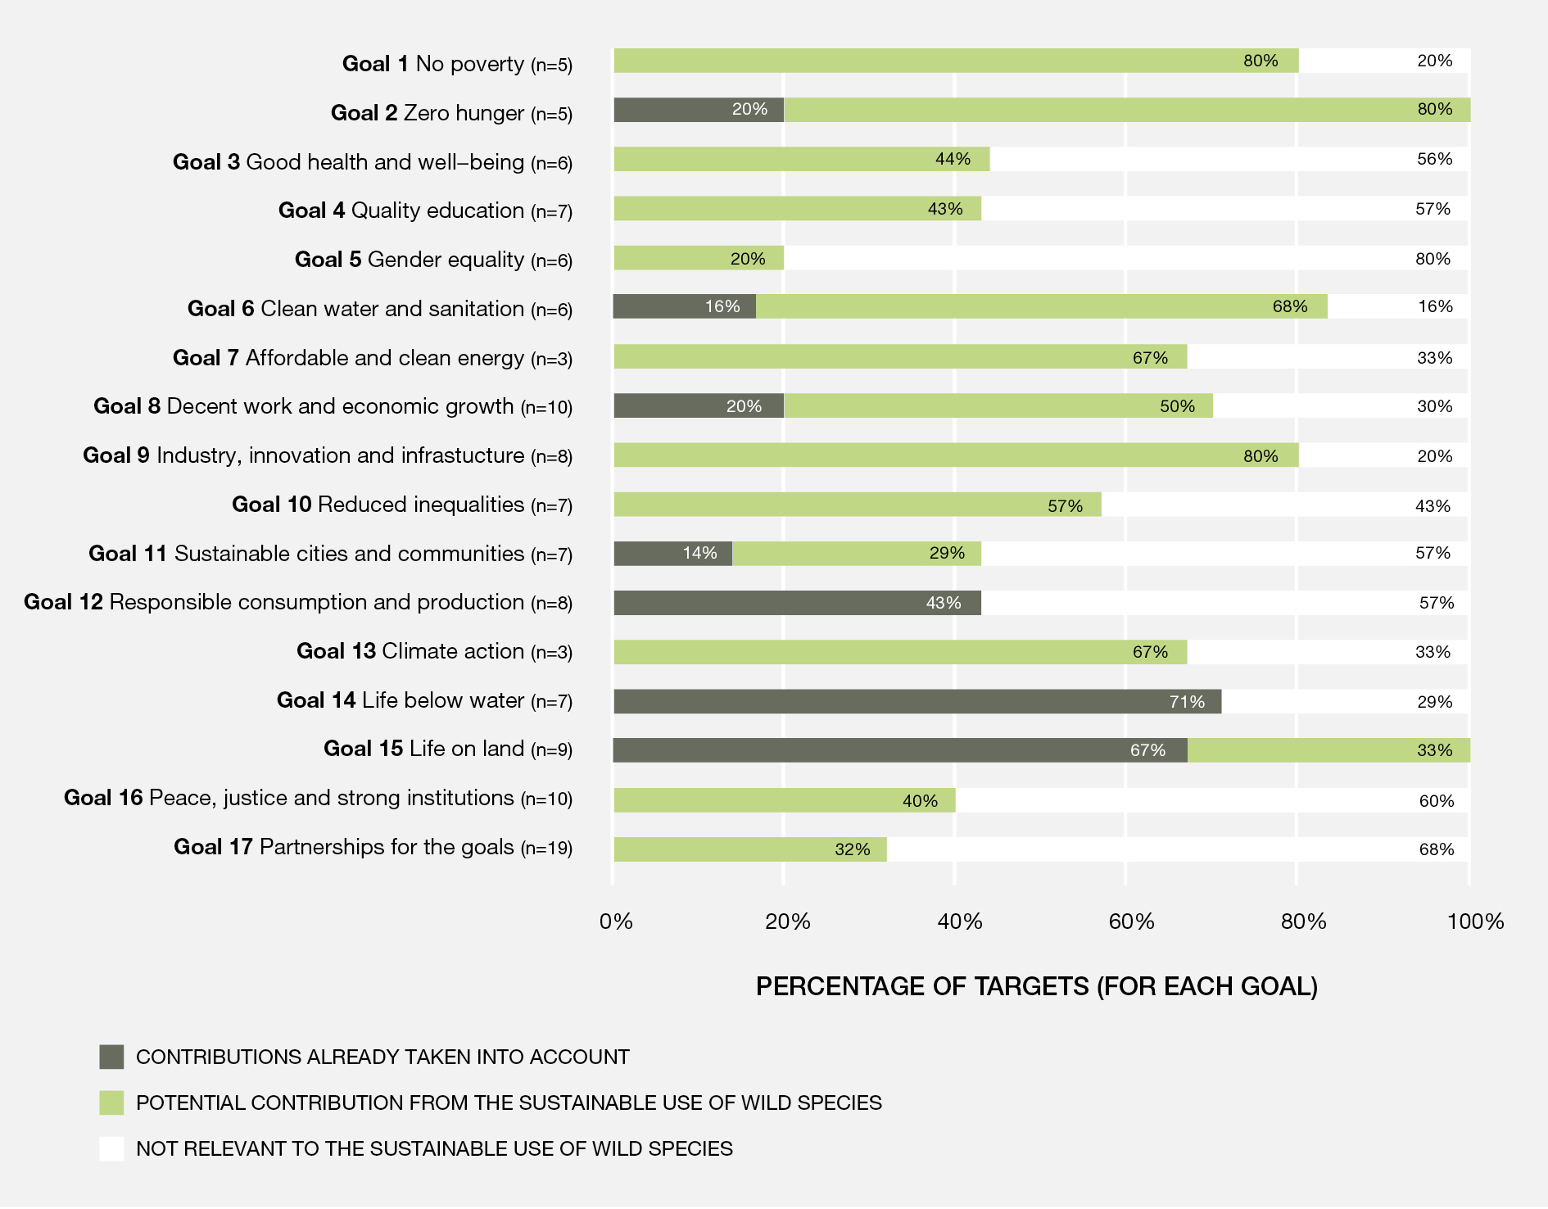
Figure SPM.2. Sustainable use of wild species has unacknowledged potential to contribute to the achievement of many targets of the Sustainable Development Goals. This figure shows the untapped potential of including the sustainable use of wild species in strategies to achieve the Sustainable Development Goals. The potential contribution of the sustainable use of wild species to achieve each Goal was assessed based on the wording of the “outcome targets” (n=x) under each Goal and the evidence documented in the Thematic Assessment of the Sustainable Use of Wild Species. The percentages showed in the figure refer to the number of targets related to the sustainable use of wild species that are “already taken into account” (grey bar), have "potential relevance" (green bar), or have "no relevance” (white bar) to achieve each Goal. Supporting information and details on assessments for each Goal are available in chapter 1 {1.6}. A data management report for this figure is available at https://doi.org/10.5281/zenodo.6036274.
A.2. Sustainable use of wild species is central to the identity and existence of many indigenous peoples and local communities.
(A.2.1) Wild species play essential roles in the well-being of many indigenous peoples and local communities. Loss of opportunity to engage in sustainable use of wild species represents an existential threat to indigenous peoples and local communities (well established) {1.4, 2.2.4, 3.3.1.4, 3.3.2., 3.3.3, 3.3.4.3.1, 4.2, 6.5, 6.6}. Uses of wild species are central to the identities, cultural expressions and livelihoods of many indigenous peoples and local communities (figure SPM.3). While all wild species in use are important, some have special significance as cultural keystone species (box SPM.1); that is, they provide multiple benefits that define key elements of a people’s tangible and intangible cultural heritage. Continued ability to engage in sustainable use of wild species and the cultural practices associated with them is essential for indigenous peoples and local communities to survive and thrive (well established) {1.4, 2.2.4, 2.2.8, 3.2.1, 3.3.3, 3.3.4, 4.2.2.2.5, 4.2.3.4, 4.2.3.5, 4.2.2.6, 6.5.2}.
Box SPM.1. Cultural keystone species: wild rice
Wild rice (Zizania palustris) is a cultural keystone species, providing physical, spiritual and cultural sustenance for many indigenous peoples in the Great Lakes region of North America. Remarkable for its high protein and micronutrient profile when processed correctly, this aquatic grain can be stored for long periods of time, which represents a particularly important property in a region characterized by severe winters and short growing seasons. The significance of wild rice to the identities of indigenous peoples in the region can be seen in nomenclatures and traditions. The name of the Menominee Indian Tribe of Wisconsin (United States of America) means “wild rice people”. When the Anishinaabe peoples migrated from the Atlantic coast and the north-east of North America, oral tradition instructed that they should move westward until they arrived at “the place where food grows on water”. Wild rice remains a healthy staple in the diets of indigenous peoples in the Great Lakes region and is an important part of many feasts and ceremonies {1.4.1}.
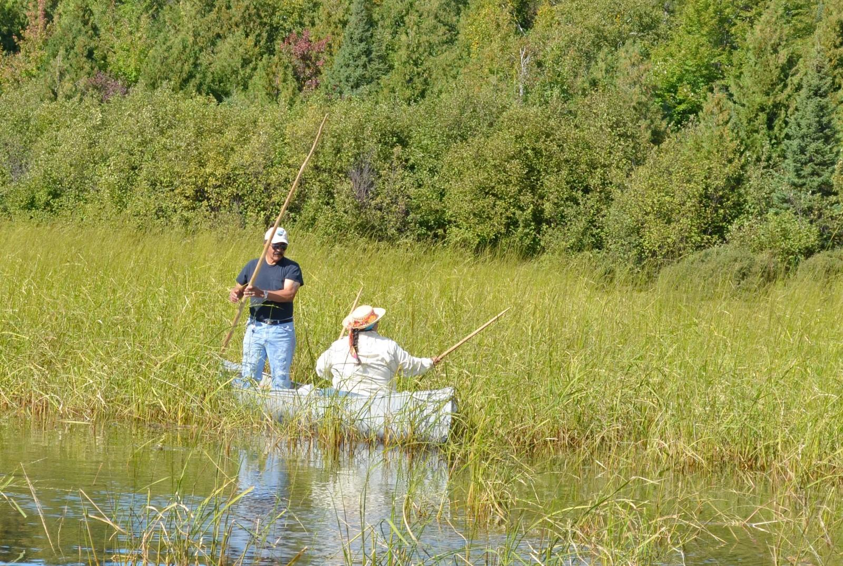
Harvesting wild rice, a cultural keystone species for indigenous peoples in the Great Lakes region of North America.
(A.2.2) Sustainable use of wild species contributes to the livelihoods of indigenous peoples and local communities through subsistence, as well as trade in informal and formal markets (well established) {4.2.4.3.2}. Subsistence uses of wild species are important sources of food, medicine, fuel and other livelihood resources for indigenous peoples and local communities in both developed and developing countries. Often, wild species are considered superior to cultivated species or other substitutes, as identified in discussions with indigenous peoples and local communities. Many wild foods have nutritional benefits over processed foods and there may be no culturally acceptable alternative for ceremonial and ritual materials (well established) {3.3.1.7.1, 3.3.2.3.4, 3.3.3.3.3, 3.3.3.4.2, 3.3.5.2.1}. Wild species also provide a basis for culturally meaningful employment (well established) {1.6, 3.3.3.2.1, 3.3.5.2.3}. Indigenous peoples and local communities have engaged in long-distance trade of wild species and materials derived from them for millennia. Trade continues to be an important source of goods and monetary income for many indigenous peoples and local communities (well established) {4.2.4.3.2}.
(A.2.3) Knowledge, practices and worldviews guide sustainable uses of wild species by many indigenous peoples and local communities (well established) {1.4.1, 2.2.4, 2.2.5, 4.2.5.2.4}. For many indigenous peoples and local communities, sustainable uses of wild species are embedded in and maintained through indigenous and local knowledge, practices and spirituality. While indigenous and local knowledge and the cultures of indigenous peoples and local communities are diverse, common values with respect to sustainable use of wild species include an obligation to engage nature with respect, reciprocate for what is taken, avoid waste, manage harvests and ensure fair and equitable distribution of benefits from wild species for community well-being (well established) {1.4, 2.2.4, 4.2.5.2.4}. These values are frequently upheld by community institutions and governance (well established) {2.2.4.2, 4.2.2.4}.
Figure SPM.3. Sustainable use of wild species is essential to the well-being of many indigenous peoples and local communities. In turn, sustainable use also contributes to maintaining abundant, healthy populations of wild species. Photos, clockwise from top. Well-being and health: fishing by Mayangna communities in Nicaragua. Language: Inuit language encodes knowledge necessary for successful hunting, fishing and trapping in the Canadian Arctic. Art, crafts and music: animal motifs engraved on an ostrich egg by a Khomani San artist from the Kalahari, South Africa. Ritual and ceremony: spring festival in the Kedarnath Valley, India. Animals and plants as kin, totems and spirits: vicuñas are revered by peoples of the Andean altiplano. Community institutions and governance: the Karamojong people of Uganda make decisions about uses of wild species in a sacred meeting place. Livelihoods and economy: in the Solomon Islands, fishing is central to local livelihoods. Fishing is organized around customary sea tenures and fish are distributed through a kinship-based system. Clothing, fuel, fodder and shelter: the bark of Himalayan nettle is used as fibre for clothing, ropes and sacks by indigenous peoples and local communities in Nepal. Food: in the Brazilian Amazon a local fisherman carries a pirarucú, an important food fish. Traditional medicines: a Roma woman gathers Hypericum sp. in the Carpathians. Learning and knowledge transmission: in Canada, an Inuk boy learns how to skin a caribou.
A.3. Ensuring sustainability of the use of wild species, including by promoting sustainable use and halting overexploitation, is critical to reverse the global trend in biodiversity decline.
(A.3.1) Effective management systems that promote the sustainable use of wild species can contribute to broader conservation objectives (established but incomplete) {1.1.1, 3.3.3.3.4, 3.3.3.4.1, 3.3.4.3.2, 3.3.5.2.3, 4.2.4.3.1}. Based on the assessment of 10,098 species from 10 taxonomic groups documented for the International Union for Conservation of Nature Red List of Threatened Species, at least 34 per cent of the wild species assessed are used sustainably (established but incomplete) {3.2.1, 3.2.2, 4.2.4.3.1}. This includes 172 threatened or near-threatened species. Effective management systems that promote sustainable use, supported by policies linked to land tenure and rights of access, have contributed to the conservation of ecosystems such as forests at the local level (well established) {3.3.2.3.4., 4.2.2.2.4, 4.2.2.6}. Revenues from the sustainable use of wild species can make a substantial contribution to the conservation of landscapes and seascapes (established but incomplete) {4.2.3.3.5, 4.2.4.3.1, 4.2.4.3.3, 4.2.5.2.3}. Revenues from non-extractive practices, notably tourism in protected areas, can make a significant contribution to overcoming funding shortfalls for protected areas if the revenue is used to support protected area management (established but incomplete) {4.2.4.3.1}. Revenues from the extractive use of wild animals, including hunting and fishing licenses and concession fees, provide an important and substantial income stream for conservation agencies and local communities in some countries (well established) {3.3.3.2.4}. Large areas of land that are managed for recreational hunting (e.g., approximately 1.4 million km² in Africa) could contribute to conservation objectives and spatial conservation targets, but their unique biodiversity values as well as their ecological and social durability have mostly not been evaluated (established but incomplete) {3.3.3.2.4}.
(A.3.2) Overexploitation has been identified as the main threat to wild species in marine ecosystems and the second greatest threat to those in terrestrial and freshwater ecosystems (well established) {1.1, 3.3.1.4}. Addressing the causes of unsustainable use and reversing the trend will result in better outcomes for these wild species. Many uses of wild species occur within the context of declining wild species populations and ranges. For example, unsustainable fishing is the main cause of the increased extinction risk of sharks and rays over the past half-century (well established) {3.3.1}. Among the 1,250 shark and ray species identified today, 1,199 have been recently assessed and 449 (37.5 per cent) have been assessed as threatened (well established) {3.3.1.3}. Unsustainable hunting has been identified as a threat for 1,341 wild mammal species, including 669 species that were assessed as threatened, and declines in large-bodied species with low intrinsic rates of population increase have been linked to hunting pressure (well established) {3.3.3}. Negative impacts of hunting have also been reported for bird species (well established) {3.3.3.2.5, 3.3.3.2.6, 3.3.3.3.4}. An estimated 12 per cent of wild tree species are threatened by unsustainable logging {3.2.1.4} and unsustainable gathering is one of the main threats for several plant groups, notably cacti, cycads and orchids (well established), as well as other plants and fungi harvested for medicinal purposes {3.2.2, 3.3.2.3.2, 4.2.4.3.1}. Overall, unsustainable harvesting contributes towards elevated extinction risk for 28–29 per cent of near-threatened and threatened species from 10 taxonomic groups assessed on the International Union for Conservation of Nature Red List of Threatened Species {3.2.1, 3.2.2}.
(A.3.3) Indigenous peoples manage fishing, gathering, terrestrial animal harvesting and other uses of wild species on more than 38 million km² of land in 87 countries (well established) {1.3.2}. This area coincides with approximately 40 per cent of terrestrial conserved areas, including many with high biodiversity value (well established) {1.3.2, 1.4}. Globally, deforestation is generally lower on indigenous territories, in particular where there is security of land tenure, continuity of knowledge and languages and alternative livelihoods (well established) {4.2.2.2.5}. The long history of sustainable uses of wild species in these areas has played a role in maintaining and increasing local levels of biodiversity while supporting indigenous peoples’ well-being and livelihoods (well established). Examples of customary provisions to promote the sustainable use of wild species include rest periods, spatial and temporal prohibitions on use, and designation of areas and species for exclusive use by kinship groups (well established) {1.1.2, 1.4, 3.3, 4.2.5.2}.
B. Status and trends in uses of wild species
Status and trends in uses of wild species display strong disparities according to the social and ecological contexts in which they occur. Although common principles of sustainable use have been identified, methods and tools to assess the sustainability of the use of wild species are constrained by lack of a comprehensive set of indicators, especially regarding non-extractive use and social components of extractive uses.
B.1. Status and trends in uses of wild species vary depending on types and scales of use, and social-ecological contexts.
(B.1.1) Recent global estimates indicate that approximately 34 per cent of marine wild fish stocks are overfished and 66 per cent are fished within biologically sustainable levels, but this global picture displays strong heterogeneities (well established) {3.2.1.1}. In countries or regions implementing robust fisheries management, stocks are increasing in abundance and tend to be above target levels (figure SPM.4) (well established) {3.3.1}. These countries provide roughly half of the fisheries landings reported to the Food and Agriculture Organization of the United Nations and mostly concern large-scale fisheries (well established) {3.3.1}. For countries and regions with low-intensity fisheries management measures, the status of stocks is often poorly known (well established) {3.3.1.2}, but generally believed to be below the abundance that would maximize sustainable food production (established but incomplete) {3.3.1}. For small-scale fisheries that have been assessed around the world, many have been considered to be unsustainable or only partially sustainable, especially in Africa for both inland and marine fisheries and in Asia, Latin America and Europe for coastal marine fisheries (established but incomplete) {3.3.1.4.1}. The diversity of contexts in which small-scale fisheries operate have often made conventional data-driven fisheries management inadequate and unsuccessful, but when the involvement, participation and empowerment of indigenous peoples and local communities are maintained or promoted, the sustainability of small-scale fisheries can be achieved (well established) {6.5.1.1, 6.5.3.1}.

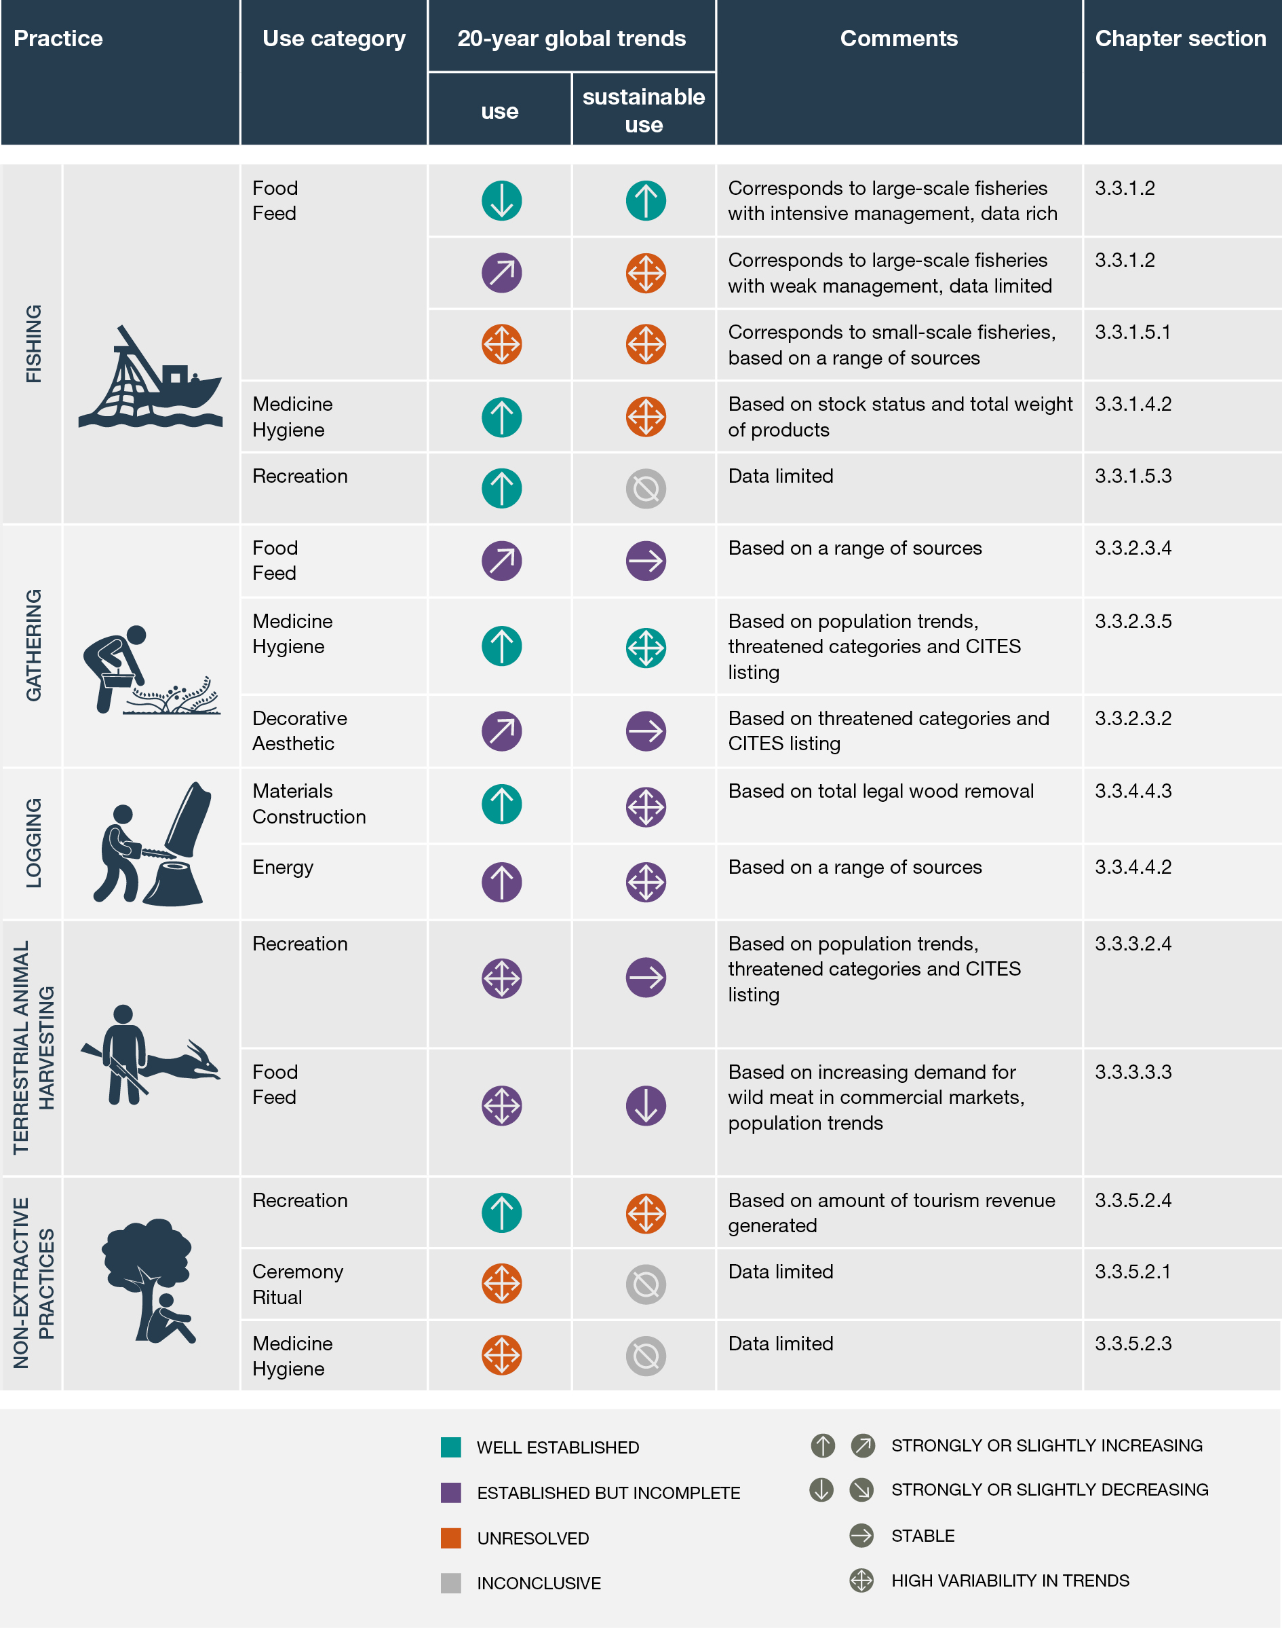
Figure SPM.4. Global trends in use and sustainable use of wild species from 2000 to the present. The figure shows only the top two to three use categories for each practice, selected based on which uses were most documented in the systematic literature reviews conducted as part of chapter 3 analysis. Additional use categories are included in chapter 3 {3.3}. Trends in use refer to an assessment of the overall state of use for wild species in relation to the specified practice, i.e., has overall use increased strongly, increased, stayed the same, decreased or decreased strongly. The multi-directional arrow depicts highly variable trends across areas or sectors for a given category of practice-use. The colours of the arrows refer to the confidence levels associated with those trends. Trends in sustainable use specifically refer to whether the intensity and form of use have been deemed sustainable over the 20-year period. For additional explanations see the definition of sustainable use in the glossary of the assessment. Data supporting global trends and regional variations come from practice-based systematic reviews of over 1,600 scientific texts. Use of indicators and other variables in the analysis varied widely across the five practice categories. The search for appropriate indicators demonstrated knowledge gaps in existing global data sets and indicators sets {3.2}. Thus, the comments column contains brief reference to how the trend was determined, with further explanations in chapter 3 as referenced in the final column. In some categories a subdivision demonstrates the ways in which the practice is understood and analysed in the available literature. For a definition of the practices, see appendix I of the present summary, and for an explanation of knowledge gaps, see appendix III. Abbreviations: CITES – Convention on International Trade in Endangered Species of Wild Fauna and Flora.
(B.1.2) Unintentional bycatch of threatened and/or protected marine species is unsustainable for many populations, including wild sea turtles, seabirds, sharks, rays, chimaeras, marine mammals and some bony fishes. Reducing unintentional bycatch and discards is progressing, but still insufficient (well established) {3.3.1.1}. While fishing of target species may be sustainable, the conservation status of bycatch species and other associated and dependent species is often poorly known. Bycatch is a well-known issue for several large-scale fisheries, such as shrimp or bottom-trawl fisheries, but it is also a concern for several small-scale fisheries (well established) {3.3.1.1, 3.3.1.5}. There have been recent advances in monitoring and managing fishing mortality of marketable incidental species and discarded bycatch species, however global uptake of effective bycatch management measures is severely lagging in a majority of marine capture fisheries (well established) {3.3.1.5}. For example, nearly all (99 per cent) shark and ray species are officially declared to be taken unintentionally, but are valuable and are retained for food. Consequently, shark species have been declining steeply since the 1970s, especially in tropical and subtropical coastal shelf waters (well established) {3.3.1.3}.
(B.1.3) Trade in wild plants, algae and fungi for food, medicine, hygiene, energy, and ornamental use is increasing (figure SPM.4) (well established) {3.3.2}. There is a growing demand for wild foods in the food and aromatics industries including among fine dining and haute cuisine establishments, and among urban populations (well established) {3.3.2.2.2, 3.3.2.3.4}. There is also a growing interest and ongoing demand for products produced at least in part from harvested wild plants and fungi, to complement chemical medicines in many developed and developing countries (well established) {3.3.2.3.5}. Trade in ornamental plants has increased rapidly over the past 40 years. Although much of the trade is in cultivated plants, poaching of ornamental species from the wild continues to occur, and can threaten the survival of species (well established) {3.3.2.3.2}. Harvests that have been sustainable in the past due to smaller markets and sustainable harvesting practices may become unsustainable if, for example, harvesting is undertaken without following established techniques and protocols (well established) {3.3.2.3.4}, or new technologies are employed which increase the volume of harvest or result in damage to or death of the organism, for example when entire trees are felled rather than climbed to harvest ripe fruits (established but incomplete) {3.3.2}.
(B.1.4) Terrestrial animal harvesting takes place in a variety of governance, management, ecological and socio-cultural contexts, which affect the outcomes for sustainable use. Globally, populations of many terrestrial animals are declining due to unsustainable use, but the impacts of use on wild species and society can be neutral or positive in some places (figure SPM.4) (well established) {3.3.3}. Hunting (a sub-category of terrestrial animal harvesting, see appendix I) for food, medicine and recreation is a prominent practice in terms of number of species and biomass of harvested animals (well established) {3.3.3.2}. Sustainability of hunting for food, especially in tropical areas, has been negatively affected by profound socio-economic changes, which have resulted in shifts from local-level subsistence towards more intensive wild meat trade (well established) {3.3.3.2.3}. The impacts of hunting on the abundance of wild species vary worldwide depending on the biological characteristics of the animals as well as the management systems but are generally lower for species with high population growth rates, or high ecological adaptability, and where hunting is well managed (well established) {3.3.3.2.4}. There is considerable variation in the way recreational hunting is governed and administered in different regions, which makes any generalization about its sustainability or unsustainability difficult {3.3.3.2.4}. Some species are recovering from small population sizes under management systems that allow regulated recreational hunting, usually as a way to generate revenue and increase the land area for population expansion (established but incomplete) {3.3.3.2.4}. Harvesting live animals for a variety of purposes, including the pet trade, affects thousands of wild species. There are more than 1,000 species of birds, reptiles, fish and mammals legally and illegally traded for personal and commercial use as pets. While the total dollar value of species traded as pets is less than 1 per cent of the total trade of wild species, the number of individuals traded is in the millions (established but incomplete) {4.2.4.1}. For example, about 12 million live parrots were recorded in international trade between 1980 and 2015 (established but incomplete) {3.3.3.3}. Harvesting of vicuña (Vicugna vicugna) fibre is a good example of sustainable non-lethal use of wild animals, associated with an increase of populations across its range, especially in areas where communities benefit from sustainable use projects (well established) {4.2.4.4.1}.
(B.1.5) Large-bodied mammals are the most targeted species for subsistence and commercial hunting, as these animals provide more meat for consumption and sale to generate more economic benefits for hunters’ households (well established) {3.3.3.2.3}. Large mammals alone comprised 55 per cent to 75 per cent of total wild meat biomass hunted annually in different regions of the world, although hunters may target smaller animals when large animals become scarce and some traditional small band societies (e.g., the San, the Hadza, the Ache, Native American groups) harvest small game as a primary source of protein and daily nutrition (well established) {3.3.3.2.3}. Selective hunting of particular species, individuals or populations which have particular attributes (e.g., large-sized or large horns) can impact ecosystem structure and processes, and cause changes to the genetic structure of affected populations {3.3.3.2.4}, shifts in the distribution of species across multiple trophic levels and shifts in ecosystem functions (well established) {3.3.3.3.1, 3.3.3.3.3}.
(B.1.6) Logging for energy is prevalent globally, but reliance on wood for heating and cooking is highest in developing countries (well established) {3.3.4}. Logging for energy accounts for 50 per cent of all wood consumed globally, and accounts for 90 per cent of timber harvested in Africa. Fuelwood use is declining in most regions but is increasing in sub-Saharan Africa (established but incomplete) {3.3.4.4.2}. Fuelwood demand can be met at a global and national scale when comparing supply-demand balances, but localized fuelwood shortages and associated forest and woodland degradation occur in areas where people have few alternatives for cooking and heating (established but incomplete) {3.3.4.4.2}. Sustainable fuelwood logging remains a renewable energy opportunity that provides income, heating and cooking in developing countries where 1.1 billion people do not have access to electricity or alternative energy sources (established but incomplete) {3.3.4.4.2}, provided air pollution (indoor and outdoor) and climate change emissions are mitigated.
(B.1.7) Destructive logging practices and illegal logging threaten sustainable use of natural forests (established but incomplete) {3.3.4}. The outcomes of logging affect forest ecology, as well as other forest-based uses of wild species, such as gathering, terrestrial animal harvesting and observing wild species (well established) {3.3.4}. Demand for wood and, therefore, logging are expected to increase (well established) {3.3.4.1}. Although there is an expected increase in production of plantation wood, there is also a projected increase in timber demand that will not be matched by plantation wood (well established) {3.3.4.1, 3.3.4.1.2}. Inventory-based management plans, selective logging and reduced-impact logging practices could reduce the impacts of logging, including threats to non-target species, but logging sustainability depends on the planning, techniques and implementation used to minimize damage to the residual forest stand, as well as forest soils, flora and fauna (well established) {3.3.4.2}. About 20 per cent of the world’s tropical forests (3.9 million km²) are currently subject to selective logging (well established) {3.2.1.4, 3.3.4.2}. A geographic shift has been observed in illegal logging and related timber trade. Illegal logging has declined in parts of the tropical Americas, as well as parts of the tropical and mountainous regions of Asia due to improved monitoring and collaborative transboundary collaborations. However, illegal logging and trade have increased in other regions, including Southeast Asia, Northeast Asia and parts of Africa (established but incomplete) {3.3.4.2}.
(B.1.8) Nature-based tourism is an important non-extractive practice and recreational use of wild species. Demand for media (e.g., documentaries) and in situ observing (e.g., wildlife watching tourism) related to wild species was growing up to 2020 (figure SPM.4) (well established) {3.3.5.2.3}. Wildlife watching tourism generates significant revenues and has the potential, when it is regulated and well-managed, to make positive contributions to the conservation of wild species, community development and livelihoods (well established) {3.3.5.2.3}. Although non-extractive practices are frequently less directly harmful to wild species and ecosystems than extractive ones, wildlife watching may have unintended detrimental impacts through changes to species behaviour, physiology, the health of species, ecosystems or humans, or damage to habitats (well established) {3.3.5.2.3}. Lack of effective institutions, enforcement, regulatory measures and governance structures often make it challenging to address negative outcomes (well established) {2.2.3}. Many of the unsustainable impacts of the tourism industry could be mitigated through context-based understanding, implementation of best practice guidelines for observing, education of tourists and tour operators, collaborative engagement with all stakeholders and sector-specific regulation (well-established) {3.3.5.2.3}.
B.2. The sustainability of the use of wild species is influenced negatively or positively by multiple drivers.
(B.2.1) Multiple drivers affect the sustainability of the use of wild species and these interact with one another (figure SPM.5) (well established) {4.3, 4.4}. Outcomes for a particular species and a particular practice can be simultaneously impacted by multiple drivers, some positive, some negative, as well as mediating factors that may mitigate or amplify impacts on multiple scales. As a result, to be effective, governance responses address the multiple drivers affecting use and are flexible enough to accommodate differences among species, practices, sites and scales. For instance, the sustainability of wild meat hunting is increasingly driven by socio-economic changes, recreation, entertainment, trade, or trafficking, rather than solely by hunting for subsistence (well established) {3.3.3}.

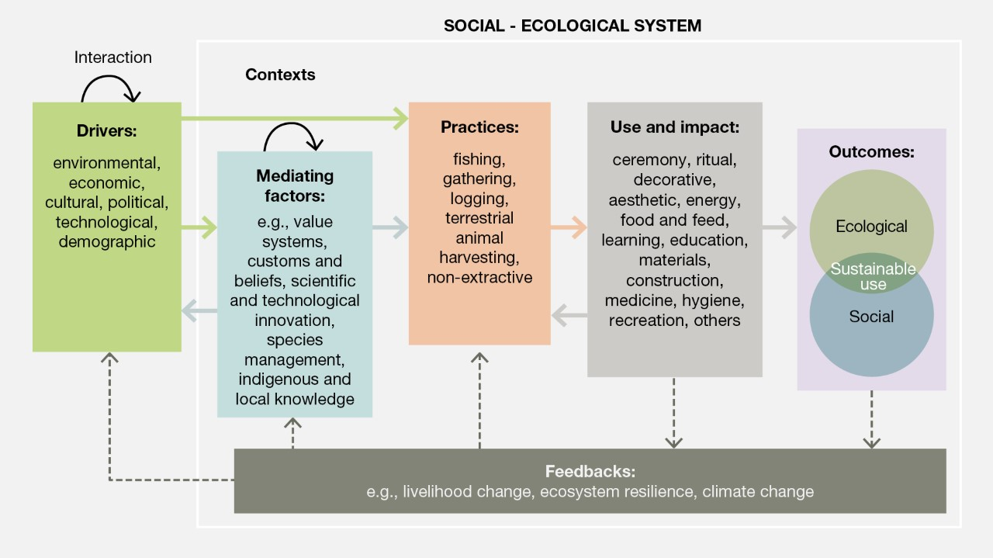
Figure SPM.5. Conceptual approach to the drivers of sustainable use of wild species. Diagram showing relationships between different components of the social-ecological systems relating to the direct use of wild populations, as they have been conceptualized in the Thematic Assessment of the Sustainable Use of Wild Species. The diagram shows how these systems are affected by a combination of drivers (green) and mediating factors (blue) that affect practices (orange) and uses (grey). The complex nature of these interactions means that it is often not possible to separate the effects of direct drivers from those of indirect drivers as defined in the IPBES conceptual framework.
(B.2.2) Drivers such as landscape and seascape changes, climate change, pollution and invasive alien species impact the abundance and distribution of wild species, and can increase stress and challenges for the human communities who use them (well established) {4.2.1.2., 4.2.1.4, 4.2.1.5, 4.2.1.6}. The prevailing trend is a reduction in species’ abundance and shifts in their spatial distributions, although landscape and seascape changes, climate change, pollution and invasive alien species may positively affect some species. These drivers also place pressure on the capacity of systems to sustain extractive harvests at previous levels and may increase the need to use wild species to meet basic needs. Efforts to directly address such drivers can also have positive outcomes for sustainable use (established but incomplete) {4.2.1.2., 4.2.1.5.}.
(B.2.3) Climate change is an increasingly strong driver affecting sustainable use, creating many challenges (well established) {4.2.1.2}. Climate change strongly affects the use of wild species through, for example, changes to mean temperature and precipitation, the impacts of increased frequency and intensity of hydro-meteorological events and changes in spatial distribution, productivity and habitats of wild species under use (well established) {4.2.1.2}. For example, climate-related impacts on logging include changing forest composition and productivity as a result of increased intensity and frequency of floods, droughts and wildfires. While cultural burning and prescribed fire will continue to be important forest management tools, repeated intense wildfires have the potential to degrade landscapes, reduce local population density of important understory and overstory species and support proliferation of invasive alien species (established but incomplete) {4.2.1.2.5}. These effects are compounded and complicated by interactions of climate change with other environmental, sociocultural, political and economic drivers and associated underlying causes. Developing effective responses is also challenged by incomplete knowledge of climate change patterns and by many gaps in understanding of how climate change affects sustainability of uses (established but incomplete) {4.2.1.2}.
(B.2.4) Regulations, together with market forces, have resulted in a shift from wild species to specimens derived from farmed stocks (established but incomplete) {4.2.4.3.1}. Over the past 40 years, trade in many wild populations has been replaced or supplemented by trade from farmed stocks of the same species of plants or animals (well established) {4.2.2.2.1, 4.2.4.3.1}. Such farming is notable for fish, birds, amphibians and plants where more than 50 per cent of recorded trade is from farmed sources (well established) {3.2.1.1, 3.3.1.5.1}. This shift has been attributed to multilateral agreements and associated legislation restricting trade in wild harvested specimens, combined with market forces relating to quality and consistency of supply {3.2.1.1, 4.2.2.2}. Shifts to farmed stocks can reduce harvest impacts on wild populations where there is no specific demand for specimens of wild origin and where laundering of illegally harvested wild specimens into trade can be avoided (established but incomplete) {4.2.2.2.1}. However, the impacts of a shift to farmed stocks on livelihoods, equitable sharing of benefits, conservation of habitat, welfare of farmed animals, potential introduction of invasive alien species and potential transmission of zoonotic diseases need to be considered as part of the individual evaluations of sustainable use (established but incomplete) {4.2.1.4}.
(B.2.5) Throughout the world, where people living in poverty rely on the use of wild species, environmental degradation and resource depletion threaten their livelihoods and well-being (well established) {4.2.3.5}. Rural populations in developing countries rely disproportionally on the use of wild species and comprise nearly 3.5 billion people, or 45 per cent of the human population (established but incomplete) {4.2.3.3.5, 4.2.3.5.2}. A great diversity of wild species (aquatic and terrestrial animals, plants, fungi and algae) is harvested for subsistence purposes in the Americas, Asia and Africa, as an affordable and easily accessible resource (well established) {4.2.3.5}. Drivers related to economics and governance can contribute towards unsustainable use (well established) {4.2.3.3, 4.2.3.5}. The lack of complementary alternatives for people living in poverty, which can be driven by many factors, may lead them to intensify their use of wild species, further depleting the resource in decline and creating negative feedback that exacerbates poverty, resource depletion and environmental degradation. However, economic and political systems that perpetuate poverty and inequity are the underlying drivers of such unsustainable uses (well established) {4.2.3.3, 4.2.3.5}. Effective policies consider levels of poverty, inequality and food insecurity, that affect developing countries in particular, as well as social, including economic, conditions and cultural preferences (well established) {4.2.2.7.1, 4.2.3.5}.
(B.2.6) Multiple drivers threaten indigenous peoples’ and local communities’ ability to maintain and restore practices associated with sustainable use of wild species (well established) {4.2.2.4, 4.2.3.4, 4.2.4.3.1}. International instruments that support the rights of indigenous peoples and local communities to access lands, territories and customary sustainable resource uses have not always been fully implemented in national policies. Lack of data and indicators to monitor progress in this regard undermines opportunities to support the sustainable use of wild species by indigenous peoples and local communities (well established) {2.2.9.3, 2..3.3, 4.2.2.4, 4.2.3.4}. Sectoral policies, such as those related to forestry, agriculture, energy, infrastructure and resource extraction, as well as conservation policies, also frequently compromise access of indigenous peoples and local communities to traditional lands and resources (well established) {6.4.4.1}. Other factors that threaten sustainable use of wild species by indigenous peoples and local communities include loss of indigenous and local languages (established but incomplete) {3.3, 4.2.5.1, 4.2.5.2.1}, education programmes divorced from local, cultural and environmental conditions (well established) {4.2.6.4.2, 6.4.3.2}, and lack of attention to gendered roles, including those in matrilineal and matriarchal cultures (well established) {4.2.3.5}. Many indigenous peoples and local communities identify integration into monetized and commodified economic systems as undermining values toward nature and sustainable use of wild species (well established) {3.3.2.3.5, 3.3.3.3.4, 4.2.5, 6.4.4.4}.
(B.2.7) Land tenure and resource rights can contribute to sustainable use (well established) {4.2.2.6}. Tenure arrangements that foster secure rights over land and resource use and trade can incentivize resource conservation, sustainable use, and diverse livelihoods, in part because there are more opportunities for effective regulation of use patterns (established but incomplete) {4.2.2.3} and they allow for longer-term planning. In regions where tenure insecurity has been reduced there is evidence of improved food security and positive conservation outcomes for wild species (well established) {4.2.2.6}. However, illegal seizures of land violate the rights of indigenous peoples, diminishing food security and positive conservation outcomes for wild species (established but incomplete) {4.2.6.2.3}.
(B.2.8) Inequitable distribution of costs and benefits from the use of wild species often undermines sustainability (well established) {4.2.2.5}. Allocation of usage rights and benefits can be influenced by existing inequities within and between communities and companies and between generations {4.2.2.6.1}, across levels of government, among jurisdictions with shared governance of cross-boundary species, and others. These inequities can be expressed both at the site of wild species’ use and at all scales of trade, particularly when products are sold outside the community (well established) {4.2.2.7}.
(B.2.9) Gender is seldom taken into account in the governance of wild species, leading to inequities in the distribution of costs and benefits from their use. There are often gender inequities in how the costs and benefits of wild species’ uses are distributed, with women bearing more of the costs and receiving fewer benefits of use (well established) {3.3.4.2.2., 4.2.3.6, 6.4.3, 6.4.4}. Many institutions and policies governing wild species’ use do not take gender into account, resulting in women being excluded from decision-making processes, which further exacerbates burdens on women and those of diverse gender identities {4.2.3.6.3, 6.5.4.1}. Frequently, these inequities result from disparities in the security of land tenure and access (well established) {4.2.2.6}. Securing women’s participation in decision-making leads to better resource governance outcomes, sustainable livelihoods and resilience.
(B.2.10) Urbanization is a dominant global trend which has negative impacts or indirect positive influences on sustainable use (well established) {4.2.3.3.4}. The shift from rural to urban lifestyles can reduce the use of some wild species, notably those linked to subsistence livelihoods, but this effect varies among contexts and interacts with other factors, such as infrastructure development and cultural and economic conditions (established but incomplete) {4.2.3.2, 4.2.3.3.4}. Furthermore, this transition is often characterized by the growth of peri-urban areas. In such areas, densities are urban, but economic infrastructure and services are still rural-oriented, resulting in ongoing demand for wild species that leads to overexploitation and unsustainable use. Similarly, urbanization and development are associated with increased demand for some wild species, such as wild meat and seafood products (established but incomplete) {4.2.1.5, 4.2.3.3.4, 4.2.4.3.1}.
(B.2.11) Global trade in wild species is a major driver of increased use. When not effectively regulated, it can become a driver of unsustainable use. Global trade in wild species has expanded substantially over the past 40 years in terms of volumes, value and trade networks (well established) {4.2.4.4.1, 4.2.2.2.1}. Global trade in wild species, both live or of their parts and derivatives, provides an important income source for exporting countries, often higher income for harvesters, and can diversify sources of supply to allow pressure to be redirected from species being used unsustainably (well established) {4.2.2.2.1}. However, global trade in wild species also decouples the consumption of wild species from the place of origin, introduces structures and dynamics that are different from those that govern local trade relations and practices, and can shift governing strategies from collective action to individual-based strategies (established but incomplete) {4.2.1.4, 4.2.4.4.1}. Without effective regulations operating across the supply chain (from local to global), global trade in wild species generally increases pressure, leading to unsustainable use and sometimes to wild population collapses (e.g., shark fin trade) (well established) {4.2.4.3.1, 4.3.2.2}. International trade has also been recognized as an important and rapidly growing source of introduction of invasive alien species {4.2.1.7}. Sustainable, legal and traceable trade of wild species is important for biodiversity-dependent communities, especially indigenous peoples and local communities and people in vulnerable situations in developing countries and has the potential to contribute to reversing biodiversity decline (well established) {4.2.3.3.5, 4.2.4.2.2}.
(B.2.12) Illegal harvesting and trade in wild species occur across all practices, involving numerous species, and often lead to unsustainable use (established but incomplete) {4.2.4.3.1}. Illegal trade in wild species is regarded as the third largest class of illegal trade, with estimated annual values of between US$ 69 billion and US$ 199 billion {4.2.4.4.1}. Volumes and value of illegal trade in wild species are greatest for timber and fish, but even lower levels of illegal trade strongly affect the sustainable use of rare species. Illegal trade is not governed by traditional or institutional safeguards and often results in harvests that exceed biological limits of sustainability (well established) {4.2.2.2, 4.2.4.3.1}. Illegal trade is further associated with social injustices and the involvement of criminal networks and can lead to violent conflicts (well established) {4.2.4.3.1, 4.2.4.3.2}. International cooperation is often required to address illegal harvest and trade (established but incomplete) {3.3.4.2}.
(B.2.13) Conflict, including armed conflict, can have significant and diverse impacts on sustainable use. Indigenous peoples and local communities and other people in vulnerable situations can be displaced from territories, severing their relationships to valued species. This can result in unsustainable use in other areas due to the migration and settlement of displaced peoples (established but incomplete) {4.2.2.8}. Overexploitation of species by armed forces is also a major issue in many regions experiencing conflict (established but incomplete) {4.2.2.8.2}. The disruption of institutional structures and processes (informal and formal) governing wild species, as well as the disruption of economies, investment and development (leading to fewer livelihood alternatives to wild species’ use) can also amplify these impacts of conflict (established by incomplete) {4.2.2.8.3}.
(B.2.14) Culture, comprising language, knowledge, religion, food habits, values and philosophies, influences people’s interactions with wild species and the extent to which particular practices and uses are acceptable and sustainable (well established) {4.2.5}. Culture is dynamic and actions that influence culture, such as education and awareness-raising, have the potential to drive changes in behaviour towards more sustainable uses of wild species, but the outcomes are uncertain (established but incomplete) {4.2.6.4}. Use and relationships between people and nature are often mediated and managed by diverse customary rules and norms. For instance, many religious beliefs, myths and taboos pertaining to the use of certain wild plants and the hunting of wild animals have fostered sustainable use in several cases (e.g., sacred groves), but it has also been documented that some beliefs have facilitated the unsustainable use of wild species (well established) {4.2.5.2.2}.
(B.2.15) Education, communication and public awareness are key drivers of sustainable use as they provide knowledge and capacity for improved decision-making regarding the sustainability of wild species’ uses (established but incomplete) {4.2.6.4}, but are seldom prioritized as policy options (established but incomplete) {6.4.3.2}. Education efforts are more effective when they promote time outside in nature, when they respect the cultures and languages of indigenous peoples and local communities and include those living in vulnerable situations, notably elders, youth, women and girls (established but incomplete) {3.3.5, 4.2.6.4}. Learning in and from nature, for example through citizen science and social learning, fosters a sense of responsibility and stewardship, and can change attitudes and behaviour via increased ecological knowledge (well established) {3.3.5.2.4, 4.2.6.4, 4.2.6.3.2, 4.2.6.4.5}. Changes in educational programmes to include place-based knowledge, environmental ethics, cultural competency, and intragenerational and intergenerational transmission of knowledge can foster sustainable use of wild species and conservation of biodiversity (established but incomplete) {4.2.6.4}. Recognizing and embedding indigenous and local knowledge into education systems would support sustainable use of wild species (established but incomplete) {6.4.3, 6.4.4.2, 6.6.2}. However, education and outreach remain underutilized as policy options and aligning national educational policies with those for sustainable use can enhance sustainable use of wild species (established but incomplete) {6.4.3.2, 6.4.2.1}.
(B.2.16) Science, research and technology create conditions that can support or undermine sustainable use of wild species, and local livelihoods based on them by, for example, setting quotas or harvest levels (established but incomplete) {4.2.6.2}. Advances in fields such as gene sequencing and data networks are creating new ways to identify, characterize, manage, and monitor species by, for example, providing a better understanding of genetic variability in species populations and assisting identification of illegally harvested and traded species, as well as those that may be mislabelled or listed as threatened or rare. Advances in miniaturization and spatial data technologies facilitate the monitoring of terrestrial and aquatic animals, while information and communications technologies such as smartphones and applications supporting citizen science allow the collection of large volumes of data that can be analysed with new computational methods. However, diffusion of these technologies remains unequal and may further exacerbate existing inequities in access to wild species and markets for them (established but incomplete) {4.2.6.2}. Biotechnologies and industrial processes based on them may provide alternatives for unsustainably harvested species, thereby reducing pressure on wild populations, but they can also negatively impact small-scale producers and harvesters who depend on this income, lowering local motivation to conserve the ecosystems on which those species depend (established but incomplete) {4.2.6.2}.
B.3. Key elements of sustainable use of wild species have been identified in relevant international and regional standards, agreements and certification schemes but indicators are incomplete, most notably for social components.
(B.3.1) Conceptualizations of sustainable use are evolving over time. Nevertheless, statements in international and regional agreements continue to maintain a common emphasis on not causing irreversible harm to biodiversity and supporting the material and non-material contributions of biodiversity to human well-being (well established) {2.2.2, 2.2.3.7, 2.2.5, 2.2.7}. Sustainable use of wild species is therefore best operationalized through a set of specific targets or indicators in the ecological and social domains. These targets and indicators will require periodic revision, as knowledge and experience grow and public policy dialogue progresses (well established) {2.3.1, 2.3.4}. Ideally, indicators are developed jointly by all the actors in the social-ecological system (well established) {1.3.1, 1.5} and additional efforts are undertaken by all actors in order to address existing knowledge gaps (see appendix III).
(B.3.2) Available indicators provide a fragmented view of wild species’ use in social-ecological systems across the globe and within each practice, impeding both full evaluation of sustainability of practices in many instances and comparisons of sustainability across practices (well established) {3.2}. Of the hundreds of indicators codified in relevant multilaterally agreed goals and targets, for example the Sustainable Development Goals and the Aichi Biodiversity Targets, only a small percentage relates specifically to the sustainable use of wild species (well established) {3.2.1, 3.2.2}. Further, although there are widely accepted sustainability indicators in fishing and logging, global and regional indicator frameworks for gathering, non-extractive practices and terrestrial animal harvesting are lacking (figure SPM.6) (established but incomplete) {2.3, 3.2.1.2}. For all practices, there are few social indicators of sustainable use in global and regional indicator sets (established but incomplete) {2.3}.

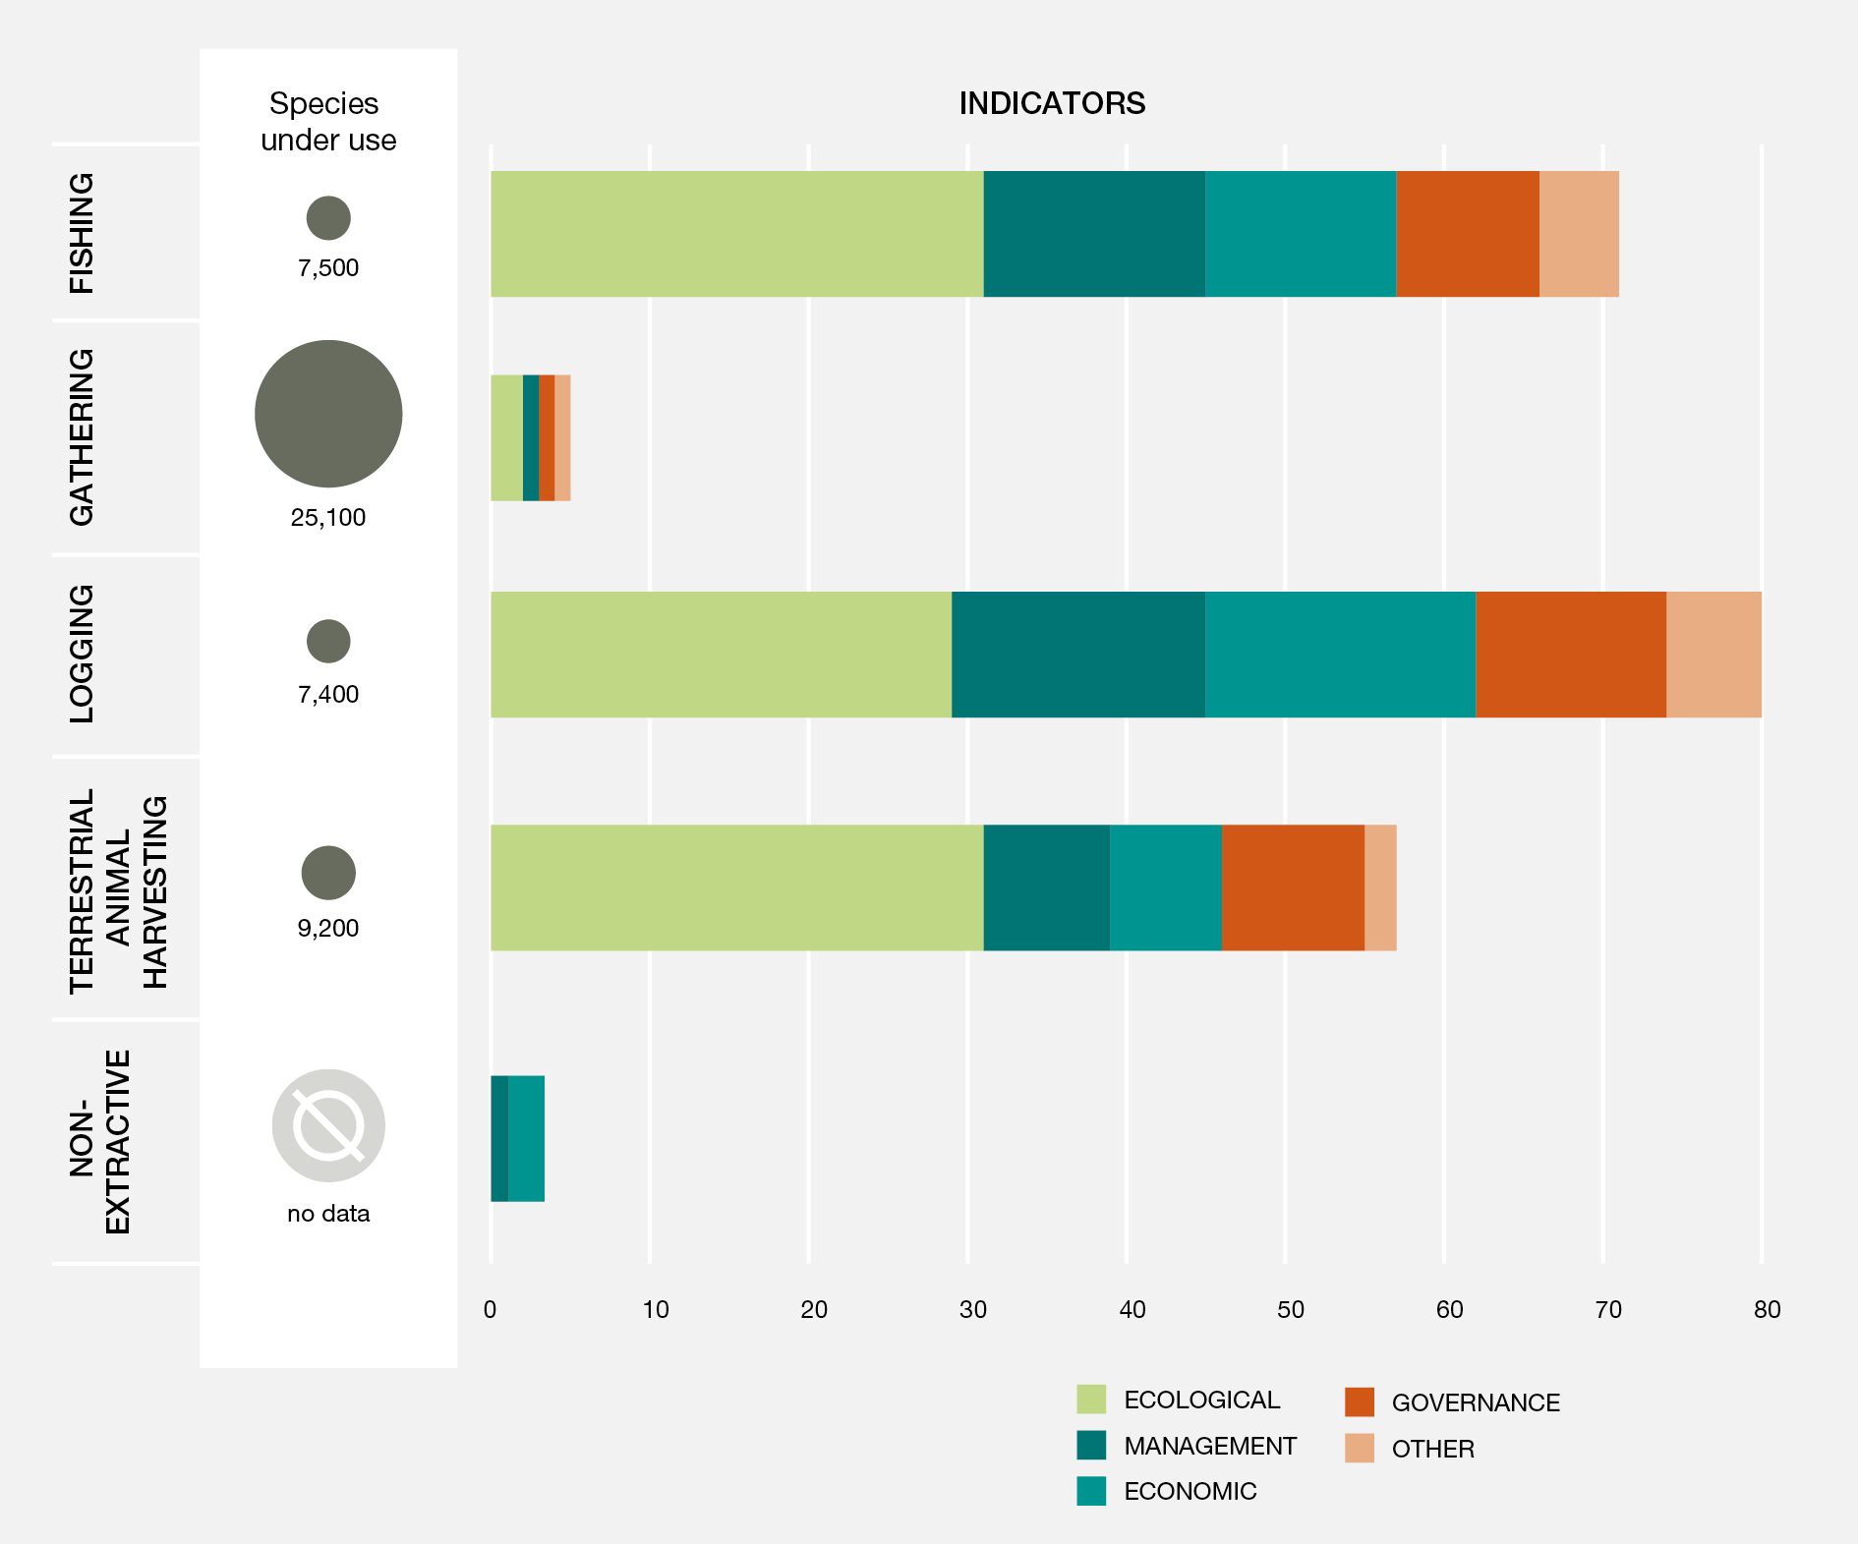
Figure SPM.6. Wild species used worldwide compared with indicators of sustainable use by practice. This figure displays the approximate number of wild species used, categorized by practice type, in comparison with the number of widely used global indicators of sustainable use of wild species by practice type. The terrestrial animal harvesting group is based primarily on a large regional indicator set due to the paucity of global indicators. Data for this analysis are from chapter 2 {2.3.2.2.2} and chapter 3 {3.2.1, table 3.1 and box 3.1 in 3.2.2}. A data management report for this figure is available at https://doi.org/10.5281/zenodo.6452576.
(B.3.3) Many of the ecological, economic and governance indicators in global and regional indicator sets have low sensitivity or specificity for the sustainability of individual practices, thus requiring substantial contextual information to be interpreted reliably (established but incomplete) {2.3.4}. Very few indicators capture the social-ecological linkages now globally recognized to be important to sustainable use. Monitoring by many indigenous peoples and local communities focuses on interlinked social and ecological elements and can inform the development of local and global indicators that recognize these linkages at different scales (well established) {2.3.4}.
C. Key elements and conditions for the sustainable use of wild species
Policy instruments and tools are most successful when they pay attention to and fit both the ecological and social contexts in which they are applied. Many policy instruments for the sustainable use of wild species have been successful in some circumstances, but have failed in others.
C.1. Policy instruments and tools are most successful when tailored to the social and ecological contexts of the use of wild species and support fairness, rights and equity.
(C.1.1) Conceptualizations of sustainable use of wild species influence policymaking by determining the ecological and social elements that are considered, monitored, assessed and used in policy (box SPM.2) (established but incomplete) {2.3.2, 2.3.3, 2.3.4, 2.2.10}. Sustainable use of wild species is increasingly understood as inextricably social and ecological. Voluntary agreements often invoke both dimensions. However, national frameworks and international instruments largely continue to emphasize ecological dimensions, as well as some social, including economic, and governance dimensions, while cultural contexts receive little attention (well established) {2.2.3, 2.2.4, 2.2.8, 2.2.10, 6.4.1.2}. Adverse effects of these conceptual oversights include reduced effectiveness and inequities (well established) {2.2.10, 2.3.4}, in particular a lack of recognition of the sustainable use practices of indigenous peoples and local communities and support for their tenure and access rights (well established) {6.4.4.1}.
Box SPM.2. The Convention on International Trade in Endangered Species of Wild Fauna and Flora and the Convention on Biological Diversity
The Convention on International Trade in Endangered Species of Wild Fauna and Flora was established in 1973 to protect wild species from overexploitation associated with international trade and to avoid utilization that is incompatible with their survival. As at April 2021, the Convention had 183 parties. The assessment found that the Convention has been an important instrument for driving global coordination of regulations and enforcement regarding international trade in wild species, as well as the establishment of institutions and tools to ensure sustainable use (well established) {4.2.2.2}. As a result of those efforts, 101 countries now have the legislation and institutions in place to fully implement the Convention and a further 43 countries are in a position to partially implement it. Tools for assessing whether trade is detrimental to the survival of a species in trade (termed non-detriment findings) have been developed for a wide range of taxa with different life histories and vulnerabilities to trade. As at 2021, over 38,700 species were listed in the appendices to the Convention and subjected to regulation by the parties. Based on these operational indicators, the Convention on International Trade in Endangered Species of Wild Fauna and Flora is a successful policy instrument. Nevertheless, based on trends of continuing decline in the status of species affected by international trade, these species continue to be affected by unsustainable levels of use and illicit trade (established but incomplete) {4.2.2.2}. The Convention focuses on regulating international trade but other factors affecting the use of wild species fall outside the scope of the Convention and can continue to drive unsustainable and/or illegal trade both from the supply and demand sides of trade. These issues also affect domestic trade in wild species, which can be significant, and so species can continue to decline despite international trade restrictions. Successful outcomes for the species listed in the appendices to the Convention have often been linked to complementary actions that either reduce demand for wild species, achieve greater coherence between domestic policies and the decisions of the Convention, involve local communities affected by decisions relating to international trade, or reduce illegal trade (established but incomplete) {4.2.2.2}. Durable outcomes from Convention decisions are more likely if there is a good fit between the regulatory options available to the Convention and the specific contexts in which they are applied. There is a growing body of evidence that can support better outcomes for species and complement biological information to inform decisions, including for economics, consumer behaviour, the structure of legal and illicit markets, impacts on livelihoods and the role of communities in promoting sustainable use and combating illegal trade.
The Convention on Biological Diversity is an international treaty with 196 parties as at April 2021 that lists among its three objectives the sustainable use of biological diversity, including a specific provision “to protect and encourage customary use of biological resources in accordance with traditional cultural practices that are compatible with conservation or sustainable use requirements” {2.2.2, 5.9.2}. In 2010, the Convention established the Aichi Biodiversity Targets to guide action to 2020, including targets for sustainable use {2.2.2, 3.2}. A new post-2020 global biodiversity framework is expected to be adopted at the fifteenth meeting of the Conference of the Parties to the Convention on Biological Diversity {5.9.1}.
(C.1.2) Policy instruments and tools commonly fail when they are not tailored to local ecological and social contexts (figure SPM.7) (established but incomplete) {1.4, 4.2.2, 6.5.2.3}. The use of wild species takes place in landscapes and seascapes with diverse ecologies, cultures, politics and histories, all of which affect policy outcomes. Policies and regulations that fail to recognize and account for the diversity of uses and benefits associated with a practice can lead to negative social and ecological outcomes. Such adverse outcomes are especially pronounced in cases where there are differences between large-scale commercial actors and subsistence or small-scale actors (well established) {6.4.3.1}. Similarly, multiple pre-existing policies and instruments often apply to a species, practice or place (well established) {6.5}. Where customary governance is ignored, new policies may undermine previously successful approaches to sustainable use. New policy instruments that do not account for the history and current conditions of use also may exacerbate pre-existing tensions and create conflict, even where other enabling conditions are present (well established) {6.5.4.2}. The need for policy which is “fit for purpose” is widely acknowledged but incompletely pursued (well established) {6.5.2.1, 6.5.4.2}. For example, community-based and nature-based tourism standards that combine legal and regulatory approaches with social and information-based approaches provide livelihood benefits to communities while protecting indigenous and local cultures and environments (established but incomplete) {6.4.1.3, 6.4.4.5}. Many of the unsustainable impacts of the tourism industry could be mitigated through context-based understanding, implementation of best practice guidelines for observing, communication, education and public awareness of tourists and tour operators, collaborative engagement with all stakeholders and sector-specific regulation (well established) {3.3.5.2.3}.
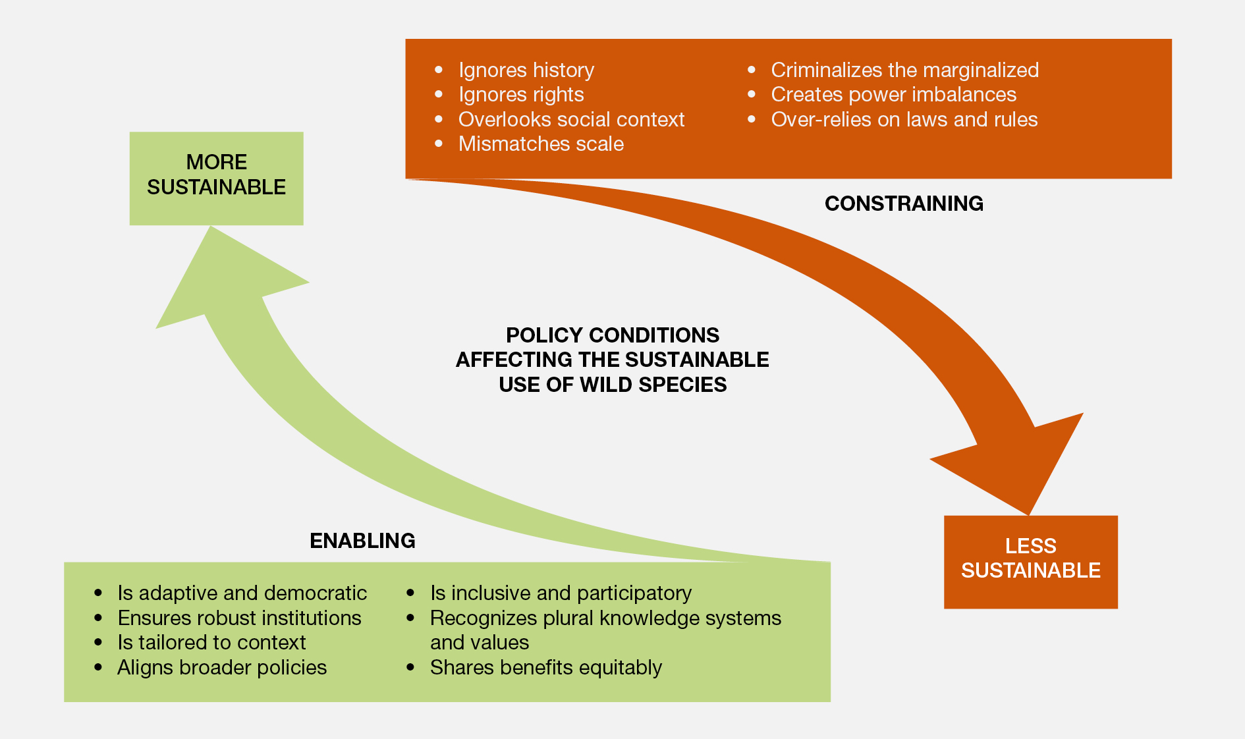
Figure SPM.7. Conditions that enable (green) or constrain (red) sustainable use policies.
(C.1.3) Fairness, rights and equitable distribution of benefits are essential to ensure the sustainable use of wild species (figure SPM.7) (well established) {6.6.3}. People’s perceptions of fairness and justice shape their willingness to comply with regulations that govern sustainable use {6.4.3}. Inequitable distribution of benefits from the use of wild species can undermine sustainability by encouraging over-harvesting, short-term gains over long-term sustainable management, poaching and unsustainable mining of natural resources by companies (well established) {3.3, 4.2.2.5}. Small producers, who lack political or economic power, can easily lose out if measures are drafted in a way that primarily promotes the interests of the advantaged (box SPM.3) (well established) {6.5.2}. In contrast, secure rights of access to and use of wild common property resources, along with social capital, participation in governance mechanisms and accountability, positively influence the sustainability of uses of wild species (well established) {4.2.3.2, 6.4.4, 6.5.1}. Equitable distribution of benefits from the sustainable use of wild species is a stated goal of many governance and institutional frameworks, but their implementation is often incomplete (well established) {2.2.6, 6.5.2.1, 6.6.3}. Further efforts are required to realize these goals and ensure sustainable use policies are aligned {4.2.2, 6.4.1.1, 6.4.3.1}.
Box SPM.3. Distribution of benefits from vicuña fibre
The vicuña (Vicugna vicugna) is one of the rare success stories of international conservation, with significant social outcomes though still limited economic outcomes. This camelid has one of the most valuable and highly priced animal fibres on the international market. Luxury garments made from vicuña fibre are sold in the most exclusive fashion houses around the world. Vicuña fibre is produced mainly by extremely low-income indigenous communities from the Andes, who “pay the cost” of vicuña conservation by allowing vicuñas to graze on communal or private land. The production of fibre also relies on substantial investments borne primarily by state institutions and local communities. However, it is almost impossible for a remote Andean community to negotiate with an international textile company or large trading company on equal terms or directly place its product in the international market. As a consequence, most of the benefits of the global trade in vicuña fibre are captured by traders and international textile companies. Limited economic returns are a disincentive for community participation. Efforts to increase the benefits accrued by poor rural communities focus on explicitly redressing access asymmetries, strengthening producer associations and the provision of added value at the local level (well established) {4.2.3.5}.
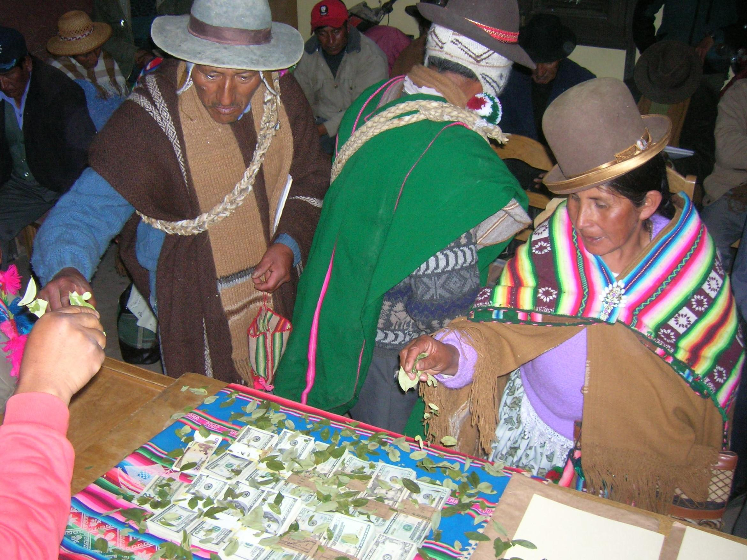
Distribution of benefits from vicuña fibre harvest in Sajama, Bolivia (Plurinational State of).
(C.1.4) Effectiveness of market-based incentives, such as certification and labelling, is mixed and mostly limited to high-value markets (established but incomplete) {6.4.3.1}. Certification and labelling schemes operate on the premise that providing information to consumers will result in a market shift that favours sustainable products, thereby incentivizing and rewarding sustainable practices by producers through price premiums and increased market share (well established) {6.4.3.1, 6.5.1.2}. In general, certification and labelling, when carefully designed and implemented, can promote ecological, economic and to a lesser extent social sustainability, but benefits have largely been for large-scale operations and where there is high market demand (established but incomplete) {6.4.3.1, 6.5.1.3}. Certification and labelling are widely used in large-scale commercial fishing, logging and non-extractive recreational practices. In the cases of fishing and logging, certification and labelling frequently have been successful in securing and increasing market share, but it is unclear how often certification supports transitions from unsustainable to sustainable practices (established but incomplete) {6.4.3.1}. Certification may also lead to specialization around a few value chains. Furthermore, market-based incentives have generally not delivered price premiums for producers (well established) {6.4.3.1}. Relatively high costs to obtain certification, satisfy ongoing reporting requirements and realize market benefits often place certification beyond the reach of small-scale producers, including indigenous peoples and local communities (established but incomplete) {6.4.3.1, 6.5.2}. The viability of market-based incentives such as certification and labelling also depends on appropriate design, in line with international trade regulations (established but incomplete) {6.4.3.1}.
C.2. Policy instruments and tools are more effective when they are supported by robust and adaptive institutions and are aligned across sectors and scales. Inclusive, participatory mechanisms enhance the adaptive capacity of policy instruments.
(C.2.1) Robust governance systems tend to be adaptive to changes in social and ecological conditions and include participatory mechanisms (well established) {6.6.1}. The social and ecological conditions under which uses of wild species occur are always dynamic. Consequently, policy instruments and management tools are most effective when they address the causes of unsustainable use and adapt to changing circumstances (well established) {6.5.2}. Adaptive processes are enhanced by collaborative learning and governance. Successful co-learning is characterized by comprehensive, continuous, iterative and transparent engagement between key actors, including governance institutions and those who depend on wild species for their livelihoods and well-being (box SPM.4) (well established) {6.5}. Collaborative governance arrangements that meaningfully engage these key actors, such as biosphere reserves designated by the United Nations Educational, Scientific and Cultural Organization, can ensure that policy decisions on sustainable use are equitable (well established) {4.2.2.2, 4.2.2.3, 6.5}. Such participatory mechanisms are more effective when implemented through inclusive processes that integrate customary and statutory laws, include participation of indigenous peoples and local communities in policy design, recognize gendered differences in the knowledge and practices of uses of wild species and include close follow-up through monitoring (box SPM.4) (well established) {6.5.2.2}. Conservation instruments such as protected areas or other effective conservation measures can also contribute to the sustainability of the use of wild species (well established) {6.5.1.1}. However, to be effective, protected areas should be inclusive of indigenous peoples and local communities and other people involved, avoid displacing indigenous peoples, local communities and dependent livelihoods, be embedded in larger planning processes, and have a full implementation strategy (well established) {4.2.2.2, 4.2.2.3, 4.2.3.2.2, 6.5, 6.5.1.1}.
Box SPM.4. Moving from unsustainable to sustainable fishing at local and large scales
Local scale
Pirarucú is among the largest freshwater fishes in the Amazon, playing an important role in the Amazonian economy and culture since the sixteenth century. As for many fisheries worldwide, the introduction of modern technologies occurred during the second half of the twentieth century and rapidly induced an uncontrolled increase in fishing pressure, which led to the overfishing of pirarucú stocks in most parts of the Amazon. Official protective measures were first introduced in the 1980s by Brazilian government agencies but had little effect due to the lack of enforcement capacity of local authorities. In 1998, community-based management was introduced in small riverine communities at Mamirauá Reserve (Brazil). The governance system adopted was based on a local management committee with the capacity to approve and enforce rules, conduct and oversee the activity and equitably distribute the benefits generated. Fishermen provided their traditional knowledge and were responsible not only for protecting the fishing grounds but also for submitting an annual management plan to the government authorities. Local scientific projects were also conducted on the biology of the species, as well as the technical, social and economic aspects of the fishery. The results of these ongoing surveys and evaluations allow the improvement of the technical guidelines in a truly adaptive management approach. Nowadays, community-based management of pirarucú is performed within a hundred small local communities in the Brazilian Amazon and in other Amazonian countries. After two decades, pirarucú fisheries management has demonstrated that conservation of the species can be reconciled with its sustainable use, generating positive social, economic and ecological results (well established) {6.5.1.1}.
Large scale
Atlantic bluefin tuna has been sustainably exploited for two millennia by traditional fisheries, but the rise of the sashimi market during the 1980s generated new and strong demand, which sharply increased the value of the fish and led to uncontrolled international overcapacity in the fishing fleet and critical overexploitation in the 1990s and 2000s, including a severe problem of illegal catch. The failure of bluefin tuna management at that time was partly due to the multilateral nature of the International Commission for the Conservation of Atlantic Tunas. The scientific body of the Commission had alerted the management body about the critical status of Atlantic bluefin tuna stocks in the 1990s, but the scientific advice carried little weight against fisheries lobbies and national interests, which were most influential in maintaining high quotas. During the 2000s, however, environmental non-governmental organizations became more powerful and efficiently used communication tools to call the attention of the public to the poor stock status of bluefin tuna. Following a shift in public opinion, the management body of the Commission started to pay more attention to scientific advice and implemented a first rebuilding plan in 2007, which was reinforced in the following years. The final Atlantic bluefin tuna rebuilding plan included a reduction in the length of the fishing season for the main fleets, an increase in the minimum catch size, new tools to monitor and control fishing activities and a strong reduction in fishing capacity and annual quotas. As a result of this plan, the Atlantic bluefin tuna population has been rebuilt and is now exploited within biologically sustainable levels (well established) {6.5.3.3}.
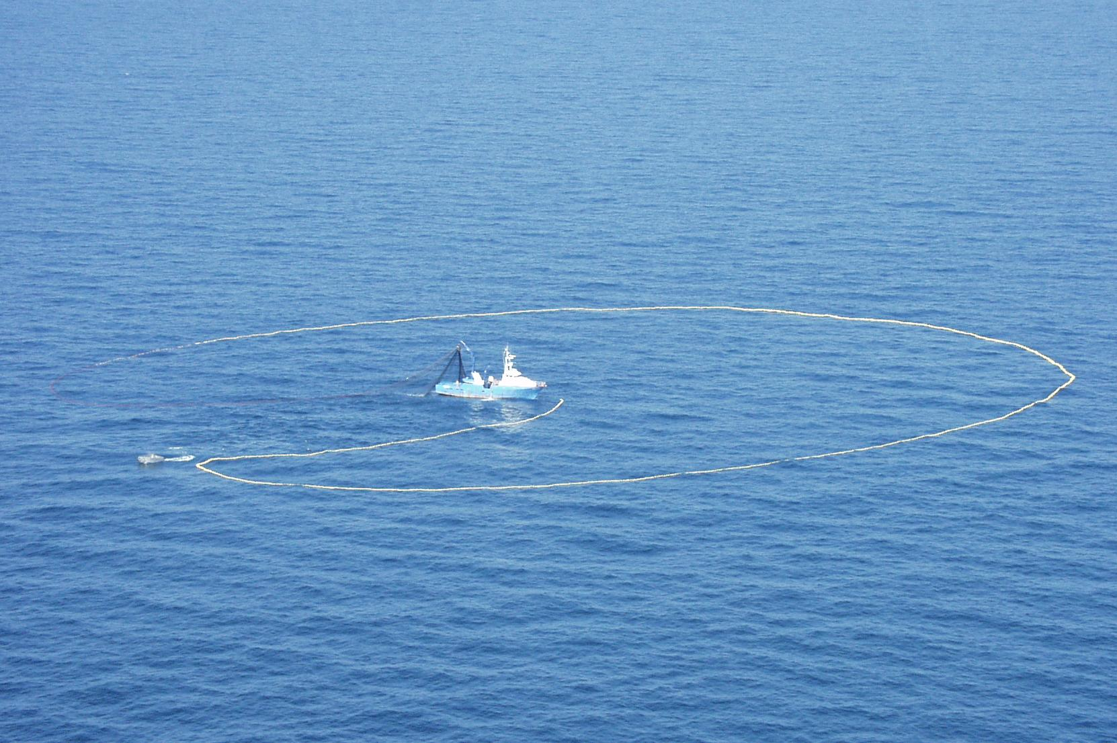
Purse seiner fishing Atlantic bluefin tuna.
(C.2.2) Aligning and coordinating policies across sectors and scales of governance can create enabling conditions for sustainable use of wild species (well established) {6.5.1.2, 6.5.2.2}. Policies enacted to govern diverse sectors, including, but not limited to, agriculture, energy and transportation, often also affect uses of wild species. The interaction of such policies can support or undermine sustainable use. For example, sectoral policies designed to advance national economies and territorial connections can escalate the exploitation of wild species, displace local uses and exacerbate poverty (well established) {4.2.3.5}. Further, laws are often built incrementally and, as a result, may come to lack coherent objectives and strategies (well established) {6.5.3}. If well designed, strategic combinations of policies can simultaneously alleviate multiple drivers of unsustainable use and create a supportive environment for sustainable use of wild species (well established) {6.5.3, 6.6.4}. Similarly, policies that align at international, national, regional, subnational, and local levels are more effective at supporting sustainable use of wild species, with fewer negative and unintended consequences. When attention is paid to coordinated interactions between approaches, actors, and scales, outcomes are more effective (well established) {6.5}.
(C.2.3) Policies that support secure tenure rights and equitable access to land, fisheries and forests, as well as poverty alleviation, create enabling conditions for sustainable use of wild species (well established) {6.4.4.1}. When national sectoral policies are aligned with targeted policies to support local tenure of land, fisheries and forests, the resulting synergy creates enabling conditions for the sustainable use of wild species. Sustainable use of wild species can also be enhanced by well-designed holistic approaches that co-address poverty and environment in policy design, and acknowledge that poverty is a multidimensional driver (well established) {4.2.3.4}. For example, policies that alleviate poverty can also empower local customary institutions that, in turn, support sustainable use of wild species (well established) {6.5.1} (see also B.2.5).
(C.2.4) Strengthening customary institutions and rules often contributes to the sustainable use of wild species (well established) {6.4.4.2}. Attention to customary institutions and rules governing uses of wild species can reduce conflicts and increase policy effectiveness (well established) {6.5}. Customary approaches can lower transaction costs for monitoring and enforcement compared with formal governance systems. For example, taboos limit the use of individual species. Such customary approaches can support the ecological and economic dimensions of sustainability and are particularly effective at supporting its social dimensions. However, historical and cultural systems, such as taboos, have seldom been incorporated into policies for managing the use of wild species (well established) {6.4.4.3}.
C.3. Effective monitoring of social, including economic, and ecological outcomes supports better decision-making. Scientific evidence is often limited, and indigenous and local knowledge is underutilized and undervalued.
(C.3.1) Monitoring of the ecological and social, including economic, aspects of uses of wild species is critical for sustainable use (well established) {3.2.4, 3.3.3.3.4}. The lack of ongoing monitoring of population dynamics may make the most adaptive of regulations insufficient to prevent species decline (well established) {4.2.2.2.3}. Where governance systems are informed by monitoring of species health and use, equitable participation by those dependent on wild species (particularly for food) and the inclusion of strong mechanisms for dispute resolution, there is evidence of sustainable use (well established) {4.2.2.2}. Scientific monitoring is limited or lacking for many extractive and non-extractive practices (well established) {3.3.1, 3.3.3, 3.3.5} and is identified as a critical knowledge gap for sustainable use {3.5}. Many indigenous peoples and local communities have well-developed monitoring practices that contribute to sustainable use through stewardship and adaptive and innovative learning (well established) {4.2.2.2, 4.2.2.4.}. Examples of traditional measurement observations include the amount of caribou back fat observed by hunters or the changing flavour of fish. For some communities, knowledge of species trends and dynamics has been passed from generation to generation, resulting in knowledge that exceeds the time frames of most scientific studies. Increasingly robust networks of indigenous peoples and local communities dedicated to monitoring with a hybrid of traditional and scientific methods are generating important information about the status of wild species and their uses (well established) {2.3.3, 3.4, 4.2}.
(C.3.2) Policy instruments and tools are more effective when they are inclusive of plural knowledge systems (well established) {1.1.2, 1.4, 2.2.6, 2.2.8, 6.6.2}. Bringing together scientists and holders of indigenous and local knowledge improves decision-making (well established) {2.2.3, 3.4, 4.2}. Co-production of knowledge by indigenous peoples and local communities and scientists can create robust information about social and ecological conditions and enhance decision-making (well established) {1.1.2, 1.4, 2.2.6, 2.2.8, 4.2.2.2, 6.5.1.1, 6.5.1.2.}. While there is global recognition of the importance of indigenous and local knowledge in sustainable management of wild species, national policy initiatives often do not involve indigenous peoples and local communities in decision-making. Inclusion of indigenous peoples and local communities in the development and implementation of policies for sustainable use of wild species requires sustained commitment and recognition of both indigenous and local knowledge and science as authoritative; doing so can be mutually beneficial. It is also important that engagement with indigenous peoples and local communities ensure free, prior and informed consent and follows international protocols on access and benefit sharing, for example based on the Nagoya Protocol on Access to Genetic Resources and the Fair and Equitable Sharing of Benefits Arising from their Utilization to the Convention on Biological Diversity (well established) {1.1.2, 1.4, 2.2.6, 6.4.4.2, 6.5.3.3}. Legal and regulatory instruments are more effective when they take into account indigenous and local knowledge and science (well established) {6.5.3.3}.
D. Pathways and levers to promote sustainable use and enhance the sustainability of the use of wild species in a dynamic future
There is an urgent need to implement and scale up policy instruments that work, while recognizing the need for adaptive management and transformative changes to address current and future pressures and challenges. Scenarios point to a future where the sustainability of the use of wild species will become increasingly vulnerable to pressures associated with climate change, technological advances and increasing consumption.
D.1. The sustainability of the use of wild species in the future is likely to face challenges due to climate change, increasing demand and technological advances. Addressing and meeting these challenges will require transformative changes.
(D.1.1) According to most scenarios and models, climate change is expected to lead to multiple changes, such as changing wild species distribution and population dynamics, increasing frequency of extreme events and altering nutrient cycles, as well as ecological changes, which will affect wild species and their use across all practices, through multiple impacts. There is uncertainty however about future trajectories. Climate change may further exacerbate social, including economic, vulnerabilities and inequalities (well established) {5.2.1.2, 5.2.1.5, 5.4}. Climate change has implications for all extractive and non-extractive practices, including effects on the population dynamics of targeted wild species and the ecosystems they inhabit (well established) {5.4}. For example, climate change projections in high-emission scenarios up to 2100 from the Intergovernmental Panel on Climate Change show a decrease in global ocean biomass; the global catch is projected to be potentially reduced in all systems and more substantially in tropical systems, while a poleward shift in marine species could create new opportunities in mid- to high-latitude oceans (established but incomplete) {4.2.1.2.2, 5.4.2.5, 5.4.2.8}.
(D.1.2) For many practices, demand is linked to demographic trends and consumption patterns. Growing human populations and consumption will result in greater pressure on wild species (well established) {5.4.3.1, 5.4.4.4, 5.4.6.8, 5.9.4}. For example, global fish demand is expected to almost double by mid-century and will increase in all regions of the world, while the demand for gathered wild plants, algae, and fungi is increasing both at the local level, where most products are consumed, as well as in international markets (well established) {5.4.2.2, 5.4.2.8, 5.4.3.4}. Demand for wood-based bioenergy is expected to increase, while at the same time there are continuing reductions in global forest cover due to increased logging and mortality resulting from climate change. Forest plantations may meet some of the growing demand but there are likely to be trade-offs between the management of natural forests to meet demand for wood and biodiversity conservation (well established) {5.4.5.1}. Non-extractive practices including nature-based tourism are also likely to grow and potentially generate negative environmental trends resulting from, for example, increasing waste. Projections of increasing tourism growth suggest that significant additional efforts will be necessary to mitigate these negative impacts (well established) {5.4.6}.
(D.1.3) Technological advances will affect future uses of wild species both negatively and positively (well established) {5.4.2.3, 5.4.3.3, 5.4.4.3, 5.4.5.3}. Technological advances are likely to make many extractive practices more efficient, such as the ability to exploit resources more rapidly and more intensively. However, this may have potentially negative consequences (well established) {5.4.2.3, 5.4.5.3}. At the same time, technological advances are also likely to enhance monitoring, surveillance, and enforcement (well established) {5.4.2.3, 5.5.4.8}. Progress in information and communication technologies has the potential to profoundly modify wild species observation through improved virtual wildlife watching (established but incomplete) {5.4.6.3}. According to scenarios for a specific area, technological innovations could support sustainable use of natural forests through multiple routes. Uptake of technologies for sustainably advancing agricultural intensification, particularly in working lands of producer countries, could enable land to be spared for forest conservation, conditional on the type of governance in place and that the negative effects be overcome (established but incomplete) {5.4.5.3}. Technologies in wood manufacturing can improve the efficiency of uses of wood for construction materials and energy production (established but incomplete) {5.4.5.3}. Technological innovations that enhance efficiency and reduce waste may help the sustainable use of wild species (well established) {5.4.5.3}. Consideration of customary uses and land tenure, access and resource rights in accordance with national legislation may also help (established but incomplete) {5.4.5.3, 5.4.5.8, 5.8}.
(D.1.4) Scenarios projecting the future use of wild species are few in number (well established) {5.3}, but they indicate that transformative changes are needed to ensure sustainable use and to enhance the sustainability of the use of wild species (established but incomplete) {5.8}. In most scenarios, transformative changes that enable sustainable use of wild species under future conditions share common characteristics. These characteristics include concerted action on leverage points, integration of plural value systems, equitable distribution of costs and benefits, changes in social values, cultural norms and preferences and effective institutions and governance systems (established but incomplete) {5.8}. Ambitious goals are necessary but not sufficient to drive transformative change. Translating high-level goals into meaningful and inclusive action at multiple scales will require coordination between multilateral institutions, multiple arms of government, business and civil society (well established) {5.9.2}.
Scenarios identify actions that will be needed to assure the future sustainability of each practice. In the case of fishing, most scenarios indicate that future sustainable use may require fixing current inefficiencies, reducing illegal, unreported, and unregulated fishing and suppressing harmful financial subsidies that contribute to overcapacity and overfishing in marine systems (established but incomplete) {5.4.2.4}, supporting small-scale fisheries, adapting to changes in oceanic productivity due to climate change and proactively creating effective transboundary institutions (established but incomplete) {5.4.2.8}. Sustainable logging may be supported by the management and certification of forests for multiple uses, technological innovations to reduce waste in the manufacturing of wood products and economic and political initiatives that recognize the rights of indigenous peoples and local communities, including land tenure (well established) {5.4.5.3, 5.4.5.6, 5.4.5.8}. At the same time, development and improvement of sustainable forest management practices would provide tools to support sustainable economic activities and wild species-based products, thus reducing pressure on forest resources (established but incomplete) {3.3.4.5.1, 4.2.3.3.3, 5.4.5.4}. Wild meat is a primary objective of terrestrial animal harvesting. Projected future demand for wild meat shows differing regional trends, with increases in some areas and declines in others due to changing cultural norms, social acceptability and preferences. Increased regulation or bans on wild meat trade could be viable in some regions, while similar regulations would lead to food insecurity in other regions (established but incomplete) {5.4.4.4}.
D.2. To address current and projected future pressures, concerted interventions will be needed to implement and scale up policy actions that have been shown to support the sustainable use of wild species.
(D.2.1) Key elements (sets of policy actions) that support sustainable use of wild species have been identified (see section C, figure SPM.8). However, with the exception of fishing, these key elements are poorly integrated into binding agreements and this limits progress towards their implementation (table SPM.1) (established but incomplete) {2.2.6, 2.2.7}. The following seven key elements have been shown to enhance the sustainability of the use of wild species (table SPM.1): inclusive and participatory decision-making, inclusion of multiple forms of knowledge and recognition of rights, equitable distribution of costs and benefits, policies tailored to local social and ecological contexts, monitoring of social and ecological conditions and practices, coordinated and aligned policies, and robust customary and statutory institutions (well established) {6.6}. Integration of these key elements into binding agreements, voluntary agreements and certification schemes differs strikingly among practices. Binding agreements for fishing display the strongest integration of these seven key elements, although two key elements (inclusive and participatory decision-making, acknowledgement of rights and equitable distribution of benefits) remain largely absent (table SPM.1) (established but incomplete) {2.2.6}. Certification schemes for gathering and logging integrate most of these key elements, but do not address alignment of policies or coordination of interactions with other practices. These two prior key elements are only reflected in voluntary agreements for gathering, terrestrial animal harvesting and non-extractive practices (table SPM.1) (well established) {2.2.6}. All types of agreements related to logging and non-extractive practices entirely overlook one or two key elements (table SPM.1). Integrating all seven key elements into binding agreements, voluntary agreements and certification schemes for all practices is a prerequisite for the future of sustainable use of wild species (established but incomplete) {6.6}.
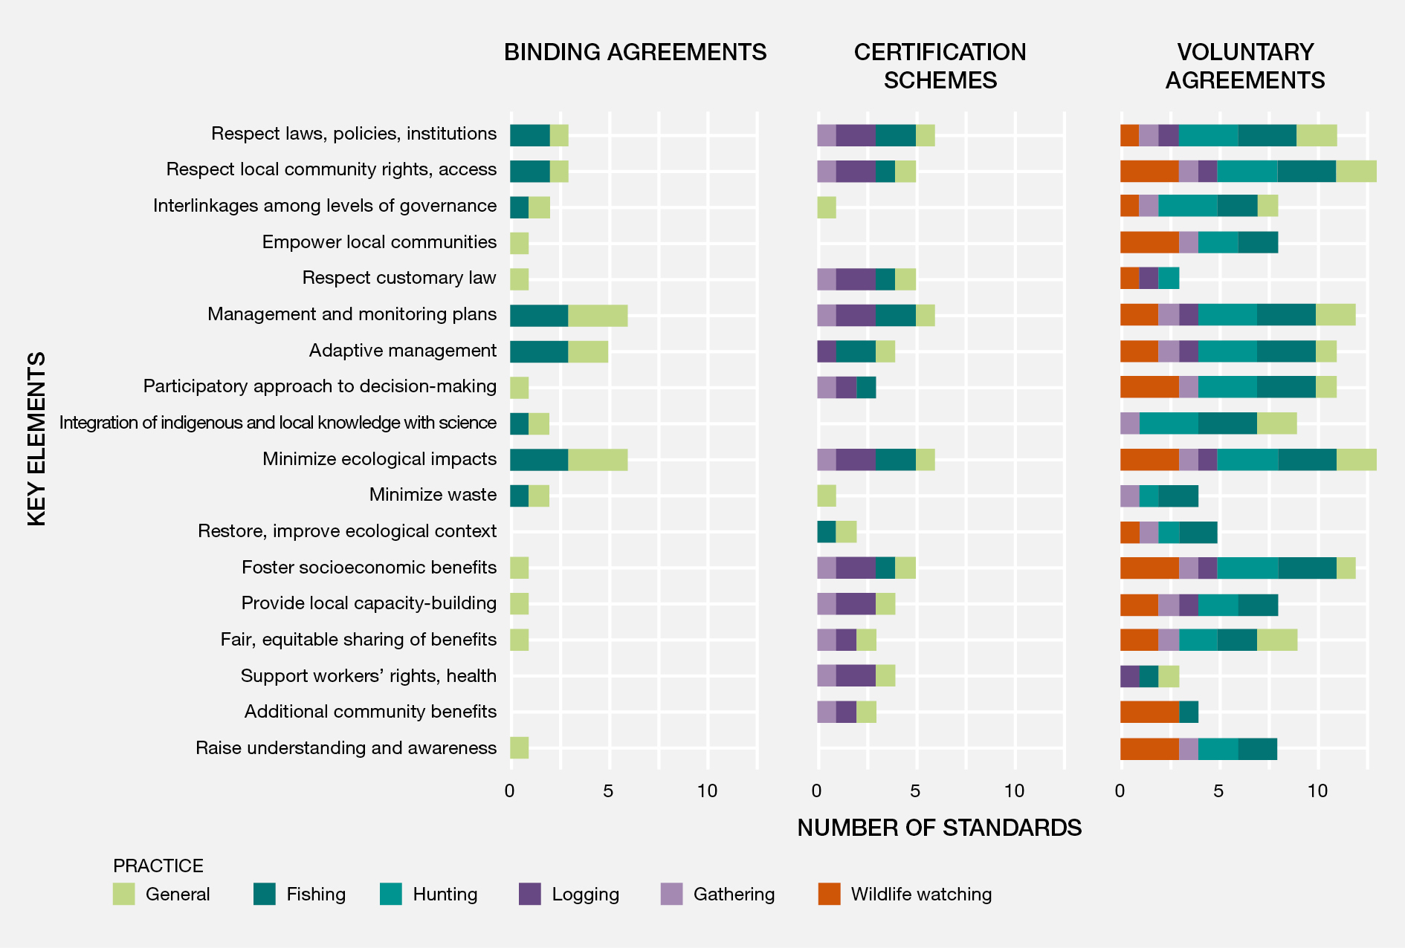
Figure SPM.8. Themes in key elements of sustainable use of wild species in international and regional agreements, including binding agreements (n=6), certification schemes (n=6) and voluntary agreements (n=13). A data management report for this figure is available at https://doi.org/10.5281/zenodo.6473133.
Table SPM.1. Seven key elements of effective policy for sustainable use of wild species, their presence in current international agreements and examples of policy options. Colour coding based on the data drawn from analysis of chapter 2 {figure 2.3 in 2.2.6.2}. Pictograms represent (from left to right): fishing, gathering, logging, terrestrial animal harvesting and non-extractive practices.
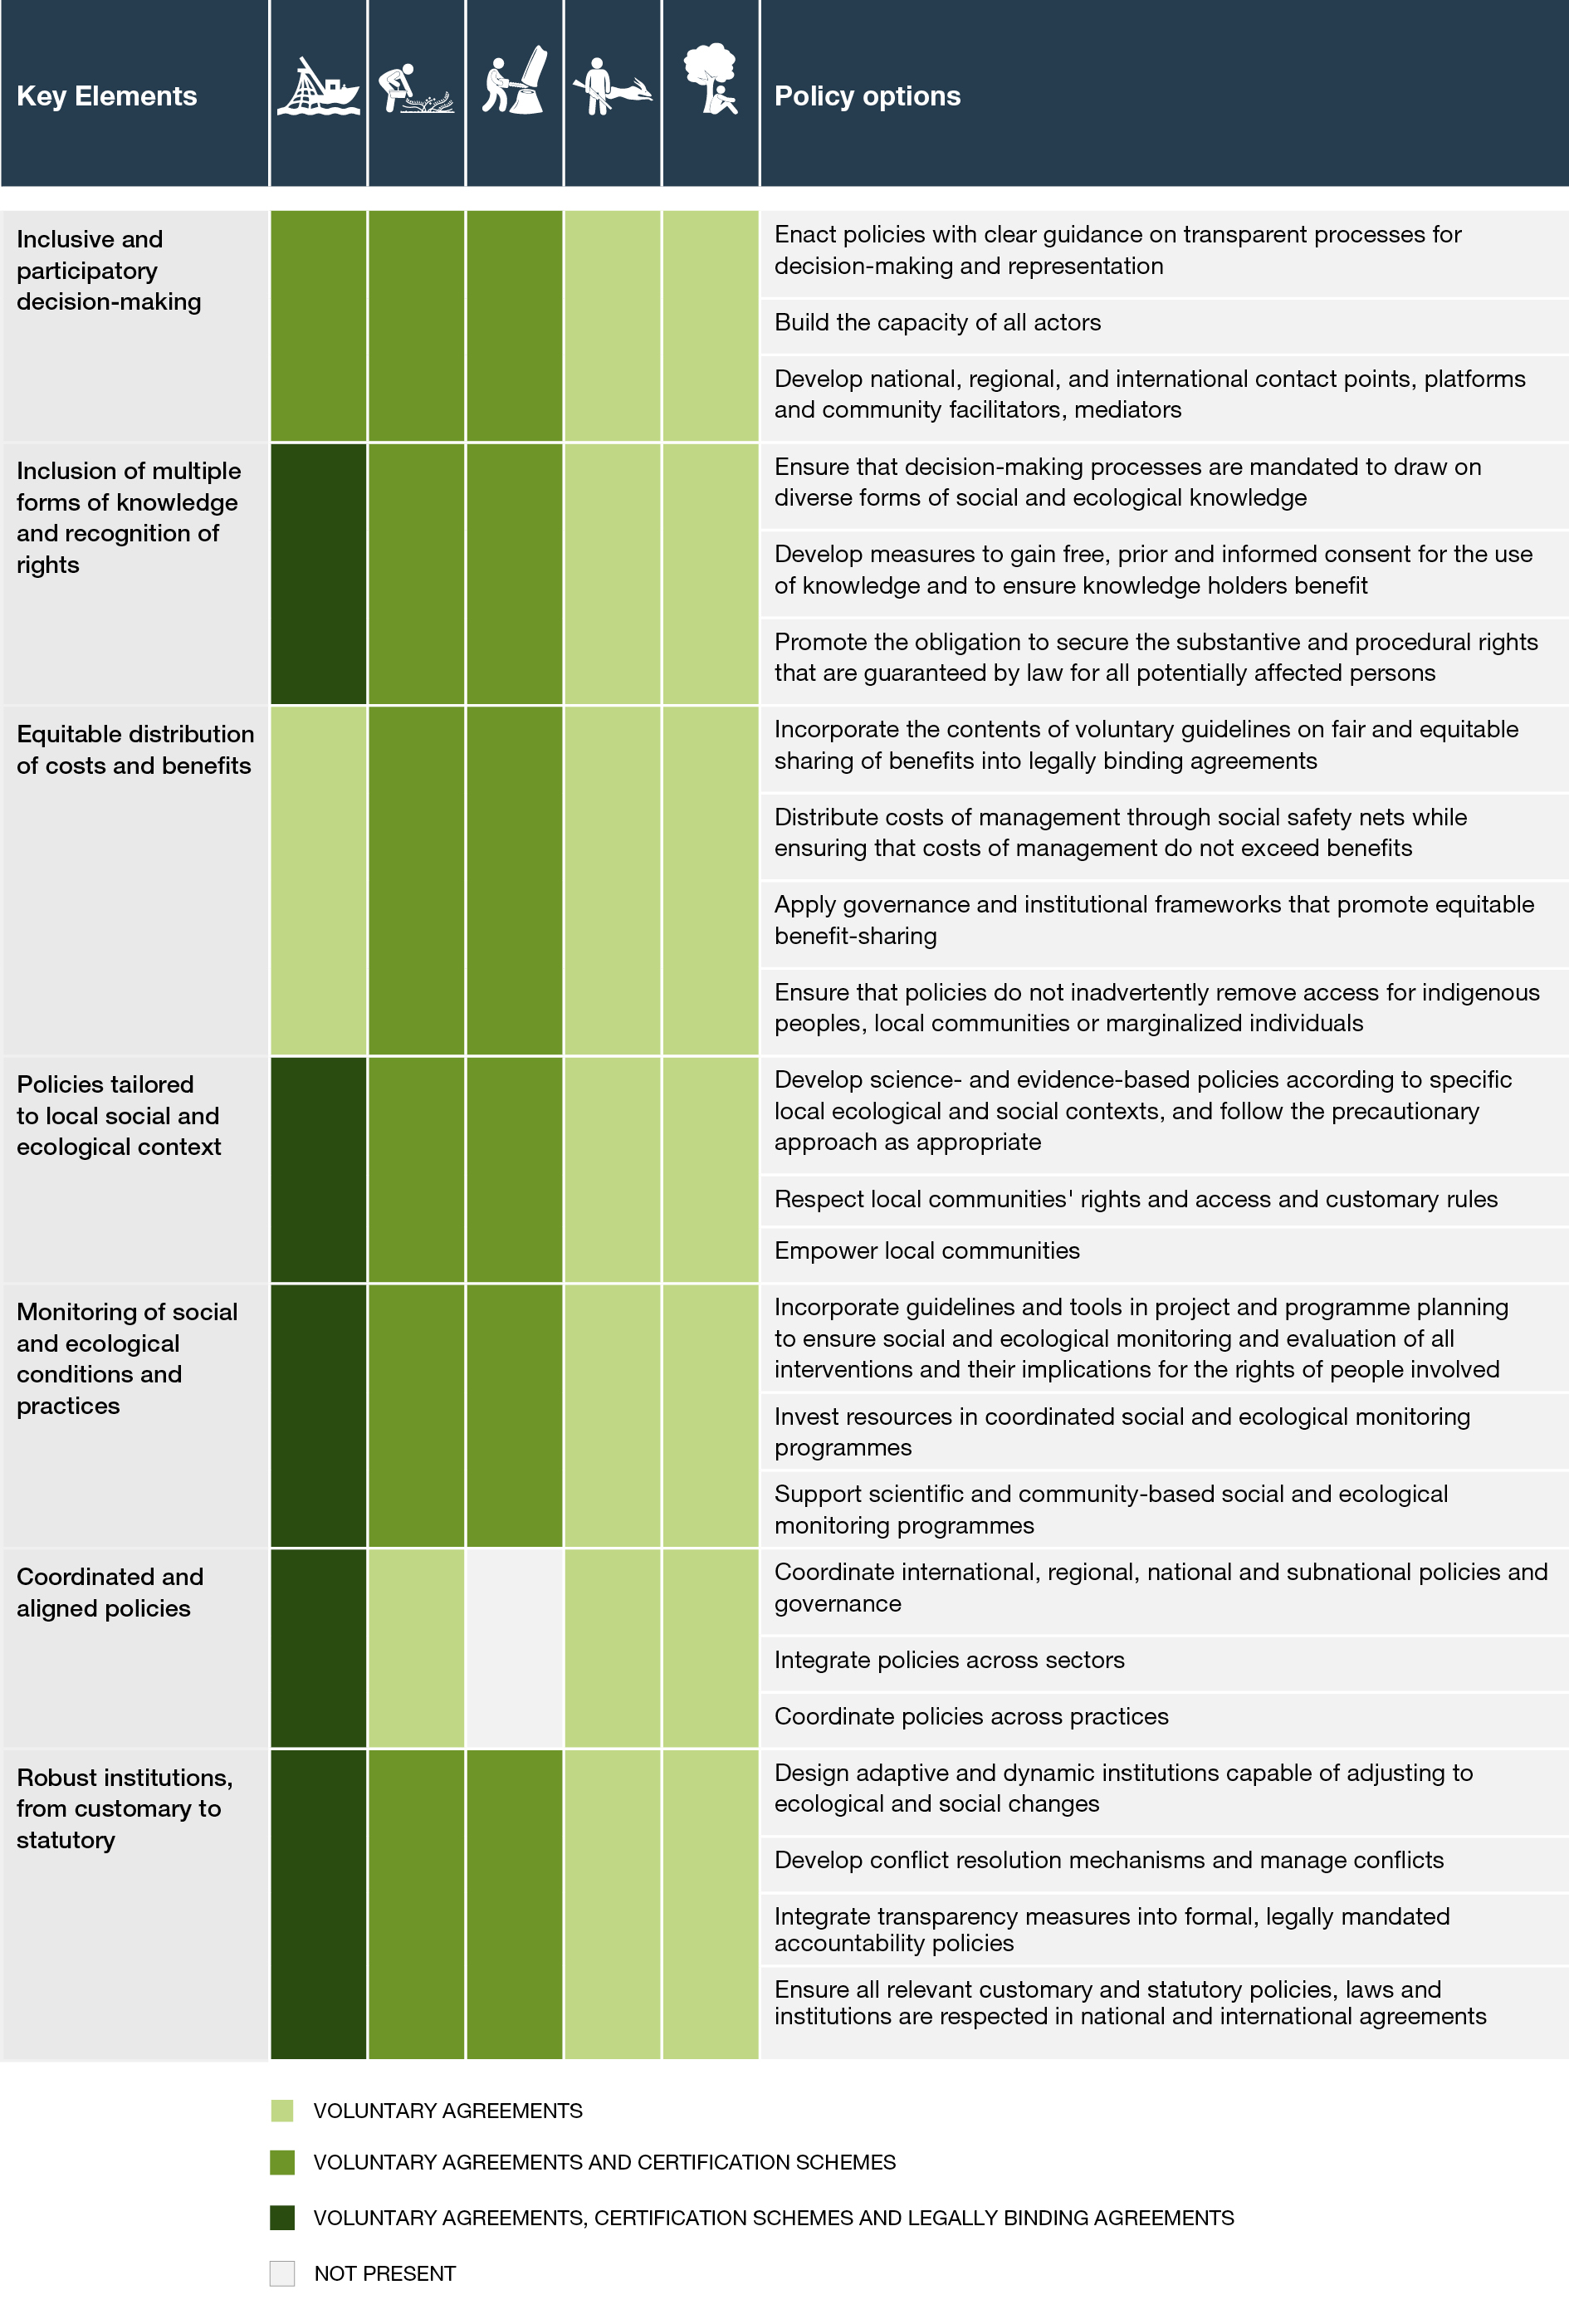
(D.2.2) These seven key elements have been deployed in limited contexts and could be used as levers of changes to promote sustainable use and enhance the sustainability of the use of wild species in the future if they are scaled up across practices, regions and sectors (well established) {6.6}.
- Policy options that are inclusive and participatory will strengthen sustainable uses of wild species (well established) {6.5.1.1, 6.6.1}. Stakeholder diversity promotes buy-in and collaboration, and expands the knowledge base for decision-making (e.g., co-management), provided that power imbalances and conflicts are managed (well established) {4.2.2.2.3, 6.5.4, 6.6.2, 6.6.8}. Specific actions to promote inclusive and participatory processes include enacting policies with clear guidance on procedures for decision-making and representation (e.g., specifying membership roles and responsibilities) and building capacity that enables all parties to participate fully (well established) {6.5.1.1, 6.6.1}.
- Policy options that recognize and support multiple forms of knowledge will enhance the sustainability of the use of wild species (well established) {6.6.2}. Sustainable use of wild species will be enhanced by policy processes that protect indigenous and local knowledge and draw on diverse forms of knowledge, bringing scientists, indigenous peoples and local communities and other relevant actors together in a co-learning process (well established) {6.6.2}. Measures to ensure that indigenous and local knowledge holders have provided free, prior and informed consent for, and receive benefits from, the use of their knowledge are important, for example, through the enactment of access and benefit-sharing mechanisms {6.5.2.4}.
- Policy instruments and tools will only be effective if they ensure fair and equitable distribution of costs and benefits from sustainable use of wild species (well established) {6.4.3.1, 6.5.3.3, 6.6.3}. Policies that overlook social equity increase the risk of unsustainable use of wild species (established but incomplete) {6.5.3.3}. Specific actions and plans could include enacting guidelines on access and benefit sharing that are currently common in voluntary agreements, and applying governance and institutional frameworks that ensure fair and equitable distribution of costs and benefits. This may ensure that policies do not inadvertently criminalize or deprive local communities or marginalized individuals of access and equitable distribution of costs and benefits, and identify measures that may ensure preventing the misappropriation of genetic resources and associated traditional knowledge (well established) {6.4.4, 6.6.3}.
- Context-specific policies are needed to ensure the sustainable use of wild species (well established) {6.5.2.1, 6.5.3.2, 6.6.4}. Effective policies are purpose-built to local, social and ecological conditions in which uses take place (well established) {4.2, 5.5}. Actions to empower indigenous peoples and local communities and respect their rights, access and customary rules are fundamental to the development of context-specific policies.
- Monitoring wild species and practices is crucial to prevent species decline (well established) {4.2.2.2.3}. Monitoring is resource intensive and will require more support and investment in all countries to overcome the capacity, financial, technical and institutional challenges that generate strong limitations to monitoring wild species, which are more pronounced in developing countries. Monitoring efforts that are inclusive of indigenous peoples, local communities and scientific approaches, and facilitate equitable participation of all key actors, can better inform decision-making (well established) {3.2.4, 3.3.3, 3.3.5}.
- Policy instruments that are aligned at international, national, regional and local levels, and that maintain coherence and consistency with existing international obligations and take into account customary rules and norms, will be more effective (well established) {6.5.1.2, 6.5.2, 6.6.6}. Policy outcomes will also be more effective and will lead to fewer negative and unintended consequences when attention is paid to coordinated interactions between approaches, actors, and scales (well established) {6.5.1.2, 6.6.3}.
- Robust institutions in terms of sustainable use of wild species, including customary institutions, will be essential to future sustainable use of wild species (well established) {6.5.1.3, 6.6.7}. Institutions that support collaborative and decentralized learning and shared interests in sustainable use are more effective than centralized systems aimed only at top-down governance (established but incomplete) {4.2.2.6}. Adaptive and dynamic institutions capable of adjusting to changing circumstances will be needed to face current and future challenges to sustainable use of wild species (well established) {6.5.1.1, 6.5.1.3, 6.5.3.2, 6.6.7}. The integration of conflict resolution mechanisms will make institutions more effective, while transparency initiatives connected to legally mandated measures of accountability will enhance trust in institutions.
D.3. The world is dynamic and to remain sustainable, use of wild species requires constant negotiation and adaptive management. It also requires a common vision of sustainable use and transformative change in the human-nature relationship.
(D.3.1) Successful adaptation and negotiation require attention to the dynamics of both the social and ecological contexts of uses (well established) {2.2.3.7}. Because the species under use, the ecosystems that support them and the social systems within which uses occur are dynamic and change over time and space, the sustainable use of wild species is an ongoing adaptive process, which may be depicted as follows: (i) assess status and trends in wild species under use; (ii) identify drivers of (un)sustainability; (iii) adapt uses and management; and (iv) re-assess after a given time interval and re-adapt use and management, if needed (well established) {1.3, box 2.3, 4.2.2.2, 4.2.2.4, 6.5.1.3}. Continuous long-term monitoring is needed to inform such adaptive management processes and benefit from approaches that integrate complementary information from science and indigenous and local knowledge (well established) {2.2.6, 2.3.3, 2.3.4}.
(D.3.2) Intensification of existing uses and/or the emergence of new uses for wild species have often led to the rapid and substantial reconfiguration of trade-offs and synergies within and among practices, with negative impacts on the sustainability of the use (well established) {3.4}. They can also create novel interfaces that influence disease risk, but the link with the intensification of the use of wild species and zoonotic diseases is unresolved (established but incomplete) {4.2.1.7}. Such changes can be fast and profound. For instance, rapid development of new markets can produce rapid changes in resource exploitation and overwhelm the ability of institutions to respond (established but incomplete) {4.2.2.2}. Intensification of uses can reinforce negative impacts, such as land degradation or the introduction of invasive alien species, modifying the spillover risk of novel or known pathogens from wild species hosts to domestic animals and humans (established but incomplete) {4.2.1.7.2.}. Transparency and effective institutions informed by evidence, and robust management and governance, will likely help tackle threats to ecosystems and health by recognizing the interconnection between humans, domestic and wild animals, plants, and the wider environment, contributing to sustainable development, and ultimately reducing the risk of future spillover events (well established) {4.2.1.7}. Governance that supports the involvement of multiple sectors at varying levels of society in decision-making, (e.g., One Health), can limit risk from zoonotic disease and provide positive ecological and social outcomes (established but incomplete) {4.2.1.4}.
(D.3.3) Achieving transformative change relating to the use of wild species requires moving towards a common vision while recognizing different value systems and conceptualizations of sustainable use (established but incomplete) {1.3.3, 1.4.1}. This could be achieved, at least at a local level, by promoting participatory and inclusive approaches to the use of scenarios and models to explore the different uses of wild species and identify pathways to sustainable use, while helping different actors think through decision options from a variety of value perspectives (established but incomplete) {5.7}.
(D.3.4) The sustainable use of wild species will benefit from a transformative change in the prevailing conceptualization of nature, shifting from the human-nature dualism deeply rooted in many (but not all) cultures, to a more systemic view that humanity is part of nature (well established) {1.3.3, 1.4}. Views of the human-nature relationship that separate nature (understood as existing by itself) from culture (produced by humans) have a profound influence on perceptions of the functioning of the biosphere and the language used to understand and describe it. Although many cultures consider nature and humans to be indivisible, a conceptual separation between people and nature is pervasive and may be found in most national and international instruments and policies (well established) {1.4}. This human-nature dualism further fosters the illusion that humanity could exist apart from or in control of the rest of nature, to such an extent that humans’ use of nature ad libitum ultimately led to major environmental crises, such as climate change and biodiversity decline (well established) {1.3.3}. Considering humanity to be part of nature (i.e., a member or a citizen of nature, among others) would lay the foundation for a more respectful and sustainable relationship, as shown by indigenous peoples’ and local communities’ traditional practices and uses (well established) {1.4}.

Appendix I
Definitions
Table SPM A.1 Definitions for the thematic assessment of the sustainable use of wild species of the Intergovernmental Science-Policy Platform on Biodiversity and Ecosystem Services (see also chapter 1 and the glossary of the assessment).
Extractive practices | Extractive practices are defined as the temporary or permanent removal of organisms, part of them or materials derived from them, and may result in mortality of the individual to be used (e.g., hunting or whole-plant harvest), but does not necessarily do so (e.g., limited collection of plant propagules or shearing and releasing of vicuña).
Fishing | Fishing is defined as the removal from their habitats of aquatic animals (vertebrates and invertebrates) that spend their full life cycle in water (e.g., fish, some marine mammals, shellfish, shrimps, squids, corals). Fishing most often results in the death of the aquatic animal, but it may not in some cases. To reflect both situations, fishing has been subdivided into a lethal and a “non-lethal” category. Lethal fishing is defined as the general and more usual meaning of fishing that leads to the killing of the animal, such as in traditional commercial fisheries. “Non-lethal” fishing is defined as the temporary or permanent capture of live animals from their habitat without intended mortality, such as in aquarium fish trade or catch and release. However, unintended mortality may occur in “non-lethal” fishing and the term “non-lethal” is therefore put in quotes. The killing of species that spend part of their life cycle in terrestrial environments (e.g., walrus, sea turtles) is encompassed by the definition of hunting.
Gathering | Gathering is defined as the removal of terrestrial and aquatic algae, fungi, and plants (other than trees) or parts thereof from their habitats. Gathering may, but often does not, result in the death of the organism. Gathering includes whole-plant harvest and removal of above and/or below ground plant parts, as well as the fruiting bodies of macrofungi. It also includes removal of non-woody portions of trees (e.g., leaves, propagules and bark). Where removal of propagules or death of an individual plant occurs (e.g., whole-plant and root removal), effects on population sustainability are contingent upon factors including timing, frequency, and intensity of harvest. The harvest of wood and woody parts of trees is encompassed by the definition of logging.
Logging | Logging is defined as the removal of whole trees or woody parts of trees from their habitat. Logging generally results in the death of the tree, but also includes cases in which it may not, such as coppicing. Logging occurs in forests that may be classified as primary, naturally regenerating, planted and plantation. This assessment does not address logging from plantation forests except as it has bearing on the practice in the other forest types. Harvest of non-woody parts of trees (e.g., leaves, propagules and bark) is here defined as gathering.
Non-extractive practices | Non-extractive practices are defined as practices based on the observation of wild species in a way that does not involve the harvest or removal of any part of the organism. The observation can imply some interaction with the wild species, such as the activities of wildlife and whale watching, or no interaction with the wild species, such as remote photography.
Social-ecological systems | Social-ecological systems are complex adaptive systems in which people and nature are inextricably linked in which both the social and ecological components exert strong influence over outcomes. The social dimension includes actors, institutions, cultures and economies, including livelihoods. The ecological dimension includes wild species and the ecosystem they inhabit.
Terrestrial animal harvesting | Terrestrial animal harvesting is defined as the removal from their habitat of animals (vertebrates and invertebrates) that spend some or all of their life cycle in terrestrial environments. As for fishing, terrestrial animal harvesting often results in the death of the animal, but it may not in some cases. To reflect both situations, terrestrial animal harvesting has been sub-divided into a lethal and a “non-lethal” category. Hunting is defined as the lethal category of terrestrial animal harvesting which leads to the killing of the animal, such as in trophy hunting. “Non-lethal” terrestrial animal harvesting is defined as the temporary or permanent capture of live animals from their habitat without intended mortality, such as pet trade, falconry or green hunting. Non-lethal harvest of animals also includes removal of parts or products of animals that do not lead to the mortality of the host, such as vicuña fibre or wild honey. Unintended mortality may however occur in this category and the term “non-lethal” is therefore put in quotes.
Transformative change | Transformative change is defined in line with previous work of the Intergovernmental Science-Policy Platform on Biodiversity and Ecosystem Services approved by its Plenary, as a fundamental, system-wide reorganization across technological, economic and social factors, including paradigms, goals and values, needed for the conservation and sustainable use of biodiversity, good quality of life and sustainable development.

Appendix II
Communication of the degree of confidence
Figure SPM.A1. The four-box model for the qualitative communication of confidence. Confidence increases towards the top-right corner, as suggested by the increasing strength of shading. Source: IPBES (2016). Further details of the approach are documented in the IPBES Guide on the Production of Assessments.

In the thematic assessment of the sustainable use of wild species, the degree of confidence in each main finding is based on the quantity and quality of evidence and the level of agreement regarding that evidence (figure SPM.A1). The evidence includes data, theory, models and expert judgement.
- Well established: there is a comprehensive meta-analysis or other synthesis or multiple independent studies that agree.
- Established but incomplete: there is general agreement, although only a limited number of studies exist; there is no comprehensive synthesis, and/or the studies that exist address the question imprecisely.
- Unresolved: multiple independent studies exist but their conclusions do not agree.
- Inconclusive: there is limited evidence and a recognition of major knowledge gaps.

Appendix III
Knowledge gaps table
Table SPM.A.2. Knowledge gaps table for the thematic assessment of the sustainable use of wild species.
Sector | Knowledge gaps in information, data, indicators and scenarios
Data and information availability and access | - Data and information on wild species and their uses at the same scales as those used for their management {2.1}  - Context-specific information on practices and uses and their outcomes {1.4, 3.3, 4.2, 6.5}  - Long-term temporal and spatial studies, particularly for non-fishing practices {4.5}  - Consistency among worldwide and regional databases concerning the harvest of wild species and the social components of their use {3.2.1.5}  - Databases containing information on policies adopted at different levels of governance addressing sustainable use of wild species {3.2.1}  - Information about the interlinkages among different taxonomic groups of wild species, specific ecosystem functions, nature’s contributions to people and human well-being {3.2.4, 3.5, 3.6.2}  - Information on sources, quality assurance, safety and efficiency of traditional uses of wild species {3.5}  - Robust indicators at multiple temporal and spatial scales, particularly for gathering, logging and non-extractive practices {3.2.1, 3.3.2, 3.3.4, 3.3.5}  - Indicators reflecting the social components of uses of wild species (for all practices) {2.2, 2.3, 3.2, 6.4}  - Strengthen the consistency, breadth and depth of documentation of threats and use and trade classification schemes in the International Union for Conservation of Nature Red List of Threatened Species assessments {3.2.1, 3.2.2}
Assessment methods, models and scenarios | - Studies on the effectiveness of various policy instruments and tools (including certification schemes and other market mechanisms) {5.6}  - Studies of ecosystem resilience and how resilience is affected by uses of wild species, particularly for practices other than fishing {4.5}  - Studies addressing the interactions of multiple drivers of unsustainable uses {3.2.2, 6.5}  - Methods which combine information from multiple knowledge systems {3.2}  - Evaluation of the impacts of changes in social-ecological systems (especially their social components) on sustainable use of wild species {4.5, 5.3, 6.7}  - Scenario studies for gathering, terrestrial animal harvesting and non-extractive practices {5.3, 6.5.2}  - Scenario studies focusing on cultural, rights and equity aspects of use of wild species {5.6}  - Archetype scenarios exploring uses of wild species {5.6}
Indigenous and local knowledge | - Methods co-developed with indigenous peoples and local communities for weaving science and indigenous and local knowledge {3.5, 4.5}  - Documentation of indigenous and local knowledge regarding sustainable use of wild species, ensuring free, prior and informed consent {3.5}  - Monitoring processes and indicators co-produced with indigenous peoples and local communities {3.5, 4.5}  - Scenarios co-produced with indigenous peoples and local communities, based on indigenous and local knowledge and values {5.11}  - Approaches to support and revitalize indigenous and local knowledge and customary governance {4.5}  - Capacity-building and support for indigenous peoples and local communities to conduct research, monitoring and governance, to support and enhance the sustainability of the use of wild species {3.5, 4.5}
Multiple uses and interactions of uses with other pressures | - Interactions between ecological and social components of uses of wild species {3.4.3, 5.4, 6.5}  - Interactions among practices, such as logging, gathering, terrestrial animal harvesting and non-extractive practices {3.4}  - Interactions between pollution, climate change, urbanization and human consumption of wild species {4.5}  - Impacts of climate change on wild species distribution, the ecosystems they inhabit and policies addressing their use {3.5, 4.5}  - Impacts of invasive alien species on sustainable uses of wild native species {4.5}
Practices | Fishing  - Assessments of small-scale fisheries in coastal and inland areas {3.3.1}  - Assessments of all types of fisheries in South and East Asia, Latin America and Africa {3.3.1}  - Consistent differentiation between wild and non-wild species, especially for production, consumption and trade statistics {3.3.1, 3.3.4}  - Life histories information for wild species {3.3.1}  - Documentation on bycatch and discards {3.3.1}  - Long time series for population status and harvest volumes {3.3.1}  - Information on trade in ornamental fishes {3.3.1}  - Studies on the social components of fishing, especially governance and equity considerations {5.4.2}  Gathering  - Information on the uses of wild plants, algae and fungi {3.2}  - Information on trade in wild plants, algae and fungi {3.3.2, 3.5}  - Studies of the effects of harvest techniques on wild plants, algae and fungi {3.3.2}  - Information on urban gathering, especially for Asia and the Pacific {3.3.2}  - Information on formal and informal governance systems {4.5}  - Impacts of the use of wild plants, algae and fungi on human health and food security {3.3.1, 3.3.2, 3.3.5}  - Projections and scenarios on the gathering of wild plants, algae and fungi {5.4.3}  - Projections and scenarios on the impacts of climate change on distributions of wild plants, algae and fungi in use and the traditional territories of indigenous peoples and local communities that rely on them {5.4.3, 5.5}  Logging  - Information on timber trade, especially species, sources (naturally regenerating versus plantation forests) and the legality (legal versus illegal) of wild species entering markets {1.4.1, 3.3.4}  - Consistent differentiation between naturally regenerating versus plantation sources of wood in production, consumption and trade statistics {3.3.1, 3.3.4}  - Studies exploring interactions among multiple drivers of logging outcomes (e.g., climate change, agriculture and development) {3.3.4, 4.3.2.4, 4.5}  - Studies exploring how context-specific factors affect the drivers of use of wood from naturally regenerating forests and their interactions {4.3.2.4, 4.5}  Terrestrial animal harvesting  - Information on harvest and trade of edible insects {3.3.3, 3.5}  - Information on wild meat harvesting from understudied areas, especially from the Asian tropics {3.2.1, 3.3.3}  - Information on the impacts of various forms of terrestrial animal harvesting in conjunction with other pressures on wild populations {3.3.3.2.4}  - Empirical evidence for the link between hunting and conservation of landscapes {3.3.3.2.4}  - Analyses of the identity and location of harvesting in the trade of wild reptiles {3.3.5}  - Impacts and role of green hunting and trophy hunting on the sustainable use and conservation of wild species {3.3.3}  - Scenarios related to environmental changes, particularly climate change {5.4.4}  Non-extractive practices  - Information on the species that are the focus of non-extractive practices across different regions {3.2}  - Information on trends and sustainability of non-extractive practices {3.2}  - Information on formal and informal governance systems {4.5}  - Impacts of nature-based tourism on less charismatic species of wild flora and fauna {3.3.5}  - Scenario studies on non-extractive practices {5.4.6}

Authors are listed, with, in parentheses, their country or countries of citizenship, separated by a comma when they have more than one, and, following a slash, their country of affiliation, if different from the country or countries of their citizenship, or their organization if they belong to an international organization. The countries and organizations having nominated the experts are listed on the IPBES website.
IPBES (2019): Global Assessment Report on Biodiversity and Ecosystem Services of the Intergovernmental Science-Policy Platform on Biodiversity and Ecosystem Services, E. S. Brondizio, J. Settele, S. Díaz and H. T. Ngo (eds.), IPBES secretariat, Bonn, Germany. Available at https://doi.org/10.5281/zenodo.3831673.
United Nations, Convention on Biological Diversity (Rio de Janeiro, Brazil, 1992).
IPBES (2022). Thematic Assessment Report on the Sustainable Use of Wild Species of the Intergovernmental Science-Policy Platform on Biodiversity and Ecosystem Services, J. M. Fromentin, M. R. Emery, J. Donaldson, M. C. Danner, A. Hallosserie and D. Kieling (eds.), IPBES secretariat, Bonn, Germany. Available at https://doi.org/10.5281/zenodo.6448567.
Robust fisheries management is understood here as an organizational scheme which regularly evaluates the status of fished populations and the performance of fisheries, sets management regulations consistent with the best knowledge available and has the capacity to monitor catches and effort, constrain effort and impose effective deterrents for non-compliance.
IPBES (2019): Summary for policymakers of the Global Assessment Report on Biodiversity and Ecosystem Services of the Intergovernmental Science-Policy Platform on Biodiversity and Ecosystem Services, S. Díaz, J. Settele, E. S. Brondízio, H. T. Ngo, M. Guèze, J. Agard, A. Arneth, P. Balvanera, K. A. Brauman, S. H. M. Butchart, K. M. A. Chan, L. A. Garibaldi, K. Ichii, J. Liu, S. M. Subramanian, G. F. Midgley, P. Miloslavich, Z. Molnár, D. Obura, A. Pfaff, S. Polasky, A. Purvis, J. Razzaque, B. Reyers, R. Roy Chowdhury, Y. J. Shin, I. J. Visseren-Hamakers, K. J. Willis and C. N. Zayas (eds.), IPBES secretariat, Bonn, Germany. Available at https://doi.org/10.5281/zenodo.3553579.
IPBES (2016): Summary for policymakers of the Assessment Report on Pollinators, Pollination and Food Production of the Intergovernmental Science-Policy Platform on Biodiversity and Ecosystem Services, S. G. Potts, V. L. Imperatriz-Fonseca, H. T. Ngo, J. C. Biesmeijer, T. D. Breeze, L. V. Dicks, L. A. Garibaldi, R. Hill, J. Settele, A. J. Vanbergen, M. A. Aizen, S. A. Cunningham, C. Eardley, B. M. Freitas, N. Gallai, P. G. Kevan, A. Kovács-Hostyánszki, P. K. Kwapong, J. Li, X. Li, D. J. Martins, G. Nates-Parra, J. S. Pettis, R. Rader and B. F. Viana (eds.)., IPBES secretariat, Bonn, Germany. Available at http://doi.org/10.5281/zenodo.2616458.
IPBES (2018): IPBES Guide on the Production of Assessments, IPBES secretariat, Bonn, Germany. Available at https://ipbes.net/guide-production-assessments.

