UNITED  NATIONS | 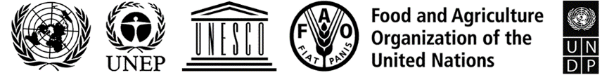 |  |  | BES
 |  |  | IPBES/9/INF/2/Rev.1
 |  | Intergovernmental Science-Policy  Platform on Biodiversity and  Ecosystem Services | Distr.: General  30 August 2022  English only
Plenary of the Intergovernmental Science-Policy
Platform on Biodiversity and Ecosystem Services
Ninth session
Bonn, Germany, 3–9 July 2022
Item 7 (b) of the provisional agenda*
Assessing knowledge: methodological assessment regarding the diverse conceptualization of multiple values of nature and its benefits, including biodiversity and ecosystem functions and services
Chapters of the methodological assessment regarding the diverse conceptualization of multiple values of nature and its benefits, including biodiversity and ecosystem functions and services (assessment of the diverse values and valuation of nature)
Note by the secretariat
- In section VI of decision IPBES-6/1, the Plenary of the Intergovernmental Science-Policy Platform on Biodiversity and Ecosystem Services (IPBES) approved the undertaking of a methodological assessment regarding the diverse conceptualization of multiple values of nature and its benefits, including biodiversity and ecosystem functions and services (referred to as the “assessment of the diverse values and valuation of nature”), in accordance with the procedures for the preparation of the Platform’s deliverables set out in annex I to decision IPBES-3/3 and as outlined in the scoping report set out in annex VI to decision IPBES-4/1.
- In paragraph 2 of section II of decision IPBES-9/1, the Plenary approved the summary for policymakers of the methodological assessment of the diverse values and valuation of nature (IPBES/9/14/Add.2) and accepted the chapters of the assessment. The approval was based on the understanding that the assessment experts would subsequently revise the chapters to ensure consistency with the summary for policymakers as approved (IPBES/9/14, para. 74). The final chapters of the assessment, including their executive summaries, are available at ipbes.net/values-assessment. They are presented without formal editing.
- A laid-out version of the final assessment report on the diverse values and valuation of nature, including a foreword, statements from key partners, acknowledgements, a preface, the summary for policymakers, the revised chapters, and annexes setting out a glossary and lists of acronyms, authors, review editors and expert reviewers, will be made available on the IPBES website.

* IPBES/9/1.

